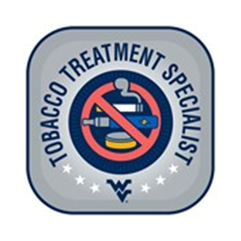

**West Virginia University, School of Dentistry’s Certified Tobacco Treatment Training Program**

**About the program:**

West Virginia University School of Dentistry’s Certified Tobacco Treatment Training Program is an online, self-paced course for professionals in the fields of counseling, education, dentistry, medicine, nursing, pharmacy, public health, and social work. CTTTP consists of a minimum of 24 continuing education hours. Participants must have a minimum of an associate degree to enroll. Successful participants earn a Tobacco Treatment Specialist (TTS) certificate to provide effective, evidence-based tobacco treatment interventions to assist with tobacco use disorder/vaping cessation.

**Next online course offered: January 13, 2025 – March 15, 2025**.

**Training goals:**

Participants who successfully complete the WVU School of Dentistry’s Tobacco Training Program can:

* Understand the science behind tobacco addiction, and nicotine withdrawal symptoms.
* Inform clients/students about the consequences of tobacco use disorder.
* Develop effective, individualized tobacco use disorder treatment plans for all types of tobacco and nicotine use.
* Track abstinence progress and outcome measures.
* Educate other providers and the public regarding tobacco prevention and cessation across a wide range of settings.

**Required Criteria to attain a Tobacco Treatment Specialist Certificate**:

* Full online participation in the WVU School of Dentistry’s Certified Tobacco Treatment Program (24-hour course)
* Achievement of a minimum score of 80% on the WVU Tobacco Treatment Specialist Certification Examination
* Proclamation of a tobacco-free lifestyle