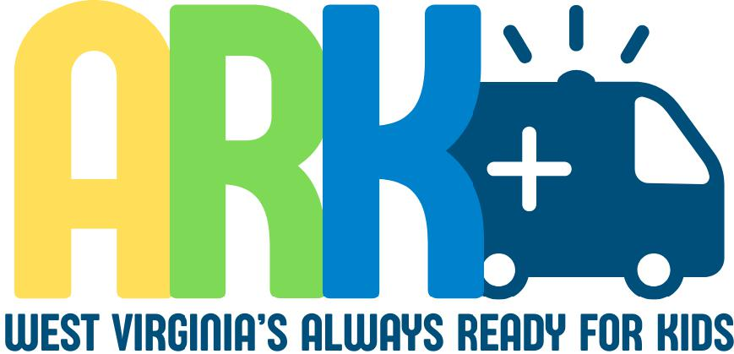

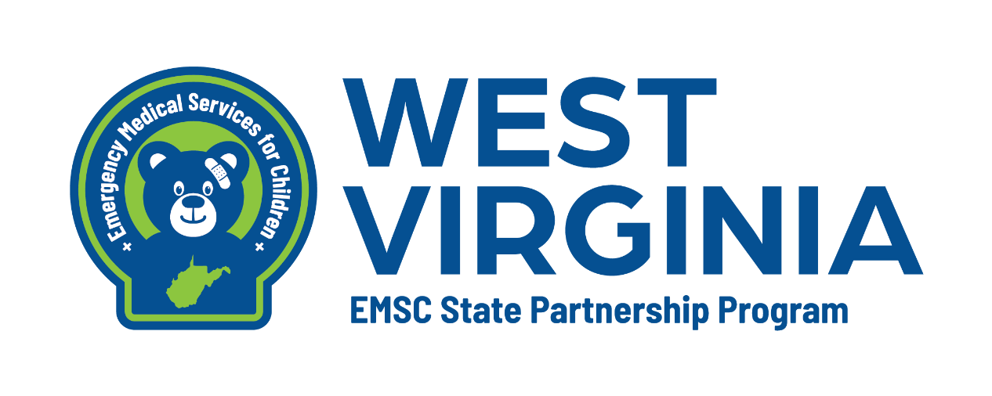

WEST VIRGINIA ALWAYS READY FOR KIDS PREHOSPTIAL PROGRAM
WEST VIRGINIA OFFFICE OF EMS | 350 Capitol St. Charleston, WV 25301

Table of Contents
Introduction 3
Program Criteria
PECC 4
Pediatric Equipment 4
Safe Transport 5
EMSC Assessments 5
Education 5
Quality Assurance 5
Community Outreach 6
Summary of Requirements 6
Application and Review Process 7
Application 9
Attestation Form 11
PECC Attestation Form 12
Appendices
Community Outreach

“The Health Resources and Services Administration (HRSA), Department of Health and Human Services (HHS) provided financial support for this project. The EMSC State Partnership award provided 100% of total costs and totaled $190,650. The contents are those of the author. They may not reflect the policies of HRSA, HHS or the U.S. Government.”
Introduction
The West Virginia EMS for Children (WVEMSC) program is pleased to introduce a voluntary Pediatric Ready EMS Recognition program. This three-tiered system will recognize Basic Life Support (BLS) and Advanced Life Support (ALS) agencies who have demonstrated a commitment to excellence in pediatric emergency care and better healthcare outcomes for pediatric patients. The 3-year recognition showcases agencies who go above and beyond by providing the best care for pediatric patients.

If your agency is interested in applying for recognition, please review this guidebook. Agencies who are awarded recognition will receive a certificate for display and decals for trucks. The guidebook will be reviewed annually with the most recent version available on the WVEMSC website.
Again, this is a voluntary recognition program and your decision to participate will not affect your EMS agency license.

Please contact Erin Timbrook, WV EMSC Program Coordinator at 304-380-4728 or erin.j.timbrook@wv.gov with any questions or concerns.

Thank you for all you do!
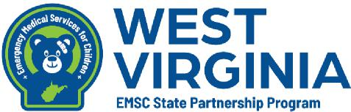

Pediatric Emergency Care Coordinator (PECC)
Participating agencies are required to have a designated Pediatric Emergency Care Coordinator (PECC). This individual will serve as a liaison between the agency and the WVEMSC program and will oversee all facets of pediatric care at the agency to include training, operations, protocols and prevention.
This position is not intended to be full-time and can be incorporated into current job duties.
The PECC should meet the following roles and responsibilities:
- Ensure that fellow EMS providers follow pediatric clinical practice guidelines
- Promote pediatric continuing education opportunities
- Oversee pediatric process improvement
- Ensure the availability of pediatric medications, equipment, and supplies
- Promote agency participation in pediatric prevention programs
- Promote agency participation in pediatric research efforts
- Liaises with the emergency department pediatric emergency care coordinator
o Promote family-centered care at the agency EMS
The agency PECC must be documented in ImageTrend as a position for the agency and required documentation (attestation form) be submitted to the EMSC Coordinator.

Equipment
Interested applicants must be compliant with the minimum
medication and equipment supply list provided by the West Virginia Office of EMS. The pediatric equipment in this section was approved by the WVEMSC Advisory Committee and details the appropriate equipment and supplies to care for the pediatric patient.
Equipment will be verified by the Office of EMS inspector.
Appointments with the inspector will be made once a complete application is received or during your agency’s initial inspection or renewal.

Safe Transport
The agency must provide a policy that outlines safe transport for all patients regardless of age or weight. This policy should include a commercially appropriate pediatric transport device. These devices should be designed to transport children between 5 and 99 pounds on every ambulance in service.

WVEMSC Assessments
The WVEMSC program is required to collect data from the state’s EMS agencies to determine progress with the program performance measures. The survey process is once a year and takes about 10-15 minutes to complete. Agencies participating in Pediatric Ready EMS must complete assessments as requested by the WVEMSC program. This will also include the PPRP survey.

Education
In addition to education requirements from the Office of EMS and the National Registry of EMTs, agencies applying for Pediatric Ready EMS recognition must meet additional pediatric education and skills verifications.
Eighty percent (80%) of agency credentialed providers must have a certification for a current nationally accepted pediatric course. Examples include Pediatric Advanced Life Support (PALS), Handtevy Pre-Hospital Pediatric Provider, Pediatric Education for Prehospital Professionals (PEPP), and Emergency Pediatric Care (EPC).
For each level of recognition, there are additional hours of training required.
- Bronze- 2 hours
- Silver- 4 hours
- Gold- 6 hours

Quality Assurance
Agency leadership must review 100% of the following call types: pediatric cardiac arrest, pediatric stoke, advanced airway interventions, IO insertion or attempts, and trauma alert patients.

Community Outreach
Pediatric Ready EMS recognition requires agencies to regularly participate in outreach initiatives within their community. There must be at least one outreach activity offered annually. Documentation for verification of events will be required in the application process.
Some examples of Outreach include:
- Hosting a community safety day at EMS station
- Hosting a community CPR class, including child/infant curriculum components
- Providing a presentation to local elementary school students on EMS
- Conducting injury prevention talks at the local swimming pool or local public library
- Holding a bike safety rodeo
- Community Health Fairs
- Hosting events with your local hospital
- Hosting events with community-based organizations or local county public health departments
- Hosting Pediatric Disaster Trainings or drills
Summary of Requirements
- Designated Pediatric Emergency Care Coordinator (PECC)
- Policy for Safe Transport of pediatric patients
- Additional pediatric education
- Quality Assurance
- Community Outreach events

Application and Review Process

Application
The Prehospital Always Ready for Kids EMS application and attestation forms can be found on the WV EMS for Children website or requested from the EMS for Children Program Coordinator at erin.j.timbrook@wv.gov or 304-380-4728.
Documents to submit:
Application
Attestation and Compliance Form
PECC Attestation Form
Current pediatric equipment inventory list.
Training roster for all staff (last 12 months).
Designation of PECC (name, role, and contact).
Copy of Pediatric Readiness Self-Assessment results.
Documentation of community outreach events (if applicable).
Summary of pediatric case review or quality improvement activity.

WVEMSC Program Review
Once completed, the application and attestation forms should be sent to the WVEMSC Coordinator at the information above. Only complete applications with signed attestation forms will be accepted. If further information is needed, the agency will be contacted by the WVEMSC Coordinator. The applying agency will be contacted to schedule a visit with the Bureau of EMS inspector to verify equipment.
Upon successful submission of the application and equipment check verification, all documentation will be presented to the West Virginia EMSC Advisory Medical Director and committee. The committee will review applications and supporting documentation on a rolling basis to determine if the agency meets the recognition requirements.

Award of Recognition
Agencies who successfully complete the recognition process will receive a certificate and decals. Their agency name will also be listed as Pediatric Ready on the WVEMSC website. Agencies are encouraged to promote their recognition in their community. Agencies will be asked to attend the WVEMSC Advisory meeting to obtain their certificate and decals. The recognition will be valid for three (3) years from that date.

Renewal
At the end of the 3-year recognition cycle, the agency may apply for renewal by completing the application and review process.

Suspension or Revocation.
Recognition in the Pediatric Ready program may be suspended or revoked if the agency:
- Willfully or repeatedly violated any provision of these guidelines.
- Willfully or repeatedly acted in a manner inconsistent with preserving the health and safety of patients, the public, or providers.
- Provided falsified information in order to gain recognition
In the event that an agency no longer maintains recognition status, decals must be removed from all vehicles and returned to the WVEMSC program.

West Virginia Prehospital Always Ready for Kids Recognition Program
The West Virginia Prehospital Always Ready for Kids Recognition Program is a voluntary recognition initiative designed to acknowledge EMS agencies that demonstrate excellence in pediatric care. The program encourages pediatric readiness, education, quality improvement, and community engagement. Agencies may apply for recognition at one of three levels: Bronze, Silver, or Gold.

Agency Information

Agency Name:
Agency Address:
City: State: ________ ZIP:
Agency Phone Number: ______________
Agency Email:
PECC Name: _____________________________________________
PECC Phone Number: ____
PECC Email: ________________________________________________
Medical Director Name: _______________________________________
Medical Director Email: _______________________________________

Recognition Levels and Criteria
Agencies may apply for one of the following recognition levels. Each level builds on the requirements of the previous one.

Level I – Bronze (Baseline Pediatric Readiness)
- Carry a complete pediatric equipment inventory (airway, BVM, suction, monitoring, IV/IO, pediatric immobilization devices, as required by WVOEMS Licensure).
- Provide pediatric-specific orientation or training (minimum 2 hours annually for all staff).
- Designate a Pediatric Emergency Care Coordinator (PECC) or equivalent within the agency.
- Complete the Pediatric Readiness Self-Assessment Survey.
- Maintain up-to-date pediatric dosing references and treatment protocols in all response units.
- Have a Pediatric Disaster Plan.

Level II – Silver (Enhanced Pediatric Capacity)
- Meet all Level I criteria.
- Ensure at least 4 hours of pediatric-specific education annually per provider.
- Conduct at least one pediatric case review or quality improvement activity annually.
- Participate in at least one pediatric skills or disaster drill annually, demonstrating use of a Pediatric Disaster Plan.

Level III – Gold (Community Outreach and Excellence)
- Meet all Level I and II criteria.
- Ensure at least 6 hours of pediatric-specific education annually per provider.
- Conduct at least two pediatric-focused community outreach or prevention events annually (e.g., safety day, CPR for kids, bike safety, car seat check).

Required Attachments
- Current pediatric equipment inventory list.
- Training roster for all staff (last 12 months).
- Designation of PECC (name, role, and contact).
- Copy of Pediatric Readiness Self-Assessment results.
- Documentation of community outreach events (if applicable).
- Summary of pediatric case review or quality improvement activity.

Certification
I certify that the information provided in this application is accurate and complete, and that the agency meets the requirements for the level of recognition being requested. The agency agrees to maintain these standards for the duration of the recognition period (three years).

Agency Director Signature: _________________________ Date: _____________________
Medical Director Signature: Date: _____________________
Attestation and Compliance Reporting Form
Pediatric Ready EMS Recognition Program
To be completed by an EMS Agency Administrator (e.g. chief operating officer, administrator, director, president,
etc.)
By signing this form, I attest that my EMS agency:
- Is compliant with all applicable West Virginia Bureau of EMS statues and regulations
- Shall participate in WV EMS for Children (WVEMSC) assessments
- Has a policy in place that outlines safe transport for all patients and includes a commercially appropriate pediatric transport device.
- Has a designated individual to serve as the Pediatric Emergency Care Coordinator and meets the job roles outlined in the chart listed on page 12 and has listed this job in the individual’s ImageTrend profile.
- Maintains, on all EMS vehicles, all pediatric equipment mandated by the WV Office of Emergency Medical Services.
- Requires 80% off all providers to obtain a certification for a nationally accepted pediatric course.
- Must review 100% pediatric arrest, pediatric stroke, advanced airway interventions, IO insertion or attempts and trauma alert patients.
- Regularly participates in at least one community outreach event annually and will maintain records of participation

Signature Date___________________

Printed Name_____________________________________ Title _______________________

Pediatric Emergency Care Coordinator (PECC)
Designation Form
By signing this form, I agree that I am the designated Pediatric Emergency Care Coordinator and responsible for all facets of pediatric care at my agency. I will work in collaboration with the West Virginia Bureau of EMS and the West Virginia EMS for Children Program on
pediatric education, operations, protocols and preventions.
I agree to:
- Ensure that the pediatric perspective is included in the development of EMS protocols
- Ensure that fellow EMS providers follow pediatric clinical practice guidelines
- Promote pediatric continuing education opportunities
- Oversee pediatric process improvement
- Ensure the availability of pediatric medications, equipment, and supplies
- Promote agency participation in pediatric prevention programs
- Promote agency participation in pediatric research efforts
- Liaises with the emergency department pediatric emergency care coordinator
- Promote family-centered care at the agency EMS
Name:
Agency:
Job Title:
WV Certification Number:
Email:
Phone:

Signature _______________________________________ Date: _____________________

Appendix
Community Outreach Examples
- Hosting a community safety day at the station
- Hosting a community CPR class, including child/infant curriculum components
- Providing a presentation to local elementary school students on EMS
- Conducting injury prevention talk at the local swimming pool or local public library
- Holding a bike safety rodeo
- Community Health Fairs
- Hosting events with your local hospital
- Hosting events with community-based organizations or local county public health departments
- Hosting Pediatric Disaster Trainings or drills

