To register for the **Medical Preparedness and Response for Bombing Incidents MGT-348** course use the link or scan the QR code below, ***select your course dates and site, complete the registration process on the TEEX student portal.*** NOTE: Laptop or desktop has a better viewing range, *If using a smartphone to register, you may need to turn your device sideways to see all the screen prompts.*

1. Acknowledge the “General Liability Release Form” (click the box on the right) Note: The class Itinerary Button may take 10 to 15 minutes to load after registering for the class.
2. **Pretests are required to be completed prior to the start of the class**. The course administration will open as soon as you register for the course. This will allow you to complete the pre-course administrative actions. You will be receiving an email from [ecampus@teex.tamu.edu](mailto:ecampus@teex.tamu.edu) confirming your registration in the course that includes a direct link to access the class on your student portal.

You will access the class by either clicking on the link in the welcome email or by logging into your Student Portal account on <https://my.teex.org/TeexPortal/> and finding the class in which you are enrolled. You will see The Class ***Itinerary Button*** which will take you directly to the start button to complete the ***General Liability Release Form*** by checking the box. You do not need to download and sign, just check the box. Once the Liability box is checked you have access to take the Pretest.

**After completion of the PRETEST, you will be given access to download the class materials**.

**NOTE** Printed Materials **will not** be provided. Please download the class materials to your laptop or tablet, bring that device to class with you to: **1)** view the materials during lecture, **2)** access the DHS evaluation **3)** take the POSTTEST. Please have your TEEX log in information on the device you will be using in class*.*

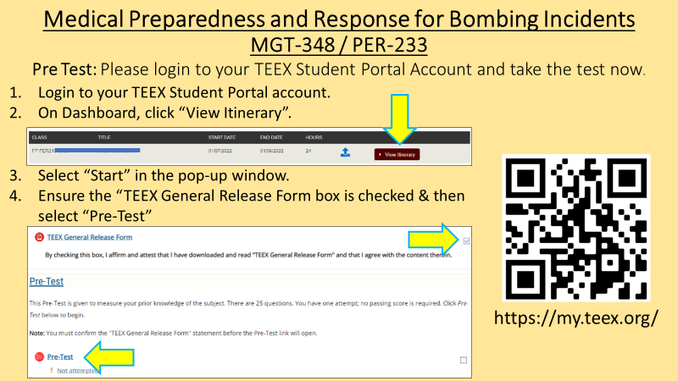

**Note:** Be prepared to show a ***photo ID the first day of class*** when you sign in, this is a requirement of our CE providers.