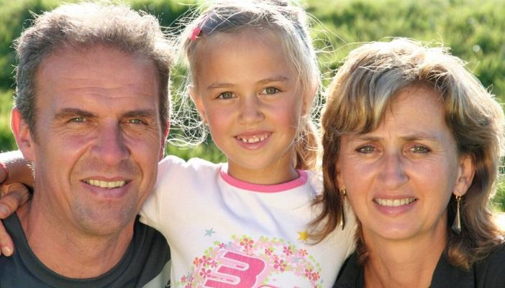

West Virginia 2024 Annual Progress and
Services Review
West 2019
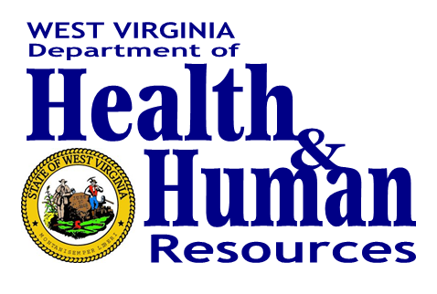

Bureau for Social Services
350 Capitol Street, Room 730
Charleston, WV 25301

Contents
State Agency Administering Programs 5
The Bureau for Children and Families 6
Office of Programs 6
The Office of Operations 7
Office of Planning, Research and Evaluation 8
The Office of Field Operations 8
Update on Collaboration and Vision 9
Vision Statement 10
Collaboration 10
1. Update on Assessment of Performance 25
Safety 31
Permanency 54
Well-Being 88
Child and Family Involvement in Case Planning 94
Caseworker Visits with Parents 101
Mental/Behavioral Health of the Child 114
Systemic Factors 117
Information Systems 117
Case Review 121
Training 130
Quality Assurance System 151
Service Array 170
Agency Responsiveness to the Community 220
Foster and Adoptive Parent Licensing/Recruitment 256
2. Update on Plan for Enacting the States Vision 264
Staff Training, Technical Assistance and Evaluation 307
Child and Family Service Continuum 308
Prevention 308
Child Protective Services 312
Youth Services 315
Foster Care 317
Service Coordination 329
Service Description 333
Stephanie Tubbs Jones Child Welfare Services Program (title IV-B, subpart 1) 339
Services for Children Adopted from Other Countries 339
Services for Children under the Age of Five 340
Efforts to Track and Prevent Child Maltreatment Deaths 341
Disaster Relief Act 351
COVID Aide, Relief, and Economic Security (CARES) Act 351
Promoting Safe and Stable Families (title IV-B, subpart 2) 352
Populations at Greatest Risk 353
Emergency Funding for the MaryLee Allen Promoting Safe and Stable Families (PSSF) Funding 355
Monthly Caseworker Visit Formula Grants and Standards for Caseworker Visits 356
Additional Service Information 357
Child Welfare Waiver Demonstration Activities 357
Adoption and Legal Guardianship Incentive Payments 360
Adoption Savings 361
Adoption Savings Methodology 362
Adoption Savings Expenditures 362
Family First Act Transition Grants 363
3. Update on John H. Chafee Foster Care Program for Successful Transition to Adulthood 365
Agency Administering Chafee 365
Description of Program Design and Delivery 366
Serving Youth Across the State 371
Serving Youth of Various Ages and Stages of Achieving Independence 373
Collaboration with Other Private and Public Agencies 374
Determining Eligibility for Benefits and Services 375
Cooperation in National Evaluation 376
Chafee Training 376
Additional Chafee Funding Division X 377
Access to Medicaid for Former Foster Youth 378
Education and Training Vouchers (ETV) 379
Additional Funding ETV Division X 380
4. Update on CAPTA 381
Program Areas 381
Supplemental CAPTA Funding American Rescue Plan 394
5. Update on Targeted Plans within the 2020-2024 CFSP 395
Foster and Adoptive Parent Diligent Recruitment Plan 395
Health Care Oversight and Coordination Plan 405
Disaster Plan 405
Training Plan 405
6. Update on Statistical Information 405
CAPTA Annual State Data Report: 406
Juvenile Justice Transfers: 410
Education and Training Vouchers: 411
Inter-Country Adoptions: 411
Monthly Caseworker Visit Data: 411
7. Financial Information 412

State Agency Administering Programs
The West Virginia Department of Health and Human Resources (the Department) is a cabinet level agency of state government created by the Legislature that operates under the general direction of the Governor. This Department can be described as an umbrella agency with responsibility for several different programs and services including, but not limited to, public health; behavioral health; child support enforcement; medical services; children’s health insurance; drug control policy; inspector general; health care authority; and services to children, families, and vulnerable adults. The Department operates under the direction of a Cabinet Secretary, and the major programs are assigned to different Bureaus. Each Bureau operates under the direction of a commissioner. The authority and responsibilities of the Commissioner vary from Bureau to Bureau. The Commissioner of the Bureau for Children and Families (BCF) is Linda Watts.

Update 2023:
During the calendar year 2021 the Department made the decision to split the BCF into two separate bureaus, the Bureau for Social Services (BSS) and the Bureau for Family Assistance (BFA). The Commissioner of BSS is Jeffrey Pack. The Interim Commissioner for BFA is Janie Cole. The reorganization of these bureaus is ongoing. This document will reference programs as being housed under the Bureau for Children and Families due to the reorganization not being finalized. This document will reference BSS instead of BCF in the 2023 updates.

Update 2024:
The reorganization of the Bureau for Children and Families is still ongoing. Under this section you will find an updated organizational chart for BFA and BSS.

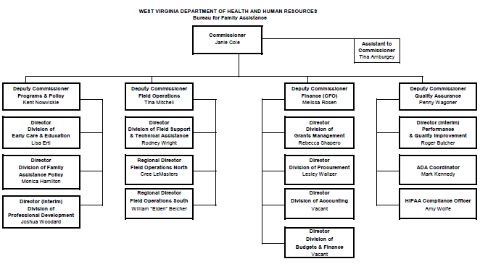
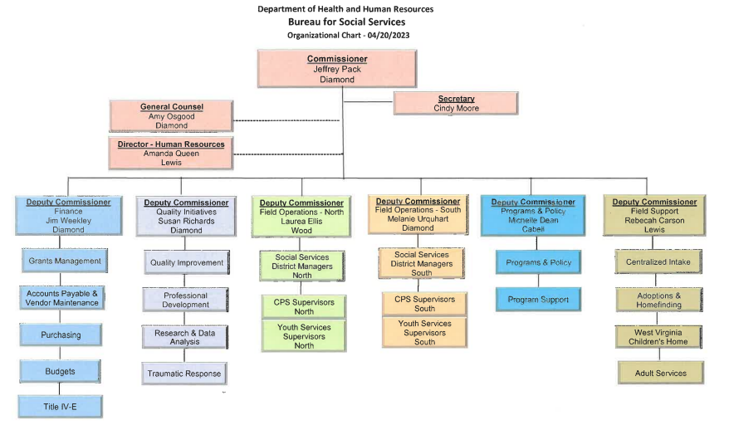

The Bureau for Children and Families
Located within the BCF are individual offices which perform various functions for the BCF. The offices are: The Office of Programs & Resource Development; the Office of Field Operations; the Office of Planning; Research and Evaluation; the Office of Operations/Safe at Home; and the Office of Field Support. A Deputy Commissioner or Director provides oversight to each office and reports to the Commissioner of the BCF, who, in turn, reports to the Cabinet Secretary of the Department. In addition, the Division of Training Director reports to the Commissioner, and is charged with the oversight, coordination, and delivery of training to BCF employees and foster parents statewide. This training includes New Worker Training, Supervisory Training, and Tenured Worker Training on new initiatives and professional development activities.

Office of Programs
The Office of Programs and Resource Development, under the direction of Deputy Commissioner Janie Cole, has primary responsibility for program planning and development related to child welfare. The staff formulates policy, develops programs, and produces appropriate state plans and manual materials to meet federal specifications and applicable binding court decisions. Such manual material is used as guidance for the implementation of applicable programs by field staff deployed throughout the state.

The Department, through the BCF, is responsible for administering child welfare services in accordance with WV Code §49-1-105. The administration of federal grants, such as Child Abuse Prevention Treatment Act funds, Chafee Independent Living funds, Title IV-E funds, and Title IV-B funds, is also a responsibility of this Bureau.
The staff within the BCF is primarily responsible for initiating or participating in collaborative efforts with other Bureaus in the Department on initiatives that affect child and vulnerable adult welfare. The staff in the BCF also joins with other interested groups and associations committed to improving the wellbeing of children, families, and vulnerable adults.

For the most part, the staff within the Children and Adult Services (CAS) policy division is not involved in the direct provision of services. In some cases, however, staff do assist with the provision of services or are directly involved in service delivery. For example, staff in CAS operate the Adoption Resource Network and maintain financial responsibility for a case once an adoption subsidy has been approved. The Director position serves as both the IV-B and IV-E Coordinator.

Update 2024:
This document was submitted to the Children’s Bureau on June 30, 2023, by Andrea Ramsey-Mitchell, Program Manager of the Bureau for Social Services. West Virginia’s approved Child and Family Services Plan and any approved Annual Progress Services Report can be located at https://dhhr.wv.gov/bss/reports/Pages/State-Plans.aspx .

In addition, this office is responsible for the Division of Family Assistance, the Division of Early Care and Education.

The Division of Training is charged with the oversight, coordination, and delivery of training to BCF employees and foster parents statewide. This training includes New Worker Training, Supervisory Training, and Tenured Worker Training on new initiatives and professional development activities. This Division reports directly to the Commissioner.

Update 2024:
The BSS, Office of Programs and Resource Development is now under Deputy Commissioner Michelle Dean. This office houses CAS as mentioned above, as well as Institutional Investigation Unit, Licensing Unit, and Program Support.

The Division of Family Assistance and Division of Early Childcare and Education are now located under the Bureau of Family Assistance.

The Division of Training under Bureau for Children and Families will be reorganized as each new Bureau will have its own Division of Training.

State CAPTA Coordinator  Alice N. Hamilton, LSW  350 Davis St.  Princeton, WV 24739  304-425-8738  Alice.N.Hamilton@wv.gov | State IV-B and IV-E Coordinator  Vacant, Director  350 Capitol Street, Room 691  Charleston, WV 25301

The Office of Operations
The Deputy Commissioner of Operations, Amy Hymes, is responsible for oversight of West Virginia’s Child Welfare Demonstration Project, Safe at Home, as well as monitoring out of state placements.

The Division of Grants and Contracts; the Division of Finance; the Division of Personnel, and Procurement report to the Chief Financial Officer, James Weekley. Major responsibilities of the Office of Operations are approving and monitoring subrecipient grants and contracts; oversight of the bureau budget; oversight of personnel and procurement activities; and developing and producing research and analysis on the results of operations for the major programs operated by the Bureau.

Update 2023:
The Office of Operations under BSS has been renamed the Office of Finance and is under the direction of Deputy Commissioner Jim Weekley. This office oversees Grants Management, Accounts Payable and Vendor Maintenance, Purchasing, Budgets and Title IV-E.

BSS now has two Offices for Field Operations that oversee daily functions of BSS district offices in every county. The offices are divided into North and South. Deputy Commissioner Amy Hymes oversees the North and Deputy Commissioner Melanie Urquhart oversees the South.

Safe at Home is now housed in the Office of Programs and Resource Development, Division of CAS.

Update 2024:
No update as the reorganization is still ongoing.

Office of Planning, Research and Evaluation
The Office of Planning, Research and Evaluation, under the direction of Assistant Commissioner Kevin Henson, has the responsibility for major activities of the Child and Family Services Review (CFSR) and the Program Improvement Plan (PIP); Child Welfare Oversight and the statewide continuous quality improvement program; including conducting case reviews, as well as social service program review and peer reviews; assisting district offices in developing corrective action and program improvement plans and internal critical incident review. These activities reside in the Division of Planning and Quality Improvement (DPQI) under the direction of Jane McCallister. DPQI is also responsible for the management evaluation review of the SNAP program and TANF Quality Improvement review and corrective action.

Update 2023:
Each new Bureau will have an Office of Quality Assurance. BSS Division of Quality Assurance is under Deputy Commissioner Susan Richards. This Office includes the Division of Quality Improvement, Professional Development, Research and Data Analysis, and Trauma Response.

BFA has not finalized their Office of Quality Assurance at this time.

Update 2024:
No update as the reorganization is still ongoing.

The Office of Field Operations
The Office of Field Operations is under the direction of two Deputy Commissioners. Tina Mitchell, Deputy Commissioner of Field Operations South, oversees Regions II and IV, and Tanagra O’Connell, Deputy Commissioner of Field Operations North oversees Regions I and III. Together, the Deputy Commissioners of Field Operations coordinate their efforts to ensure staff and customer needs are being addressed and resolved in a timely manner.

Field Operations’ charge is the direct service delivery of all services within the BCF, as well as Customer Services. There are two additional directors, one for Family Assistance Programs and one for Social Services Programs, that assist with supervision and direction for field staff.

West Virginia is divided into four regions. Each region is supervised by a Regional Director (RD) who reports directly to the Deputy Commissioner. Various counties are grouped to create districts. If a county is large enough, it is considered its own District. Various districts are grouped into regions. The district is supervised by a Community Services Manager. All supervisory staff report directly to the Community Services Manager. Field staff are responsible for the service delivery of Child Protective Services (CPS), Youth Services (YS), Foster Care (FC), and Adoption.

Update 2023:
As mentioned above, the Office of Field Operations is divided differently. BSS now has two Offices for Field Operations that oversee daily functions of BSS district offices in every county. The offices are divided into North and South. Deputy Commissioner Amy Hymes oversees the North and Deputy Commissioner Melanie Urquhart oversees the South.

BFA has an Office of Field Operations that is led by Deputy Commissioner Tina Mitchell. This Office contains the Division of Field Support and Technical Assistance and Divisions of Field Operations North and South.

Update 2024:
No update as the reorganization is still ongoing.

Update on Collaboration and Vision
West Virginia is a small rural state known to have a highly collaborative child welfare system with multiple partnerships but has struggled with the resources to provide services to children and families at the community level. The Family First Prevention Services Act (FFPSA) of 2019 has provided our state with the opportunity to implement model programs aimed at providing services to children and families in their homes and communities and reduce reliance on out of home care. Due to the state’s small size and lack of community-based resources, the state has relied on out of home care and services that assist in the preservation and reunification of children and families. With the implementation of this legislation, the door has been opened for the state to step up its focus on community services and make use of its people who are willing to help others and for all its citizens to live the best lives possible.

The WV Department of Health and Human Resources shares a close relationship with several partnerships, including its Court Improvement Program and the state’s provider networks. Although these entities may not always agree, they have been able to come to a consensus on the importance of keeping children and families together and providing services at the community level for those who need the services. The Child Welfare System Reform, that includes sister Bureaus within the WV Department of Health and Human Resources, share their resources and a vision to develop a continuum of community-based services.
There are many collaborative groups that have been in existence in the state for many years. These teams have designed and implemented initiatives to help accomplish goals outlined by the state and Congress. Many times, collaborative groups utilize the same members, who provide a wealth of information to each group. Many of the members of these collaboratives participated in the CFSR and in many of the PIP groups. They received copies of the review and were involved in PIP discussions and planning sessions. It was apparent to all involved that West Virginia needs to focus on seeing families timely and developing case plans to address services needed by the families and youth who receive services from the BCF.

During PIP discussions participants developed a root cause analysis which found WV rated 56% strength on meeting assigned time frames on accepted referrals. The data supports that caseworkers are much less likely to meet this time frame if the case is already open. Of the timeframes met, 73% were met on intakes on families unknown to the agency versus 26% on referrals of already open cases. DPQI case review data indicates the measurement for CFSR Item 1 has steadily decreased over the last four FFYs. The FFY 2018 data indicates the agency is meeting the assigned timeframes for face-to-face contact with alleged child victims 50% of the time.

The Department of Justice (DOJ) has also reviewed the state's performance. They found that the state has an over-reliance on congregate care and has not provided services to prevent placement. Therefore, West Virginia has entered into an agreement with the DOJ to improve service delivery at a community level and reduce the number of children and youth placed in congregate care.

During the recent State Team Meeting in Washington, in late April 2019, members of the Department, which includes both representatives from its Child Welfare System, as well as its Prevention Programs, and the Court Improvement Program (CIP), worked together to develop a vision statement for West Virginia that depicts the state’s vision for the Child Welfare System for the next five years. This vision was shared and accepted by all the BCF’s Leadership Team.

Although all agree that the state’s vision must be much more proactive and preventative, the vision below is the team’s realistic vision for where we envision the state in the next five years.

Vision Statement
West Virginia will develop a proactive system which preserves safe and healthy families.

Collaboration
The Department involves stakeholders from across the state and all child welfare systems. The inclusion of diverse individuals representing the many facets of the system is a necessary step for meaningful improvement. Additionally, the Department obtains input from stakeholders by partnering with several high-level groups that together provide oversight and direction for child welfare in West Virginia. These oversight groups are:

• Commission to Study Residential Placement of Children.
• Safe at Home West Virginia.
• West Virginia Court Improvement Program.
• Education of Children in Out of Home Care Advisory Committee; and
• Child Welfare Collaboration

Update 2024:
During the 2021-2022 calendar year, the Bureau for Social Services partnered with several other organizations and agencies in the development of a statewide needs assessment regarding unserved, underserved, and inadequately served populations. A collaborative was developed encompassing a variety of backgrounds including domestic violence, rape and crisis centers, child advocacy centers, CASA, prosecutors, courts, and others. The initial purpose of the collaborative focused on domestic violence, but due to the intersectionality of child welfare and domestic violence and other victim-centered crimes, the opportunity to expand its focus was seized.

The Collaborative determined it would conduct a long survey of both professionals serving targeted populations and a short survey targeted toward community partners and the public, as well as conduct listening sessions and focus groups to engage our partners and the community in discussion. The long survey was developed and distributed first, receiving 116 responses. The Collaborative met and discussed the results of the long survey and began the process of developing the short community survey.

The community survey received 126 responses and was distributed through public social media sites, existing listservs and through many community organizations serving victims of violence including:
- Substance Abuse Recovery Programs;
- Youth services programs;
- Disability groups; and,
- Racial justice groups.

The Collaborative met in summer of 2021 to finalize the listening session and focus group questions. Six focus groups and four listening sessions were held in fall of 2021. The focus groups were focused on professionals providing services and the listening sessions were focused on gathering feedback from marginalized communities and included:
- Persons with disabilities;
- People of color;
- People in later life and people experiencing cognitive disabilities; and,
- LGBTQ+ people and allies.

The listening sessions and focus groups were intentionally designed to be facilitated by members of the respective groups and trusted individuals within their communities, excluding the inclusion of state actors or other benefiting professionals to ensure the conversations could be free without hesitancy from the community.

The feedback received highlighted areas within the state where services are lacking particularly accessibility regarding substance use and mental health services.

Commission to Study Residential Placement of Children

The Commission to Study Residential Placement of Children tracks the Commission’s goals and progress of the goals, as well as the goals of the oversight groups and others. Progress is provided in the Annual Progress Report Advancing New Outcomes, Findings, Recommendations, and Actions. This report is provided to the Legislative Oversight Commission on Health and Human Resources Accountability, the Oversight Group members, and is available on the Department’s website at: http://www.wvdhhr.org/oos_comm/

The Commission’s goal for the next five years is to be proactive rather than reactive when it comes to West Virginia’s providing services to families. Rather than picking up the pieces when a family has been separated, the Commission would like the family to remain together while fixing the issues, with potential to pull them apart should the need arise.

Bringing together a diverse group of individuals representing the many facets of the system is a necessary step for meaningful improvement. The Commission carries out its work with strong collaborative participation from all of West Virginia’s child and family service systems. Open discussion, research and materials presented at quarterly meetings reflect the day-to-day experiences and voices of field staff, families, and youth from all areas.

The Commission works in collaboration with other projects/initiatives including Safe at Home West Virginia, Education of Children in Out-of-Home Care Advisory Committee, West Virginia Court Improvement Program, and others to support its goals in the study of the residential placement of children.

Update 2023:
The year 2021 continued to present multiple variants of the world-wide pandemic, COVID-19. In December 2020, vaccines were approved for use in the United States and West Virginia led the nation in getting the highest-risk citizens vaccinated through the Operation Save Our Wisdom program. In September of 2021, as protection began to wane from the vaccines, booster shots were released to assist those in certain populations and in high-risk settings and eventually expanded to individuals aged 16 and up in December 2021. At the end of December an oral antiviral treatment for COVID-19 became available in limited supply by prescription. Progress for eventually eradicating this virus is ongoing and the focus remains to get vaccinated.

During 2021, the Commission examined the requirements established by W. Va. Code §49-2-125(d). In conjunction with responsibilities set forth by state code, the Commission continued to meet quarterly to discuss the following priority goals for 2021:
• Transformational Collaborative Outcomes Management (TCOM)
• Provider input at Multidisciplinary Team (MDT) and court hearings
• Implementation of Every Student Succeeds Act (ESSA) (focus on children in foster care)
• Transitioning youth aging out of foster care

In addition to these goals, the 2021 quarterly meetings of the Commission to Study Residential Placement for Children continued to provide members and stakeholders information and updates while making decisions and/or recommendations that affected the residents of West Virginia. The Commission continues to focus on sharing ideas and providing members and stakeholders with the most up-to-date information to improve the health and well-being of those being served.

Update 2024:
The year 2022 continued to present challenges in the areas of the Opioid epidemic. According to a Mountain State Spotlight article from October 5, 2022, the West Virginia Department of Health, and Human Resources (DHHR) reported that West Virginians dying of drug overdoses each year was slowing. It was a 4% decrease compared to the previous year. The epidemic contributed to the children in foster care, not only those who were using the drugs.

Although the number of West Virginians dying of drug overdose in 2022 decreased by 4% compared to the previous year, the opioid epidemic continued to affect children in foster care. Many children who entered into foster care are linked to abuse, neglect and deplorable living conditions because of parental substance abuse. As a result, many new programs are being implemented to try to assist those struggling with substance use and overdose.

DHHR’s Office of Drug Control Policy (ODCP) is both leading and monitoring these efforts, which include expanding access to naloxone; the statewide “Save a Life Day,” which provides naloxone to all 55 counties; and OneBox, a West Virginia-born invention to get naloxone into communities and finding new ways to get naloxone in the hands of people when they need it. Additionally, ODCP partners are driving innovation that saves lives. The West Virginia Collegiate Recovery Network and the West Virginia Drug Intervention Institute launched a new overdose prevention and education initiative on West Virginia’s college and university campuses titled, “Be the One.” The purpose of the initiative is to educate and motivate individuals, campuses, and communities to take action across the continuum to prevent medication misuse, prevent and respond to overdoses, to build informed communities, and promote recovery and recovery support. The initiative is the first of its kind and spans many topics.

With partners and programs such as these, the Commission continues to broaden its efforts and find new ways to address this critical issue that is affecting our children and adults within West Virginia’s communities.

Safe at Home, West Virginia

West Virginia’s Title IV-E Waiver demonstration project, Safe at Home West Virginia, aims to provide wraparound behavioral health and social services to youth ages 12 to 17 years with specific identified behavioral health needs who are currently in congregate care or at risk of entering congregate care.

The Title IV-E Waiver allows the existing level of funding to be refocused on wraparound community-based services to achieve better outcomes for children and families aimed at returning and keeping children in their communities.

Safe at Home West Virginia seeks to increase permanency for all youth by reducing their time in foster care, increasing positive outcomes for youth and families in their homes and communities, and preventing child abuse and neglect and the re-entry of youth into foster care.

Update 2023:
In 2020, SAH WV yielded successful outcomes indicating a significant percentage of youth remaining in their home and being diverted from entering out-of-home care. The Department continued to provide SAH WV outside of the waiver. There has been an increase in the number of youths served by Safe at Home West Virginia over the past four years. During the first several months of 2021, the referrals to SAH WV stabilized and then decreased.
As reported, a subgroup of the Service Delivery Development Workgroup revised and made recommendations to accept the following updated materials:
- Wraparound 101 training
- Applied Wraparound training.
- Procedures manual
- All forms and documentation
- Resources and guides
These documents were approved and are currently being implemented. The subgroup has continued to recommend the approval of the updated training and allow SAH WV providers to begin implementation of these trainings.
Partnership with Marshall University
BSS continued working with Marshall University related to the CANS and FAST. Several training courses took place by video and live webinars due to the Pandemic during the year of 2021. The WV Residential providers are being enrolled in the CANS/FAST system. As part of the state’s redesign of residential care, each residential provider will revisit a CANS on children placed in their facility.
SAH WV is exploring utilization of the services Marshall University can provide in case review, fidelity monitoring, training, and TA. This partnership continues to develop in 2022 so additional information will be provided in subsequent progress reports.
During late 2021, oversight of the SAH WV program was transferred to the Office of Policy and Programs, Division of Children and Adult Services.
Update 2024:

SAH WV program continues to be utilized statewide. The program received 839 referrals in 2022. BSS continues to monitor the program for outcomes. In 2023 BSS will develop performance indicators in collaboration with the SAH WV providers.

The Service Delivery and Development workgroup is no longer meeting.
Partnership with Marshall University

BSS continues to partner with Marshall University. In 2022, Marshall University developed a report on SAH WV utilizing data from CANS. This report will be provided on a quarterly basis to BSS for review and to assist with the monitoring of the program.

West Virginia Court Improvement Program

The West Virginia Court Improvement Program (WV CIP) mission is to “advance practices, policies, and laws that improve the safety, timely permanency, and well-being of children and due process for families in child abuse/neglect and juvenile cases”. To aid in that mission, the BCF worked with the Court Improvement Board to enhance representation to parents and children.
Under the West Virginia Code, the child welfare agency, parents, and children are represented by an attorney in child welfare proceedings. The Department of Health and Human Resources is represented by the county prosecuting attorney and the Attorney General’s Office. Children and parents are represented by public defenders or private attorneys that are court-appointed and paid through Public Defender Services. The quality of the representation for all parties varies vastly. There is very little standardization of expectations of the attorney. West Virginia Code § 49-4-601(g) requires any attorney representing a party to receive a minimum of eight hours of continuing legal education training every two years on child abuse and neglect procedure and practice. Attorneys representing children must first complete training on representation of children that is approved by the administrative office of the Supreme Court of Appeals.
West Virginia, in collaboration with the Prosecuting Attorneys’ Institute, Public Defender Services, West Virginia State Bar, judges, Court Improvement Programs, and the administrative office of the Supreme Court of Appeals, will determine the level of training and qualifications that are required for attorneys representing the child welfare agency, parents, and children in child welfare proceedings. West Virginia will implement Standards of Practice for attorneys representing parties in child welfare proceedings to ensure that attorneys are competent in the relevant laws and litigation skills. Attorneys should be well versed in in-court advocacy, as well as out-of-court client counseling and advocacy to help clients navigate the child welfare system. Additionally, attorneys should receive training in relevant topics such as understanding substance use and recovery, trauma, available services to assist families, and disproportionality, disparity, and bias.
West Virginia will seek to draw down title IV-E funds to support and enhance legal representation for the child welfare agency, parents, and children. West Virginia will enter into memoranda of understanding with the appropriate legal agencies. These agreements will ensure that the child welfare agency is not involved in evaluating individual attorney performance or making decisions on individual attorney contracts for attorneys representing children or parents.
Update 2023:

CIP activities 2021 Calendar year
The Supreme Court of Appeals of West Virginia established the West Virginia Court Improvement Program Oversight Board in 1995. This Board took over the Broadwater Committee’s work to improve outcomes for children and families in child abuse and neglect cases. The Court established the Broadwater Committee in the mid-1990s during Chief Justice Margaret Workman’s previous tenure on the Supreme Court, from 1988 to 1999.

The Court Improvement Program Board was created as a result of the federal Omnibus Budget Reconciliation Act of 1993. That act designated federal funding beginning in fiscal year 1995 for grants to state court systems to assess their foster care laws and judicial processes and to develop and implement a plan for system improvement. The Oversight Board is the multidisciplinary advisory group and task force to implement the program in West Virginia. The U.S. DHHS Administration for Children and Families continues to fund the program annually. Judge C. Carter Williams of the Twenty-Second Judicial Circuit (Hampshire, Hardy, and Pendleton Counties) is the chair of the Oversight Board.

The mission of the West Virginia Court Improvement Program is to advance practices, policies, and laws that improve the safety, timely permanency, and well-being of children and due process for families in child abuse/neglect and juvenile cases.

Staff engaged in many activities to meet the mission of the CIP in the calendar year 2021.

Education and Community Outreach Training continued in 2021 with the addition of a few in-person training courses on topics related to child welfare. CIP sponsored 27 training sessions with 2,080 professionals in attendance.

CIP continued to support the JANIS this year. JANIS holds information on abuse and neglect cases. Data from JANIS is used to identify trends in how abuse and neglect cases are handled in West Virginia. Over 4,700 cases were added to JANIS in 2021.

Three law students from West Virginia University Law school completed the first CIP Externship in abuse and neglect during the fall of 2021. These students received real life experience working in multiple aspects of abuse and neglect cases.

New View restarted in April 2020 as a judicial resource program wherein Judges or their designees can refer children to the program. Once screened in, a CIP Field Coordinator reviews both Court and State Child Welfare Agency records, interviews the child and case collaterals, and attends pertinent hearings and multi-disciplinary team (MDT) meetings. They then make recommendations to the child’s MDT.

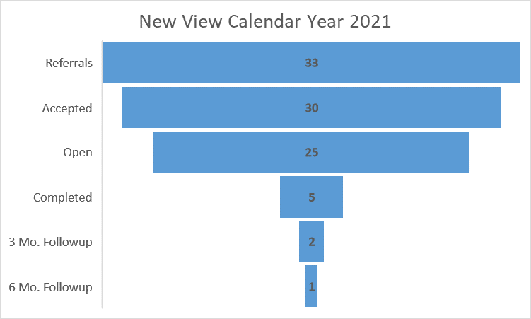

Quality Hearing Project: All CIPs are required to have a project to improve hearing quality. WV CIP has a project that looks at the quality of the multidisciplinary team meeting and its impact on the subsequent court hearing. If the MDT is quality, in that all parties are present, feel heard, and come to consensus on the case plan, then factors and variables that indicate quality will be apparent in the hearing. This means that there was enough discussion at the MDT so that judicial inquiries are easily answered in the hearing. CIP staff are observing MDTs and the subsequent hearing to see if there is a correlation.

As a precursor to the project, the CIP conducted surveys among the various stakeholders that attend MDTs through September 30, 2021. There were 1144 completed surveys, of which about 81% of respondents indicated they attended an MDT in the previous year.
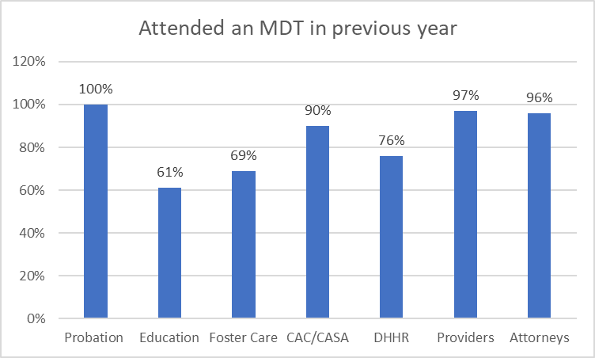
Although MDTs are prescribed by WV Code, not all stakeholders who attend MDTs have had formal training about MDTs.

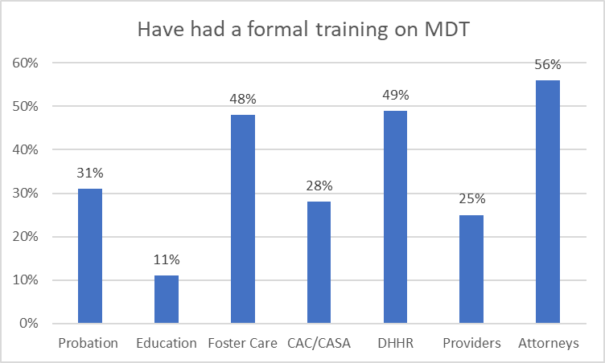

The CIP will continue to analyze the results of the surveys, and this will help drive future activities related to this project.

Update 2024:
CIP Staff engaged in a variety of education and community outreach activities to meet the mission of the CIP in calendar year 2022.

Education and Community Outreach

Training taking place in 2022:
• 1,099 training attendees
• Ten new magistrates trained on Title IV-E reasonable efforts.
• Four judicial stakeholder’s meetings held, each tailored to the community and addressing local issues in abuse and neglect proceedings
• Virtual and on-site new user trainings provided to new Juvenile Abuse and Neglect Information Services (JANIS) users
• Ten Lunch and Learn sessions held.
• CIP supported the Emergency Shelter Provider Network (ESPN) conference, Court Appointed Special Advocate (CASA) training, and the development of trafficking education curriculum carried out by Children’s Home Society

CIP continued to support JANIS, a software system that holds information on abuse and neglect cases. Data from JANIS is used to identify trends in how abuse and neglect cases are handled in West Virginia. More than 4,700 cases were added to JANIS in 2022. Work continues to strengthen the quality of the data contained in the system.

New View
The New View program restarted in April 2020 as a judicial resource program wherein judges or their designee can refer children to the program. Once screened in, a CIP Field Coordinator reviews both Court and State Child Welfare Agency records, interviews the child and case collaterals, and attends pertinent hearings and MDT meetings. They then make recommendations to the child’s MDT. Fifteen children had reviews completed during 2022. The second annual New View report was released in 2022 and is available upon request.

Quality Hearing Project
All CIPs are required to have a project to improve hearing quality. WV CIP has a project that looks at the quality of the MDT meeting and its impact on the subsequent court hearing. If the MDT is quality, in that all parties are present, feel heard, and come to consensus on the case plan, then factors and variables that indicate quality will be apparent in the hearing. This means there was enough discussion at the MDT that judicial inquiries are easily answered in the hearing. CIP staff are observing MDTs and the subsequent hearings and will see if there is a correlation. This project continues the needs assessment, a report demonstrating findings from 1,044 survey participants was released in Spring 2022 and is available upon request. About 100 MDT/hearing pairs have been observed. These observations will continue through March 2023. The next phase of the project will be to analyze data, perform root cause analysis, and develop a theory of change. This phase will begin summer 2023 and continue through winter 2024.

Missing From Care Project
This project seeks to identify reasons and solutions as to why youth run away. Due to a shortage of information on West Virginia’s runaway children, CIP began interviews in 2019 with youth who were missing from care for more than 24 hours. To date, 277 interviews have been completed, and once 300-350 interviews are completed data will be analyzed for possible solutions to reduce the incidence of running and subsequent harmful effects for West Virginia youth.

Parent Resource Navigator
With additional funding to address gaps in service created by the COVID-19 pandemic, the CIP supported the startup of a parent navigator program in Morgan County. The parent navigator assists parents with ‘navigating’ the system and works with them to help them meet requirements for reunification. There were 33 new abuse and neglect petitions filed in Morgan County in 2022.

The parent navigator program in Morgan County:
• Took in 30 new parents this year and worked with about 60 parents at any given time.
• The parent navigator attended 55 MDTs and 324 court hearings.
• The navigator reported 17 reunifications. Of the six terminations reported, four were voluntary.

West Virginia Regional Partnership Grants

West Virginia was awarded the Regional Partnership Grant (RPG) for Cabell, Wayne, and Lincoln Counties. RPG serves children that are involved with Child Protective Services due to substance abuse. The grant provides a wrap-around approach for service delivery. The population served is ages 0-12. Marshall University, Prestera Center, and Children’s Home Society have partnered with the Department to provide these services. The referral for these services originates within BCF.

Update 2023:
West Virginia has been awarded two RPGs. The first one was awarded in October 2017 and will end in September 2022 with a possible extension. The first grant serves Cabell, Wayne, and Lincoln Counties. The second grant was awarded in Oct 2019 and will continue until September 2024. The second grant serves Kanawha, Boone, Raleigh, and Wyoming Counties.

RPG serves children that are involved with Child Protective Services due to substance use. The grant provides a wraparound approach for service delivery. The population served is ages 0-12. Marshall University, Prestera Center, Children’s Home Society, FMRS and Southern Highlands have partnered with the Department to provide these services. The referral for these services originates within BSS.

Since October 2017, the RPGs have served 310 adults and 281 children by providing these families with wraparound services that will assist them in overcoming their substance use disorder. The focus has been on providing the families with services that they will benefit from long after RPG services are removed from their home. The Program Director maintains office hours in each county’s local office to staff current cases with CPS and CMSs. The purpose of these meetings is to provide information, coordinate care, assure barriers to referrals are addressed, and discuss possible referrals for the program.

Outcomes that have been demonstrated include:

- Caregivers report reductions in trauma symptoms, anxiety, and depression.
- Caregivers report less problems with substances.
- All the children were in a home-like setting at the end of the services.

Update 2024:
West Virginia has been awarded three RPGs. The first grant was awarded in October 2017 and was extended through September 2023. This grant served Cabell, Wayne, and Lincoln Counties. The second grant was awarded in October 2019 and will continue until September 2024. The second grant serves Kanawha, Boone, Raleigh, and Wyoming Counties. The third grant was awarded in October 2022 and is in the first-year planning stage. This grant will begin serving families in Mason, Putnam, McDowell, and Mercer Counties in October 2023 and will continue until September 2026.

RPG serves children that are involved with Child Protective Services due to substance use. The grant provides a wraparound approach for service delivery. The population served is ages 0-12. Marshall University, Prestera Center, FMRS and Southern Highlands have partnered with the Department to provide these services. The referral for these services originates within the Bureau for Social Services.

Since October 2017, the RPGs have served 431 adults and 402 children by providing these families with wraparound services that will assist them in overcoming their substance use disorder. The focus has been on providing the families with services that they will benefit from long after RPG services are removed from their home. The Program Director maintains office hours in each county’s local office to staff current cases with CPS and CMSs. The purpose of these meetings is to provide information, coordinate care, assure barriers to referrals are addressed, and discuss possible referrals for the program.
Outcomes that have been demonstrated include:

- 67% of the children remained with one or both parents or were reunited with parents.
- Although data is limited, all children were reported as being in the normal range for mental health issues by the time the case was closed.
- By the end of the service, more families had residential and financial stability and less family conflicts.
- Parents reported a decrease in substance use and improvement in adjustment to trauma and depression.
Education of Children in Out of Home Care Advisory Committee
The Education of Children in Out-of-Home Care Advisory Committee focused on the following major objectives during 2018: (1) Build a data sharing system between the Department and the West Virginia Department of Education (DOE) to implement the provisions of the federal Every Student Succeeds Act, (ESSA), which requires the WV DOE to annually report on the educational status and achievement of children in foster care; (2) Increase educational participation in multi-disciplinary teams; and (3) Monitor the educational programs of children placed out-of-state.

Update 2023:
The Education of Children in Out-of-Home Care Advisory Committee continued its work on the following major objectives during 2021: (1) Increase educational participation in MDT meetings; (2) Monitor the educational programs of children placed out-of-state; (3) Identify promising and best practices with respect to the education of children in out-of-home care; and (4) Develop transition programs and services to assist out-of-home care students in returning to school, transitioning to work, or reunifying with their communities once they leave an institution or other out-of-home environment.

Under ESSA, the WV DOE is required to annually report on the educational status and achievements of children in foster care. However, due to the COVID-19 pandemic, the state testing program was canceled for the 2019-20 and the 2020-21 school years. Therefore, the data normally reported in the Annual Report on the educational status and achievements of students in out-of-home care is unavailable.

The WV DOE has initiated two programs to ease the transition of children in out of state residential treatment facilities when they return to West Virginia and to support youth in foster care in their educational activities, these two programs are Transition Specialists and Recovery Specialists.

Transition Specialists
Transition Specialists are available. They coordinate, collaborate, and advocate for students, assist with enrollment in public schools—plan for services and support, connect students and parents to community resources, attend meetings, and assist with college and career planning.

Education Recovery Specialists
Recovery Specialists help with school enrollment of foster youth, gathering needed documentation, teaching foster parents about basic education services and resources, working with other agencies to assist foster youth and increasing collaboration with other needed agencies.

During 2022, the Education of Children in Out-of-Home Care Advisory Committee will continue to work on: (1) Facilitating the implementation of the foster care provisions of the ESSA; (2) Increasing educational participation in MDT meetings; (3) Monitoring the education programs of children placed out-of-state; (4) Improving and expanding transitional services; and (5) Identifying and disseminating promising and best practices in the education of children in foster care.

The Bridge is implemented and modeled after Check and Connect, a Nationally recognized intervention-based program created by the University of Minnesota for students who show warning signs of disengagement in school and who are at risk of dropping out. It is through Check and Connect that Bridge Mentors track and monitor the attendance, behavior, and course completion of students on their caseload.

The Bridge program thrives in guiding students in foster/kinship care towards their education goals. When students stay in school, they can envision a positive future. The Bridge currently supports 92 students on their respective journeys. This is accomplished through educational advocacy, mentoring, student enrichment, college funding support, and post-secondary education planning. Consistent guidance between students and their mentors has shown us that students are improving in the areas of attendance, behavior, and course completion at an astounding rate.

The Expansion:
In 2021 the Bridge Program was granted the opportunity to expand from one mentor to five which will allow the program to serve up to 150 students as opposed to 33. This expansion was made possible by support from WV DOE, the Milan Puskar Foundation, and The Greater Kanawha Valley Foundation.

Graduation Rates:
To date 100% of students in the Bridge have graduated from high school with a post-secondary plan in place and this year is no different. In fact, due to the expansion, the Bridge expects to graduate 25 high school seniors this spring who all have a plan moving forward. Whether it be college, trade school, military, or the workforce, students have shown persistence and drive when it comes to their goals after graduating.

Attendance:
The students that are in the Bridge Program typically struggle with attendance when they cannot identify a reason to attend school or when they don’t have plans past high school to work towards. Mentors work one on one with students to establish goals and outline a specific plan to achieve those goals. This intentional work has led to an astounding increase in attendance. By showing up to school, students have realized that this also increases their overall grade point average which has allowed them to do things that they really enjoy like participating in school sports, marching in the band, or participating in show choir. With established goals in place, from October of 2021 to March of 2022 students in the Bridge have attended school 94% of the time on average.

Behavior:
Through the Check and Connect App used to track the progress of students, data is input regarding a student’s behavior. Mentors track the number of detentions, suspensions, and general behavior infractions that take place with their students. The most recent data report on behavior shows us that only 3.3% of students in the program are exhibiting behaviors that are indicative of a student receiving detention or suspension in school.

Course Completion:
One of the largest challenges that our students face within the school is obtaining the motivation and organizational skills that are necessary to keep up with their course work. Because of this, most of the students in the program have come to our Mentors with multiple credit recovery courses to complete. Even with these extra hurdles, our students have shown significant improvement in their courses across all four schools in the program. Through persistence on behalf of both the Mentors and the students, 100% of students in the Bridge are on track to either graduate or advance to the next grade level.

Number of Students enrolled in the Bridge:
There are currently 92 students enrolled in The Bridge Program and that number continues to grow each week with new referrals coming in from school staff and administration.

Number of Connections:
Since the expansion of the Bridge, Mentors have already made 3,147 connections with students in the program and that number continues to climb each day. A “connection” is any intentional conversation or assistance that a Mentor offers to a student.

Update 2024:
The Education of Children in Out-of-Home Care Advisory Committee held three (3) regular meetings in 2022. The meetings were held on March 16, June 16, and September 21, 2022. All meetings were held virtually via Microsoft TEAMS.

In 2022, the West Virginia Schools of Diversion and Transition’s (WVSDT) Education Recovery Specialists (newly created positions in 2021) assisted children in foster care and their parents by:

- Participating in Individual Education Plan (IEP) meetings and Multi-Disciplinary Team (MDT) meetings, where appropriate.
- Coordinating with teachers, administrators, transition specialists, county school systems, host agencies, and DHHR, as applicable, for continuation of education services.
- Assisting DHHR and WVDE in tracking educational needs and progress for targeted students.
- Assisting students in obtaining additional educational and tutoring services, as needed, to reach grade level academically.
- Contacting community resources, state, and non-profit agencies to link, refer, and/or advocate on behalf of and support of students.
- Providing educational support and training for foster parents.
- Developing relationships with foster care agencies for the purpose of identifying and assisting foster youth with their educational needs; and,
- Coordinating activities with WVSDT’s Transition Specialists.

In 2022 data from the Education Recovery Specialists indicate that they received over 80 referrals from 25 county school districts. The largest increase in referrals was from DHHR personnel. Many of the responses to referrals provided supports for children in out-of-home care for enrollment, special education referrals and IEP assistance, and acquisition of needed documents (e.g., birth certificates, immunization records, transcript analysis, social security cards)

During 2022 the Education Recovery Specialists conducted 10 training courses for foster agency workers and foster parents, training over 700 individuals. The Educational Recovery Specialists also made presentations to county school district personnel and received many referrals after meeting with principals and school counselors. Foster parents who have been trained continue to reach out to ERS personnel for advice and assistance.

The Education Recovery Specialists have provided a vital linkage between DHHR personnel and education personnel for providing educational services to children in foster care.

This new leadership initiative from the WVSDT is targeted at closing the achievement gap for children in foster care as well as gaining understanding why the vast majority of children in foster care are doing so poorly in school and why some children in foster care are doing well academically.

Child Welfare Collaborative
The West Virginia Child Welfare Collaborative is an open and independent group of stakeholders, with meetings facilitated by the Department for the purpose of sharing information, ideas, and feedback surrounding major child welfare reform initiatives throughout the state. Meetings are open to interested parties, and regular attendees include representatives of the Legislative, Judicial, and Executive branches of state government, foster and adoptive families, residential care providers, socially necessary service providers, educational institutions, social work organizations, advocacy organizations, law enforcement, and concerned citizens.
Child Welfare Community Collaboratives
In addition to these high-level collaborative groups, West Virginia has community collaboratives that combine several counties or districts together to review existing services and develop new services within the collaborative community. Members of these collaboratives include Family Resource Networks, Department CSMs, local providers of community services as well as foster care services. These collaboratives meet routinely to identify gaps in services in their communities and their members take these service gaps to their Regional Summits. Regional Directors then relay the identified service gaps from the Regional Summits to BCF Leadership.

Members of the Regional Summits as well as local collaboratives were involved in helping to develop the state’s Program Improvement Plan (PIP). West Virginia received technical assistance from the Capacity Center for States to identify key issues that led to several areas needing improvement during the Child and Family Services Review. BCF staff as well as community stakeholders met numerous times to identify overarching themes that could be targeted to improve outcomes. From those meetings, goals were selected, and a PIP developed. Please see West Virginia’s submitted PIP.

In the next five years, the state will improve its organization and operation of these community hubs. The expectation is that these community hubs will develop extensive resource directories through the Family Resource Networks and communities to front-line staff and families in need of assistance.

The increase of availability, accessibility, and knowledge of existing services within communities will help provide wrap-around at a community level to prevent families coming to agencies' attention. The goal is to develop a more family friendly, cohesive, community-based structure for the development and use of services. The Child Welfare System in West Virginia will concentrate on becoming more proactive in its delivery of services. The Department of Justice (DOJ) partnered with the Department in support of West Virginia’s plan to expand statewide community-based services, such as, mobile crisis response, wrap-around services, in-home behavioral support services and Expanded School mental health services.
The state is also exploring the use of Family Treatment Drug Courts and has selected a few counties in which to pilot this program. At this point, details have not been finalized. It will be based on the national model. For details, please refer to https://www.ndci.org/

In addition to Family Treatment Drug Courts, West Virginia has been researching the Sobriety Treatment and Recovery Team (START) Model since 2016 and is again exploring the possibility of implementing this program in piloted areas. The program is designed to meet the needs of young children with substance-abusing parents involved with the child welfare system. It uses an intensive intervention model that integrates addiction services, family preservation, community partnerships, and best practices in child welfare and substance abuse treatment. The program aims to reduce recurrence of child abuse and neglect, improve substance use disorder (SUD) treatment rates, build protective parenting capacities, and increase the state’s capacity to address co-occurring substance abuse and child maltreatment. It was adapted in 2006 from the START model developed in Cleveland, Ohio, and has been used successfully in Kentucky. For more information visit https://www.zerotothree.org/resources/811-kentucky-sobriety-treatment-and-recovery-team-start-program-for-parents-involved-with-the-child-welfare-system

Update 2023:
The START project implementation continues for the counties of Kanawha, Putnam, Mercer, Fayette, and Raleigh. BSS (previously BCF) has partnered with the Office of Drug Control Policy who provides grant funding for the project. Additional Partners for the employment of the START child protective service workers and family mentors are comprehensive behavioral health centers and include Prestera Center (Putnam and Kanawha), Southern Highlands Community Mental Health Services (Mercer), and FMRS Mental Health Systems (Raleigh and Fayette). Putnam County is the first county to hire and train a functional dyad team and have started serving approximately 10 families. The other counties are in various stages of hiring and training staff with Kanawha County likely to accept referrals in the first quarter of 2022. An additional partner, Marshall University, will provide program evaluation and, depending upon outcomes, there will be discussion on the next steps for the project.

A challenge with START implementation is the number of qualified applicants to fill the positions, which is further complicated by the positions being outside of BSS. Discussions have been held and will continue about the benefits and shortcomings of bringing the positions under the BSS umbrella. Also noteworthy, in early 2022 Congresswoman Carol Miller expressed interest in the START program in WV and BSS, along with the founding agency, Children and Family Futures, were able to meet and discuss the program with a staffer from her office.

Additionally, as mentioned in previous updates, the West Virginia Child Welfare Collaborative has continued to hold virtual meetings that are open to the public and independent stakeholders. Meetings help share information, ideas, and feedback surrounding child welfare reform initiatives throughout the state.

Update 2024:
Start implementation continues with ongoing technical assistance provided by Children and Family Futures. Additional families have been served through the program in all five counties. The Office of Drug Control Policy within DHHR continues to provide the funding and discussions are now underway for the future of the program. While the initial evaluation by Marshall University is positive, the impact is relatively small, and challenges related to staffing continue. Below is a chart that was provided in Marshall University’s report.

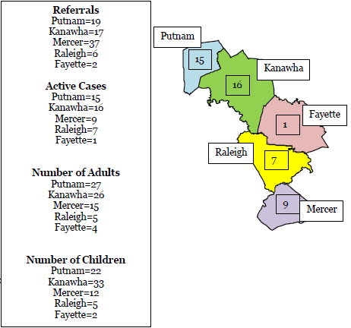

Update on Assessment of Performance
The most reliable data West Virginia has to evaluate performance comes from the Child and Family Service Reviews (CFSR) style reviews, the Adoption and Foster Care Analysis and Reporting System (AFCARS) and the National Child Abuse and Neglect Data System (NCANDS). West Virginia has a comprehensive quality assurance system in operation. The Department’s QA system operates in all jurisdictions of the state and is part of an overall Continuous Quality Improvement (CQI) process. West Virginia’s quality assurance system utilizes data from various sources to monitor the efficacy of program improvement measures. The State utilizes CFSR style social service review data in conjunction with the State’s data profile (contextual data report), and data from the State’s Statewide Automated Child Welfare Information System (SACWIS) in the development, planning, and monitoring of Child and Family Services Plan (CFSP) goals and other statewide child welfare initiatives. The Division of Planning and Quality Improvement (DPQI) utilizes the case review process and standards set forth by the US Department of Health and Human Services Administration for Children and Families. This process is used for the continuous measurement of the State’s performance in the areas of safety, permanency, and well-being. (Refer to-Quality Assurance Systemic Factor Section)

The DPQI social services case review data provides for CQI through the identification of the district’s strengths and areas for improvement. The review data is used at the district level to evaluate case practice and assist districts in making improvements in the provision of services to children and families. Following the social service review exit with the district management team, DPQI completes a comprehensive report on the results of the review. DPQI provides this information to CAS and the Program Manager for Community Partnerships for the identification of service needs and development of services. DPQI compiles the exit summary data report and corrective action plan for each district and distributes the findings to the district’s management staff, the Regional Program Manager, Regional Director, Director of Training, Policy Program Specialists, and Department Leadership.
The CFSRs Onsite Review Instrument and Instructions (OSRI) is the only official instrument to be used in rating a case for CFSR determinations of substantial conformity. The OSRI contains the questions, applicability notes, instructions, and definitions, which provide more detailed information.
Child and Family Services Review Round 3

West Virginia began the round 3 Child and Family Services Review (CFSR) in January 2017 with the submission of the Statewide Assessment. The Administration for Children and Families (ACF) ACF Children’s Bureau approved the Department’s BCF existing case review process, employing the federal onsite review instrument, for the purpose of the CFSR. The BCF DPQI staff reviewed 40 foster care cases and 25 in-home cases between April 2017 and September 2017; the ACF CHILDREN’S BUREAU conducted secondary oversight of all 65 cases to ensure the accuracy of the ratings. Stakeholder interviews of BCF key partners were also completed by the ACF CHILDREN’S BUREAU in April 2017; the results of those interviews, together with the stateside assessment, were used to determine substantial conformity of systemic factors rated by the CFSR (45 CFR § 1355.34(c).

West Virginia’s CFSR Final Report was received from the ACF CHILDREN’S BUREAU in December 2017. West Virginia did not meet substantial conformity levels on the seven CFSR Outcomes and four of the seven CFSR Systemic Factors. West Virginia utilized the CFSR findings to begin a multi-faceted approach to gathering and analyzing information upon which to lay the foundation for systemic change within the child welfare system with the long-range goal of improving outcomes for WV children and families. The major factors impacting practice in West Virginia were identified through the review of the CFSR Final Report, through WV’s CFSR style social service review data, data from the SACWIS, the Supreme Court of Appeals of West Virginia Child Abuse and Neglect (CAN) database, and consultation with external stakeholders. The cross-cutting barriers to higher outcome achievement identified include the inability to attract and retain qualified staff; failure to establish foster care resource homes at a rate sufficient to the rate of foster care entry; a lack of engagement with families to ensure child safety; identification of service needs; ensuring appropriate service provision; and the lack of services sufficient to address identified customer needs.

The PIP development process focused on addressing the underlying conditions that hold the highest potential to positively impact WV children and families while aligning with the current child welfare reform initiatives. The PIP addresses CFSR Items 1-6 and 12-15. (See WV Program Improvement Plan Pgs. 26-53). The WV Program Improvement Plan is not finalized and approved at this time, nonetheless the established goals are:

- Creating and supporting a Healthy Workforce
- Increase Family Support Services and Family Resource Homes to meet the needs of children and Families Community Support and Family Resources
- Transforming the culture of child welfare management to increase competency, skill, and accountability of our child welfare practice.
- Increase effectiveness and efficiency and create a prevention-focused organizational culture in order to ensure the needs of children and families are addressed throughout the life of the case. Various strategies to reach the goals are being developed.

The West Virginia CFSR Round 3 Measurement Plan was approved in 2018. West Virginia intends to use state generated data and information from its CQI process for PIP monitoring and measurement of performance. Measurement of systemic factors will be by completion of the key activities associated with each strategy associated with the factor. Measurement of CFSR items and associated outcomes will be measured by completion of social services case reviews completed by DPQI. West Virginia used state-conducted case review data from December 1, 2017, through November 30, 2018, to establish a baseline. This baseline resulted from a review of twelve districts representing all four regions of the state and included the review of 125 cases separated as 65 placement and 60 in-home. The original reporting periods are listed in the chart below. Each reporting period data set will contain the same number of districts and at a minimum the same number of cases. West Virginia has been advised that although the PIP has not yet been approved the reporting period case review data can be used to show progress toward reaching PIP improvement goals.

Measurement Period | Review Data Dates | Report Date
Baseline | December 1, 2017-November 30, 2018 | December 2018
1st Period | June 1, 2018-May 31, 2019  (125 cases, 60 in-home services, 65 foster care) | June 2019
2nd Period | December 1, 2018-November 30, 2019 | December 2019
3rd Period | June 1, 2019-May 31, 2020 | June 2020
4th Period | December 1, 2019-November 30, 2020 | December 2020
5th Period | June 1, 2020-May 31, 2021 | June 2021
Data gathered during the first reporting period of June 2018-May of 2019 indicate WV met the PIP goal established for CFSR Items 2, 6, 12, and 13.
Update 2023:
The West Virginia Child and Family Services Review (CFSR) Round 3 PIP was approved by the ACF, and BSS provided notice of the same on 12/13/19. The WV PIP Implementation Period was 12/1/19-11/30/21. The established goals were:

- Creating and supporting a healthy workforce (Safety Outcome 1, Safety Outcome 2, Permanency Outcome 1, Permanency Outcome 2, Well-Being Outcome 1, Well-Being Outcome 2, Well-Being Outcome 3)
- Increase family support services and family resource homes to meet the needs of children and families through community support and family resources. (Safety Outcome 2, Permanency Outcome 1, Well-Being Outcome 2, Well-Being Outcome 3, Systemic Factors: Case Review, Notice to Caregivers, Array of Services, Individualizing Services, Diligent Recruitment of Foster and Adoptive Homes)
- Transforming the culture of child welfare management to increase competency, skill, and accountability of our child welfare practice. (Safety Outcome 1, Safety Outcome 2, Permanency Outcome 1, Permanency Outcome 2, Well-Being Outcome 1, Systemic Factors: Statewide Information System, Case Review)
- Increase effectiveness and efficiency and create a prevention-focused organizational culture in order to ensure the needs of children and families are addressed throughout the life of the case. (Safety Outcome 1, Well-Being Outcome 1)

The FFY 2021 social service case reviews were completed by the Division of Planning and Quality Improvement (DPQI). DPQI utilizes the January 2016 version of the Federal CFSR OSRI as the unit’s primary internal tool for evaluating the quality of services delivered to children and families. Case related information was entered into the OMS and reports generated from that system are used for evaluating continuous quality improvement efforts within BSS. Administrative data reports, information from stakeholders, and other data sources are also used to update the assessment of performance.

DPQI completed 125 CFSR style case reviews during the 2021 FFY. The data set is based upon the review of social services cases between October 1, 2020, to September 30, 2021. The review consisted of 65 foster care and 60 in-home social service cases. DPQI staff conducted 741 interviews during FFY 2021. Of the interviews completed, 78 were with children, 183 were with parents/caregivers (biological/adoptive/legal guardians/live-in-paramours/caregivers), 58 were with foster parents, and 120 were judicial staff such as attorneys, guardians-ad-litem, juvenile probation officers, and Court Appointed Special Advocates, and the remainder were with other parties who may have information relative to the case review. Case reviews conducted were reflective of practice that occurred approximately 12 months prior to the date of the review. CFSR style case reviews were completed in each of the four regions of the state and included the following districts: Kanawha, Greenbrier/Monroe/Pocahontas/Summers, Fayette, Wood, Putnam/Mason, Jackson/Roane/Clay, Barbour/Preston/Taylor, Nicholas/Webster, Mercer, Cabell, Logan, and Lincoln/Boone.

Measurement Period | Review Data Dates | Report Date
Baseline | December 1, 2017-November 30, 2018 | December 2018
1st Period | June 1, 2018-May 31, 2019 | Date of first PIP  Measurement Progress Report
2nd Period | December 1, 2018-November 30, 2019
3rd Period | June 1, 2019-May 31, 2020 | June 2020
4th Period | December 1, 2019-November 30, 2020 | December 2020
5th Period | June 1, 2020-May 31, 2021 | June 2021
6th Period | December 1, 2020-November 30, 2021 | December 2021
Non-Overlapping Period | December 1, 2021-March 31, 2023
7th Period (Optional) | June 1, 2021-May 31, 2022 | June 2022
8th Period (Optional) | December 1, 2021-November 30, 2022 | December 2022
9th Period (Optional & Condensed) | June 1, 2022-May 31, 2023 | June 2023

Progress toward PIP implementation activities, and data related to PIP goal achievement, was provided to the ACF CHILDREN’S BUREAU in electronically submitted reports biannually. The implementation period ended November 2021. The next measurement data set will be examined in May 2022.
Update 2024:
The West Virginia Child and Family Services Review (CFSR) Round 3 PIP was approved by the ACF, and BSS provided notice of the same on 12/13/19. The WV PIP Implementation Period was 12/1/19-11/30/21. The established goals were:
1. Creating and supporting a healthy workforce (Safety Outcome 1, Safety Outcome 2, Permanency Outcome 1, Permanency Outcome 2, Well-Being Outcome 1, Well-Being Outcome 2, Well-Being Outcome 3)
2. Increase family support services and family resource homes to meet the needs of children and families through community support and family resources. (Safety Outcome 2, Permanency Outcome 1, Well-Being Outcome 2, Well-Being Outcome 3, Systemic Factors: Case Review, Notice to Caregivers, Array of Services, Individualizing Services, Diligent Recruitment of Foster and Adoptive Homes)
3. Transforming the culture of child welfare management to increase competency, skill, and accountability of our child welfare practice. (Safety Outcome 1, Safety Outcome 2, Permanency Outcome 1, Permanency Outcome 2, Well-Being Outcome 1, Systemic Factors: Statewide Information System, Case Review)
4. Increase effectiveness and efficiency and create a prevention-focused organizational culture in order to ensure the needs of children and families are addressed throughout the life of the case. (Safety Outcome 1, Well-Being Outcome 1)
The FFY 2022 social service case reviews were completed by the Division of Planning and Quality Improvement (DPQI). DPQI utilizes the January 2016 version of the Federal CFSR OSRI as the unit’s primary internal tool for evaluating the quality of services delivered to children and families. Case related information was entered into the OMS and reports generated from that system are used for evaluating continuous quality improvement efforts within BSS. Administrative data reports, information from stakeholders, and other data sources are also used to update the assessment of performance.

DPQI completed 125 CFSR style case reviews during the 2022 FFY. The data set is based upon the review of social services cases between October 1, 2021, to September 30, 2022. The review consisted of 65 foster care and 60 in-home social service cases. DPQI staff conducted 870 interviews during FFY 2022. Of the interviews completed, 125 were with children, 203 were with parents/caregivers (biological/adoptive/legal guardians/live-in-paramours/caregivers), 95 were with foster parents, and 108 were judicial staff such as attorneys, guardians-ad-litem, juvenile probation officers, and Court Appointed Special Advocates, and the remainder were with other parties who may have information relative to the case review. Case reviews conducted were reflective of practice that occurred approximately 12 months prior to the date of the review. CFSR style case reviews were completed in each of the four regions of the state and included the following districts: Kanawha, Hardy/Grant/Pendleton, Monongalia/Marion, Hampshire/Mineral, Marshall/Wetzel/Tyler, Wayne, Harrison, Raleigh, McDowell, Doddridge/Ritchie/Pleasants, Randolph/Tucker, and Mingo.

Measurement Period | Review Data Dates | Report Date
Baseline | December 1, 2017-November 30, 2018 | December 2018
1st Period | June 1, 2018-May 31, 2019 | Date of first PIP Measurement Progress Report
2nd Period | December 1, 2018-November 30, 2019
3rd Period | June 1, 2019-May 31, 2020 | June 2020
4th Period | December 1, 2019-November 30, 2020 | December 2020
5th Period | June 1, 2020-May 31, 2021 | June 2021
6th Period | December 1, 2020-November 30, 2021 | December 2021
Non-Overlapping Period | December 1, 2021-March 31, 2023
7th Period (Optional) | June 1, 2021-May 31, 2022 | June 2022
8th Period (Optional) | December 1, 2021-November 30, 2022 | December 2022
9th Period (Optional & Condensed) | June 1, 2022-May 31, 2023 | June 2023
Progress toward PIP implementation activities, and data related to PIP goal achievement, was provided to the ACF Children’s Bureau in electronically submitted reports biannually. The implementation period ended November 2021. The next measurement data set will be examined in June 2023.

Safety
Safety Outcome 1: Children are, first and foremost, protected from abuse and neglect.
Timeliness of Initiating Investigations of Reports of Child Maltreatment (Item 1)
Purpose of Assessment: To determine whether responses to all accepted child maltreatment reports received during the period under review were initiated and face-to-face contact with the child(ren) made within the time frames established by agency policies or state statutes.
Strength Rating Defined
- Timely face-to-face contact with children occurred on all investigations and/or assessments during the period under review (within state policy guidelines) AND
- All investigations and/or assessments during the period under review were initiated in a timely manner (within state policy guidelines).
- OR, if policy guidelines could not be met, it was due to circumstances beyond the control of the agency.

Concerted Efforts Required and/or Special Considerations in Rating
Circumstances beyond the control of the agency may include:
- Other agencies (such as law enforcement) causing delays.
- Child/family not located despite documented efforts to locate them.
- Lack of Community Resources
If the state has a policy that allows for exceptions to the face-to-face contact time frames when the child is in the hospital (or other specific circumstances), reviewers should rate the item based on the state’s policy requirements.
Goals and strategies to impact Safety Outcome 1 are in the WV Program Improvement Plan pgs. 26-29, 44-49, 51-53

DPQI Quality Assurance Case Review Data
Baseline: 61.9%
PIP Goal: 69.7%
Reporting Period 6/2018-5/2019: 60.27%

Source: DPQI Case Review Data

Source: COGNOS Time to First Contact Report FFY 2018

Source: COGNOS Statewide Referrals Report Calendar Year 2018

The outcome rating for Safety 1 based on DPQI case reviews for FFY 2018 indicates safety outcome one was substantially achieved in 55.56% of the cases reviewed, and not achieved in 44.44% of the cases reviewed. FFY data is based on case reviews completed October 1, 2017, to September 30, 2018. Case reviews are reflective of practice that occurred 12 months prior to the date of the review. The Child and Family Reviews Round 3 baseline indicated this measure as substantially achieved in 61.9% of the applicable cases reviewed. The WV Program Improvement Goal for this item is 69.7%

COGNOS reports provide calendar year data regarding the time to first contact. The Time to First Contact Report is monitored by the District Community Services Managers, Regional Directors, and the Deputy
Director of Field Operations on a regular basis. The COGNOS Statewide Referrals report continually shows an increase in the number of child maltreatment reports received and assigned for further assessment.

West Virginia continues to perform substantially below the 95% compliance threshold. The state continues to utilize crisis teams to assist Districts experiencing a backlog in Family Functioning Assessments. The teams have been expanded to now include district level CPS staff who agree to work outside of their district for a brief period of time. These workers are given monetary incentives to assist in the FFA backlog reduction effort.

Further analysis is needed regarding the referral acceptance rate versus the substantiation rate of child maltreatment on new intakes. Therefore, this issue is being addressed in the WV PIP through a threshold analysis conducted by the Capacity Center for States. This will examine the number of duplicate intakes on the same family/child accepted/assigned, percentage of intakes assigned versus maltreatment findings found, as well as other areas of the intake process to determine what corrective action is needed.

Update 2023:
DPQI Quality Assurance Case Review Data
FFY 2020: 50%
FFY 2021: 60.27%

Source: DPQI Case Review Data

Source: COGNOS Time to First Contact Report FFY 2021

Source: COGNOS Statewide Referrals Report Calendar Year 2021

CFSR Measure: Recurrence of Maltreatment
Of all children who were victims of a substantiated maltreatment report during a 12-month period, the percentage who were victims of another substantiated maltreatment report within 12 months will be 9.5% or less.
CFSR Round 3 Data Profile February 2022
Observed Performance: FY19-20 is 5.4%
FY18-19 is 7%
Risk Standardized Performance: FY19-20 is 7.0%
FY18-19 is 9.0%

CFSR Measure: Maltreatment in Foster Care
Of all children in out-of-home care during a 12-month period, the victimization rate per 100,000 days of care will be 9.67 or less.
CFSR Round 3 Data Profile February 2022
Observed Performance: FY19 is 2.86
FY18 is 3.07
Risk Standardized Performance: FY 19 is 3.95
FY 18 is 4.23

CFSR Outcome Safety 1 consists of one CFSR Item (Item 1). The outcome rating for Safety 1 based on DPQI case reviews for FFY 2021 indicates safety outcome one was substantially achieved in 60.27% of the cases reviewed, and not achieved in 39.73% of the cases reviewed. FFY data is based on case reviews completed October 1, 2020, to September 30, 2021. Case reviews are reflective of practice that occurred approximately 12 months prior to the date of the review. The outcome rating for Safety Outcome 1 based on DPQI case reviews for FFY 2020 indicates Safety Outcome 1 was substantially achieved in 50% of the cases reviewed, and not achieved in 50% of the cases reviewed. FFY data is based on case reviews completed October 1, 2019, to September 30, 2020.

COGNOS reports provide federal fiscal year data regarding the time to first contact. The Time to First Contact Report is monitored by the District Community Services Managers, Regional Directors, and the Deputy Directors of Field Operations on a regular basis. The percentage of face-to-face contacts with alleged child victims made within assigned timeframes has shown a steady increase over the last three federal fiscal years. COGNOS reports indicate the assigned time to first contact with alleged child victims during FFY 2019 was met in 44% of the intakes accepted for further assessment. This percentage increased to 51.60% during FFY 2020 and to 60.5% during the most recent FFY.

COGNOS Statewide Referrals report provides data regarding the number of child maltreatment referrals received, and accepted for further assessment, during a calendar year. During calendar year 2021 the report indicates the number of child maltreatment reports received was 37,175 and those assigned for further assessment were 23,431. This is an increase when compared to the prior calendar year. During calendar year 2020 the report indicates the number of child maltreatment reports received was 33,858 and 21,990 of those were assigned for further assessment of the family. This is an increase of 3,317 referrals of child maltreatment received and 1,441 accepted.

The Department met the two CFSR safety data indicators. The Department met the national standard of 9.5% or less of children with a substantiated child maltreatment report and had a second substantiated child maltreatment report within twelve months. The Department also met the national standard of 9.67 or less incidence of maltreatment in out-of-home care per 100,000 days in care.

The agency met the two CFSR safety data indicators and COGNOS data indicates that the percentage of cases in which face to face contact with the alleged child victim was made within the assigned time frame has steadily increased from 44% in 2019 to 51.6% in 2020 to 60.50% in 2021. DPQI social services case reviews also show an increase of 10.27% with a finding of 60.27% in FFY 2021 from 50% in FFY 2020. The primary reason for missed time frames given by caseworkers is caseload size. The primary rationale given for missed timeframes by district level management staff is insufficient staffing levels. Most district Corrective Action Plans (CAPS) developed in 2021 include a strategy to increase meeting face to face timeframes with alleged child victims. Strategies to positively impact Outcome Safety 1 were included in the West Virginia Program Improvement Plan. Activities implemented to improve the outcome included: a threshold analysis of the Centralized Intake system, worker recruitment and retention activities, and the development of intake tracking logs. Data related to PIP goal achievement will be discussed following completion of the first optional measurement period in May of 2022.

Update 2024:
DPQI Quality Assurance Case Review Data
FFY 2021: 60.27%
FFY 2022: 65.48%
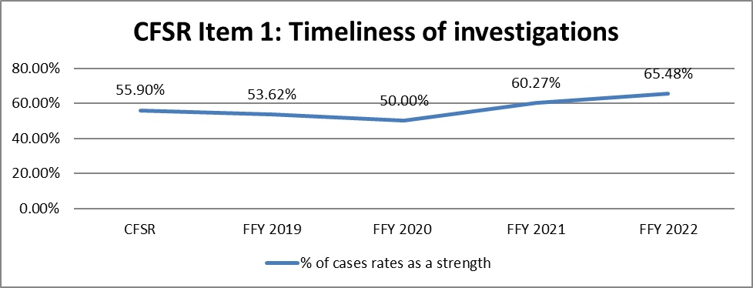
Source: DPQI Case Review Data
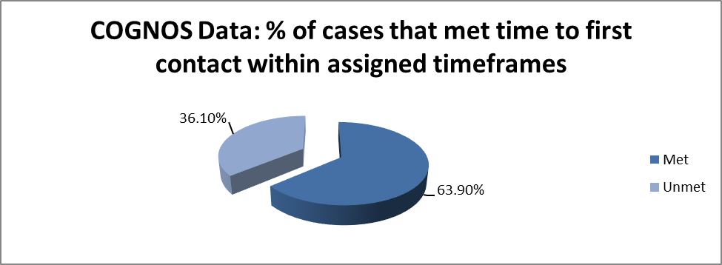
Source: COGNOS Time to First Contact Report FFY 2022
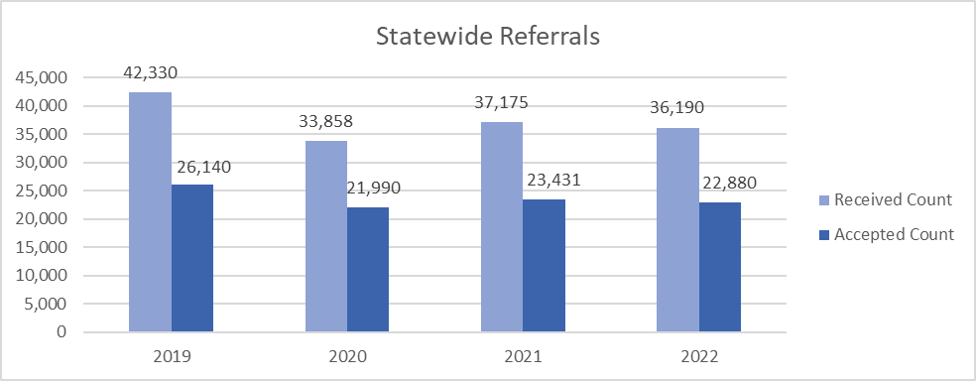
Source: COGNOS Statewide Referrals Report Calendar Year 2022
CFSR Measure: Recurrence of Maltreatment
Of all children who were victims of a substantiated maltreatment report during a 12-month period, the percentage who were victims of another substantiated maltreatment report within 12 months will be 9.7% or less.
CFSR Round 4 Data Profile February 2023
Observed Performance: FY 20-21 4.5%
FY19-20 is 5.4%
Risk Standardized Performance: FY20-21 is 6.1%
FY19-20 is 7.2%
CFSR Measure: Maltreatment in Foster Care
Of all children in out-of-home care during a 12-month period, the victimization rate per 100,000 days of care will be 9.07 or less.
CFSR Round 4 Data Profile February 2023
Observed Performance: FY20 is 2.51
FY19 is 2.86
Risk Standardized Performance: FY 20 is 3.43
FY 19 is 3.87

CFSR Outcome Safety 1 consists of one CFSR Item (Item 1). The outcome rating for Safety 1 based on DPQI case reviews for FFY 2022 indicates safety outcome one was substantially achieved in 65.48% of the cases reviewed, and not achieved in 34.52% of the cases reviewed. This data is based on case reviews completed October 1, 2021, through September 30, 2022. The outcome rating for Safety Outcome 1 based on DPQI case reviews for FFY 2021 indicates safety outcome one was substantially achieved in 60.27% of the cases reviewed, and not achieved in 39.73% of the cases reviewed. This data is based on case reviews completed October 1, 2020, to September 30, 2021. Case reviews are reflective of practice that occurred approximately 12 months prior to the date of the review.
COGNOS reports provide federal fiscal year data regarding the time to first contact. The Time to First Contact Report is monitored by District Social Services Managers, Deputy Commissioners over the Regions, and the Deputy Director of Field Operations on a regular basis. The percentage of face-to-face contacts with alleged child victims made within the assigned timeframes has shown a steady increase over the last four federal fiscal years. COGNOS reports indicate the assigned time to first contact with alleged child victims during FFY 2022 was met in 63.9% of the intakes accepted for further assessment. The same report indicates initial contact timeframes were met at a rate of 60.5% during FFY 2021, 51.60% during FFY 2020, and 44% during FFY 2019.
During calendar year 2022, the COGNOS Statewide Referrals report indicates the number of child maltreatment reports received was 36, 190. Of this number, 22, 880 were assigned for further assessment of the family. This reflects a 63% acceptance rate. During calendar year 2021 the report indicates the number of child maltreatment reports received was 37,175 and those assigned for further assessment were 23,431. This is also a 63% acceptance rate. When the two data sets are compared, calendar year 2022 reflects 985 less child maltreatment reports received and 551 less accepted for further assessment of the family.
The Department met the two CFSR safety data indicators. The Department met the national standard of 9.7% or less of children with a substantiated child maltreatment report and had a second substantiated child maltreatment report within twelve months. The Department also met the national standard of 9.07 or less incidence of maltreatment in out-of-home care per 100,000 days in care.
The agency met the two CFSR safety data indicators. COGNOS data indicates that the percentage of cases in which face to face contact with the alleged child victim was made within the assigned time frame has increased each year over the last four years. The rate of timeframes for contact with alleged child victims being met has steadily increased from 44% in 2019, to 51.6% in 2020, to 60.50% in 2021, and to 63.9% in 2022. DPQI social services case reviews also show an increase when the last three years of data are compared. DPQI data shows an increase from 50% during FFY 2020, to 60.27% during FFY 2021, to 65.48% during FFY 2022. The primary reason for missed timeframes given by caseworkers is caseload size. The primary rationale given for missed timeframes by district level management staff is insufficient staffing levels. Staffing levels during the period under review have a dramatic impact on how well districts perform. Districts with a high staff turnover rate score significantly lower on all measures. The lack of staff results in the failure to initiate investigations into child maltreatment in a timely manner. It also creates a backlog of assessments that have not been documented and cleared. Most district level Corrective Action Plans (CAPS) developed in 2022 include a strategy to improve on this item. Strategies to positively impact Outcome Safety 1 were included in the West Virginia Program Improvement Plan. Activities implemented to improve the outcome included: a threshold analysis of the Centralized Intake system, worker recruitment and retention activities, and the development of intake tracking logs. Data related to PIP goal achievement will be discussed following completion of the measurement period in May of 2023. To positively impact Outcome Safety 1, BSS has formed a Differential Response Workgroup designed to develop a system that establishes multiple pathways to respond to received child maltreatment reports. The group is evaluating models of decision making and responding to child maltreatment reports in other states to determine a method that could produce positive outcomes in West Virginia.
Safety Outcome 2: Children are safely maintained in their homes whenever
possible and appropriate.
Services to Family to Protect Children in the Home and Prevent Removal or Re-Entry into Foster Care (Item 2)
Purpose of Assessment: To determine whether, during the period under review, the agency made concerted efforts to provide services to the family to prevent children’s entry into foster care or re-entry after reunification.
Strength Rating Defined
- In cases where safety issues were present, safety-related services were offered to families to prevent removal of children during the period under review.
- OR, if safety-related services were not offered, this was because the safety issues warranted immediate removal of the child.
Concerted Efforts Required and/or Special Considerations in Rating
This item is solely focused on rating the provision of appropriate safety-related services in response to safety concerns. If implementing a safety plan was the only provision needed to ensure the children’s safety rather than safety-related services, this item should be rated as Not Applicable (NA), and the safety plan should be assessed in Risk and Safety Assessment and Management (Item 3).
Concerted efforts include working to engage families in needed safety-related services and facilitating a family’s access to those services.
Goals and strategies to impact Safety Outcome 2 are in the WV Program Improvement Plan pgs. 26-29, 36-42, 44-49

DPQI Quality Assurance Case Review Data

Baseline: 37.3% PIP Goal: 45.9% Reporting Period 6/2018-5/2019: 52.46%

Source: DPQI Case Review Data

Source: DPQI Case Review Data FFY 2018
Source: DPQI Case Review Data
Update 2023:
DPQI Quality Assurance Case Review Data

FFY 2020: 56%

FFY 2021: 63.64%

Source: DPQI Case Review Data
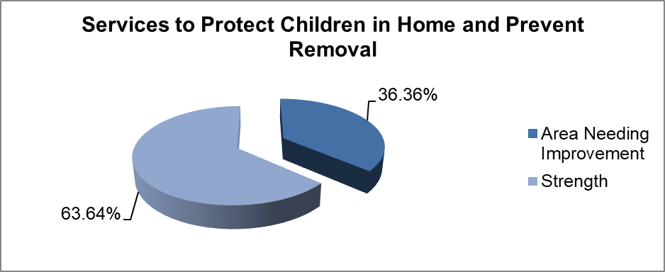
Source: DPQI Case Review Data FFY 2021

Source: DPQI Case Review Data
Update 2024:
DPQI Quality Assurance Case Review Data

FFY 2021: 63.64%
FFY 2022: 57.14%
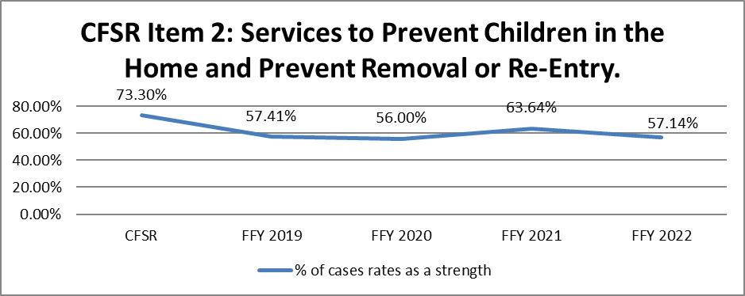
Source: DPQI Case Review Data
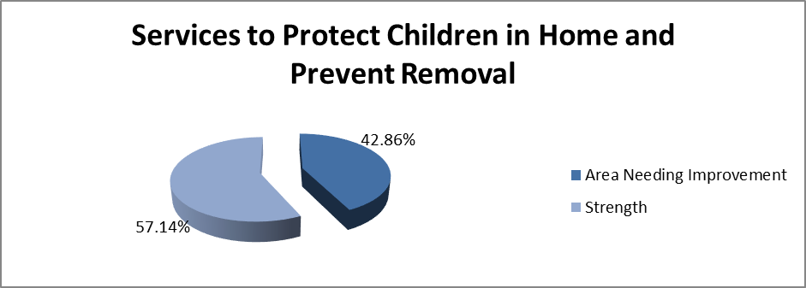
Source: DPQI Case Review Data FFY 2022
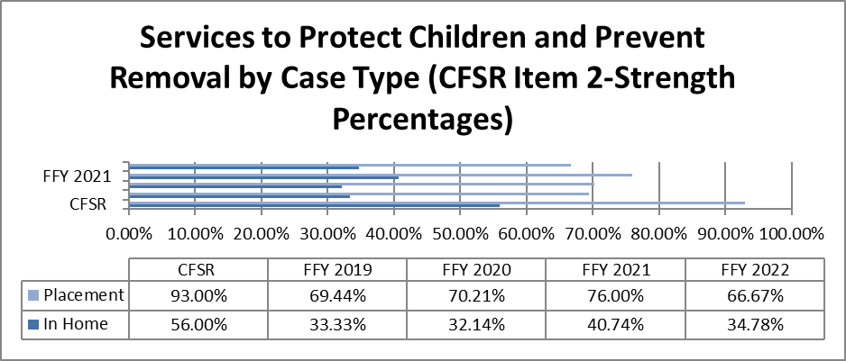
Source: DPQI Case Review Data
Risk and Safety Assessment and Management (Item 3)
Purpose of Assessment: To determine whether, during the period under review, the agency made concerted efforts to assess and address the risk and safety concerns relating to the child(ren) in their own homes or while in foster care.
Strength Rating Defined
- For cases with risk and/or safety concerns present during the period under review, the agency conducted initial and/or ongoing assessments of all children in the family during the period under review, unless the time frame and circumstances did not warrant ongoing assessments.
- The assessments were of good quality, accurately identifying risk and safety concerns, and they occurred at key junctures of the case.
- If safety concerns were identified during the period under review, the agency adequately addressed concerns and/or responded by developing and monitoring appropriate safety plans that ensured the children’s safety.
- There were no repeat maltreatment and/or recurring safety concerns within 6 months of a report substantiated and/or accepted during the period under review.
- Additionally, for foster care cases, there were no safety concerns related to visitation with parents or family members during the period under review and there were no safety concerns related to the child’s foster care placement during the period under review.
Concerted Efforts Required and/or Special Considerations in Rating
Consider worker visitation practices (Caseworker Visits with Child [Item 14] and Caseworker Visits with Parents [Item 15]) when assessing this item. Although a rating on this item does not need to be consistent with the ratings on worker visits, reviewers should consider whether the frequency and quality of worker visits with children and/or parents supported quality assessments of risk and safety.
Documentation of completed assessments in a case record alone is not enough to decide that this item could be rated as a Strength. Reviewers must also determine the quality of assessments, assess whether there were any concerns present during the period under review, and evaluate whether the agency responded appropriately to any concerns.
Goals and strategies to impact Safety Outcome 2 are in the WV Program Improvement Plan pgs. 26-29, 36-42, 44-49

DPQI Quality Assurance Case Review Data

Baseline: 29.6%

PIP Goal: 34.8%

Reporting Period 6/2018-5/2019: 32.8%

Source: DPQI Case Review Data

Source: DPQI Case Review Data

Update 2023:

DPQI Quality Assurance Case Review Data
FFY 2020: 31.78%
FFY 2021: 38.4%

Source: DPQI Case Review Data

Source: DPQI Case Review Data

Outcome Safety 2 is measured by performance on CFSR Items 2-services to protect children in the home and prevent foster care entry or re-entry and 3-risk and safety assessment and management on the 2016 Federal CFSR Onsite Review Instrument. The outcome rating for Safety 2 based on case reviews for FFY 2021 indicates Safety Outcome 2 was substantially achieved in 36.8% of the cases reviewed, partially achieved in 12.8%, and not achieved in 50.4% of the cases reviewed. FFY data is based on case reviews completed October 1, 2020, to September 30, 2021. FFY 2020 (10/1/19-9/30/20) data shows Outcome Safety 2 was substantially achieved in 30.23% of the cases reviewed, partially achieved in 15.5%, and not achieved in 54.26% of the cases reviewed. Case reviews are reflective of practice that occurred 12 months prior to the date of the review.

DPQI social services case reviews indicate the strength rating performance on both CFSR items 2 and 3, and Outcome Safety 2, continues to increase. CFSR Item 2 increased by almost 8%, while CFSR Item 3 and Outcome Safety 2 increased by almost 7%. Despite these gains, there continues to be a significant disparity in case ratings when in-home and placement cases are compared. CFSR Item 2 rated 76% strength on foster care cases and 40.74% strength on in-home cases. CFSR Item 3 likewise shows a significant difference when foster care (55.38% strength) and in-home (20% strength) cases are compared. CFSR Outcome Safety 2 was substantially achieved in 53.85% of the placement cases reviewed and only 18.33% of the non-placement cases. For FFY 2021, CFSR Items 2 and 3 and Safety Outcome 2 show a strength rating difference of over 35% when the two case types are compared.

Strategies to positively impact Outcome Safety 2 were included in the West Virginia PIP. The activities included efforts to recruit and retain staff. The inability to do so is often cited by district management staff as the main rationale for negative review findings on CFSR items related to safety. Other activities in the PIP designed to positively impact these items include monitoring to ensure quality contact between caseworkers and children and families occurs regularly, and that assessments of child safety are completed throughout the life of each case. Data related to PIP goal achievement will be discussed following completion of the first optional measurement period in May of 2022. Aside from the PIP activities, BSS is also strengthening new worker training in relation to the importance of case management activities related to in-home cases.

Despite overall improvement on Outcome Safety 2, barriers to higher levels of achievement are observed during social services case reviews. The majority of children in placement in West Virginia entered foster care to ensure their safety. DPQI case review findings indicate the child welfare system is often missing opportunities to impact family risks before they become safety threats necessitating removal. Case reviewers found that in-home safety plans are often inadequate to control the factors impacting child safety, and/or are not monitored to ensure safety, while parents receive services to achieve behavioral change. Case reviews also indicate that safety plans are not being updated as circumstances in the case warrant. In addition, safety related services placed in the home do not always match the identified safety threat, or services are not referred into the homes in a timely manner.

Child maltreatment often involves multiple contributing factors. These factors are usually rooted in complex individual and societal problems. Therefore, addressing child maltreatment requires a multifaceted approach. The Supreme Court of Appeals of West Virginia CAN database tracks the status and timeliness of all West Virginia child abuse and neglect cases. Data is collected and entered into the JANIS. The charts below indicate the factors resulting in new child welfare petitions being filed. These are allegations referenced in the original petition and subsequent amended petitions. This looks at 3,720 new petitions (cases) in West Virginia. These petitions were filed in the calendar year 2020.

Source: The Supreme Court of Appeals of West Virginia Child Abuse and Neglect (CAN) database
Definitions

Risk Factor | Definition
Abuse of Sibling | When a child in the home is removed due to the abuse of their sibling(s)
Unsanitary Living Conditions | Filthy, unsanitary living conditions which pose a threat to the child’s safety
Sexual Crimes | Sexual assault, molestation, etc.
Alcohol Abuse | When alcohol abuse is specified in the petition
Opioid Abuse | When opioids are specified in the petition (Added 2019)
Amphetamine Abuse | When Amphetamine use is included in the petition (Added 2019)
Drug Abuse - General | Unspecified substances are included in the petition, or the specified substance is something other than opioids, alcohol, or amphetamines
Mental Health | When the mental health of a parent is identified as a contributing factor to the abuse of a child in the petition
Domestic Violence | When domestic violence is specified in the petition between the parents or any party in the home

Substance abuse
West Virginia has had a severe drug epidemic for many years. The CIP chart below examines substance abuse across 10 years. While the numbers appear to decrease, it should be noted that records in JANIS have decreased meaning fewer records for the sample. The congruency line is what percentage of cases for that year have been entered into JANIS and therefore are available for computation. These numbers reflect over 30,000 cases entered into JANIS between 2011 and 2021. This is an aggregate look at substance use. This means these numbers (in blue) represent the number of cases wherein at least one type of substance abuse was indicated.

Again, while this chart looks as though substance use has decreased, when isolating one year data from 2020, amphetamine use was the most noted risk factor for incoming cases that year.

Source: The Supreme Court of Appeals of West Virginia Child Abuse and Neglect (CAN) database

Update 2024:

DPQI Quality Assurance Case Review Data

FFY 2021: 38.4%
FFY 2022: 29.6%

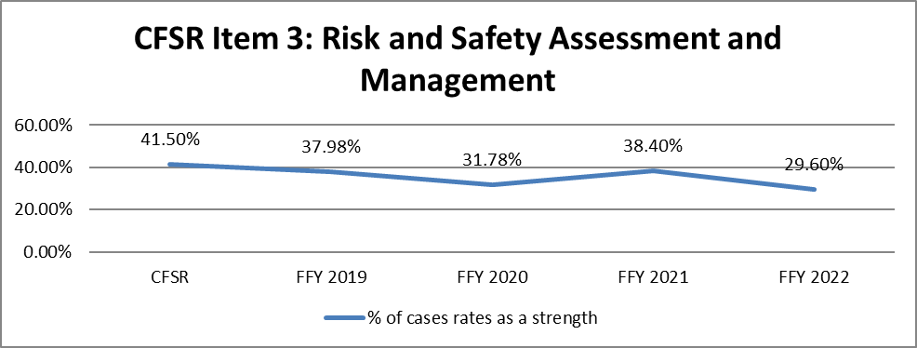

Source: DPQI Case Review Data
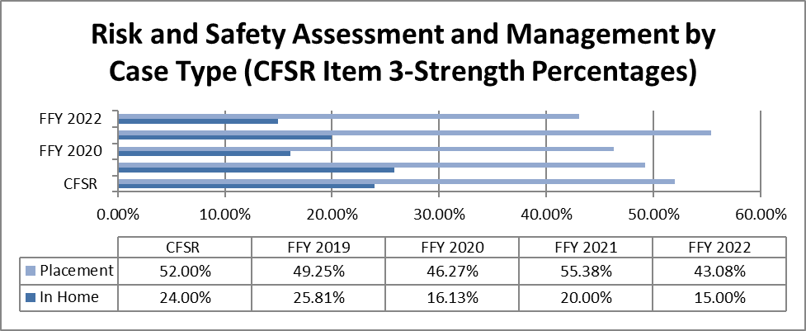

Source: DPQI Case Review Data

CFSR Outcome Safety 2 is measured by performance on CFSR Items 2-services to protect children in the home and prevent foster care entry or re-entry and 3-risk and safety assessment and management on the 2016 Federal CFSR Onsite Review Instrument. The outcome rating for Safety 2 based on case reviews conducted during FFY 2022 indicates Safety Outcome 2 was substantially achieved in 28% of the cases reviewed, partially achieved in 19.2%, and not achieved in 52.8% of the cases reviewed. FFY data is based on case reviews completed October 1, 2021, to September 30, 2022. FFY 2021 data shows Safety Outcome 2 was substantially achieved in 36.8% of the cases reviewed, partially achieved in 12.8%, and not achieved in 50.4% of the cases reviewed. This FFY data set is based on case reviews completed October 1, 2020, to September 30, 2021.

DPQI social services case reviews indicate the strength rating performance on CFSR items 2 and 3, and on Outcome Safety 2, decreased when FFYs 2021 and 2022 are compared. CFSR Item 2 decreased by 6.5%, CFSR Item 3 and Outcome Safety 2 decreased by 8.8%. The disparity in Safety Outcome 2 ratings when in-home and placement cases are compared continues to be a concern. CFSR Item 2 rated 66.67% strength on foster care cases and 34.78% strength on in-home cases. CFSR Item 3 likewise shows a significant difference when foster care (43.08% strength) and in-home (15% strength) cases are compared. CFSR Outcome Safety 2 was substantially achieved in 40% of the placement cases reviewed and 15% of the non-placement cases reviewed. For FFY 2022, Safety Outcome 2 shows a strength rating difference of 25% when the two case types are compared.

Strategies to positively impact Outcome Safety 2 were included in the West Virginia PIP. The activities included: efforts to recruit and retain staff, monitoring to ensure quality contact between caseworkers and children and families occurs regularly, and that assessments of child safety are completed throughout the life of each case. Data related to PIP goal achievement is reported following the completion of each data measurement period. In addition to the PIP activities, BSS has also implemented 20% pay increases for field workers and supervisors. This action was specifically designed to stabilize staffing levels in these positions. Staff turnover and an inability to fill vacant positions are the primary reasons given by District level managers for negative item ratings.

DPQI social services case reviews show that the majority of children in placement in West Virginia entered foster care to ensure their safety. In most cases reviewed, case reviewers found the child welfare system missed opportunities to intervene in families before safety threats or youth behaviors necessitate foster care entry. Case reviewers found this was due to not actively engaging parents and age-appropriate children in the assessment and planning process initially and on an ongoing basis, failure to consistently document information critical to the assessment of child safety and risk, and not consistently tracking identified safety issues throughout the life of the case. Review findings show safety related services placed in the home do not always match the identified safety threat, or referrals for services are not made in a timely manner. Protection plans and safety plans are often inadequate to control the factors impacting child safety and/or are not monitored regularly. Protection and safety plans involving informal providers are often found to be inadequate to ensure child safety due to the lack of information and instruction given to the provider and the limited amount of contact between the provider and the caseworker. Case reviewers found that some informal safety providers were unaware of their role in the case. Case reviews also indicate that safety plans are not being updated as circumstances in the case warrant. The inadequacy of safety planning results in services not being provided at a level sufficient to ensure child safety in the home while parents receive services to achieve behavioral change.

The causes of child abuse are often complex and part of larger societal factors. One such contributing factor in West Virginia is substance abuse disorders. The impact of substance abuse disorders is not individual in nature. It impacts families, communities, and the state. DPQI staff found that most child welfare cases reviewed during FFY 2022, over 72%, indicated substance abuse by at least one member of the family. Data related to the impact of substance abuse disorders on child welfare in the state is also monitored by the Supreme Court of Appeals of West Virginia. The Supreme Court of Appeals of West Virginia Child Abuse and Neglect (CAN) database was created to collect and track the status and timeliness of all child abuse and neglect cases in the court system. The data presented in the following risk-factor analysis was pulled from the CANS Database. (Please see CIP Data Notes) Court staff review petitions and enter the risk factors on each case. Cases may have more than one risk factor indicated.
Risk Factors/ Allegations outlined in the petition.

The Court Improvement Program has collected data on risk factors or allegations referenced in court documents, specifically the original and amended petitions. JANIS users are instruction to indicate the factors mentioned in these documents. In order to get a truer picture of the risk factors involved in abuse and neglect, the factors collected changed. In the fall of 2019, the risk factors were changed slightly to gain more insight on opioid and amphetamine use. Beginning in 2019, JANIS captured data on the following:
- Mental Health- There is reference to a mental health issue of an adult in the home or the child that led to the filing of the petition.
- Domestic Violence- there is reference to domestic violence between adults in the home in the petition.
- Sexual Crimes- There is reference to sexual abuse of the child or sibling in the home.
- Alcohol Abuse- Excessive alcohol use is reference.
- Opioid Abuse- Opioid are specifically mentioned.
- Amphetamine Abuse- Amphetamines are specifically mentioned.
- Other Substance Abuse- Other drugs are referenced in the petition or the user could not determine with specificity of the type of drug. Note that this could be used in tandem with specific drug use as well.

The following chart indicates percentage of cases entered in JANIS from January 1, 2019- December 31, 2022, that contained reference to an aforementioned risk factor. It should be noted that in some cases multiple factors were present.

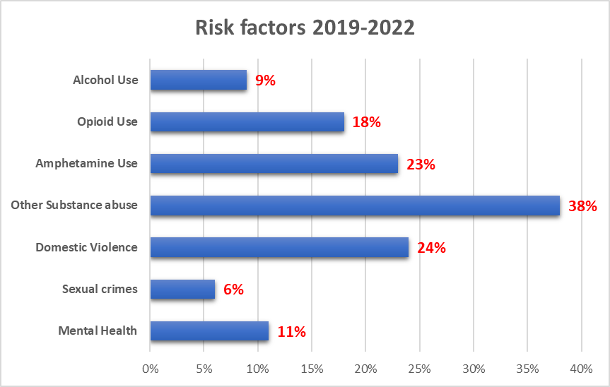

Source: The Supreme Court of Appeals of West Virginia Child Abuse and Neglect (CAN) database

In 2020, the CIP added additional risk factors to JANIS.
· Abuse of sibling (non-abused child)- This means that this particular child was not referenced as an alleged victim in the petition, but a sibling was.
· Unsafe/unsanitary living conditions- Often described in the petition.
· Neglect- Could include medical, educational, and other types of neglect explained in the petition.
· Previous termination- If the respondent/parent had previously had parental rights terminated to a child
· Parent Abandonment- Self explanatory

Because these factors were not added until 2020, the chart below only looks at the percentage of cases between January 1. 2020 and December 31, 2022.

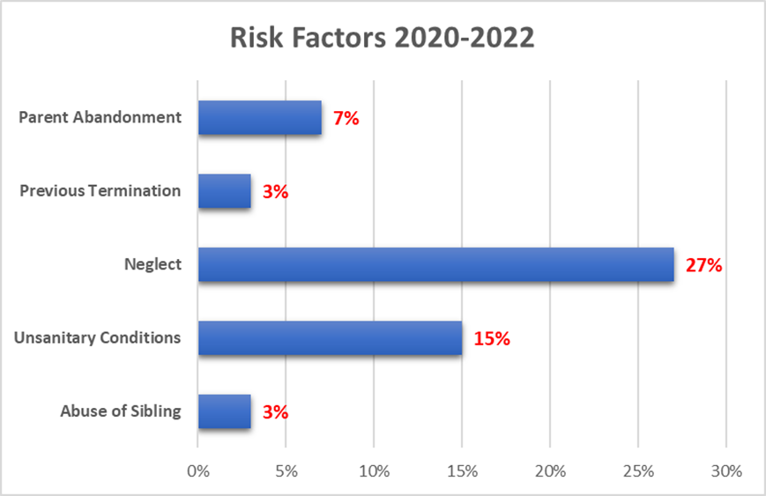

Source: The Supreme Court of Appeals of West Virginia Child Abuse and Neglect (CAN) database

Data was pulled from the Juvenile Abuse and Neglect Information System (JANIS) on February 1, 2023. Cases are manually entered into JANIS by Court Staff. It should be noted that not all cases are entered into JANIS. This data should be considered snap-shot data and does not account for 100% of cases. Further the calculations below are only made using cases entered that have all the information needed to make the calculation. Because of this, only a fraction of cases is available for the measurement calculation. The Court Improvement Program of the Supreme Court of Appeals of West Virginia, (CIP), is working towards increasing congruency in the number of cases entered in JANIS with the number of new petitions filed as well as enhancing the quality of data and increasing the number of records available for measurement calculations. During the 2022 calendar year, CIP staff assisted with entering over 1100 cases in the database or about 25% of all new cases added that year.

It should be noted that should these charts be compared with charts from previous year’s reports, the numbers may be different. This is because the calculations are performed based on data available in JANIS at the time of the report. New cases and case updates are added daily resulting in a change each time reports are run. For that reason, all years included in this report were run on the same day despite having existing charts from previous years.

Permanency
Permanency Outcome 1: Children have permanency and stability in their living situations.
Stability of Foster Care Placement (Item 4)
Purpose of Assessment: To determine whether the child in foster care is in a stable placement at the time of the onsite review and that any changes in placement that occurred during the period under review were in the best interests of the child and consistent with achieving the child’s permanency goal(s).
Strength Rating Defined
- A child only experienced one placement setting during the period under review, and that placement is stable.
- OR, the child’s current placement is stable, and every placement made for the child during the period under review was based on the needs of the child and/or to promote the accomplishment of case goals.
Concerted Efforts Required and/or Special Considerations in Rating
None.
Goals and strategies to impact Permanency Outcome 1 are in the WV Program Improvement Plan pgs. 26-29, 36-42

DPQI Quality Assurance Case Review Data

Baseline: 73.8%

PIP Goal: 80.8%

Reporting Period 6/2018-5/2019: 76.92%
Outcome Safety 2 is measured by performance on Items 2 and 3 on the 2016 Federal CFSR Onsite Review Instrument. The outcome rating for Safety 2 based on case reviews for FFY 2018 indicates Safety Outcome 2 was substantially achieved in 27.2% of the cases reviewed, partially achieved in 9.6%, and not achieved in 63.2% of the cases reviewed during FFY 2018. FFY data is based on case reviews completed October 1, 2017, to September 30, 2018. Case reviews are reflective of practice that occurred 12 months prior to the date of the review. The Child and Family Reviews Round 3 baseline indicated Item 2 as a strength in 37.39% of the applicable cases reviewed. The WV Program Improvement Goal for this item is 45.9%. Improvement was observed on the measurement for Item 2, services to families to protect children in the home and prevent removal or re-entry into foster care, during the first reporting period. The item rated 52.46% strength during this timeframe. Therefore, meeting the PIP goal for this item. The Child and Family Reviews Round 3 baseline indicated Item 3 as a strength in 29.6% of the applicable cases reviewed. The WV Program Improvement Goal for this item is 34.8%
Barriers to higher levels of achievement on this outcome include, as reported by district staff, the lack of effective outpatient and in-patient treatment programs to address addiction along with an overall lack of quality mental health services for both adults and children. Districts also report a lack of quality in-home parenting services. The other important factor in monitoring safety in the home is worker contact with service providers and families. Caseworkers are not having regular contact with safety service providers according to DPQI case review interviewees, and case documentation.
These barriers are being addressed in the WV PIP through efforts to support, recruit, and maintain agency staffing levels, and activities to improve knowledge about addiction and behavioral health services in the state. In addition, WV is addressing Safety Outcome 2 through the inclusion of more direct oversight by supervisors on casework practice through reflective supervision.

Source: DPQI Case Review Data

Update 2023:

DPQI Quality Assurance Case Review Data
FFY 2020: 71.64%
FFY 2021: 75.38%

Source: DPQI Case Review Data

CFSR Measure: Placement Stability
Of all children who enter care in a 12-month period, the rate of placement moves per 1,000 days of out-of-home care will be 4.44 or fewer.

CFSR Round 3 Data Profile February 2022
Observed Performance: 21A21B is 2.72.
20B21A is 2.69.
20A20B is 2.64.
Risk Standardized Performance: 21A21B is 2.75.
20B21A is 2.74.
20A20B is 2.65.
Update 2024:
DPQI Quality Assurance Case Review Data

FFY 2021: 75.38%
FFY 2022: 70.77%
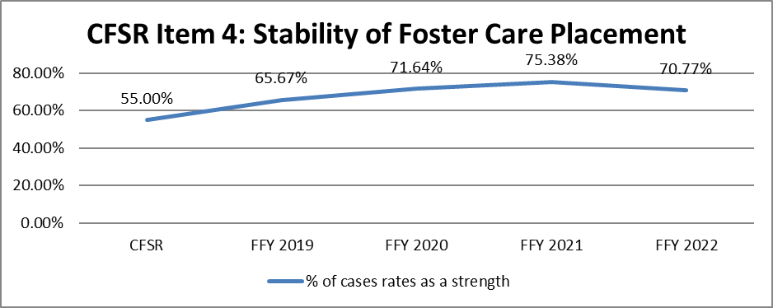
Source: DPQI Case Review Data
CFSR Measure: Placement Stability
Of all children who enter care in a 12-month period, the rate of placement moves per 1,000 days of out-of-home care will be 4.48 or fewer.
CFSR Round 4 Data Profile February 2023
Observed Performance: 22A-22B is 2.80.
21B-22A is 2.61.
21A-21B is 2.72.
Risk Standardized Performance: 22A-22B is 2.58.
21B-22A is 2.46.
21A21B is 2.60.
Permanency Goal for Child (Item 5)
Purpose of Assessment: To determine whether appropriate permanency goals were established for the child in a timely manner.
Strength Rating Defined
- The child’s permanency goal(s) was/were documented in the case file (unless the case was opened for fewer than 60 days).
- Permanency goals during the period under review were established timely (assess timeliness by considering the length of time in foster care and the circumstances of the case).
- Permanency goals during the period under review were appropriate for the child’s needs and considering the circumstances of the case.
- Requirements were met (as applicable) for termination of parental rights under the Adoption and Safe Families Act.
Concerted Efforts Required and/or Special Considerations in Rating
Although this item is not focused on achievement of permanency goals, it does require the reviewer to consider whether the agency was conducting appropriate permanency planning for the child since he or she entered foster care and to assess the impact of those efforts during the period under review. The item is rated based on goals in place during the period under review, but reviewers must also document and consider how long the child was in foster care before a goal was established in determining the timely establishment and appropriateness of the goals.
For example, in the case of a child who had been in foster care with a goal of reunification for several years before the period under review and the goal is changed to adoption at some point during the period under review, the agency's continuation of the reunification goal during the period under review would be considered not appropriate and the establishment of the adoption goal would not be considered timely.
Goals and strategies to impact Permanency Outcome 1 are in the WV Program Improvement Plan pgs. 26-29, 36-42

DPQI Quality Assurance Case Review Data
Baseline: 63.1%
PIP Goal: 70.7%
Reporting Period 6/2018-5/2019: 64.62%

Source: DPQI Case Review Data

Update 2023:
DPQI Quality Assurance Case Review Data
FFY 2020: 61.19%
FFY 2021: 80%

Source: DPQI Case Review Data
Update 2024:
DPQI Quality Assurance Case Review Data
FFY 2021: 80%
FFY 2022: 83.08%
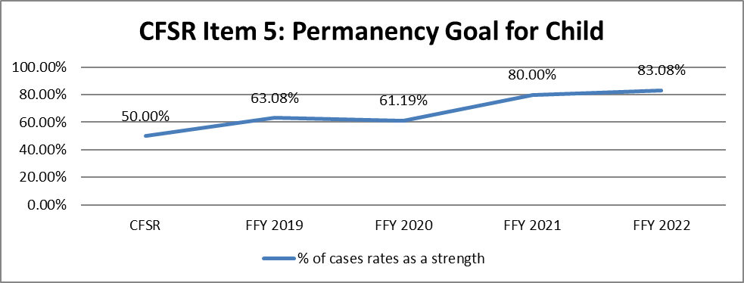
Source: DPQI Case Review Data
Achieving Reunification, Guardianship, Adoption, or Other Planned Permanent Living Arrangement (Item 6)
Purpose of Assessment: To determine whether concerted efforts were made, or are being made, during the period under review to achieve reunification, guardianship, adoption, or other planned permanent living arrangement.
Strength Rating Defined
- During the period under review, the agency made concerted efforts to achieve timely permanency for the child.
- OR, for children with the goal of Other Planned Permanent Living Arrangement, during the period under review, the agency made concerted efforts to place the child in a living arrangement that could be considered permanent until discharge from foster care.
Concerted Efforts Required and/or Special Considerations in Rating
Generally, “timely achievement” is considered to have occurred within 12 months for the goal of reunification, within 18 months for the goal of guardianship, or within 24 months for the goal of adoption. However, the focus of this item is on assessing the efforts that were made to achieve permanency rather than on meeting the specific time frames noted for each goal. For example, if a child was reunified at the 12th month, but could have been reunified sooner had concerted efforts been made, the item could be rated as an Area Needing Improvement. Similarly, if a child did not achieve adoption within 24 months, but the agency and court had been making concerted efforts to achieve the goal of adoption despite circumstances beyond their control that caused a delay, the item could be rated as a Strength.
Concerted efforts toward achieving permanency may include:
- Actively and effectively implementing concurrent planning. Specifically, this means actively working on a second permanency goal simultaneously with the goal of reunification such that there is progress made to have that second goal for permanency achieved quickly should reunification not work out.
- Regularly assessing the safety of the home and family to which the child is to return. This includes utilizing appropriate safety plans and safety-related services to allow reunification to occur timely and safely rather than waiting until all risk and safety concerns are fully resolved before reunification occurs.
- Ensuring appropriate services are provided in a timely manner for parents seeking to achieve reunification.
- In cases of adoption, conducting mediation with the child’s parents, as appropriate, to work toward obtaining voluntary terminations and avoiding lengthy court trials.
- Considering open adoptions, when in the child’s best interest
- Addressing any concerns, a child, youth, or prospective adoptive family may have about adoption through specific discussions or counseling.
- Conducting searches for absent parents and relatives early on and periodically throughout the case
- Establishing paternity early on in cases, as applicable
- Initiating child-specific recruitment efforts to identify permanent placements.
- Ensuring that permanency hearings are held timely, thoroughly address the issues in the case, and the child’s need for permanency.
- Ensuring home studies or other legal processes required to finalize permanency happen timely.
- Finalizing the permanency of a placement for youth with a goal of Other Planned Permanent Living Arrangement through written agreements

Goals and strategies to impact Permanency Outcome 1 are in the WV Program Improvement Plan pgs. 26-29, 36-42

DPQI Quality Assurance Case Review Data
Baseline: 69.2%
PIP Goal: 76.6%
Reporting Period 6/2018-5/2019: 78.46%

Source: DPQI Case Review Data
COGNOS Point in Time Report 3/21/19

COGNOS Point in Time Report 3/21/19

Outcome Permanency 1 is measured by performance on Items 4, 5, and 6 of the 2016 Federal CFSR Onsite Review Instrument. During case reviews conducted during FFY 2018, Permanency 1 was substantially achieved in 35.38% of the cases reviewed, and partially achieved in 58.46% of the cases reviewed. Case reviews are reflective of practice that occurred approximately 12 months prior to the date of the review. The Child and Family Reviews Round 3 baseline indicated Permanency 1 as substantially achieved in 41.54% of the applicable cases reviewed. During this period Item 4 rated as strength in 73.8% of the applicable cases reviewed. The WV Program Improvement Goal for this item is 80.8%. The item rated 76.92% strength during the first PIP reporting period. The Child and Family Reviews Round 3 baseline indicated Item 5 as rated strength in 63.1% of the applicable cases reviewed. The WV Program Improvement Goal for this item is 70.7%. The item rated as strength in 64.62% of the applicable cases reviewed during the PIP first reporting period. The Child and Family Reviews Round 3 baseline indicated Item 6 as strength in 69.2% of the applicable cases reviewed. The WV Program Improvement Goal for this item is 76.6%. Improvement was observed on the measurement for Item 6, efforts to achieve permanency, during the first PIP reporting period. The item rated 78.46% strength during this timeframe. Therefore, meeting the PIP goal for this item.

When Outcome Permanency 1 data is examined, improvement was observed in meeting the measure during FFYs 2017 and 2018. Agency leadership has taken steps to educate staff on the selection of appropriate permanency goals. The efforts appear to have been successful based upon the case review data for the last two FFYs. The WV PIP will seek to further improve Outcome Permanency 1 by improving staffs’ knowledge of available safety and treatment services and enhancing the current services array to address substance abuse and other identified needs to ensure appropriate and individualized services are available and accessible. The WV PIP will also address this outcome by creating and supporting a healthy workforce and creating a prevention-focused organizational culture in order to ensure the needs of children and families are addressed throughout the life of the case.

Update 2023:
DPQI Quality Assurance Case Review Data
FFY 2020: 68.66%
FFY 2021: 61.54%

Source: DPQI Case Review Data
COGNOS Point in Time Report 3/17/2022

COGNOS Point in Time Report 3/17/2022

CFSR Measure: Permanency in 12 Months for Children Entering Foster Care
Of all children who enter care in a 12-month period and stay for eight days or more, the percentage who discharge to permanency within 12 months of entering care will be 42.7% or higher.

CFSR Round 3 Data Profile February 2022
Observed Performance: 19A19B is 35.1%
18B19A is 36.0%
Risk Standardized Performance: 19A/19B is 36.7%
18B/19A is 37.1%

CFSR Measure: Permanency in 12 Months for Children in Care 12 to 23 Months
Of children in care on the first day of the 12-month period who had been in care between 12 and 23 months, the percentage discharged to permanency within 12 months of the first day will be 45.9% or more.
CFSR Round 3 Data Profile February 2022
Observed Performance: 21A21B is 61.3%
20B21A is 61.0%
20A20B is 60.6%
Risk Standardized Performance: 21A21B is 60.5%
20B21A is 59.9%
20A20B is 59.4%

CFSR Measure: Permanency for Children in Care 24 Months or Longer
Of children who enter care on the first day of the 12-month period who had been in care for 24 months or more, the percentage discharged to permanency within 12 months of the first day will be 31.8% or more.

CFSR Round 3 Data Profile February 2022
Observed Performance: 21A21B is 54.3%
20B/21A is 54.5%
20A20B is 51.4%
Risk Standardized Performance: 21A21B is 45.7%
20B/21A is 47.1%
20A20B is 44.3%

CFSR Measure: Re-entry to Foster Care in 12 Months
Of children who enter care in a 12-month period, who are discharged within 12 months to reunification, live with relatives, or guardianship, the percent who reenter care within 12 months of their discharge will be 8.1% or less.

CFSR Round 3 Data Profile February 2021
Observed Performance: 19A19B is 7.7%
18B19A is 9.0%
Risk Standardized Performance: 19A19B is 5.5%
18B19A is 5.9%
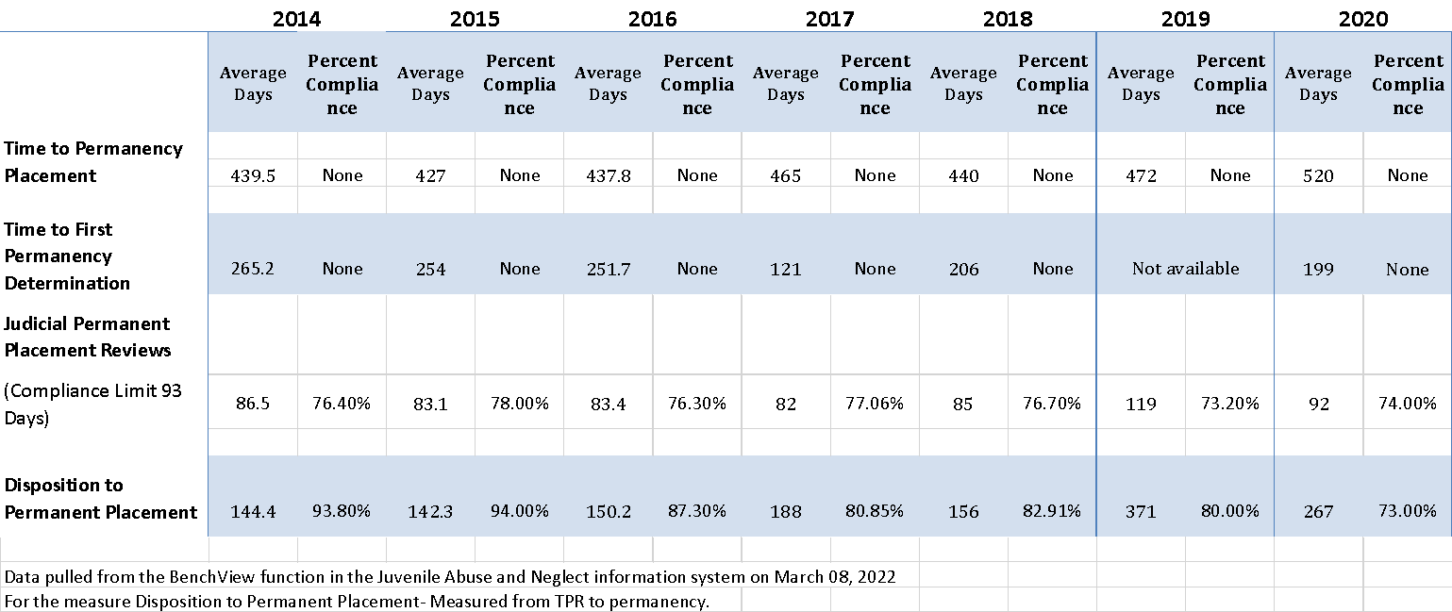

The Supreme Court of Appeals of West Virginia Child Abuse and Neglect (CAN) database
This chart looks at certain performance measures over time. Data to calculate these measures are contained in JANIS. It should be noted that this does not capture 100% of cases, but a sampling of cases for that year. These numbers reflect the work of all child welfare professionals.

This measures the average (mean) time from filing of the original petition to the permanency achieved date for each child. This is calculated using all records for all children, including both original petitions filing date and the permanency achieved date.

Source: The Supreme Court of Appeals of West Virginia Child Abuse and Neglect (CAN) database
This chart demonstrates time to permanency in days. The line indicates the rising numbers of new petitions each year. Data to calculate this data is taken from JANIS. Only records with the completed data fields needed to calculate this figure are included. This is sample data.
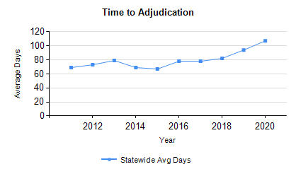
Source: The Supreme Court of Appeals of West Virginia Child Abuse and Neglect (CAN) database
Trend Charts for ALL Circuit Courts - Statewide data 2011 - 2020 YTD
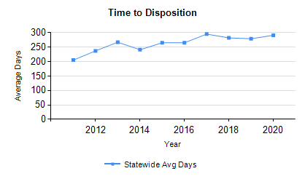
Source: The Supreme Court of Appeals of West Virginia Child Abuse and Neglect (CAN) database
Trend Charts for ALL Circuit Courts - Statewide data 2011 - 2020 YTD
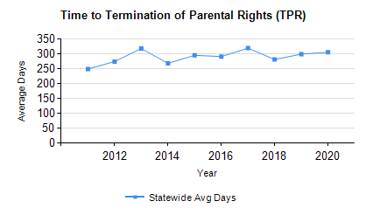
Source: The Supreme Court of Appeals of West Virginia Child Abuse and Neglect (CAN) database

Trend Charts for ALL Circuit Courts - Statewide data 2011 - 2020 YTD

Outcome Permanency 1 is measured by performance on three CFSR Items. These include Item 4-stability of foster care placement, Item 5-permanency goal for the child, and Item 6-achieving reunification, guardianship, adoption, or other planned permanent living arrangement as found in the 2016 Federal CFSR Onsite Review Instrument. During case reviews conducted during FFY 2021, Permanency 1 was substantially achieved in 40% of the cases reviewed, and partially achieved in 56.92% of the cases reviewed. Case reviews are reflective of practice that occurred approximately 12 months prior to the date of the review. During FFY 2020, Permanency Outcome 1 was 31.34% substantially achieved and 34.33% substantially achieved. Positive increases in findings were observed in CFSR items 4 and 5, while a slight decrease was noted in CFSR Item 6. DPQI case review data for Outcome Permanency 1 shows an increase in meeting the measure when FFYs 2020 and 2021 are compared. The increase observed is 8.66%.

The February 2022 Child and Family Services Review Round 3 Data Profile indicates that West Virginia did not meet the CFSR national standard for permanency within 12 months for children entering foster care. West Virginia did meet or exceed the CFSR national standards for permanency within 12 months for children in care 12 to 23 months, permanency within 12 months for children in care for 24 months or more, re-entry into foster care, and placement stability.

Barriers to ensuring that children who enter foster care are discharged timely to a caregiver who will ensure they remain safe, and their needs are met until they reach adulthood are complex. These barriers include delays in the court process such as extended improvement periods being granted to parents and parents being adjudicated at separate times. It is not unusual for the parents in the same court case to be on separate timelines. The difference in court timelines for parents involved in the same case and extensions to improvement periods and other delays in the court process can be caused by case circumstances such as waiting for paternity testing to be completed, multiple fathers or unknown fathers named, parents remaining in rehabilitation programs, and parents who are incarcerated but are expected to be released during the court case. Delays in the court process were also caused by the COVID-19 pandemic.

Barriers to higher Permanency 1 Outcomes are also societal and agency related. These include the inability of relatives to serve as resource providers due to historic or current addiction or CPS history, a lack of resource homes, inability to transform relative resource homes to traditional resource providers willing to foster additional children, lack of supports to foster parents in order to stabilize placements, and the inability to ensure adequate staffing levels with the result being increased functional caseloads. Strategies to positively impact Outcome Permanency 1 are included in the West Virginia Program Improvement Plan. These strategies include increasing the number of resource homes, ensuring resource families are engaged in the caseworker process, and staff recruitment and retention efforts. Data related to PIP goal achievement will be discussed following completion of the first optional measurement period in May of 2022.

Supreme Court of Appeals of West Virginia data in conjunction with DPQI case review data provides a more extensive data set when measuring the achievement of permanency goals. CANS data indicates (on average) the amount of time it takes children to reach permanency has steadily increased since 2015. The same data set shows that the number of new petitions filed decreased when the year 2020 is compared with the three years prior. (See charts above)

Update 2024:
DPQI Quality Assurance Case Review Data
FFY 2021: 61.54%
FFY 2022: 64.62%
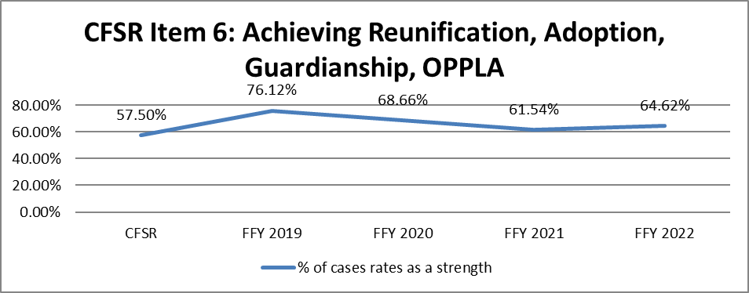
Source: DPQI Case Review Data
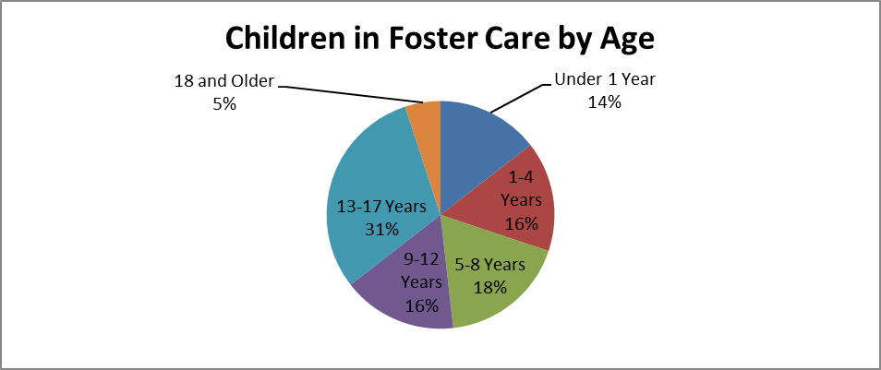
BSS Child Welfare Dashboard Point in Time Report 3/18/2023
CFSR Measure: Permanency in 12 Months for Children Entering Foster Care
Of all children who enter care in a 12-month period, the percentage who discharge to permanency within 12 months of entering care will be 35.2% or higher.
CFSR Round 4 Data Profile February 2023
Observed Performance: 20B-21A is 36.0%
20A-20B is 33.8%
Risk Standardized Performance: 20B-21A is 27.8%
20A-20B is 26.2%
CFSR Measure: Permanency in 12 Months for Children in Care 12 to 23 Months
Of children in care on the first day of the 12-month period who had been in care between 12 and 23 months, the percentage discharged to permanency in the subsequent 12 months will be 43.8% or more.
CFSR Round 4 Data Profile February 2023
Observed Performance: 22A-22B is 64.7%
21B-22A is 62.5%
21A-21B is 61.3%

Risk Standardized Performance: 22A-22B is 64.2%
21B-22A is 61.9%
21A-21B is 61.3%
CFSR Measure: Permanency for Children in Care 24 Months or Longer
Of children who enter care on the first day of the 12-month period who had been in care for 24 months or more, the percentage discharged to permanency in the subsequent 12 months will be 37.3% or more.
CFSR Round 4 Data Profile February 2023
Observed Performance: 22A-22B is 58.0%
21B-22A is 56.3%
21A-21B is 54.3%

Risk Standardized Performance: 22A-22B is 56.7%
21B-22A is 54.4%
21A-21B is 52.0%
CFSR Measure: Re-entry to Foster Care in 12 Months
Of children who are discharged to permanency (excluding adoption) in a 12-month period, the percentage who reenter care within 12 months of discharge will be 5.6% or less.
CFSR Round 4 Data Profile February 2023
Observed Performance: 21A-21B is 6.5%
20B-21A is 7.3%
Risk Standardized Performance: 21A-21B is 7.1%
20B-21A is 7.9%

The Supreme Court of Appeals of West Virginia Child Abuse and Neglect (CAN) database was created to collect and track the status and timeliness of all child abuse and neglect cases in the court system. The data presented in the following charts was pulled from the CANS Database. (Please see CIP Data Notes under Outcome Safety 2)
Time to Adjudication
This measure will include calculating the average (mean) and median time from filing of the original petition to adjudication. The average will be calculated using all respondent records including original petition filing date and the beginning date of the adjudicatory hearing date for each respondent. If a respondent was added after the preliminary hearing as a result of an Amended Petition, time to the Adjudicatory Hearing would be calculated from the date the respondent was added or served rather than the original petition date.
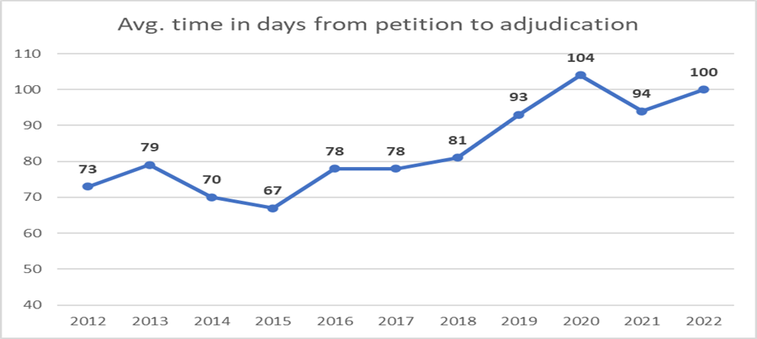
Source: The Supreme Court of Appeals of West Virginia Child Abuse and Neglect (CAN) database
Time to Disposition
This measure will include calculating the average (mean) and median time from filing of the original petition to disposition. The average will be calculated using all respondent records including original petition filing date and the date of the earliest provided disposition date for each respondent. If a respondent was added after the preliminary hearing as a result of an Amended Petition, or service was delayed to a respondent who was included in the original petition, time to the Disposition Hearing would be calculated from the date the respondent was added or served rather than the original petition date.
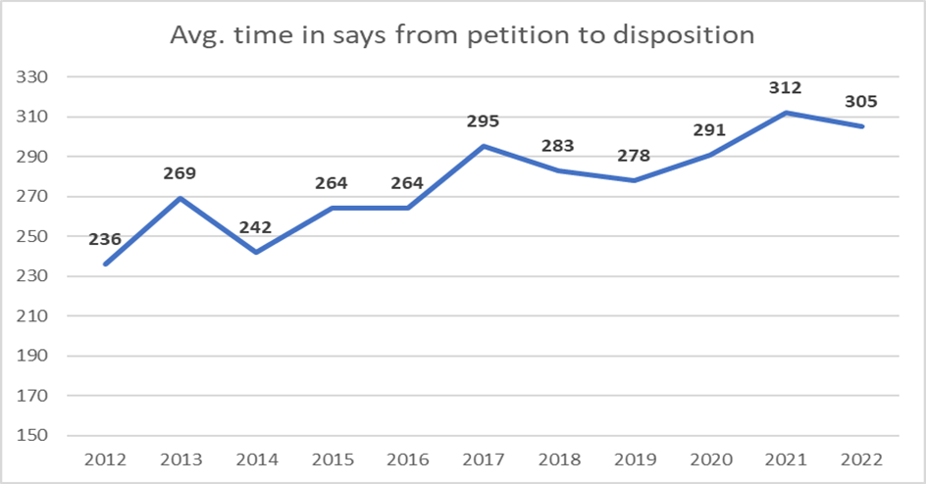
Source: The Supreme Court of Appeals of West Virginia Child Abuse and Neglect (CAN) database
Time to Termination of Parental Rights (TPR)
Court Improvement data indicates that the time to Termination of Parental rights has fluctuated over the years but is currently at an average of less than twelve months. This measure consists of the average (mean) time from filing of the original petition to termination of parental rights for each respondent. All respondent items including applicable dates for both items will be included in the calculation. If a respondent was added because of an Amended Petition, or service was delayed to a respondent who was included in the original petition, time to the Termination of Parental Rights would be calculated from the date the respondent was added or served rather than the original petition date.
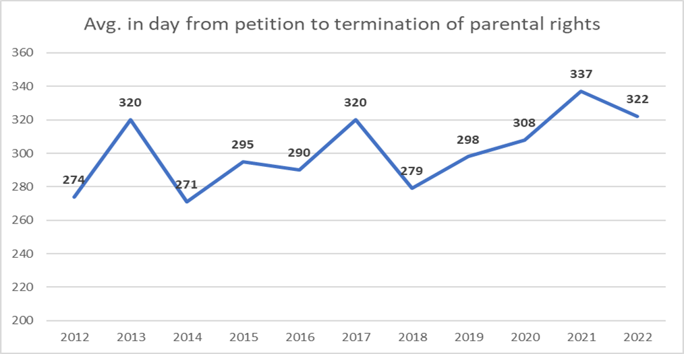
Source: The Supreme Court of Appeals of West Virginia Child Abuse and Neglect (CAN) database
Time to Permanent Placement
This chart compares the number of new petitions filed for the year with the average time in days to permanency for the same year. When looking at the 10-year timeframe, the average days to permanent placement increased by 47%, however, the number of new cases increased by just over 50%. Time in average days to permanent placement measures the average (mean) time from filing of the original petition to the permanency achieved date for each child. This is calculated using all records for all respondents, including both original petitions filing date and the permanency achieved date.
Note: The number of new cases for 2022 is a preliminary number. The final reportable number is generally not available until Spring after the Court Statistician reviews, verifies, and finalizes the number.

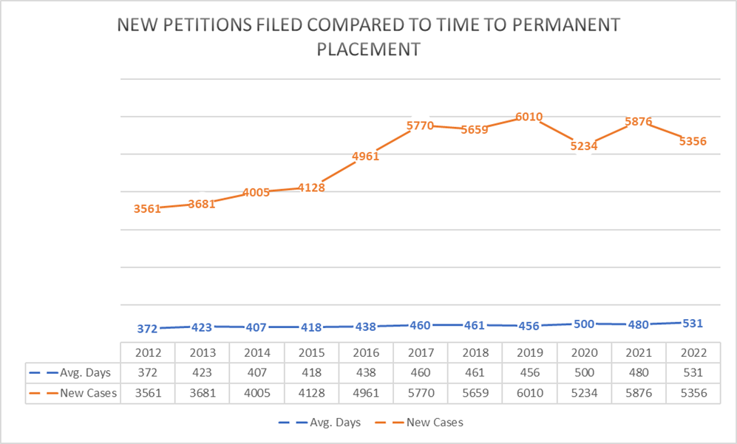Source: The Supreme Court of Appeals of West Virginia Child Abuse and Neglect (CAN) database
Additional CIP Performance Measures
In early 2023, West Virginia became one of 11 states to implement a new series of performance measures called JCAMP (Judicial, Court, and Attorney Measures of Performance). The Court Improvement Program (CIP) currently uses a variety of performance measures that look at timeliness in abuse and neglect hearings. The JCAMP measures will augment these measures to collect a broad spectrum of data that will guide CIP and stakeholder efforts in making systemic improvements to the child welfare system. A group of relevant stakeholders will be identified, assembled, and will guide this work. This project will be completed September 30, 2023.
CFSR Outcome Permanency 1 is measured by performance on three CFSR Items. These include Item 4-stability of foster care placement, Item 5-permanency goal for the child, and Item 6-achieving reunification, guardianship, adoption, or other planned permanent living arrangement as found in the 2016 Federal CFSR Onsite Review Instrument. DPQI social services case reviews conducted during FFY 2022 show Outcome Permanency 1 was substantially achieved in 49.23% of the cases reviewed, partially achieved in 44.62% of the cases reviewed, and not achieved in 6.15% of the cases reviewed. Permanency Outcome 1 was substantially achieved in 40%, partially achieved in 56.92%, and not achieved in 3.08% of the cases reviewed during FFY 2021. Case reviews are reflective of practice that occurred approximately 12 months prior to the date of the review. When comparing the two FFYs, rating increases were observed in CFSR Items 5 and 6 and a decrease is noted in CFSR Item 4. DPQI case review data for Outcome Permanency 1 shows an increase of over 9% in meeting the measure when FFYs 2021 and 2022 are compared.
The February 2023 Child and Family Services Review Round 4 Data Profile indicates that West Virginia did not meet the CFSR national standard for permanency within 12 months for children entering foster care, or for children’s reentry into foster care within 12 months of exiting care to permanency (excluding adoption). West Virginia met or exceeded the national standards for permanency within 12 months for children in care 12 to 23 months, permanency within 12 months for children in care for 24 months or more, and placement stability.
Several complex factors impact the ability of child welfare professionals to achieve permanency for children in foster care. These include systemic factors as well as family and community characteristics. One such contributing factor in West Virginia is substance abuse disorders. Parents with substance abuse disorders are less likely to actively engage in the case planning process. During case reviews, caseworkers often report an inability to locate parents with such disorders after their children enter foster care. It should be noted that case documentation often does not support concerted efforts by caseworkers to locate and engage these parents. Attorneys who represent parents with addictive disorders also often report an inability to locate and engage the parents.
Another factor impacting the achievement of permanency for children is the court system. As the CIP data above indicates, when examined over a 10-year period, both the average number of days to discharge to a permanent placement and the number of new cases have both increased. DPQI case reviews conducted during FFY 2022 observed delays in the court process often being the result of case circumstances such as parents not attending hearings, waiting for paternity testing to be completed, and parents being adjudicated separately. Delays can also occur when parents are in substance abuse disorder treatment programs resulting in judges extending improvement periods.
An additional factor impacting the achievement of permanency for children is a lack of resource homes willing to provide stability and permanency for children. During exit meetings, district level managers report a lack of resource homes sufficient to meet the number of children in need of placement. These managers often report being forced to place children in shelter care, scheduling staff to stay with children in hotels or the agency office or being forced to look outside the state to locate placements. Substance abuse disorders often impact multiple generations in a family. Due to this, some potential relative resource homes are unable to act as placement options for children due to historical criminal and/or CPS history. Childhood trauma can cause a variety of emotional and behavioral responses in children. District level management staff report an unwillingness on the part of some traditional foster parents to report these behaviors or accept services designed to address them. District staff also report that some traditional foster parents do not provide sufficient notice when a child needs to be moved from the placement. This lack of notice, and unwillingness to accept services, results in BSS staff being unable to make efforts to preserve the placement.
West Virginia included strategies designed to positively impact Outcome Permanency 1 in the CFSR Rd. 3 Program Improvement Plan. These strategies included increasing the number of traditional resource homes, ensuring resource families are engaged in the caseworker process, and staff recruitment and retention efforts. Additional permanency improvement efforts in the PIP included activities designed to transition relative resource homes to traditional resource homes willing and able to foster nonrelative children.
Permanency Outcome 2: The continuity of family relationships and connections is
preserved for children.
Placement with Siblings (Item 7)
Purpose of Assessment: To determine whether, during the period under review, concerted efforts were made to ensure that siblings in foster care are placed together unless a separation was necessary to meet the needs of one of the siblings.
Strength Rating Defined
During the period under review, siblings in foster care are placed together unless separation was necessary to meet the needs of one of the siblings. If separation was necessary, the circumstances are reconsidered over time to determine whether separation needs to continue.
Concerted Efforts Required and/or Special Considerations in Rating
Concerted efforts to place siblings together may include:
- Asking the children/family about potential placement resources who may accept a sibling group (e.g., relatives and/or fictive kin) and following up with searches and assessments.
- Searching for resource homes that can accommodate the sibling group.
- For cases where valid reasons for separation exist, providing any services or making arrangements to support the eventual placement of the siblings together.
Source: DPQI Case Review Data

Update 2023:
DPQI Quality Assurance Case Review Data

FFY 2020: 79.07%

FFY 2021: 75.76%
Source: DPQI Case Review Data
Update 2024:
DPQI Quality Assurance Case Review Data
FFY 2021: 75.76%
FFY 2022: 60.53%
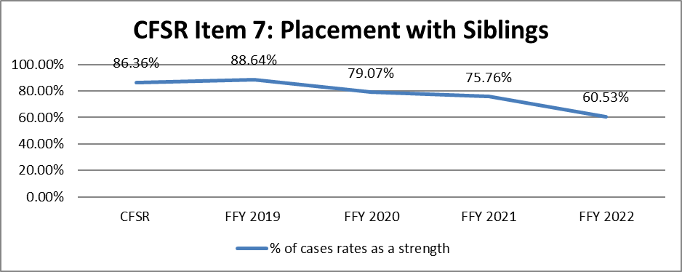

Source: DPQI Case Review Data
Visiting with Parents and Siblings in Foster Care (Item 8)
Purpose of Assessment: To determine whether, during the period under review, concerted efforts were made to ensure that visitation between a child in foster care and his or her mother, father, and siblings is of sufficient frequency and quality to promote continuity in the child’s relationship with these close family members.
Strength Rating Defined
- During the period under review, the child had visitation with parents/caregivers and siblings (as applicable) that was of good quality and at a frequency that promoted continuity in their relationships.
- The frequency of visits is determined based on the child’s needs and the circumstances of the case and not on state policy or resource availability.
- Decisions about supervision during visits, location, length, etc., are made in such a way that supports a positive visitation experience for the child and ensures quality interactions with parents/siblings.
Concerted Efforts Required and/or Special Considerations in Rating
Concerted efforts to ensure frequent, quality visitation may include:
- Creating a visitation plan with the family that outlines details for frequency, location, duration, etc.
- Engaging relatives or kin in supporting visitation by providing transportation or assisting with supervision
- Providing transportation services for parents and children to attend visits.
- Assessing the feasibility and appropriateness of visitation in prison facilities for incarcerated parents
- Discussing visitation with parents/child to assess whether frequency and quality are meeting their needs.
- Facilitating the most frequent visitation possible while ensuring the child’s safety

Source: DPQI Case Review Data

Update 2023:
DPQI Quality Assurance Case Review Data
FFY 2020: 52.34% FFY 2021: 45.16%

Source: DPQI Case Review Data
Update 2024:
DPQI Quality Assurance Case Review Data
FFY 2021: 45.16%
FFY 2022: 31.67%
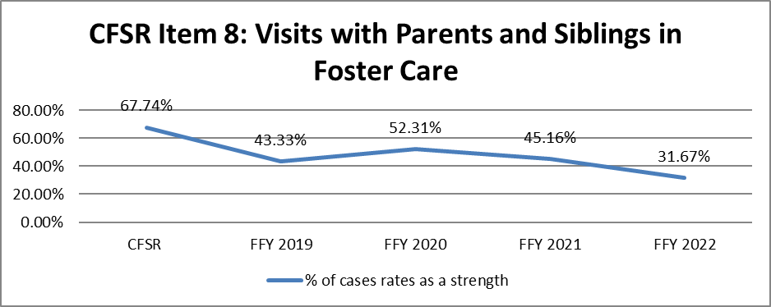
Source: DPQI Case Review Data
Preserving Connections (Item 9)
Purpose of Assessment: To determine whether, during the period under review, concerted efforts were made to maintain the child’s connections to his or her neighborhood, community, faith, extended family, Tribe, school, and friends.
Strength Rating Defined
- During the period under review, the child’s important connections (neighborhood, community, faith, school, extended family, Tribe, and friends) that they had before entering care were identified and maintained.
- For a child who is a member of, or eligible for membership in, a federally recognized Indian Tribe:

- If the child entered foster care during the period under review and/or had a termination-of-parental-rights hearing during the period under review, the Tribe was provided timely notification of its right to intervene in any state court proceedings reviewing an involuntary foster care placement or termination of parental rights.
- The child was placed in foster care in accordance with Indian Child Welfare Act placement preferences, or concerted efforts were made to do so.

Concerted Efforts Required and/or Special Considerations in Rating
Concerted efforts to preserve connections may include:
- Having discussions with the child and family, or others who are familiar with the child, in order to identify the child’s most important connections.
- Making efforts to keep the child in the same school, if it is in the child’s best interests to do so.
- Ensuring the child has visits or contact with extended family members and siblings who are not in foster care.
- Placing the child in a foster home that is in the same community they lived in previously.
- Taking the child to any religious activities he or she used to attend or connecting the child to a faith community with which he or she identifies.
- For a child of Native American heritage, ensuring participation in tribal activities he or she had been involved in
- Providing information to foster parents about the child’s cultural heritage and any cultural needs or preferences that should be maintained.
Source: DPQI Case Review Data
Update 2023:
DPQI Quality Assurance Case Review Data
FFY 2020: 83.33%
FFY 2021: 83.08%

Source: DPQI Case Review Data
Update 2024:
DPQI Quality Assurance Case Review Data
FFY 2021: 83.08%
FFY 2022: 67.69%
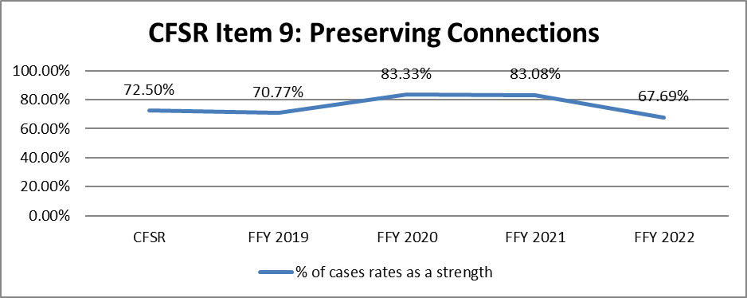
Source: DPQI Case Review Data

Relative Placement (Item 10)
Purpose of Assessment: To determine whether, during the period under review, concerted efforts were made to place the child with relatives when appropriate.
Strength Rating Defined
- Unless the child required a specialized placement that precluded placement with relatives, or the identity of relatives is unknown despite concerted efforts to locate them:
- During the period under review, the child was placed with relatives and the placement was stable.

OR

- Concerted efforts were made to identify, locate, inform, and evaluate paternal and maternal relatives as potential placement resources for the child, as appropriate, during the period under review.
Concerted Efforts Required and/or Special Considerations in Rating
Concerted efforts to identify, locate, inform, and evaluate relatives as placement resources may include:
- Asking the child and parents/caretakers about relatives
- Sending letters to relatives to inform them of the child’s status in foster care and need for placement.
- Conducting home studies of relatives
- For cases where the whereabouts of the parents/caretakers are unknown and therefore relatives are unknown, evidence that the agency made a sufficient inquiry into the parents’ identity, location, and status. Agencies are expected to use viable sources of information such as parent locator services, case files, and central registries. In some situations, posting a legal advertisement in a newspaper might be a reasonable approach if lesser methods have failed to yield results, as would contacting the parents at the last known addresses or phone numbers.
- For cases that have been opened for some time, if concerted efforts were made before the period under review, evidence that any relatives who were previously ruled out were reconsidered (if appropriate) during the period under review.

Source: DPQI Case Review Data

Update 2023:
DPQI Quality Assurance Case Review Data
FFY 2020: 95.16%
FFY 2021: 91.53%
Source: DPQI Case Review Data
Update 2024:
DPQI Quality Assurance Case Review Data
FFY 2021: 91.53%
FFY 2022: 77.05%
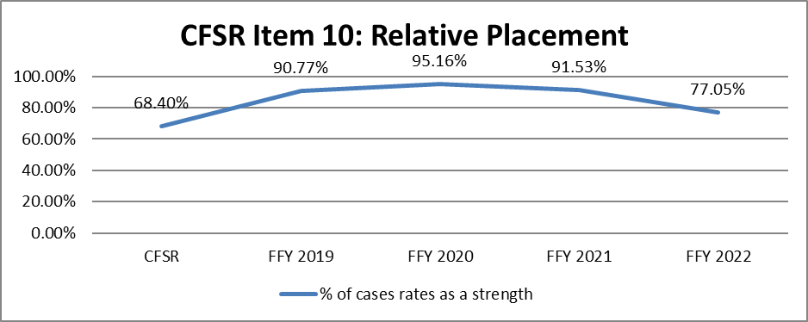Source: DPQI Case Review Data
Relationship of Child in Care with Parents (Item 11)
Purpose of Assessment: To determine whether, during the period under review, concerted efforts were made to promote, support, and/or maintain positive relationships between the child in foster care and his or her mother and father or other primary caregiver(s) from whom the child had been removed through activities other than just arranging for visitation.
Strength Rating Defined
Concerted efforts were made during the period under review to promote, support, and otherwise maintain a positive and nurturing relationship between the child in foster care and the parents/caretakers from whom he or she was removed by encouraging and facilitating activities and interactions that go beyond just arranging for visitation.
Concerted Efforts Required and/or Special Considerations in Rating

Concerted efforts may include:
- Encouraging a parent’s participation in school-related activities, doctor’s appointments for the child, or engagement in after-school activities
- Providing or arranging transportation so that parents can participate in activities with the child.
- Providing opportunities for therapeutic situations to strengthen the relationship.
- Encouraging foster parents to serve as mentors/role models for parents.
- Encouraging/facilitating communication with parents who do not live near the child and/or are unable to have frequent face-to-face visitation.

Source: DPQI Case Review Data

Outcome Permanency 2 is measured by performance on Items 7, 8, 9, 10, and 11 on the 2016 Federal CFSR Onsite Review Instrument. Case reviews conducted during FFY 2018 show Permanency 2 to be substantially achieved in 56.92% of the cases reviewed and partially achieved in 35.38% of the cases reviewed. Case reviews are reflective of practice that occurred 12 months prior to the date of the review. Permanency Outcome 2 is not measured on the WV Program Improvement Plan.

DPQI case review data has shown that CFSR Item performance on items 7, 8, 9, 10, and 11 has fluctuated over time. As is the case for most other outcomes, the co-occurrence of addiction and child maltreatment has impacted this outcome. Many districts report barriers created by the court to maintaining parent-child relationships and ensuring regular parent-child visitation as courts order no contact between the parents and child until addiction treatment has been completed or multiple drug screens return negative for substances. Other barriers to higher conformity on the outcome include inadequate number of resource homes within communities. This results in children being placed further from their home communities therefore resulting in connections not being preserved. The WV PIP does not directly address Outcome WB 3, however, many of the strategies within the PIP should positively impact the outcome.

Update 2023:

DPQI Quality Assurance Case Review Data
FFY 2020: 35.94%
FFY 2021: 31.15%

Source: DPQI Case Review Data

Outcome Permanency 2 is measured by performance on CFSR Items 7, 8, 9, 10, and 11 on the 2016 Federal CFSR Onsite Review Instrument. Case reviews conducted during FFY 2021 show Outcome Permanency 2 to be substantially achieved in 47.69% of the cases reviewed and partially achieved in 52.31% of the cases reviewed. During FFY 2020 52.24% of the cases reviewed were substantially achieved and 44.78% of the cases reviewed were partially achieved. Case reviews are reflective of practice that occurred 12 months prior to the date of the review.

The continuity of primary relationships and connections are being preserved for most children served in out of home care. DPQI case review data indicates strength ratings of 75% or more in three of the five items associated with this outcome. Despite these positive findings, DPQI data also indicates there are areas in which improvements can be made. Slight declines in item ratings were observed in all the five CFSR Items associated with Outcome Permanency 2. CFSR Outcome Permanency 2 has decreased by 4.55% over this period.

DPQI case review data indicates caseworkers are making concerted efforts to ensure that siblings in foster care are placed together unless separation was necessary to meet the needs of one of the siblings. This item rated 75.76% strength during FFY 2021 case reviews. This item and Item 10, Relative Placement, rated 91.53% strength during FFY 2021, are often found to be linked during case reviews. The limited number of foster home placement options available within most districts ensures that staff diligently seek out relative placements. District staff report that this practice often ensures that sibling groups can be placed together. Department staff and service providers continue to make concerted efforts to meet the ever-increasing need for transportation and supervision services associated with parent/family-child visitation supporting the parent-child relationship. DPQI reviewers frequently noted delays in initiating visitation with one or more parents/caregivers in cases that did not meet the measure. Children in placement due to abuse and neglect proceedings are often unable to maintain contact and relationships without approval from the court system. Judges often do not permit contact between the child and the parent/s if the parent/s fails to complete substance abuse treatment or have positive drug screens due to safety concerns for the child. DPQI case reviewers have seen improvement in relation to the barrier to more frequent and quality parent-child contact in districts in which Family Treatment Courts are operating. The WV CFSR Round 3 PIP does not directly measure performance on Outcome Well-Being 3, however the strategies within the PIP should positively impact the outcome.
Update 2024:
DPQI Quality Assurance Case Review Data
FFY 2021: 31.15%

FFY 2022: 12.07%
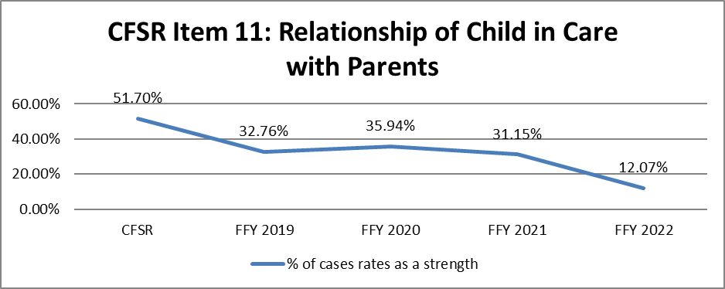
Source: DPQI Case Review Data
Outcome Permanency 2 is measured by performance on CFSR Items 7, 8, 9, 10, and 11 on the 2016 Federal CFSR Onsite Review Instrument. Case reviews conducted during FFY 2022 show Outcome Permanency 2 to be substantially achieved in 30.77% of the cases reviewed, partially achieved in 60% of the cases reviewed, and not achieved in 9.23% of the cases reviewed. During FFY 2021, 47.69% of the cases reviewed were substantially achieved and 52.31% of the cases reviewed were partially achieved. Case reviews are reflective of practice that occurred 12 months prior to the date of the review.
FFY 2022 is the second consecutive year in which lower strength percentage ratings were noted in all five CFSR items of which Outcome Permanency 2 is comprised. Substantial conformity with the measure declined by almost 17% when FFYs 2022 and 2021 are compared. Strength ratings on CFSR Item 7, placement with siblings, decreased by 15.23% between FFY 2021 and 2022. District level management staff often report that unless a relative is willing to act as a placement option, siblings are often separated due to an inability to locate traditional resource homes willing to foster sibling groups. CFSR Item 8, visits with parents and siblings in different foster care settings, decreased by 13.49% when the last two federal fiscal years are compared. DPQI case reviews indicate this decline is often due to the inability of children in placement to maintain contacts and relationships without approval from the court system. Due to concern for the safety of the child, most judges do not permit contact between the child and the parent if the parent fails to complete substance abuse treatment or has positive drug screens. DPQI case reviewers have seen improvement in relation to this barrier to more frequent and quality parent-child contact in districts in which Family Treatment Courts are operating. Some jurisdictions also restrict the scheduling of visitation until after the preliminary hearing occurs. Case reviewers also found that caseworkers often fail to schedule sibling visitation if parental visitation cannot occur. The volume of children in foster care puts a strain on the limited resources within most communities to support the parent-child and sibling relationships. This is voiced by district level management staff who report a lack of providers willing to assist with transportation and the supervision of visits. The continuity of primary relationships and connections, CFSR Item 9, is being preserved for most children served in out of home care. DPQI case review data indicates strength ratings of 67.69% of the cases reviewed. Barriers to higher strength ratings include failing to place children within their home community. This reduces the likelihood that children will maintain connections with friends and extended family members. CFSR Item 9 and 10, relative placement (77.05% strength on all applicable cases), are often linked. Due to the limited number of resource homes available within most districts, staff make diligent efforts to locate, evaluate, and when appropriate utilize relatives as placement providers. District management staff report caseworkers are reporting to the court that these efforts are being made initially as well as on an ongoing basis throughout the placement episode. DPQI social services reviews indicate CFSR Item 11, relationship of child in care with parents, rated a strength in 12.07% of the applicable cases reviewed. This item is impacted by the same court and provider issues discussed for CFSR Item 8. The WV CFSR Round 3 PIP does not directly measure performance on Outcome Well-Being 3, however the strategies within the PIP should positively impact the outcome.

Well-Being
Well-Being Outcome 1: Families have enhanced capacity to provide for their
children’s needs.
Needs and Services of Child, Parents, and Foster Parents (Item 12)
Purpose of Assessment: To determine whether, during the period under review, the agency (1) made concerted efforts to assess the needs of children, parents, and foster parents (both initially, if the child entered foster care or the case was opened during the period under review, and on an ongoing basis) to identify the services necessary to achieve case goals and adequately address the issues relevant to the agency’s involvement with the family, and (2) provided the appropriate services.
Strength Rating Defined
- Concerted efforts were made during the period under review to assess the needs of the children, parents, and foster parents initially accurately and comprehensively (for cases that opened during the period under review) and periodically on an ongoing basis (as needed) to update assessment information relevant to ongoing case planning.
- Assessment of needs for the children does not include education, physical health, and mental/behavioral health (including substance abuse)
- Assessment of needs for parents refers to a determination of what the parents need to provide appropriate care and supervision and to ensure the safety and well-being of their children.
- Assessment of needs for foster parents refers to a determination of what the foster parents need to provide appropriate care and supervision to the child in their home.
- Concerted efforts were made during the period under review to provide appropriate services to the children, parents, and foster parents that were matched to needs identified in assessments.
Concerted Efforts Required and/or Special Considerations in Rating
Concerted efforts to locate parents may include:
- Contacting the parents at the last known addresses or phone numbers
- Using the federal parent locator service, reviewing case files/central registries
- Asking about relatives and making efforts to contact any identified relatives.
- Asking the children’s current/previous schools for parent information
- Posting a legal advertisement in a newspaper (after all other search methods have been exhausted)
Concerted efforts to assess needs may include:
- Conducting formal assessments through a contracted provider or another agency
- Conducting informal but thorough assessments using interviews with the child, family, and service providers
- Spending adequate time engaging with the child, parents, and foster parents to gain an in-depth understanding of their needs.
- Using screening and assessment tools to assess specific issues such as domestic violence, substance abuse, cognitive abilities, or parenting skills.
Concerted efforts to provide appropriate services may include:
- Ensuring accessibility of needed services by providing for transportation
- Monitoring service participation to ensure that the services are meeting needs.
- Ensuring availability of services by removing or addressing any barriers to participation, such as waitlists or scheduling conflicts
- Ensuring that services are matched to the parents’ needs and are culturally appropriate.
Reviewers should not rate a parent for this item if, during the entire period under review, the case file documented that it was not in the child’s best interests to involve the parent in case planning. In such a situation, the item questions are not applicable. This would include cases in which there are ongoing safety threats that could emotionally or physically re-traumatize the child and that cannot be mitigated by the agency or other interventions. Typically, both the agency and court are involved in making this determination.
Goals and strategies to impact Well-Being Outcome 1 are in the WV Program Improvement Plan pgs. 26-29, 36-42, 44-49, 51-53

DPQI Quality Assurance Case Review Data
Baseline: 19.2%
PIP Goal: 23.7%
Reporting Period 6/2018-5/2019: 28%
Source: DPQI Case Review Data
DPQI Case Review Data
DPQI Case Review Data

Update 2023:
DPQI Quality Assurance Case Review Data
FFY 2020: 25.58
FFY 2021: 22.4%

Source: DPQI Case Review Data
Source: DPQI Case Review Data

Source: DPQI Case Review Data
Update 2024:
DPQI Quality Assurance Case Review Data
FFY 2021: 22.4%
FFY 2022: 20%

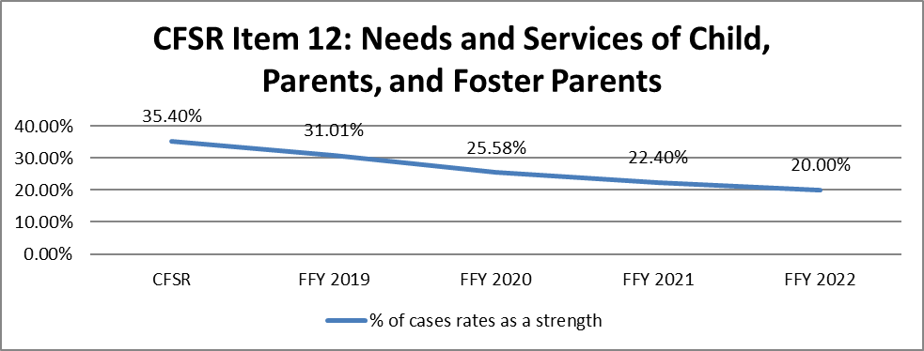
Source: DPQI Case Review Data
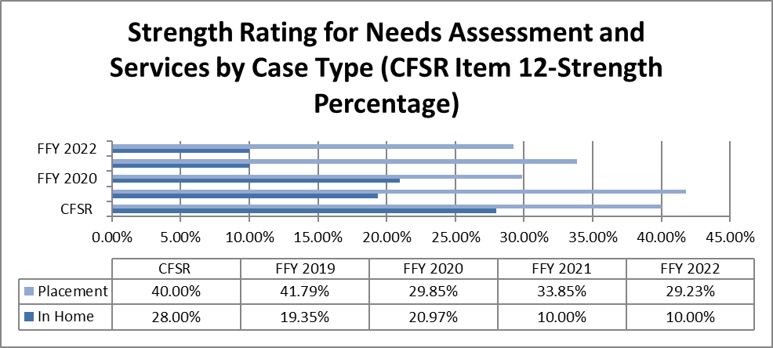
Source: DPQI Case Review Data
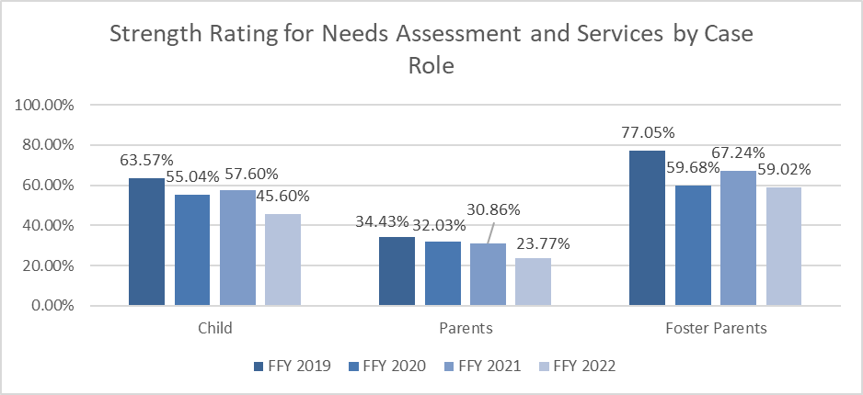
Source: DPQI Case Review Data

Child and Family Involvement in Case Planning (Item 13)
Purpose of Assessment: To determine whether, during the period under review, concerted efforts were made (or are being made) to involve parents and children (if developmentally appropriate) in the case planning process on an ongoing basis.
Strength Rating Defined
During the period under review, concerted efforts were made to actively involve the children (if developmentally appropriate) and parents/caretakers in case planning activities.
Concerted Efforts Required and/or Special Considerations in Rating
Concerted efforts to engage families in case planning may include:
- Having age-appropriate discussions with children and explaining case plans in language they understand
- Ensuring children understand permanency goals and changes made to goals.
- Discussing family strengths and needs with children and parents.
- Evaluating other case plan goals and progress in services with both children and parents
- Ensuring that case planning meetings are arranged based on the family’s availability and are utilized to engage the family in case planning discussions.

Goals and strategies to impact Well-Being Outcome 1 are in the WV Program Improvement Plan pgs. 26-29, 36-42, 44-49, 51-53

DPQI Quality Assurance Case Review Data
Baseline: 27.6%
PIP Goal: 32.8%
Reporting Period 6/2018-5/2019: 35.25%

Source: DPQI Case Review Data

Source: DPQI Case Review Data

Update 2023:
DPQI Quality Assurance Case Review Data
FFY 2020: 25%
FFY 2021: 27.42%
Source: DPQI Case Review Data
Source: DPQI Case Review Data
Update 2024:
DPQI Quality Assurance Case Review Data
FFY 2021: 27.42%
FFY 2022: 17.21%
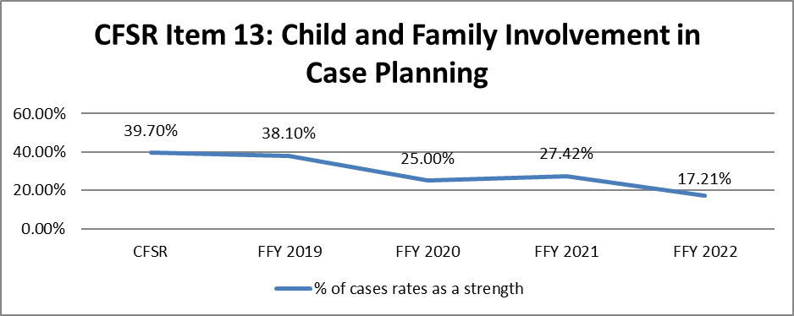
Source: DPQI Case Review Data
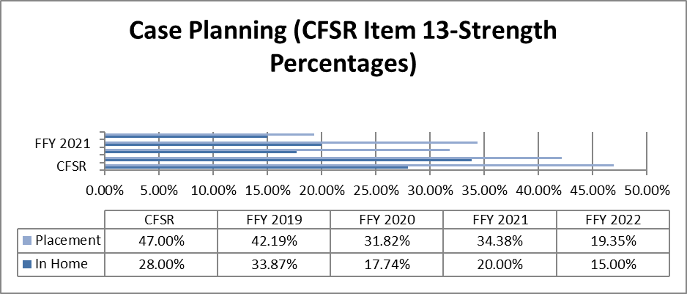
Source: DPQI Case Review Data
Caseworker Visits with Child (Item 14)
Purpose of Assessment: To determine whether the frequency and quality of visits between caseworkers and the child(ren) in the case are sufficient to ensure the safety, permanency, and well-being of the child and promote achievement of case goals.
Strength Rating Defined
During the period under review, the caseworker visited the children (for in-home cases, all children must be visited) frequently enough to adequately assess their safety, promote timely achievement of case goals, and support their well-being. The visits were of good quality, with discussions focusing on the children’s needs, services, and case plan goals. The children were visited alone, and the length and location of visits was conducive to open, honest, and thorough conversations.
Concerted Efforts Required and/or Special Considerations in Rating
Typically, visit frequency must be at least monthly for a Strength rating, unless there is substantial justification for less frequent visits.
Goals and strategies to impact Well-Being Outcome 1 are in the WV Program Improvement Plan pgs. 26-29, 36-42, 44-49, 51-53

DPQI Quality Assurance Case Review Data
Baseline: 29.6%
PIP Goal: 34.8%
Reporting Period 6/2018-5/2019: 26.4%

Source: DPQI Case Review Data

Source: DPQI Case Review Data
Update 2023:
DPQI Quality Assurance Case Review Data
FFY 2020: 27.91%
FFY 2021: 26.4%
Source: DPQI Case Review Data
Source: DPQI Case Review Data
Update 2023:
DPQI Quality Assurance Case Review Data
FFY 2021: 26.4%
FFY 2022: 25.6%
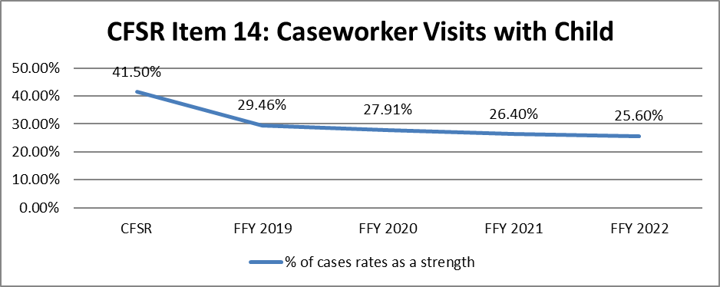
Source: DPQI Case Review Data
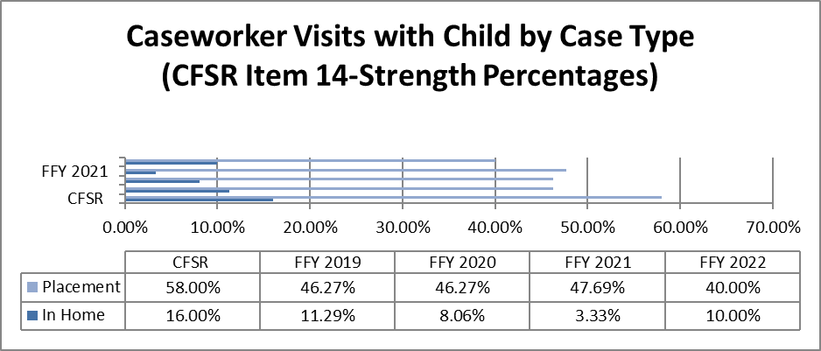
Source: DPQI Case Review Data

Caseworker Visits with Parents (Item 15)
Purpose of Assessment: To determine whether, during the period under review, the frequency and quality of visits between caseworkers and the mothers and fathers of the child(ren) are sufficient to ensure the safety, permanency, and well-being of the child(ren) and promote achievement of case goals.
Strength Rating Defined
During the period under review, the caseworker visited the parents frequently enough to monitor their progress in services, promote timely achievement of case goals, and effectively address their children’s safety, permanency, and well-being needs. The visits were of good quality, with discussions focusing on the parent’s and children’s needs, services, and case plan goals. The length and location of visits were conducive to open, honest, and thorough conversations.
Concerted Efforts Required and/or Special Considerations in Rating
Typically, visit frequency must be at least monthly for a Strength rating, unless there is substantial justification for less frequent visits, which could vary depending on the circumstances of the case. For example, for parents who are incarcerated, efforts should be made to arrange face-to-face contact; however, this may not be permitted or viable in a facility that is out of state. A similar situation would be parents who live out of state. In lieu of face-to-face visits, the agency’s efforts to maintain monthly communication with the parents via phone calls and/or letters should be considered.
If the case goal is not to place the child with that parent permanently, monthly face-to-face contact is not always required for a Strength rating, and frequency should be determined based on the circumstances of the case and needs of the children.
Goals and strategies to impact Well-Being Outcome 1 are in the WV Program Improvement Plan pgs. 26-29, 36-42, 44-49, 51-53

DPQI Quality Assurance Case Review Data
Baseline: 5.7%
PIP Goal: 8.4%
Reporting Period 6/2018-5/2019: 5.88%
Source: DPQI Case Review Data
Source: DPQI Case Review Data

Well-Being Outcome 1 is measured by performance on Items 12, 13, 14, and 15 on the 2016 Federal CFSR Onsite Review Instrument. FFY 2018 case review data indicates Well-Being Outcome 1 was substantially achieved in 12% of the cases reviewed, and partially achieved in 31.2% of the cases reviewed. Case reviews are reflective of practice that occurred 12 months prior to the date of the review. The Child and Family Reviews Round 3 baseline indicated Permanency 1 was substantially achieved in 41.54% of the applicable cases reviewed. During this time period Item 12 rated as strength in 19.2% of the applicable cases reviewed. The WV Program Improvement Goal for this item is 23.7%. The item rated 28% strength during the first PIP reporting period. Therefore, meeting the PIP goal for this item under The Child and Family Reviews Round 3 baseline indicated Item 13 as rated strength in 27.6% of the applicable cases reviewed. The WV Program Improvement Goal for this item is 32.8%. The item rated as strength in 35.25% of the applicable cases reviewed during the PIP first reporting period and therefore, met the PIP goal for this item. The Child and Family Reviews Round 3 baseline indicated Item 14 as strength in 29.6% of the applicable cases reviewed. The WV Program Improvement Goal for this item is 34.8%. The item rated as strength in 26.4% of the applicable cases reviewed during the PIP first reporting period. The Child and Family Reviews Round 3 baseline indicated Item 15 as strength in 5.7% of the applicable cases reviewed. The WV Program Improvement Goal for this item is 8.4%. The item was rated as strength in 5.88% of the applicable cases reviewed during the PIP first reporting period.

Review data indicates placement cases scored higher on the measure than in-home cases. The inability to have frequent and quality contacts with children and parents by caseworkers had a direct impact on Well-Being Outcome 1. As the Practice Performance Report accurately indicates, neither the quality nor the quantity of caseworker contacts with children and parents is sufficient to ensure child safety and achieve case goals.

Well-Being Outcome 1 data has fluctuated somewhat over time, but overall has decreased since FFY 2015. Reviewed cases show concerning trends which include lack of regular quality contact with children and families, failure to regularly assess for child and family service needs throughout the life of the case, less than optimal service provision to address identified needs, lack of establishment of case plans/goals through engagement of family members, and failure to close cases timely. These barriers to higher outcome achievement are addressed in the WV PIP through closure of cases timely and, when appropriate, stabilization of the workforce, more frequent and higher quality interactions between caseworkers and supervisors, improvement of staffs’ knowledge of available treatment services, and enhancements to service array to address substance abuse and other identified needs to ensure appropriate and individualized services are available and accessible.

Update 2023:
DPQI Quality Assurance Case Review Data
FFY 2020: 6.25%
FFY 2021: 2.44%

Source: DPQI Case Review Data
Source: DPQI Case Review Data

Well-Being Outcome 1 is measured by performance on CFSR Items: 12-needs assessment of and services to child(ren); parents, and foster parents; 13-child and family involvement in case planning; 14-caseworker visits with child; and 15-caseworker visits with parents on the 2016 Federal CFSR Onsite Review Instrument. FFY 2021 (10/1/20-9/30/21) case review data indicates Well-Being Outcome 1 was substantially achieved in 12% of the cases reviewed, and partially achieved in 32% of the cases reviewed. FFY 2020 (10/1/19-9/30/20) case review data indicates Well-Being Outcome 1 was substantially achieved in 11.63% of the cases reviewed, and partially achieved in 33.33% of the cases reviewed. Case reviews are reflective of practice that occurred 12 months prior to the date of the review.

Rating decreases were observed during FFY 2021 in three of the four CFSR items related to Well-Being Outcome 1. Only CFSR Item 13 showed a 2.42% increase in strength ratings when the two data sets were compared. Review data over time shows concerning trends in relation to non-placement cases which includes: the lack of regular quality contact with children and families, failure to regularly assess for child safety and family service needs throughout the life of the case, less than optimal service provision, lack of the establishment of case plans and goals, and failure to close cases timely. As the Practice Performance Report accurately indicates, the overall level of contact between caseworkers and children and parents, regardless of case type, is well below a standard which would allow for the ongoing assessment of child safety and ensuring appropriate service provision throughout the life of a case. For children, the quantity of contact was sufficient in only 32.8% and the quality was sufficient in 49.17% of the cases reviewed during FFY 2021. Both the frequency and quality of caseworker visitation with the father was sufficient in 1.9% of the applicable cases. This same data set shows that the quality and quantity of contact with the mother was sufficient in 4.96% of the applicable cases. Case reviews indicate a lack of concerted efforts to engage the parents even if the location of the parent is known to the agency. The frequency and quality of caseworker contact with parents and children impacts multiple CFSR items and outcomes.

As indicated above, cases that failed to meet the measure for assessments and service provision for children, parents, and foster parents resulted from a lack of ongoing assessments of, and service provision to, the child(ren) and parent/s and, to a lesser extent, foster parents. DPQI case review data for FFY 2021 shows that Sub-item 12A (children) rated 57.6% strength, Sub-item 12B (parents) rated 30.89% strength, and Sub-item 12C (foster parents) rated 67.24% strength. The lack of on-going case work in non-placement cases is particularly notable as non-placement cases rated lower on all applicable Outcome Well-Being 1 items and subitems. An additional barrier to higher goal achievement is a lack of quality services to address identified needs. Case reviews find service needs are often correctly identified but no treatment services to address the identified needs are provided.

District management staff often indicate the lack of quality treatment services in an area coupled with the lack of public transportation as obstacles to meeting customer service needs. Reviews also found that providers in some areas have issues with staff recruitment and retention and this negatively impacts the ability to provide quality services to families. District staff often state that the inability of the providers to maintain sufficient professional staffing levels is the primary barrier to higher levels of achievement on all CFSR Outcomes. Some providers utilize paraprofessionals as workers and this, according to some district level managers, negatively impacts the quality of services provided.

The WV CFSR Round 3 Program Improvement Plan does address these barriers in multiple ways. BSS partnered with the Capacity Center for States to identify service gaps and map available addiction services. Other PIP activities are designed to increase the knowledge and skill of supervisors in an effort to support staff throughout the casework process and reduce turnover, attract qualified staff, and ensure meaningful quality contacts between caseworkers and children and parents regardless of case type. Data related to PIP goal achievement will be discussed following completion of the first optional measurement period in May of 2022.
Update 2023:
DPQI Quality Assurance Case Review Data
FFY 2021: 2.44%
FFY 2022: 3.28%
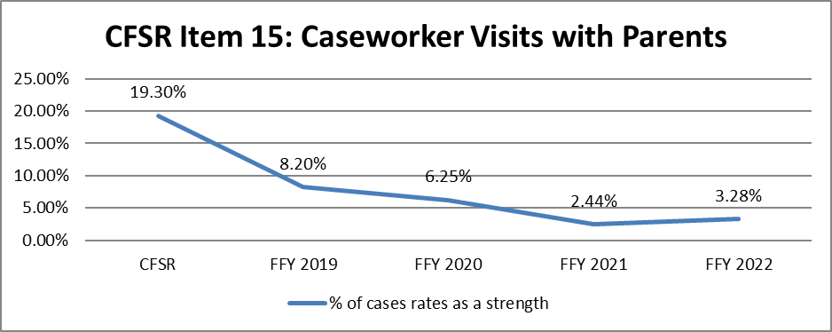
Source: DPQI Case Review Data
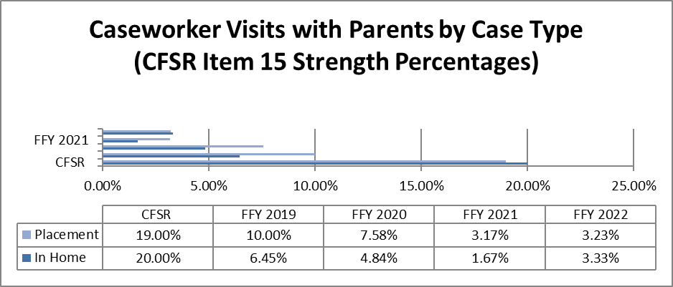
Source: DPQI Case Review Data
Well-Being Outcome 1 is measured by performance on CFSR Items: 12-needs assessment of and services to child(ren); parents, and foster parents; 13-child and family involvement in case planning; 14-caseworker visits with child; and 15-caseworker visits with parents on the 2016 Federal CFSR Onsite Review Instrument. FFY 2022 case review data indicates Well-Being Outcome 1 was substantially achieved in 12% of the cases reviewed, and partially achieved in 24.8% of the cases reviewed, and not achieved in 63.2% of cases reviewed. FFY 2021 case review data indicates Well-Being Outcome 1 was substantially achieved in 12% of the cases reviewed, partially achieved in 32% of the cases reviewed, and not achieved in 56% of the cases reviewed. Case reviews are reflective of practice that occurred 12 months prior to the date of the review.
FFY 2022 social services case review data shows decreased strength ratings in three of the four CFSR items of which Well-Being Outcome 1 is comprised. Only CFSR Item 15 showed an increased strength rating, when the two years of data are compared, and this increase was less than 1%. When data sets are compared over time, a concerning decrease in strength ratings is noted. The current strength ratings on CFSR Items 12, 13, and 14 are the lowest observed during the last five federal fiscal years. A disparity in strength ratings across these items is noted when placement and non-placement data is compared. Substantial conformity ratings for nonplacement cases are noted in 3.3% of the cases reviewed while substantial conformity ratings for placement cases are noted in 12% of the cases reviewed by DPQI.
DPQI social services case reviews indicated a low level of quality contacts with parents. This is a major barrier to higher levels of achievement for Well-Being Outcome 1. Data suggests that WV needs significant improvement in the frequency and quality of caseworker contact with parents. Caseworker contacts with parents often occur during MDT meetings and court hearings. The frequency of visits between caseworkers and parents in the family home is not sufficient to engage the parents in the development and evaluation of case goals. The quality of caseworker contacts is insufficient to evaluate the efficacy of service provision and evaluate parental behavioral changes necessary to resolve the child safety issues warranting agency intervention. Additional barriers to higher levels of conformity include the lack of regular quality caseworker contacts with children. The frequency and quality of contacts is insufficient to evaluate child safety, ensure appropriate assessment of service needs, and determine the efficacy of services provided. DPQI case reviews also note in many cases a lack of service provision to address identified needs. The Practice Performance Report shows the level of contact between caseworkers and children and parents. For children, the quantity of contact was sufficient in 31.2% of the cases reviewed during FFY 2022. This same data set indicates the quality of caseworker contacts with children was sufficient in 43.33% of the cases reviewed. Both the frequency and quality of caseworker visitation with the father was sufficient in 3.92% of the applicable cases. This same data set shows that the quality and quantity of contact with the mother was sufficient in 6.84% of the applicable cases. The frequency and quality of caseworker contact with parents and children impacts additional CFSR items and outcomes.
Cases that failed to meet the measure for assessments and service provision for children, parents, and foster parents resulted from a lack of ongoing assessments of service needs and failure to provide appropriate services when needs were identified. DPQI case review data for FFY 2022 shows that Sub-item 12A (children) rated 45.6% strength, Sub-item 12B (parents) rated 23.77% strength, and Sub-item 12C (foster parents) rated 59.02% strength. These are lower than FFY 2021 strength ratings for these sub-items. Social services cases without child placement rated lower on three of the four items included in Outcome Well-Being 1. The only item in which non-placement cases rated higher was CFSR Item 15. The difference between the two case types was less than 1%, the combined strength ratings for both case types on all applicable cases for the item was 3.28%. Reviewers report an additional barrier to achieving the measure is related to the failure to provide services to address all identified needs of family members. For example, domestic violence may be identified as a reason that BSS is involved with the family; however, no services are put in place to address the issue.
District management staff indicate multiple barriers related to quality and quantity of service providers in an area to have an impact on meeting this measure. The most noted is unstable worker staffing within the district. Some districts report an insufficient quantity of service providers to adequately meet the needs of customers. They report a lack of sufficient staffing and staff turnover within the provider network as a reason for appropriate services not being provided in a timely manner to families. Provider staffing issues also impact the quality of services provided to families. An additional barrier to meeting customer service needs in many areas is a lack of public transportation. District managers report that district staff must assist with transporting customers for assessments and services. This additional duty prevents district staff from performing other casework duties.
The WV CFSR Round 3 Program Improvement Plan does address these barriers in multiple ways. BSS partnered with the Capacity Center for States to develop a map of available addiction services around the state. In addition, the PIP contains actions to increase the knowledge and skill of supervisors to support staff throughout the casework process and reduce turnover, attract qualified staff, and ensure meaningful quality contacts between caseworkers and children and parents regardless of case type.
Well-Being Outcome 2: Children receive appropriate services to meet their
educational needs.
Educational Needs of the Child (Item 16)
Purpose of Assessment: To assess whether, during the period under review, BSS made concerted efforts to assess children’s educational needs at the initial contact with the child (if the case was opened during the period under review) or on an ongoing basis (if the case was opened before the period under review), and whether identified needs were appropriately addressed in case planning and case management activities.
Strength Rating Defined
Concerted efforts were made during the period under review to assess the children’s educational needs initially (if the case was opened during the period under review) or on an ongoing basis and to provide appropriate services to address needs.
Concerted Efforts Required and/or Special Considerations in Rating
In-home cases are only applicable for this item if 1) educational issues are relevant to the reason for the agency’s involvement with the family, and/or 2) it is reasonable to expect that the agency would address educational issues given the circumstances of the case.
The focus of this item is on the agency’s efforts, even if those efforts were not fully successful due to factors beyond the agency’s control.
Concerted efforts to assess needs may include:
- Having an educational assessment conducted by the school.
- Conducting an informal assessment based on interviews with the child, parents/caretakers, and/or foster parents.

Concerted efforts to provide services may include:
- Advocating for services on behalf of the child (by the caseworker and/or foster parents)
Source: DPQI Case Review Data

Well-Being Outcome 2 is measured by performance on Item 16 on the 2016 Federal CFSR Onsite Review Instrument. FFY 2018 case review data indicates Well-Being Outcome 2 was substantially achieved in 76.54% of the cases reviewed. Case reviews are reflective of practice that occurred 12 months prior to the date of the review.

When examined over the prior CFSP time period of FFY 2015-FFY 2018, Well-Being Outcome 2 data indicated a general upward trend. Caseworkers are doing better at identifying the educational needs of children and ensuring such needs are met through service provision. Case reviews indicate the Safe at Home West Virginia program has had a positive impact on this outcome. The WV PIP does not directly address WB 3, however, many of the strategies within the PIP should positively impact the outcome.

Update 2023:
DPQI Quality Assurance Case Review Data
FFY 2020: 69.12%
FFY 2021: 75%

Source: DPQI Case Review Data

Well-Being Outcome 2 is measured by performance on Item 16-educational needs of the child on the 2016 Federal CFSR Onsite Review Instrument. DPQI social services case reviews conducted between October 2020 and September 2021 (FFY 2021) indicate Well-Being Outcome 2 was substantially achieved in 75% of the cases reviewed. FFY 2020 (Oct. 2019-Sept. 2020) case review data indicates Well-Being Outcome 2 was substantially achieved in 69.12% of the cases reviewed. Case reviews are reflective of practice that occurred 12 months prior to the date of the review.

A 17.31% difference was found in strength ratings between placement cases (80.95% Strength) and non-placement cases (63.64 Strength). Although the disparity between the case types is less than it was last year (29.55%), the significant amount of difference in strength ratings remains concerning. This can be linked back to the inadequate frequency and quality of caseworker contact with families involved in non-placement cases. The WV PIP does not directly address Outcome Well-Being 3, however many of the strategies within the PIP should positively impact the outcome.
Update 2024:
DPQI Quality Assurance Case Review Data
FFY 2021: 75%
FFY 2022: 61.29%

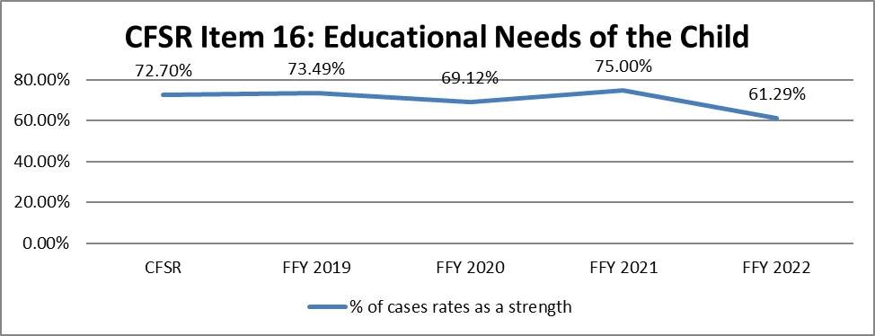
Source: DPQI Case Review Data
Well-Being Outcome 2 is measured by performance on Item 16-educational needs of the child on the 2016 Federal CFSR Onsite Review Instrument. DPQI social services case reviews conducted between October 2021 and September 2022 indicate Well-Being Outcome 2 was substantially achieved in 61.29% of the cases reviewed, partially achieved in 6.45% of the cases reviewed, and not achieved in 32.26% of the reviewed cases. FFY 2021 case review data indicates Well-Being Outcome 2 was substantially achieved in 75% of the cases reviewed. (Partially achieved in 9.37%, and not achieved in 15.63%, of all applicable cases) When compared, the two data sets show a 13.71% decrease in substantial conformity with the measure. Case reviews are reflective of practice that occurred 12 months prior to the date of the review.
DPQI case reviews indicate concerted efforts to assess and address children’s educational needs through appropriate services are less likely to occur for children not in a placement setting. A 45.94% difference was found in strength ratings between cases involving placement (80.56% Strength) and non-placement cases (34.62% Strength). The link between frequent quality caseworker contacts with children involved in non-placement cases has a direct impact on this measure. The WV PIP does not directly address Outcome Well-Being 3, however many of the strategies within the PIP should positively impact the outcome.
Well-Being Outcome 3: Children receive adequate services to meet their physical
and mental health needs.
Physical Health of the Child (Item 17)
Purpose of Assessment: To determine whether, during the period under review, the agency addressed the physical health needs of the children, including dental health needs.

Strength Rating Defined
During the period under review, the children’s physical health and dental needs were accurately assessed initially (if the case was opened during the period under review) and on an ongoing basis, and any needed services were provided.
In addition, for foster care cases, if the child was prescribed medication for physical health issues, the agency provided appropriate oversight for appropriate use and monitoring of medications.
Concerted Efforts Required and/or Special Considerations in Rating
In-home cases are only applicable for this item if 1) physical health issues were relevant to the reason for the agency’s involvement with the family, and/or 2) it is reasonable to expect that the agency would address physical health issues given the circumstances of the case.
Source: DPQI Case Review Data

Update 2023:
DPQI Quality Assurance Case Review Data
FFY 2020: 76.32%
FFY 2021: 78.67%

Source: DPQI Case Review Data

As indicated in previous years, DPQI social services case reviews find that children in placement are more likely to have their physical health needs assessed and receive appropriate services to address identified needs than children involved in non-placement cases. While strength ratings were observed to have increased in both case types, the item ratings indicate an 81.54% Strength for placement cases (79.1% in FFY 2020) and a 60% Strength for non-placement cases (55.56 in FFY 2020), non-placement cases continue to perform at a lower level.
Update 2024:
DPQI Quality Assurance Case Review Data
FFY 2021: 78.67%
FFY 2022: 60.53%
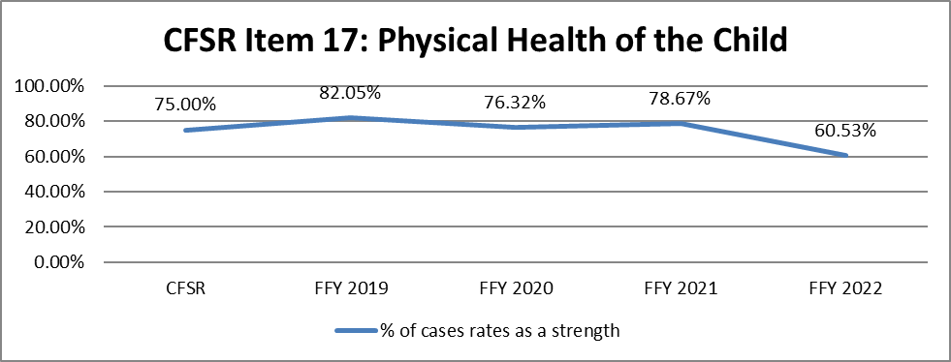
Source: DPQI Case Review Data
Cases are reviewed to determine if BSS addressed the physical health needs of the child, including optical and dental health. In-home cases are applicable to the measure if a child’s health issues were relevant to the reason for the agency’s involvement with the family. All placement cases are applicable for this measure. Federal fiscal year social services case review data indicates 60.53% of all applicable cases rated a strength on the item. Children in placement (64.62% strength) are more likely to have their physical health needs assessed and receive appropriate services to address identified needs than children involved in non-placement cases (36.36% strength). A barrier to higher levels of conformity on this item for placement cases include relative foster parents failing to ensure children in care receive timely routine and follow up dental and optical health examinations. A barrier to higher levels of conformity on this item for cases without a placement episode include lack of worker quality contacts that include discussions about children’s physical health needs.

Mental/Behavioral Health of the Child (Item 18)
Purpose of Assessment: To determine whether, during the period under review, the agency addressed the mental/behavioral health needs of the children.
Strength Rating Defined
- During the period under review, the children’s mental and/or behavioral health needs were accurately assessed initially (if the case was opened during the period under review) and on an ongoing basis, and any needed services were provided.
- In addition, for foster care cases, if the child was prescribed medication for mental health issues, the agency provided appropriate oversight for appropriate use and monitoring of medications.
Concerted Efforts Required and/or Special Considerations in Rating
In-home cases are only applicable for this item if 1) mental/behavioral health issues were relevant to the reason for the agency’s involvement with the family, and/or 2) it is reasonable to expect that the agency would address mental/behavioral health issues given the circumstances of the case.

Source: DPQI Case Review Data

Well-Being Outcome 3 is measured by performance on Items 17 and 18 on the 2016 Federal CFSR Onsite Review Instrument. FFY 2018 case review data indicates Well-Being Outcome 3 was substantially achieved in 67.69% of the cases reviewed, and partially achieved in 24.62% of the cases reviewed. The data reflects a 9.44% increase in the percentage of substantially achieved cases when compared to the prior FFY. Case reviews are reflective of practice that occurred 12 months prior to the date of the review.

Children in foster care receive medical care through a statewide comprehensive managed care program known as West Virginia Health Check. Health Check is the name of West Virginia’s Early and Periodic Screening, Diagnosis and Treatment (EPSDT) Program. This program employs Regional Program Specialists who assist families with scheduling EPSDT examinations, which include vision and oral health screenings, within three days of placement. The specialist can also link families with other needed medical services. The Regional Program Specialist helps ensure these medical assessments are completed annually and provides the child welfare agency with copies of the completed health examinations. DPQI case reviewers find this information in the electronic case record.

Children in placement are more likely to have their behavioral health needs assessed and receive appropriate services to address identified needs than children involved in non-placement cases. Behavioral health assessments and services to address identified needs are provided or coordinated for children in placement by placement providers. The case review data indicates children in non-placement cases are less likely to have behavioral health assessments completed even when displaying overt behaviors that indicate such assessments are warranted. Barriers to children receiving behavioral health assessments and/or services are lack of contact by agency staff with children in non-placement cases, lack of mental health providers within a district, the focus on one child and failing to assess all children in the home, and limited follow-up on behavioral health issues after reunification. The WV PIP does not directly address WB 3, however many of the strategies within the PIP should positively impact the outcome.

Update 2023:
DPQI Quality Assurance Case Review Data
FFY 2020: 51.35%
FFY 2021: 59.49%
Source: DPQI Case Review Data

Well-Being Outcome 3 is measured by performance on Items 17-physical health of the child and 18-mental/behavioral health of the child on the 2016 Federal CFSR Onsite Review Instrument. FFY 2021, October 2020-September 2021, case review data indicates Well-Being Outcome 3 was substantially achieved in 60% of the cases reviewed, and partially achieved in 13.64% of the cases reviewed. FFY 2020, October 2019-September 2020, case review data indicates Well-Being Outcome 3 was substantially achieved in 53.7% of the cases reviewed, and partially achieved in 14.81% of the cases reviewed. The data reflects a 6.37% decrease in the percentage of substantially achieved cases when compared to the prior FFY. Case reviews are reflective of practice that occurred 12 months prior to the date of the review.

Case review data indicates most children (73.81%) in placement have behavioral health assessments and receive services to address their identified needs. In comparison, children (43.24%) not experiencing a placement episode during the period under review are much less likely to have behavioral health assessments completed even when displaying overt behaviors that indicate such assessments are warranted. A contributing factor in cases that did not meet the measure was assessments and services not being provided or not being initiated in a timely manner. Again, this was found most often in non-placement cases.

Well-Being Outcome 3 DPQI case review data indicates that children in placement (81.54% strength) are much more likely to have their physical and behavioral health needs assessed and receive appropriate services to address identified needs when compared to children involved in non-placement cases (60% strength). Although the WV CFSR Round 3 PIP does not directly address Outcome Well-Being 3, many of the strategies within the PIP should positively impact the outcome.
Update 2024:
DPQI Quality Assurance Case Review Data
FFY 2021: 59.49%
FFY 2022: 25%

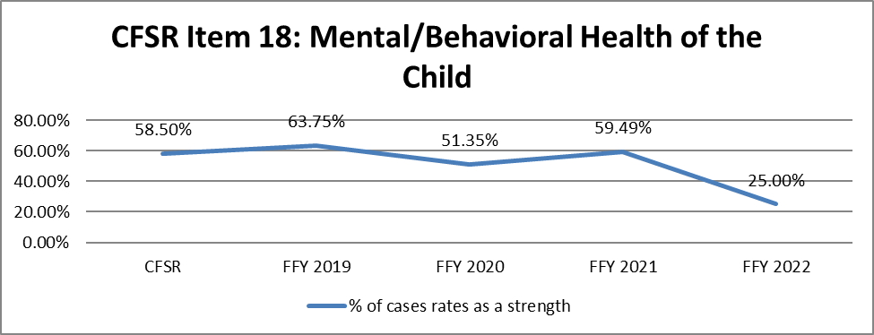
Source: DPQI Case Review Data

Children in placement settings received behavioral health assessments and services to address their identified needs in 40.74% of the cases reviewed during FFY 2022. These children are assessed and have access to more mental health care services by the nature of the placement setting. In comparison, children not experiencing a placement episode were assessed and provided services to address their behavioral health needs in 13.51% of the applicable cases reviewed. Non-placement cases rated as strength less often due to several factors. Parents sometimes fail to recognize the need for treatment of mental health issues in children. Limited quality contacts by child welfare workers results in a lack of agency knowledge regarding the behavioral health needs of children, and limited discussions with parents about obtaining services to address such needs.
Well-Being Outcome 3 is measured by performance on Items 17-physical health of the child and 18-mental/behavioral health of the child on the 2016 Federal CFSR Onsite Review Instrument. Federal fiscal year 2022 case review data indicates Well-Being Outcome 3 was substantially achieved in 40.37% of the cases reviewed, partially achieved in 9.17% of the cases reviewed, and not achieved in 50.46% of the cases reviewed. Data collected during FFY 2021 indicates Well-Being Outcome 3 was substantially achieved in 60% of the cases reviewed, partially achieved in 13.64% of the cases reviewed, and not achieved in 26.36% of the cases reviewed. The data reflects a 19.63% decrease in substantial conformity with the measure when the current and former Federal fiscal years are compared. DPQI case review data indicates Well-Being Outcome 3 to be in substantial conformity in 55.38% of the placement cases reviewed during the period. The same data found the measure to be in substantial conformity in 18.18% of cases reviewed during the federal fiscal year when children did not experience an alternative placement setting. Case reviews are reflective of practice that occurred 12 months prior to the date of the review. Although the WV CFSR Round 3 PIP does not directly address Outcome Well-Being 3, many of the strategies within the PIP should positively impact the outcome.

Systemic Factors

Information Systems
The Department has opted to replace the current IV-A, IV-D, IV-B/E and Medicaid management systems with one single integrated eligibility system called PATH – Peoples Access to Help. The RFP closed last December 2017, and a contract was awarded, finalized, and signed. The vendor, Optum Consulting, has completed system requirements and architecture planning, transferring hardware and software licensing, and bringing up the PATH solution infrastructure. Detailed design requirements are underway with development activity starting soon after.

The focus is on creating an operational information system that readily identifies the status, demographic characteristics, location, and goals for the placement of every child who is (or within the immediately preceding 12 months, has been) in foster care. A robust data quality plan with management oversight tools (dashboards, reports, and quality alerts) is a key component of the schema for the IES.

The general expectation is that all common functions will be addressed in IES. Requirements gathering with external stakeholders (the Courts, Education, and others) has begun in an effort to understand the types of data which can be gleaned from these other systems. The intent is to display information gathered through interfaces rather than capture and store that information in the CCWIS.
Through the technical assistance of the Capacity Building Center for States, the ongoing work of the Court Improvement Program and West Virginia DOE, the CCWIS will utilize data exchanges to obtain source data to reduce errors. Using rolling wave planning with a spiral implementation, the child welfare components of the new PATH system are currently scheduled to be piloted in production November 30, 2020, with full system implementation expected by March 2021.

Since the new system will be developed and iteratively implemented, the SACWIS will operate concurrently until all development activity has been completed and all functionality to support child welfare operations, reporting and fund claiming has been successfully implemented. FACTS data will be used to guide conversion and current compliance reporting will be leveraged to verify and validate the conversion effort and data migration to the new system.

FACTS has already begun data cleansing to prepare for conversion activities. FACTS is focusing on maintaining the accuracy and validity of the Title IV-E claiming data, demonstration waiver evaluation data and the IV-B, IV-E and Title XIX compliance reporting. The initial emphasis has been on resolving client duplication in the legacy data for a future push to the Master Client Index, which is central to the new system operations. In addition to surveillance and performance reporting around this initiative, we are planning on some extent of data corrections necessary to scrub the data of inaccuracies and inconsistencies.

Since legacy FACTS will be operating concurrently it is important to note that there are no planned maintenance activities beyond updates required to meet federal and state mandates, data cleansing, pre-archival and data conversion preparation. New functionality, updates to business rules and new data outcomes will all be rendered in the new CCWIS with only minor configurations performed if necessary. The mandatory interfacing to the IV-A, IV-D and title XIX systems will remain in the legacy system until all necessary functions are implemented across the involved programs in the new integrated system. The mandated interface with education and the courts has been accounted for in the requirements and implemented in the new system.

The full legacy system retirement is planned to occur after all social service programs supported by the legacy system are integrated and implemented statewide in PATH.

Although modifications are being considered, a Standard Operating Procedure remains in place for districts to report monthly on each child in care. The report referred to as the “Kids in Care” is provided to each Regional Program Manager by the last day of each month. It includes pertinent information on each child including, but not limited to: Name, Client ID, Demographics, Removal Date, Placement Type, and location. Districts maintain this report and use it for multiple purposes:

- As a printable document for use in emergency situations when there is no or limited access to electronic systems.
- A tracking tool to compare data entered into the FACTS system to verify correct entry of removals, placements, and reunifications.
- Compare and track boarding care payments to foster care parents.
- Quick glance at the use of kinship versus other placement types.
- Verify date of last Multidisciplinary Team meeting.

In addition to the “Kids in Care” report, legacy FACTS has a monthly payment approval process for every child in placement. During this payment approval process, workers evaluate each child on their caseload and determine if the authorized payment to providers is correct. Supervisors are able to see which providers will receive payments for placements of every child in foster care, thus enabling them to make corrections as needed regarding the current placement of children in foster care.

Once supervisors assure every child’s placement has been entered, the SACWIS system guides workers to enter the child’s location, visitation plan and permanency plan. These screens cannot be completed unless demographic information on each child has previously been entered.

A memo has been developed and will be released in September 2019, reminding staff of the mandate to complete this process.

Currently, BSS only has data from Maternal Child and Family Health to confirm that placements are entered timely. This data measures the percentage of time Health Checks are completed within 30 days of placement. Each month, it captures children/youth from previous months.

Performance Measures | Completed Data
The percentage of foster children initially placed in January 2019 who were entered into FACTS within each timeframe after placement. | 99.0%
The percentage of foster children initially placed in January 2019 who received a documented Health Check exam within each time frame after placement. | 95.3%

Update 2023:

Design Validation for the WV PATH Child Welfare system began in May 2021 and concluded in January 2022. Design Validation included the continuum of Child Welfare and Adult Services. This validation included reviewing the functionality of the CW PATH system as well as the Functional Design Systems documents. Financial payments, documents and notifications, and reports were also part of the validation. At the present time, all design validation tickets submitted are being addressed through joint triage sessions.

The GoLIve for the Child Welfare PATH system is scheduled for September 30, 2022. The following are tasks to be completed by the GoLive date:

- Scenario writing for all BSS programs - completed.
- UAT Testing - Testing began April 2022 and will continue until August 31, 2022
- Data Cleansing and Conversion - In progress
  - Review of Deliverables - Completed
  - Training for Conversion Tagging and Merging - In Progress
  - Conversion Tagging - Active Cases and Active Participants - In Progress
  - Conversion Plans - In progress

- Review of PATH system Training Materials - In progress
- Scheduling Training for BSS staff - Begins July 2022
- Design Validations - In progress
  - Family First - In Progress
  - Provider Portal - In Progress
  - Retro/Recon - In Progress

Update 2024:
Design validation for WV PATH continued in 2022. The GoLive date was pushed to January 1, 2023. This GoLive date was met, and WV PATH is live for Child Welfare and Adult Services. BSS continues to work with the design team to work through glitches and errors in the system.

Count of Placements Entered Late (over 7, 24-hour days)
 | 05/21 | 06/21 | 07/21 | 08/21 | 09/21 | 10/21 | 11/21 | 12/21 | 01/22 | 02/22 | 03/22 | 04/22
Region 1 | 11 | 17 | 14 | 31 | 18 | 10 | 14 | 15 | 9 | 14 | 19 | 9
Region 2 | 34 | 16 | 35 | 26 | 26 | 16 | 20 | 19 | 15 | 15 | 26 | 14
Region 3 | 9 | 13 | 9 | 10 | 10 | 11 | 4 | 13 | 8 | 3 | 3 | 9
Region 4 | 15 | 10 | 28 | 12 | 20 | 17 | 6 | 7 | 20 | 8 | 16 | 8
Total Late | 69 | 56 | 86 | 79 | 74 | 54 | 44 | 54 | 52 | 40 | 64 | 40
Total Placements | 147 | 168 | 173 | 151 | 147 | 124 | 102 | 110 | 127 | 123 | 142 | 114
Percentage Late | 47% | 33% | 50% | 52% | 50% | 44% | 43% | 49% | 41% | 33% | 45% | 35%
In order to improve transaction data, BSS revised the Homefinding Specialists responsibilities to include data entry for the placement of children entering kinship or relative provider homes as well as completing the demand payments.

Update 2024:
The information above in the chart labeled “Count of Placements Entered Late” was erroneously reported. There are not any data reports that were able to be obtained regarding this information.

The Office of Maternal Child Health provided data on the percentage of foster children entered into the system timely.

The percentage of foster children initially placed in January 2022 who were entered into FACTS within each timeframe after placement. | 91.7%
The percentage of foster children initially placed in January 2019 who received a documented Health Check exam within each time frame after placement. | 63.3%

Case Review
The case review system reveals WV continues to struggle with written case plans developed jointly with the child’s parent(s). Efforts are underway to improve case planning outcomes by streamlining current policies and practices for both Child Protective Services (CPS) and Youth Services (YS) cases. The workgroup assigned to this project has made modifications to policy and forms for the current CPS practice model to reduce duplication in work and simplify both processes and documentation. For YS cases, the FAST is being utilized to assess family needs and move them toward change. At the present time, staff in each of the four regions are piloting the new forms and processes for both CPS and YS.

Update 2023:
See sections Child Protective Services and Youth Services for update.

Update 2024:
See sections Child Protective Services and Youth Services for update.

West Virginia does an excellent job of ensuring periodic reviews occur for each child no less than every 6 months, either by Court or Administrative Review. Review hearings are scheduled in all jurisdictions quarterly until permanency is achieved and the case is dismissed from the docket. An AFCARS report specific to this reporting element is generated from FACTS monthly that reflects every case with no review documented. This report is utilized by Regional Program Managers and Regional Directors to work with districts on getting these reviews documented in FACTS. In rare instances, the reviews have not been held and the report serves as a prompt for districts to request scheduling.

Effective February 2, 2018, data collection on review hearings in abuse and neglect cases moved to the JANIS. This merger created data integrity problems with respect to tracking two important measures, 1) Days from Original Petition Date to First Review Hearing, and 2) Days Between Review Hearings. The Court Improvement Program along with the Supreme Court of Appeals of West Virginia Information Technology (IT) department are working diligently to correct all and ensure accuracy of information in JANIS and will not release data until it is error free. To that end, data for these measures is not available as of April 30, 2019. Update data will not be available until summer 2019.

Update 2023:
Data was pulled from the Juvenile Abuse and Neglect Information System (JANIS) on May 17, 2022. Cases are manually entered into JANIS by court staff. It should be noted that not all cases are entered into JANIS. This data should be considered snap-shot data and does not account for 100% of cases. Further, the calculations in the proceeding sections are made using cases which contain information needed to complete calculations resulting in a fraction of cases available for the measurement. The Court Improvement Program of the Supreme Court of Appeals of West Virginia is working towards increasing congruency in the number of cases entered in JANIS with the number of new petitions filed as well as enhancing the quality of data and increasing the number of records available for measurement calculations.

Update 2024:
Data was pulled from the Juvenile Abuse and Neglect Information System (JANIS) on February 1, 2023. Cases are manually entered into JANIS by Court Staff. It should be noted that not all cases are entered into JANIS. This data should be considered snap-shot data and does not account for 100% of cases. Further the calculations below are only made using cases entered that have all the information needed to make the calculation. Because of this, only a fraction of cases is available for the measurement calculation. The Court Improvement Program of the Supreme Court of Appeals of West Virginia, (CIP), is working towards increasing congruency in the number of cases entered in JANIS with the number of new petitions filed as well as enhancing the quality of data and increasing the number of records available for measurement calculations. During the 2022 calendar year, CIP staff assisted with entering over 1100 cases in the database or about 25% of all new cases added that year.

It should also be noted that should these charts be compared with charts from previous year’s reports, the numbers may be different. This is because the calculations are performed based on data available in JANIS at the time of the report. New cases and case updates are added daily resulting in a change each time reports are run. For that reason, all years included in this report were run on the same day despite having existing charts from previous years.

Time to Adjudication

This measure will include calculating the average (mean) and median time from filing of the original petition to adjudication. The average will be calculated using all respondent records including original petition filing date and the beginning date of the adjudicatory hearing date for each respondent. If a respondent was added after the preliminary hearing as a result of an Amended Petition, time to the Adjudicatory Hearing would be calculated from the date the respondent was added or served rather than the original petition date.

Update 2023:
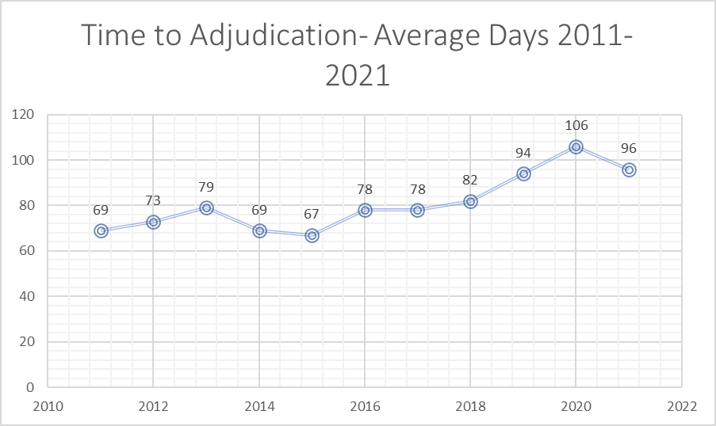

Update 2024:
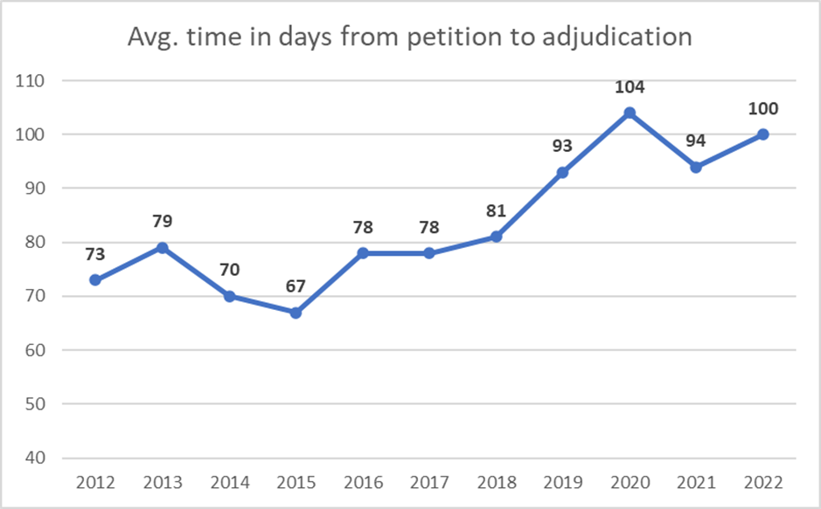

Time to Disposition
This measure will include calculating the average (mean) and median time from filing of the original petition to disposition. The average will be calculated using all respondent records including original petition filing date and the date of the earliest provided disposition date for each respondent. If a respondent was added after the preliminary hearing as a result of an Amended Petition, or service was delayed to a respondent who was included in the original petition, time to the Disposition Hearing would be calculated from the date the respondent was added or served rather than the original petition date.

Update 2023:

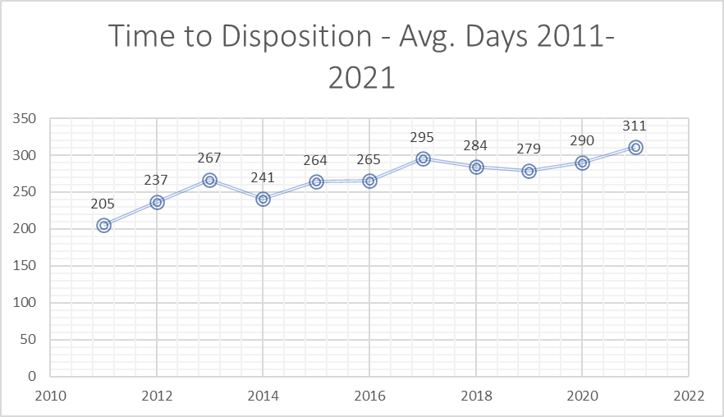

Update 2024:

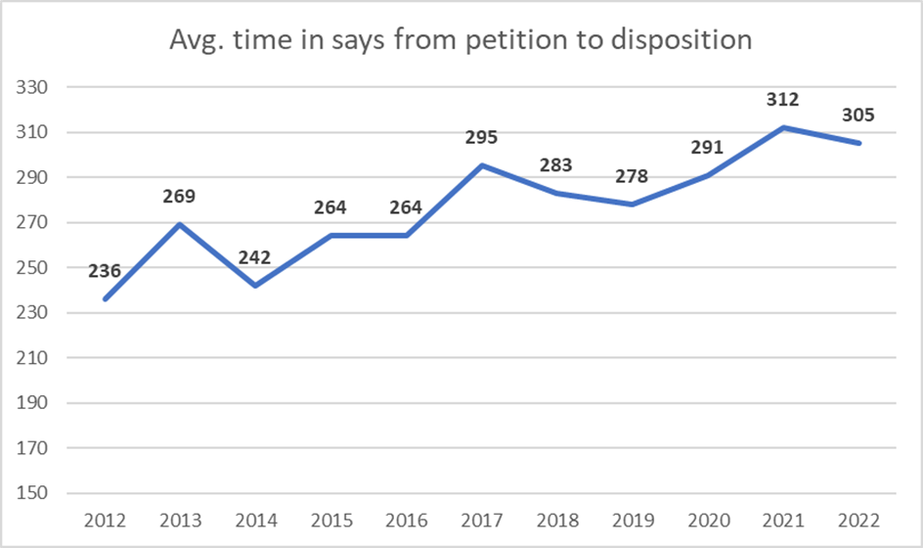

Time to Termination of Parental Rights (TPR)

Court Improvement data indicates that the time to Termination of Parental Rights has fluctuated over the years but is currently at an average of less than twelve months.

This measure consists of the average (mean) time from filing of the original petition to termination of parental rights for each respondent. All respondent items including applicable dates for both items will be included in the calculation. If a respondent was added as a result of an Amended Petition or service was delayed to a respondent who was included in the original petition, time to the Termination of Parental Rights would be calculated from the date the respondent was added or served rather than the original petition date.

Update 2023:
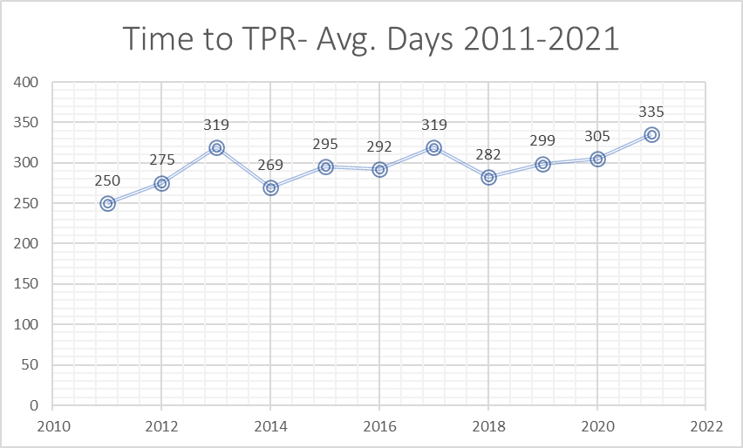

Update 2024:
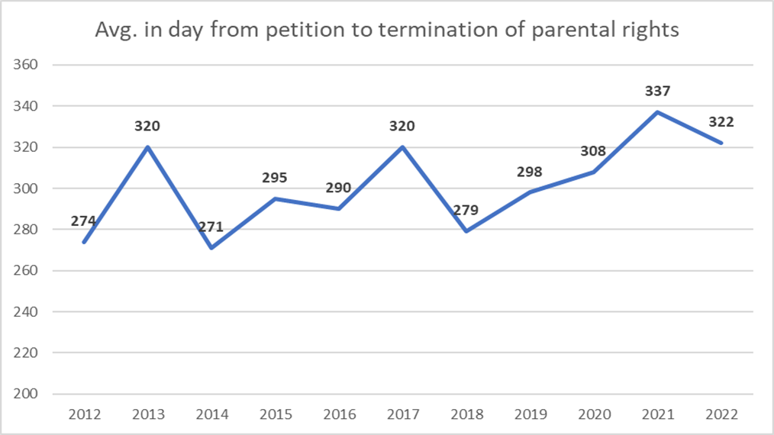

Time to Permanent Placement

With rare exception, permanency is addressed at every review hearing held quarterly. Court Improvement data indicates that the time from removal to permanent placement is beginning to increase steadily but is still within the eighteen-month timeframe.

Update 2023:
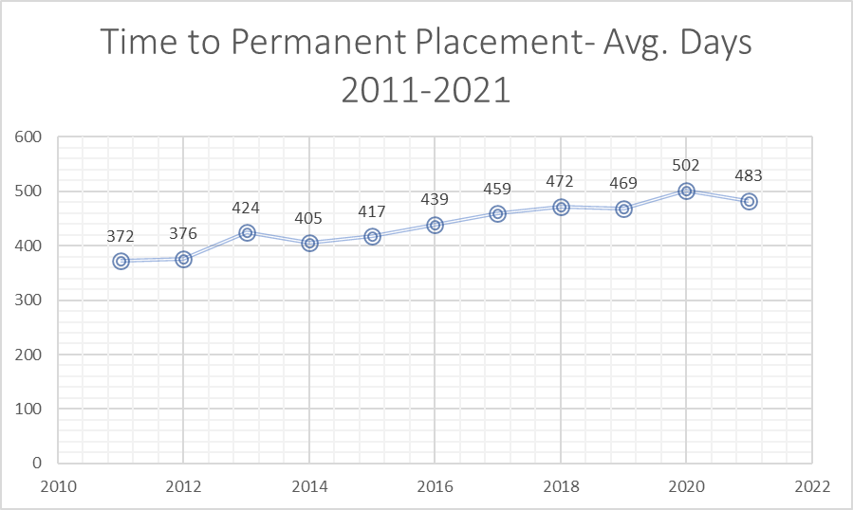

Update 2024:
This chart compares the number of new petitions filed for the year with the average time in days to permanency for the same year. When looking at the 10-year timeframe, the average days to permanent placement increased by 47%, however, the number of new cases increased by just over 50%. Time in average days to permanent placement measures the average (mean) time from filing of the original petition to the permanency achieved date for each child. This is calculated using all records for all respondents, including both original petitions filing date and the permanency achieved date.

Note: The number of new cases for 2022 is a preliminary number. The final reportable number is generally not available until Spring after the Court Statistician reviews, verifies, and finalizes the number.

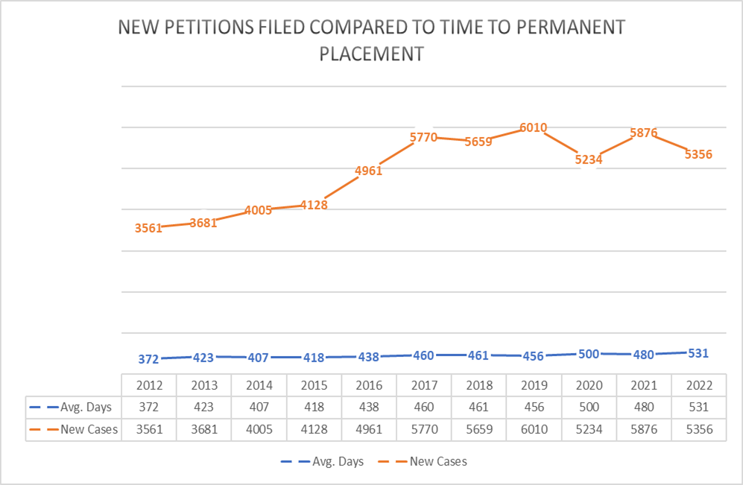

Other performance Measures

In early 2023, West Virginia became one of 11 states to implement a new series of performance measures called JCAMP (Judicial, Court, and Attorney Measures of Performance). The Court Improvement Program (CIP) currently uses a variety of performance measures that look at timeliness in abuse and neglect hearings. The JCAMP measures will augment these measures to collect a broad spectrum of data that will guide CIP and stakeholder efforts in systemic improvements to the child welfare system. A group of relevant stakeholders will be identified, assembled, and will guide this work. This project will be completed September 30, 2023.

Some supervisors have their own tracking systems for knowing when youth have been in out of home care for 15 of the last 22 months, however, there is no statewide uniform tracking system. A statewide protocol that does exist is in relation to staffing cases for decisions as to disposition. Specifically, the Standard Operating Procedure titled, “Dispositional Staffing”, contains information for an internal process that allows BSS to formulate a recommendation regarding termination of parental rights, legal guardianship, or an alternative disposition while facilitating concurrent planning and the timely transfer of appropriate cases to the adoption unit.
During design sessions for the state’s new CCWIS, processes are being put in place both to prompt workers for action when youth have been in care for 15 of the last 22 months and to track decisions at this point in the case work process regarding TPR.

In June 2017, CAS staff mailed 2,031 paper surveys to foster parents statewide to determine their rate of notification of hearings and whether they felt they were heard. Respondents had until August 31, 2017, to return the surveys. 651 respondents returned their survey yielding a 32% response rate. The responses were as follows:

- 27% of foster/adoptive parents are always notified of court hearings.
- 20% foster/adoptive parents always have their opinion heard at court hearings.
- 30% of foster children always attended MDTs when appropriate.
- 11% of foster children attending MDTs always had their opinion heard.
- It was felt MDTs always made the best decision for the foster child 24% of the time.
- 19% of foster/adoptive parents were always asked to be involved in case planning.

In February 2018 supervisors statewide were to address with staff as part of their monthly unit meeting the provision of support to foster care parents, including the need to ensure they are made aware of and invited to attend court proceedings. Specific policy and code sections were shared with supervisors to review with their staff on this important topic.
West Virginia currently has a dispositional tracking form for all cases in which children have been removed from the home and placed in foster care. The form tracks the removal date, date of each hearing and review, and a request to staff the case for termination of parental rights when children have been in care fifteen of the most recent twenty-two months. However, use of this form is sporadic. The state will incorporate the use of this form into periodic reviews completed by its Child Welfare Consultants and Regional Program Managers.

The BCF monitors the quality-of-service provision by Socially Necessary Service (SNS) providers through a review process that requires a score of 80% or above during the provider’s retrospective reviews for each service provided. When providers initially fall below 80%, they are given a six-month probation period wherein KEPRO (previously APS Healthcare) provides additional training and technical assistance. At the end of the six-month period, the service(s) falling below 80% is once again evaluated. If the service(s) still scores below 80%, it is closed, and the provider is no longer allowed to continue providing that service. In addition to the review process, in 2018 new agreements were developed with SNS providers that include new requirements and uniformity with monthly reports.

An average of thirty SNS providers are reviewed each year retrospectively to ensure they are providing IV-B Subpart II services as requested. Review rounds are 18-month cycles. Therefore, a provider scoring less than 80% on a specific service may not have reached the six-month re-review prior to this report. Providers who fell below 80% for a service during their normal review period were placed on probation for each service category that did not meet the 80% rule. At the end of the probation period, each provider goes through a follow-up review on the service(s) not meeting the 80% rule. If a provider falls below 80% on the services a second time, then the service will be closed for that provider. Providers may decide not to offer a specific service after receiving below 80%.

Training
The BCF Division of Training is responsible for the oversight, development, coordination, and delivery of training and professional development for BCF staff, foster parents, prospective foster parents, and providers statewide. The Mission of the Division of Training is to provide timely, comprehensive, competency-based training to new and tenured staff in a professional and consistent manner to assure quality delivery of services that promote the health and well-being of West Virginia’s families.
The Division of Training is constructed of a central office in Charleston and staff trainers that are out stationed across the state. Staff trainers must have four years of experience in the program area they train and be licensed as social workers with a master’s degree preferred. The Division of Training provides most of its staff training. Training is also provided through contracts with The Social Work Education Consortium (SWEC) and the West Virginia Coalition Against Domestic Violence (CADV). The Division of Training is also responsible for developing curriculum; developing presentations for meetings and events; ensuring that training conforms with BCF policy and procedures; coordinating joint and cooperative training initiatives for BCF employees, providers, and community stakeholders; acting as a liaison between BCF and the State’s SACWIS system; administering the Title IV-E training grants; and serving as an approved provider of Social Work Continuing Education Units (CEUs) through the West Virginia Board of Social Work.

Child Welfare Initial Staff Training is provided through its pre-service training, consisting of 220 hours taken over a nine to ten-week period. The training is constructed of a combination of online training to learn basic concepts, classroom training to learn how to apply the concepts, and transfer of learning activities in their local offices to see the concepts in action and build skills. The following table demonstrates the employees who were trained in 2018 by classification. Contracted employees are required to complete the same training as staff employees.
Classification of Employee | Number
Child Protective Services | 164
Youth Services | 29
Contracted Youth Services | 19
Adoption | 5
Home-Finding | 5
Centralized Intake | 5
TOTAL NUMBER TRAINED: | 238 Employees

Child Welfare pre-service training is designed to take the employee through the casework process. All Child Welfare employees are trained in Interviewing, The Court Process, and Children in Care and are broken out by program area for Initial and Family Assessment. The following table outlines the training that is completed by topic area.

Training Topic | Format | Hours
Orientation; Worker Safety; Introduction to Child Welfare Concepts | Online | 12 hours
Interviewing, Interview Taping, and Transfer of Learning | Classroom  Transfer of Learning | 36 hours
Intake Assessment and Preparing for First Contact | Classroom  Online | 16 hours
Initial Assessment (by program area) | Classroom  Transfer of Learning | 36 hours
Family Assessment and Case Planning | Classroom, Online,  Transfer of Learning | 26 hours
The Court Process | Classroom, Online,  Transfer of Learning | 28 hours
Children in Care | Classroom  Transfer of Learning | 24 hours
Case Documentation | Classroom | 42 hours
TOTAL HOURS: |  | 220 hours

At the end of the ninth week, after it has been verified that the employee has completed all 220 hours of training, staff must successfully complete a competency test before assuming a caseload. The competency test contains three sections: a written knowledge examination, a skills-based interview based on the employees’ program area, and a critical thinking examination to determine if the employee can make the correct decision based on information collected in the interview. The interview portion consists of actors role-playing a selected scenario with the employee interviewing the various members of the family. The employee must pass all three sections of the test with a score of 80% or above and may take the test up to three times. If the employee does not pass the test after three attempts, he/she must go back through new worker training from the beginning. Child welfare pre-service training must be completed before a caseload can be assigned according to law and for the purpose of Title IVE billing, and record checks are completed in FACTS every two weeks to ensure that no cases are assigned. If a caseload is found during the record check the trainer contacts the supervisor, CSM, and Regional Director to take action and have the caseload removed. The following table provides information on competency testing results in 2018.
Total Tested | Passed  1st Attempt | Passed  2nd Attempt | Passed  3rd Attempt | Did Not Pass
213 | 171 | 42 | 0 | 0

The Division of Training starts two Child Welfare training rounds per month, one north and one south. Students are registered through a centralized onboarding process where the students’ names are identified when Oasis processing begins the new hire process. The supervisor or CSM is contacted to enroll the student in a training round and get the student enrolled in Blackboard (BCFs’ learning management system for asynchronous online training). The employee can begin completing the initial online training starting on the first day of employment. The employee is scheduled to begin training within one to three weeks and may select either the next round or the closest round to the employee’s location. In 2018 the average time between start date and first day of training was 2.81 weeks, and the average time between start date and training completion (including competency testing) was 11.92 weeks.
The following data demonstrates the functioning of child welfare pre-service training in 2018.
Total number of Training Rounds | 22 Rounds
Total Number of Students Trained | 238 Students
Total Hours of Training Provided | 7,025 Hours
Average Time from Start Date to Training Start | 2.81 Weeks
Average Time from Start Date to Training End | 11.92 Weeks
Average Time from Training Start to Training End | 9.08 Weeks

In 2015 the West Virginia Legislature passed a law that allowed employees hired by the Department to have a degree not in social work or a related field, provided they participate in a four-year training plan created and provided by the Department. This law was passed because of workforce shortages in various parts of the state. In 2018, 18% of staff hired by the Department had a degree in social work, 52% had a related degree, and 30% had an unrelated degree. The inclusion of staff without social work training in the workforce has caused the Division of Training to reevaluate each training it provides to ensure that all the information is included about what an employee needs to perform child welfare jobs. Curriculum revisions and updates will continue over the next one to three years.

West Virginia has implemented a comprehensive training program for new supervisors in the past year that incorporates job-related training and management training provided by the West Virginia Division of Personnel (DOP) and the Department’s Office of Human Resource Management (OHRM). When new supervisors are hired, they are identified in the onboarding process and enrolled in the next series of “Putting the Pieces Together,” a nine-day curriculum for Child Welfare supervisors that was adapted from a training developed by the University of Colorado. The training consists of three three-day modules: Administrative Supervision, Supportive Supervision, and Educational Supervision and is directly related to their jobs as Child Welfare supervisors. West Virginia starts two new supervisor training rounds per year, and supervisors are required to complete the training in their first year as a supervisor. New supervisor training also consists of a Policy Review by the Child Welfare Consultants in the first 30 days of employment and an online training on documentation in the FACTS system. The following information demonstrates the functioning of supervisor training.
Total Child Welfare New Supervisor Training: | 18  Students | 6  Sessions | 108  Total Hours

West Virginia passed Initial Staff Training in the last Child and Family Services Review. There were some deficiencies identified in the area of supervisor training that were addressed by the development and implementation of the supervisor training plan in the last year. In the next five years the goals for Initial Staff Training are:
- Revise and expand initial staff training to include information related to the implementation of the Family First Prevention Services Act, including providing a greater emphasis on candidacy and in-home case planning and services.
- Develop and implement training for new positions in the CPS Career Ladder including CPS Senior and CPS Case Coordinator and training on mentoring (PIP).
- Revise new worker training for the implementation of the new C-WIS system.
- Develop and implement Child Welfare-specific training for new managers with an emphasis on those with a background in a program area other than Child Welfare.

Update 2023:

In July 2021 the Bureau for Children and Families (BCF) was reorganized into two bureaus: Bureau for Social Services and the Bureau for Family Assistance (BFA). All Child Welfare programs went under the newly created Bureau for Social Services. The Division of Training was also split between the two bureaus, with training staff placed under the bureau that was responsible for the programs they trained. The Division of Training (DOT) was renamed as the Division of Professional Development (DPD) during the reorganization. Initial reorganization activities were completed in December 2021 and continued into 2022. Also in 2021, BSS fully implemented the new child welfare support positions created as part of its Program Improvement Plan. New staff training rounds were implemented for those positions and put on the new worker training schedules.

The following information demonstrates the functioning of Initial Staff Training in 2021:
New Child Welfare Worker Training Staff Classifications:
Classification of Employee | Number/Full Round | Number/Partial Round
Child Protective Services | 120 | 13
Youth Services | 18 | 4
Contracted Youth Services | 9 | 1
Adoption | 4 | 3
Home-Finding | 2 | 3
Centralized Intake | 4 | 0
TOTAL NUMBER TRAINED: | 157 | 24

New Child Welfare Worker Training - Detailed Information:

Month | # Training Rounds Occurring/Month | #Training Rounds Starting/Month | # New Workers (Duplicated) | Hours  Classroom  Training | Hours  TOL training | Total  Training  Hours
January | 6 | 1 | 68 | 380 | 68 | 448
February | 5 | 1 | 65 | 258 | 46 | 304
March | 6 | 2 | 70 | 358 | 56 | 414
April | 5 | 1 | 58 | 336 | 68 | 404
May | 6 | 2 | 59 | 349 | 58 | 407
June | 5 | 1 | 44 | 342 | 64 | 406
July | 5 | 1 | 48 | 304 | 60 | 364
August | 5 | 2 | 44 | 406 | 64 | 470
September | 5 | 2 | 47 | 334 | 70 | 404
October | 6 | 1 | 61 | 332 | 56 | 388
November | 5 | 1 | 48 | 224 | 56 | 280
December | 5 | 1 | 49 | 314 | 64 | 378

New Child Welfare Worker Training - Summary:
Total number of Pre-service Training Rounds Started | 16 rounds
Total Number of Students Trained (unduplicated) | 181 students
Total Hours of Training Provided | 3,937 hours
Average Time from Start Date to Training Start | 22 calendar days
Average Time from Start Date to Training End | 104 calendar days
Average Time from Training Start to Training End | 82 calendar days

Competency Testing:
Total Tested | Passed  1st Attempt | Passed  2nd Attempt | Passed  3rd Attempt | Did Not Pass
156 | 123 | 31 | 2 | 0

New CPS Senior Training – Summary:
Total New CPS Senior Training: | 12  Students | 2  Rounds | 24  Total Hours

New CPS Case Coordinator Training – Summary
Total CPS Case Coordinator Training: | 7  Students | 1  Rounds | 16  Total Hours
New HHR Case Aide Training – Summary
Total HHR Case Aide Training: | 24  Students | 3  Rounds | 48  Total Hours

New Child Welfare Supervisor Training:
Total Child Welfare New Supervisor Training: | 26  Students | 2/ 9  Sessions/Days | 72  Total Hours
Update 2024:

During 2022, the Division of Professional Development (DPD) continued training new worker training in the virtual environment. DPD is having preliminary discussions about a hybrid new worker training schedule including returning to some “in-person” training. Additionally, the Bureau for Social Services (BSS) completed their reorganizational activities. One of their primary tasks was to address the staffing shortages. Lastly, West Virginia’s new SACWIS system went “live” on January 1, 2023. In preparation, DPD staff were trained in the new system in October 2022 and continued to prepare for the release of the new system.

The following information demonstrates the functioning of Initial Staff Training in 2022:

New Child Welfare Worker Training Staff Classifications:

Classification of Employee | Number/Full Round | Number/Partial Round
Child Protective Services | 143 | 30
Youth Services | 39 | 8
Contracted Youth Services | 24 | 2
Adoption | 5 | 11
Home-Finding | 9 | 7
Centralized Intake | 6 | 5
TOTAL NUMBER TRAINED: | 289 | 63

New Child Welfare Worker Training - Detailed Information:

Month | # Training Rounds Occurring/Month | #Training Rounds Starting/Month | #New Workers (Duplicated) | Hours  Classroom  Training | Hours  TOL training | Total  Training  Hours
January | 4 | 1 | 62 | 230 | 48 | 278
February | 4 | 1 | 56 | 212 | 38 | 250
March | 4 | 1 | 53 | 200 | 56 | 256
April | 4 | 1 | 66 | 240 | 46 | 286
May | 4 | 1 | 51 | 270 | 53 | 323
June | 4 | 1 | 47 | 218 | 32 | 250
July | 4 | 1 | 55 | 218 | 51 | 269
August | 5 | 2 | 82 | 270 | 38 | 308
September | 3 | 0 | 58 | 165 | 33 | 198
October | 4 | 2 | 59 | 216 | 22 | 238
November | 5 | 1 | 76 | 250 | 38 | 288
December | 5 | 1 | 76 | 330 | 43 | 373

New Child Welfare Worker Training - Summary:

Total number of Pre-service Training Rounds Started | 16
Total Number of Students Trained (unduplicated) | 352
Total Hours of Training Provided | 3317
Average Time from Start Date to Training Start | 20 calendar days
Average Time from Start Date to Training End | 83 days
Average Time from Training Start to Training End | 64 days

Competency Testing:

Total Tested | Passed  1st Attempt | Passed  2nd Attempt | Passed  3rd Attempt | Did Not Pass
225 | 176 | 41 | 8 | 0

New CPS Senior Training – Summary:

Total New CPS Senior Training: | 17  Students | 3  Rounds | 45  Total Hours

New CPS Case Coordinator Training – Summary:

Total CPS Case Coordinator Training: | 15  Students | 2  Rounds | 40  Total Hours
New HHR Case Aide Training – Summary:

Total HHR Case Aide Training: | 19  Students | 3  Rounds | 45  Total Hours

New Child Welfare Supervisor Training:

Total Child Welfare New Supervisor Training: | 26  Students | 2/9  Sessions/Days | 72  Total Hours
Ongoing Staff Training
West Virginia provides Ongoing Staff Training in two parts: In-service training, which takes place after pre-service training within the first year of employment; and professional development training, which is for tenured staff training after the first year of employment. Staff can register for training through GoSignMeUp, a software registration program. In-service training staff must complete 100 hours of combined classroom and online training that expands on the knowledge and skills learned in pre-service training. The Social Work Education Consortium, which consists of six public universities with accredited social work programs, provides part of the training to ensure that workers understand the concepts of social work. The following classes are required for Year One In-service Training:

Name of Training | Format | Hours | Provider
Introduction to Domestic Violence | Classroom | 6 | WVCADV
Substance Abuse | Class and online | 16 | SWEC
Working with Foster Parents/Caregivers | Classroom | 6 | SWEC
Legal and Ethical Issues in Social Work Practice 1 | Classroom | 6 | SWEC
Diversity and Cultural Factors 1 | Classroom | 12 | Staff
Human Behavior in the Social Environment 1 | Classroom | 12 | SWEC
Trauma-Informed Practice | Class and online | 9 | SWEC
Family Centered Practice for Permanency | Classroom | 6 | Staff
Family Engagement Principles | Classroom | 6 | Staff
Meaningful Contacts | Classroom | 6 | Staff
Critical Incidents in CPS Practice | Classroom | 6 | Staff
Online Job-Specific Training | Online | 13 | Staff
TOTAL HOURS: |  | 100

Feedback received from staff and supervisors has been that 100 hour of training after pre-service and within the first year of employment is too much. However, the 100 hours of training is currently written into the law that was passed for the restricted social work license and so cannot be reduced at this time. To compensate, the Division of Training plans to incorporate an additional week of training prior to competency testing to complete 28 hours of this training, and parts of some training are being made available online for better access.

The restricted license legislation also requires tenured staff training for the second, third, and fourth year of licensure at 60 hours per year (total 180 hours). West Virginia has been developing and implementing this training at a fast pace since 2015 when the legislation was passed, and all four years of training will be completed in the next year. This training consists of both classroom and online training provided by the West Virginia Coalition Against Domestic Violence, the West Virginia Social Work Education Consortium, and staff trainers. Training topics include yearly content on trauma-informed practice, culture and diversity, social work ethics, family engagement, and human behavior in the social environment (i.e., Systems Theory). The following information demonstrates the functioning of restricted license training in 2018.

Total Classroom Training: Year One | 1,966 Students | 117 Sessions | 900  Total Hours
Total In-Service Online Training: Year One | 2,486  Students | 16  Hours | 2,866  Total Hours
Total Classroom Training: Year Two | 636 Students | 30  Sessions | 1,974  Total Hours
Total Online Training: Year Two | 329 Students | 18  Hours | 3,866  Total Hours
Total Classroom Training: Year Three | 56  Students | 5  Sessions | 30  Total Hours
Total Online Training: Year Three | 85  Students | 18  Hours | 510  Total Hours
Total Online Training: Year Four | 11  Students | 6  Hours | 66  Total Hours

The Division of Training tracks the completion of this training and files a yearly report with the West Virginia Board of Social Work. To comply, staff must complete a minimum of 80% of the required training for their current year of licensure and 20 hours of CEUs every two years. Staff who fall below the 80% requirement must complete a corrective action plan with their supervisor and CSM to catch up with their training. Staff who have a regular license or regular provisional license must take ongoing training to maintain their licenses as well. Those with a regular license must take 40 hours of continuing education units every two years, and those with a regular provisional license must complete four college social work courses over four years and 20 hours of CEUs. In the past year BCF implemented a requirement for tenured staff and supervisors to complete 12 hours of job-specific training per year.

There are several strategies related to training in the PIP and the new five-year plan. Statewide and regional training for managers, supervisors, and staff will be implemented and held twice per year. In addition, all supervisors and managers will be required to complete a shortened version of the new supervisor training that was implemented last year and the Division of Training, along with representatives from policy and DPQI, will begin offering targeted training and technical assistance to district offices based on the results of their reviews. The training that has been developed for restricted license training will be opened to all staff and supervisors to meet the yearly 12-hour training requirement and for CEUs.

West Virginia did not pass the item for Ongoing Training in its last review, primarily because of a lack of supervisory training. The new supervisor training plan was implemented in the last year to address this issue, along with the requirement for 12 hours of job-specific training for supervisors and staff that will be tracked by their managers. The plan for ongoing training will include additional strategies to improve ongoing training for workers and supervisors. In the next five years the plan for Ongoing Staff Training includes:

- Develop and implement training for staff, supervisors, and managers on the Family First Prevention and Services Act, including training on candidacy, prevention services, case planning, and in-home services.
- Develop and implement trauma-informed training for supervisors and staff related to a) increasing the percentage of children who remain in their own homes safely, and b) increasing positive outcomes for youth aging out of foster care through targeted training for regional, district, and unit meetings.
- Develop and implement statewide and regional staff, supervisor, and manager meetings twice per year for training, skill development, and peer support. (PIP)
- Increase supervisor and manager skills through ongoing training and peer support to address their ability to support staff and provide direct supervision. (PIP)
- Provide ongoing training and technical assistance for supervisors and managers on reflective supervision in conjunction with Casey Family Programs. (PIP)
- Provide a condensed version of new supervisor training for all managers and supervisors and a requirement for them to attend. (PIP)
- Develop and implement teams consisting of representatives from Training, Policy, CWCs, and DPQI to provide targeted training and technical assistance to districts based on the results of their reviews.
- Develop and implement a plan to provide training and technical assistance to shift staff from a crisis orientation to a quality orientation as they come out of crisis, including the use of in-home services and case planning.
- Provide training and technical assistance to tenured managers, supervisors, and staff on the new C-WIS system and the use of data.
- Provide training and technical assistance for court personnel through the West Virginia Supreme Court/Court Improvement Program.

Update 2023:
In 2021 the Division of Professional Development continued to provide ongoing training virtually due to the COVID-19 pandemic. Ongoing staff shortages in critical needs positions and the large amount of training provided on new initiatives resulted in a decrease in staff attendance at ongoing training sessions. Initiatives related to West Virginia’s CFSR Program Improvement Plan continued including reflective supervision, regional and statewide meetings, and regional training for supervisors. Ongoing training related to managed care for foster care continued as well. West Virginia also initiated training for all child welfare staff on protecting social services recipients from discrimination. Casey Family Programs provided ongoing training on reflective supervision and customer services in child welfare.
New Initiatives:
Session Title | Number of Sessions | Session Hours | Number of Participants
Protecting Social Services Participants from Discrimination | 50 | 3 | 1214
Assessing Families and Case Planning | Self-Paced | .5 | 528
Responding to Runaway, Missing, or Abducted Children | Self-Paced | .5 | 326
Interstate Compact on the Placement of Children (ICPC) | Self-Paced | .5 | 299

Casey Family Programs:
Session Title | Number of Sessions | Session Length | Number of Participants
Peer to Peer Reflective Supervision Round 2 - Spring 2021 | 10 | 1.5 | 140
Customer Services in Child Welfare for Supervisors | 2 | 1.5 | 168
Customer Services in Child Welfare for Workers | 16 | 1.5 | 626

Aetna:
Session Title | Number of Sessions | Session Length | Number of Participants
Family Finding Orientation for BSS Management | 8 | 1.5 | 96

Ongoing Training Plan Requirements:
Live Training - Session Title | Number of Sessions | Number of Participants
Introduction to Domestic Violence | 7 | 110
Substance Abuse | 9 | 97
Working with Foster Parents/Caregivers | 9 | 81
Trauma-Informed Practice | 7 | 64
Critical Incidents in CPS Practice | 2 | 25
Diversity and Cultural Factors | 3 | 17
Legal and Ethical Issues in Social Work Practice | 8 | 48
Human Behavior in the Social Environment 1 | 11 | 68
Working with Families Experiencing Domestic Violence | 8 | 54
Secondary Trauma | 3 | 39
Family Centered Practice for Permanency | 1 | 7
Appalachian Culture | 2 | 18
Social Work Ethics in Practice | 1 | 11
Human Behavior in the Social Environment 2 | 4 | 18
Working with Domestic Violence Offenders | 1 | 18
Domestic Violence and Co-Occurring Tactics of Control | 1 | 10
Understanding Poverty | 2 | 16

Online Self-Paced Training - Session Title | Number of Hours/Session | Number of Participants
Trauma-Informed Practice | 2 | 137
Working with People with Disabilities | 4 | 110
Drug-Affected Infants | 4 | 98
Common Mental Health Disorders | 4 | 116
Human Trafficking | 4 | 88
Human Behavior in the Social Environment | 4 | 94
LGBTQ Issues in Casework Practice | 4 | 62
Engagement Principles/ Engaging Absent Parents | 4 | 56
Rural Social Work Practice | 4 | 45
Substance Abuse and Adolescents | 4 | 54
Family Resilience and Inclusion | 4 | 50
Diversity Informed, Trauma informed Practice | 4 | 43
Kinship Care | 4 | 55
Contemporary Issues in Diversity | 4 | 63
Family Dynamics | 4 | 46
Social Work Perspective | 4 | 29
Systems Theory | 4 | 35
Opioid Use | 4 | 44
Trauma Informed Practice and Out-of-Home Placement | 4 | 38
Using Technology in Social Work Practice | 4 | 38
Contemporary Issues in Social Work Practice | 4 | 43
Social Class in the U.S. | 4 | 31

Ongoing Supervisor Training:

Session Title | Number of Sessions | Session Length | Number of Participants
Statewide Supervisor Meeting – Spring 2021 | 2 | 5 | 175
Statewide Supervisor Meeting – Fall 2021 | 2 | 5 | 168

Update 2024:

The Division of Professional Development (DPD) continued to provide most of its ongoing training virtually. BSS’s continued staffing issues in critical positions continues to be a contributing factor in ongoing attendance. Along with DPD’s continuous ongoing training schedule and annual refresher trainings, DPD also conducted a statewide “in-person” training for all child welfare staff and supervisors reviewing policy changes made during the COVID-19 pandemic while training on the state’s CSED Waiver. West Virginia also initiated training for all child welfare staff on how the STAT Home Model complements existing foster care and CSED Waiver services. WV’s Manager Care Organization (Aetna) provided ongoing training on discharge planning.

New Initiatives:

Session Title | Number of Sessions | Session Hours | Number of Participants
Connecting Families to Success | 61 | 6 | 712
2022 Annual Refresher Protecting Social Services Participants from Discrimination | 58 | 2.5 | 962
2022 Critical Incident Refresher | Self-Paced | 1 | 364
An Introduction to West Virginia's Stabilization and Treatment Home Model (STAT) | Self-Paced | 1 | 689

Aetna:

Session Title | Number of Sessions | Session Length | Number of Participants
Aetna – Discharge Planning | 11 | 1.5 | 365

Ongoing Training Plan Requirements:

Live Training - Session Title | Number of Sessions | Number of Participants
Introduction to Domestic Violence | 6 | 60
Substance Abuse | 7 | 34
Working with Foster Parents/Caregivers | 7 | 48
Trauma-Informed Practice | 7 | 40
Critical Incidents in CPS Practice | 5 | 66
Diversity and Cultural Factors | 3 | 29
Legal and Ethical Issues in Social Work Practice | 7 | 36
Human Behavior in the Social Environment 1 | 6 | 28
Working with Families Experiencing Domestic Violence | 4 | 17
Secondary Trauma | 5 | 22
Family Centered Practice for Permanency | 2 | 10
Appalachian Culture | 3 | 16
Social Work Ethics in Practice | 4 | 18
Human Behavior in the Social Environment 2 | 4 | 15
Working with Domestic Violence Offenders | 3 | 12
Domestic Violence and Co-Occurring Tactics of Control | 2 | 13
Understanding Poverty | 4 | 25

Online Self-Paced Training - Session Title | Number of Hours/Session | Number of Participants
Trauma-Informed Practice | 2 | 121
Working with People with Disabilities | 4 | 99
Drug-Affected Infants | 4 | 74
Common Mental Health Disorders | 4 | 89
Human Trafficking | 4 | 61
Human Behavior in the Social Environment | 4 | 55
LGBTQ Issues in Casework Practice | 4 | 39
Engagement Principles/ Engaging Absent Parents | 4 | 46
Rural Social Work Practice | 4 | 30
Substance Abuse and Adolescents | 4 | 35
Family Resilience and Inclusion | 4 | 26
Diversity Informed, Trauma informed Practice | 4 | 34
Kinship Care | 4 | 38
Contemporary Issues in Diversity | 4 | 34
Family Dynamics | 4 | 24
Social Work Perspective | 4 | 21
Systems Theory | 4 | 25
Opioid Use | 4 | 29
Trauma Informed Practice and Out-of-Home Placement | 4 | 34
Using Technology in Social Work Practice | 4 | 27
Contemporary Issues in Social Work Practice | 4 | 20
Social Class in the U.S. | 4 | 19

Ongoing Worker Training:

Session Title | Number of Sessions | Session Length | Number of Participants
Child Welfare Regional Worker Meeting – Spring 2022 | 12 | 3 | 455

Foster Parent Training

West Virginia contracts with the member schools of the West Virginia Social Work Education Consortium (SWEC) to provide most of its foster parent training. SWEC trains all Department, and some providers foster and kinship homes through the Child Welfare League of America’s PRIDE model, including both pre-service and ongoing training. SWEC also trains some of the provider agency homes, although some agencies have chosen to become certified as PRIDE trainers and train their own foster parents. SWEC also provides trauma-informed practice training to foster families that is completed directly after pre-service training. In 2018, SWEC provided a total of 59 training rounds to 1,242 participants. Approximately 72% of the prospective foster parents who started the program completed the training. The schools also offer advanced Level II and Level III training to foster/adoptive parents. In 2016/2017 there were 162 advanced trainings held with 2,133 participants.
The SWEC universities collect a large volume of data for each of their respective programs. Pre-service training is evaluated after each session using a 10-point Likert scale, with 10 being the most positive score. The aggregate statewide mode for the training was over 9. Qualitative comments were almost uniformly positive, with the most frequent comments being, “the training was more helpful than I thought” and “I wish I had this training for my own kids”. Negative comments centered on facilities in which the training was held.
In addition to quantitative and qualitative continuous assessments, biannual surveys of foster parents are administered to assess the perception of foster parents of the efficacy of training longitudinally. The surveys found that after one and three years, the relevancy of the training mirrored the results of the training assessment immediately following the training. Furthermore, the surveys assessed what the foster parents perceived as content they needed to better address the needs of the foster children in their care. This data is juxtaposed with surveys of home finding specialists to assess gaps in needed content to discern future advanced in-service training more comprehensively.
West Virginia passed the systemic factor of Foster Parent Training in its last Child and Family Services Review. Plans are underway to further streamline and improve foster parent training in the state. Some of the provider agencies are currently piloting the new PRIDE blended model with positive results. In addition, BCF partnered with Casey Family Programs to assess its kinship care program and there will be recommendations related to training. The five-year plan for foster parent training includes the following.
- Develop and implement training for foster families, staff, and providers on subjects related to the implementation of the Family First Prevention Services & Treatment Act.
- Pilot the PRIDE blended model with provider agencies to assess if this model can be successful in West Virginia and implement statewide if it is successful.
- Implement changes to training based on the recommendations of the kinship care report completed by Casey Family Programs.
- Expand child-specific ongoing training opportunities for foster parents through a contract with the Foster Parent College and SWEC.

Update 2023:

In 2021, the West Virginia SWEC continued to provide training for new and potential foster parents in West Virginia with a focus on kinship care families. The majority of the training continued to be virtual due to the COVID-19 pandemic, although some of the schools provided face-to-face training in small groups for participants who were unable to participate in virtual training because of technology issues. Access to foster parent training was actually improved for most foster parents because they were able to attend a session anywhere in the state on the virtual platform, reducing the amount of time a foster parent had to wait for training because of the training’s location. The West Virginia SWEC also continued to provide PRIDE ongoing training for foster parents.

2021 Pre-Service PRIDE Trainings | Number of Rounds | Number of Starters | Number of Finishers
West Virginia University | 23 | 340 | 277
Marshall University | 18 | 143 | 112
West Virginia State University | 9 | 220 | 146
Shepherd University | 12 | 375 | 277
Concord University | 33 | 395 | 333
Total PRIDE Pre-Service Training | 95 | 1,473 | 1,145
 | Rounds | Participants | Finishers

2021 In-Service PRIDE Trainings | Number of Sessions | Number of Participants
West Virginia University | 12 | 89
Marshall University | 2 | 30
West Virginia State University | 2 | 24
Shepherd University | 25 | 326
Concord University | 8 | 55
Total PRIDE Pre-Service Training | Sessions-49 | Participants-524

Update 2024:

In 2022, the West Virginia SWEC continued to provide training for new and potential foster parents in West Virginia with a focus on kinship care families. The majority of the training continued to be virtual; however, some in-person training continued. Foster Parent participants continue reporting the virtual platform is more conducive to their needs.

2022 Pre-Service PRIDE Trainings | Number of Rounds | Number of Starters | Number of Finishers
West Virginia University | 21 | 332 | 260
Marshall University | 16 | 133 | 100
West Virginia State University | 10 | 233 | 169
Shepherd University | 14 | 268 | 255
Concord U332niversity | 29 | 447 | 406
Total PRIDE Pre-Service Training

 | Rounds | Participants | Finishers

Staff and Provider Training

The Department, in conjunction with the states Court Improvement Program, developed provider training for Child Placing Agencies and Residential Treatment Facilities and placed it on the Department’s BCF website. The training includes a video titled “The Time is Now”, Away from Supervision Training and Normalcy and Prudent Parenting Training.

The video titled “The Time is Now” is for parents in West Virginia child abuse and neglect proceedings and explains the procedure for child abuse and neglect cases. This training is a great resource for providers to be informed about the process for parents and children.

The Away from Supervision Training includes the Child Abuse Prevention and Treatment Act requirements for state agency staff as well as provider staff caring for youth in foster care. This training includes policy and procedures for guidance in the event a child runs away while in out-of-home care.
The Normalcy and Prudent Training includes requirements for the IV-E agency and provides training to help ensure staff are following a reasonable and prudent parenting standard of care which includes activities typical for children. Following these requirements allows for youth in foster care to lead as normal a life as possible and thereby reduces the risk of running away and falling prey to trafficking.

In addition to the training developed and provided on the Department’s website, the West Virginia Rules for Child Placing Agencies §78-2 and Residential Child Care and Treatment Facilities §78-3 require specific training.

The Child Placing Agencies §78-2 requires:

Child placing agencies require that all employees involved in child placing services, within three (3) months of employment, complete a minimum of forty (40) hours of orientation training in areas including:
- Agency philosophy and goals
- Agency operations overview
- Protocol for emergencies and incidents
- Confidentiality
- Universal precautions
- Infectious and communicable disease
- The risks of exposure to infectious agents, materials and instruments, and the control and disposal of them
- Licensing rules and legal aspects of substitute care
- Service planning
- Interviewing
- Conflict resolution
- Crisis intervention and passive restraint
- Mandatory abuse/ neglect reporting
- First Aid
- CPR

Child placing agencies require that all employees providing direct services to clients receive at least twenty (20) hours of ongoing training within six (6) months of employment in areas including:
- Assessment of family dynamics
- Human growth and development
- Values and cultural diversity
- Ethics
- Child abuse and neglect issues
- Behavior management

Child placing agencies require that after the first year of employment all employees providing direct services to clients complete a minimum of twenty-five (25) hours of training per year, fifteen (15) hours of which shall be directly related to the employee's responsibilities.

Residential Child Care and Treatment Facilities §78-3 requires:

Residential providers are to orient all new employee to the following topics within the first 10 days of employment:
- Agency mission, philosophy, and goals
- Agency services, policies, and procedures
- Agency’s CQI program
- Confidentiality and disclosure of information, including federal confidentiality requirements and penalties for violation.
- Legal rights of the person served.
- Mandatory reporting procedures for suspected abuse/ neglect
- Identifying and documentation of incidents
- Responsibility to abide by professional ethics.
- Fire drills
- Procedures for medical and psychiatric emergencies, including notification of guardians.

Residential providers are required to train all clinical and direct care employees on the following topics within 30 days of employment:
- Basic medical needs and problems of the population served.
- Basic first aid and medication reactions (updated every 3 years)
- CPR (every 2 years)
- Supervision of self-administration of medication as applicable, including typical medications prescribed, appropriate dosages & schedules and common side effects.
- Basic de-escalation techniques and passive restraints
- Protocols for universal disease precautions and providing services to children with contagious and infectious diseases.
- Appropriate management of suicidal threats or behaviors
- Children’s trauma stress experiences, to include impact on development, behavior, and relationship; types of traumas; cultural factors; recognizing how on-going stressors impact child traumatic stress; responding to crises with interventions; strategies and interventions to promote resiliency & health.
- Food handler’s certification as necessary
- Agency’s policy defining & prohibiting corporal and degrading punishment.
- Procedures for maintaining a safe, hygienic, and sanitary environment, including retarding the spread of infection and proper storage of cleaning supplies and hazardous materials.

Residential providers are required to train all program employees with direct care responsibilities on the following topics within 90 days of employment:
- Sensitivity to differences in cultural norms and values
- Management of children attempting to escape supervision.
- Sensitivity to sexual identity (LGBTQ)
- Family dynamics, including human growth and development.
- Proper documentation techniques
- Basic therapeutic or behavior management techniques

Residential providers are required to provide annual training to employees on the following topics throughout employment:
- Supervision of self-administration of medication as applicable, including typical medications prescribed, appropriate dosages, schedules, and common side effects.
- Basic de-escalation techniques and passive restraints
- Protocols for universal disease precautions and providing services to children with contagious and infectious diseases.
- First Aid certification to be renewed every three years.
- CPR certification to be renewed every two years.

The Child Placing Agency and Residential Child Care and Treatment Facilities have an annual on-site visit and a licensing review every two years. To ensure that training is occurring statewide for current foster parents, adoptive parents, and staff of state-licensed facilities, the Licensing Specialist reviews employee/foster parent files and training records and interviews current employees and foster parents.
To ensure that the training foster/adoptive parents and Residential Treatment employees receive adequately prepares them to care for the needs of West Virginia foster children, BCF is developing a survey that will allow for the collection of valuable data to gain information in real time. Agencies will be able to learn from the results and turn the data into useful content to further engage and train foster/adoptive parents and residential staff.

The survey will be provided to West Virginia Child Placing Agencies and Residential Child Care and Treatment Facilities. The agency/facility will administer the survey quarterly. The agencies will be required to compile and maintain the quarterly data and provide the data to BCF annually. After the quarterly survey has been given, the Child Placing and Residential Treatment agencies must address any training needs the survey identifies as lacking.

As part of the review process, the licensing specialist will review the survey data to ensure identified training needs are being addressed by the agency/facility. The Specialist will interview 10% of foster/adoptive parents or Residential Treatment employees. The interview will address an agency that provides training to determine if the training meets their needs and prepares them to do their job duties effectively and adequately care for West Virginia foster children.

Update 2022:
The Residential Child Care and Treatment Facilities and Child Placing Agencies have an annual on-site visit and a licensing review every two years. The Licensing Specialist reviews employee/foster parent files and training records and interviews current employees and foster parents to ensure that training is occurring as directed.

BCF developed and distributed surveys to the Residential Treatment Providers and the Child Placing Agencies to ensure staff are being adequately trained to care for the needs of West Virginia foster children. The providers survey their staff and foster parents quarterly and provide additional training when needed. The BCF licensing specialists have incorporated this into the review process.

The Minimum Licensing Requirements for Residential Child Care and Treatment Facilities for Children and Transitioning Adults in West Virginia §78-3 is being updated during the 2021 Legislative Session to include the survey requirement for staff. The Child Placing Agency survey requirement will be incorporated into their contract.

Rule §78-3 was updated during the 2020 Legislative Session to include training for all employees on interacting with victims of sex trafficking.

Update 2023:
No 2023 Update

Update 2024:
No 2024 Update

Quality Assurance System
Operating in the jurisdictions where the services included in the CFSP are provided
The Department’s BCF has a comprehensive Quality Assurance (QA) System. The Department’s QA system is centrally administered, operates in all jurisdictions of the state, and is part of an overall Continuous Quality Improvement (CQI) process. Most QA functions are administered by the DPQI. DPQI is under the Office of Planning, Research, and Evaluation. West Virginia has 12 designated DPQI staff for the purpose of providing quality assurance and includes three Program Managers, nine Health and Human Resource Specialist Seniors, and one DPQI Director. These staff members are stationed in various offices located across the Department’s four regions.
West Virginia’ s quality assurance system evaluates social services case management activities and decisions in the areas of Child Protective Services from initial abuse/neglect report to case closure, Youth Services cases with and without judicial oversight, Critical Incidents, and Intake Assessments as received by West Virginia Centralized Intake.
DPQI completes CFSR style social service case reviews for each of the Department’s districts. One district level review is completed each month by DPQI staff. The review includes the examination of randomly selected cases consisting of in-home and out-of-home placement cases. The largest metropolitan area is reviewed at least once each calendar year. The review cycle is continued until each district has been reviewed.
The BCF comprises Community Services Districts that are divided into four regions. DPQI completed 125 CFSR style case reviews during the 2018 FFY. The FFY 2018 data is based on the review of social services cases between October 1, 2017, to September 30, 2018. The review consisted of 65 foster care and 60 in-home social service cases. Case reviews conducted were reflective of practice that occurred approximately 12 months prior to the date of the review. CFSR style case reviews were completed in each of the four regions of the state and included the following districts: Calhoun/Gilmer/Wirt, Fayette, Monongalia/Marion, Wood, Jackson/Roane/Clay, Cabell, Kanawha, Putnam/Mason, Berkeley/Morgan/Jefferson, Lewis/Upshur/Braxton, Wyoming, Greenbrier/Summers/Monroe/Pocahontas.
In July 2014, WV established a centralized intake system. Statewide implementation was phased in starting in July 2014 with full statewide implementation by February 2015. Centralized Intake call centers are located in the northern and southern parts of the state. DPQI is responsible for the sampling and review of intake assessments. DPQI provides ongoing feedback to the Director of Centralized Intake as well as the Deputy Commissioner over Centralized Intake and the Commissioner. Each reviewer, in addition to other assignments, is randomly assigned ten Centralized Intakes to review each month. In addition to these ten, each review team also reviews any accepted intakes received on their monthly on-site case reviews. From May of 2018 to May of 2019 DPQI staff completed 618 reviews on intakes received by Centralized Intake.
West Virginia has established an internal child fatality review committee to review all child deaths due to child abuse and neglect and child near fatalities. Cases that are deemed by the internal review team to need an intensive level of review are reviewed by a member of DPQI in conjunction with two representatives from field staff. The results are reviewed by an internal review team quarterly. The objective is for the team to learn from these fatalities and near fatalities in order to prevent similar deaths in the future.
In order to improve outcomes DPQI recommended the BCF institute a quality assurance process that incorporates local, regional, and state level Quality Councils. The Quality Councils process includes DPQI case review of districts, development of a district Corrective Action Plan (CAP) based on review results, and submission of the CAPS to agency leadership. The DPQI Case Review and resulting exit report begin the CQI process at the district and regional levels. This process continues through to the state level utilizing the Child Welfare Oversight Team (CWO) to monitor child welfare data by state, region, and district. Each district has a corrective action plan, which is sent to the regional Quality Council for review and monitoring. The regional Quality Councils meet on a quarterly basis and have staff that represent each district and each level of management including CPS workers, supervisors, coordinators, YS workers, CSMs, and child welfare consultants. The CWO team is composed of individuals on the state level and key stakeholders that can impact child welfare in a way that the district and regions are not able to. The CWO team reviews and provides feedback on stakeholder surveys. The team also reviews surveys for statewide trends and provides feedback to the regions and/or divisions. This data is reported to the regional Quality Councils to process and incorporate into their regional plans as needed.
The DPQI unit also completes targeted reviews and related activities. For example, during FFY 2018 DPQI staff assisted in the merging of duplicate customers in the Family and Child Tracking System. This is being done to eliminate data quality errors and to prepare for conversion to the new automated child welfare reporting system.
In addition to the data and information collected through the CFSR style case review process, DPQI staff also collect additional information during the onsite reviews. This information includes such things as whether or not foster parents are notified of court hearings and MDTs, if domestic violence is indicated in the case if services were needed in the case but not provided due to not being available in the area. This information is provided in the exit summary reports and used for state planning purposes.
Have standards to evaluate the quality of services
Standards to ensure that children and families are provided quality services that protect their safety and health, from referral intake to the achievement of permanency, are defined by federal and state laws and Department policy, at https://dhhr.wv.gov/bss/policy/Pages/default.aspx . Department outcome measures are based on federal requirements and state policy. Department BCF staff have access to an internal data dashboard that captures outcome data. This includes the timeliness of initiating investigations of child maltreatment compared to the assigned time frame.
Regulations and standards for West Virginia foster homes and institutions can be found in Systemic Factor G. Foster and Adoptive Parent Licensing, Recruitment, and Retention.
In order to evaluate the state’s efforts to improve performance in the areas of safety, permanency, and wellbeing, DPQI utilizes the federal CFSR process as a model to measure and evaluate the state’s performance for the above-mentioned areas. DPQI utilizes the January 2016 version of the Federal CFSR OSRI as the unit’s primary internal tool for evaluating the quality of delivery of services to children and families. The OSRI evaluates the quality of service delivery to children and families. Each review follows the guidelines established by the Federal Bureau for Children and Families. Pairs of DPQI reviewers complete a review of the paper and electronic records and conduct key case participant interviews to evaluate adherence to policy and practice standards. The goal of the reviews is to improve practice to achieve positive outcomes for the children and families being served. The period under review covers a 12-month section of time going backwards from the start of the review date to 12 months prior. Preliminary case reviews to collect information are done related to FACTS records only. From this, reviewers develop a list of questions and information needed to complete the CFSR review. DPQI review teams then conduct interviews with designated stakeholders including the case worker, parents, service providers, placement providers, youth if age appropriate and any other parties who may have information relative to the case review. DPQI reviewers also review the paper file for additional information as part of the review process and include this information in review findings.
After the cases are rated each case is debriefed. At a minimum, case debriefings are composed of two review teams and a DPQI program manager. During these debriefings, case ratings are discussed in relation to CFSR instrument instructions and clarification guides to ensure fidelity to the tool. DPQI program managers then complete initial and secondary QA activities.
Identifies strengths and needs of the service delivery system
The DPQI social services case review data provides for continuous quality improvement through the identification of the district’s strengths and areas in need of improvement. The review data is used at the district level to evaluate case practice and assist districts in making improvements in the provision of services to children and families. After completion of the CFSR style reviews, exit conferences are held at the district offices where DPQI staff assists the district in interpreting the results of the review. At the exit conference the data indicators, based on the 18 items reviewed, are discussed with the district. The district is also provided with a comparison chart from their prior review. At that time, an exit interview is conducted by DPQI staff with the district’s management staff. During the exit conference, district management staff can comment on the factors that contributed to the strengths and areas in need of improvement. Additionally, districts are asked to identify services not available or accessible in the area. DPQI creates a list of base questions to be asked at all the exit interviews. The questions are based on the previous Federal Fiscal Year data and the overall issues impacting practice within the State.
The Critical Incident Field Review Team performs a detailed review of the facts and circumstances surrounding a critical incident involving a child alleged to have died or been critically injured as a result of abuse and/or neglect. This includes, but is not limited to, a review of current child protective services, child, and family history of abuse and/or neglect, BCF interventions, and services provided by external providers. Interviews are conducted with staff and external providers. A search of FACTS is conducted to identify the CPS or YS history of the family. All Intake Assessments are reviewed to determine if the screening decision follows the code and policy. All assessments are reviewed to determine if the findings are correct and procedures for completing the assessment adhere to policy. Case plans and safety plans are reviewed to determine if the plans appropriately addressed the identified problems in the home. All case contacts are reviewed to determine the quantity and quality of caseworker interaction with the family. All services are reviewed to ensure requests were made in a timely manner and the provider delivered the requested services. Through the review process, gaps in service availability and provision are identified. The findings are of each case reviewed at the quarterly critical incident review meeting and the team determines if the critical incident was due to abuse and neglect.
Provides relevant reports
DPQI staff utilizes the CFSR OMS developed by JBS International to complete case reviews and develop relevant reports. The OMS is available for states to use not only for the Federal CFSR, but also for continuous quality improvement (CQI) purposes. The OMS is a web-based application that provides DPQI staff with the ability to complete case reviews and provide relevant district, regional, and state level reports. Because the OMS is automated it reduces the risk of reviewer error in completing the OSRI.
Following the social service review exit interview with the district management team, DPQI completes a comprehensive report on the results of the review. The exit summary report is then provided to the district for review and comments. DPQI provides this information to CAS and the Program Manager for Community Partnerships for the identification of service needs and development of services. Districts complete a corrective action plan based on the identified areas needing improvement as outlined in the exit summary. DPQI compiles the exit summary, data and corrective action plan for each district and distributes the findings to the district’s management staff, the Regional Program Manager, Regional Director, Director of Training, Policy Program Specialists, and BCF Leadership.
DPQI provides ongoing feedback to the Director of the Centralized Intake Unit (CIU) and the training staff assigned to the unit. The CIU utilizes the results of the reviews to improve the quality of the intakes and adhere to the fidelity of the screening process.
The Critical Incident Review Team develops recommendations for modification of internal procedures, policies or programs of the BCF; identifies programmatic or operational issues that point to the need for additional internal training or technical assistance; develops recommendations for external stakeholders to assist in the effort to reduce or eliminate future child fatalities through improved services to children and families, and; identifies community resources for children and families that are needed but currently unavailable or inaccessible. The Critical Incident Review Team submits an annual report to the Commissioner of the BCF for presentation to the state legislature. The report can be found at: https://dhhr.wv.gov/bss/reports/Pages/Critical-Incidents.aspx .
Evaluates implemented program improvement measures
West Virginia’s quality assurance system utilizes data from various sources to monitor the efficacy of program improvement measures. The State utilizes CFSR style social service review data in conjunction with the State’s data profile (contextual data report), and data from the State’s SACWIS in the development, planning, and monitoring of CFSP goals and other statewide child welfare initiatives.
As indicated earlier, results of the social services reviews are used by districts to develop corrective action plans. The comparison chart provided to the districts at the social services review exit conferences and discussion of the corrective action plan developed at the conclusion of the prior review allow management staff to evaluate the efficacy of the strategies for improvements that were implemented.
The CIU utilizes the results of the DPQI intake assessment reviews, along with feedback from external stakeholders, to improve the quality of the intakes and improve fidelity to the Safety Assessment and Management System. The information is also used to ensure uniformity in screening decisions.
West Virginia intends to use state generated data and information from its CQI process for PIP monitoring and measurement of performance. Measurement of systemic factors will be by completion of the key activities associated with each strategy associated with the factor. Measurement of CFSR items and associated outcomes will be measured by completion of social services case reviews completed by the Division of Planning and Quality Improvement.
Update 2023:
Changes began last year within the Department in an effort to improve the child welfare system in West Virginia. These changes include The BCF being divided into two different bureaus. The new BSS will oversee child welfare programs in the state. Due to ongoing restructuring the information provided in the Quality Assurance Systemic Factor section of this document may change over the next calendar year. No revisions will be made to the DPQI social services case review process during the PIP reporting process.
Operating in the jurisdictions where the services included in the CFSP are provided.
The Department’s BSS continues to have a comprehensive Quality Assurance (QA) System. The Department’s QA system is centrally administered and operating in all jurisdictions of the state and is part of an overall Continuous Quality Improvement (CQI) process. Most QA functions are administered by the DPQI. DPQI is under the direction of the Office of Quality Control. West Virginia has 13 designated DPQI staff for the purpose of providing quality assurance which includes three Program Managers, nine Health and Human Resource Specialist Seniors, and one DPQI Director. These staff members are stationed in various offices located across the Department’s two regions.
West Virginia’s quality assurance system evaluates social services case management activities and decisions in the areas of 1) Child Protective Services, from initial abuse/neglect report to case closure, 2) Youth Services cases, with and without judicial oversight, 3) Critical Incidents, and 4) Intake Assessments as received by West Virginia Centralized Intake.
DPQI completes CFSR style social service case reviews for each of the Department’s districts. One district level review is completed each month by DPQI staff. The review includes the examination of randomly selected cases consisting of in-home and placement cases. The largest metropolitan area is reviewed once each calendar year. The review cycle is continued until each district has been reviewed. Additional data and information are collected through the CFSR style case review process. This information is provided in the exit summary reports and used for state planning purposes.
BSS comprises Community Services Districts that are divided into two regions. The FFY 2021 social service case reviews were completed utilizing the January 2016 version of the Federal CFSR OSRI as the unit’s primary internal tool for evaluating the quality of service delivery to children and families. Case related information is entered into the Online Monitoring System (OMS) and reports generated from that system are used for evaluating continuous quality improvement efforts within BSS. Administrative data reports, information from stakeholders, and other data sources are also used to update the assessment of performance.
DPQI completed 125 CFSR style case reviews during the 2021 FFY. The data set is based upon the review of social services cases between October 1, 2020, to September 30, 2021. The review consisted of 65 foster care and 60 in-home social service cases. DPQI staff conducted 741 interviews during FFY 2021. Of the interviews completed, 78 were with children, 183 were with parents/caregivers (biological/adoptive/legal guardians/live-in-paramours/caregivers), 58 were with foster parents, and 120 were judicial staff such as attorneys, guardians-ad-litem, juvenile probation officers, and Court Appointed Special Advocates, and the remainder were with other parties who may have information relative to the case review. Case reviews conducted were reflective of practice that occurred approximately 12 months prior to the date of the review. CFSR style case reviews were completed in each of the two regions of the state and included the following districts: Kanawha, Greenbrier/Monroe/Pocahontas/Summers, Fayette, Wood, Putnam/Mason, Jackson/Roane/Clay, Barbour/Preston/Taylor, Nicholas/Webster, Mercer, Cabell, Logan, and Lincoln/Boone.
In July 2014, WV established a centralized intake system. Statewide implementation was phased in starting in July 2014 with statewide implementation by February 2015. Centralized Intake call centers are located in the northern and southern parts of the state. DPQI is responsible for the sampling and review of accepted intake assessments. DPQI provides ongoing feedback to the Director of Centralized Intake as well as the Deputy Commissioner overseeing Centralized Intake and the Commissioner. Through December of 2021, DPQI conducted approximately 90 reviews of maltreatment intake reports monthly. The reviews were conducted from a random sample pull and primarily assessed the sufficiency of the information gathered during the intake process. The areas assessed included demographic information that would help identify and locate the family, such as names and addresses. DPQI also assessed the inclusion of absent parents, collateral sources of information, and current locations of household members for immediate and timely responses. The reviews conducted by DPQI also assessed the sufficiency of information related to the extent of the reported maltreatment, the surrounding circumstances of the reported maltreatment and whether additional, pertinent information was gathered related to child and adult functioning. Information sufficiency regarding the presence of domestic violence, substance abuse and other safety and risk factors were also assessed as was whether or not the Centralized Intake worker had searched the FACTS system to ascertain a history or any open assessments and/or cases on the family. Examples of data collected by DPQI during the Centralized Intake reviews and provided to the Director of Centralized Intake and the Deputy Commissioner over CI are presented below.

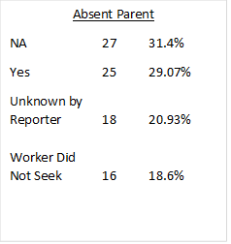
CENTRALIZED INTAKE REVIEWS WITH ABSENT PARENT JUNE 2021 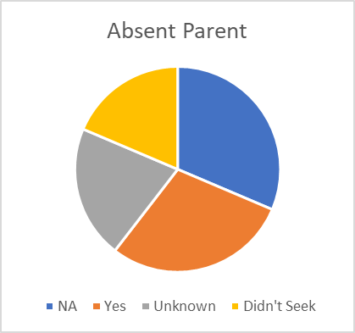Source: DPQI Centralized Intake Review Data

CENTRALIZED INTAKE REVIEWS WITH COLLATERALS JUNE 2021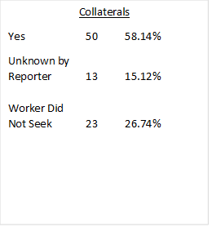 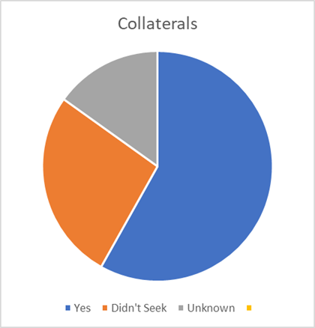
Source: DPQI Centralized Intake Review Data

CENTRALIZED INTAKE REVIEWS WITH NAMES JUNE 2021
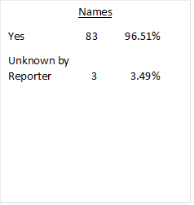 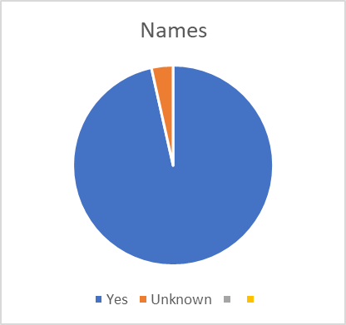 Source: DPQI Centralized Intake Review Data
West Virginia has established an internal child critical incident review team to review all child deaths and near fatalities alleged to be the result of child abuse and neglect. Critical incidents determined to meet the review criteria are reviewed by a member of DPQI in conjunction with two representatives from field staff. The results are reviewed by an internal review team quarterly. The objective of the review is to gather insight surrounding casework practice to prevent future critical incidents. Specific review criteria are outlined in the Critical Incident Review SOP document, updated July 2021.
West Virginia has instituted a continuous quality assurance process that incorporates three levels of continuous quality improvement oversight councils. They are the district level, the regional level Quality Councils and the state level CWO. The CWO meets on a quarterly basis. The Continuous Quality Improvement Council process currently in place includes DPQI case review of districts, development of a district corrective action plan (CAP) based upon review results, and submission of the CAPS to agency leadership. The DPQI case review and resulting exit report begin the CQI process at the district and regional levels. This process continues through the state level utilizing the CWO to monitor child welfare data by state, region, and district. The Quality Councils at each level provide a feedback loop. Each Council is composed of peer representation who then reports the information back to staff in each local office. At the Regional level, representatives from the local councils meet to discuss issues that have arisen at the local level that cannot be resolved there. They also review corrective action plans and goals currently in place to determine if progress is being made or if goal changes need to occur. The regional Quality Council also reviews and discusses regional trends and issues as they relate to service delivery. Feedback is given to each staff member via the minutes of the meeting. The CWO provides feedback to each Regional Director, who is a member of the State Council. Each is provided with a spreadsheet containing the issues and results. This spreadsheet, along with minutes of the CWO meeting, is shared with all staff. The CWO utilizes case review data, stakeholder surveys, AFCARS, NCANDS and NYTD data to drive change within the organization to improve outcomes for children and families.
The DPQI unit also completes targeted reviews and related activities. In 2021 the DPQI Unit conducted a threshold analysis on the screening decisions by Centralized Intake and the correlating assessment outcomes. DPQI conducted 400 intake reviews from a random sample pull to be used for this analysis. During this process, the unit followed the intakes out 120 days to determine whether repeat reports of maltreatment were received and whether any intakes received during that time frame resulted in an open maltreatment case. The information was compiled and provided to the Capacity Center for States for data analysis. The largest percentage of results for the data sample and the in-depth case reviews was the category of “false positive”. This category reflects where CI accepted a report for investigation, but the assessment did not result in findings of abuse or neglect and no additional reports were received (within 120 days) that resulted in any findings or open cases. This category was found to be at 46.1%. CI is currently conducting an in-depth study of the false positive cases to evaluate the screening decision and the sufficiency of the resulting maltreatment assessment. The results of this study will be used to ensure that screening decisions and maltreatment assessments are consistent and meet policy guidelines. The threshold analysis workgroup will continue to meet to review the outcome of these reviews and to make recommendations regarding our intake process and screening decisions.
Standards to evaluate the quality of services
Standards to ensure that children and families are provided quality services that protect their safety and health, from referral intake to the achievement of permanency, are defined by federal and state laws and Department policy, at https://dhhr.wv.gov/bss/policy/Pages/default.aspx . Department outcome measures are based on federal requirements and state policy. Department staff have access to an internal data dashboard that captures outcome data. This includes the timeliness of initiating investigations of child maltreatment compared to the assigned time frame.
Regulations and standards for West Virginia foster homes and institutions can be found in Systemic Factor G. Foster and Adoptive Parent Licensing, Recruitment, and Retention.
In order to evaluate the state’s efforts to improve performance in the areas of safety, permanency, and wellbeing, DPQI utilizes the federal CFSR process as a model to measure and evaluate the state’s performance for the above-mentioned areas. DPQI utilizes the January 2016 version of the Federal CFSR OSRI as the unit’s primary internal tool for evaluating the quality of delivery of services to children and families. Each review follows the guidelines established by the Federal Bureau for Children and Families. Pairs of DPQI reviewers complete a review of both the paper and electronic records and conduct key case participant interviews to evaluate adherence to policy and practice standards. The goal of the reviews is to improve practice to achieve positive outcomes for the children and families being served. The period under review covers a 12-month section of time going backwards from the start of the review date to 12 months prior. Preliminary case reviews to collect information are done related to FACTS records only. From this, reviewers develop a list of questions and information needed to complete the CFSR review. DPQI review teams then conduct interviews with designated stakeholders including the case worker, parents, service providers, placement providers, youth if age appropriate and any other parties who may have information relative to the case review. DPQI reviewers also review the paper file for additional information as part of the review process and include this information in review findings.
After the cases are rated, each case is debriefed. At a minimum, case debriefings are composed of two review teams and a DPQI program manager. During these debriefings case ratings are discussed in relation to CFSR instrument instructions and clarification guides to ensure fidelity to the tool. DPQI program managers then complete initial and secondary QA activities. During CFSR Round 3 case reviews, and PIP implementation measurement periods, ACF Children’s Bureau provides secondary oversight on a percentage of the cases reviewed by DPQI.
Identifies strengths and needs of the service delivery system
The DPQI social services case review data provides for continuous quality improvement through the identification of the district’s strengths and areas for improvement. The review data is used at the district level to evaluate case practice and assist districts in making improvements in the provision of services to children and families. After completion of the CFSR style reviews, exit conferences are held at the district offices where DPQI staff assist the district in interpreting the results of the review. At the exit conference, the data indicators, based on the 18 items reviewed, are discussed with the district. The district is also provided with a comparison chart from their prior review. At that time, an exit interview is conducted by DPQI staff with the district’s management staff. During the exit conference, district management staff can comment on factors that contributed to the strengths and areas needing improvement. Additionally, districts are asked to identify which needed services are not available or inaccessible in the area. DPQI creates a list of base questions to be asked at all the exits. The questions are based on the previous FFY data and the overall issues impacting practice within the State. During the exit, DPQI staff discuss the prior CAP activities and if they appear to have been impactful in relation to improving outcomes for children and families.
The Critical Incident Field Review Team completes a review of the child fatality or near fatality when the family has a previous child welfare history within the prior twelve months. In FFY 2020, review of IIU cases was added to the Critical Incident SOP. These cases involve children who are in foster care at the time of the critical incident. These children are reviewed through the same process as non-custody critical incident reviews. This process includes a thorough review of all current and historical case documentation. The team conducts interviews with agency staff, service providers and investigating officers who have been involved with the family during the 12-month period. The internal review process is a quality assurance process which looks at practice, policy, and training to determine whether there are areas that, if improved, could have prevented the death or severe injury to the child. Through the review process gaps in service availability and provision are identified. The information gathered by the Field Review Team is presented to the critical incident review team which meets quarterly.
Provides relevant reports
DPQI staff utilizes the CFSR OMS developed by JBS International to complete case reviews and develop relevant reports. The OMS is available for states to use not only for the Federal CFSR, but also for continuous quality improvement (CQI) purposes. The OMS is a web-based application that provides DPQI staff with the ability to complete case reviews and provide relevant district, regional, and state level reports. OMS is automated and logical, because of this it reduces the risk of reviewer error in completing the OSRI.
Following the social service review exit with the district management team, DPQI completes a comprehensive report on the results of the review. The exit summary report is provided to the district for review and comments. DPQI provides this information to CAS and the Program Manager for Community Partnerships for the identification of service needs and development of services. Districts complete a corrective action plan based on the identified areas needing improvement outlined in the exit summary. DPQI compiles the exit summary, data and corrective action plan for each district and distributes the findings to the district’s management staff, the Regional Program Manager, Regional Director, Director of Training, Policy Program Specialists, and Department Leadership.
DPQI provides ongoing feedback to the Director of CIU, and the training staff assigned to that unit. The CIU utilized the results of the reviews to improve the quality of the intakes and adhere to the fidelity of the screening process.
The Critical Incident Review Team identifies issues and makes recommendations for needed modification of internal procedures, policies, and programs of BSS. This process is utilized in conjunction with the CQI process which is monitored by the state Child Welfare Oversight Team. The Critical Incident Review Team submits an annual report which includes a Plan for Action containing activities designed to increase awareness, support practice, and improve outcomes in child welfare cases. This report is submitted to the Commissioner of BSS for presentation to the state legislature. The report can be found at: https://dhhr.wv.gov/bcf/Reports/Pages/Critical-Incident-Reports.aspx
Evaluates implemented program improvement measures
West Virginia’s quality assurance system utilizes data from various sources to monitor the efficacy of program improvement measures. The State utilizes CFSR style social service review data in conjunction with the State’s data profile (contextual data report), and data from the SACWIS in the development, planning, and monitoring of CFSP goals and other statewide child welfare initiatives.
As indicated earlier, results of the social services reviews are used by districts to develop corrective action plans. The comparison chart provided to the districts at the social services review exit conferences and discussion of the corrective action plan developed at the conclusion of the prior review allow management staff to evaluate the efficacy of the strategies for improvements that were implemented. Beginning in January of 2020, DPQI also began providing a report at district exits that compares the review findings with the ten CFSR items being evaluated on the WV CFSR PIP data measures. This report allows districts to view their data in comparison to the WV CFSR Round 3 item data goals.
The CIU utilizes the results of the DPQI intake assessment reviews, along with feedback from external stakeholders, to improve the quality of the intakes and improve the Child Protective Services investigation fidelity. The information is also used to ensure uniformity in screening decisions.
West Virginia uses state generated data and information from its CQI process for PIP monitoring and measurement of performance. Measurement of systemic factors will be by completion of the key activities associated with each strategy associated with the factor. Measurement of CFSR items and associated outcomes will be measured by completion of social services case reviews completed by the DPQI. Data related to PIP goal achievement was reported out biannually during the implementation period, 12/1/19-11/30/21, in the West Virginia Child and Family Services Review Round 3 Program Improvement Plan Progress Report. Hereafter, the data related to the PIP measurement periods will be discussed following the completion of each data measurement period.
Update 2024:
The West Virginia Department of Health and Human Resources Bureau for Social Services is divided into districts. BSS Community Services Districts are divided into two regions. The number of districts, and the counties of which they are comprised, have changed since the development of the West Virginia CFSR Rd. 3 Program Improvement Plan Measurement Plan. However, no revisions will be made to the DPQI social services case review process during the PIP reporting process.
The Department’s BSS continues to have a comprehensive Quality Assurance (QA) System. The Department’s QA system is centrally administered and operating in all jurisdictions of the state and is part of an overall Continuous Quality Improvement (CQI) process. Most QA functions are administered by the Division of Planning and Quality Improvement. DPQI is under the direction of the Office of Quality Initiatives. West Virginia has 13 designated DPQI staff for the purpose of providing quality assurance which includes three Program Managers, nine Health and Human Resource Specialist Seniors, and one DPQI Director. These staff members are stationed in various offices located across the Department’s two regions.
West Virginia’s quality assurance system evaluates social services case management activities and decisions in the areas of 1) Child Protective Services, from initial abuse/neglect report to case closure, 2) Youth Services cases, with and without judicial oversight, 3) Critical Incidents, and 4) Intake Assessments as received by West Virginia Centralized Intake.
DPQI completes CFSR style social service case reviews for each of the Bureau’s districts. One district level review is completed each month by DPQI staff. The review includes the examination of randomly selected cases consisting of in-home and placement cases. The largest metropolitan area is reviewed once each calendar year. The review cycle is continued until each district has been reviewed. Additional data and information are collected through the CFSR style case review process. This information is provided in the exit summary reports and used for state planning purposes.
BSS comprises Community Services Districts that are divided into two regions. The FFY 2022 social service case reviews were completed utilizing the January 2016 version of the Federal CFSR OSRI as the unit’s primary internal tool for evaluating the quality-of-service delivery to children and families. Case related information is entered into the Online Monitoring System (OMS) and reports generated from that system are used for evaluating continuous quality improvement efforts within BSS. Administrative data reports, information from stakeholders, and other data sources are also used to update the assessment of performance.
DPQI completed 125 CFSR style case reviews during the 2022 FFY. The data set is based upon the review of social services cases between October 1, 2021, to September 30, 2022. The review was comprised of 65 foster care and 60 in-home social service cases. DPQI staff conducted 870 interviews during FFY 2022. Of the interviews completed, 125 were with children, 203 were with parents/caregivers (biological/adoptive/legal guardians/live-in-paramours/caregivers), 95 were with foster parents, and 108 were judicial staff such as attorneys, guardian-ad-litems, juvenile probation officers, and Court Appointed Special Advocates, and the remainder were with other parties who may have information relative to the case review. Case reviews conducted were reflective of practice that occurred approximately 12 months prior to the date of the review. CFSR style case reviews were completed in each of the two regions of the state and included the following districts: Kanawha, Hardy/Grant/Pendleton, Monongalia/Marion, Hampshire/Mineral, Marshall/Wetzel/Tyler, Wayne, Harrison, Mingo, Raleigh, McDowell, Doddridge/Ritchie/Pleasants, and Randolph/Tucker.
In July 2014, WV established a centralized intake system. Statewide implementation was phased in starting in July 2014 with full statewide implementation by February 2015. Centralized Intake call centers are in the northern and southern parts of the state. DPQI is responsible for the sampling and review of accepted intake assessments. DPQI provides ongoing feedback to the Director of Centralized Intake as well as the Deputy Commissioner over Centralized Intake and the BSS Commissioner. Through December of 2022 DPQI conducted approximately 160 reviews of maltreatment intake reports monthly. The reviews were conducted from a random sample pull and primarily assessed the sufficiency of the information gathered during the intake process. The areas assessed included demographic information that would help identify and locate the family, such as names and addresses. DPQI also assessed the inclusion of absent parents, collateral sources of information, and current locations of household members for immediate and timely responses. The reviews conducted by DPQI assessed the sufficiency of information related to the extent of the reported maltreatment, the surrounding circumstances of the reported maltreatment and whether additional, pertinent information was gathered related to child and adult functioning. Information sufficiency regarding the presence of domestic violence, substance abuse and other safety and risk factors was also assessed. DPQI staff also assessed whether the Centralized Intake worker had searched the FACTS system to ascertain a history or if there were any open assessments and/or cases on the family. The purpose of the reviews is to determine whether Centralized Intake staff gathered, or attempted to gather, sufficient information to identify and locate the family, make an informed screening decision, and determine the most appropriate response time. Examples of data collected by DPQI during the Centralized Intake reviews are shown below.
Example 1
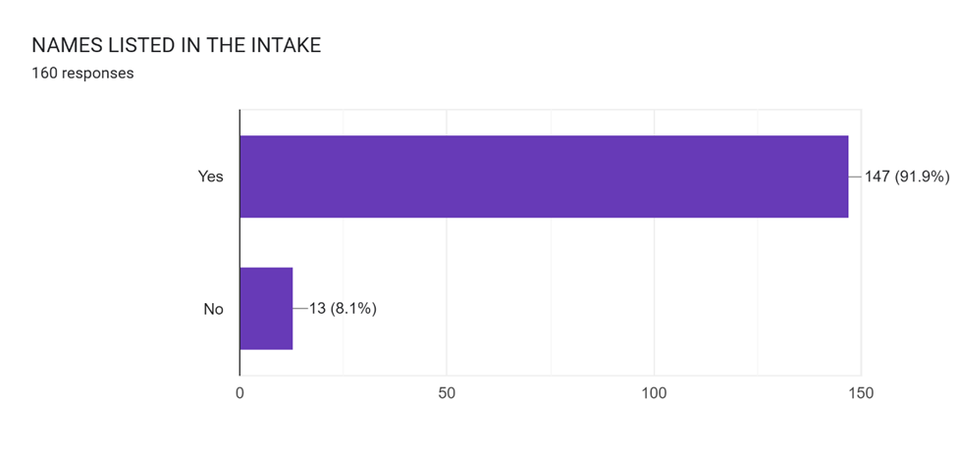

Example 2
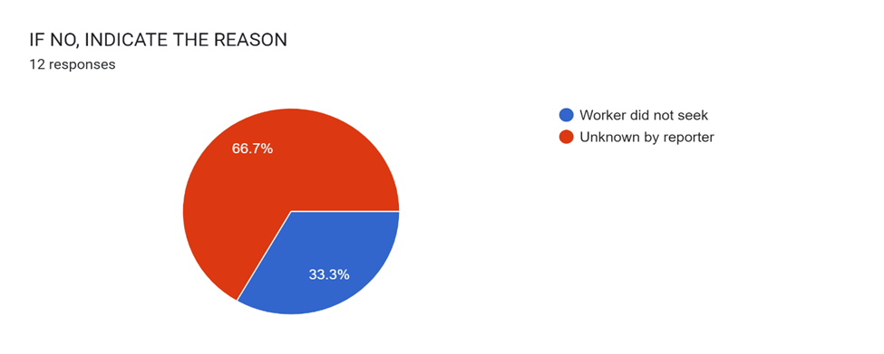
Example 3
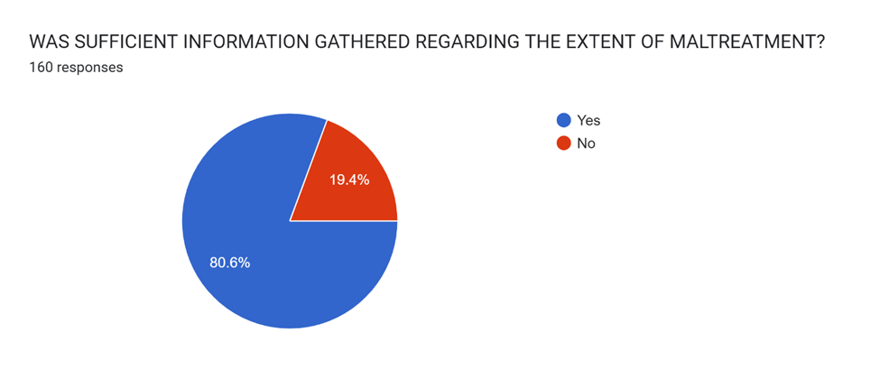

Example 4
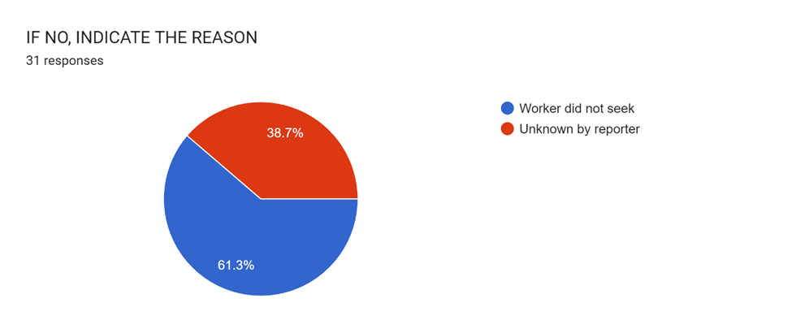
Example 5
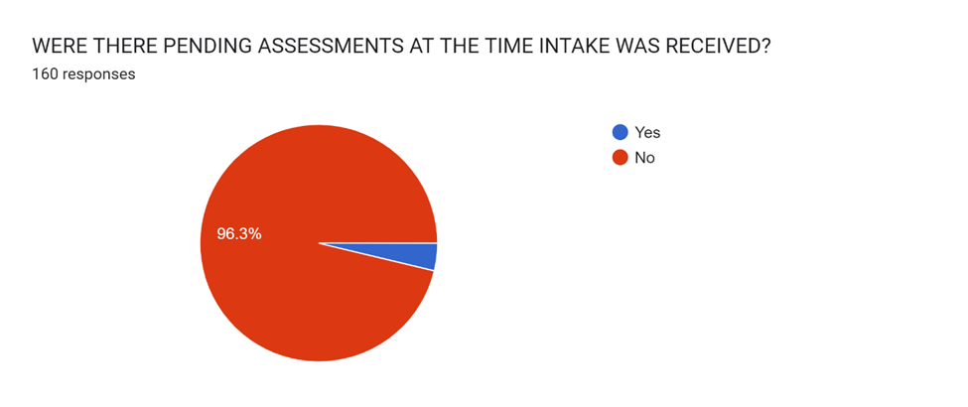

Example 6
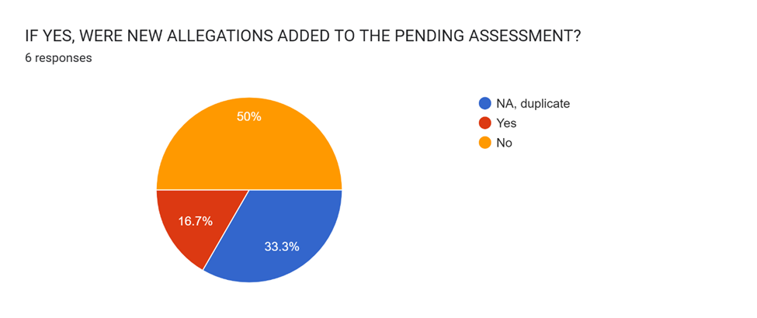
The West Virginia Bureau for Social Services utilizes a critical incident review process as part of the quality assurance process. The process examines casework practice, policies, and training to identify areas for program improvement. The internal review process involves the review of child fatalities or near fatalities alleged to be the result of child abuse or neglect. Cases meet the criteria for a critical incident review if the family was involved with the Bureau within a twelve-month period preceding the incident. The Field Review Team includes a member of DPQI, a policy representative, and a field staff representative examining the case file and completing interviews with key stakeholders in the case. The results of the critical incident reviews are presented quarterly during Critical Incident Review Committee meetings. Members of the Critical Incident Review Committee generate recommendations for a plan of action based upon the information presented during the meetings. The objective of the review is to gather insight surrounding casework practice to prevent future critical incidents. Specific review criteria are outlined in the Critical Incident Review SOP document, updated July 2021.
West Virginia has instituted a continuous quality assurance process that incorporates three levels of continuous quality improvement oversight councils. They are the district level, the regional level Quality Councils and the state level CWO. The CWO meets on a quarterly basis. The Continuous Quality Improvement Council process currently in place includes DPQI case review of districts, development of a district corrective action plan (CAP) based upon review results, and submission of the CAPS to agency leadership. The DPQI case review and resulting exit report begin the CQI process at the district and regional levels. This process continues through the state level utilizing the CWO to monitor child welfare data by state, region, and district. The Quality Councils at each level provide a feedback loop. Each Council is composed of peer representation who then reports the information back to staff in each local office. At the Regional level, representatives from the local councils meet to discuss issues that have arisen at the local level that cannot be resolved there. They also review corrective action plans and goals currently in place to determine if progress is being made or if goal changes need to occur. The regional Quality Council also reviews and discusses regional trends and issues as they relate to service delivery. Feedback is given to each staff member via the minutes of the meeting. The CWO provides feedback to each Deputy Commissioner, who is a member of the State Council. Each is provided with a spreadsheet containing the issues and results. This spreadsheet, along with minutes of the CWO meeting, is shared with all staff. The CWO utilizes case review data, stakeholder surveys, AFCARS, NCANDS and NYTD data to drive change within the organization to improve outcomes for children and families.
Other Targeted Reviews Conducted by DPQI
In addition to the recurring types of reviews conducted monthly by the DPQI, the unit completes other targeted types of reviews. The Bureau for Social Services is developing a differential response protocol for reports of child maltreatment. In 2022, DPQI reviewed an additional 200 Centralized Intakes to evaluate whether the assigned timeframe assigned was supported by the documentation gathered during the intake process. These reviews also evaluated whether the outcome in the field mirrored the level of risk and safety identified during the intake process.
DPQI also conducted Documentation Outcomes reviews associated with the monthly district reviews. DPQI Reviewers document the item pre-ratings for cases, which is based solely on the electronic record review. During a district’s exit meeting, this data is shared with district staff and is compared to the final item findings. The purpose of these reviews is to help districts understand the importance of thorough documentation in their cases. The final item ratings tend to improve, based on the information gathered during case participant interviews. DPQI stresses the importance of documentation, and that undocumented work does not accurately reflect the district’s casework practice or capture what is occurring within a family’s case.
Standards to evaluate the quality of services.
Standards to ensure that children and families are provided quality services that protect their safety and health, from referral intake to the achievement of permanency, are defined by federal and state laws and Department policy, at https://dhhr.wv.gov/bss/policy/Pages/default.aspx. Department outcome measures are based on federal requirements and state policy. Department staff have access to an internal data dashboard that captures outcome data. This includes the timeliness of initiating investigations of child maltreatment compared to the assigned time frame.
In order to evaluate the state’s efforts to improve performance in the areas of safety, permanency, and wellbeing, DPQI utilizes the federal CFSR process as a model to measure and evaluate the state’s performance for the above-mentioned areas. DPQI utilizes the January 2016 version of the Federal CFSR OSRI as the unit’s primary internal tool for evaluating the quality of delivery of services to children and families. Each review follows the guidelines established by the Federal Bureau for Children and Families. Pairs of DPQI reviewers complete a review of both the paper and electronic records and conduct key case participant interviews to evaluate adherence to policy and practice standards. The goal of the reviews is to improve practice to achieve positive outcomes for the children and families being served. The period under review covers a 12-month section of time going backwards from the start of the review date to 12 months prior. Preliminary case reviews to collect information are done related to FACTS and PATH records only. From this, reviewers develop a list of questions and information needed to complete the CFSR review. DPQI review teams then conduct interviews with designated stakeholders including the case worker, parents, service providers, placement providers, youth if age appropriate and any other parties who may have information relative to the case review. DPQI reviewers also review the paper file for additional information as part of the review process and include this information in review findings.
After the cases are rated, each case is debriefed. At a minimum, case debriefings are composed of two review teams and a DPQI program manager. During these debriefings case ratings are discussed in relation to CFSR instrument instructions and clarification guides to ensure fidelity to the tool. DPQI program managers then complete initial and secondary QA activities. During CFSR Round 3 case reviews, and PIP implementation measurement periods, ACF Children’s Bureau provides secondary oversight on a percentage of the cases reviewed by DPQI.
Identifies strengths and needs of the service delivery system.
The DPQI social services case review data provides for continuous quality improvement through the identification of the district’s strengths and areas for improvement. The review data is used at the district level to evaluate case practice and assist districts in making improvements in the provision of services to children and families. After completion of the CFSR style reviews, exit conferences are held at the district offices where DPQI staff assist the district in interpreting the results of the review. At the exit conference, the data indicators, based on the 18 items reviewed, are discussed with the district. The district is also provided with a comparison chart from their prior review. At that time, an exit interview is conducted by DPQI staff with the district’s management staff. During the exit conference, district management staff can comment on factors that contributed to the strengths and areas needing improvement. Additionally, districts are asked to identify which needed services are not available or inaccessible in the area. DPQI creates a list of base questions to be asked at all the exits. The questions are based on the previous FFY data and the overall issues impacting practice within the State. During the exit, DPQI staff discuss the prior CAP activities and if they appear to have been impactful in relation to improving outcomes for children and families.
The Critical Incident Review process involves a thorough review of child fatalities or near fatalities, when a family has a child welfare history within the twelve months preceding the incident. Since FFY 2020 the review process has included the review of Internal Investigative Unit (IIU) cases, which involve children in foster care placement at the time of incident. When a critical incident meets criteria for review, a Field Review Team is assigned to examine current and historical case documentation. The Field Review Team conducts interviews with agency staff, service providers, and investigating officers who have been involved with the family during the preceding 12-month period. The internal review process is a quality assurance process which looks at practice, policy, and training to determine whether there are areas that, if improved upon, could have prevented the death or severe injury to the child. Through the review process service availability and provision are identified, and any gaps are noted. The information gathered by the Field Review Team is presented quarterly to the Critical Incident Review Committee. Recommendations of the Critical Incident Review Committee are included in a Plan for Action.
Provides relevant reports
DPQI staff utilizes the CFSR OMS developed by JBS International to complete case reviews and develop relevant reports. The OMS is available for states to use not only for the Federal CFSR, but also for continuous quality improvement (CQI) purposes. The OMS is a web-based application that provides DPQI staff with the ability to complete case reviews and provide relevant district, regional, and state level reports. OMS is automated and logical, because of this it reduces the risk of reviewer error in completing the OSRI.
Following the social service review exit with the district management team, DPQI completes a comprehensive report on the results of the review. The exit summary report is provided to the district for review and comments. DPQI provides this information to CAS and the Program Manager for Community Partnerships for the identification of service needs and development of services. Districts complete a corrective action plan based on the identified areas needing improvement outlined in the exit summary. DPQI compiles the exit summary, data and corrective action plan for each district and distributes the findings to the district’s management staff, the Regional Program Manager, Regional Director, Director of Training, Policy Program Specialists, and Department Leadership.
DPQI provides ongoing feedback to the Director of CIU, and the training staff assigned to that unit. The CIU utilized the results of the reviews to improve the quality of the intakes and adhere to the fidelity of the screening process.
The Critical Incident Review Committee identifies issues and makes recommendations for needed modification of internal procedures, policies, and programs of BSS. This process is utilized in conjunction with the CQI process which is monitored by the state Child Welfare Oversight Team. The Critical Incident Review Team submits an annual report which includes a Plan for Action containing activities designed to increase awareness, support practice, and improve outcomes in child welfare cases. This report is submitted to the Commissioner of BSS for presentation to the state legislature. The report can be found at: https://dhhr.wv.gov/bcf/Reports/Pages/Critical-Incident-Reports.aspx
Evaluates implemented program improvement measures.
West Virginia’s quality assurance system utilizes data from various sources to monitor the efficacy of program improvement measures. The State utilizes CFSR style social service review data in conjunction with the State’s data profile (contextual data report), and data from the SACWIS in the development, planning, and monitoring of CFSP goals and other statewide child welfare initiatives.
Results of the social services reviews are used by districts to develop corrective action plans. The comparison chart provided to the districts at the social services review exit conferences and discussion of the corrective action plan developed at the conclusion of the prior review allow management staff to evaluate the efficacy of the strategies for improvements that were implemented. Beginning in January of 2020, DPQI also began providing a report at district exits that compares the review findings with the ten CFSR items being evaluated on the WV CFSR PIP data measures. This report allows districts to view their data in comparison to the WV CFSR Round 3 item data goals.
The Centralized Intake Unit utilizes the results of the DPQI intake assessment reviews, along with feedback from external stakeholders, to improve the quality of the intakes and improve the Child Protective Services investigation fidelity. The information is also used to ensure uniformity in screening decisions.
West Virginia used state generated data and information from its CQI process for CFSR Rd. 3 PIP development, implementation, and monitoring. Data related to PIP goal achievement was reported out biannually during the implementation period, 12/1/19-11/30/21, in the West Virginia Child and Family Services Review Round 3 Program Improvement Plan Progress Report. The data related to PIP measurement periods is now discussed following the completion of each data measurement period in a written report and meeting. West Virginia’s non-overlapping PIP measurement period will end in May 2023.

Service Array
In 2017, the CFSR found that the West Virginia service array lacked services to address substance abuse. The lack of adequate substance abuse services negatively impacts child and family outcomes in the state. It was also found that providers of addiction services often have wait lists and limited-service availability in more rural portions of the state.
Other necessary services for children and families that were also noted as lacking included mental health services for children, sex offender treatment, batterer offender treatment, autism support services, post-adoption services, kinship family support services, and housing.
The Service Array workgroup met several times in early 2018 to review data and information related to the CFSR findings and to discuss the status of services in West Virginia. During the meetings, the group discussed several issues related to the determination of the availability of substance abuse services, including the perceptions of stakeholders that substance abuse services were unavailable, when there was evidence that the development of substance abuse services had been developed prior to and after the CFSR in 2017.
In March 2017, the Department’s Bureau for Behavior Health developed “Need” maps and “Treatment/Recovery'' maps using 2016 data. The Need maps provide the ranking of the county (from 1 to 55) for Drug Exposed Infants; Children Removed Due to Substance Abuse; Overdose Deaths; EMS Runs with Naloxone Administration; and Opioid Prescriptions. The “Treatment/Recovery'' maps show the rates (beds per 100,000 population) per GASCA Region (which is also the BBH Regions) for Detoxification, Treatment Beds; Recovery Beds; and Doctors That Prescribe Buprenorphine to Medicaid Patients.
During these meetings and subsequent correspondence through email, the Service Array workgroup determined that Department staff and stakeholders may not know where to find service availability for substance abuse and other services an individual or family might need. West Virginia has a 24-hour helpline (Help4WV) staff and other stakeholders may need to know specifically how to assist those needing help with addiction or mental illness. Help4WV provides free help securing a referral or placement for treatment https://www.help4wv.com. The members with BBH and BMS stated that they have developed multiple new “Response for Application '' (RFA) with a focus on substance abuse over the past several months.
Update 2023:
Service Array Workgroup
The Service Array Workgroup continued to meet monthly throughout 2021. Over the course of two workgroup meetings, members developed and approved a charter outlining workgroup and member responsibilities. The workgroup continues to assist the ODCP with map revisions as it relates to service gaps that continue to be identified. The Community Partnership Program will continue to connect the ODCP with Child Welfare Staff, Family Support staff within the department, and community partners. The workgroup’s additional project focuses on developing a Blackboard course on service array resources already available throughout the state. This will help engage workers and gather feedback on worker’s utilization of the ODCP map. It will also ensure that workers gain a basic knowledge of resources throughout WV that might be available outside of BSS.

The reorganization of BCF caused delays that could result in the course not being approved. Due to the course development being predicated on prior BCF organization, adjustments to the course will need to be made when reorganization is finalized. The course references several programs, services, resources, bureaus, and offices within the DHHR, and the workgroup utilized information on the DHHR website to reference. The workgroup felt that although BCF information is a large portion of the course, other information in the course related to bureaus and offices outside of BCF are still important and for these reasons the workgroup is proceeding with course approval requests.

Over the course of two workgroup meetings, members developed a draft charter outlining workgroup and member responsibilities. The Office of Drug Control Policy (ODCP) created the SUD service mapping as outlined in a previous PIP item. Representatives from ODCP participate in the workgroup and provide updates regarding the mapping and solicit member feedback.
In 2022, the workgroup will focus on completing the blackboard course, discussing ways to track utilization of the ODCP map by social services staff, and track other service gaps.

West Virginia Service Communication Plan
The Service Communication Plan is carried out by the Community Partnership Program. This plan acts as a mechanism for feedback between community partners, DHHR Leadership and stakeholders regarding service gaps.

The Service Communication Plan SOP outlines team roles and responsibilities of the Regional Summits, Community Collaboratives, Community Partnership, Community Service Managers, Child Welfare Collaborative, and the Child Welfare Reform Oversight Team. The Community Partnership Program will offer technical assistance to these entities through the Service Array Coordinator and the Program Manager to ensure the plan is followed.

The Community Partnership Program is working with chairs of the Regional Summits, Chairs and CSMs involved in the Community Collaborative and Family Resource Network directors to help strengthen their infrastructure. The Service Array Coordinator is working to ensure these entities understand the importance their role will play in this plan and the goal to communicate on service availability, service gaps, and how to build service capacity.

The 2021 First Semi-Annual Community Collaborative Service Gap Report was provided to the Child Welfare Collaborative and Child Welfare Oversight (CWO) Team in April 2021. Feedback on ways to address the reported service gaps was provided by Child Welfare Oversight to the Community Partnership Unit. To continue with the communication plan, the Community Partnership Unit used the feedback to reach out to other entities and make connections on service expansion opportunities.

The Second Semi- Annual Community Collaborative Service Gap Report was due at the end of July 2021. The report was provided to the CWO team in October 2021. The main service gaps that were identified seem to be similar to the ones reported before, however, the reports did show that the Collaboratives are working with their Regional Summits to address service gaps on a larger scale.

The service gaps that could not be resolved were presented to the CWO. Some of the service gaps such as lack of foster homes, lack of SUD resources and services for treatment and prevention, issues with collaborative attendance, and lack of community support are service gaps that have been issues for several years. One service gap that was often reported by the Collaboratives is lack of understanding of mental health or behavioral health services in the community. At the CWO meeting a connection with the Bureau for Behavioral Health was made and both groups are working on making sure the appropriate information is provided to the Collaboratives from someone in the Bureau for Behavioral Health.

During 2021 the Bureau for Children and Families split into two bureaus, Bureau for Social Services and Bureau for Family Assistance. Management of the Family Resource Networks, Community Collaboratives and Regional Summits will be with the Bureau for Family Assistance. Details on carrying out the Service Communication Plan and maintaining collaboration between the two bureaus have not been finalized. This will be a goal for 2022.

Update 2024:
The Service Array Workgroup continued to meet monthly throughout 2022. The workgroup continued to focus on developing a Blackboard course on service array resources already available throughout the state. This would help ensure workers gain a basic knowledge of resources throughout WV that might be available outside of BSS. Due to the reorganization of BCF into BSS and BFA, and the course being predicated on the previous structure of BCF, many changes were made to the presentation. Numerous websites for programs had changed and oversight of some programs had not yet been determined. However, with the announcement of DHHR once again being reorganized, it was decided that additional updates will need to be made once these changes take effect. Due to this, it was decided that work on the blackboard course will be halted until 2024.

The Services Array workgroup began work on a survey to gather information on free and low-cost community services available in and around West Virginia. These services will include, but are not limited to, music and art programs, athletics, clubs, camps, and other community programs. These types of programs and services have been shown to decrease mental health symptoms, suicidal thoughts, and criminal activities, as well as increasing community involvement, self-esteem, and family connection. The survey will be open to anyone and will not be closed after the initial information gathering period concludes. This will allow for changes and updates to be made to the information at any point. Once the initial information period concludes the results will be compiled. How the information will be stored and shared has not yet been determined.

West Virginia Service Communication Plan
The Service Communication Plan carried out by the Community Partnership Program is no longer in place due to the dissolution of the Child Welfare Oversight (CWO). The 13 Community Collaborative groups continued to meet throughout 2022 to discuss service gaps in their areas and ways to address these unmet needs. All 13 completed the 1st Semi-Annual Service Gap survey that was due in January 2022, and 8 of the 13 completed the second survey that was due in July 2022. The information provided was combined into a report that was shared with the Chairpersons of each Collaborative group.

West Virginia’s Service Array includes:

- Family Support Services.
- Community-Based/Prevention Services.
- Services that assess the strengths and needs of children and families and determine other service needs.
- Services that address the needs of families in addition to individual children in order to create a safe home environment.
- Services that enable children to remain safely with their parents when reasonable; and
- Services that help children in foster and adoptive placements achieve permanency.
The Department is the designated lead agency for Community-Based Child Abuse Prevention (CBCAP) activities. The Division of Early Care and Education (ECE) within the Department’s BCF manages the activities funded by the CBCAP grant. ECE is also responsible for coordination and administration of the Child Care and Development Fund and the Head Start State Collaboration Office. ECE staff work closely with the Bureau for Public Health, which includes Birth to Three and the state’s Maternal Infant Early Childhood Home Visiting program (MIECHV). Activities and initiatives that touch all aspects of children’s lives and wellbeing are coordinated through the state Early Childhood Advisory Council (ECAC).
Through CBCAP activities, the Department works closely with Prevent Child Abuse West Virginia to coordinate prevention efforts across the state to give children good beginnings by strengthening families and communities. They work collaboratively to build awareness, provide education, and strive to keep children free from abuse and neglect.
The Department funds and supports several child abuse prevention initiatives that use a combination of CBCAP, Temporary Assistance for Needy Families (TANF), and MIECHV funds, state appropriations, and private funds. These initiatives include In Home Family Education Programs (IHFEP), Family Resource Centers (FRC), and Partners in Prevention grants to communities. These programs are considered an integral part of the child welfare continuum by building and increasing protective factors that enable parents and families to nurture and parent appropriately and connect them to concrete supports that help keep families out of the child welfare system. Programs are community based and driven, with advisory boards made up of program participants, service providers, and local leaders. Services are available to any member of the community, regardless of income, and are voluntary.
Family Resource Centers
Twenty-three Family Resource Centers across the state aid families and communities based on their community’s needs and gaps in service. FRC staff are connected to local resources and provide referrals and concrete assistance through food, baby, and hygiene pantries. Depending on community needs, they also offer childcare, support groups, parenting education, and play groups. Services are offered to any family with children from prenatal through eighteen years of age. In State FY 2020, the funding allocation to the FRCs was increased to allow them to expand into unserved communities in their catchment areas and serve more families. This was made possible through TANF funds, and the programs now have oversight from both ECE and Family Assistance staff.
Update 2023:
During 2021, the Family Resource Centers have served the following individuals statewide:
- 565 Children with disabilities
- 2,320 Parents with disabilities
- 19,186 children received preventative direct services.
- 19,108 parents and caregivers received preventative services directly from the Family Resource Centers
- 16,372 Total number families who received preventative direct services.

Update 2024:
During 2022, the Family Resource Centers have served the following individuals statewide:
- 83 Children with disabilities
- 1,093 Parents with disabilities
- 22,160 Children received preventative direct services.
- 21,237 Parents and caregivers received preventative services directly from the Family Support Centers
- 20,679 Families received preventative direct services.
Maternal Infant Early Childhood Home Visiting program (MIECHV)
While MIECHV funds the majority of In-Home Family Education Programs in the state, thirteen IHFEs are jointly funded through CBCAP and MIECHV funds. Programs may choose from two evidence-based models, Parents as Teachers, or Healthy Families America. These programs systematically assess family strengths and needs, and enhance family functioning through trusting relationships, teaching problem solving skills, and promoting positive parent-child interactions. They also educate parents and caregivers on child development and connect them to referrals and resources.
Update 2023:
During FY 2021, The MIECHV program served 3569 participants. This program reached 1,556 households and involved 21,159 home visits.

MIECHV program awardees serve high-risk populations. Awardees tailor their programs to serve populations of need within their state. WV reported the following data:
- 55.7% of households were low income.
- 26.4% of households included someone who used tobacco products in the home.
- 19.2% of households included a child with developmental delays or disabilities.

West Virginia performance highlights include a continuity of insurance coverage and depression screening. 98.7% of caregivers enrolled in home visiting had continuous health insurance coverage for at least six consecutive months. 93.3% of caregivers enrolled in home visiting were screened for depression within three months of enrollment or within three months of delivery.

Update 2024:
During FY 2022, The MIECHV program served 3487 participants. This program reached 1,522 households and involved 20,807 home visits.

MIECHV program awardees serve high-risk populations. Awardees tailor their programs to serve populations of need within their state. WV reported the following data:

- 54.1% of households were low income.
- 25.6% of households included someone who used tobacco products in the home.
- 19.7% of households included a child with developmental delays or disabilities.

West Virginia performance highlights include a continuity of insurance coverage and depression screening. 99.4% of caregivers enrolled in home visiting had continuous health insurance coverage for at least six consecutive months. 90.8% of caregivers enrolled in home visiting were screened for depression within three months of enrollment or within three months of delivery.
Partners in Prevention
Partners in Prevention (PIP) is a community grant and networking program that focuses on preventing child abuse and neglect. Forty-four PIP teams work to build protective factors within communities and families by promoting local needs-based activities with the cooperation of community members, local organizations, policy makers, and parents.

The Department’s various Bureaus have a commitment to collaboration. All Bureaus and Divisions maintain linkages to one another and communicate frequently on joint programs and projects to reduce child maltreatment and strengthen families and communities.

Also, the BCF refers families to the Bureau of Medical Services for many preventative services such as Birth to Three and Right from the Start. Workers make referrals to these programs at the time of assessment.
Update 2023:
During FY 2021, Partners in Prevention teams across the state of West Virginia:
- Provided Public Education and/or Services to 50,272 individuals and organizations.
- Distributed 52,141 pieces of educational materials and/or resource packets to caregivers and community members.
- Trained 2,975 individuals and/or organizations through locally based workshops and a variety of prevention curricula.
- Coordinated 1,462 public events in their communities, and
- Generated 3,501 public messages (via printed articles, radio, television, and social media) about the importance of supporting and nurturing children and families, as well as public engagement activities to help families thrive.

Update 2024:
During FY 2022, Partners in Prevention teams across the state of West Virginia:

- Provided Public Education and/or Services to 57,565individuals and organizations.
- Distributed 71,248 pieces of educational materials and/or resource packets to caregivers and community members.
- Distributed 52,141 pieces of educational materials and/or resource packets to caregivers and community members.
- Trained 4,201 individuals and/or organizations through locally based workshops and a variety of prevention curricula.
- Coordinated 338 public events in their communities.
- Generated 4,018 public messages (via printed articles, radio, television, and social media) about the importance of supporting and nurturing children and families, as well as public engagement activities to help families thrive.

Birth to Three

WV Birth to Three is a statewide system of services and support for children under age three who have a delay in their development, or may be at risk of having a delay, and their families. The Department, through the Bureau for Public Health and the Office of Maternal, Child and Family Health, WV Birth to Three, is the lead agency for Part C of the Individuals with Disabilities Education Act (IDEA), assures that family centered, community-based services are available to all eligible children and families. WV Birth to Three partners with families and caregivers to build upon their strengths by offering coordination, support, and resources to enhance children’s learning and development.

To be eligible for WV Birth to Three services, an infant or toddler under the age of three can either have a delay in one or more areas of their development or be at risk of possibly having delays in the future. A child may have delays in one or more of the following areas:

Cognitive - thinking and learning.
Physical - moving, seeing, and hearing.
Social/emotional - feeling, coping, getting along with others.
Adaptive - doing things for him/herself.
Communication - understanding and communicating with others.

A child may also have risk factors such as a condition which is typically associated with a developmental delay such as Down Syndrome or a combination of biological and other risk factors. Some of these factors may include family stressors.

As a result of individualized support and services, families will: know their rights, effectively communicate their child’s needs, and help their child develop and learn. The child will demonstrate improved social emotional skills and relationships, acquisition of knowledge of skills including language and communication, and use of appropriate behaviors to meet their needs.

Update 2023:
WV Birth to Three reports during the time period of December 2nd, 2020, through December 1st, 2021, they served 7,462 children through an Individualized Family Service Plan (IFSP). The IFSP identifies the child’s current developmental levels and helps determine what services will be provided.

Update 2024:
WV Birth to Three reports during the time period of December 2nd, 2021, through December 1st, 2022, they served 8,277 children through an Individualized Family Service Plan (IFSP). The IFSP identifies the child’s current developmental levels and helps determine what services will be provided.
Right from The Start
The Right from The Start (RFTS) Program is a home visitation program which provides targeted case management and/or the provision of enhanced prenatal care services for Medicaid pregnant women up to 60 days postpartum and infants through one year of age. Targeted case management in the RFTS Program includes: an Initial Assessment for prenatal or infant clients, development of an individualized Service Care Plan reassessed on an ongoing basis, depression screening, domestic violence screening, tobacco/substance use screening, assistance with locating needed resources, education and counseling programs for the mother, transportation assistance to medical appointments, and referrals as needed. Enhanced prenatal care services include childbirth education, parenting education, health education and nutritional evaluation/counseling. All services are provided by a registered nurse, licensed social worker, or registered dietician. These services have the combined purpose to improve birth outcomes and reduce infant mortality and morbidity in a high-risk population with a medically focused approach.
The Right from the Start (RFTS) Program has been delivering services, providing health care for low-income mothers and infants at-risk of adverse health outcomes for over two decades. The services are free and support mothers, their new babies, and their families by helping create a safe, nurturing home.
The Designated Care Coordinator provides professional, individualized, and comprehensive care that empowers families to achieve the healthiest possible outcomes during pregnancy and infancy. The program empowers participants to choose lifestyles resulting in healthy families.
The RFTS is a carefully crafted and highly interdependent partnership with tertiary care centers, primary care centers, local health departments, private practitioners and community agencies working within West Virginia. Its focus is the continuum of care model. The RFTS coordinates services provided to high risk, low-income pregnant women through the second postpartum month and to Medicaid eligible high-risk infants through age one. The RFTS also helps provide access to other enhanced services, such as parenting classes, transportation to medical appointments, smoking cessation programs and health and nutrition programs.
Maternity Services
Maternity Services is limited funding of prenatal, delivery, postpartum and routine newborn hospital care for low-income, medically indigent pregnant women who are determined to be ineligible for Medicaid, have no insurance to cover obstetrical care, and have monthly income below 185% FPL. This includes minors and income eligible non-citizens. Maternity Services requiring prenatal care are provided in the standards outlined in the American College of Obstetricians and Gynecologist guidelines.
Maternity Services also acts as a guarantor of payment for initial prenatal exams and associated laboratory/diagnostic testing. Maternity Services is the payer of last resort. If the client is approved for Medicaid or another third-party source, the practitioner is paid by that source.
The Drug Free Moms and Babies (DFMB) Project is a comprehensive and integrative medical and behavioral health program for pregnant and postpartum women. The project supports healthy baby outcomes by providing prevention, early intervention, addiction treatment, and recovery support services.
This project is supported through funding from the Department's Division of Behavioral Health and Health Facilities, the WV Office of Maternal, Child, and Family Health, and the Claude Worthington Benedum Foundation.

Key Project Aspects

- Screening, Brief Intervention, Referral and Treatment (SBIRT) services integrated in maternity care clinics
- Collaboration with community partners for the provision of comprehensive medical, behavioral health, and social services
- Long term follow-up for two years after the birth of the baby provided by a recovery coach. In addition, home visits and other services to help women maintain sobriety and access needed resources are provided.
- Program evaluation of effective strategies for identifying women in need, preventing addiction and abuse, treating women with substance abuse problems, and delivering recovery coaching services.
- Provider outreach education to other maternity care clinics in West Virginia to facilitate the duplication of successful model programs.

Family Resource Networks
The Family Resource Networks (FRNs) are organizations that are responsive to the needs and opportunities in West Virginia communities. Partnering with citizens and local organizations, the FRNs provide indirect services, including managing, supervising, and coordinating a variety of programs and initiatives in their respective communities. The FRNs work with the Family Resource Centers where direct services are provided.
In 1995, the office of the Governor’s Cabinet on Children and Families negotiated a federal-state partnership agreement whereby a small portion of federal Medicaid administrative funds and other federal funding sources would be made available to help support local assessment of needs, planning, and resource development by West Virginia’s FRNs.
The 47 FRNs, representing all West Virginia’s 55 counties, are organizations that understand and are responsive to the needs and opportunities in West Virginia communities. Partnering with citizens and local organizations, the FRNs organize and mobilize activities that support innovative projects and provide needed resources on upfront prevention and intervention approaches that contribute directly or indirectly to the health and safety of the Medicaid eligible population.
The FRNs have a resource directory for each county in West Virginia. Through a Benedum Foundation grant, the Alliance of Family Resource Networks (WVAFRN) and Marshall County FRN have developed a central website. The website will include a link to each of the FRNs that will include their resource directories and current events. The WVAFRN website is: http://wvfrn.org/ and a quick directory can be found on this same website at: http://wvfrn.org/quick-directory/ .
The following three key quantitative indicators document the benefits of local FRN activity to the state’s Medicaid program. These indicators are: 1) Strategies to address alcohol, tobacco and other drug prevention and intervention; 2) Strategies to address child and family safety and wellbeing prevention and intervention; and 3) Strategies to address economic and poverty prevention and intervention.
- Alcohol, Tobacco and other drug prevention and intervention activities
40 of 47 FRNs were involved in alcohol, tobacco and other drug prevention and intervention activities. During the fiscal year July 1, 2017, through June 30, 2018, the FRNs were involved in approximately 248 activities related to alcohol, tobacco and other drug prevention and intervention.
Update 2023:

- Alcohol, Tobacco and other drug prevention and intervention activities
All 47 FRNs were involved in alcohol, tobacco and other drug prevention and intervention activities. During the state fiscal year July 1, 2020, through June 30, 2021, the FRNs were involved in approximately 966 activities related to alcohol, tobacco and other drug prevention and intervention.

Update 2024:

● Alcohol, Tobacco and other drug prevention and intervention activities
All 47 FRNs were involved in alcohol, tobacco and other drug prevention and intervention activities. During the state fiscal year July 1, 2021, through June 30, 2022, the FRNs were involved in approximately 1,271 activities related to alcohol, tobacco and other drug prevention and intervention.

- Child and Family Safety and Wellbeing
All 47 FRNs were involved in child and family safety activities. During the fiscal year July 1, 2017, through June 30, 2018, the FRNs were involved in approximately 960 activities related to child and family safety.

Update 2023:

- Child and Family Safety and Wellbeing
All of the 47 FRNs were involved in child and family safety activities. During the fiscal year July 1, 2020, through June 30, 2021, the FRNs were involved in approximately 1,286 activities related to child and family safety.

Update 2024:

● Child and Family Safety and Wellbeing
All of the 47 FRNs were involved in child and family safety activities. During the fiscal year July 1, 2021, through June 30, 2022, the FRNs were involved in approximately 1,921 activities related to child and family safety.

- Economic and Poverty
45 of 47 FRNs were involved in economic and poverty activities. During the fiscal year July 1, 2017, through June 30, 2018, the FRNs were involved in approximately 316 activities related to economic and poverty activities.
Update 2023:

- Economic and Poverty
45 of the 47 FRNs were involved in economic and poverty activities. During the fiscal year July 1, 2020, through June 30, 2021, the FRNs were involved in approximately 980 activities related to economic and poverty activities.

Update 2024:

● Economic and Poverty
45 of the 47 FRNs were involved in economic and poverty activities. During the fiscal year July 1, 2021, through June 30, 2022, the FRNs were involved in approximately 2,208 activities related to economic and poverty activities.

The West Virginia FRNs documented a total of 2,749 events for the public serving over 408,000 family members. 37,526 (9.18%) of those family members completed surveys showing that 36,116 (96.24%) of the families stated the event was beneficial. 30,934 (82.43%) people who filled out surveys had families who lived under 300% of the Federal Poverty Level.

Update 2023:

The West Virginia FRNs documented a total of 3,232 events for the public during the fiscal year, July 1, 2020, through June 30, 2021. These events served over 464,000 family members. 24,778 (18.72%) of those family members completed surveys showing nearly all of the families stated the event was beneficial. Due to COVID-19 restrictions, written surveys were not completed at all events. Reports state 68,587 potential Medicaid eligible recipients attended the events.

Update 2024:
The West Virginia FRNs documented a total of 5,400 events for the public during the fiscal year, July 1, 2021, through June 30, 2022. These events served over 423,000 family members with 273,052 of those being potentially Medicaid eligible. 10,689 of those family members completed surveys showing nearly all of them reported the event was beneficial.

Expanded School Mental Health Approach (ESMHA)
The Expanded School Mental Health Approach (ESMHA) is an integrated approach that builds on core services typically provided by schools. It is a three-tiered framework that includes the full continuum of mental health prevention, early intervention, and treatment services. The four expected outcomes of this approach are: 1) reduced barriers to learning; 2) improved academic performance; 3) improved attendance; and 4) improved school functioning/behavior. Currently there are 40 ESMH sites in 20 counties.
Update 2023:

The ESMH is an integrated approach that builds on core services provided within schools. It is a three-tiered framework that includes the full continuum of mental health prevention, early intervention, and treatment services. The four expected outcomes of this approach are: 1) reduced barriers to learning; 2) improved academic performance; 3) improved attendance; and 4) improved school functioning/behavior. There are currently 74 ESMH sites in 26 counties.

Additionally, through a partnership with WV Department of Education’s Project Aware Grant, 18 schools in Cabell, Harrison, Wirt, Fayette, Logan, and Clay counties are included as ESMH sites. BBH has also released an Announcement of Funding opportunity to add 20 ESMH sites statewide this fiscal year (FFY 2022). This will bring the total of ESMH schools to 93 in the state if all submitted proposals are approved. ESMH schools also work in tandem with their regional Prevention Lead Organizations in the selection, training, and implementation of evidence-based prevention programs to help address students’ needs and the prevention of behavioral issues and substance misuse. Evidence-based programs are selected based on data obtained from assessments.
Update 2024:
The Expanded School Mental Health (ESMH) approach is an integrated approach that builds on core services provided within schools. It is a three-tiered framework that includes the full continuum of mental health prevention, early intervention, and treatment services. The four expected outcomes of this approach are reduced barriers to learning; improved academic performance; improved attendance; and improved school functioning/behavior. West Virginia has 74 ESMH schools and 18 in partnership with Project Aware for a total of 92 schools across 30 counties.
Trauma Informed Elementary Schools (TIES)

Trauma-Informed Elementary Schools (TIES) is a program designed to bring trauma-informed services to early elementary school classes, pre-K through grade 1. TIES is nationally recognized, and research driven. The TIES program is funded by the Claude Worthington Benedum Foundation and the Department’s Bureau for Behavioral Health for the 2018-19 school year.

The goal of TIES is to bring early intervention to children who exhibit symptoms of chronic stress or trauma in the classroom, symptoms that interfere with the child's ability to learn, such as disruptive, defensive, or withdrawn behavior. Schools receive training, have a resource liaison available for consultation and parent education and receive a therapeutic toolbox for the classroom.

For children in need of treatment, Crittenton can work collaboratively with the school and the child's family to build an integrated environment that helps the child develop self-regulation skills. Crittenton is currently partnering with elementary schools in Hancock, Ohio, Tyler, and Wood counties. Sustainability planning is underway to extend TIES beyond the 2018-19 school year.

Update 2023:
TIES is a prevention and early-intervention program that is designed to bring trauma-informed principles into the classroom and, for children that are referred for treatment, to provide an integrated approach for the school and home environments. Providers serve as trauma-informed agencies and seek to improve outcomes for children by providing trauma-informed practices for teachers and by strengthening family functioning with interventions. In this Bureau for Behavioral Health program, the expanded TIES project will serve eight elementary schools in pre-kindergarten, kindergarten and first grade classrooms in Ohio and Hancock counties. TIES is currently in Weirton Elementary, Bethlehem Elementary, Steenrod Elementary, Madison Elementary, Middle Creek Elementary, Ritchie Elementary, Woodsdale Elementary, and West Liberty Elementary. TIES includes teacher training in the principles of the Attachment, Regulation and Competency (ARC) Trauma Treatment Framework, incorporation of trauma-informed practices in the classroom, a bachelor-level staff to act as a resource liaison for the school, and referral to professional, licensed, trauma-focused therapeutic services. The program focuses on improving functioning and reducing stress symptoms in children referred for treatment so that they can self-regulate within the classroom environment, as measured by exhibiting WV Child and Adolescent Needs and Strengths Assessment (WVCANS) score improvement for the child and the caregiver, through the reduction of actionable items.
Update 2024:
Trauma-Informed Elementary Schools (TIES) is a prevention and early-intervention program that is designed to bring trauma-informed principles into the classroom and, for children that are referred for treatment, to provide an integrated approach for the school and home environments. Providers serve as trauma-informed agencies and seek to improve outcomes for children by providing trauma-informed practices for teachers and by strengthening family functioning with interventions. In this BBH program, the expanded TIES project serves eight elementary schools in pre-kindergarten, kindergarten and first grade classrooms in Ohio and Hancock counties. TIES is currently in Weirton Elementary, Bethlehem Elementary, Steenrod Elementary, Madison Elementary, Middle Creek Elementary, Ritchie Elementary, Woodsdale Elementary, and West Liberty Elementary. TIES includes teacher training in the principles of the Attachment, Regulation and Competency (ARC) Trauma Treatment Framework, incorporation of trauma-informed practices in the classroom, a bachelor level staff to act as a resource liaison for the school, and referral to professional, licensed, trauma-focused therapeutic services. The program focuses on improving functioning and reducing stress symptoms in children referred for treatment so that they can self-regulate within the classroom environment, as measured by exhibiting WV Child and Adolescent Needs and Strengths Assessment (WVCANS) score improvement for the child and the caregiver, through the reduction of actionable items.
Services that assess the strengths and needs of children and families and determine other service needs.
Transformational Collaborative Outcomes Management (TCOM)
Transformational Collaborative Outcomes Management (TCOM) is a framework that includes the philosophy, strategies, and tools to address the needs of children and families, including those served by youth placed in out-of-state facilities or returning from existing out-of-state placements. TCOM includes a structured assessment that directly informs service/intervention planning which includes the Family Advocacy and Support Tool (FAST), the Child and Adolescent Needs and Strengths (CANS) and the Adult Needs and Strengths Assessment (ANSA). The TCOM tools provide effective decision-making at every level of the system because it involves a shared understanding of the current needs and strengths of children, youth, and caregivers.

The WV FAST will support effective interventions with the entire family and be utilized by the Department YS Workers who are involved with the YS Program. The WV CANS will be utilized when a child is being placed out-of-home and utilized typically by service providers.

In 2018, the following was continued:
- Experts Training (training-the-trainers).
- Automated certification process.
- All Department YS Workers trained in the use of the WV CANS and received annual certification/recertification.
- The CANS Algorithms used for decisions for placement and treatment in the Safe at Home West Virginia wraparound program, the Regional Clinical Reviews, and the Out-of-State Clinical Reviews; and
- Promoted the Family First Prevention Services Act (FFPSA), the TCOM model for YS staff that include a Family Assessment (WV FAST) and the Case Plan to identify both the child as a "candidate" and specified services as required by FFPSA.

Update 2023:

TCOM directly informs service/intervention planning using assessments including the Family Advocacy and Support Tool (FAST), the Child and Adolescent Needs and Strengths (CANS), and the Adult Needs and Strengths Assessment (ANSA). TCOM tools assist with providing effective decision-making at every level of the system as it involves a shared understanding of the current needs and strengths of children, youth, and caregivers.

In 2019, the Department contracted with Marshall University’s Center of Excellence for Recovery to continue development of the TCOM model, which includes use of the TCOM tools. Marshall University’s Center of Excellence for Recovery is responsible for the management of the TCOM model and tools in West Virginia.

In 2021, the following services and activities were completed:

- Continued virtual training on the CANS and FAST tools, and Wraparound. The training included transferring the identified needs from the CANS and FAST onto a Case Plan. Training also includes how to develop Specific, Measurable, Achievable, Relevant and Timely (SMART) goals and objectives.

- Continued offering and training of Marshall University students in psychology, social work, and school psychology in the FAST and CANS tools to support the readiness of a competent workforce.

- Annual “Booster” training for TCOM trainers (those already certified).

- Continued one-on-one technical assistance (TA) sessions on the CANS and FAST tools.

- Supervisory Training development that includes using the FAST tool during staff evaluation. A “checklist” to guide supervisor’s during their staff evaluation will be included in training.

- Videos were developed to support issues identified during training and technical assistance sessions.

These videos include:
- Video-Collaboration
- Video-Action Trumps Anchor
- Video-How and Why to use a summary sheet.
- Video-Background Needs
- Video-Masking
- Video-Rating of a “1” on the CANS/FAST
- Video-Using the CANS/FAST Manual
- Video-Importance of Addressing all Items.
- Live Webinar-Traumatic/Adverse Childhood Experiences and Symptoms Resulting from Exposure
- Live Webinar-WV Trainers-Rock and Roll and Annual updates.

- Chart Review of the Department’s Raleigh County Youth Service cases. Chart Reviews will continue in other West Virginia counties in 2022.

- Oversight of the automated TCOM/CANS system that collects, stores and reports data for the state as requested. The Public Consulting Group (PCG) provides the maintenance, data requests, and upgrades to the system as requested. The WV Residential providers are being set up in the system to prepare for them to enter information into the system.

The programs currently entering data into the CANS database are:
o Safe at Home providers
o Children’s Mental Health
o CSED
o Expanded School-Based Mental Health
o Mobile Crisis

- Marshall University represents West Virginia in a University partnership with eighteen different TCOM universities to learn and collaborate on best practices to promote the state's objectives.

- Working collaboratively with state partners on the preliminary work to develop the Adult Needs and Strengths Assessment (ANSA) West Virginia Manual and training.

- Working with representatives from the Department, Berry-Dunn, the University of Maryland (who will provide training approved by National Wraparound Institute (NWI)), Dr. Lyons, developer of the TCOM tools and his colleagues with the University of Kentucky, and others to plan and support the Wraparound training, technical assistance, and Fidelity Outcomes to be initiated in 2022.

- Working with the Casey Foundation and Dr. Lyons with the University of Kentucky. A Latent Class Analysis was completed in 2020 on youth in group residential and psychiatric residential treatment facilities. Since the completion, this information has been shared across the state to provide a better understanding of the needs and interventions of these youth. The CANS was used to complete the analysis.

- CANS information from Department case plans was collected and sent to Dr. Lyons and the University of Kentucky TCOM Staff to develop a Decision-Support Model (formerly referred to as Algorithms).

- In addition to continuing the work above, Marshall University and partners will implement activities and enhancements in 2022 which include:
- Live Webinar-Supervisor Training
- Recorded Webinar-Strengths in detail with examples.
- Recorded Webinar-How to Review a CANS/FAST with a family.
- Recorded Webinar-Strengths in detail with examples.
- Recorded Webinar-CANS/FAST Refresher Webinar for all people in WV who are currently certified in using these tools.
- Recorded Webinar-How to write goals, outcomes, and strategies.
- Recorded Webinar-Introducing the FAST to the Caregiver/Foster Parent.
- Provide one-on-one training to Department YS Supervisors.
- Chart Reviews of the Department’s Raleigh County Youth Service cases in West Virginia counties as recommended.
- Develop ANSA Manual and Rating Sheet.
In 2022, Marshall University and PCG will include:
o Adding New agencies and users to WV CANS
o Create Invoicing System
o Expansion of reporting for CANS-5 reports annually
o Modify system to enable communication to PATH
o Host on-line tool on the PCG secure server
o Help Desk and General maintenance
- Other modifications and reports as specified by Marshall University and/or the Department.
o Group Residential and PRTF reviews.

Update 2024:

Transformational Collaborative Outcomes Management (TCOM) directly informs service/intervention planning using assessments including the Family Advocacy and Support Tool (FAST), the Child and Adolescent Needs and Strengths (CANS), the Crisis Assessment Tool (CAT), and the Adult Needs and Strengths Assessment (ANSA). TCOM tools assist with providing effective decision-making at every level of the system as it involves a shared understanding of the current needs and strengths of children, youth, and caregivers.

DHHR entered a contract in 2019 with Marshall University’s Center of Excellence to continue to fully develop and manage the TCOM model, which includes use of the TCOM tools.

Working closely with the Praed Foundation at the University of Kentucky, Center for Innovation in Population Health (IPH) and in partnership with the West Virginia Department of Health and Human Resources, service providers and other stakeholders, the goal is to help people achieve their health and wellness goals as they navigate healthcare, child welfare, justice, behavioral health, education, and other complex systems.

In 2022, the following services and activities completed:
- Virtual training on the CANS and FAST tools, and Wraparound, including how to transfer CANS and FAST information into a Case Plan. The training also includes how to develop specific, measurable, achievable, relevant, and timely (SMART) goals and objectives.
- Supervisory training for supervisors in the Case Review counties (Fayette, Hancock, Mercer, Putnam, and Wayne) including using the FAST tool during staff evaluation. A checklist was developed to guide supervisors during their supervisor staff case reviews.
- Annual booster training for TCOM trainers (TCOM trainers must first meet training and certification requirements provided by the Praed Foundation).
- Virtual one-on-one technical assistance sessions on completing the CANS/FAST and how to use these tools in Case Plan development.
- Cloud-based professional animation videos designed and available on the TCOM website to help support issues identified during training and technical assistance sessions.
- Development of the CANS Storyboard. The Storyboard is a visual snapshot of the family’s needs and strengths as identified by the CANS.
- Recorded live webinars that allow participants to review critical information at any time and reach a larger audience for focused training purposes.
- Provide a platform for support of the Praed Foundation website and navigation and website access code distribution for DHHR staff and grant supported programs.
- Tracking certification of TCOM tools. In addition to the reminders the Praed Foundation provides individuals when their certification is about to expire, Marshall University also tracks and reminds individuals and managers when certification is nearing their expiration date or has expired in the following programs: DHHR staff, SAH WV, CSED, Children’s Mental Health, Shelter, Residential, Child Placement Agencies, Mobile Crisis Units, and School Based Mental Health and TCOM Trainers when certification is near expiring.
- DHHR Youth Services Chart Reviews and Report for Hancock, Mercer, Putnam, and Wayne counties’ Youth Service cases as recommended.
- Enhancements to the automated TCOM/CANS system that collects, stores, and reports data for the state as requested. The Public Consulting Group (PCG) provides maintenance, data requests, and upgrades to the system as requested.
- Marshall University represents West Virginia in a University partnership with sixteen different TCOM universities (University of Kentucky, IPH; Northwestern University-Illinois; University of Illinois-Urbana Champaign; Latoya University of Chicago; University of Maryland; Indiana University – Purdue; Rutgers University – New Jersey; Case Western Reserve University – Ohio; Boise State University – Idaho; University of Oklahoma; University of Texas; Smith College – Massachusetts; Vanderbilt University – Tennessee; University of Wisconsin; Mental Health Alliance – California; and Department of Mental Health in Vermont) to learn and collaborate on best practices to promote the states’ objectives.
- Wraparound Fidelity Outcome Review of the WV Wraparound Programs (SAH WV and CSED). Marshall University TCOM staff completed the Gold Standard Training approved by the National Wraparound Institute to conduct Wraparound Training and Wraparound Case Reviews. Marshall University TCOM staff work with representatives from DHHR, the University of Maryland, and Dr. Lyons, developer of the TCOM tools and his colleagues with the University of Kentucky, IPH support the Wraparound training, technical assistance, and Fidelity Reviews.
- Support the Quality Assessment Process – The TCOM team collaborated with DHHR, Dr. Lyons with the University of Kentucky, IPH, and other key stakeholders to develop a Decision-Making Model and tool that will identify a recommended level of care needed for specific children.

In 2023, Marshall University and PCG will include:
- Complete a Latent Class Analysis - Working with the Casey Foundation and the University of Kentucky, a Latent Class Analysis (grouping patterns of children’s needs) using CANS data was completed in 2020 on youth in group residential and psychiatric residential treatment facilities. Since the completion, this information has been shared across the state to provide a better understanding of the needs and interventions of these youth according to patterns of needs (Residential Kids).
- Working collaboratively with state partners on the preliminary work to develop the Adult Needs and Strengths Assessment (ANSA) West Virginia Manual and training.
- CANS Manual Update – The CANS Manual, Rating Sheet, and other supportive materials will be updated.
- Caseload Intensity - Intensity/complexity of a case can be measured by using CANS. The more needs a child has the more intense or complex the case is.

Additional information on TCOM training and resources: https://www.marshall.edu/coefr/Tcom.
Services that address the needs of families in addition to individual children in order to create a safe home environment:
Safe at Home West Virginia
West Virginia’s Title IV-E Waiver demonstration project, Safe at Home West Virginia, aims to provide wraparound behavioral health and social services to 12 to 17-year-olds with specific identified behavioral health needs who are currently in congregate care or at risk of entering congregate care. The Title IV-E Waiver allows the existing level of funding to be refocused on wraparound community-based services to achieve better outcomes for children and families aimed at returning and keeping children in their communities.
Some of the most common successes achieved by youth and families as reported by stakeholders in interviews in August 2018 were improved grades and school attendance, improved behavior or emotional regulation, youth sobriety, youth taking responsibility for themselves, healthier family, and peer relationships, living in a safer location, increased parenting skills, and achieving permanency.
Local Coordinating Agencies did particularly well in developing high quality Wraparound and Crisis Safety Plans, where the content of those plans demonstrated a strong adherence to the wraparound model.
At twelve months, Safe at Home youth were more likely to have returned home from congregate care than youth from the historical comparison group; spend less time in congregate care than do the matched comparison youth, and at a statistically significant rate; and more likely to return to their home county than youth in the historical matched comparison group.
When youth do need to enter foster care, Safe at Home youth are more likely to be placed in a relative home, and at a statistically significant rate. Safe at Home youth are also more likely to reunify as compared to cohorts at a statistically significant rate.
Update 2023: See Safe at Home update in Collaboration section.
Update 2024: See Safe at Home update in Collaboration section.
Socially Necessary Services

Socially Necessary Services (SNS) are services provided to children and families which are necessary to provide for the child’s safety, permanency, and well-being, but are not covered through Medicaid. To build accountability and control costs, the SNS program is being revised. The SNS Redesign will deliver the following:
- The most appropriate services to meet the needs of our children and families.
- Reunification and family preservation services are targeted.
- The cost of the services is controlled to only meet the needs of children and families; and
- Ensure appropriate monitoring and oversight of services and providers.

In 2018, the following was initiated as part of the SNS Redesign:
- The Department entered into agreements with active SNS providers.
- A Gap Analysis was conducted of all SNS providers to gather information on what SNS services are being provided and where these services are located.
- A Request to Become an SNS Provider process was developed to ensure that potential SNS providers are providing services in locations where they are needed based on the gap analysis and recommended by the county CSM and Community Collaborative. The information/documentation will be sent to the Department’s BCF, Office of Children and Adult Services, Regulatory Management Unit for approval.
- The process is being piloted with a potential agency to ensure the process, that will include the gap analysis/data works well (Project Hope).

Socially Necessary Services Retrospective Reviews
Each provider chooses which individual services they want to provide so the number of agencies differs per service.
Providers may decide not to offer a specific service after receiving below 80% on a service review and/or may not have received a referral to provide a specific service that scored below 80% by the next scheduled review.
Review rounds are 18-month cycles. Therefore, a provider scoring less than 80% on a specific service may not have reached the six-month re-review prior to this report.
Providers who fall below 80% for a service during their normal review period are placed on probation for each service category that did not meet the 80% rule. At the end of the probation period, each provider goes through a follow-up review on the service(s) not meeting the 80% rule. If a provider falls below 80% on the services a second time, then the service is closed for that provider.

Of significant need is Safety Services. The Service Array Workgroup will assess the issues as to why providers are having difficulty providing these services promptly and appropriately. This array of services will be unbundled in the new Comprehensive Child Welfare System.
Update 2023:

The Department’s BSS convened virtual meetings with Socially Necessary Services providers starting in May 2020 in response to the COVID 19 pandemic. These meetings were held bi-weekly to discuss service provisions to comply with the Center of Disease Control guidelines on safety during the pandemic. In July 2020, the meetings were changed to monthly after receiving feedback from the providers requesting a change in frequency. This will continue in FFY 2021 as providers have deemed it beneficial to have the opportunity to voice concerns.

During FFY 2019-2020 the in-person review process was suspended due to the COVID-19 Pandemic. Reviews switched from on site and desk audit format to desk audits only and slowly started transitioning to include site reviews. As providers transitioned to virtual services for those allowed under Pandemic guidelines and slowly returned to in-home service provision, the review process also had to adapt. Review times, sample sizes, and service array were all affected including issues such as working through provider outbreaks, their geographic coverage areas, their record keeping systems, “stay-at-home orders,” and the color-coded system set up by the Governor’s office. As the pandemic continued, reviews slowly transitioned back to on site and regular desk audits as providers began returning to in-home services.

During the FFY 2020, there were 36 retrospective reviews conducted on SNS providers. None of the reviews were re-reviews of providers who scored under 80% on services during the previous review.

During the review, 32 of the SNS providers scored above 80% for each service they provided; but four of the SNS providers had at least one service fall below the 80% threshold. All five of the providers will be reviewed in the coming months.

During the review period, a total of five services fell below the 80% threshold. Specifically, the following number of services fell below 80%:

- Three providers had one service score below 80%
- One provider had two services score below 80%

The following table shows the services that fell below 80% and the total number of providers for each service for FFY 2019 and FFY 2020:
Service Name | FFY 2019  # Services of this type below 80% | FFY 2019  # Providers for this service * | FFY 2020  # Services of this type below 80% | FFY 2020  # Providers for this service * | FFY 2021  # Services of this type below 80% | FFY 2021  # Providers for this service *
Agency Transportation | 1 | 19 | 0 | 12 | 0 | 25
Case Management | 0 | 1 | 1 | 1 | 0 | 5
Connection Visit | 0 | 0 | 0 | 1 | 0 | 2
Family Crisis Response | 0 | 1 | 0 | 1 | 0 | 5
General Parenting | 0 | 0 | 0 | 0 | 1 | 2
Homemaker Services | 1 | 1 | 1 | 1 | 0 | 12
Needs Assessment/Service Plan | 0 | 2 | 0 | 1 | 0 | 8
Pre-Reunification Support | 3 | 7 | 0 | 5 | 1 | 0
CAPS Review | 2 | 6 | 0 | 1 | 0 | 2
Private Transportation 1 | 0 | 2 | 0 | 2 | 0 | 33
Private Transportation 2 | 0 | 3 | 0 | 2 | 0 | 8
Private Transportation 3 | 0 | 0 | 0 | 0 | 0 | 9
Transport Time | 6 | 12 | 1 | 6 | 0 | 25
Intervention Travel Time | 1 | 19 | 0 | 9 | 0 | 25
Supervised Visitation 2 | 7 | 22 | 0 | 8 | 0 | 25
Supervised Visitation 1 | 2 | 22 | 0 | 13 | 0 | 19
Adult Life Skills | 14 | 29 | 3 | 9 | 2 | 21
Agency Transportation 1 | 2 | 34 | 1 | 16 | 0 | 43
Agency Transportation 2 | 1 | 19 | 0 | 11 | 1 | 34
Agency Transportation 3 |  |  |  |  | 0 | 1
Supervision | 2 | 17 | 0 | 9 | 1 | 24
Individualized Parenting | 7 | 23 | 0 | 11 | 0 | 26
Safety Services | 6 | 17 | 1 | 5 | 0 | 17
MDT | 0 | 13 | 0 | 9 | 1 | 21
Chaffee Preplacement | 0 | 1 | 0 | 0 | 0 | 1
Chafee Phase 2 Part 1 | 1 | 1 | 1 | 1 | 0 | 3
Private Transportation |  |  |  |  | 0 | 2
Public Transportation |  |  |  |  | 0 | 10
Intervention Travel Time |  |  |  |  | 0 | 24
Public Transportation |  |  |  |  | 0 | 3
Public Transportation 3 |  |  |  |  | 0 | 1
Lodging |  |  |  |  | 0 | 14
Meals |  |  |  |  | 0 | 14
Home Study |  |  |  |  | 0 | 14
*Each provider chooses which individual services they want to provide so the number of agencies differs per service.

Providers may have decided not to offer a specific service after receiving below 80% or may not have received a referral to provide a specific service that scored below 80% by the next scheduled review.

Review rounds are 18-month cycles. Therefore, a provider scoring less than 80% on a specific service may not have reached the six-month re-review prior to this report.

Providers who fell below 80% for a service during their normal review period were placed on probation for each service category that did not meet the 80% rule. At the end of the probation period, each provider goes through a follow-up review on the service(s) not meeting the 80% rule. If a provider falls below 80% on the services a second time, then the service will be closed for that provider.

During the FFY 2020-2021, zero providers had services closed after the initial review, due to a zero-compliance score.

During the FFY 2020-2021 four providers were placed on probation for those services that fell below 80% and none have received a follow-up review yet.
The review of the data provided above for FFY 2020 and FFY 2021 shows no increase in the number of services reviewed that fell below an 80% compliance rule. In FFY 2019-20, 69% of reviewed socially necessary service providers scored above 80% for all of the services they provide. 31% of the reviewed SNS providers had one or more services fall below 80%. This indicates that during the past FFY year of 2019, the providers of SNS have improved their service provision. The following data reflects the number of family cases and individuals that received Family Preservation and Reunification services through SNS during FFY 2020:
- Family Preservation- 3653 Unique Individuals and 2589 Unique Cases
- Reunification- 803 Unique Individual and 516 Unique Cases
Update 2024:

During FFY 2022, there were 30 retrospective reviews conducted on SNS providers. None of the reviews were re-reviews of providers who scored under 80% on services during the previous review.

During the review, 30 of the SNS providers scored above 80% for each service they provided; but two of the SNS providers had at least one service fall below the 80% threshold. The two providers were reviewed again before the end of the cycle.

During the review period, a total of nine services fell below the 80% threshold. Specifically, the following number of services fell below 80%:

● One provider had one service score below 80%
● One provider had nine services score below 80% which resulted in the Bureau implementing a Corrective Action Plan.

The following table shows the services that fell below 80% and the total number of providers for each service for FFY 2022:

Service Name | # Services of this type below 80% | # Providers for this service *
Agency Transportation | 1 | 28
Case Management | 0 | 0
Connection Visit | 0 | 0
Family Crisis Response | 0 | 3
General Parenting | 0 | 0
Homemaker Services | 0 | 1
Needs Assessment/Service Plan | 0 | 0
Pre-Reunification Support | 0 | 0
CAPS Review | 0 | 0
Private Transportation 1 | 0 | 0
Private Transportation 2 | 0 | 0
Private Transportation 3 | 0 | 0
Transport Time | 0 | 15
Intervention Travel Time | 1 | 24
Supervised Visitation 2 | 1 | 3
Supervised Visitation 1 | 1 | 17
Adult Life Skills | 2 | 19
Agency Transportation 1 | 1 | 0
Agency Transportation 2 | 1 | 0
Agency Transportation 3 | 0 | 0
Supervision | 0 | 24
Individualized Parenting | 1 | 26
Safety Services | 1 | 11
MDT | 0 | 20
Chaffee Preplacement | 0 | 0
Chafee Phase 2 Part 1 | 0 | 0
Private Transportation | 0 | 1
Public Transportation | 0 | 3
Intervention Travel Time | 1 | 24
Public Transportation 2 | 0 | 0
Public Transportation 3 | 0 | 0
Lodging | 0 | 0
Meals | 0 | 0
Home Study | 0 | 0
*Each provider chooses which individual services they want to provide so the number of agencies differs per service.

Providers may have decided not to offer a specific service after receiving below 80% or may not have received a referral to provide a specific service that scored below 80% by the next scheduled review.

Review rounds are 18-month cycles. Therefore, a provider scoring less than 80% on a specific service may not have reached the six-month re-review prior to this report.

Providers who fell below 80% for a service during their normal review period were placed on probation for each service category that did not meet the 80% rule. At the end of the probation period, each provider goes through a follow-up review on the service(s) not meeting the 80% rule. If a provider falls below 80% on the services a second time, then the service will be closed for that provider.

During FFY 2022, zero providers had services closed after the initial review, due to a zero-compliance score.

During FFY 2022 two providers were placed on probation for those services that fell below 80% and both have received a follow-up review yet.

The following data reflects the number of family cases and individuals that received Family Preservation and Reunification services through SNS during FFY 2021:
● Family Preservation- 4249 Unique Individuals and 2983 Unique Cases
● Reunification- 4971 Unique Individual and 3396 Unique Cases

Services that enable children to remain safely with their parents when reasonable

Office of Drug Control Policy
In 2017, House Bill 2620 was signed into law creating the Office of Drug Control Policy (ODCP). Under the direction of Department Cabinet Secretary Bill J. Crouch, the ODCP leads in the development of all programs and services related to the prevention, treatment and reduction of substance use disorder, in coordination with the Department’s Bureaus and other state agencies. The goal of the ODCP is to maximize funds to fight substance and opioid abuse. The ODCP wishes to expand neonatal centers (i.e., Lily’s Place) to support mothers and babies born addicted to substances and opioids and develop treatment beds for substance use disorder through the Medicaid waiver.

Update 2023:

From October 1, 2020, through September 30, 2021, Lily’s Place reports that they have had 24 admissions with an average length of stay of 19 days. They have successfully discharged 18 infants to parents; three to infants to relatives, and three infants to foster care.

Thomas Memorial Hospital’s Baby STEPS program in South Charleston reports that their program has been closed since mid-April 2021 due to staffing issues and low census. Most of the infants they are seeing now have exposure to methamphetamine and other medications instead of opiates so treatment with methadone and other medications is not required.

Due to staffing issues created by the pandemic, the decision was made to house any infant requiring treatment in their NICU to consolidate the patient population and reduce the need for additional personnel to staff an entire unit. From October 1, 2020, through September 30, 2021, Baby STEPS reports 16 admissions with an average length of stay of 8.66 days. They successfully discharged 10 infants to parents; no infants to relatives; and six infants to foster care.

Update 2024:
From October 1, 2021, to September 30, 2022, Lily’s Place reports that they have had 20 admissions with an average length of stay of 3 weeks. They have successfully discharged 18 infants to parents; one infant to a relative; and three infants to foster care.

Project Hope for Women and Children

Project Hope offers a safe living environment for new or expectant mothers suffering from substance use disorder and their children. The project provides women with the treatment and recovery resources necessary to facilitate long-term well-being. Other services include medication-assisted treatment, job placement and training, and spiritual counseling.

The project offers 18 single-family apartments that include two or three bedrooms, one bathroom, a living room and kitchenette with laundry facilities on site and support staff available 24/7.
This recovery initiative complements existing projects, such as Health Connections, Cabell Hospital’s Maternal Opioid Medication Support (MOMS), Marshall Health’s Maternal Addiction Recovery Center (MARC) and Lily’s Place.
Bureau for Behavior Health, Children’s Wraparound
The Children’s Mental Health Wraparound initiative of the Department’s Bureau for Behavioral Health (BBH) is modeled after the National Children’s Wraparound Model and philosophy. The purpose of Children’s Mental Health Wraparound is to prevent out-of-home placement of children with serious emotional disturbances and have them thrive at home with their families and in their schools and communities.

Currently, Children’s Mental Health Wraparound services are provided in six counties (Cabell, Kanawha, Raleigh, Marion, Harrison, and Berkeley) by five agencies (Braley and Thompson/ResCare, National Youth Advocate Program, Necco, Prestera, and FMRS). In the State Fiscal Year 2018, the BBH Children’s Mental Health Wraparound Program had 118 referrals. Of these, 43 were accepted into the Children’s Wraparound Program. Of the 75 not accepted, 39 did not meet eligibility requirements, 18 were unable to be contacted after numerous attempts, 12 of the parents declined voluntary services, and four were not accepted during a brief period of funding transition. Any referrals not accepted received recommendations and referrals for other services to help meet the family’s needs.

The following are findings for Children’s Mental Health Wraparound accepted cases:
- 24 or 52% are male.
- 16 or 35% are age 11 or younger.
- 4 or 9% have been adopted.
- 8 or 17% are in the care of a relative/guardian.
- 23 or 50% of these accepted referrals were involved with the Department’s Child Protective Services.
- 11 or 24% of accepted referrals are children who have an intellectual/developmental disability (IDD) diagnosis in addition to a serious emotional disturbance (SED) diagnosis and are not eligible for IDD Waiver or have not applied for IDD Waiver.
- 6 or 13% have a diagnosis of Autism.
- 39 or 85% receive Medicaid; and
- 12 or 26% have a parent incarcerated or a parent with a history of incarceration.

The Children’s Wraparound successfully maintained 41, or 89%, of accepted children/youth who were at risk of placement in their homes and communities by providing individualized, strength-based, trauma-focused, community-based planning and intensive intervention that safely preserves family relationships and empowers children and families to help meet their own needs.
Update 2023:
During State Fiscal Year 2021 (July 1st, 2020-June 30th, 2021), BBH worked on the development of a new pathway to services system. This system has been coined the Assessment Pathway. This process will include a blending of Wraparound services with BSS and the Bureau of Medical Services. The agencies across six regions of the state provided training on billing of waiver services and received refresher training on Wraparound Facilitation.

BBH also contracted with Marshall University to develop a standardized curriculum on Wraparound Facilitation through the University of Maryland. This curriculum will allow Wraparound providers in the state to gain a clear understanding of providing high-fidelity service.

BBH Wraparound – number served -FY2021: 310
Total Services- FY2021: 8,516

Update 2024:

BBH Children’s Wraparound is now part of the West Virginia Wraparound model that includes Safe at Home with BSS, and Children with Severe Emotional Disturbances (CSED) with BMS. Interim Services through BBH provides the first phase of wraparound services to clients waiting for CSED approval.

The Assessment Pathway is utilized to refer children and families to WV Wraparound services.

The Epi Information System went live in October 2021. Data provided is from October 2021 through June 2022.

Total Number Enrolled: 206 unique clients enrolled in CMHW during the reporting period. (This is the population used as the denominator to calculate percentages.)

Total Number Served: 196 clients (95%) had monthly/service data.

Total Number Referred: 175 clients (85%) had a value listed for referral date into CMHW.

Gender: 43% female (n = 89); 54% male (n = 111); remainder are listed as other or transgender
Under age 11 at Entry: 35% (n = 73) are under the age of 11 upon entry vs 61% (n = 125) aged 11 or older upon entry. Data is missing for 4% of clients.

Adopted: 16% (n = 33) are adopted vs. 66% (n = 135) not adopted. Data is missing for 19% of clients.
CPS Involvement at Entry: 7% (n = 14) reported CPS involvement at entry vs. 49% with no reported CPS involvement at entry. Data is missing for 44% of clients.

IDD at Entry: 7% (n = 15) self-reported IDD at entry vs. 65% (n = 134) without self-reported IDD at entry (including those not screened). Data is missing for 28% of clients.

Marshall University has continued to provide training on Wraparound to providers across West Virginia.
- 271 trained in Introduction to Wraparound
- 145 trained in Engagement
- 51 trained in Intermediate Wraparound
Children’s Mobile Crisis Response

Children’s Mobile Crisis Response is currently in two pilot areas. United Summit Center serves Barbour, Braxton, Doddridge, Gilmer, Harrison, Lewis, Marion, Monongalia, Preston, Randolph, Taylor, Tucker, and Upshur counties. FMRS serves Raleigh County and the surrounding area in West Virginia.

The program links children and their families/caregivers to services in the community, involves families in treatment, and avoids unnecessary hospitalization or residential placement. The Children’s Mobile Crisis Response has served 445 children/youth. Of the 928 crisis calls taken, 345 were managed by phone, 566 required an in-person response, and 335 crisis plans were completed.

The Mobile Crisis Program will continue for another year through the Department’s Office of Drug Control Policy.
Update 2023:
During State Fiscal Year 2021 (July 2020-June 2021), BBH contracted with subject matter expert Liz Manley on mobile crisis services to provide six training courses for Children’s Mobile Crisis Response Teams. Additionally, BBH provided supplemental funding to add additional staff in an effort to expand services and decrease response times. These TA and Training sessions focused on such topics as Safely Responding to Crisis Situations during COVID-19, Safety Techniques for Crisis Response when responding to a Crisis Situation, Overview and Updates on the latest trends and data in Crisis Services, Responding to Calls with Special Populations, and How to Plan for Effective Self Care as a First Responder.
BBH Mobile Crisis Response and Stabilization - number served – State Fiscal Year 2021: 833
Update 2024:

During FY 2022, BBH applied for and was awarded a national Quality Learning Collaborative training grant. This grant will provide intense and in-depth training on mobile response and stabilization services and how they act as the first point of contact for assisting with the prevention of children being removed from the home. This training grant will go in conjunction with the training curriculum that is being provided by the University of Connecticut through a grant that BBH provides to Marshall University. Additionally, BBH provided supplemental funding to add additional staff to expand services and decrease response times.

All crisis providers began training under the new Mobile Response Curriculum in December 2022 and completed the first of three parts of the training. From July-September 2021, 397 youth were served through Children’s Mobile Crisis Response; 502 youth were served from October-December 2021; and 604 youth were served from January-June 2022.
Regional Family Coordinators – State Opioid Response (SOR)
FFY 2020: State Opioid Response (SOR) Regional Family Coordinators are housed in six Youth Service Centers. The SOR Regional Family Coordinators serve all counties in West Virginia. The SOR Family Coordinators facilitate the needs of family members of the youth or young adults involved in treatment and recovery at the Regional Youth Service Centers through screening, referrals, engagement and connecting the family to treatment and recovery services available through the community partners in the region and the state. An outreach event is scheduled in May at the Moorefield Ballfield with activities for families and referral/service information.
Regional Family Coordinators – System of Care (SOC)
FFY 2020: SOC Regional Family Coordinators promote coordination and integration of family-centered care, facilitate participation and involvement of the entire family in a child, youth and/or young adult’s treatment and recovery, and connect families affected by mental health and/or co-occurring disorders with support and resources. The Family Coordinator facilitates the needs of family members of the children, youth and young adults involved in services at the Regional Youth Service Center and those who have been referred by other community agencies through referral, engagement, and connecting the family to treatment and recovery services available through the community partners in the region and state. The SOC Family Coordinators assist families in system navigation, including connecting them with resources to meet their basic living, social and emotional, educational, behavioral, and mental health service needs.
Update 2023:
The Bureau for Behavioral Health (BBH) continues as the Lead Family Coordinator and continues to facilitate statewide Family Advisory Board monthly meetings. Speakers present information on newly located resources. The group provides feedback on new projects, revises brochures, and develops the Family Connections newsletter available on the BBH website.
Currently there are three regional Family Advisory Boards. BBH staff have provided several presentations this year, including a presentation to statewide parent organizations made up of staff who are employed by the West Virginia Division of Personnel. BBH staff participated in a statewide Families Conference in which there were 141 families in attendance. This conference was for families of youth with intellectual and/or developmental disabilities (ID/DD) or co-existing disorders of ID/DD and mental health issues. The conference provided a weekend of training, outreach, and family bonding.
Regional Youth Service Centers (RYSCs) provided at least one Regional Family Coordinator to promote integration of family-centered care, facilitate participation and involvement of the entire family in a youth's or young adult's treatment and recovery, and connect families affected by the state's opioid and substance-use crisis with peer support and resources. Family Coordinators address needs of family members of youths and young adults (ages 12-25) involved in treatment at the RYSC through screening, referral, engagement, and connecting families to treatment and recovery services. During federal fiscal year 2021 six grants were finalized; all Family Coordinators were hired, and services were provided. Over the lifetime of the SOR I grant--federal fiscal years 2019-2021--369 youth and their families were provided services.
For FY2022 goals:
• Family Coordinators will continue Nurturing Parents for Fathers.
Training and Technical Assistance will be delivered to Mobile Crisis Response and Stabilization Teams on crisis services with an emphasis on LGBTQ and BIPOC youth.
Update 2024:
Regional Family Coordinators – State Opioid Response (SOR)
In 2022, the State Opioid Response (SOR) Regional Family Coordinators were housed in the six Youth Service Centers. The SOR Regional Family Coordinators serve all counties in West Virginia. The SOR Family Coordinators facilitate the needs of family members of the youth or young adults involved in treatment and recovery at the Regional Youth Service Centers through screening, referrals, engagement and connecting the family to treatment and recovery service available through the community partners in the region and the state.

Regional Family Coordinators – System of Care (SOC)
The Bureau for Behavioral Health continues as the Lead Family Coordinator and continues to review the Family Coordinator strategic plan with the Family Coordinators in communities. The Lead Family Coordinator conducts monthly meetings with the Statewide Family Advisory Board, where the families provide feedback on various services so the services may be improved. The families give feedback on new projects and new program brochures. They also learn about resources. The Lead Family Coordinator continues to issue a quarterly newsletter titled, Family Connections, which includes stories of interest, upcoming events, and many resources.

The community Family Coordinators provide Nurturing Parenting, Strengthening Families, and SMART Recovery to various groups, such as teens, LGBTQ, and trauma groups.

The Family Coordinators go into schools, treatment courts, libraries, boys and girls clubs. They attend sports events and anywhere families gather. The Family Coordinators also collaborate with Healthy Grand families. Coordinators are currently being trained in 24/7 Dad to effectively reach fathers for inclusion in family dynamics. The Family Coordinators also conduct many outreach events throughout the year with a particular focus on Children’s Mental Health Awareness Day where information about resources is disseminated.

For FFFY 2022 329 children received services from SOR family coordinators.

Children’s Crisis and Referral Line and Warm Peer Line

On October 1, 2020, BBH launched a statewide, 24/7 Children’s Crisis and Referral Line which seeks to connect families in crisis immediately with regional Mobile Crisis Response and Stabilization Teams through warm transfer referrals. It will also connect professionals and families not in crisis with appropriate community-based behavioral health services and support.

A companion to the Crisis and Referral Line is a statewide, 24/7 Peer Warm Line utilizing peers, including Peer Recovery Support Specialists (PRSS) employed by First Choice Services. The Warm Line is for young adults and adults experiencing life challenges or recovering from SMI or co-occurring substance use disorder (SUD) and their families. The Warm Line will give any individuals experiencing life challenges, but not in crisis, the option to talk with peers who will listen actively and nonjudgmentally and link them with resources as needed, including referrals to other PRSS and regional Family Coordinators in the state.
First Choice Services manages the Children’s Crisis and Referral Line and Warm Peer Line – Statewide Services CALL 1-844-HELP4WV.
Update 2023:
During SFY 2022, BBH provided six training courses to Children’s Crisis and Referral Line (CCRL) Staff and prepared to move the crisis line to the second phase of services. During the final six months of calendar year 2021 BBH trained crisis line staff on statewide services. The state anticipates the Children’s Crisis and Referral Line to be the point of entry for children’s services.

The referral aspects of the CCRL went live via soft launch in October 2020, with a press release to the public in January 2021.

Children’s Crisis and Referral Line is the system point of entry for the new Wraparound Assessment Pathway as they take the statewide calls for referral for services as well and provide a warm transfer process for connection to Children’s Mobile Crisis Response Teams.
Children’s Crisis and Referral Line - number served -FY2021: 320

Update 2024:

During FY 2022, BBH provided four trainings to Children’s Crisis and Referral Line (CCRL) staff and began preparations for moving the crisis line forward to the second phase of services with the goal for the CCRL to be the systems point of entry for children’s services. CCRL also will be tasked as the system point of entry for the new Wraparound Assessment Pathway (launched October 2021) as it takes statewide calls for referral for services and provides a warm transfer process for connection to Children’s Mobile Crisis Response Teams.

*FY 2022 there 681 calls, chat, and texts with an average of 57 calls per month.
*Note service data is separated this year because of a change in data collection method during the FY period.

Services that help children in foster and adoptive placements achieve permanency

Regional Clinical Review Teams, Out-of-State Review Teams, and Conference Calls

The Regional Clinical Review Process is a coordinated effort to provide a comprehensive and coordinated clinical review of designated youth. The process has several steps to assure that the review is objective, thorough, and includes a standardized assessment tool utilized in all reviews. The role of the review process is to identify what the youth’s current treatment and permanency needs are and serve as a resource to the youth’s individual Multidisciplinary Team (MDT).

The goal is to determine that the type and level of services match the treatment and permanency needs by evaluating that:

- The care being provided meets the youth’s assessed need.
- The facility where the youth is placed has a program in place to meet the youth’s need.
- The youth and family/legal guardian are involved in the treatment and their input is considered in the treatment and discharge planning process.
- Discharge planning is occurring from the time of admission throughout the youth’s treatment; and
- The identified discharge plan is detailed and specific and addresses continued treatment and permanency needs.

Each Department Region has one team consisting of community members that represent group residential facilities, psychiatric residential treatment facilities and acute care hospitals, treatment foster care, Safe at Home, and Children’s Mental Health Wraparound (WRAP), community mental health centers, and agencies working with youth with intellectual disabilities. Individuals with expertise in certain areas may be called upon occasionally. This team participates in Regional Clinical Review Teams, Out-of-State Review Teams, and conference calls.

Regional Clinical Coordinators (RCC) assist and coordinate the activities of the Clinical Review Team/Process by establishing working relationships with community partners and ensuring that the Clinical Review Process is completed as outlined in the established protocols and timeframes. The RCCs also provide resource awareness and system navigation to families, probation staff, therapists, social workers, and other service providers responsible for developing individualized, person-centered treatment plans. RCC services are available to children and families regardless of the child’s custodial status.

In 2017-18, there were 16 children reviewed by Regional Clinical Review Teams, 148 reviewed by Out-of-State Review Teams, and 98 reviewed via Conference Calls.

Update 2023:
Each region has a Clinical Review Team that participates in Clinical Staffings, Regional Clinical Review Teams and Out-of-State Reviews. Clinical Staffings include youth at risk of out of state or out of home placement. These teams consist of community members that represent group residential facilities, psychiatric residential treatment facilities and acute care hospitals, treatment foster care, Safe at Home and Children’s Mental Health WRAP, community mental health centers, school transition specialists and agencies working with youth with intellectual disabilities. Individuals with expertise in certain areas may be called upon occasionally. Reviews occur virtually.
# Of Kids Reviewed in 2020-2021 | Regional Clinical Review Teams | Out-of-State Review Teams | Clinical Staffings
Region I | 1 | 36 | 0
Region II | 0 | 52 | 58
Region III | 0 | 51 | 5
Region IV | 0 | 34 | 8
State Total | 1 | 173 | 71

Out of State Youth
All Regions
July 2020-June 2021
(Total-565)
These numbers are unduplicated, so if a child went out of state more than once, he or she is only counted once. These numbers represent all the youth that have been out of state this year.
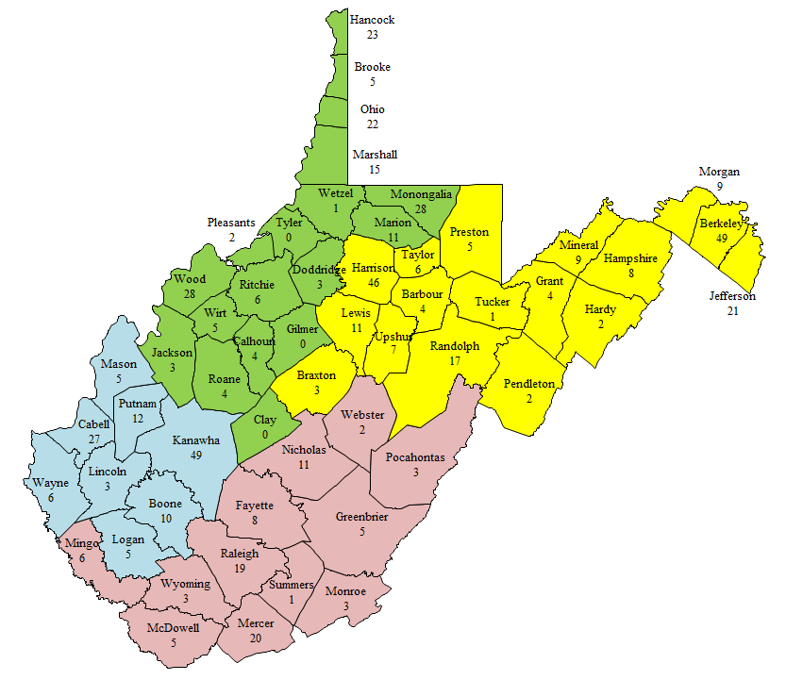

Update 2024:

Out-of-State Youth
All Regions
July 2021-June 2022

These numbers are unduplicated, so if a child went out of state more than once, he or she is only counted once. These numbers represent all the youth that have been out of state this year.

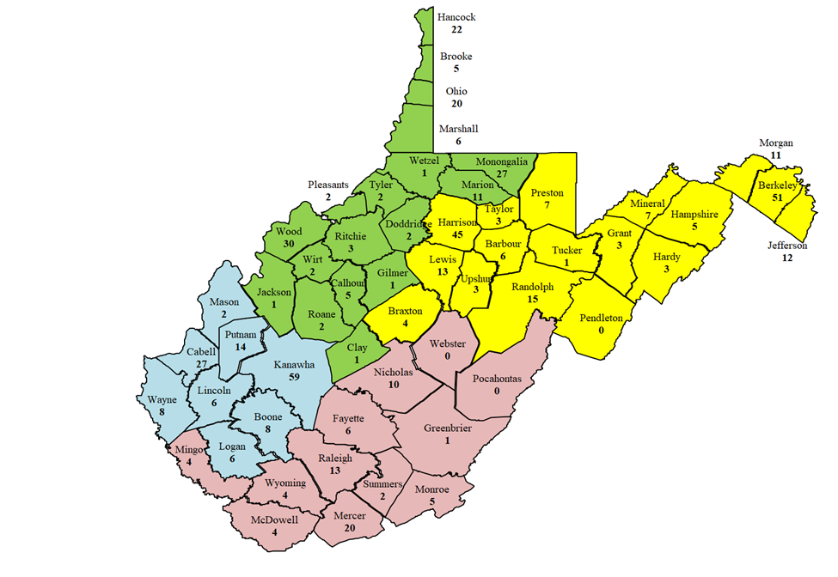

Bureau for Juvenile Services (BJS) Conference Call-Meetings

Senate Bill 393 required the Department to establish non-secure facilities for the rehabilitation of youth status offenders. Therefore, all youth who were status offenders at Robert Shell (a secured facility) had to be transitioned to an alternative placement. After a meeting regarding a youth whose IQ was 44, and in need of a specialized placement, the West Virginia Division of Corrections and Rehabilitation, Bureau for Juvenile Services (BJS) and other stakeholders began having conference call meetings on June 29, 2017, to discuss alternative placements for vulnerable children who have special needs and who have been placed within the Bureau for Juvenile Services. These calls have continued through 2018.

A total of 181 youth has been staffed. Thirteen of the 181 youth had duplicated reviews for a total of 168 unduplicated youth being reviewed. Currently there are 21 youths on the review list.

The ages of the youth are youth 12 years and under (62); youth 13 to 14 years (64); youth 15 to 17 (54); and youth 18 years and older (1).

Placements: youth in-state (66); youth out-of-state (46); youth remaining in their own home with services (39); youth committed to Bureau of Juvenile Services (8).

A total of 106 youth was identified as Intellectually/Developmentally Disabled. Forty-three were below an Intelligence Quotient (IQ) of 70; 41 were Borderline (70-85 IQ); and 22 were within the Autism Spectrum.
The weekly conference call participants include staff and administrators from Bureau for Juvenile Services; the Department’s Bureau for Children and Families Regional Directors (4); the Department’s Bureau for Behavioral Health; the Department’s Interstate Compact Placement of Children (ICPC) Central Office; the Department’s Bureau for Medical Services; PSIMED (mental health provider); Supreme Court of Appeals of West Virginia, Division of Probation and Division of Children and Juvenile Services; West Virginia Department of Education, Diversion and Transition Programs; child’s probation officer; and child’s primary Department worker.

Update 2023:

A total of 514 unduplicated youth has been staffed to date. Of the 514 unduplicated youth, 116 have returned to detention for a second time, 39 of them have returned to detention for a third time, and 22 have returned to detention for at least their fourth time.

Currently there are 28 youth on the review list.

The ages of the youth are as follows:

- age eight - 1
- age nine - 7
- age ten - 18
- age eleven - 75
- age twelve - 138
- age thirteen - 150
- age fourteen - 80
- age fifteen, sixteen, and seventeen - 209
- age eighteen or older - 11

All youth staffed with the Bureau for Juvenile Service have been discharged to the following types of foster care placements:

- shelters - 61
- youth in state residential - 141
- youth in Out of State placements - 185
- returned home with services - 178.
- committed to BJS - 34

A total of 301 youth has been identified as Intellectually/Developmentally disabled; 122 were below an Intelligence Quotient (IQ) of 70; 103 were borderline (70-85 IQ), and 76 were within the Autism Spectrum. 52 youth were deemed criminally incompetent to stand trial. An IQ was not available to the Bureau for Juvenile Services for 335 of the youth staff.

Update 2024:
In 2022, 647 kids have been placed in BJS custody that meet the criteria since the committee began in June 2017.

Of those youth:
- 63 have been in BJS twice.
- 53 have been in BJS three times.
- 34 have been in BJS for 4 or more times.

There are 42 kids on the list currently. Ages of the youth involved in this process are (these are not unduplicated numbers):

- Age eight – 1
- Age Nine – 9
- Age ten – 24
- Age eleven – 90
- Age twelve – 176
- Age thirteen – 228
- Age fourteen - 93
- Ages fifteen, sixteen, and seventeen- 262
- Age eighteen - 13

All youth staffed with the Bureau for Juvenile Service have been discharged to the following types of foster care placements.

- Shelters - 73
- Youth in In-state residential - 172
- Youth in Out of State residential - 229
- Returned home with services - 238
- Committed to BJS - 41

These are not unduplicated numbers. If a youth comes to BJS detention and is released home then comes back and goes to placement, they are counted in both areas.

- 142 - Below 70 IQ
- 132 - With 70-85 IQ
- 90 - On the Autism Spectrum
- 61 - Youth determined incompetent
- 483 - Youth IQ was not provided

Court Improvement Program: Support for Multidisciplinary Treatment (MDT) Teams

Provider Input at MDT and Court Hearings

During 2018, the Department’s BCF and the Court Improvement Program (CIP) began addressing a concern regarding service providers not receiving notifications of/having input at MDT meetings and Court Hearings. Although the lack of notifications to providers for MDT and Court Hearings appear to be isolated, BCF and CIP took the following steps:

- Department staff were notified that notification to MDTs and Court hearings are required and that when a provider cannot attend, the monthly reports by providers can be shared at MDT and Court Hearings to allow the provider to have input.
- The CIP and Department managers will develop a survey for Department staff to identify where MDTs work well and where improvements are needed.

Update 2023:

The Quality Hearing (MDT) Project purpose is to determine if quality MDTs lead to quality hearings and, in turn, lead to reduced time in care for children in abuse and neglect cases. This project is being conducted by the Court Improvement Program under the auspices of the Division of Children and Juvenile Services within the Supreme Court of Appeals of West Virginia. This project, which began in 2019, included data information gathering via conversations with BSS Regional Managers and Community Services Managers around the state and via surveys to Department field staff (205), attorneys (260), probation officers (80), residential providers (92), CAC/CASA staff (63), and foster care families (390). At the time of this report, the team is going through the results and transferring them from Survey Monkey into Excel for analysis. There were 1,144 surveys completed.

Of those about 81% (935) reported attending an MDT in the previous year.

Of those who participated in the Department survey, about 78% were either CPS workers or CPS Supervisors.

When asked if they had ever had formal training- the results varied widely among professions. Foster care parents were not asked about formal training- they were asked if they felt they were provided enough information on what an MDT is and how it operates.

Education providers (N=54) were asked if they received a desk guide for MDTs. Less than 3% responded yes.

CIP is now observing MDTs and the subsequent court hearing to collect additional data. To date, there have been 19 observation pairs completed and entered into Survey Monkey.
The final report for the MDT survey should be completed winter 2022 and will be shared with CIP stakeholders.

Update 2024:
Research suggests that if certain indicators are present during child welfare hearings, the outcomes for the child and family are better. Indicators include presence and engagement of case parties and judicial inquiries that lead to findings that shepherd the child to permanency. In West Virginia, all children involved in abuse and neglect cases participate in MDT teams. These are held throughout the life of the case and can be critical in monitoring the child’s case and preparing the parties for the subsequent hearing.

CIP has a hearing quality project that focuses on the impact of the MDT on the subsequent hearing. The project seeks to find if the quality of the MDT reflects in the quality of the hearing. Currently, Division of Children and Juvenile Services staff are collecting data directly from MDT and court observations. It is expected that the data will reveal a correlation between quality MDTs and quality hearings. Both are important to helping children reach permanency.

Stakeholder surveys were collected 2019-2021. More than 1,100 surveys were completed; it should be noted that the survey participants represent only a portion of all West Virginia stakeholders. Numbers for education personnel and providers are unknown, but these respondents likely represent a very small portion of the total number of personnel.

Stakeholder Group | Estimated # in West Virginia | % Represented by Survey
Probation | 317 | 25%
Attorneys | 6,284 | 5%
Foster care parents | 4,500 | 6%
DHHR | 800 | 19%
CAC & CASA | 380 | 15%

However, this report still provides some insight into the perceptions and practices surrounding MDTs in West Virginia. Below are some of the significant findings from the surveys. The full report is available here: Child Abuse and Neglect - Reports - West Virginia Judiciary (courtswv.gov)
Although 1,144 participants took the survey, 20% did not report attending an MDT, leaving 914 surveys from individuals who have attended an MDT.
• Results mirrored those from the 2008 study in that practices and perceptions vary widely across the state. While the fundamentals spelled out in the West Virginia Code were the same, there is not a statewide practice that can be identified, but rather multiple regional practices.
• The culture difference between DHHR and attorneys found in the 2008 study was not as pronounced in the current surveys.
• Attorneys reported attending the most MDTs in the previous year than any other group. They were also the group most likely to experience scheduling conflicts (92%).
• Providers stated they had the furthest to travel to attend MDTs. DHHR workers said they average about 5 miles to travel to MDTs, although most respondents stated MDTs are most often held at DHHR offices (36%), followed by county courthouses (35%).
• Twenty-nine percent reported their county has MDTs on regular set days, 69% said there was no set day, and two percent said they didn’t know.
• The majority of respondents agreed that DHHR had the overall responsibility for facilitating the meeting. The next most cited group was prosecuting attorneys.
• While there seems to be some consensus as to who leads the meetings, there is more dissention over who handles scheduling and notifying participants of the meeting.
• On average, about two-thirds of those responding say DHHR is responsible for both scheduling and notifying participants of the meeting.
• Interestingly, when asked about time spent in the child welfare profession, DHHR workers averaged the least amount of time in the profession. Only 43% of professionals who reported attended an MDT in the past year also reported having training on MDTs.
• Foster care parents and representatives were asked if they received adequate information about what an MDT is and its function. Nearly all (98%) stated they had heard of an MDT but only 55% said they felt they received enough information. About 8% said they received no information at all.
• Overall, most participants that the MDTs accomplished their stated goals, met frequent enough to effective, were sensitive to the needs of all team members, and were able to reach consensus.
• Only three-fourths of survey takers felt that for the most part, MDT practices contribute to the child achieving permanency in a timely manner.
• When looking at being engaged in the MDT, meaning there was ample input from the team member, DHHR workers and attorneys for the children were listed as very much and consistently engaged. Less than one-third of respondents said this for the child.
• About one-third of attorneys said their work on MDTs results in uncompensated work, meaning unbillable hours.
• Overall, DHHR workers were more current than their counterparts with regards to recent MDT training. This could be due to the relatively newness in their positions. When looking at the time of employment within CPS, survey respondents said they had been employed anywhere from less than three months to 28 years with an average of about four years on the job. Less than one third of the workers found their MDT training to be effective. Most were neutral or negative on how well the MDT training prepared them for their role in actual MDTs. Less than half (43%) stated they had help in preparation for MDT meetings.
• Several foster parents reported they received notification of MDTs via text message.
• About half of foster parent respondents indicated they were invited to the hearing following the MDT and of those 60% said they attended.

Professionals and paraprofessionals (attorneys, DHHR workers, CASA/CAC, providers, probation, and education) were asked what they thought MDTs should accomplish. Over three-fourths (76%) responded; data from this question is shown on the following chart.
The West Virginia Division of Corrections and Rehabilitation Division of Juvenile Services staff continue to observe MDTs and the subsequent court hearing through March 2023. As of January 26, 2023, data has been captured on 92 pairs of MDT/hearings observed in 25 counties.
Educational Input at Multidisciplinary Treatment (MDT) Teams

On May 2, 2018, a Memorandum signed by the Honorable Gary Johnson, Administrative Director, Supreme Court of Appeals of West Virginia; Steven Paine, West Virginia State Superintendent of Schools; and Bill J. Crouch, Cabinet Secretary, the Department and sent to West Virginia County Superintendents of Schools and Department Community Services Managers.

The Memorandum recognized the legal mandates and the importance for educators at the MDT meetings and a commitment for the notification and participation of school officials at MDTs.

Update 2023:

In 2021, the Department and the WV DOE encountered challenges in bringing education to the table at MDT meetings. As a result, staff from the Supreme Court of Appeals of West Virginia developed a survey for County Superintendents of Schools to bring awareness to the importance of staffing MDT meetings appropriately and to determine barriers to participation. Following the survey, the WV DOE asked each county superintendent to appoint an MDT contact from their district to be responsible for ensuring the participation of district staff in the MDT process.

After each district appointed a representative, training was provided by the Department on the responsibilities of the MDT. In November and December 2021, districts were polled to see how the MDT participation was progressing. There were mixed results from counties reporting full participation to others reporting receiving no invitations or communication with the Department.

Follow-up took place for districts still struggling to implement the legal mandate for MDT meetings.
Update 2024:

In 2022, the West Virginia Schools of Diversion and Transition’s (WVSDT) Education Recovery Specialists (newly created positions in 2021) assisted children in foster care and their parents by:

- Participating in Individual Education Plan (IEP) meetings and Multi-Disciplinary Team (MDT) meetings, where appropriate.
- Assisting DHHR and West Virginia Department of Education (WVDE) in tracking educational needs and progress for targeted students.
- Assisting students in obtaining additional educational and tutoring services, as needed, to reach grade level academically.
- Contacting community resources, state, and non-profit agencies to link, refer, and/or advocate on behalf of and support of students.
- Providing educational support and training for foster parents.
- Developing relationships with foster care agencies for the purpose of identifying and assisting foster youth with their educational needs; and,
- Coordinating activities with WVSDT’s Transition Specialists.
- Coordinating with teachers, administrators, transition specialists, county school systems, host agencies, and West Virginia Department of Health and Human Resources (DHHR), as applicable, for continuation of education services.

In 2022 data from the Education Recovery Specialists indicate that they received over 80 referrals from 25 county school districts. The largest increase in referrals was from DHHR personnel. Many of the responses to referrals provided supports for children in out-of-home care for enrollment, special education referrals and IEP assistance, and acquisition of needed documents (e.g., birth certificates, immunization records, transcript analysis, social security cards, etc.).

During 2022, education recovery specialists conducted 10 training courses for foster agency workers and foster parents, training over 700 individuals. The Educational Recovery Specialists also made presentations to county school district personnel and received many referrals after meeting with principals and school counselors. Foster parents who have been trained continue to reach out to ERS personnel for advice and assistance.

Education recovery specialists have provided a vital linkage between DHHR personnel and education personnel for providing educational services to children in foster care.

This new leadership initiative from the WVSDT is targeted at closing the achievement gap for children in foster care as well as gaining understanding why the vast majority of children in foster care are doing so poorly in school and why some children in foster care are doing well academically.
Child Placement Network
The West Virginia Child Placement Network (WVCPN) was launched in 2005 as a centralized resource for identifying daily placement availability for children when they cannot remain in their own homes. In August 2006, the WVCPN was awarded the 2006 State Information Technology Award in the Government-to-Government category. In January 2008, the “Facility Detail” screen added the placement criteria for: IQ Range(s); accepted ages; mental; physical; and court involved. In July 2010, the WVCPN “Daily Report” began featuring real-time data, export options, and the ability to refresh the data contained in the report to the current second. In February 2012, the provider type, “Transitional Living” was added. Currently, the WVCPN has 76 participating facilities. The WVCPN website address is https://www.wvdhhr.org/wvcpn/Default.asp.
The West Virginia Adult Behavioral Health Placement Network

The West Virginia Adult Behavioral Health Placement Network is a centralized resource for identifying daily availability of residential crisis, group home and treatment services across West Virginia for adults with mental health and/or substance abuse issues. There are currently 94 licensed service agencies that provide regular updates about bed vacancies, with additional details about accepted ages, gender, and type of behavioral health challenge. The website also provides updates on new facilities or expansions in services as available. The website is intended to be a source of information for those seeking available resources throughout West Virginia. To access the West Virginia Adult Behavioral Health Placement Network, visit http://www.wvdhhr.org/wvabhpn/ .
Update 2023:

The West Virginia Adult Behavioral Health Placement Network is retired. BBH is working on plans for a new placement network that should be operational by 2023.

Update 2023:

The West Virginia Adult Behavioral Health Placement Network is retired. BBH is working on plans for a new placement network and hopes to finalize it by the end of 2023 or early 2024.

Implementation of Every Students Succeeds Act (ESSA): Focus on Foster Care Children

A memorandum was provided to West Virginia County School Superintendents and Department Community Services Managers from the Honorable Gary Johnson, State Superintendent of Schools Steven L. Paine, and Department Cabinet Secretary Bill Crouch which stated, “It is imperative that school districts develop a protocol that works best for each county in adhering to ESSA, West Virginia law, and this commitment to our state’s children.”

The Education of Children in Out-of-Care Advisory Committee developed a guiding tool on conducting MDTs. Additionally, the agreement for the exchange of data as required by ESSA was finalized. The WV DOE is reviewing exemplary programs to close the gap for children in foster care. In the 2017-18 school year, the WVDE, Office of Diversion and Transition Programs collected data from the following:

- 6,109 educational records with the Department, FACTS database for children in out-of-home (OOH) care
- 6,082 children had attendance records in WVEIS.
- 3,023 children of the matches are assessment eligible (grades 3-8 and grade 11)
- 2,652 children had assessment records.
- There were 369 missing assessments from eligible students.
- General Summative Assessment Results for grades 3-8 and grade 11 are measured in five categories: Exceeds Standard; Meets Standard; Partially Meets Standard; and Does Not Meet Standard.
- OOH student scores were lower in English/Language Arts and Mathematics for all grade levels (3-5th grade, 6-8th grade, and 11th grade).
- Proficiency Breakdown: Although most children in OOH care did not meet expectations, data indicated that some students did not take tests in English/Language Arts or Mathematics.
- The participation rates for children in OOH care were lower in each area than English Language Learners (ELL), Low Socio-Economic Status (SES) and Special Education (SPED).
- Attendance Rates: OOH students were equal to Low SES and SPED at 92%. Whereas all other students reflected 93% and ELL 95% participation rate.

In addition, the role of the local schools and the Department County offices ensures collaboration, communication, and implementation of Every Students Succeeds Acts (ESSA). This is the responsibility of the Department Community Services Manager (CSM) and/or designer to ensure these partnerships are made and maintained.

Update 2023:
The Education of Children in Out-of-Home Care Advisory Committee continued its work on the following major objectives during 2021: 1) Increase educational participation in multi-disciplinary teams; 2) Monitor the educational programs of children placed out-of-state; 3) Identify promising and best practices with respect to the education of children in out-of-home care; and 4) Develop transition programs and services to assist out-of-home care students in returning to school, transitioning to work, or reunifying with their communities once they leave an institution or other out-of-home environment.

Under Every Student Succeeds Act (ESSA), the WV DOE is required to annually report on the educational status and achievements of children in foster care. However, due to the COVID-19 pandemic, the state testing program was canceled for the 2019-20 and the 2020-21 school years. Therefore, the data normally reported in the Annual Report on the educational status and achievements of students in out-of-home care is unavailable.
During 2022, the Education of Children in Out-of-Home Care Advisory Committee will continue to work on: 1) Facilitating the implementation of the foster care provisions of Every Student Succeeds Act (ESSA); 2) Increasing educational participation in MDTs; 3) Monitoring the education programs of children placed out-of-state; 4) Improving and expanding transitional services; and 5) Identifying and disseminating promising and best practices in the education of children in foster care.

Update 2024:

The Education of Children in Out-of-Home Care Advisory Committee continued its work on the following major objectives during 2023: (1) increase educational participation in multi-disciplinary teams; (2) monitor the educational programs of children placed out-of-state; (3) identify promising and best practices with respect to the education of children in out-of-home care; and (4) develop transition programs and services to assist out-of-home care students in returning to school, transitioning to work, or reunifying with their communities once they leave an institution or other out-of-home environment.
Under Every Student Succeeds Act (ESSA), the West Virginia Department of Education is required to annually report on the educational status and achievements of children in foster care.

During 2023, the Education of Children in Out-of-Home Care Advisory Committee will continue to work on: (1) facilitating the implementation of the foster care provisions of ESSA; (2) increasing educational participation in MDTs; (3) monitoring the education programs of children placed out-of-state; (4) improving and expanding transitional services; and (5) identifying and disseminating promising and best practices in the education of children in foster care.

The West Virginia Adult Drug Courts Program

The West Virginia Adult Drug Courts (ADC) Program is a cooperative effort of criminal justice, social service, substance abuse treatment, and law enforcement systems. The ADCs are established in accordance with the West Virginia Drug Offender Accountability and Treatment Act (West Virginia Code § 62-15-1, et seq.) and are designed and operated consistent with the National Association of Drug Court Professionals, key ingredients of the Drug Court model (known as the Ten Key Components (NADCP, 1997) which became the core framework not only for ADCs but for most types of problem-solving court programs. The West Virginia ADC is operated under policies and procedures established in consultation with the Supreme Court of Appeals of West Virginia. All ADCs use evidence-based treatment approaches and assessments and are to be evaluated annually.
Program components include intensive supervision; frequent, random, and observed drug testing; meetings between participants and their probation officers; counseling sessions for participants; court appearances for participants; and community service.

The program seeks to achieve a reduction in recidivism and substance abuse among offenders and to increase the likelihood of successful rehabilitation through early, continuous, and intense treatment; mandatory periodic drug testing; community supervision; appropriate sanctions and incentives; and other rehabilitation services, all of which is supervised by a judicial officer.

For State Fiscal Year 2018 the average annual cost per drug court participant was $3,814 as compared to $19,425 in the Regional Jail or $26,081 in a Division of Corrections and Rehabilitation prison. These costs include intensive supervision, treatment, case management, and drug testing.

As of June 30, 2018, there were 28 operating ADC programs comprising 34 individual courts covering 46 counties.

Update 2023:

For State Fiscal Year 2021, the average annual cost per drug court participant was $5,331 as compared to approximately $19,425 in a regional jail or $26,081 in a Division of Corrections and Rehabilitation prison. These costs include intensive supervision, treatment, case management, and drug testing. There were 842 participants served by the West Virginia ADC Program in State Fiscal Year 2021. As of June 30, 2021, there were 29 operating ADC programs that cover 46 counties.

Update 2024:

For FY 2022, the average annual cost per Adult Drug Court (ADC) participant was $5,988 which is an increase of $657 from FY 2021, as compared to $19,425 in the Regional Jail or $26,081 in a Division of Corrections and Rehabilitation prison. These costs include intensive supervision, treatment, case management, and drug testing.

As of June 30th, 2022, there were twenty nine (29) operating ADC programs covering forty-six (46) counties: Berkeley, Boone, Brooke, Cabell, Calhoun, Doddridge, Fayette, Greenbrier, Hampshire, Hancock, Hardy, Harrison, Jackson, Jefferson, Kanawha, Lewis, Lincoln, Logan, Marion, Marshall, Mason, McDowell, Mercer, Mingo, Monongalia, Monroe, Morgan, Nicholas, Ohio, Pendleton, Pleasants, Pocahontas, Preston, Putnam, Raleigh, Randolph, Ritchie, Roane, Summers, Tyler, Upshur, Wayne, Wetzel, Wirt, Wood, and Wyoming counties.

National reports support the effectiveness of ADCs that adhere to best practices and evidence-based practices from the fields of substance abuse treatment and counseling. There were 884 total participants served in FY 2022.

The West Virginia Juvenile Drug Court Program

The West Virginia Juvenile Drug Court (JDC) Program is a cooperative effort of juvenile justice, social service, substance abuse treatment, law enforcement and education systems.

JDCs are established in accordance with West Virginia Code §49-4-703 and are designed and operated consistent with the developmental and rehabilitative needs of the juveniles and operate under uniform protocol and procedures established by the Supreme Court of Appeals of West Virginia.

The program seeks to divert non-violent, juvenile offenders engaging in substance abuse from the traditional juvenile court process to a non-adversarial, intensive, individualized outpatient substance abuse treatment process which includes parental involvement and cooperation. All JDCs use evidence-based treatment approaches and assessments and are evaluated annually.

Program components include intensive supervision; frequent, random, and observed drug testing; meetings between juveniles and probation officers and parents and probation officers; counseling sessions for juveniles and for families; court appearances for juveniles and parents; and community service.

For State Fiscal Year 2018, the average cost per youth was $1,057. This cost includes intensive supervision and individualized treatment services and includes services to the family. This contrasts with the approximately $110,000 annually in a residential or correctional facility placement. There were 291 participants served by the JDC programs for State Fiscal Year 2018. As of June 30, 2018, there were 16 operational JDC programs.

Update 2023:
For the State Fiscal Year 2021, the average cost per youth was $4,269. This cost is primarily for intensive supervision, contingency management, and drug testing. The cost contrasts with the minimum $100,000 annually in a residential or correctional facility placement. There were 280 participants served by the 17 JDC programs for State Fiscal Year 2020.

Update 2024:

As of June 30th, 2022, there were seventeen (17) * JDC programs serving the following counties: Berkeley, Boone, Brooke, Cabell, Hancock, Harrison, Jefferson, Kanawha, Lincoln, Logan, McDowell, Mercer, Monongalia, Morgan, Ohio, Pleasants, Putnam, Raleigh, Randolph, Ritchie, Wayne, Wirt, and Wood Counties. *McDowell and Cabell Counties were inactive for FY 2022.

Cost savings for the criminal justice system stem from reduced re-arrests, law enforcement contacts, court hearings, and use of detention centers. Other cost savings for the State result from reduced out-of-home placement and decreased use of residential treatment centers.

For FY 2022 the average cost per youth was $5,203. This cost includes intensive supervision and individualized treatment services and includes services to the family. This is in contrast to the approximately $110,000 annually in a residential or correctional facility.
There were 266 participants served by the JDC programs for fiscal year 2022.

Family Treatment Court

West Virginia is going to use the Family Treatment Court model to address cases entering the child welfare system that allege child abuse or neglect involving parental use of alcohol or other drugs. The family treatment court’s mission is to ensure the safety and well-being of children and to offer parents a viable option to reunify with their children. A family treatment court does this by providing children and parents with the skills and services necessary to live productively and establish a safe environment for their families. The court partners with child protective services and an array of service providers for parents, children, and families.

The Family Treatment Court includes an interdisciplinary team working together to address the complex issues facing families affected by substance use disorders. The Family Treatment Court draws on best practices from the treatment court model, dependency court, and child welfare services to effectively manage cases within ASFA mandates. In this way, Family Treatment Court ensures the best interests of children are addressed while providing necessary services to parents.

Update 2023:

As of June 30, 2021, Family Treatment Courts were in Boone, Nicholas, Ohio, Randolph, Roane/ Calhoun, Logan, McDowell, Fayette, Wood, and Wetzel counties. At that point, they had served 138 participants and 172 kids. 35 participants graduated, 66 kids were reunified with their families and 48 achieved permanencies with at least one parent.

Update 2024:

WV has 11 Family Treatment Courts (FTC) serving 13 counties in Boone, Ohio, Randolph, Nicholas, Roane & Calhoun, Kanawha, Logan, McDowell, Fayette, Wood, and Wetzel, Tyler & Marshall Counties. In 2022, the FTC programs in WV served 230 participants and 415 children. 64 participants graduated, 111 kids were reunified with their families and 107 achieved permanency with at least one parent.
Transitioning Youth from Foster Care

In 2018, the Commission to Study Residential Placement of Children, Service Delivery and Development (SDD) Workgroup updated the It’s My Move wallet cards to include a scan code that links directly to the It’s My Move website. The It’s My Move website is a program that assists youth in gaining life skills to support them as they transition to adulthood. The website includes the Readily at Hand checklist of key documents and experiences needed as youth transition to adulthood. Youth can set up their own account, track their own progress, add notes, and save their information as they move through the checklist.

The following related goals are underway or have been achieved:

- Readily at Hand, http://www.itsmymove.org/rah.php, is an online and printable checklist of essential skills and experiences and links to information about needed documents. Updates to the website are currently underway.
- Youth who are transitioning to adulthood are provided the desk guide and wallet card for the It’s My Move website, www.ItsMyMove.org/raf.php. The wallet cards have been updated to include a scan code that links to It’s My Move and Readily at Hand.
Update 2023:

Any further updates regarding Transitioning Youth from Foster Care will be located in the John H. Chafee section.

Update 2024:

Any further updates regarding Transitioning Youth from Foster Care will be located in the John H. Chafee section.
West Virginia Interagency Consolidated Out-of-State Monitoring

The West Virginia Interagency Consolidated Out-of-State Monitoring process continues to ensure children in foster care and placed outside of the state of West Virginia are in a safe environment and provided behavioral health treatment and educational services commensurate with Department and WV DOE standards.

The following summary outlines the 2018 out-of-state monitoring visits. While violations are noted, each facility also had positive programming aspects and is working on weaknesses through corrective action plans:

- Hermitage Hall, Nashville, TN – This was a return visit completed in January 2018. The facility was previously reviewed in November 2016 and since that time had four requests for investigations. Educational weaknesses identified included: teacher certification issues; wide spans of grade levels in elementary and middle grade classrooms; lack of Career Technical Education (CTE) options; lack of structure leading to excessive restraints; no continuum of services for students with disabilities; expired IEPs; scheduling issues; and confusion about the rights of parents who retain educational rights.

- Devereux, Viera, FL – The review was completed in March 2018. No major violations were found – Devereux has a very low turnover rate of employees with many in the school and on the treatment, team employed for more than 20 years. Strengths identified include teachers are certified in special education; classrooms are observed four times per week through observation rooms; excellent technology availability and use; lesson plans are standard-based and contain quality instruction; educational field trips are provided monthly; and outdoor recreation opportunities are provided for students. A change in Florida State Standards no longer requires CTE coursework to graduate. Therefore, Devereux currently has no CTE programming in place where formerly they had an on-site cosmetology program. The facility administration was encouraged to develop partnerships for students to participate in community-based opportunities for work experience and career planning.

- George Junior Republic, Grove City, PA – A follow-up visit was conducted in March 2018. A Department team along with one WV DOE representative visited George Junior to determine progress since the placements to this facility were suspended in January 2015. The team had the same concerns after the visit regarding treatment of WV youth, details of programming and attitude towards feedback and discussion regarding changes that should be considered.

- Timber Ridge, Winchester, Virginia – A review was completed in May 2018. Corrective Action Plan includes work toward improving teacher certification issues; IEP Services; Transition Services, including a focus on the lack of CTE offerings; and Notification to Transition Specialist of Upcoming Discharges to provide support and planning with the home county in West Virginia.

- Natchez Trace, Waverly, TN – A review was completed in September 2018. The Corrective Action Plan includes work toward improving teacher certification issues; IEP Services; provision of FERPA training to school staff; and Notification to Transition Specialists of Upcoming Discharges.

- Foundations for Living, Mansfield, Ohio – A review was completed November 2018 (reports pending). Weaknesses identified include: no CTE programs offered due to acute care in self-harm; trafficking, drug, and alcohol treatment; and mental health concerns.

Update 2023:
The West Virginia Interagency Consolidated Out-of-State Monitoring process continues to ensure children in foster care and placed outside of the State of West Virginia are in a safe environment and provided behavioral health treatment and educational services commensurate with Department and WV DOE standards.

Due to the COVID-19 pandemic, out-of-state monitoring reviews were placed on hold in March of 2020. The out-of-state monitoring reviews resumed in late 2021 with one review occurring.

Abraxas, located at 165 Abraxas Road, Marienville, PA 16239, was reviewed December 2021. No immediate safety issues were identified.
Update 2024
The West Virginia Interagency Consolidated Out-of-State Monitoring process continues to ensure children in foster care and placed outside of the state of West Virginia are in a safe environment and provided behavioral health treatment and educational services commensurate with DHHR and WVDE standards.
The following summary outlines the 2022 out-of-state monitoring visits. In all cases, the facilities had noted strengths and were offered an opportunity to work to correct noted deficits through corrective action.
· Sandy Pines, Jupiter, FL – The review was completed in February 2022. At the time the visit was conducted, there were several pending complaints from WV BSS workers and family members of children at the placement concerning communication issues with facility staff. Guardians and family found professional staff hard to reach and inconsistent with information provided about child treatment progress. Findings of the review included poor individualization of treatment planning, failure to involve youth in their treatment planning, and failure to provide meaningful progress updates to parents and guardians. Issues were also noted with medication consents and therapy notes which lacked individualization and substance. The review of educational services found that the facility was not utilizing the WV IEP plans that youth were admitted with and had not created new IEPs for their education as per contract. There were additional problems verifying instructional hours for students. While Sandy Pines did submit acceptable corrective action measures, use of the facility for West Virginia youth was suspended in February 2023 following a court issued moratorium on placements, resulting from an investigation by the Florida Agency for Health Care Administration.
· Wood Services, Inc., Langhorne, PA- The review was completed in April 2022. No major violations were found. The educational issues noted consisted of assuring guardian notification of IEP meetings, individualization of student schedules and assuring alternative lesson planning for students who refuse the classroom. Documentation was found to be inconsistent for contracted speech and occupational therapy providers.

· Timber Ridge Schools, Cross Junction, VA – The review was completed June 2022. Some issues with providing timely training for staff were noted, as well as some discrepancies with treatment planning which were minor in nature. The need for clearer documentation of therapy, including provider’s credentials, client response to interventions and connection of interventions to the treatment plan were noted for improvement. Educational issues noted were a need to individualize student schedules, record keeping deficits for indirect behavioral services, and lack of documented minutes of special education services provided to the students.

· The Hughes Center, Danville, VA – This visit was conducted in October 2022. Some issues were noted regarding assuring guardian involvement in treatment planning and follow up on medical consents. Discrepancies were found between the facility’s restraint policies and WV expectations, but no issues of practice were identified with WV residents and policy revisions for WV youth were requested. Education noted a need to provide more information on student special education services and submission of IEPs for all WV students.

· Alabama Clinical Schools, Birmingham, AL – The visit was conducted in November 2022. Some staff training deficiencies and background check issues were identified for correction. Although minimal restraints were noted for WV residents, variation from WV expectations was cited. Educational issues noted were differences in expectations for staff credentials, a lack of vocational opportunities for youth, and accurate documentation of time special education services are provided in the school day.

Agency Responsiveness to the Community
The Division of Planning and Quality Improvement (DPQI) utilizes Child and Family Service (CFSR) style reviews to evaluate case practice with children and families. Specifically, to the WV Service Array, the DPQI identifies service gaps through the reviews and focus groups with parents, youth, and stakeholders.

In addition to the DPQI process, the West Virginia Community Collaborative Groups (Collaboratives) identify and address service gaps in their communities. The Collaboratives were originally formed in the late 90’s with the purpose of continuous community assessment over specified geographical areas. In 2014, West Virginia was federally approved by the Administration for Children and Families to develop the IV-E demonstration project known as Safe at Home WV. As part of Safe at Home WV, Collaboratives play a key role in identifying these community-based services and, if needed, assist in developing services based on the needs of the children and families in their community. The Collaboratives have a sense of “community ownership” for children at-risk of being placed in out-of-home care and keeping children closer to their families and home communities when they must be placed out-of-home.

The Collaboratives are expected to provide bi-annual reports to the Department’s BCF. However, not all Collaboratives provide these reports, they are not always provided consistently, the reports are not reviewed through a formal service development plan, the Department’s BCF does not have a Memorandum of Understanding that formalized this relationship, and the information is not included in a formal service delivery and development plan for identifying service needs and gaps.

Although the Collaboratives continue to meet, some Collaboratives do not consistently provide community data reports on the service needs and gaps. The needs and gaps are reported to the four Regional Summits as well as the Regional CQI team. CSMs are mandated members of each of these teams. They are to notify their Regional Director of these gaps in service and the Regional Director is to report the information to BCF Leadership.

The BCF has notified newer CSMs of their responsibility to participate in each of these groups and their responsibility to make their Regional Director aware of any information shared at the Summits.

Update 2023:

The Community Collaboratives Semi-Annual Report continues to be used to identify service gaps provided by community partners involved in the Collaboratives. This information is provided through the previously mentioned Service Communication Plan to Child Welfare Oversight, which is composed of leadership members of BSS and sister Bureaus.

The Managed Care Organization, Aetna, and the Administrative Services Organization, KEPRO, continue to conduct focus groups of foster youth, former foster youth, service providers, biological parents, and foster care providers to gain feedback on their lived experiences and interactions with child welfare. This data is provided under the Socially Necessary Services section.

During calendar year 2020, monthly service provider meetings were held to discuss issues regarding the COVID-19 pandemic. These calls were made with the Child Placing Agencies, Socially Necessary Service Providers and Residential Providers. In 2021, these meetings continued but were changed to quarterly instead of monthly due to the decrease in COVID-19 cases. The providers had an open line of communication with the agency to help combat issues that might arise, COVID-19 or non-COVID-19 related. This allowed the agencies to be another voice for the families, individuals, and communities they serve.

See additional updates on Agency Responsiveness to the Community under the Service Array section for more information on Agency Responsiveness to the Community.

Update 2024:

The Community Collaboratives Semi-Annual Report continues to be used to identify service gaps provided by community partners involved in the Collaboratives. This information is provided through the previously mentioned Service Communication Plan to Child Welfare Oversight, which is composed of leadership members of BSS and sister Bureaus. Oversite of the Community Collaboratives will transition to the Bureau for Family Assistance in 2023.

The Managed Care Organization, Aetna, and the Administrative Services Organization, KEPRO, continue to conduct focus groups of foster youth, former foster youth, service providers, biological parents, and foster care providers to gain feedback on their lived experiences and interactions with child welfare. This data is provided under the Socially Necessary Services section.

The quarterly meetings held in 2021 regarding issues related to the COVID-19 pandemic were discontinued in 2022.

See additional updates on Agency Responsiveness to the Community under the Service Array section for more information on Agency Responsiveness to the Community.

Communication and Dissemination Process

The Family Resource Networks (FRNs), currently develop the Family Resource Directories for each of the fifty-five counties in West Virginia annually. The FRNs support and promote the collaboration of all citizens to develop strategies for communities to succeed. Recently, the FRNs began putting their directories on a central website. This website was made possible because of a Benedum grant that was awarded to the Marshall County FRN. The BCF recently required, as a part of the FRN Contract, the FRNs to utilize the central website as their resource directory. WV does need to develop a standardized process for the FRNs that will address how the information is to be gathered and how often the website needs to be updated and monitored.

On January 1, 2018, through June 30, 2018, seven (7) of the thirteen (13) Collaboratives (Family Central; Family Southern; Family Ways; Little Kanawha; Nicholas-Webster; Fayette/Raleigh; and Upper Potomac) reported for the January 1, 2018, through June 30, 2018, biannual report. Of the seven (7) Collaboratives that reported, five (5) reported that they were addressing substance abuse issues and five (5) reported addressing foster parent recruitment/retention.

On July 1, 2018, through December 31, 2018, nine (9) of the thirteen (13) Collaboratives (Family Central; North Central; Nicholas-Webster; Family Ways; Upper Potomac; Family Southern; South Central; Raleigh/Fayette; and Greenbrier) reported for the July 1, 2018, through December 31, 2018, biannual report. Of the nine (9) Collaboratives that reported, eight (8) reported that they were addressing substance abuse issues and four reported addressing foster parent recruitment/retention.

Other issues that were being addressed by the Collaboratives during the 2018 calendar year were: Respite/Wraparound; Increasing Collaborative Membership/Key Partners; School Based Behavioral Health; Family Support/Basic Needs; Family/Youth Mentoring and Support; Support for Safe at Home WV program; Youth Transitioning; Recruitment and Retention of Department staff; Expanding Court Appointed Special Advocates (CASA); Multidisciplinary Treatment Teams; Truancy Diversion; and School Education on Mental Health Services for Children and Families.
Program Plan to be Implemented:
1.1 Partner with the Capacity Building Center to develop a Service Array map of available substance use services throughout the state (utilizing work of the Department, Bureau for Behavioral Health (ranking)), and what barriers exist. Map development completed and will include:
- Identify type of services needed.
- Barriers for substance abuse services are identified
1.2 Service Array Workgroup will meet at least monthly to collect information to develop a map of service availability.
2.1 The Department will partner with the Family Resource Networks to provide Service Directories of available services on the FRN website that can be accessed by all Department staff and stakeholders.
2.2 Staff will be notified of the website and Resource Directories through short Blackboard training
2.3 Staff will be notified quarterly through PSA blasts that highlight new services
2.4 Provide information on WV DHHR Facebook on FRN website and Resource Directories.
2.5 Service Array Workgroup will meet at least monthly to collect information to develop a map of service availability.
- 2.6 WV DHHR will develop and execute a formal statewide communication plan that will include all DHHR Bureaus (and others as needed) to improve cross-system service provision (identifying service availability, accessibility, barriers, and service development).
2.6.1 Memorandum of Understanding between all DHHR Bureaus
- Memorandum of Understanding between DHHR and Community Collaborative Groups completed (July 1, 2019)
- Standardize communication process completed that:
- Applies the Service Array map and Community Collaborative Group reports for evaluation of service development and expansion.
- Formal Communication Plan utilized for service development

All information about progress or the lack of progress to the Department’s goals are shared at Statewide ESSA, Trafficking, Drug Affected Infants group and CIP Data Statute and Rules committee meetings on a regular basis. Goals for each program area are discussed at length and cross training within the meetings occurs to ensure the state is maximizing all its resources to achieve safety, permanency and well-being for its children and families.

Stakeholder Focus Group

As of March 2020, KEPRO is no longer the contracted entity with the Department managing Socially Necessary Services and Medically Necessary Services. While some functions remained subcontracted to the new vendor, Aetna Better Health, focus groups were not. The contractual change occurred during this rating period. Therefore, the number of focus groups completed overall will be less than in previous years.

KEPRO conducted focus groups with families, foster parents, and youth to assist the Department in identifying systemic issues including gaps in service and general practice. Below are summaries of the information that was discovered during these groups.

In March 2020, a new contract was initiated between the Department and Aetna Better Health of WV (ABH WV) to bring all children currently in foster care and children with completed adoptions and legal guardianship cases under managed care. This contract included the members receiving Socially Necessary Services. As part of the contract, ABHWV assumed control of the SNS focus groups from KEPRO, the previous vendor.

When ABHWV assumed control of the SNS focus groups, the process was changed from having new members for each focus group to a group that maintained the same members for a year. Also, due to COVID-19 restrictions, the meetings were held virtually with no in-person option from June 2020 to June 2021. The first focus group for SNS was held on June 29, 2020, and was composed of biological parents of children who had been removed and put into Department custody. The parents and the children received SNS during the removal episodes. One family received SNS before the removal episode as well. Due to having the same members for the next year, all focus group questions were not asked at the first meeting or at subsequent meetings. The questions were split out and covered over the course of a year.

The first meeting introduced the focus group members to the purpose of the group, the ground rules, ABHWV facilitation staff, and each other. The members explained their reasons for wanting to participate in the focus group. One member said she wanted to improve the system and remove some of the barriers she encountered. Another member stated that she was not pleased with the SNS she received, especially the service of Supervision while she was still in the Family Preservation section of her case. She found the service to be disruptive and “creepy”. She stated that the SNS provider did not give her any reason for why the service was provided or what he/she was looking for while in the home. She stated that the CPS worker on the case also did not elaborate what purpose the service served. She said that once her children were removed, her visitation times and locations were constantly changing. She said that lack of communication led to service disruption and canceled visitation.

One member said that if she had had a service navigator or a peer support specialist that specialized in CPS, she would have made more progress. She said she felt “lost” all the time. She never really understood the court process, the seriousness of her situation, and what the next steps should be. She said that at the second hearing, the judge told her that he was going to terminate her parental rights and that she would never see her child again. That was the first time she understood the seriousness of the situation and began really participating in an improvement period.
2018 Annual Youth Stakeholder Focus Group Summary
Socially Necessary Services/Community Behavioral Health Services

During Contract Year 2018-2019, the Consumer & Community Affairs Liaison facilitated twelve (12) Focus Groups with youth, families and foster parents that reside in the community and utilize Socially Necessary Services (SNS) and Community Behavioral Health Services.

The purpose of these focus groups is to provide youth in West Virginia the opportunity to candidly share their experiences and opinions. These groups are conducted on a regular basis in various regions across the state to gain insight regarding the utilization and impact of these services in the state. Information is gathered throughout the year with a minimum of twelve (12) focus groups that reflect consumers’ voices regarding access, service delivery, cultural competency, and outcomes.

Total: Ninety-six (96) youth, family and foster parents utilizing Socially Necessary Services/Community BH Services

The focus group questions were developed with input from BCF. The intent of these questions was to generate responses identifying systemic issues regarding consumer perceived problems and solutions regarding:

• Access
• Service delivery
• Gaps in support systems
• Engagement with system staff
• Cultural competency
• Consumer knowledge of services and supports

Focus Group Questions and Responses:

1. Is your current agency/family committed to providing health and educational materials that appeal to various social, cultural, and special needs groups?
One hundred percent (100%) or 96 participants agreed that the agencies were committed to providing pertinent materials that addressed their individual needs.
2. Are intake forms or materials available in different languages?
One hundred percent (100%) or 96 respondents stated that materials were available in different languages.
3. Does your provider offer assistance for those with disabilities? For example: large print, sign language, assistive technology.
One hundred percent (100%) or 96 participants agreed that their agencies offered assistance for those with disabilities.
4. Does the agency have trained interpreters readily available for various languages, including sign language?
One hundred percent (100%) or 96 participants stated that the agencies had access to trained interpreters for various languages and sign language.
5. Do the agencies/families have established connections with various communities, cultural, ethnic, and religious groups to help better serve diverse groups?
One hundred percent (100%) or 96 participants agreed that the agencies had established connections to serve diverse groups.
6. In the past six months has this agency sponsored at least one activity that has helped improve communication and teamwork between residents of different cultural, language and ethnic groups?
One hundred percent (100%) or 96 participants agreed that the agencies had established connections to serve diverse groups.
7. Do you have the opportunity to attend racial group holidays or functions within diverse communities? What was it?
One hundred percent (100%) of those responding stated that they had attended one or more group holidays or community functions within diverse communities.
They were as follows: Passover services Holiday cookouts.
Easter services ethnic dining/meal prep
Various protestant church groups Cultural Art Festival
Catholic services Italian Festival
Christmas parties Hanukkah services
8. Are you provided linkages with advocates for diverse communities who can give you reliable information regarding community opinions about diverse and important issues?
One hundred percent (100%) of participants or 96 of those responding agreed that they were provided linkages to advocates regarding diverse and important issues.
9. Do you have access to religious services in which you affiliate?
One hundred percent (100%) of participants or 96 respondents stated, “Yes.”
10. Does your care provider (Family) alter your programming or care based on your values or culture?
One hundred percent (100%) of participants or 96 respondents stated, “Yes.”
11. Do you feel your services are tailored to your needs?
Ninety-four percent (94%) of participants or 90 respondents stated, “Yes.” Another Six percent (6%) or 6 participants said, “No.”
12. Are visits arranged in situations you and your family are comfortable with- both physically and emotionally?
One hundred percent (100%) or 96 participants agreed that the visits were comfortable, both physically and emotionally.
13. Are you allowed visits with siblings, extended family, kin, or your friends you want to keep in touch with from home?
One hundred percent (100%) or 96 participants stated that they were allowed to stay in touch with extended family, kin, and friends from home.
14. Are you able to contact family and friends by means other than visitation, phone calls and letters? Do you have access to email, skype, FaceTime, texting, twitter, Facebook, Instagram, Snapchat?
One hundred percent (100%) or 96 participants stated that they were able to contact family and friends via email, skype, FaceTime, Facebook, etc., with supervision and timelines.
15. If you are celebrating a special occasion or holiday, do you have input in the planning? Are your family traditions considered, foods your family likes, ways to decorate?
One hundred percent (100%) of participants or 96 respondents stated, “Yes” to both questions.
16. Do you have access to personal care items or services that match your needs? (Haircuts, dye…)
One hundred percent (100%) of participants or 96 respondents stated, “Yes.”
17. Do you feel you get to express your personal style in clothing and appearance?
One hundred percent (100%) of participants or 96 respondents stated, “Yes.”
18. Do caregivers understand or demonstrate an understanding of sex/gender issues? Are staff comfortable talking about LGBTQ issues? Does staff initiate discussions related to LGBTQ issues?
Ninety-four percent (94%) of participants or 90 respondents stated, “Yes.” Another Six percent (6%) or 6 participants said, “No.”
19. Do you feel that caregivers use inclusive language rather than identifying activities based on stereotyped gender roles?
Ninety-four percent (94%) of participants or 90 respondents stated, “Yes.” Another Six percent (6%) or 6 participants said, “No.”
20. Do you feel isolated or separated/segregated due to your sexual orientation? Have you been punished or given consequences for age-appropriate sexual conduct that is different from what heterosexual youth would receive?
Eighty-two percent (82%) or 79 participants said, “No.” Another eighteen percent (18%) or 17 participants said, “Yes.”
21. Did caregivers ask what pronoun you preferred to use? Did they just assume, or do they continue to refer to you by your birth sex?
One hundred percent (100%) or 96 participants said, “Yes.”
22. Have caregivers identified support groups, places, and people for you outside of the family setting?
One hundred percent (100%) or 96 participants said, “Yes.”
Update 2023:

2021 Annual Youth Stakeholder Focus Group Summary
Socially Necessary Services/Community Behavioral Health Services
Aetna Better Health of WV (ABH WV) Mountain Health Promise (MHP) facilitated twelve focus groups with families receiving Socially Necessary Services. The purpose of these focus groups is to provide those receiving services from BSS in West Virginia the opportunity to candidly share their experiences and opinions. These groups were conducted virtually on a monthly basis to gain insight regarding the utilization and impact of these services in the state. Information is gathered throughout the period regarding access, service delivery, treatment plan goals, cultural competency, and outcomes. The focus group questions were developed with input from BSS.

The intent of these questions is to generate responses identifying systemic issues regarding consumer-perceived problems and solutions regarding:
• Access
• Service delivery
• Gaps in support systems
• Engagement with system staff
• Cultural competency
• Consumer knowledge of services and supports

Please note that during this period, COVID-19 restrictions were in place. Face-to-face focus groups were suspended. The contract for stakeholder engagement with families receiving Socially Necessary Services moved from Kepro to Aetna Better Health of WV Mountain Health Promise in March 2020 and focus groups began in June 2020. The method of recruitment and process for holding meetings changed during this change of providers. Instead of meeting with a different group of family members for each focus group meeting, participants agreed to participate for the period of one year. This resulted in a much smaller number of total participants in the SNS focus groups.

In March 2020, a new contract was initiated between the Department and Aetna Better Health of WV (ABH WV) to bring all children currently in foster care and children with completed adoptions and legal guardianship cases under managed care. This contract included all children in in-state Residential Treatment Facility (RTF) care. As part of the contract, ABHWV assumed control of the RTF focus groups from KEPRO, the previous vendor.

The format for RTF focus groups under Aetna changed to a virtual format due to COVID-19 restrictions. Meetings were held virtually with the children in the facilities. When available, meetings were held with the parents of some of the children in alternate months. This format allows ABH WV staff to gather information from the parents and the children interacting with the in-state residential treatment facilities. The first RTF focus group was held on July 30, 2020.
Focus Group Questions and Responses:
- Is your current agency committed to providing health and educational materials that appeal to various social, cultural, and special needs groups?
33% responded “Yes.” 33% responded “No.” 34% did not respond. The person that responded yes said that she works with adults with disabilities, so she is “on the lookout” for this type of thing and that her foster care agency is very good about having it available. She also said that the child’s medical providers have this information available.
- Are intake forms or materials available in different languages?
33% said “Yes”. 33% said “No”. 34% did not respond. The person that responded yes said that she particularly notices that the information sent out by Aetna Better Health of WV has numerous languages available. She has also noticed that the medical providers for her child often have a sign up that offers interpreters or interpretation services.
- Does your provider offer assistance for those with disabilities? For example: large print, sign language, assistive technology.
33% responded “Yes”. 67% did not respond. The person that responded yes said again that she looks for those things and that it is present with her foster care agency and also with the child’s medical providers.
- Does the agency have trained interpreters readily available for various languages, including sign language?
33% responded “Yes”. 67% did not know. The participant stated again that the medical providers for her child often have a sign up that offers interpreters or interpretation services.
- Does the agency have established connections with various community, cultural, ethnic, and religious groups to help better serve diverse groups?
25% responded “Yes”. 50% responded “No”. 25% responded that they do not have a foster care agency because they are a kinship/relative caregiver. The respondents who said no stated that when they have had children from other races/ethnicities in their homes, the foster care agency has been of little help to them. They found assistance through church or other foster families that they know.
- In the past six months has this agency sponsored at least one activity that has helped improve communication and teamwork between residents of different cultural, language and ethnic groups?
25% responded “Yes”. 50% of people responded “No”. 25% responded that they are not affiliated with a foster care agency because they are a kinship/relative caregiver. These groups were conducted during COVID-19 restrictions and most gatherings and events were on hold.
- Do children in your care have the opportunity to attend racial group holidays or functions within diverse communities?
100% said “Yes”, they did have opportunities. One person is a kinship/relative caregiver and takes the child to family reunions and other family activities. The other respondents feel they meet this item through church activities because their church populations are diverse. For most of this period, churches were meeting virtually, but two of the focus group members had church in the parking lot so families were still gathering outside.
- Do you provide links with advocates for diverse communities who can give the children reliable information regarding community opinions about diverse and important issues?
100% responded “Yes”.
- Do you provide access to religious services in which the children in your care affiliate?
100% or responded “Yes” but qualified by saying that they all received the children in their care when they were first born or very young. The Department told the foster parents/resource families that the families of origin for the children did not affiliate with a certain religion. The families take the children to their churches and the children participate in those religious activities.
- Do you alter your programming or care based on the values or culture of the child for which you are providing care?
100% of people responded “Yes”. They all felt that they altered their care, but two families felt that they were not supported when trying to accommodate children from races other than white. When children of color were placed in their homes, neither their foster care agency nor the Department provided guidance about caring for the hair and skin of the children. They sought out suggestions from friends and church family.
- How do you individualize care for each child in your care to meet their needs?
One respondent stated she shopped around for childcare for the child to ensure diversity of children and staff at the facility. Another respondent stated she realized early on that the toys in her home didn’t represent the children she was fostering. She sought dolls with different skin tones and dolls that had braces on their legs so that the children could see a representation that looked like them.
- Are visits arranged in situations you and your family are comfortable in, both physically and emotionally?
50% of people responded “Yes”. 50% of people responded “No”. According to several of the respondents, they are not consulted about the visitation schedule. They are expected to make the child available regardless of any type of schedule the family may have. Respondents stated that visitation times for children often changed and were never the same day of the week and time of day each time. The professionalism of the visitation provider changes according to which agency the provider is from. One respondent stated that a provider presented to pick the children up while wearing pajamas. All respondents stated that none of the providers have identification from the provider agency and rarely does the same person present to the home to pick up the children. This makes the resource families uncomfortable and afraid they will release the child to someone who is not with a provider agency. This fear is especially heightened when an arranged pick-up is verbally agreed upon by phone and then the foster family takes the child to a parking lot or other place for exchange. There is no way by phone or in person to verify that the person is from an SNS provider agency. It also is difficult for the children because they are picked up by strangers and transported for visitations.
- Are the children in your care allowed visits with siblings, extended family, kin, or friends they want to keep in touch with from home or previous placements?
20% responded “Yes”. 80% responded “No”. One respondent stated that, because she is related to the child, she often goes to family reunions and other functions and takes the child with her. The child does not have any siblings. One respondent stated she has adopted a child and she sought to get that child’s siblings placed with her. She was told that the children had been placed with a paternal grandmother and that “trumped” the rights of the siblings to be placed together. She continues to try to contact the grandmother via Facebook to arrange visitation between the siblings but thus far has not had success. The Department refused to provide her with any other way to contact the grandmother. Another respondent said that she has two children in a sibling group of five. The other three children are in two different places. She has contact with their resource families, but the Department does not want the siblings to visit with one another but has not provided a reason why. Another respondent stated that she has adopted one child and recently discovered that a younger sibling had been born. She has repeatedly called the Department’s County office to inquire about the sibling but has never received a call back. One respondent stated that her child was removed from her care and that she and her child are still in contact with the foster family even after reunification. She said that her parents are deceased and that the foster parents serve as grandparents to the child and as guidance to her. They are supportive of her, and her recovery and they all visit often.
- Are children in your care able to contact family and friends besides visitation, phone calls and letters? Do they have access to visits via email, Skype, Facetime, texting, Twitter, Facebook, Instagram, Snapchat?
80% responded “Yes”. 20% responded “No”. Most respondents stated that the children were allowed to have other contact with the parents outside face-to-face visitation, but that the children were young, and it didn’t go very well. One respondent tried Facetime and Zoom, but the child couldn’t understand what was expected of her and the parent became frustrated and terminated the visit.
- If the child is celebrating a special occasion or holiday, do you give the child input in the planning? Do you consider their family traditions, foods their family likes, ways to decorate?
100% responded “Yes' ' they give the child input on planning. 33% stated they had a good relationship with the bio family and could talk to them to get input about family traditions, foods, and ways to decorate and that they used that information to plan special occasions for the children. 66% stated they didn’t have access to the bio family to ask for input and the children were too young to relay the information or remember. Two of the children in care were placed in the foster home directly from the hospital because they had Neonatal Abstinence Syndrome (NAS).
- Do you provide access to personal care items or services that match the child’s needs? (Haircuts, dye…)
100% responded “Yes”. One caregiver stated that she did after she learned what was necessary to properly care for the child’s hair and skin.
- Do you allow the children in your care to express their personal style in clothing and appearance?
100% responded “Yes”. Most children in the group were very young. One respondent stated that the child picks out her own clothes and, as long as they are appropriate for the weather, she does not interfere. Another respondent stated that a child in her care only wants to wear Crocs and a Batman costume regardless of the activity for the day. She stated that, as long as the mask doesn’t interfere with his vision and he doesn’t need a coat, she is “A-OK with him being Batman!”
- Do you feel you understand or demonstrate an understanding of sex/gender issues? Are you comfortable talking about LGBTQ issues? Do you initiate discussions related to LGBTQ issues?
100% of the group said they would have a learning curve about sex/gender issues. 66% of the group stated that they are seeking out continuing education about healthy sexual development that takes into account non-binary children and LGBTQ children from their agency or Mission WV. 33% said that the child they cared for was too young and the issue had not come up yet.
- Do you use inclusive language rather than identifying activities based on stereotyped gender roles?
100% stated they were unsure if they used inclusive language. One respondent stated that a child in her care prefers dolls and dresses and that she has provided those items for him. He also likes to play with Tonka trucks at times and those are provided for him as well. Another respondent stated that she tries to provide varying age-appropriate activities to all the children in her care regardless of gender.
- Do you isolate or separate/segregate who identify as LGBT from other children in your home due to their sexual orientation? Have you punished or given consequences to a LGBTQ child for age-appropriate sexual conduct that is different from how you would handle that behavior for a heterosexual child in your care?
100% responded “No”. All respondents stated that they have not been in this situation as they all only care for very young children so far.
- Do you ask what pronoun children who come into your care prefer to use? Do you just assume, or do you continue to refer to the child by their birth sex?
100% responded that all the children that are in their care have been in their care either since the child’s birth or within the first few years of life of the child. They assumed and referred to the children by their birth sex but all express openness about changing that if a child tells them otherwise.
- Have you identified support groups, places, and people for you/children in your care?
80% responded “Yes”. 20% responded “No”. Most people in the group are part of the WV Foster, Adoptive, Kinship Network. One participant is also in a group for foster parents at her church and her child is in the foster children’s group at church. One person participates in the WV Healthy Grand family’s program. She said that when the group met in person her granddaughter went with her and the kids were all together and it acted as a support group for them as well.

Update 2024:

2022 Annual Youth Stakeholder Focus Group Summary
Socially Necessary Services/Community Behavioral Health Services

Aetna Better Health of WV (ABHWV) Mountain Health Promise (MHP) facilitated six focus groups with families receiving Socially Necessary Services. The purpose of these focus groups is to provide those receiving services from BSS in West Virginia the opportunity to candidly share their experiences and opinions. These groups were conducted virtually and in person throughout the year to gain insight regarding the utilization and impact of these services in the state. Information is gathered throughout the period regarding access, service delivery, treatment plan goals, cultural humility, and outcomes. The focus group questions were developed with input from BSS.

The intent of these questions is to generate responses identifying systemic issues regarding consumer-perceived problems and solutions regarding:
- Access
- Service delivery
- Gaps in support systems
- Engagement with system staff
- Cultural humility
- Consumer knowledge of services and support.

Please note that as a result of virtual capability developed during COVID-19 restrictions, some groups chose to participate virtually while other groups chose an in-person format. The facilitator accommodated the preferences of the groups, respectively.

SNS Focus Group Questions and Responses:

1. Are intake forms or materials offered in different languages?
24% answered “Yes”. 14% answered “No”. 63% answered “I don’t know”.

2. Do the providers offer assistance for those with disabilities? For example: large print, sign language, assistive technology.
40% answered “Yes”. 2% answered “No”. 58% answered “I don’t know”.

3. Do the providers have trained interpreters readily available for various languages, including sign language?
14% answered “Yes”. 4% answered “No”. 82% answered “I don’t know”.

4. Do children have access to religious services in which they affiliate?
90% answered “Yes”. 4% answered “No”. 6% answered “I don’t know”.

5. Do children have access to personal care items or services that match their needs (such as haircuts)?
100% answered “Yes”.

6. Is there a service you feel would benefit you or the child that you have not gotten?
19% answered “Yes”. 56% answered “No”. 25% answered “I don’t know”.

7. If you answered yes to the question above, what was it?
50% of those that answered “No” above, stated children’s mental health services. 33% stated respite. 17% answered concrete items for children with autism like weighted blankets, fidget spinner, etc.

8. Do you alter care based on the values or culture of children in your care?
85% answered “Yes.” 4% answered “No.” 6% answered “Somewhat.” 6% answered “I don’t know.”

9. Do you individualize care for each child to meet their needs?
100% answered “Yes.”

10. Are visits arranged in situations you and your family are comfortable with – physically and emotionally?
62% answered “Yes.” 29% answered “No.” 10% answered “I don’t know.”

11. Are the children in your care allowed visits with siblings, extended family, kin, or their friends they want to keep in touch with from home?
60% answered “Yes.” 29% answered “No.” 6% answered “I don’t know.” 6% answered “N/a.”

12. Are the children in your care able to contact family and friends besides visitation, phone calls, and letter? Do they have access to email, Skype, Facetime, texting, Twitter, Facebook, Instagram, Snapchat?
71% answered “Yes.” 17% answered “No.” 10% answered “Too young.” 2% answered “I don’t know.”

13. If the child in your care is celebrating a special occasion or holiday, does the child have input in the planning? Are their family traditions considered, food their family likes, ways to decorate?
94% answered “Yes.” 4% answered “No.”2% answered “No, too young to provide input.”

14. Have you identified support groups, places, and people for the child outside of the family setting?
91% answered “Yes.” 6% answered “No.” 2% answered “I don’t know.”

15. Does the child have a relative or kin that lives far away that could be considered for placement/continuation of relationship and if so, was that information followed up on by the BSS worker?
10% answered “Yes.” 84% answered “No.” 6% answered “I don’t know.”

16. Engagements by too many systems at the same time – do you feel overwhelmed by too many contacts from too many people in the system at the same time (Aetna CM, BPH staff, BSS worker)?
39% answered “Yes.” 59% answered “No.” 1% answered “I don’t know.”

17. Are enough people in contact with you so that you feel like you know what is going on in your case? Was the engagement beneficial?
58% answered “Yes.” 40% answered “No.” 1% answered “I don’t know.”

18. Did you, the caregiver, have input on when visitation occurs?
52% answered “Yes.” 48% answered “No.”

19. Are you committed to providing health and educational materials to the child that appeal to various social, cultural, and special needs groups?
98% answered “Yes.” 2% answered “I don’t know.”

20. Do you have established connections with various communities, cultural, ethnic, and religious groups to help better serve diverse groups?
82% answered “Yes.” 6% answered “No.” 12% answered “I don’t know.”

21. In the past six months, has your agency sponsored at least one activity that has helped improve communication and teamwork between residents of different cultural, language, and ethnic groups?
73% answered “Yes.” 4% answered “No.” 22% answered “I don’t know.”

22. Do children have the opportunity to attend racial group holidays or functions within diverse communities?
58% answered “Yes.” 12% answered “No.” 30% answered “I don’t know.”
23. Are you able to provide links to advocates for diverse communities who can give you reliable information regarding community opinions about diverse and important issues? If you are unable to do so, can your agency provide links with advocates for diverse communities who can give you reliable information regarding community opinions about diverse and important issues?
72% answered “Yes.” 2% answered “No.” 26% answered “I don’t know.”

24. Do you allow children in your care to express their personal style in clothing and appearance?
100% answered “Yes.”

25. Do you understand or demonstrate an understanding of sex/gender issues?
86% answered “Yes.” 12% answered “No.” 1% wrote in “N/A.” 1% skipped that question.

26. Do you initiate discussions related to LGBTQ issues?
40% answered “Yes.” 49% answered “No.” 8% answered “I don’t know.” 1% wrote in “N/A.” 2% skipped the question.

27. Do you use inclusive language rather than identifying activities based on stereotyped gender roles?
42% answered “Yes.” 30% answered “No.” 26% answered “I don’t know.” 1% wrote in “N/A.” 1% skipped the question.

28. Do you ask which pronouns the child prefers to use? Do you assume? Do you continue to refer to the child by their birth gender after they tell you they prefer other pronouns?
19% answered “Yes.” 31% answered “No.” 23% answered “No, child too young to speak/answer.” 27% answered “I don’t know.”

29. Does your provider make you aware of community services that could be helpful to you or to the child in your care?
90% answered “Yes.” 2% answered “No.” 8% answered “I don’t know.”

30. Is your provider knowledgeable about services in the community? When you ask for help, can your provider refer you appropriately?
90% answered “Yes.” 4% answered “No.” 6% answered “No.”

31. Are you aware of community services in your community/how to locate services in your community?
85% answered “Yes.” 15% answered “No.”

2018 Annual Youth Stakeholder Focus Group Summary
Medically Necessary Services - Behavioral Health/Residential Facilities

The Kepro Consumer & Community Affairs Liaison facilitated twelve (12) Focus Groups with youth receiving Medically Necessary Services (MSN) for Behavioral Health issues who are currently in crisis /residential treatment facilities.

The purpose of these focus groups is to provide youth in West Virginia the opportunity to candidly share their experiences and opinions. These groups are conducted on a regular basis in various regions across the state to gain insight regarding the utilization and impact of these services in the state. Information is gathered throughout the year with a minimum of twelve (12) focus groups that reflect consumers’ voices regarding access, service delivery, treatment plan goals, cultural competency, and outcomes.

One hundred thirty-six (136) youth receiving behavioral health treatment in residential settings. The focus group questions were developed with input from BCF. The intent of these questions was to generate responses identifying systemic issues regarding consumer perceived problems and solutions regarding:

- Access
• Service delivery
• Gaps in support systems
• Engagement with system staff
• Cultural competency
• Consumer knowledge of services and supports
Focus Group Questions and Responses:
- Is your current agency/family committed to providing health and educational materials that appeal to various social, cultural, and special needs groups?
Seventy-six percent (76%) or 103 participants agreed that the agencies were committed to providing pertinent materials that addressed their individual needs, while twenty-four percent (24%) or 33 participants were unsure.
- Are intake forms or materials available in different languages?
Seventy-eight percent (78%) or 106 respondents were unsure if materials were available in different languages, while eighteen percent (18%) or 24 participants stated that the agencies did provide alternative language formats. Four percent (4%) or 6 respondents stated that forms were available in different formats.
- Does your provider offer assistance for those with disabilities? For example: large print, sign language, assistive technology.
Eighty-four percent (84%) or 114 participants agreed that their agencies offered assistance for those with disabilities, while sixteen percent (16%) or 22 participants weren’t sure.
- Does the agency have trained interpreters readily available for various languages, including sign language?
Ninety-five percent (95%) or 129 participants stated that the agencies had access to trained interpreters for various languages and sign language. Five percent (5%) or 7 respondents did not know.
- Do the agencies/families have established connections with various communities, cultural, ethnic, and religious groups to help better serve diverse groups?
Sixty-seven percent (67%) or 91 participants agreed that the agencies had established connections to serve diverse groups, while twenty percent (20%) or 27 participants said “No.” Thirteen percent (13%) or 18 participants didn’t know or had no response.
- In the past six months has this agency sponsored at least one activity that has helped improve communication and teamwork between residents of different cultural, language and ethnic groups?
Sixty-nine percent (69%) or 94 of those responding agreed that the agencies had sponsored at least one activity that promotes teamwork and communication between cultural and ethnic groups. Thirty-one percent (31%) or 42 participants said “No.”
- Do you have the opportunity to attend racial group holidays or functions within diverse communities? What was it?
Sixty-seven percent (67%) or 91 of those responding stated that they had not attended group holidays or community functions within diverse communities. Thirty-three percent (33%) or 45 had and they were as follows: Passover services Holiday cookouts.
Easter services Ethnic dining/meal prep
Christmas parties
8. Are you provided linkages with advocates for diverse communities who can give you reliable information regarding community opinions about diverse and important issues?
Thirty-three percent (33%) of participants or 45 of those responding agreed that they were provided linkages to advocates regarding diverse and important issues, while sixty-three percent (63%) or 85 participants did not. Four percent (4%) or 6 participants gave no response.
9. Do you have access to religious services in which you affiliate?
Seventy-six percent (76%) of participants or 104 respondents stated “Yes.” While twenty-three percent (23%) or 31 respondents said “No”. One (1) person did not respond.
10. Does your care provider (Family) alter your programming or care based on your values or culture?
Seventy-two percent (72%) of participants or 98 respondents stated “Yes.” “While twenty-eight percent (28%) or 38 respondents said “No.””
11. Do you feel your services are tailored to your needs?
Sixty-eight percent (68%) of participants or 92 respondents stated “Yes.” While thirty-two percent (32%) or 44 participants said “No.”
12. Are visits arranged in situations you and your family are comfortable with, both physically and emotionally?
Eighty-five percent (85%) or 115 participants agreed that visits were comfortable, both physically and emotionally, while fifteen percent (15%) or 21 participants had no family visits due to parental rights being terminated.
13. Are you allowed visits with siblings, extended family, kin, or your friends you want to keep in touch with from home?
Eighty-five percent (85%) or 115 participants agreed that visits were comfortable, both physically and emotionally, while fifteen percent (15%) or 21 participants had no family visits due to parental rights being terminated.
14. Are you able to contact family and friends besides visitation, phone calls and letters? Do you have access to email, Skype, FaceTime, texting, Twitter, Facebook, Instagram, Snapchat?
Seven percent (7%) or 9 participants stated that they were able to contact family and friends via email, Skype, FaceTime, Facebook, etc. with supervision and timelines; while ninety-three percent (93%) or 127 respondents agreed that other than face-face visitation they were only allowed to use the phone.
15. If you are celebrating a special occasion or holiday, do you have input in the planning? Are your family traditions considered, foods your family likes, ways to decorate?
Seventy-four percent (74%) of participants or 100 respondents stated “Yes.” While twenty-six percent (26%) or 36 participants said “No” to both questions
16. Do you have access to personal care items or services that match your needs? (Haircuts, dye…)
Eighty percent (80%) of participants or 109 respondents stated “Yes.” Twenty percent (20%) or 27 participants said their personal care needs weren’t met.
17. Do you feel you get to express your personal style in clothing and appearance?
Eighty-five percent (85%) of participants or 115 respondents stated “Yes.” While fifteen percent (15%) or 21 respondents said” No.”
18. Do caregivers understand or demonstrate an understanding of sex/gender issues? Are staff comfortable talking about LGBTQ issues? Does staff initiate discussions related to LGBTQ issues?
Seventy-two percent (72%) or 98 participants said “Yes” of the three questions.” Twenty-six percent (28%) or 38 respondents answered “No” to all three questions.
19. Do you feel that caregivers use inclusive language rather than identifying activities based on stereotyped gender roles?
Seventy-two percent (72%) or 98 participants said “Yes.” Twenty-six percent (28%) or 38 respondents answered “No”.
20. Do you feel isolated or separated/segregated’ due to your sexual orientation? Have you been punished or given consequences for age-appropriate sexual conduct that is different from what heterosexual youth would receive?
Forty-eight percent (48%) or 66 participants gave no response to both questions, while forty-five percent (45%) or 61 respondents answered “No” to both questions. Seven percent (7%) or 9 participants said “Yes.”
21. Did caregivers ask what pronoun you preferred to use? Did they just assume, or do they continue to refer to you by your birth sex?
Sixty-eight percent (68%) or 92 participants gave no in response to both questions, while thirty-two percent (32%) or 44 respondents answered “No” to both questions.
22. Have caregivers identified support groups, places, and people for you outside of the family setting?
Forty-five percent (45%) of participants or 61 respondents stated “Yes” there were identified supporters outside the facilities, while another forty-five percent (45%) or 62 participants said “No.” Ten percent (10%) or 13 participants had no comment.
Update 2023:
2021 Annual Youth Stakeholder Focus Group Summary
Medically Necessary Services - Behavioral Health/Residential Facilities

ABHWV completed focus groups with youth receiving Medically Necessary Services (MSN) for Behavioral Health issues who are currently in crisis /residential treatment facilities.

The purpose of these focus groups is to provide youth in West Virginia the opportunity to candidly share their experiences and opinions. These groups are conducted on a regular basis in various regions across the state of West Virginia to gain insight regarding the utilization and impact of these services in the state.

Thirty youth receiving behavioral health treatment placed in residential settings participated. Five parents of children receiving behavioral health treatment placed in residential settings participated in groups specifically for them.

The focus group questions were developed with input from BSS. The intent of these questions was to generate responses identifying systemic issues regarding consumer-perceived problems and solutions regarding:
• Access
• Service delivery
• Gaps in support systems
• Engagement with system staff
• Cultural competency
• Consumer knowledge of services and supports

- What brought you into this particular placement?
100% talked about how they came to be in this particular placement. Most talked about previous placements they had also been in when that was the case. 57% of the children said they had been in multiple placements before coming to their current placement. 30% said that they were in placement due to truancy. 23% said they had current or past criminal charges.
- What is your treatment plan? Are you working on your treatment plan at 100% capacity?
100% responded that they knew what their treatment plan was and most mentioned their discharge plan as well when describing their treatment plan. 37% said that they are working on their treatment plan 100%. 23% said they were not following their treatment plan 100%. 40% did not respond.
- Do you know what your discharge plan is and what you’re supposed to do to achieve that discharge plan?
70% said they knew what their discharge plan was. 20% said they did not know what their discharge plan was and 10% did not respond. Some of the children knew what their discharge plan said but stated that they literally had nowhere to go upon discharge. One child said that he is supposed to be stepped down to another residential treatment facility because he has completed the program at his current facility, but his worker cannot find a placement for him. Two other children said that their workers were looking for families for them. One child said her worker told her to quit trying to find a family and just focus on her transitional living plan.
- Are the services you are receiving meeting your needs? Do you feel the facility and DHHR are preparing you to return home or for adulthood/independence?
47% responded “yes”. 37% responded “no”. 16% did not respond. One child responded that he was only getting two hours of therapy per month. He had returned to the state from being in an out-of-state PRTF. He said that he knew that was not sufficient for him to be successful. The Aetna Care Manager followed up with the facility and requested additional therapy for the child monthly. A trend was identified in certain RTFs that the children were not being assessed for life skills and were not receiving independent living skills education. Those facilities were reported to the Deputy Commissioner, and she addressed that issue. All children were offered individual and group therapy. Some residents chose not to participate in therapy. Those residents stated that they feel like they have had “years of therapy” and that they no longer can benefit from therapy.
- Do you feel like your educational needs are being met?
50% responded “yes”. 33% responded no. 17% did not respond. Some of the children who responded no stated that they didn’t have access to tutors or if they did, their tutoring/teaching style did not fit their needs. These focus group sessions were held during COVID-19 restrictions and most children were attending school virtually.
- Do you have access to personal care items or services (such as haircuts, special hair care products)?
43% responded “yes”. 20% responded “no”. 47% did not respond. This was a popular question with the children in that the respondents were vehement in their responses and willing to expound on why they answered as they did. In one facility that serves both boys and girls, the girls were incensed that the boys had been allowed haircuts while the girls had not. Apparently, the facility was able to find a barber who was willing to come into the facility during COVID-19 restrictions but not a licensed cosmetologist. Three children of color stated that they received haircare products from family members because the facility did not provide it for them and did not know what to purchase for them.
- Do you attend your MDT meetings? Tell us about those meetings.
57% responded “yes”. 23% responded “no”. 20% did not respond. Many of the youth said that they are attending their MDT meetings by video-chat and by phone because of COVID-19 restrictions. One of the youths said that she attends her MDT meetings but often, they make her leave the room and it makes her feel uncomfortable because she knows they are talking about her, but she doesn’t get a say. Another youth said that her voice doesn’t get heard and that her mother feels like they don’t listen to her either.
- Do you attend your court hearings?
40% responded “yes”. 30% responded “no”. 1% said that they had not had a court hearing yet. 29% did not respond. One participant said he was able to attend court hearings previous to COVID-19, but after that, he was not able to attend a court hearing even though they have them via Zoom. Most respondents who attended court hearings did so by Zoom or by phone.
- How often do you speak with your attorney or guardian ad litem?
17% responded that they speak with their attorney whenever they want. 13% responded that they only speak with their attorney when in court for a hearing. 20% responded that they never speak to their attorney. 1% said they had not spoken to their attorney yet because their cases were so new. 49% did not respond. Most of the respondents who have never spoken to or only speak to their attorney or GAL while in court for hearing stated that they call them and leave messages but never receive a call back. One child says he never speaks to his attorney because he “feels like he’s in trouble” when he has to talk to him. Another child said she never calls her attorney because she has never met him.
- How often do you speak with your DHHR worker?
17% responded “often or whenever they want”. 20% responded “monthly”. 27% responded “rarely”. 1% responded “never”. 35% did not respond. Many of the children who responded that they rarely or never spoke to their DHHR worker also stated that they left messages but never received calls back. One child that stated he never talks to his worker said he “feels like he’s in trouble” when he has to talk to him, so he does not talk to him.
- Who is your biggest supporter?
33% responded “mom/parents”. 13% responded “sister/brother”. 1% responded “grandmother”. 1% responded that several people are supportive of them, and they have contact with them. 17% responded “other”. Examples they gave were their past therapist, their DHHR worker, their godmother, their foster family, their past foster family, their child’s adoptive mother, and their brother’s father. 1% responded “no one”. One child said that he had no one to support him at all. He said that parental rights had been terminated. 34% did not respond. One child that said her past foster family was supportive of her stated that many of the successes she has had in her life were directly related to the support of her past foster family and the example the foster mother provided for her. She said her past foster mother was “educated, successful, and a fierce advocate.” The children that stated that several people were supportive of them stated specifically that their mother, their grandmother, their siblings, and their aunts were supportive of them.
- Are there family/friends that would be supportive of you but have not been contacted or that DHHR worker will not allow you to have contact with?
33% responded “yes”. 53% responded “no”. 14% did not respond or did not know. One child wants to have contact with his previous foster family, but he is not allowed to. Some of the children said that they had a father or stepfather that they would like to have contact with, but it is prohibited by the DHHR worker. Various reasons were stated for this. The parental rights of the father of one child were terminated and that is why he was not allowed contact with him. Another child that wanted contact with an ex-stepfather was told that DHHR could not “allow some random guy” to have access to her.
- Are you visiting with your family? How? How often?
50% responded “yes”. 37% responded “no”. 13% did not respond. Of the children who responded yes, they were visiting with family, only two of those children had visited in-person. The other children were visiting virtually or by phone due to COVID-19 restrictions. Of the children who responded no, they further clarified that they “have no family”. Most children in the group were allowed weekly phone calls or Facetime sessions with their family. 27 % were allowed phone contact three times per week. The children were very disturbed by and quite vocal about how COVID-19 restrictions had almost completely eradicated in-person visitation with family during this time period.
- Are you allowed visits with siblings, extended family, kin, or your friends you want to keep in touch with from home?
43% responded “yes”. 1% responded “no”. 56% did not respond. One child who responded now stated that her brother just got out of jail and that she had written him a letter but had not heard back from him. Another child who responded yes stated that he has been separated from his brother since he was 10 years old (he is 17 years old now) and just recently found him and resumed contact with him. He further said his brother recently went to a new foster home and he is afraid that the new foster parents won’t allow him and his brother to talk to each other.
- If you are celebrating a special occasion or holiday, do you have input in the planning? Are your family traditions considered, foods your family likes, ways to decorate?
64% responded “yes”. 47% responded “no”. 17% did not respond. One child that did not respond yes or no stated that she did not know when her birthday was until she was 11 years old. Many of the children who responded yes, said that the facilities tried to provide cultural experiences but that it was difficult during COVID-19 restrictions. The children stated that those restrictions cut all activities out and made special occasions and holidays difficult to celebrate. The facilities that had cottages quarantined within their cottages at times when that was necessary due to COVID-19 exposure. One child stated that she really enjoyed outdoor activities such as hunting, fishing, hiking, and four-wheeling. She explained to her facility that she really missed those activities, and the facility had her act as a guide over the fall, spring, and summer to teach the others how to fish, how to orient themselves while hiking, and the appropriate attire, etc. They even went boating. They spent a lot of time outdoors and the staff learned a lot from her, too. The facility adapted to activities that were not prevented by restrictions and the children benefitted.
- Does staff understand or demonstrate an understanding of sex/gender issues? Are staff comfortable talking about LGBTQ issues? Does staff initiate discussions related to LGBTQ issues?
93% responded “yes”. 7% did not answer. Two of the youth stated that their facility has some non-binary residents and that there didn’t seem to be any issues for them related to gender identity at the facility. Residents at one facility said that the facility hosts groups for LGBTQ people.
- Did the staff ask what pronoun you preferred to use? Did they just assume, or do they continue to refer to you by your birth sex?
93% responded “yes”. 7% did not answer. None of the participants stated that they facility refers to them by the incorrect gender/pronouns.

Update 2024:

2022 Residential Treatment Focus Group Data

ABHWV completed focus groups with youth receiving Medically Necessary Services (MSN) for Behavioral Health issues who are currently in crisis /residential treatment facilities.

The purpose of these focus groups is to provide youth in West Virginia the opportunity to candidly share their experiences and opinions. These groups are conducted on a regular basis in various regions across the state of West Virginia to gain insight regarding the utilization and impact of these services in the state.

Twenty-five youth receiving behavioral health treatment placed in residential settings participated.

Engagement with System Staff

1. How often do you see or talk to your DHHR worker?
- 60% indicated - Monthly.
- 11%- Never
- 13% Rarely
- 3.2%- Often on phone
- 3.2% three times per month by phone
- 3.2% Every two weeks
- 3.2% Cannot reach worker.
- 3.2% Six to seven months ago

2. Have you spoken to your Aetna care manager? Did you know you are allowed to?
- 78%- No
- 78% didn’t know they could speak with their care manager.
- 4% did know they had one.
- 4% indicated Aetna on treatment plan meeting.
- 16% no response

3. How often do you meet with your therapist or other case manager?
- 50%- One time per week
- 37% Twice per week
- 13% Not enough

4. Do you attend your MDT meetings? Tell us about those?
- 42 % Virtually
- 25% Never
- 16% In person
- 16% Not sure if they even have them.
- 4% Having them without her only been in 2 and in care for 2 years.
- 4% No in last 6 months

5. Do you attend your court hearings?
- 29% In person
- 20% Virtually
- 25% In person and Virtually
- 20% Never
- 4% No hearing since March 2021

6. How often do you speak with your GAL/attorney?
- 37% Never; Doesn’t respond; never met.
- 21% Often very responsive
- 21% Only at court
- 12% Seldom
- 4% At court and on phone not helpful
- 4% No response

Service Delivery

1. Do you understand what your case plan/treatment plan goals are?
- 75% Understands the goals.
- 16% No- do not understand.
- 4% No response
- 4% Doesn’t know what they are yet.

2. Are you working on your treatment plan 100%?
- 91% Yes
- 4% Trying
- 4% No
- 1% didn’t answer.

3. Are the services you are receiving meeting your needs? Are they “fixing” the issue that caused your out of home placement?
- 79% Yes
- 16 % No
- 4% Both = not getting all services needed
- 4% Don’t know yet.

4. Describe any setbacks you feel you have experienced due to lack of services?
- 29 % said the services are fine.
- 26% didn’t know.
- 16% setbacks not due to lack of services
- 16% No response
- 12% nothing

5. What do you need that is not being provided?
- 54% Nothing
- 12 % Better food, activities out of buildings
- 44% didn’t answer.

6. Are the facility and DHHR preparing you for your return home? What services are being discussed? Has your discharge plan been discussed with you?
- 66% Yes
- 16% No
- 12% Didn’t know.

7. Is your family also receiving services while you are out of the home?
- 39% No
- 22% Yes
- 17% Don’t know.
- 13% No family to receive services.
- 8% Family doesn’t want services.

8. What services do you think your family will need for you/or when you return home?
- 41% Therapy/in-home services
- 39% Nothing/Don’t Know
- 9% No family to go home to
- 4% Money

Gaps in Support Systems

1. Who is your biggest supporter?
- 22% Sibling
- 22% Grandmother/Grandfather
- 17% Dad
- 9% Mom
- 9% Foster mom
- 9% Girlfriend/boyfriend

2. Are there family/friends that would be supportive of you but have not been contacted?
- 65% Yes
- 35% No

3. Are you visiting with your family? How? How often? Tell us more about your visits.
- 78% Yes
- 22% No

Breakdown of visitation type for YES responses:
- 42% Weekend/home pass
- 32% Weekly
- 26% Phone only.

4. Do you visit with siblings, extended family, or friends from home?
- 30% Yes
- 70% No

5. Did you provide your case worker here or DHHR worker with a list of possible relatives? Even out of state, did they follow up on that list?
- 44% Yes
- 30% No
- 17% N/A
- 9% No

6. Have you requested to be able to speak with someone and have it denied? Who denied it? Did they provide an explanation.
- 61% Yes
- 39% No
If yes and denied was explanation provided
- 43% of the denials were provided with an explanation.

7. Do you have access to personal care items or services? Such as haircuts, special hair care products)
- 61% Yes
- 39% No

8. Do you feel like your educational needs are being met?
- 91% Yes
- 9% No

9. Do you have access to tutoring and additional help when needed?
- 70% Yes
- 13% No
- 17% N/A

10. Are you on track to complete your education?
- 87% Yes
- 13% No
- 13% Graduating in 2022

11. Do you have access to medical care when needed?
- 83% Yes
- 13% No

Cultural Diversity

1. Has this facility or your DHHR worker provided you with information regarding diversity?
- 13% Yes
- 83% N
- 4% Don’t know.

2. Are interpreters available if a family member speaks another language
- 0% Yes
- 70% No
- 17% Don’t Know
- 13% N/A

3. Are you able to participate (prior to Covid) in community and cultural, ethnic, and religious activities?
- 35% Yes
- 65% No

4. If you are celebrating a special occasion or holiday, do you have input in the planning? Are your family traditions considered, foods your family likes, ways to decorate?
- 96% Yes participants are celebrated on birthdays; receive Christmas gifts.
- 4% No

5. Are there on grounds activities that promote cultural differences?
- 43% Yes
- 57% No

6. If you have specific cultural needs to you feel they are being met? Hair, clothing?
- 9% Yes
- 43% No
- 48% N/A

7. Do you feel you get to express your personal style in clothing and appearance?
- 22% Yes
- 78% No

8. Do you have access to religious services?
- 52% Yes
- 48% No

9. Does your provider alter your programming or care based on your values or culture?
- 30% Yes
- 30% No
- 40% Don’t know.

10. Do caregivers understand or demonstrate an understanding of sex/gender issues? Are staff comfortable talking about LGBTQ issues?
- 26% Yes 6
- 70% No 16
- 4% N/A
11. Does staff initiate discussions related to LGBTQ issues?
- 13% Yes
- 87% No

Consumer Knowledge of Services and Supports

1. Has staff identified support groups, places, and people for you outside of the facility?
- 57% Yes
- 43% No

2. Are you aware of the value-added benefits offered by Aetna?
- 13% Yes
- 87% No

3. Are you aware of the additional benefits provided by DHHR should you graduate from high school while in placement and decide to continue with college or a trade school?
- 78% Yes
- 22% No

2018 Annual Youth Stakeholder Focus Group Summary
Medically Necessary Services – Out of State Residential Facilities

The Kepro Consumer & Community Affairs Liaison facilitated six (6) Focus Groups with youth receiving Medically Necessary Services (MSN) for Behavioral Health issues who are currently in crisis /residential treatment facilities out of state.

The purpose of these focus groups is to provide youth in out of state placement the opportunity to candidly share their experiences and opinions. These groups are conducted on a regular basis in various states to gain insight regarding the utilization and impact of these services in each state. Information is gathered throughout the year with a minimum of six (6) focus groups that reflect consumers’ voices with regard to access, service delivery, treatment plan goals, cultural competency, and outcomes.

Total: Fifty-two (52) youth receiving behavioral health treatment placed in out of state residential settings.
The focus group questions were developed with input from the Bureau for Children and Families. The intent of these questions was to generate responses identifying systemic issues regarding consumer perceived problems and solutions in regard to:

• Access
• Service delivery
• Gaps in support systems
• Engagement with system staff
• Cultural competency
• Consumer knowledge of services and supports

1. Is your current agency/family committed to providing health and educational materials that appeal to various social, cultural, and special needs groups?
Eighty-six percent (86%) or 45 participants agreed that the agencies were committed to providing pertinent materials that addressed their individual needs, while ten percent (10%) or 5 participants said “No.” Four percent (4%) or 2 participants had no response.
2. Are intake forms or materials available in different languages?
Seventy-one percent (71%) or 37 respondents were unsure if materials were available in different languages, while twenty-three percent (23%) or 12 participants stated that the agencies did provide alternative language formats. Six percent (6%) or 3 respondent’s N/A.
3. Does your provider offer assistance for those with disabilities? For example: large print, sign language, assistive technology.
Eighty-six percent (86%) or 45 participants agreed that their agencies offered assistance for those with disabilities, while eleven percent (12%) or 6 participants weren’t sure. Three percent (2%) or 1 participant did not respond.
4. Does the agency have trained interpreters readily available for various languages, including sign language?
Eighty-one percent (81%) or 42 participants stated that the agencies had access to trained interpreters for various languages and sign language. Eleven percent (12%) or 6 respondents did not know. Eight percent (7%) or 4 respondents did not respond.
5. Do the agencies/families have established connections with various communities, cultural, ethnic, and religious groups to help better serve diverse groups?
Fifty-two percent (52%) or 27 participants agreed that the agencies had established connections to serve diverse groups, while thirty five percent (35%) or 18 participants said “No.” Eleven percent (11%) or 6 participants didn’t know and two percent (2%) or 1 participant had no response.
6. In the past six months has this agency sponsored at least one activity that has helped improve communication and teamwork between residents of different cultural, language and ethnic groups?
Seventy-three percent (73%) or 38 of those responding agreed that the agencies had sponsored at least one activity that promotes teamwork and communication between cultural and ethnic groups. Twenty-five percent (25%) or 13 participants said “No.” Two percent (2%) or 1 respondent did not reply.
7. Do you have the opportunity to attend racial group holidays or functions within diverse communities? What was it?
Forty-six percent (46%) or 24 of those responding stated that they had not attended group holidays or community functions within diverse communities. Forty percent (40%) or 21; another fourteen percent (14%) or 7 participants had no response.
- Holiday cookouts
- Easter services
- Christmas parties
8. Are you provided linkages with advocates for diverse communities who can give you reliable information regarding community opinions about diverse and important issues?
Thirty-one percent (31%) of participants or 16 of those responding agreed that they were provided linkages to advocates regarding diverse and important issues, while forty percent (40%) or 21 participants had not. Twenty-nine percent (29%) or 15 participants gave no response.
9. Do you have access to religious services in which you affiliate?
Ninety-eight percent (98%) of participants or 51 respondents stated “Yes.” While two percent (2%) or 1 respondent did not respond.
10. Does your care provider (Family) alter your programming or care based on your values or culture?
Eighty-three percent (83%) of participants or 43 respondents stated “Yes.” “While fifteen percent (15%) or 8 respondents said “No.” Two percent (2%) or 1 respondent did not reply.
11. Do you feel your services are tailored to your needs?
Seventy-seven percent (77%) of participants or 40 respondents stated “Yes.” While fifteen percent (15%) or 8 participants said “No.” Two percent (2%) or 2 respondents did not reply.
12. Are visits arranged in situations you and your family are comfortable with, both physically and emotionally?
Ninety-six percent (96%) or 50 participants agreed that visits were comfortable, both physically and emotionally, while two percent (2%) or 1 participant said “No.” Another two percent (2%) or 1 participant did not respond.
13. Are you allowed visits with siblings, extended family, kin, or your friends you want to keep in touch with from home?
Ninety-eight percent (98%) or 51 participants agreed that visits were comfortable, both physically and emotionally, while two percent (2%) or 1 participant had no response.
14. Are you able to contact family and friends besides visitation, phone calls and letters? Do you have access to email, Skype, FaceTime, texting, Twitter, Facebook, Instagram, Snapchat?
Ninety-eight percent (98%) or 51 participants said “No.” While two percent (2%) or 1 participant had no response.
15. If you are celebrating a special occasion or holiday, do you have input in the planning? Are your family traditions considered, foods your family likes, ways to decorate?
Fifty-two percent (52%) of participants or 27 respondents stated “Yes.” While forty-six percent (46%) or 24 participants said “No.” Two percent (2%) or 1 participant did not respond. * To both questions
16. Do you have access to personal care items or services that match your needs? (Haircuts, dye…)
Ninety-eight (98%) of participants or 51 respondents stated “Yes.” Two percent (2%) or 1 participant did not respond.
17. Do you feel you get to express your personal style in clothing and appearance?
Sixty-seven percent (67%) of participants or 35 respondents stated “Yes.” While thirty-one percent (31%) or 16 respondents said” No.” Two percent (2%) or 1 participant did not respond.
18. Do caregivers understand or demonstrate an understanding of sex/gender issues? Are staff comfortable talking about LGBTQ issues? Does staff initiate discussions related to LGBTQ issues?
Thirty-nine percent (39%) or 20 participants said “Yes” of the three questions.” Forty-six percent (46%) or 24 respondents had no response to all three questions. Another fifteen percent (15%) or 8 participants were not asked the questions due to the specifics of the population.
19. Do you feel that caregivers use inclusive language rather than identifying activities based on stereotyped gender roles?
Thirty-nine percent (39%) or 20 respondents said “Yes.”; while thirty-one percent (31%) or 16 participants stated they didn’t know. Fifteen percent (15%) or 8 respondents had no response and another fifteen percent (15%), or 8 participants were N/A.
20. Do you feel isolated or separated/segregated due to your sexual orientation? Have you been punished or given consequences for age-appropriate sexual conduct that is different from what heterosexual youth would receive?
Forty-eight percent (48%) or 25 participants gave no response to either questions, while fifty-two percent (52%) or 27 respondents stated the questions weren’t applicable.
21. Did caregivers ask what pronoun you preferred to use? Did they just assume, or do they continue to refer to you by your birth sex?
Twenty-eight percent (28%) or 15 participants said “Yes” in response to both questions, while thirty-one percent (31%) or 16 respondents answered “No” to both questions. Another thirty-one percent (31%) or 16 respondents did not reply to both questions and ten percent (10%), or 5 participants reported that the question did not apply.
22. Have caregivers identified support groups, places, and people for you outside of the family setting?
Fifty-two percent (52%) of participants or 27 respondents stated “Yes” there were identified supporters outside the facilities, while another forty-six percent (46%) or 24 participants said “No” and two percent (2%) or 1 participant had no comment.
Update 2023:
2021 Annual Youth Stakeholder Focus Group Summary
Medically Necessary Services - Behavioral Health/Residential Facilities

ABHWV completed focus groups with youth receiving Medically Necessary Services (MSN) for Behavioral Health issues who are currently in crisis /residential treatment facilities out of state.

The purpose of these focus groups is to provide youth in West Virginia the opportunity to candidly share their experiences and opinions. These groups are conducted on a regular basis in various regions across the state of West Virginia to gain insight regarding the utilization and impact of these services in the state.
Thirty youth receiving behavioral health treatment placed in residential settings participated. Five parents of children receiving behavioral health treatment placed in residential settings participated in groups specifically for them.

The focus group questions were developed with input from BSS. The intent of these questions was to generate responses identifying systemic issues regarding consumer-perceived problems and solutions regarding:
• Access
• Service delivery
• Gaps in support systems
• Engagement with system staff
• Cultural competency
• Consumer knowledge of services and supports

Focus Group Questions and Responses:
- What brought you into this particular placement?
100% talked about how they came to be in this particular placement. Most talked about previous placements they had also been in when that was the case. 57% of the children said they had been in multiple placements before coming to their current placement. 30% said that they were in placement due to truancy. 23% said they had current or past criminal charges.
- What is your treatment plan? Are you working on your treatment plan at 100% capacity?
100% responded that they knew what their treatment plan was and most mentioned their discharge plan as well when describing their treatment plan. 37% said that they are working on their treatment plan 100%. 23% said they were not following their treatment plan 100%. 40% did not respond.
- Do you know what your discharge plan is and what you’re supposed to do to achieve that discharge plan?
70% said they knew what their discharge plan was. 20% said they did not know what their discharge plan was and 10% did not respond. Some of the children knew what their discharge plan said but stated that they literally had nowhere to go upon discharge. One child said that he is supposed to be stepped down to another residential treatment facility because he has completed the program at his current facility, but his worker cannot find a placement for him. Two other children said that their workers were looking for families for them. One child said her worker told her to quit trying to find a family and just focus on her transitional living plan.
- Are the services you are receiving meeting your needs? Do you feel the facility and DHHR are preparing you to return home or for adulthood/independence?
47% responded “Yes”. 37% responded “No”. 16% did not respond. One child responded that he was only getting two hours of therapy per month. He had returned to the state from being in an out-of-state PRTF. He said that he knew that was not sufficient for him to be successful. The Aetna Care Manager followed up with the facility and requested additional therapy for the child monthly. A trend was identified in certain RTFs that the children were not being assessed for life skills and were not receiving independent living skills education. Those facilities were reported to the Deputy Commissioner, and she addressed that issue. All children were offered individual and group therapy. Some residents chose not to participate in therapy. Those residents stated that they feel like they have had “years of therapy” and that they can no longer benefit from therapy.
- Do you feel like your educational needs are being met?
50% responded “Yes”. 33% responded “No”. 17% did not respond. Some of the children who responded now stated that they didn’t have access to tutors or, if they did, their tutoring/teaching style did not fit their needs. These focus group sessions were held during COVID-19 restrictions and most children were attending school virtually.
- Do you have access to personal care items or services (such as haircuts, special hair care products)?
43% responded “Yes”. 20% responded “No”. 47% did not respond. This was a popular question with the children in that the respondents were vehement in their responses and willing to expound on why they answered as they did. In one facility that serves both boys and girls, the girls were incensed that the boys had been allowed haircuts while the girls had not. Apparently, the facility was able to find a barber who was willing to come into the facility during COVID-19 restrictions but not a licensed cosmetologist. Three children of color stated that they received haircare products from family members because the facility did not provide it for them and did not know what to purchase for them.
- Do you attend your MDT meetings? Tell us about those meetings.
57% responded “Yes”. 23% responded “No”. 20% did not respond. Many of the youth said that they are attending their MDT meetings by video-chat and by phone because of COVID-19 restrictions. One of the youths said that she attends her MDT meetings, but they often make her leave the room and it makes her feel uncomfortable because she knows they are talking about her, but she doesn’t get a say. Another youth said that her voice doesn’t get heard and that her mother feels like they don’t listen to her either.
- Do you attend your court hearings?
40% responded “Yes”. 30% responded “No”. 1% said that they had not had a court hearing yet. 29% did not respond. One participant said he was able to attend court hearings previous to COVID-19, but after that, he was not able to attend a court hearing even though they have them via Zoom. Most respondents who attended court hearings did so by Zoom or by phone.
- How often do you speak with your attorney or guardian ad litem?
17% responded that they speak with their attorney whenever they want. 13% responded that they only speak with their attorney when in court for a hearing. 20% responded that they never speak to their attorney. 1% said they had not spoken to their attorney yet because their cases were so new. 49% did not respond. Most of the respondents who have never spoken to or only speak to their attorney or GAL while in court for hearing stated that they call them and leave messages but never receive a call back. One child says he never speaks to his attorney because he “feels like he’s in trouble” when he has to talk to him. Another child said she never calls her attorney because she has never met him.
- How often do you speak with your DHHR worker?
17% responded “often or whenever they want”. 20% responded “monthly”. 27% responded “rarely”. 1% responded “never”. 35% did not respond. Many of the children who responded that they rarely or never spoke to their DHHR worker also stated that they left messages but never received calls back. One child that stated he never talks to his worker said he “feels like he’s in trouble” when he has to talk to him, so he does not talk to him.
- Who is your biggest supporter?
33% responded “mom/parents”. 13% responded “sister/brother”. 1% responded “grandmother”. 1% responded that several people are supportive of them, and they have contact with them. 17% responded “other”. Examples they gave were their past therapist, their DHHR worker, their godmother, their foster family, their past foster family, their child’s adoptive mother, and their brother’s father. 1% responded “no one”. One child said that he had no one to support him at all. He said that parental rights had been terminated. 34% did not respond. One child that said her past foster family was supportive of her stated that many of the successes she has had in her life were directly related to the support of her past foster family and the example the foster mother provided for her. She said her past foster mother was “educated, successful, and a fierce advocate.” The children that stated that several people were supportive of them stated specifically that their mother, their grandmother, their siblings, and their aunts were supportive of them.
- Are there family/friends that would be supportive of you but have not been contacted or that DHHR worker will not allow you to have contact with?
33% responded “Yes”. 53% responded “No”. 14% did not respond or did not know. One child wants to have contact with his previous foster family, but he is not allowed to. Some of the children said that they had a father or stepfather that they would like to have contact with, but it is prohibited by the DHHR worker. Various reasons were stated for this. The parental rights of the father of one child were terminated and that is why he was not allowed contact with him. Another child that wanted contact with an ex-stepfather was told that DHHR could not “allow some random guy” to have access to her.
- Are you visiting with your family? How? How often?
50% responded “Yes”. 37% responded “No”. 13% did not respond. Of the children who responded yes, they were visiting with family, only two of those children had visited in-person. The other children were visiting virtually or by phone due to COVID-19 restrictions. Of the children who responded no, they further clarified that they “have no family”. Most children in the group were allowed weekly phone calls or FaceTime sessions with their family. 27 % were allowed phone contact three times per week. The children were very disturbed by, and quite vocal about, how COVID-19 restrictions had almost completely eradicated in-person visitation with family during this time period.
- Are you allowed visits with siblings, extended family, kin, or your friends you want to keep in touch with from home?
43% responded “Yes”. 1% responded “No”. 56% did not respond. One child who responded no stated that her brother just got out of jail and that she had written him a letter but had not heard back from him. Another child who responded yes stated that he has been separated from his brother since he was 10 years old (he is 17 years old now) and just recently found him and resumed contact with him. He further said his brother recently went to a new foster home and he is afraid that the new foster parents won’t allow him and his brother to talk to each other.
- If you are celebrating a special occasion or holiday, do you have input in the planning? Are your family traditions considered, foods your family likes, ways to decorate?
64% responded “Yes”. 47% responded “No”. 17% did not respond. One child that did not respond yes or no stated that she did not know when her birthday was until she was 11 years old. Many of the children who responded yes said that the facilities tried to provide cultural experiences but that it was difficult during COVID-19 restrictions. The children stated that those restrictions cut all activities and made special occasions and holidays difficult to celebrate. Some facilities that had cottages quarantined within their cottages at times when that was necessary due to COVID-19 exposure. One child stated that she really enjoyed outdoor activities such as hunting, fishing, hiking, and four-wheeling. She explained to her facility that she really missed those activities, and the facility had her act as a guide over the fall, spring, and summer to teach the others how to fish, how to orient themselves while hiking, and the appropriate attire, etc. They even went boating. They spent a lot of time outdoors and the staff learned a lot from her, too. The facility adapted to activities that were not prevented by restrictions and the children benefitted.
- Does staff understand or demonstrate an understanding of sex/gender issues? Are staff comfortable talking about LGBTQ issues? Does staff initiate discussions related to LGBTQ issues?
93% responded “Yes”. 7% did not answer. Two of the youth stated that their facility has some non-binary residents and that there didn’t seem to be any issues for them related to gender identity at the facility. Residents at one facility said that the facility hosts groups for LGBTQ people.
- Did the staff ask what pronoun you preferred to use? Did they just assume, or do they continue to refer to you by your birth sex?
93% responded “Yes”. 7% did not answer. None of the participants stated that they facility refers to them by the incorrect gender/pronouns.

Update 2024:

Aetna received the contract, and this language was dropped out of the contract so these focus groups with children in OOS facilities are no longer completed.

Client Services
The DHHR maintains a unit of staff that handles calls from the public when issues arise. These staff research each case individually and report back findings to the individual who reported the issue. The following is statistical information regarding those calls.

CPS and Foster Care Calls and Inquiries
Total and Monthly CPS and Foster Care calls and inquiries from January 1, 2020, through June 30, 2020

CPS/FC | January | February | March | April | May | June | Total
CPS Calls | 89 | 81 | 87 | 88 | 120 | 89 | 554
CPS Inquiries | 40 | 26 | 21 | 34 | 40 | 25 | 186
Foster Care Calls | 0 | 0 | 2 | 1 | 0 | 3 | 6
Foster Care Inquiries | 9 | 9 | 4 | 9 | 3 | 6 | 40

Update 2023:
Total and Monthly Calls for CSRC and Client Services from January 1, 2021, through December 31, 2021

Unit | January | February | March | April | May | June | July
CSRC | 15,288 | 13,049 | 17134 | 19,944 | 14,967 | 16,567 | 21,001
Client Services | 5,510 | 4,287 | 4,211 | 4,021 | 3,091 | 2,999 | 3,525
Unit | August | September | October | November | December | Total
CSRC | 20,623 | 19,1967 | 18,652 | 19,197 | 19,645 | 216,754
Client Services | 3,668 | 3,467 | 3,393 | 3,344 | 3,305 | 44,821

Update 2023:
Total and Monthly CPS and Foster Care calls and inquiries from January 1, 2021, through December 31, 2021

CPS/FC | January | February | March | April | May | June |  | July
CPS Calls | 30 | 107 | 113 | 81 | 127 | 159 |  | 167
CPS Inquiries | 101 | 179 | 163 | 133 | 165 | 221 |  | 228
Foster Care Calls | 11 | 19 | 30 | 10 | 20 | 24 |  | 52
Foster Care Inquiries | 25 | 31 | 34 | 21 | 42 | 48 |  | 65
CPS/FC | August | September | October | November | December |  | Total
CPS Calls | 136 | 95 | 103 | 76 | 91 |  | 1,285
CPS Inquiries | 187 | 175 | 180 | 137 | 165 |  | 2,034
Foster Care Calls | 62 | 38 | 41 | 20 | 30 |  | 357
Foster Care Inquiries | 75 | 62 | 49 | 26 | 43 |  | 521
Update 2024
Total and Monthly Calls for CSRC and Client Services from January 1, 2022, through December 31, 2022
Unit | January | February | March | April | May |  | June |  | July
CSRC | 23851 | 20555 | 22306 | 19640 | 18086 |  | 21837 |  | 24831
Client Services | 4524 | 3687 | 4074 | 3525 | 3140 |  | 3712 |  | 4167
Unit | August | September | October | November |  | December |  | Total
CSRC | 28339 | 21926 | 20965 | 22515 |  | 22969 |  | 267,820
Client Services | 5099 | 4142 | 4222 | 3794 |  | 4336 |  | 48,422
Total and Monthly CPS and Foster Care calls and inquiries from January 1, 2022, through December 31, 2022
CPS/FC | January | February | March | April | May | June | July
CPS Calls | 79 | 83 | 104 | 119 | 95 | 99 | 104
CPS Inquiries | 81 | 90 | 106 | 123 | 99 | 100 | 108
Foster Care Calls | 22 | 10 | 19 | 23 | 21 | 15 | 14
Foster Care Inquiries | 22 | 12 | 20 | 23 | 21 | 15 | 15
CPS/FC | August | September | October | November | December | Total
CPS Calls | 88 | 73 | 66 | 74 | 71 | 1055
CPS Inquiries | 92 | 78 | 69 | 77 | 77 | 1100
Foster Care Calls | 15 | 11 | 5 | 5 | 4 | 164
Foster Care Inquiries | 16 | 12 | 5 | 5 | 4 | 170
Court Improvement Program
The Program Manager of Residential Licensing attends the Shelter Care Network and Youth and Family Services meetings. The meeting is facilitated/sponsored by the Court Improvement Program (CIP). The meeting is attended by the BCF, Emergency Shelter Providers, Judges, and the CIP. The Shelter Care Network meets to discuss emergency shelter care in West Virginia. The Youth and Family Services meeting is also facilitated/sponsored by the CIP. The meeting was attended by BCF, Residential and Emergency Shelter Providers, WV DOE, Bureau for Juvenile Services, Probation, Judges, and the CIP. The focus of this committee is on the services and treatment of youth in state custody. The Away from Supervision data that is collected from providers on a monthly basis is shared at this meeting.

National Youth and Transition Database (NYTD) data collected through the CCWIS system, as well as NYTD data collected through age 17, 19, and 21-year-old surveys, is and will continue to be distributed to various entities, agencies, and workgroups. The Court Improvement Program (CIP) conducts permanency reviews and NYTD data is provided to them on a regular or as needed basis and is the avenue in which NYTD data is provided to West Virginia’s court systems. NYTD data is also provided to workgroups such as the Service Development and Delivery Workgroup (SDDW), and the Transitional Living Workgroup (TLW), and to other state oversight entities such as the Bureau for Health Facilities (BHF). The SDDW, TLW, and other workgroups contain members of the Department, service providers, IL coordinators, and members of the public and use NYTD data to identify gaps in services, needs, and trends.

Additionally, through coordination with the Department, the WV MODIFY program is developing a youth council as part of the West Virginia Foster Advocacy Movement (WVFAM). This group will be youth led and made up of current and former foster youth and Chafee fund recipients. While the youth of this council will have final say over which agencies and non-former or current foster youth can participate, and what subjects would be discussed, the NYTD data will be provided to them so that their discussions and desired outcomes can be as data informed as possible. Through this method, youth most affected by this data are included. It is anticipated the WVFAM youth councils will begin in early 2020 and be split with one occurring for the northern counties and one occurring for the southern counties.

Foster and Adoptive Parent Licensing/Recruitment
Foster care is an intricate service within the child welfare system. Foster care requires a partnership between the foster care providers, whether traditional, therapeutic, kinship/relative providers. This partnership is necessary for children to appropriately achieve permanency, primarily reunification, with adoption and legal guardianship as necessary for permanency. The partnership should exist between the foster care provider, child welfare staff, the Courts, attorneys, and service providers, as well as a key partner, the biological parents, or family of origin. This congruent partnership is crucial to achieving permanency and enhancing their well-being outcomes.
Foster care providers have reported through implemented Bureau for Children and Family surveys in 2017, that they do not feel as though they are included in the process and their opinion does not matter. Of the 31% response rate to the surveys, 28% of foster parents indicated that they were always notified of MDTs, and 27% indicated that they were always notified of court hearings; with 19% reporting that they participate with the development of case planning. Additional information provided by Marissa Sanders, the Director of the WV Foster, Adoptive, & Kinship Parents Network, has indicated that this continues to be a prevalent issue for foster care providers. This results in a struggle and has frequently resulted in the loss of foster care providers through the process.
West Virginia’s child welfare system, the Bureau for Children and Families and the Court Improvement Program have begun to recognize that a true partnership with foster care providers is significantly lacking. Initiatives are being developed to address the identified barriers in communication and partnership with foster care providers and ensuring their right to be heard is recognized and shown the consideration they are entitled to have. West Virginia’s Program Improvement Plan addresses these initiatives and strategies that will be continued through the next five years.
Child welfare staff with the Bureau for Children and Families strives to place foster children with kinship/relative care providers, currently having 48% of all foster children placed in a kinship/relative care placement. With the Kinship Navigator grant awarded, services to kinship/relative care providers will be ensured through the regional navigators. Additional needs have been identified specific to kinship/relative care providers. These needs include inconsistency with caregiver payments, the lack of needs of the family and/or children being met, and the lack of linkage to services. The Department’s plan to address the needs of kinship/relative care providers is through the Kinship Navigator grant award. The Bureau for Children and Families has sub-granted the Kinship Navigator grant to Mission West Virginia for implementation. This will allow for regional Kinship Navigators to be placed locally within the regions and assist all new kinship/relative caregivers assigned to their caseloads. An assessment of needs form has been developed that will be utilized by the Kinship Navigators at three stages of placement: the initial placement, between three and six months after placement, and permanency achievement.
The Department will monitor the success of the Kinship Navigator program within the first two years of implementation through surveys provided to kinship/relatives at the onset of placement and at the achievement of permanency. If the program is successful, the Department will examine the structure of the program to determine a system of sustainability for continued improvement of kinship/relative care.
The Department has revised the Foster and Adoptive Parent Diligent Recruitment Plan to include missing components identified through technical assistance from the Capacity Building Center for States. The Foster and Adoptive Parent Diligent Recruitment Plan is attached. West Virginia currently contracts with 12 specialized/private family foster care agencies. Each agency performs their own recruitment in collaboration with Mission West Virginia. The 12 agencies have focused recruitment efforts to address challenges with placing older children and youth. Targeted recruitment efforts include targeting recruitment for older children and youth, large sibling groups, and fostering only. Additional efforts are being made in counties where greatest needs are shown. The Bureau for Children and Families develops data reports comprising the number of children in care for each of the 55 counties, and the number of family foster homes through any of the 12 contracted specialized/private agencies. This data is shared with Mission West Virginia, who develops recruitment plans based on the identified areas/counties of need revealed in the data. The Bureau for Children and Families is committed to continuing the recruitment effort and is currently in a Program Improvement Plan to implement strategies in order to achieve goals and outcomes for increased foster parent recruitment. *West Virginia’s Statewide Recruitment Plan is attached.

Over the next five years, the Bureau for Children and Families will be using a workgroup that will pull monthly samples of foster care cases from each county in order to determine the appropriateness of child removals to ensure that the children coming into care are removed due to uncontrollable safety threats. A recent study was conducted on the number of removed West Virginia children. This study broke down the number of children in foster care from each of West Virginia’s 55 counties. The number of children in foster care was compared to the overall population of the county to determine which counties had the highest number of children in foster care per capita. The study was broken down further and the number of children in foster care in each county was compared to the number of minors, 18 and under in each of the corresponding counties. The 10 counties with the highest number of children in foster care, based on the comparison of the number of minors 18 and under in each county, were then compared to the national average of children in foster care. Some West Virginia counties are nine times the national average, while the entire state of West Virginia is approximately three times the national average. This workgroup’s primary goal is to determine whether children being placed into foster care should be there, whether children can be maintained in the home with appropriate safety planning, and whether child welfare staff are exhausting all available resources in order to prevent child removals and ensure safety within the homes.

Through the 2017 West Virginia on-site CFSR findings, the Bureau for Children and Families began working on the Program Improvement Plan, which led to deeper data dives. Through deeper data analyses, it was discovered that the Bureau for Children and Families do not complete effective safety plans that would prevent children from being placed into foster care. Focus must begin to shift from removing children and placing them into foster care, onto appropriate safety planning to allow children to remain in their homes. Safety planning factors will be looked at by the workgroup charged with monthly reviews of random foster care cases in each county.

The Bureau for Children and Families contracts with 12 specialized/private foster care agencies, as well as Mission West Virginia to recruit and train foster care providers. Mission West Virginia, in addition, partners with each agency to implement recruitment efforts within each region. The specialized/private foster care providers continually host events and activities to recruit new foster care providers. Efforts among all 12 contracted agencies include the following:
- Social media,
- Public service announcements,
- Church and faith-based partnerships for recruitment (singing events, youth events, and special services,
- Marketing through newspapers, radio, television, billboards, flyers, door hangers, return mail cards, and yard signs,
- Collaborating with other placing agencies through jointed events and activities,
- Attending community and county events,
- Utilizing current foster parents as recruiters,
- Fairs, festivals, and parades,
- Speaking engagements through local clubs such as Rotary, Lions, and Women’s Clubs,
- Foster parent recruitment bonuses,
- Attending regional or county Collaboratives and Regional Summit meetings,
- Orphan Sunday, Adoption and Foster Care month activities, and
- Monthly informational sessions.
These types of events have proven to be effective for the contracted specialized agencies, as specialized/private agency foster homes have nearly doubled between March 2016 and March 2019. The table below reflects the tracked increase since March of 2016.

Month | Mar 16 | Sept 16 | June 17 | Sept 17 | Dec 17 | Mar 18 | Jun 18 | Sept 18 | Dec 18 | Mar 19
Total Increase | 692 | 779 | 987 | 955 | 1,052 | 1,066 | 1,093 | 1161 | 1,251 | 1,288
Update 2023:
The child placing agencies contracted by the West Virginia Department of Health and Human Resources continue to work diligently on recruitment efforts across the state. The new performance-based contracts are now in effect and monthly monitoring of performance measures is underway. The child placing agencies have begun to shift more toward working with families or origin to increase reunification efforts. Below demonstrates the increase of homes since the numbers began to be quarterly tracked in 2016, through 2021. Under the new performance-based contracting with the child placing agencies, this data is now provided monthly.

Month | Mar 2018 | June 2018 | Sept 2018 | Dec 2018 | Mar 2019 | Jun 2019 | Sept 2019 | Dec 2019
Increased Totals | 1,066 | 1,161 | 1,251 | 1,251 | 1,288 | 1,287 | 1,306 | 1,371

Month | Mar 2020 | Jun 2020 | Sept 2020 | Dec 2020 | Mar  2021 | Jun  2021 | Sept 2021 | Dec  2021
Increased Totals Continued | 1,415 | 1,490 | 1,529 | 1,548 | 1,517 | 1,608 | 1,577 | 1,595

Update 2024:
The contracted child placing agencies continue to recruit new homes. Though their numbers have fluctuated throughout the calendar year for 2022, they did open a significant number of new homes, yet the number of closed homes typically reflected the same number of opened homes in a reporting period, and at times more homes were closed than opened. The chart below demonstrates the number of homes that were open during the four quarters of 2022. The chart demonstrates that for the last three years the number of homes has remained relatively stable, with no substantial increase. One reason may be attributed to the increase in completed adoptions.

Month | Sept 2016 | Jun 2017 | Sept 2017 | Dec 2017 | Mar 2018 | Jun 2018 | Sept 2018 | Dec 2018 | Mar 2019 | Jun 2019 | Sept 2019 | Dec 2019
Totals | 779 | 987 | 955 | 1,052 | 1,061 | 1,161 | 1,251 | 1,251 | 1,288 | 1,287 | 1,306 | 1,371

Month | Mar 2020 | Jun 2020 | Sept 2020 | Dec 2020 | Mar 2021 | Jun 2021 | Sept 2021 | Dec 2021 | Mar 2022 | Jun 2022 | Sept 2022 | Dec 2022
Totals | 1,415 | 1,490 | 1,529 | 1,548 | 1,517 | 1,608 | 1,577 | 1,595 | 1,585 | 1,557 | 1,526 | 1,485
The Bureau for Children and Families will provide monthly and quarterly data to Mission West Virginia relating to the number of children in foster care for each of the 55 counties, as well as the number of foster homes in each of the 55 counties. Mission West Virginia will compile the data to focus targeted recruitment efforts in counties with the greatest need of foster care providers based on the number of children placed in foster care per county. Mission West Virginia will collaborate with the child placing agencies within those counties to increase the number of foster homes through targeted recruitment.

Additional efforts are also underway and will continue over the next five years to convert certified kinship/relative providers to traditional foster parents. Currently region IV is in the beginning stages of bridging relationships between kinship/relative providers and specialized/private foster care agencies to aid with the transition from the Bureau for Children and Families to a specialized/private agency. The success of this effort will allow for expansion into the other three regions and will allow for an increase in certified foster parents.

Moreover, the Department envisions over the next five years to partner with foster care providers and promote them as resource homes to support biological parents or family of origin, in being reunified with their children. The Department envisions increasing reunification support efforts by encouraging foster care providers to mentor biological parents or family of origin, become a resource and/or respite for biological parents or family of origin, and support the goal of reunification by working directly with biological parents or family of origin to increase reunification of foster children with their families.

Source: FREDI PLC-0700 Point in Time 3/31/2019

Update 2023:

678
Source: FREDI PLC-0700 Point in Time 3/31/2019; FREDI PLC-0700 Point in Time 12/31/2019; FREDI PLC-0700 Point in Time 3/31/2021; FREDI PLC-0700 Point in Time 3/31/2022

Source: FREDI PLC-0700 Point in Time 3/31/2019; FREDI PLC-0700 Point in Time 12/31/2019; FREDI PLC-0700 Point in Time 3/31/2021; FREDI PLC-0700 Point in Time 3/31/2022

West Virginia continues to work toward the reduction of foster children and youth placed in congregate care settings. Between March 31, 2021, and March 31, 2022, BSS reduced the number of foster children in congregate care settings by 167 children, approximately 19.5%. The Department has partnered with the US Department of Justice to reduce the number of children in congregate care by 25% by December 31, 2022. Since March 2019, BSS has reduced the number of children in congregate care by approximately 40%. The Department is on track to maintain the current reduction and exceed the agreed upon reduction percentage by December 2022. BSS works with all 11 child placing agencies who are contracted to provide tier foster care, to improve the tier system for the purpose of placing more children with severe behavioral needs in home settings rather than congregate care.

Update 2024:
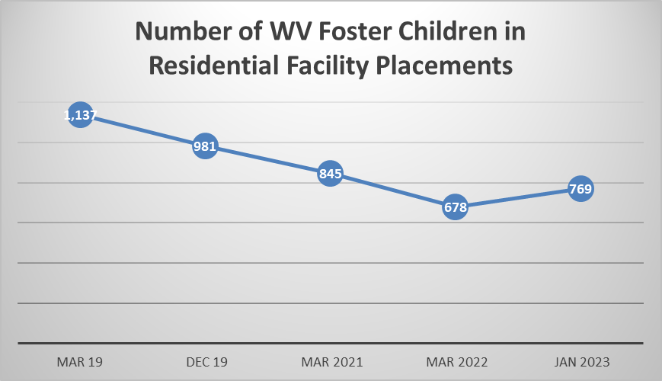
Date retrieved from Quality Review through continued monitoring of children in residential placement.

West Virginia continues to work toward the reduction of foster children and youth placed in congregate care settings. Between April 1, 2022, and Jan 31, 2023, the number of foster children in residential facilities did increase by 91 children. However, the Department did meet the reduction of 25% by December 31, 2022, as set forth through the partnership with the US Department of Justice and continues to work diligently to reduce the number even further through 2024.

Cross-Jurisdictional Placements and Requests for Placements, Interstate Compact on the Placement of Children (ICPC)

The Department has a process for tracking some data in relation to Cross-Jurisdictional Placements and Requests for Placements, but we do not have a “monitoring” system to track the progress of home study requests from other states.

There were 302 incoming requests for FFY 2018. Out of the 302 requests, WV completed 86 or 28% of the home studies within the 60-day timeframe. This is a decrease from the previous year, but it is a significant increase in the number of home study requests for the year. The most documented reason for the home studies not being completed within the 60-day timeframe is due to the lack of staffing resources and other staff duties, but staff have been very inconsistent in their reporting reasons for delays.

The State ICPC Office has developed a new process to track home study requests. State Office ICPC staff continues to monitor a tracking spreadsheet of requests and send reminders to the local staff, prior to the home study being due.

The State ICPC Office continues to enter the home study requests in the FACTS System as a referral for services when the request is received in the State Office. The referral is then transferred to the local office electronically, which should assist in timeliness.

The ICPC Standard Operating Procedure (SOP) was revised to give more step-by-step guidance to all field staff on completing the paperwork for an out of state request, completing and submitting an in-state home study, and the workers role throughout the ICPC case to ensure timely progression to permanency. The ICPC SOP was released to staff and can be re-released to ensure that everyone has reviewed it. The following activities have already been completed to improve these outcomes:

- The state ICPC Office will track all ICPC home study requests and send reminders to staff prior to the due date.
- Review the current website to determine if it is user friendly and if staff are aware of the resources available on the site.

Additional activities not yet completed include.

- Work with BCF’s Training Unit on developing or enhancing training on concurrent planning to achieve permanency while using cross-jurisdictional resources for staff.
- Determine if the development of online training for field staff to complete on cross-jurisdictional resources if feasible and needed.
- Work with the Policy Unit to determine if the Home Finding Policy can be revised to address the following: How to handle an ICPC home study when the placement resource is non-compliant, and the completion of the study is delayed.
- Review current field practices regionally to find a more streamlined process in completing the home studies.
- The ICPC Office will work with the Regional Managers in Homefinding, to develop a monitoring mechanism/process for field management, that will assist in monitoring the ICPC home studies, timeframes, overdue ICPC studies and the barriers to the studies being done timely.

Update 2023:
In FFY 2021, there were 206 incoming requests. WV completed 56 or 27% of these requests within the 60-day timeframe. There has been a decrease in cases and a small increase in timeliness. The COVID pandemic was still affecting the timeliness of completing home studies due to quarantining and the delays in completing necessary items for home study approval or denial. The State ICPC office continues to track cases. The ICPC specialist notifies the Home Finding Program Manager of the studies that have passed the 60-day due date. There is an open line of communication between the field staff completing the home studies and the ICPC office to help keep everyone informed of the progression of the home study.

The ICPC Standard Operating Procedure (SOP) was reviewed for policy and practice revisions. Changes to the SOP will occur in 2022. Additionally, the Department has decided to join the national electronic system (NEICE) for ICPC. NEICE will allow WV to increase timeliness of placements through ICPC as well as provide different tools for tracking data.

In late 2021, the Department partnered with Marshall University to develop ICPC training for Social Service Staff, Judicial Stakeholders and Community Partners. This was made possible by using funds from the NEICE grant awarded under Promoting Safe and Stable Families: Title IV-B, Subpart 2, of the Social Security Act. Training is slated to roll out in 2022.

National Electronic Interstate Compact Enterprise (NEICE)
During FFY 2021 the Department’s BSS continued to work with the state project management office, BerryDunn in the facilitation of technical calls regarding the NEICE interface to WV PATH. These calls started in June 2020 and have been held monthly since. Additional members on the call include the NEICE team, APHSA, the Department’s MIS, Optum and Tetrus. The purpose of these calls is to keep all parties informed of the progress of the interfacing of NIECE and WV PATH. During this reporting period, the Department’s MIS has requested interface codes from the State of Ohio due to its similarity to WV PATH.

In late 2021, User testing on NEICE was started with the state partners Tetrus, BerryDunn, Optum and the Department’s MIS. The Department will continue to work onboarding NEICE to align with the implementation of WV PATH in fall of 2022.

Update 2024:

In FFY 2022, there were 199 incoming requests. WV completed 39 or 20% of these requests within the 60-day timeframe. Reasons for delays range from staffing issues, non-compliance with the placement resource, and background checks. The ICPC office communicates frequently with the field management and staff.

Marshall University’s ICPC trainer held advanced training for each district in 2022. The trainer also completed 4 stakeholder meetings that are held by CIP. There was a request from CASA for the training to be held for their staff which was completed in late 2022. Feedback on training is not completed consistently by participants but the feedback that is received is positive.

National Electronic Interstate Compact Enterprise (NEICE)
During 2022, BSS continued working with the NEICE technical team for onboarding. The Department’s new CCWIS, which went live January 4th, 2023, included the NIECE interface. The BSS ICPC unit began utilizing NEICE in 2023. There have been several glitches in the system that we continue to work through.

Update on Plan for Enacting the States Vision

West Virginia will be implementing the Family First Prevention Services Act (FFPSA) on October 1, 2019. Our state views this as an exciting opportunity to leverage these changes with existing initiatives in order to create lasting change in our child welfare system. Our state sees Family First as a tool to help us realize our vision to develop a proactive system which preserves safe and healthy families and corrects a decades-old reliance on out-of-home care. Through the restructuring requirements, the focus on keeping children in the least restrictive setting, as well as the focus on primary prevention services, we believe FFPSA to be the much-needed missing piece of the puzzle.

Primary Prevention is a concept that often requires the child welfare staff to do the nearly impossible, in our crisis driven system, and think outside their child protection activities after maltreatment has already occurred. Associate Commissioner of Health and Human Services’ Administration for Children and Families, Jerry Milner, honored West Virginia by addressing some of our state leaders and stakeholders December 11, 2018, during a meeting hosted by Casey Family Programs. During his presentation Mr. Milner urged states to remember that FFPSA will be a helpful first step in re-visioning child welfare, but it must be viewed as only one of many tools that states will need. The funding allowances under FFPSA are revolutionary but they will not get us as far upstream as we need to go to effect real change.
In response to the Administration for Children and Families’ call to action, the Department of Health and Human Resources has been refining its prevention vision over the past year, preparing for the development of the State’s Family First Five-Year Prevention Plan. The goal of the prevention plan will be to expand existing prevention services, as well as enhance the array of services from which families may choose. Family engagement and family voice will be two important components of prevention service provision, much like Safe at Home.

Over the next five years, providers, foster parents, the courts, private citizens, and Department staff will be involved at every step as we begin to plan, develop, and utilize a broader range of in-home community-based services. The primary goal being to increase children served safety in their homes and decrease the number of children in out-of-home care.

Please see the attached Family First Five-Year Implementation Plan.

On December 10, 2017, ACF Children’s Bureau released the WV CFSR Final Report and the CFSR financial penalty estimates. On December 21, 2017, ACF Children’s Bureau conducted an exit conference during which the results of the CFSR case reviews and the Statewide Assessment and interviews with stakeholders conducted by ACF Children’s Bureau staff to determine conformity on the seven systemic factors was discussed. WV did not meet substantial conformity on the seven CFSR Outcomes and four of the seven CFSR Systemic Factors.

After each review round no state was found to be in substantial conformity in all the seven outcome areas and seven systemic factors. States developed and implemented Program Improvement Plans (PIP) after each review to correct those areas not found in substantial conformity. Since WV was determined not to be in substantial conformity with the seven outcomes and four of the systemic factors, a PIP must be developed to address areas of nonconformity. Following the CFSR exit conference workgroups were formed to address areas thought to impact the outcomes. These groups are Worker Recruitment and Retention, Information Systems, Foster Parent Recruitment and Retention, Field Support-Meaningful Contact, Court Improvement Program-Data Group, and Service Array group. ACF Children’s Bureau and DPQI will monitor the plan’s implementation and the state’s progress toward plan-specified goals. If WV is unable to demonstrate the agreed-upon level of improvement, the Administration for Children and Families must take a financial penalty from a portion of the state’s title IV-B and IV-E federal child welfare funds.

It should be noted that to be considered in substantial conformity on a CFSR Outcome the state must achieve a rating of 95% on the applicable cases reviewed. For each of the 18 items that make up the outcomes a state must be found to have a strength rating of 90% on the applicable cases reviewed. This is an intentionally high conformity level which no state has ever attained. Therefore, all states following each CFSR round have developed a PIP.

DPQI staff completed onsite reviews of 65 cases (all finalized) and the data compiled. The case review data indicates WV has substantially achieved a rating of 56% on the cases applicable for Safety Outcome 1, 42% substantially achieved rating on cases applicable for Safety Outcome 2, 20% substantially achieved rating on cases applicable for Permanency Outcome 1, 65% substantially achieved rating on cases applicable for Permanency Outcome 2, 26% substantially achieved rating on cases applicable for Well-Being Outcome 1, 73% substantially achieved rating on cases applicable for Well-Being Outcome 2, and 59% substantially achieved rating on cases applicable for Well-Being Outcome 3. (Please see attached chart for additional information on item specific data)

The Department had multiple meetings with its stakeholders to review the Child and Family Services Plan and developed five groups to develop its Program Improvement Plan. This plan developed strategies to improve five overarching areas which, if improved, would improve multiple CFSR outcomes. These include meaningful contact with children and families, service array, recruitment and retention of foster parents, workforce recruitment and improving safety.

West Virginia’s Program Improvement Plan has not been approved.

In June 2015 an article in the Washington Times reported West Virginia had the highest rate of overdose deaths in the U.S. West Virginia’s drug overdose death rate was more than double the national average. Statistics cited from the CDC, found that West Virginia’s rate far surpassed the second-highest state, New Mexico, which was at 28.2 deaths per 100,000. The national average was 13.4.

West Virginia’s number of children in foster care rose rapidly and the state's data suggests that most of these children were younger and were removed predominately for substance abuse by their caretakers. The tenure and skill set of workers as well as community-based services could not keep up with the rate of the crisis.

That same year, West Virginia was reviewed by the Department of Justice and the following recommendations (summarized) were made.
- West Virginia should expand in-home and community-based mental health service capacity throughout the state to minimize or eliminate unnecessary institutionalization.
- West Virginia should eliminate the unnecessary use of public and private segregated residential treatment facilities, both within the state and outside of the state. The State should ensure the availability of voluntary, comprehensive services and support in the community to divert children from segregated residential placement.
- West Virginia should ensure that all Comprehensive Centers provide for (directly or indirectly) in-home and community-based mental health services across the
- West Virginia policy, practice, and regulations should ensure that a single Intensive Care Coordinator has ultimate responsibility and accountability in cases where a child is involved in multiple child-serving systems (such as child welfare, juvenile justice, Medicaid, and special education). The State should charge this Intensive Care Coordinator with ensuring the planning, delivery and monitoring of services and supports consistent with State and federal law. This entity should coordinate the provision of services using a high-fidelity Wraparound model pursuant to the National Wraparound Initiative's published guidance.
- West Virginia should develop an interagency decision making and oversight entity to improve coordination of and access to intensive mental health services.
The Office of Drug Control Policy was established to identify strategies to address the Substance Use issues within WV. The goal of the ODCP is to work with stakeholders and identify service gaps and needs in communities across WV and to reduce the drug overdose fatalities while working toward the development of a continuum of services and supports for those addicted to drugs.

The Department of Justice has developed a partnership with WV to provide support as the state develops a continuum of community services and support for children with serious mental health disorders. West Virginia has committed to developing statewide Assertive Community Treatment for youth between the ages of 18-21, Expanded School-Based Mental Health Services, Behavioral Support Services, Children’s Mobile Crisis Response Program, Wraparound, and a Children Serious Emotional Disorder Waiver that includes Therapeutic Foster Care services.

Update 2023:
Family Treatment Courts (FTC) were established in West Virginia in 2019 with three pilot sites in Boone, Ohio, and Randolph Counties. The first expansion occurred early in 2020 with Nicholas County and Roane County. A request was made to the Courts and the Department to allow the Roane County FTC to also accept participants from Calhoun County in late Spring and this was approved. The fall of 2020 saw three more FTCs in Braxton, Logan, and McDowell County.

Family Treatment Courts in West Virginia are non-adversarial treatment courts that focus on families suffering from the effects of addiction. Parents that have been adjudicated in Circuit Court with child abuse and neglect charges are eligible for FTC. Participation is voluntary and serves as the improvement period for the abuse and neglect case. One of the goals of FTC is for parents and children to have more frequent and meaningful contact with one another if safety can be maintained. FTC participants are afforded the ability to have a collaborative treatment team that can meet the needs of not only the children but the parents as well, providing them with a safe and stable home to return to with a parent in recovery.

As of June 30, 2021, Family Treatment Courts were in Boone, Nicholas, Ohio, Randolph, Roane/ Calhoun, Logan, McDowell, Fayette, Wood, and Wetzel counties. At that point in time, they had served 138 participants and 172 kids. 35 participants had graduated, 66 kids were reunified with their families and 48 achieved permanencies with at least one parent.

Foster Care Ombudsman Report

The Foster Care Ombudsman (FCO), a legislatively created unit of state government (§W. Va.9-5-27 and §§W. Va. 49-9-101 et. seq.), is positioned within the Department’s Office of the Inspector General. The FCO advocates for the rights of foster children and foster/kinship parents, investigates and resolves complaints, monitors and reviews policy and law relating to the foster care system, proposes systemwide reforms, and conducts programs of public education. This independent, impartial, and confidential unit is developing the human resources, technology supports, structures/processes, and stakeholder relationships to effectively deploy its duties statewide.

The FCO distributed its second public-facing report, providing quarterly statistical data regarding complaints for the state fiscal year July 1, 2020, to June 30, 2021. In addition to handling situational concerns, the FCO ensured unit staffing sufficient for statewide service, initiated systemic reviews, launched a satisfaction survey process, and expanded outreach by participating in presentations, panels, and advocacy efforts to all key stakeholder groups. The FCO envisions an empathic, healing, and accountable child welfare system where voices are heard, people are empowered, and systems are responsive. To that end, the FCO exchanged information and data with leaders and lawmakers to ensure the perspectives of people served and affected by the foster care system are integrated into practice, policy, and law. The State Fiscal Year 2021 Quarterly Report is located at the following link: https://www.wvlegislature.gov/legisdocs/reports/agency/H01_CY_2020_15152.pdf

West Virginia Wraparound

During Fiscal Year 2021 (July 2020-June 2021), BBH worked on the process for the development of a new pathway to services system. This system has been coined the Assessment Pathway. This process will include a blending of Wraparound services with BSS and the Bureau of Medical Services. The agencies across the 6 regions were provided training on funding for billing of waiver services and received refresher training on Wraparound Facilitation.

BBH also contracted with Marshall University to obtain a curriculum on Wraparound Facilitation through the University of Maryland. This curriculum will allow anyone in the state providing Wraparound services to have a standardized curriculum in which they learn a clear understanding of wraparound and its processes and how to complete high fidelity services and review. This curriculum was developed by the National Wraparound Implementation Center. This model focuses on family voice and choice of services and how the wraparound plan will be developed and implemented.

BBH Wraparound – number served -FY2021: 310

Total Services- FY 2021: 8.516

Children’s Mobile Crisis Response Program

FY2021 includes an expansion of the Children’s Mobile Crisis Response & Stabilization to all BBH regions. Children’s Mobile Crisis Response was serving children through seven agencies within the following counties:
- Genesis Youth Crisis Center – Brooke, Hancock, Marshall, Ohio, and Wetzel counties
- Westbrook Health Systems – Calhoun, Jackson, Pleasants, Ritchie, Roane, Tyler, Wirt, and Wood counties
- United Summit Center - Braxton, Doddridge, Gilmer, Harrison, Lewis, Marion, Monongalia, Preston,
- and Taylor counties
- Appalachian Community Mental Health - Barbour, Randolph, Tucker, and Upshur counties
- Fayette, Monroe, Raleigh, Summers (FMRS) - Nicholas, Webster, Pocahontas, Greenbrier, Fayette, Raleigh, Summers, Monroe, Mercer, Wyoming, and McDowell counties
- Prestera Center- Boone, Cabell, Kanawha, Lincoln, Logan, Mason, Mingo, Putnam, and Wayne counties
- University Healthcare Hospital- Berkeley, Jefferson, Morgan, Pendleton, Mineral, Grant, Hardy, and Hampshire
The program continues to link children and their families or caregivers to community services. It involves families in treatment and avoids unnecessary hospitalization or residential placement. In FY 2021, the Children’s Mobile Crisis Response served 426 children/youth through these seven agencies.

The Mobile Crisis Program will continue through the Department’s Bureau for Behavioral Health.

Children’s Crisis and Referral Line and Warm Peer Line

BBH launched a statewide, 24/7 Children’s Crisis and Referral Line which seeks to connect families in crisis immediately with regional Mobile Crisis Response and Stabilization Teams through warm transfer referrals. It will also connect professionals and families not in crisis with appropriate community-based behavioral health services and support.

A companion to the Crisis and Referral Line is a statewide, 24/7 Peer Warm Line utilizing peer, including peer recovery, support specialists (PRSS) employed by First Choice Services. The Warm Line is for young adults and adults experiencing life challenges or recovering from SMI or co-occurring substance use disorder (SUD) and their families. The Warm Line will give any individuals experiencing life challenges, but not in crisis, the option to talk with peers who will listen actively and nonjudgmentally and link them with resources as needed, including referrals to other PRSS and regional Family Coordinators in the state.
First Choice Services manages the Children’s Crisis and Referral Line and Warm Peer Line – Statewide Services CALL 1-844-HELP4WV.
Regional Family Coordinators – State Opioid Response (SOR)
In 2021, the State Opioid Response (SOR) Regional Family Coordinators are housed in the six Youth Service Centers. The SOR Regional Family Coordinators serve all counties in West Virginia. The SOR Family Coordinators facilitate the needs of family members of the youth or young adults involved in treatment and recovery at the Regional Youth Service Centers through screening, referrals, engagement and connecting the family to treatment and recovery service available through the community partners in the region and the state.
Regional Family Coordinators – System of Care (SOC)
During FFY 2021, the Regional Family Coordinators (SOR and SOC) added a Family Advisory Board, completed a family survey which surveyed family needs and wants as related to how services are accessed, received and how families should be contacted or notified. The Bureau developed and published a family newsletter called Family Connections which is issued quarterly.
Family Coordinators hold statewide Family Advisory Board monthly meetings. At these meetings, the discussion focused on improving services and searching for new resources the group is not aware of. Guest speakers would attend the meeting to share resources with the Board. The Board gives feedback on new projects, revised brochures, and the Family Connections newsletter that is available online.
There are three regional Family Advisory Boards currently. The Bureau for Behavioral Health staff provided several presentations this year to include providing a presentation to statewide parent organizations made up of staff who are employed by the West Virginia Division of Personnel. One presentation was at the statewide Families Conference at which there were 141 families in attendance. This is a weekend conference in which families of youth with intellectual and/or developmental disabilities (ID/DD) or co-existing disorders of ID/DD and mental health issues attend a weekend of training, outreach, and family bonding.
In 2022, Family Coordinators will continue the program called Nurturing Parents for Fathers. This program is a 13-week group-based program for developing attitudes and skills for male nurturance. The group of 8 to 16 fathers meet weekly for 2½ hours. The Nurturing Fathers Program is an adaptation of the Nurturing Program philosophy and lessons designed and implemented specifically for dads. The Department will continue to engage and offer relevant training and activities to help fathers and partners engage with their children and families. The Regional Care Coordinators served 3010 families in 2021.
Positive Behavioral Support Services

Positive Behavioral Support (PBS) services focus on providing prevention and intervention supports for individuals who are demonstrating significant maladaptive behaviors, are at risk of out-of-home placement or involuntary commitment at a psychiatric hospital or Psychiatric Residential Treatment Facility (PRTF) or are transitioning to the community from an out-of-home placement. PBS is an evidence-based strategy to improve independence, decrease behavioral challenges, teach new skills, and improve the overall quality-of-life of individuals who are experiencing significant maladaptive behavioral challenges.

PBS embraces the conceptual approaches of wraparound or person-centered planning for individuals who have challenging behavioral needs requiring intensive support to help them demonstrate competencies to participate in community life, develop satisfying relationships, make choices, and gain personal dignity and respect. Services are designed to assist individuals to remain in or return to their homes or communities from residential treatment programs, psychiatric hospitals, or residential Crisis Response Units. The PBS program plays an integral part in our new Interim Services and Children’s Assessment Pathway by training youth, families, and providers.

The current PBS program coordinator is the West Virginia University’s Center for Excellence in Disabilities. The purpose of this program is to build both workforce capacity and systemic capacity to serve individual clients.

Therapeutic Foster Family Care (TFC)

West Virginia’s Treatment Home program (now renamed Stabilization and Treatment (STAT) homes is a family-based, therapeutic, trauma-informed behavioral health intervention. The service is provided through 11 child placing agencies (CPA) statewide. In partnership with West Virginia Wraparound and funded through the CSED Waiver, STAT Homes are designed to provide intensive treatment services to children with SED who can be served in a family-like setting, ultimately diverting children from placement in Residential Mental Health Treatment Facilities (RMHTFs). Treatment Home parents are specifically recruited and trained to provide intensive support for these children so they can remain in and actively participate in their home, school, and local community. West Virginia seeks to strengthen the Treatment Home program through development of model standards that clearly define services and activities that support the Treatment Home parents, the child and the family of origin, and clarify the role of the child-placing agency’s case manager. The first program data is anticipated to be available December 2022.

STAT providers and stakeholders provided valuable consultation and feedback through various face-to-face and virtual engagements on the proposed model and associated outcome measurements. The STAT workgroup conducted analysis regarding children receiving TFC currently as well as children in RMHTFs to determine the appropriateness of current placement setting and necessary level of care. Using this information, the STAT workgroup continued to design the model to assure that children with SED can receive services in a family-like setting, ultimately diverting children from RMHTFs.

The STAT model was in development during the entire year of 2021 and will conclude in 2022. The initial phase-in implementation of the new model will occur in July 2022. The model will leverage current Treatment Foster Care (TFC) providers to implement this service which will allow for statewide coverage.

As the model has developed, the Department has identified key performance indicators for STAT homes. As performance data is collected, the information can be utilized for ongoing refinement of the STAT home model and will help the state understand any provider capacity needs.

As the Department continues to develop this model, the Child Placing Agencies have been consulted and are collaborating to establish services and standards. The Department and the private agencies are working together to ensure the model aligns with current licensing standards and expectations. Communication has been achieved through regular meetings with CPAs. Efforts have been made to establish a rate that will support CPAs in the recruitment and retention of families to serve as foster parents in this new model as the model serves a specific population with a higher level of need that will require additional skills for foster parents.

In late 2021 and early 2022, the Department made the decision, in consultation with the Child Placing agencies, to leave its early Tiered foster care model intact. The current Tier II and Tier III foster homes will serve children with more intensive needs that don’t rise to the eligibility of a Stabilization and Treatment (STAT) home. To be eligible for a STAT home placement, children must meet the following criteria.

- Age 4 through 20.
- In state custody.
- Approved CSED Waiver participant.
- Cannot be safely served in their current setting and are at risk of immediate.
- residential mental health treatment facility placement.
- Not an immediate danger to others or self, or a habitual flight risk which cannot be safely addressed through a safety plan/flight risk plan.

Children disrupting from a foster home, Tiers I, II, or III are also eligible for a STAT home placement if they meet the above criteria and are disrupting in their current placement and are at risk of placement in a residential treatment facility.

Assertive Community Treatment

ACT is an inclusive array of community-based rehabilitative mental health services for Medicaid members with serious and persistent mental illness who have a history of high use of psychiatric hospitalization and/or crisis stabilization requiring a well-coordinated and integrated package of services provided over an extended duration to live successfully in the community of their choice.

In FFY 2021 ACT served the following age population:
- 21 patients 18-21 years of age
- 665 patients 22+years of age

Mental Health Screening Tools and Processes

BSS, Bureau of Behavioral Health, and Bureau of Medical Services continues to partner with the Department’s State Project Management Organization, BerryDunn as well as the Managed Care Organization, Aetna in development of the children’s mental health assessment pathway. The goal is to finalize and implement the pathway screening during 2022.

Quality Assurance and Performance Improvement System

The Department continues to work on development of a data dashboard as mentioned in the previous update. Many Bureaus are working together to ensure the appropriate data is collected in this dashboard.

Outreach and Education for Stakeholders

The Outreach and Education Workgroup continued to meet in 2021. The workgroup goals were to outline what topics should be provided to stakeholders for outreach and education purposes. An additional goal was to develop a Standard Operating Procedure on how information would be disseminated through various Bureaus within the Department. This included developing an outreach and education tracker to capture what information was provided to the stakeholders.

In 2022, the group will continue to make adjustments to the tasks they are working on until the products are finalized.

Update 2024:
Foster Care Ombudsman Report
The Foster Care Ombudsman (FCO), a legislatively created unit of state government (§W. Va.9-5-27 and §§W. Va. 49-9-101 et. seq.), is positioned within the Department’s Office of the Inspector General. The FCO advocates for the rights of foster children and foster/kinship parents, investigates and resolves complaints, monitors and reviews policy and law relating to the foster care system, proposes systemwide reforms, and conducts programs of public education. This independent, impartial, and confidential unit is developing the human resources, technology supports, structures/processes, and stakeholder relationships to effectively deploy its duties statewide.

The FCO distributed 4 quarterly reports for 2022. 623 complaints were made to the FCO in West Virginia during this year. 186 (29.9%) were considered invalid. 170 (27.3%) resulted in information exchange. 111 (17.8%) of the valid concerns were resolved. 69 (11.1%) of the valid concerns were partially resolved. 30(4.8%) were withdrawn by the complainant. 29 (4.7%) had insufficient information to rate validity. 26 (4.2%) of the valid concerns were not resolved. 2 (0.3%) others. 0 were declined by the FCO.

West Virginia Wraparound

BBH Assessment Pathway was fully implemented in 2022. This process includes a blending of Wraparound services with the Safe at Home Program with BSS, Children with Severe Emotional Disturbances program through BMS, and the Interim Wraparound program with BMS. Training on how to utilize the assessment pathway was provided to BSS staff and others across WV.

Marshall University continues to provide training on Wraparound Facilitation. This curriculum allows anyone in the state providing Wraparound services to have a standardized curriculum in which they learn a clear understanding of wraparound and its processes and how to complete high fidelity services and review. This curriculum was developed by the National Wraparound Implementation Center. This model focuses on family voice and choice of services and how the wraparound plan will be developed and implemented.

Trainings completed by Marshall University:
- 271 trained in Introduction to Wraparound
- 145 trained in Engagement
- 51 trained in Intermediate Wraparound

Children’s Mobile Crisis Response Program

FY2022 the Children’s Mobile Crisis Response & Stabilization continues to serve all BBH regions. Children’s Mobile Crisis Response was serving children through seven agencies within the following counties:
● Genesis Youth Crisis Center – Brooke, Hancock, Marshall, Ohio, and Wetzel counties
● Westbrook Health Systems – Calhoun, Jackson, Pleasants, Ritchie, Roane, Tyler, Wirt, and Wood counties
● United Summit Center - Braxton, Doddridge, Gilmer, Harrison, Lewis, Marion, Monongalia, Preston, and Taylor counties
● Appalachian Community Mental Health - Barbour, Randolph, Tucker, and Upshur counties
● Fayette, Monroe, Raleigh, Summers (FMRS) - Nicholas, Webster, Pocahontas, Greenbrier, Fayette, Raleigh, Summers, Monroe, Mercer, Wyoming, and McDowell counties
● Prestera Center- Boone, Cabell, Kanawha, Lincoln, Logan, Mason, Mingo, Putnam, and Wayne counties
● University Healthcare Hospital- Berkeley, Jefferson, Morgan, Pendleton, Mineral, Grant, Hardy, and Hampshire

The program continues to link children and their families or caregivers to community services. It involves families in treatment and avoids unnecessary hospitalization or residential placement.

Children’s Crisis and Referral Line and Warm Peer Line

During FY 2022, BBH provided four trainings to Children’s Crisis and Referral Line (CCRL) staff and began preparations for moving the crisis line forward to the second phase of services with the goal for the CCRL to be the systems point of entry for children’s services. CCRL also will be tasked as the system point of entry for the new Wraparound Assessment Pathway (launched October 2021) as it takes statewide calls for referral for services and provides a warm transfer process for connection to Children’s Mobile Crisis Response Teams.

*FY 2022 there 681 calls, chat, and texts with an average of 57 calls per month.
*Note service data is separated this year because of a change in data collection method during the FY period.

First Choice Services manages the Children’s Crisis and Referral Line and Warm Peer Line – Statewide Services CALL 1-844-HELP4WV.

Regional Family Coordinators – State Opioid Response (SOR)
In 2022, the State Opioid Response (SOR) Regional Family Coordinators were housed in the six Youth Service Centers. The SOR Regional Family Coordinators serve all counties in West Virginia. The SOR Family Coordinators facilitate the needs of family members of the youth or young adults involved in treatment and recovery at the Regional Youth Service Centers through screening, referrals, engagement and connecting the family to treatment and recovery service available through the community partners in the region and the state.

Regional Family Coordinators – System of Care (SOC)
The Bureau for Behavioral Health continues as the Lead Family Coordinator and continues to review the Family Coordinator strategic plan with the Family Coordinators in communities. The Lead Family Coordinator conducts monthly meetings with the Statewide Family Advisory Board, where the families provide feedback on various services so the services may be improved. The families give feedback on new projects and new program brochures. They also learn about resources. The Lead Family Coordinator continues to issue a quarterly newsletter titled, Family Connections, which includes stories of interest, upcoming events, and many resources.

The community Family Coordinators provide Nurturing Parenting, Strengthening Families, and SMART Recovery to various groups, such as teens, LGBTQ, and trauma groups.

The Family Coordinators go into schools, treatment courts, libraries, boys and girls clubs. They attend sports events and anywhere families gather. The Family Coordinators also collaborate with Healthy Grand families. Coordinators are currently being trained in 24/7 Dad to effectively reach fathers for inclusion in family dynamics. The Family Coordinators also conduct many outreach events throughout the year with a particular focus on Children’s Mental Health Awareness Day where information about resources is disseminated. For FFY 2022 329 children received services from SOR family coordinators.

Positive Behavioral Support Services

Positive Behavioral Support (PBS) services focus on providing prevention and intervention supports for individuals who are demonstrating significant challenging behaviors, are at risk of out-of-home placement or involuntary commitment at a psychiatric hospital or Psychiatric Residential Treatment Facility (PRTF) or are transitioning to the community from an out-of-home placement. PBS is an evidence-based strategy to improve independence, decrease behavioral challenges, teach new skills, and improve the overall quality-of-life of individuals who are experiencing significant maladaptive behavioral challenges.

PBS embraces the conceptual approaches of wraparound or person-centered planning for individuals who have challenging behavioral needs requiring intensive support to help them demonstrate competencies to participate in community life, develop satisfying relationships, make choices, and gain personal dignity and respect. Services are designed to assist individuals to remain in or return to their homes or communities from residential treatment programs, psychiatric hospitals, or residential Crisis Response Units. The PBS program plays an integral part in our new Interim Services and Children’s Assessment Pathway by training youth, families, and providers.

The current PBS program coordinator is the West Virginia University’s Center for Excellence in Disabilities. The purpose of this program is to build both workforce capacity and systemic capacity to serve individual clients.

Therapeutic Foster Family Care (TFC)

West Virginia’s Stabilization and Treatment (STAT) Home model is currently in the active recruitment phase with the child placing agencies. Nine of West Virginia’s child placing agencies signed the addendum agreement for the STAT home model. As of April 1, 2023, one agency has one home that is ready to begin accepting placement with two other families waiting to resolve current foster care placements as the model only allows one foster child to be placed in the home at a time due to the anticipated needs and level of behavioral and or mental health issues.

The model was revised to reflect the following:

- Ages 3-20 (revised from previous qualifications).

- In state’s custody.

- Approve and actively receive CSED waiver services (revised from previous qualifications).

- Cannot be safely served in their current setting and are at risk of immediate residential mental health treatment facility placement.

- Not an immediate danger to others or self, or a habitual flight risk which cannot be safely addressed through a safety plan/flight risk plan.

- West Virginia will continue to monitor the progress of the STAT Home model while working closely with the child placing agencies and families are on-boarded to begin accepting placements.

Assertive Community Treatment

ACT is an inclusive array of community-based rehabilitative mental health services for Medicaid members with serious and persistent mental illness who have a history of high use of psychiatric hospitalization and/or crisis stabilization requiring a well-coordinated and integrated package of services provided over an extended duration to live successfully in the community of their choice.

In FFY 2021 ACT served the following age population:
● 21 patients 18-21 years of age
● 665 patients 22+years of age

Mental Health Screening Tools and Processes

BBH Assessment Pathway was fully implemented in 2022. This process includes a blending of Wraparound services with the Safe at Home Program with BSS, Children with Severe Emotional Disturbances program through BMS, and the Interim Wraparound program with BMS. Training on how to utilize the assessment pathway was provided to BSS staff and others across WV.

Quality Assurance and Performance Improvement System

The Department continues to work on development of a data dashboard as mentioned in the previous update. Many Bureaus are working together to ensure the appropriate data is collected in this dashboard.

Outreach and Education for Stakeholders

The Outreach and Education Workgroup continued to meet in 2022. An online tracking form was developed to record all outreach and education efforts made by DHHR with outside stakeholders. This site captures what information was shared, the populations it was shared with, and well as the number of participants and the date it occurred.

West Virginia believes that in addition to its Family First Five-Year Implementation plan and the states Program Improvement Plan, focusing on two main performance goals for the next five years will help set the stage for enacting its true vision for Child Welfare as well as bring the state closer to the vision of the Family First Prevention and Services Act. These two goals are extensions of the state’s current PIP outcomes. They can be accomplished by simplifying our message to our front-line workers, Courts, providers, and communities. They include Increasing the percentage of West Virginia children who remain safe in their own homes and increasing the number of youths experiencing positive outcomes as demonstrated through National Youth Transitional Database outcomes.

Several objectives under each goal will improve the quality of safety and case planning and improve the quality of both Child Protective and Youth Services intervention in the state. These activities include improving the frequency and quality of monthly contact by caseworkers, decreasing child fatalities, improving safety planning and case planning, decreasing repeat maltreatment, and utilizing family preservation services more.

Update 2023:
In late May 2021, a new ongoing assessment and case plan training was released and to be completed by all CPS workers, supervisors, social services coordinators, and others who provide support to CPS field staff. In February 2022, a streamlined safety plan was implemented for CPS and YS staff to utilize for all case types. Training, child welfare consultants, and policy staff are beginning to provide training and technical support to field staff by districts to assist with completing accurate ongoing assessments in order to inform appropriate and effective case planning with families. Ideally, this level of support will improve case practice that will ultimately result in fewer children coming into foster care, and more in-home prevention and preservation services tailored to family needs.

Update 2024:
In mid-2022, BSS policy specialists and child welfare consultants began providing technical assistance to staff relating to the completion of the CPS on-going assessment and FAST for youth services and using the assessments to effectively case plan for children and families. Technical assistance has improved the number of completed assessments and case plans in some districts, but there is still the need for further technical assistance. The implementation of the new CCWIS system, PATH, has created some issues with staff completing assessments and case plans, but BSS is working through those challenges. Additionally, the completion of assessments is critical to identifying mental health needs in children and referring them for appropriate services. This continues to be an emphasis of the efforts to reduce the reliance on residential facility placements as part of the Department of Justice agreement. BSS policy staff, child welfare consultants, and child welfare trainers will continue to work diligently with child welfare staff to improve assessment and case planning to accomplish better outcomes for children, youth, and families.

In support of West Virginia’s second goal of improving outcomes of youth transitioning from foster care, the state will improve its frequency and quality of services provided to older youth in foster care. This, in turn, will benefit children born of previous foster children. Activities to accomplish this goal include increasing the number of youths in foster care who receive prevention and transitioning services, increasing the number of youths who receive supervised independent living services and increasing the number of youths in foster care who have and maintain permanent connections.

Update 2023:
A Transitioning Youth from Foster Care subgroup was convened and composed of providers and Department staff to focus on services, initiatives, and innovative ways to serve this population. This subgroup was developed by the Department in preparation for the Family First Prevention Services Act. The subgroup continued work in 2021, and it is working to adapt to changes within the continuum of care. As the Department’s vision for services and continuum of care vision for the future is availed, the subgroup will continue to work towards refining services and options for these youth. This subgroup will participate with the Service Delivery and Development Workgroup to connect the work and gain input to influence their efforts.
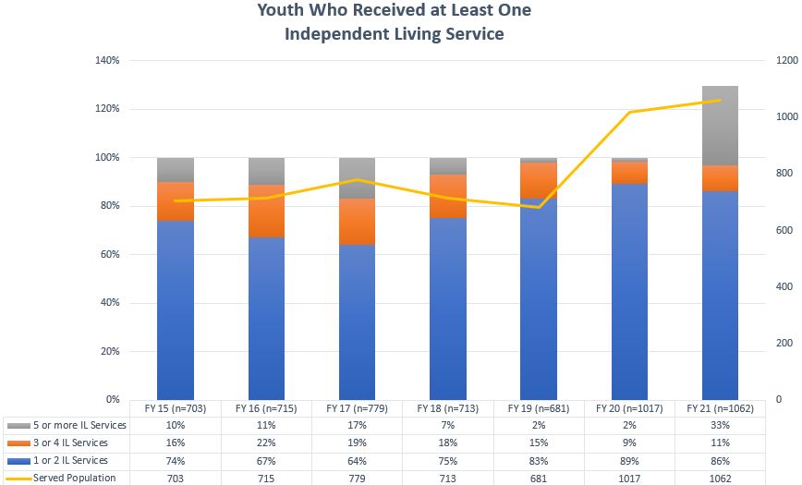

West Virginia saw an increase in the number of young people served in FFY 2020 and FFY 2021. As noted in Update for 2022, several Transitional Living Agencies in the state built-out their services and supports with more opportunities for youth to have supported experiences in housing either on-campus or close to campus. While a single category of service did not show a higher rate than any other, programs like the Aetna Connections for Life provided youth with tablets and laptops. The prior Computers for Graduates program was replaced by Connections for Life, which put these tools into the hands of youth at 13, much earlier than previously.

Throughout the Public Health Emergency, youth have been delayed in their high school completion. Foster families supported youth after age 18 while the youth finished high school. The overall number of young people aged 18 to 21 exiting went down during the pandemic. The number that existed at 21 was the highest of all four years at 20 youth in FFY 2021. Due to longer stays in care BSS workers and supervisors throughout the state were able to provide youth with the best services to support their goals.
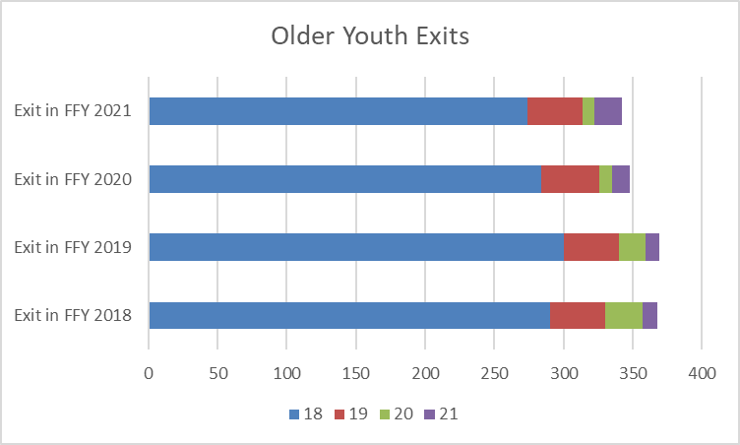

Update 2024:
The Transitioning Youth from Foster Care subgroup and the Service Development and Delivery workgroup no longer meet. There are no updates to provide on those workgroups.

The following chart reflects data from the NYTD snapshot from 2022 on youth who received at least one independent living service. West Virginia faced penalties in 2022 for not completing the NYTD surveys as required.

Source: NYTD Snapshot ACF

Source: FACTS Data Report

In FFY 2022 the number of older youth existing foster care is slightly less than previous years. Youth existing foster care at ages 19 to 21 increased 22%. This could be attributed to the start of the transitional living pilot program in 2021.

Goal 1. Ensure children receiving services, through Child Protective Services and Youth Services, remain in their own homes safely whenever possible.

The ability of the State to maintain children who are Candidates for Foster Care Placement due to Safety Concerns hinges upon quality Family Preservation Services provided to families. The percentage of Foster Care Candidates who remain in their homes until case closure will measure the success of prevention interventions. Trends in Socially Necessary Services track the number and duration of CPS and YS Family Preservation Services provided to families in their homes. Progress will be determined by increased percentages of the baseline, not on the state’s progress or lack thereof.

Objective 1.1 Increase the percentage of open cases with monthly contact by 2% in the first year and 5% each additional year.

Current Contact < 30 Days | 33% | 46% | 33% | 42%
Last Contact > 30 Days | 49% | 36% | 46% | 42%
New Case | 5% | 6% | 7% | 6%
No Contact | 13% | 18% | 17% | 15%
Source: FREDI CPS-8801 and CPS-5140 As Of 4/30/2019

Update 2023:

Source: FREDI CPS-8801 and CPS-5140 As Of 4/30/2022

Current Contact < 30 Days | 52% | 42% | 46% | 61%
Last Contact > 30 Days | 34% | 34% | 34% | 25%
New Case | 10% | 8% | 11% | 12%
No Contact | 4% | 16% | 9% | 2%

Baseline  38.5% | Reporting Year | 2021 Goal | 2022 Goal | 2023 Goal | 2024 Goal
 | Projected | 40.5% | 45.5% | 50.5%
 | Actual | 49% | 50.25% | 44%

BSS continued to work with child welfare staff over the last year to ensure that face to face contact with children is a priority despite continued COVID-19 restrictions. Child welfare supervisors continued monthly case reviews which include looking for meaningful contacts with children in case documentation. Social Service Managers (previously Community Service Managers) also continue monitoring face-to-face first contacts with victim child reports, monthly face-to-face contacts with children in placement reports and case reviews completed by child welfare supervisors. They are reporting their findings to the Deputy Commissioners (previously Regional Directors).

Update 2024:
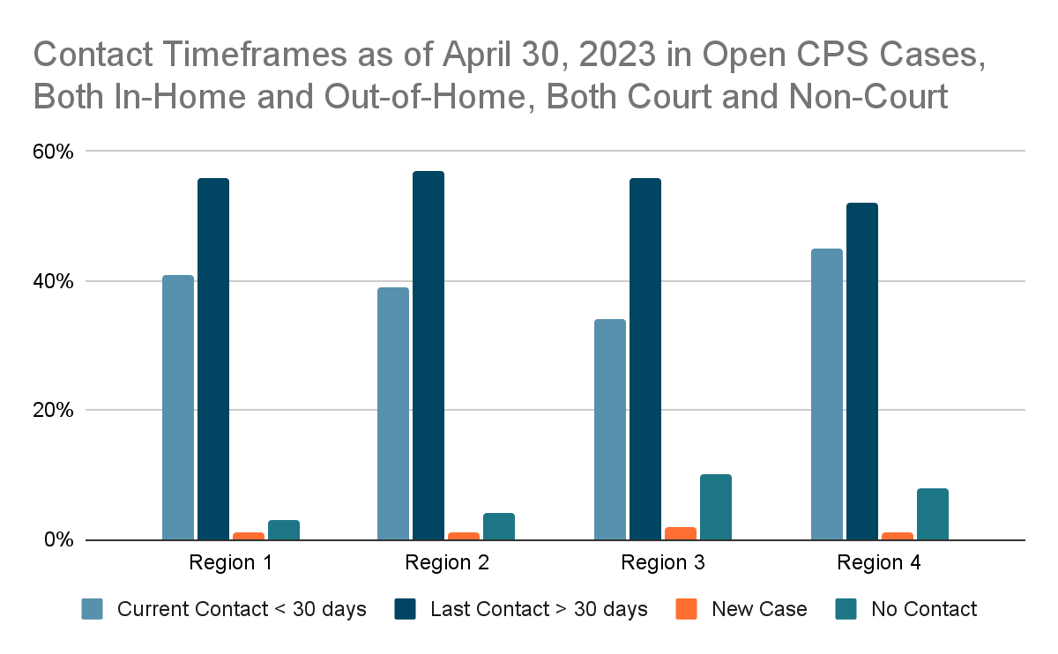

Contact Timeframe | Region 1 | Region 2 | Region 3 | Region 4
Current Contact < 30 days | 41% | 39% | 34% | 45%
Last Contact > 30 days | 56% | 57% | 56% | 52%
New Case | 1% | 1% | 2% | 1%
No Contact | 3% | 4% | 10% | 8%
Source: PATH Social Services Reports - as of 4/30/2023 (Last contact for Youth Services and Child Protective
Services Cases and Open Cases by Program)

Baseline  38.5% | Reporting Year | 2021 Goal | 2022 Goal | 2023 Goal | 2024 Goal
 | Projected | 40.5% | 45.5% | 50.5% | 55.5%
 | Actual | 49% | 50.25% | 44% | 40%

The BSS has continued its commitment to ensure that face-to-face contact with children is a priority for all child welfare staff. Child welfare supervisors coach and educate their staff during unit meetings and individual meetings regarding consistent and meaningful contacts with all the children they serve. Supervisors complete monthly case reviews which include reviewing cases for documentation of meaningful contacts with children. Social Services Managers (SSMs) also monitor reports regarding initial face to face contacts with victim children, monthly face to face contacts with children in placement and case reviews that are completed by child welfare supervisors. The SSMs report their findings to the Deputy Commissioner assigned to their district. As of January 2023, the BSS launched a new CCWIS system which has impacted consistent and accurate documentation by child welfare staff. Due to learning a new system and frequent issues with system functionality, staff have had significant delays in entering information which may have impacted this reporting year’s information.

Current Contact < 30 Days | 20% | 34% | 45% | 41%
Last Contact > 30 Days | 51% | 47% | 37% | 41%
New Case | 9% | 9% | 5% | 6%
No Contact | 20% | 10% | 13% | 11%
Source: FREDI YSS-5020 As Of 4/30/2019

Update 2023:

 | Region 1 | Region 2 | Region 3 | Region 4
Current Contact < 30 Days | 30% | 37% | 32% | 37%
Last Contact > 30 Days | 44% | 39% | 37% | 42%
New Case | 8% | 5% | 9% | 13%
No Contact | 18% | 19% | 22% | 8%
Baseline  35% | Reporting Year | 2021 Goal | 2022 Goal | 2023 Goal | 2024 Goal
 | Projected | 37% | 42% | 47%
 | Actual | 35.25% | 44% | 34%

The COVID -19 health and safety measures implemented in 2020 continued during this reporting year relative to restrictions on in-person face-to-face visits. Virtual face-to-face visits with children and families in child welfare care cases continued to be a common method of contact based on these restrictions.
Contact with children in foster homes, shelters, and residential facilities remained contingent on the placements’ current protocols or requests even once child welfare workers were permitted to resume face to face visits. In Youth Services’ cases, when face-to-face contact previously took place in the school or at court hearings, those visits remained at the discretion of the school’s or court's own protocols and safety measures. Throughout the course of the year, placement facilities experienced time frames when workers were not permitted to have routine face to face visits with children due to COVID outbreaks. Face to face contact was still permitted in times when safety concerns for the child existed.

Update 2024:

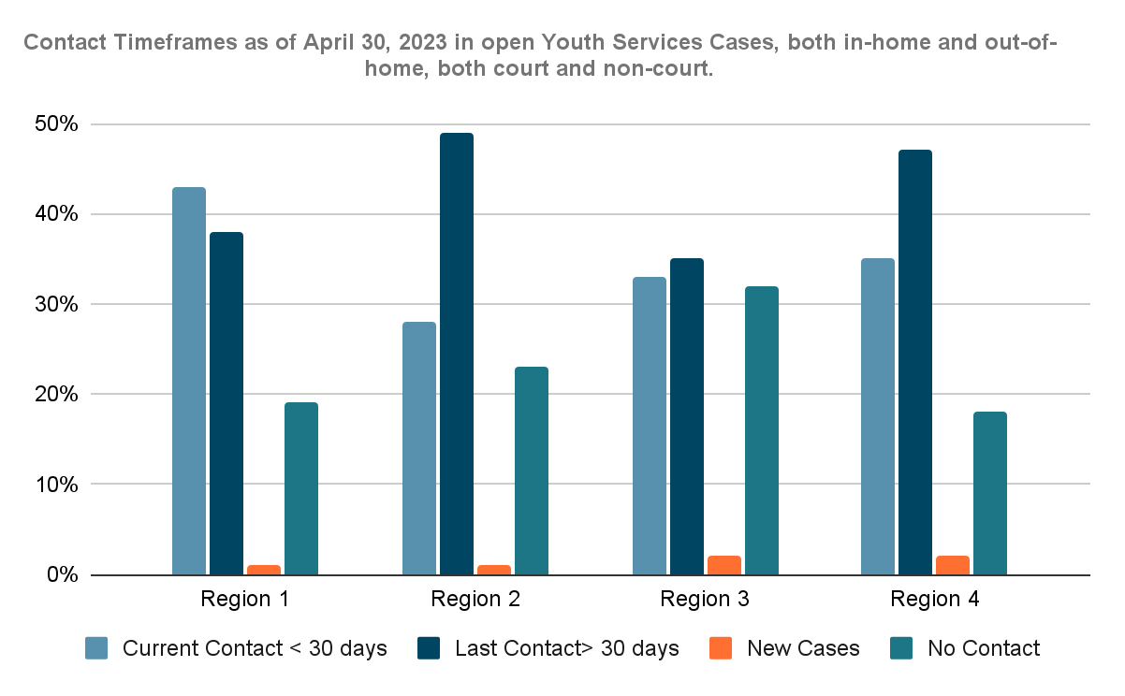

Contact Time Frame | Region 1 | Region 2 | Region 3 | Region 4
Current Contact < 30 days | 43% | 28% | 33% | 35%
Last Contact > 30 days | 38% | 49% | 35% | 47%
New Case | 1% | 1% | 2% | 2%
No Contact | 19% | 23% | 32% | 18%
Source: PATH Social Services Reports - as of 4/30/2023 (Last contact for Youth Services and Child Protective Services Cases and Open Cases by Program)

Baseline  35% | Reporting Year | 2021 Goal | 2022 Goal | 2023 Goal | 2024 Goal
 | Projected | 37% | 42% | 47% | 52%
 | Actual | 35.25% | 44% | 34% | 35%

The COVID-19 restrictions noted in previous reporting years have been lifted and have very little impact on child welfare staff’s ability to make timely contacts with children in YS cases. As reported with the CPS updates, BSS has continued a commitment to ensure that face to face contact with children is a priority for all child welfare staff. YS staff maintain this commitment as well. Child welfare supervisors coach and educate their staff during unit meetings and individual meetings regarding consistent and meaningful contacts with all the children they serve. During the T&TA sessions implemented throughout the past year, the importance of such contact has consistently been reiterated to child welfare staff and supervisors. Supervisors complete monthly case reviews which include reviewing cases for documentation of meaningful contacts with children. Social Services Managers (SSMs) also monitor reports regarding initial face to face contacts following case opening, monthly face to face contacts with children in placement, and case reviews that are completed by child welfare supervisors. The SSMs report their findings to the Deputy Commissioner assigned to their district. As of January 2023, the BSS launched a new CCWIS system which has impacted consistent and accurate documentation by child welfare staff. Due to learning a new system and frequent issues with system functionality, staff have had significant delays in entering information which may have impacted this reporting year’s information.

Objective 1.2 Increase the percentage of CPS cases open with safety plans by 2% in year one and 5% each additional year.
Source: End of Month CPS Case Counts and FREDI CPS-5170

Update 2023:

Source: End of Month CPS Case Counts and FREDI CPS-5170

Update 2024:
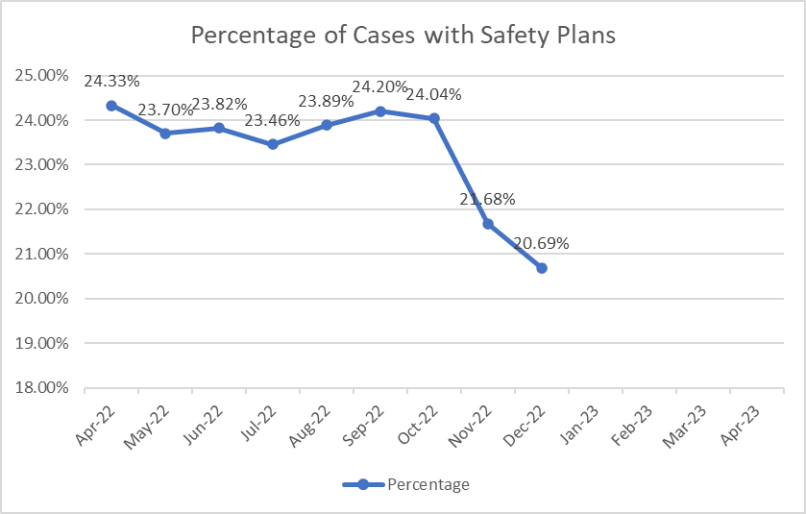
Source: End of Month CPS Case Counts and FREDI CPS-5170

Data for January through April 2023 was not available due to changing to the new CCWIS. Child welfare also changed to a paper version of the new Safety Plan, which could account for the decline in the number of cases with safety plans that were not captured in the previous SACWIS.

Baseline  20.99 | Reporting Year | 2021 Goal | 2022 Goal | 2023 Goal | 2024 Goal
 | Projected | 22.99% | 27.99% | 32.99% | 37.99%
 | Actual | 24.48% | 29.33% | 24.33% | 20.69%

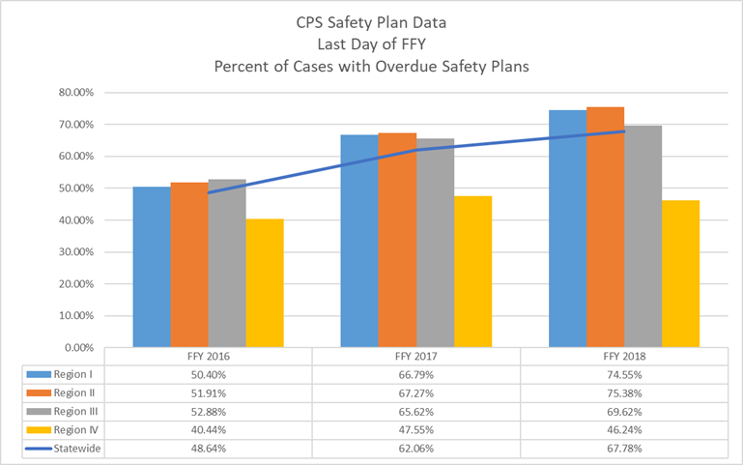
Source: FREDI CPS-5170 9/30 of each FFY
Update 2023:
Source: FREDI CPS-5170 9/30 of each FFY

Update 2024:
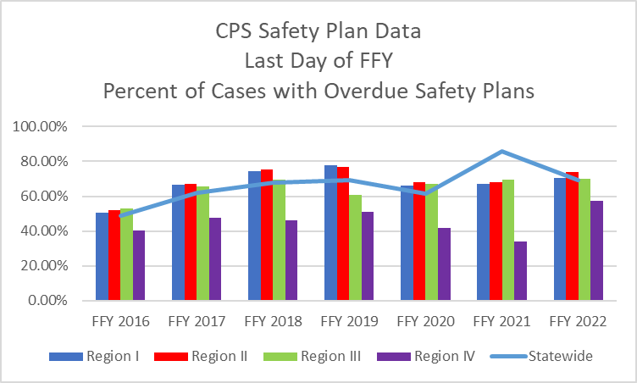
Source: FREDI CPS-5170 9/30 of each FFY
Objective 1.3 Increase the percentage of cases that have a case plan by 2% in year one and 5% each additional year.
Source: FREDI reports CPS5260 and CPS8802
Update 2023:
Source: Hand counts

April 2022 information is not complete as several districts did not submit hand counts. Technical assistance continues to be provided to districts regarding case planning.

Update 2024:
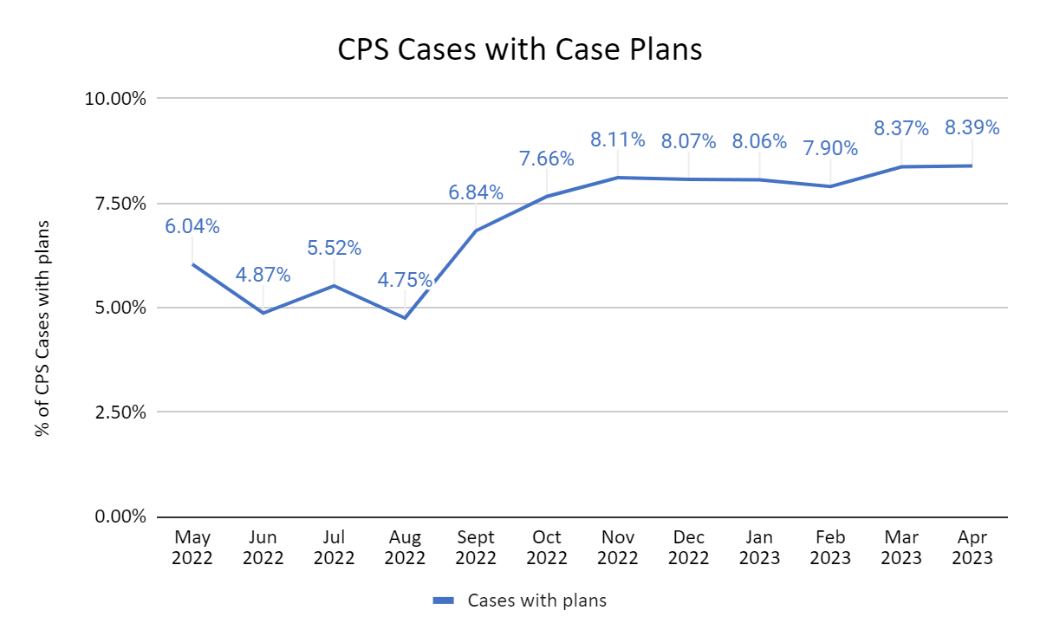

Baseline  .23% | Reporting Year | 2021 Goal | 2022 Goal | 2023 Goal | 2024 Goal
 | Projected | 2.23% | 7.23% | 12.23% | 17.23
 | Actual | 5.76% | 7.88% | 4.86% | 8.39

Source: Hand Counts

The agency began gathering data regarding cases with case plans by doing hand counts in June 2020. Ongoing technical assistance was provided to supervisors to help determine how best to gather and report the information as well as regarding the necessity for each case to have a case plan. Initially, there was a spike in the number of completed case plans because staff were considering court case plans in the data until assistance was provided to the field to only include data about case plans done through the Protective Capacities Family Assessment case plan. By initiating this process, the staff began reevaluating cases for closure, which will further help with conversion to PATH. This will also help provide more accurate data once the conversion to PATH has been completed.

Update 2023:

Baseline  .23% | Reporting Year | 2021 Goal | 2022 Goal | 2023 Goal | 2024 Goal
 | Projected | 2.23% | 7.23% | 12.23% | 17.23
 | Actual | 5.76% | 7.88% | 4.86%

Update 2024:
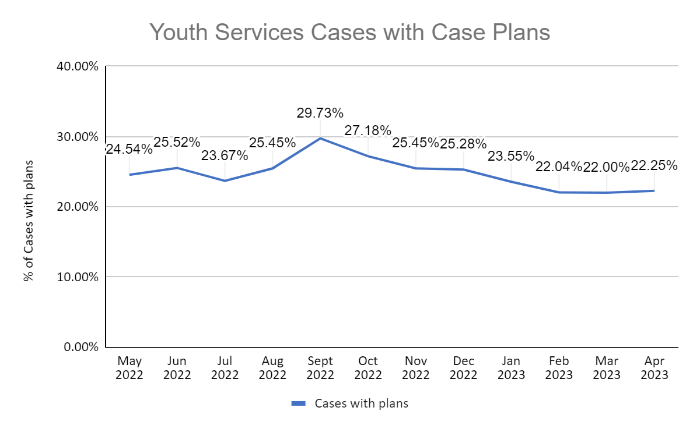
Source: Hand Counts
The agency continued to utilize hand counts completed within each county to calculate the case plans completed within Youth Services Cases. Ongoing technical assistance has continuously been provided to supervisors to help them accurately capture all cases and case plans within their respective district.
Objective 1.4 Decrease the percentage of cases with repeat maltreatment by 2 % the first two years and 5% each additional year. 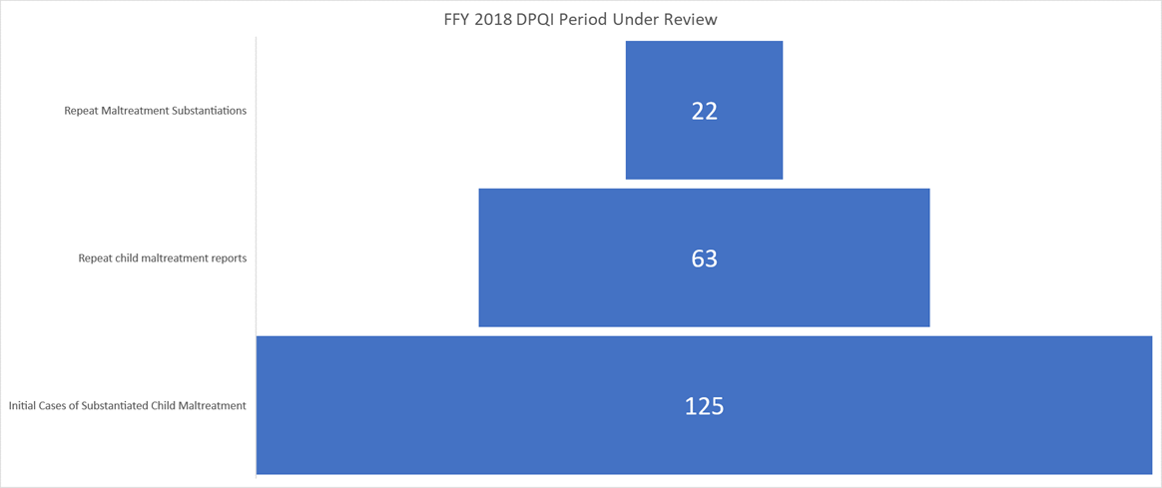Source: DPQI Review Data
- FFY 2018 reviewed cases which had at least one substantiated child maltreatment intake during the period under review (PUR-12 months from date of the review) is 125 cases.
- Of the 125 cases reviewed during the FFY, 63 cases were rated for CFSR Item 1 indicating a received, accepted, and assigned child maltreatment report during the PUR.
- Of those 63 cases, child maltreatment was substantiated in 22 cases or 17.6%
Update 2023:
West Virginia is reporting the number of cases reviewed that had substantiated maltreatment after a case was opened and services were provided. See chart below. In 2021 fifty-seven cases were reviewed, twelve cases had referrals alleging abuse or neglect occurred after the case was opened and nine had confirmed repeat maltreatment.
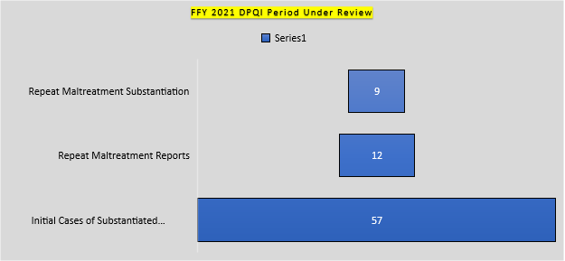
Source: DPQI Review Data
Update 2024:
West Virginia is reporting the number of cases reviewed that had substantiated maltreatment after a case was opened and services were provided. See chart below. In 2022, 62 cases were reviewed, nine referrals alleging abuse or neglect occurred after the cases were opened and four had confirmed repeat maltreatment.

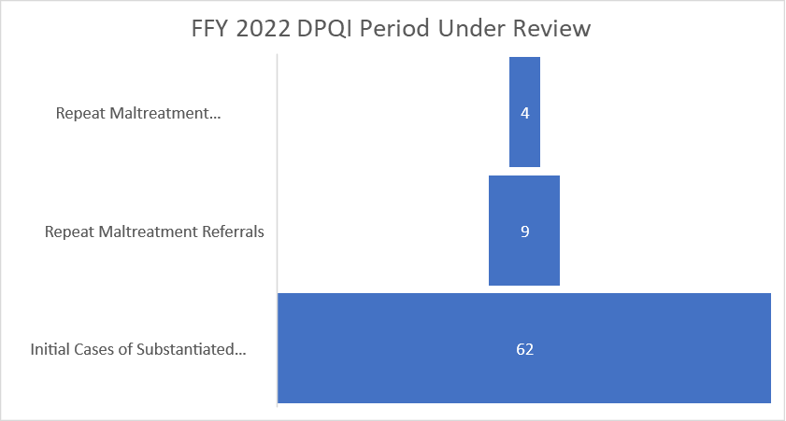

Baseline  17.6% | Reporting Year | 2021 Goal | 2022 Goal | 2023 Goal | 2024 Goal
 | Projected | 15.6% | 10.6% | 5.6% | .6
 | Actual | 14.7% | 6.9% | 15.7% | 6.45%

Objective 1.5 Increase the percentage of open cases that receive Family Preservation Services by 2% in the first year and 5% each additional year. 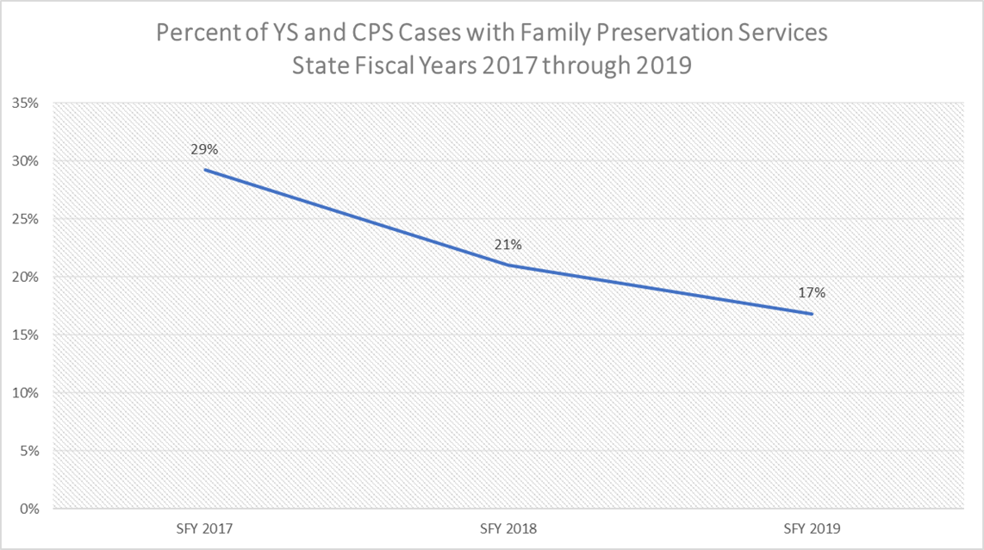Source Data: COGNOS ASO Payments

Update 2023:

Update 2024:

Baseline  21% | Reporting Year | 2021 Goal | 2022 Goal | 2023 Goal | 2024 Goal
 | Projected | 23% | 28% | 33% | 38%
 | Annual | 32% | 31% | 27% | 34%

No additional supports are needed at this time to achieve the objectives under this goal.

Goal 2. Increase positive outcomes for youth aging out of foster care.

Goal 2 utilizes NYTD survey data to measure objectives’ progress. Due to the availability of the data source, progress reporting will be delayed by one reporting year. Cohort 3 A is the baseline percentage utilized to measure the state’s ongoing progress. This group of youth represents the first cohort that the state can actualize positive change. Cohorts 1 A and B, and Cohorts 2 A and B are illustrated in the charts for each objective. This allows the state to infer the progress which should be reflected when Cohort 3 B data is available in calendar year 2021. Progress will be determined by increased percentages of the baseline, not on the state’s progress or lack thereof.

Update 2023:
West Virginia noted a dramatic dip in the High School Graduation rate at age 21 in FFY 21. Compared to FFY 18 where 75% of youth reported earning a diploma or equivalency by age 21, only 30% of youth reported this achievement. This appeared to be a data error, and West Virginia requested technical assistance from the NYTD data analysts. The analysts recommend a check of the NYTD Frequency Report and resubmit subsequent files with the corrected response values. West Virginia will make the correction and resubmit, so that we can obtain actionable results for this Goal.

Update 2024:
West Virginia did not receive any technical assistance in FFY 2022. All data submissions were completed on time. No data corrections were requested. The State has requested the assistance of Casey Family Programs to help with the redesign of the Transitional Living programs. Meetings with BSS and Casey Family Programs started in early 2023. The expected timeline for completion of this item is early 2024.

Objective 2.1 Increase the percentage of foster youth who, when surveyed at 21, completed high school or obtained high school equivalency by 5% each additional year.
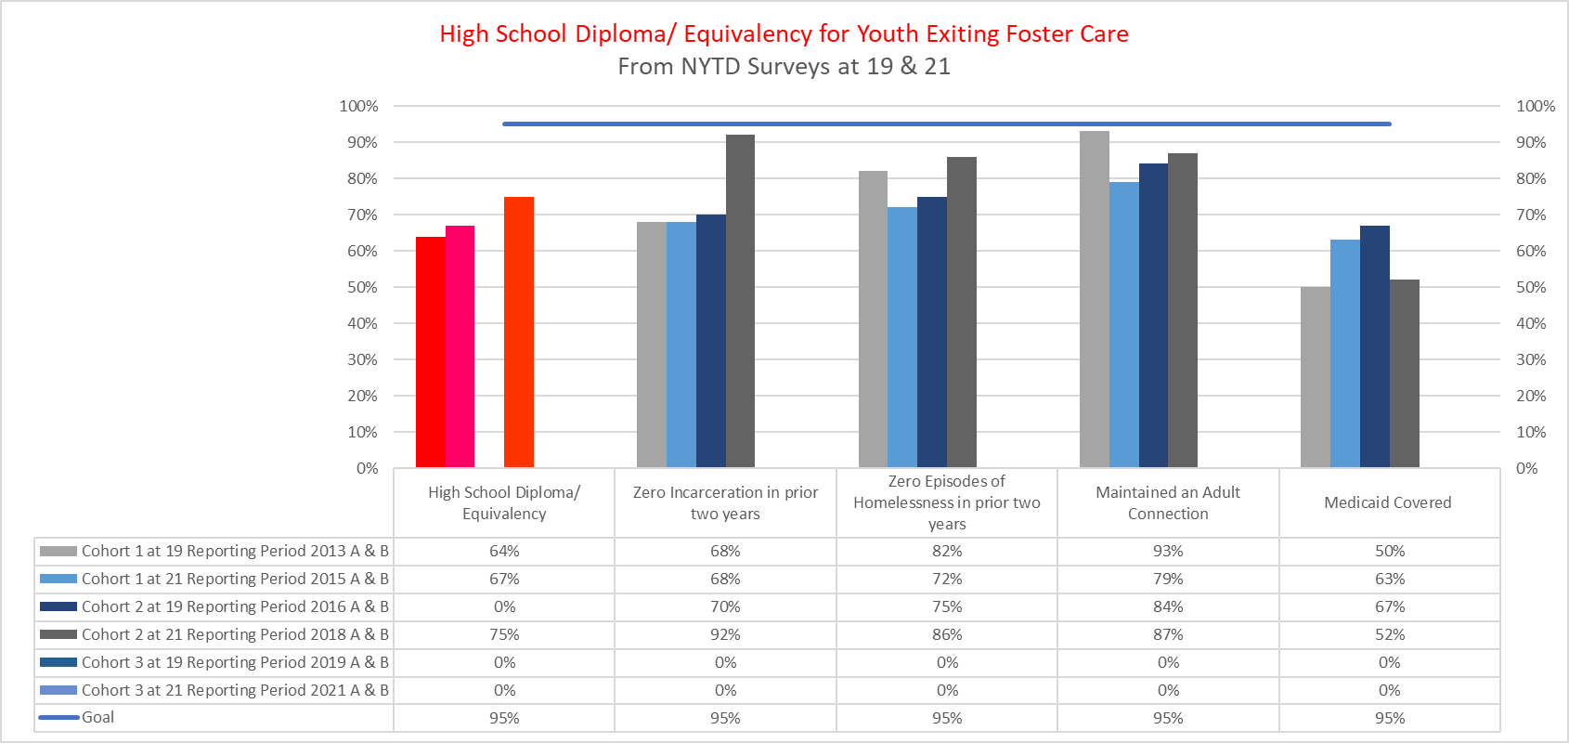
Source: NYTD Snapshots for West Virginia from ACF
Update 2023: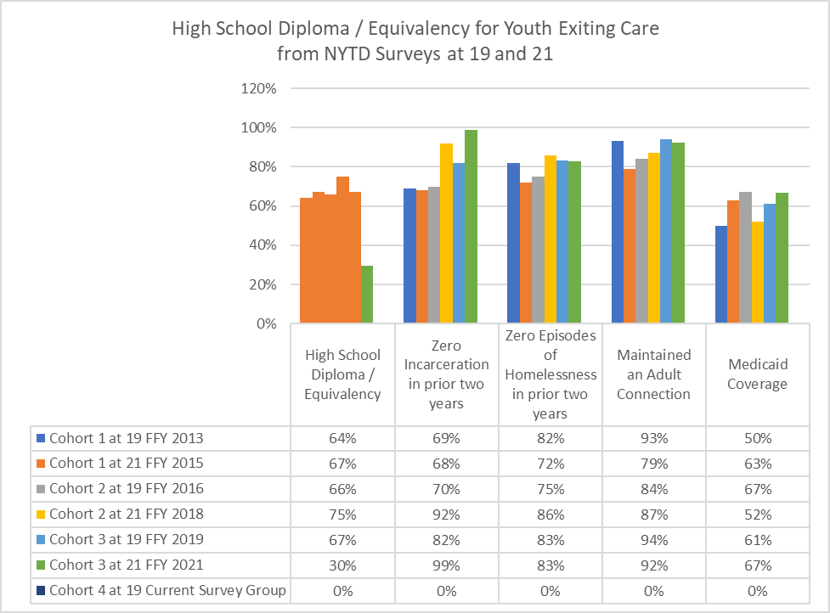Source: NYTD Snapshots for West Virginia from ACF

Update 2024

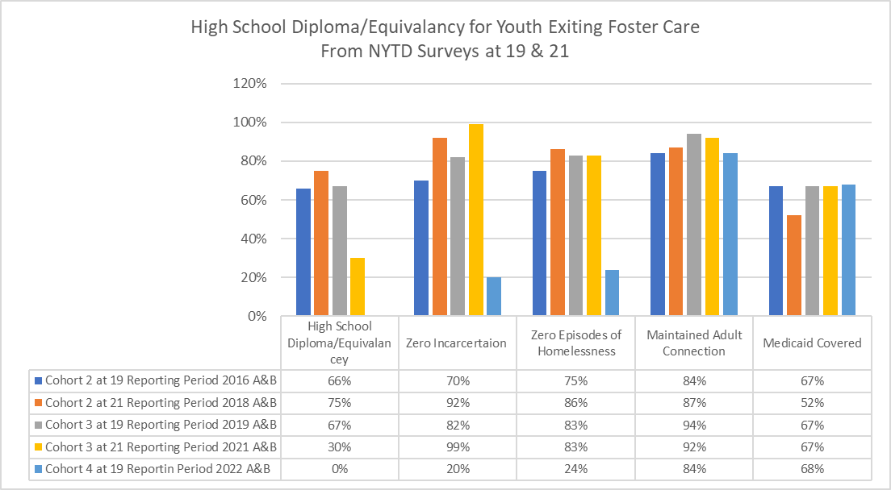
Baseline  67% | Reporting Year | 2021 Goal | 2022 Goal | 2023 Goal | 2024 Goal
 | Projected | 72% | 77% | 82% | 87%
 | Actual | 30% | 0%
Objective 2.2 Increase the percentage of foster youths, by 5% each year who, when surveyed at 21, had not been incarcerated.

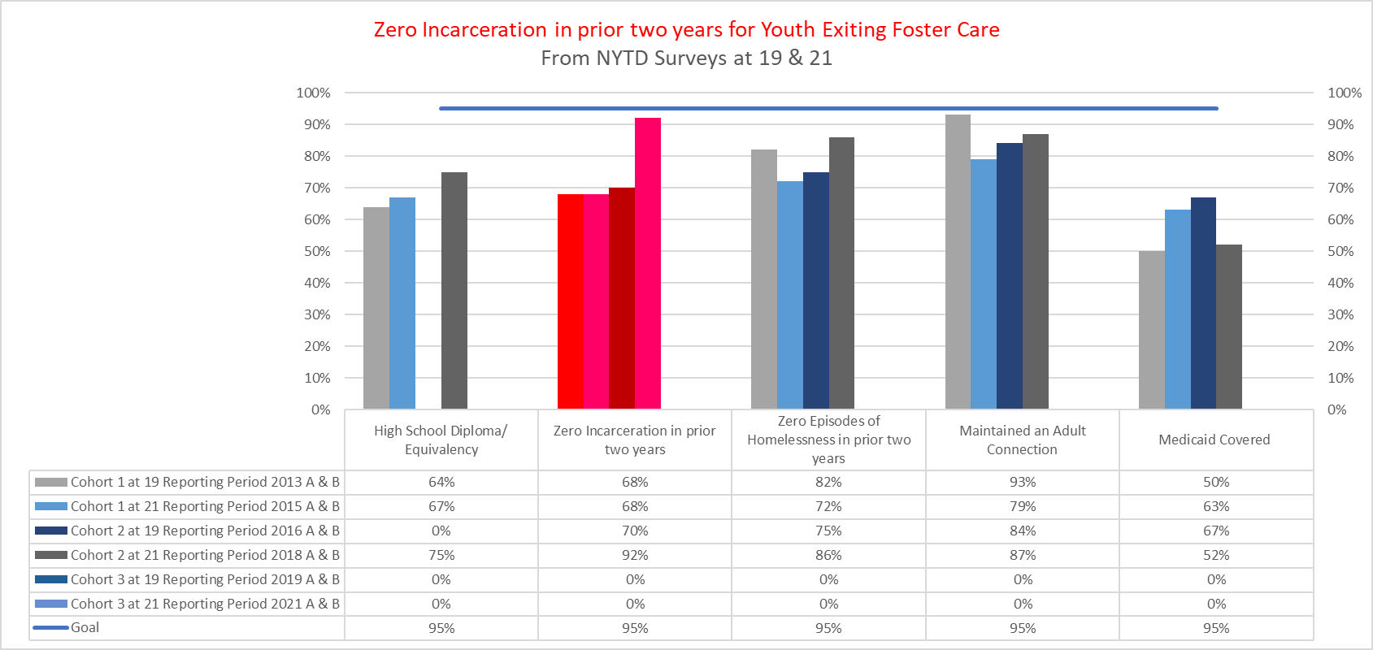
Source: NYTD Snapshots for West Virginia from ACF

Update 2023:
West Virginia reports 99% of youth did not experience incarceration in the past two years from age 19 to 21. This percentage is markedly above the goal of 87% and the baseline of 67%. This decline is consistent with the reported rate of incarceration by the Office of Research and Strategic Planning, Division of Justice, and Community Services.
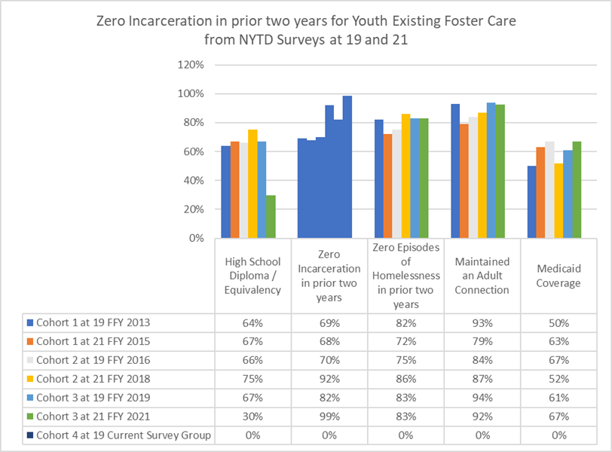

Update 2024:

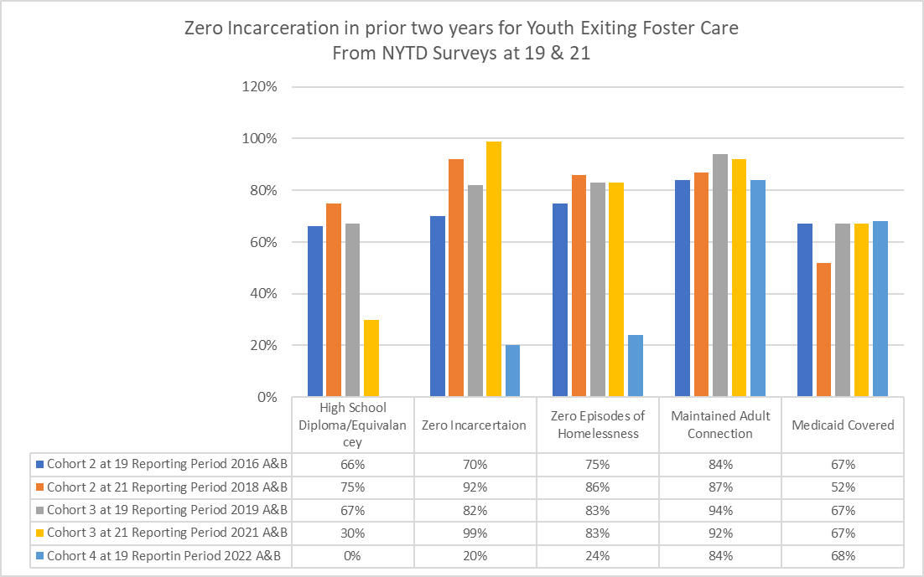

Baseline  82% | Reporting Year | 2021 Goal | 2022 Goal | 2023 Goal | 2024 Goal
 | Projected | 87% | 92% | 97% | 100%
 | Actual | 99% | 20%

Objective 2.3 Maintain the percentage of older youth in care who have a permanent connection identified at 17, 19 & 21 at or above 95%.

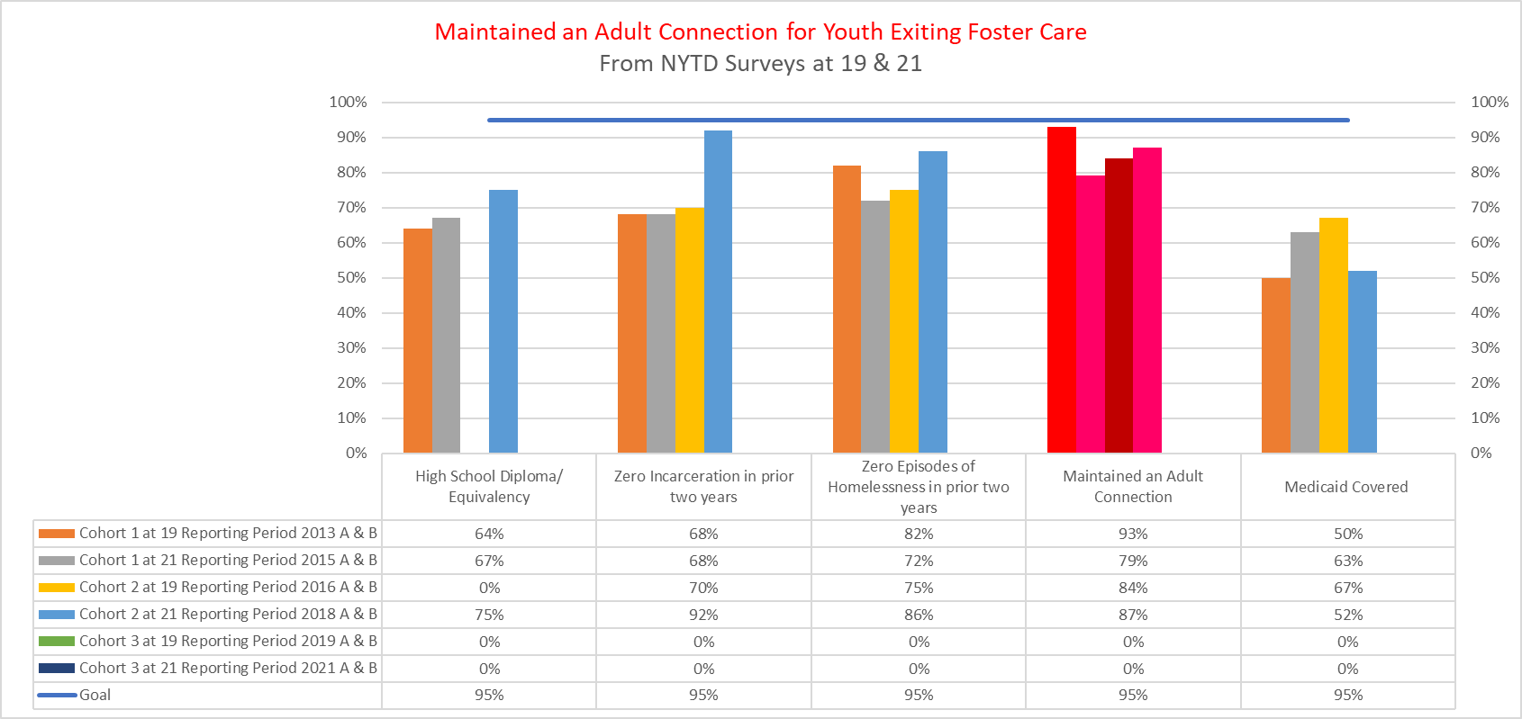Source: NYTD Snapshots for West Virginia from ACF

Update 2023:
West Virginia youth reported difficulties in maintaining adult connections at age 21 for the past two years. The pandemic created isolation for West Virginians of all ages, and a special effort continues to promote HELP4WV, which is staffed by First Choice Services. This service operates several helplines which will be continually staffed as well as text and a phone app to connect with people who are in crisis or need to find support groups. The COVID-19 pandemic is driving increases in all kinds of issues like anxiety, depression, suicidal thoughts, substance abuse or gambling addiction and this is one service that can reach across barriers and assist youth to find connection. The public awareness campaign promotes help4WV on television, social media, radio and in print.
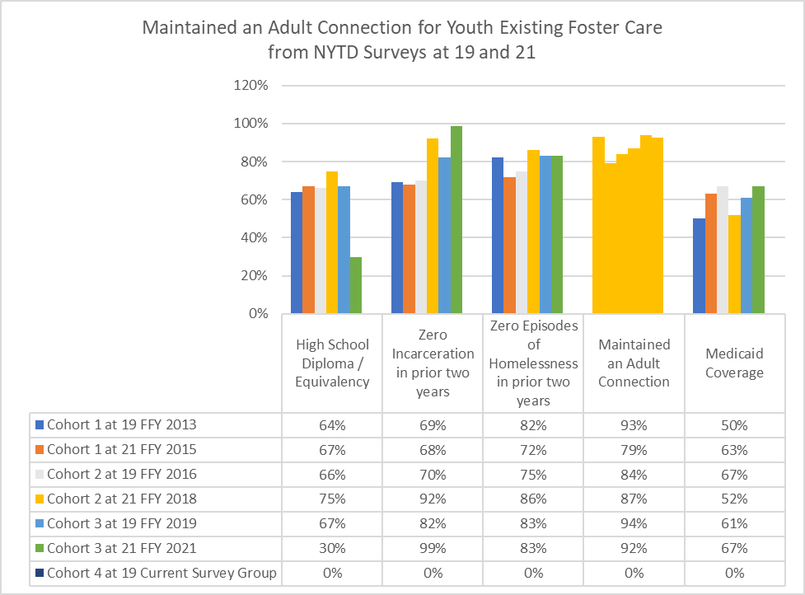

Update 2024:
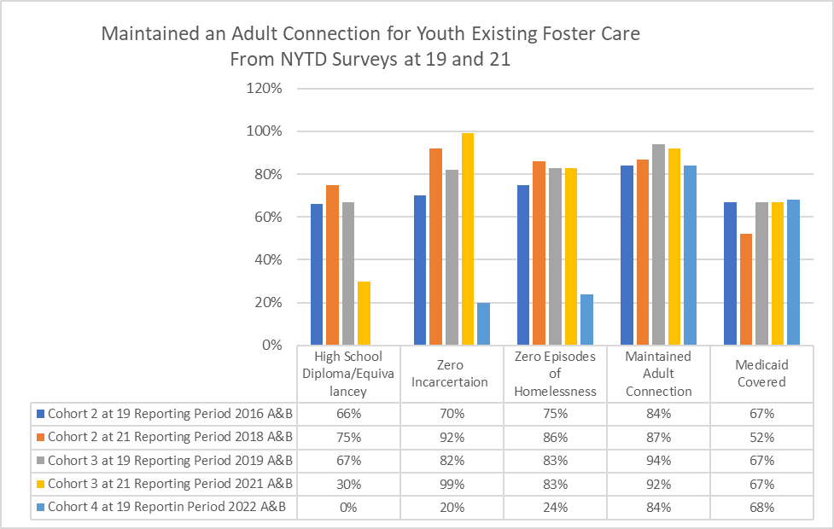

Baseline  94% | Reporting Year | 2021 Goal | 2022 Goal | 2023 Goal | 2024 Goal
 | Projected | 95% | 95% | 95% | 95%
 | Actual | 92% | 84% | 84%

Objective 2.4 Increase by 5% each year, the percentage of foster youth who, when surveyed at 21, had Medicaid.
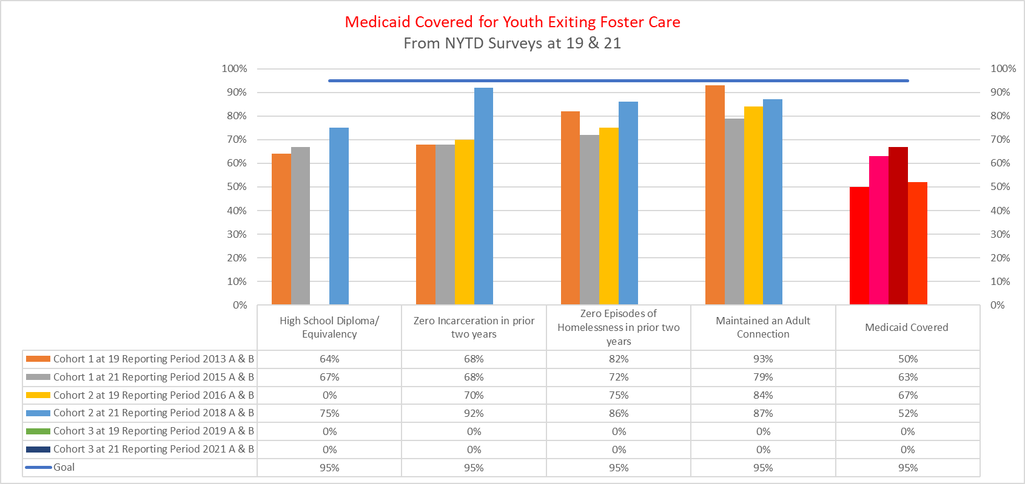
Source: NYTD Snapshots for West Virginia from ACF

Update 2023:
West Virginia had 67% of youth report access to medical care with their Medicaid benefit, which is 1% over the goal of 66%. However, youth remain unaware of the breadth of services available with their “medical card,” and they are not utilizing the wellness benefits through Aetna’s Mountain Health Promise. To increase awareness and access, Aetna has launched a public awareness campaign to ensure recipients will not lose benefits. This effort coincides with the anticipated end of the public health emergency which extended benefits during the pandemic. Youth will receive requests to update contact information in several formats (mail, phone, and email). BMS will then notify youth when it's time to renew Medicaid coverage and learn about the benefits available with Aetna.
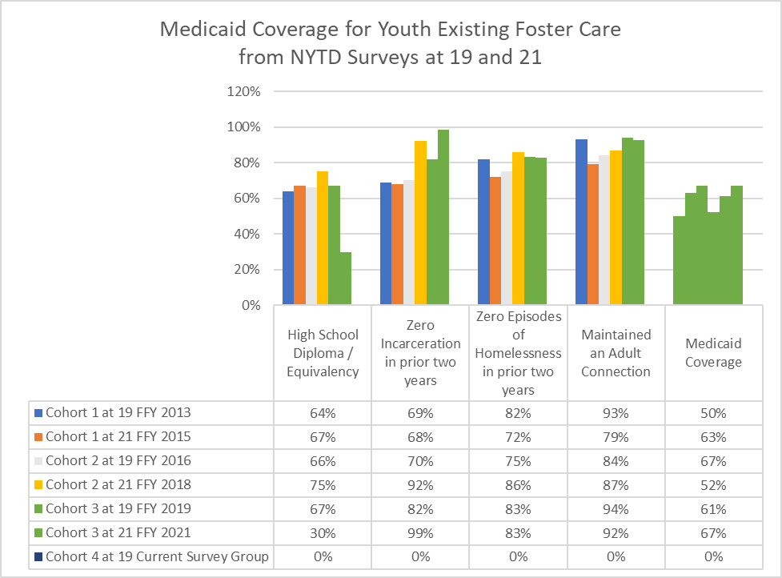

Update 2024:

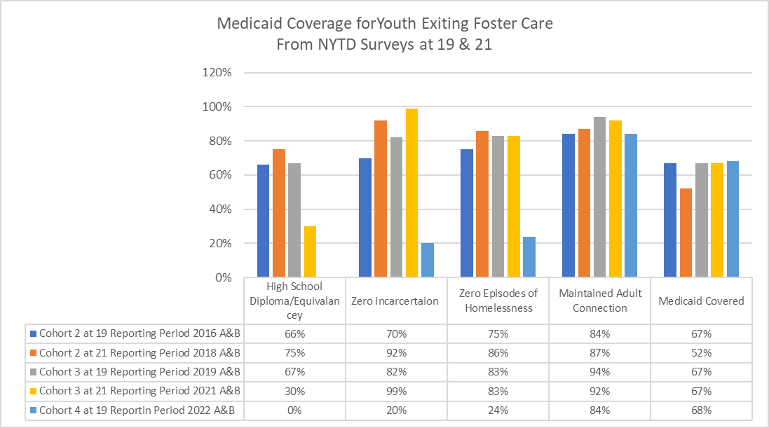

Baseline  61% | Reporting Year | 2021 Goal | 2022 Goal | 2023 Goal | 2024 Goal
 | Projected | 66% | 71% | 76% | 81%
 | Actual | 67% | 68%

Objective 2.5 Increase by 5% each year the percentage of foster youth who, when surveyed at 21, had not experienced Homelessness.

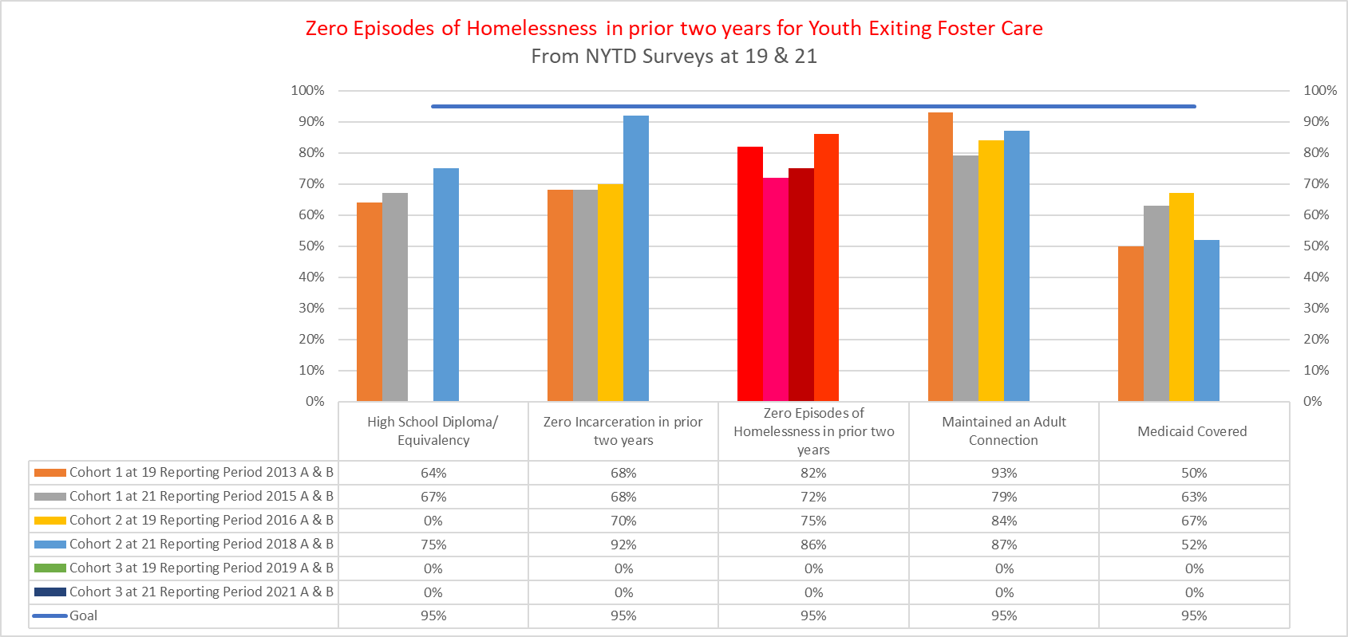
Source: NYTD Snapshots for West Virginia from ACF

Update 2023:
West Virginia youth experienced the same rate of homelessness in FFY 21 as in FFY 19. This goal had a baseline of 83% of youth having zero episodes of homelessness, which is the rate for both last reporting periods. The West Virginia Coalition to End Homelessness has become an integral part of efforts to increase retention rates, or the rate of people who were able to stay housed after being connected to permanent housing. The coalition found that, while retention rates for adult and family programs averaged 90%, the youth rate was only about 60%. Youth often lack the additional support and life skills necessary to keep a young person in housing. Youth housing navigators have been hired by the coalition to bridge that support gap with youth. Expansion of these youth housing navigators is part of the coalition’s Youth Homelessness Demonstration Program (YHDP) to reduce the number of youths experiencing homelessness in West Virginia. Another effort is the Foster Youth Initiative (FYI) Housing and Urban Development (HUD) vouchers for youth who exited foster care and need housing to prevent homelessness. The FYI program has expanded to five of the 21 Public Housing Authorities in West Virginia, which includes the major metropolitan areas of Charleston, Huntington, Morgantown, and Fairmont.
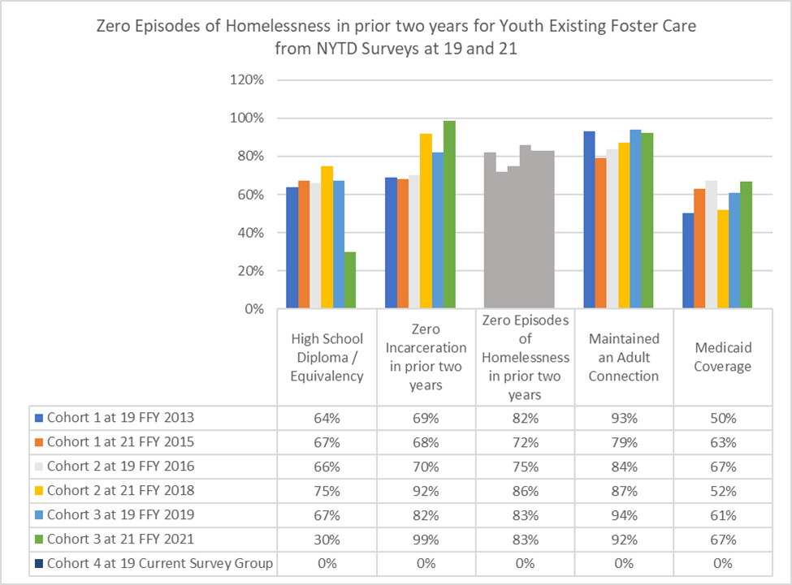

Update 2024:
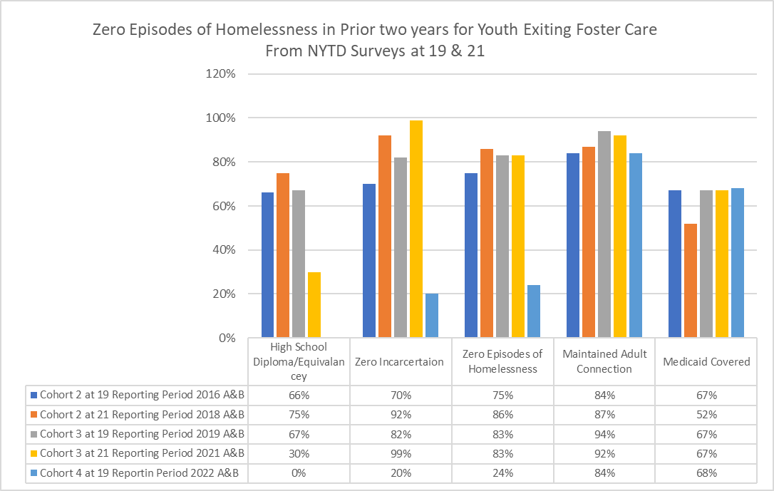

Baseline  83% | Reporting Year | 2021 Goal | 2022 Goal | 2023 Goal | 2024 Goal
 | Projected | 88% | 93% | 98% | 100%
 | Actual | 83% | 24%

Staff Training, Technical Assistance and Evaluation
Please reference the Training Plan for staff development and training in support of the goals and objectives of the Child and Family Services Plan.

To help districts move towards the outcomes identified, the Department will assemble Training and Technical Assistance Teams consisting of Quality Assurance staff, Policy staff, Training staff and local district supervisors to provide intensive training and mentoring to district staff on the areas needing improvement identified during their local Quality Assurance reviews.

These teams will also be available to aid individual districts on selected topics when they are identified as having a decrease in performance outcomes or their individual supervisors notice a decrease in performance during their monthly supervisory reviews.

Update 2023:
No new updates for the Training and Technical Assistance teams. The State is still working on implementing this program.
Update 2024:
In late 2022 BSS began deploying their Training and Technical Assistance Teams to districts with the most recent quality assurance reviews. BSS policy staff have also been providing technical assistance to specific districts regarding completing efficient assessments and using those assessments to effectively case plan for children and families.
The results of some technical assistance areas have demonstrated a slight improvement in the completion of assessment and case planning. The training and technical assistance deployment is still in the very early stages of implementation, so in-depth outcomes are yet to be determined.
The Bureau for Children and Families will continue to utilize in depth technical assistance from Casey Family Programs to assist with the implementation of several on-going initiatives including but not limited to our kinship navigator program, foster care reform, reflective supervision, and Family First Prevention Services Act implementation.

The Capacity for States will continue to assist the state as referenced in the Program Improvement Plan.

Casey Family Programs and Marshall University will continue to assist the state with data collection and analytics surrounding our Kinship Navigator Program and Case Assessment and treatment model respectively.

Update 2023:
West Virginia continued to work closely with Casey Family Programs in 2021 including the following:
- Ongoing training for child welfare staff and supervisors related to reflective supervision, customer services in child welfare.
- Building capacity for reflective supervision and workforce retention by providing targeted training and technical assistance to eight identified districts, utilizing reflective supervision to increase workforce retention.
- Development and implementation of the “gold standard” for home-finding.
- Consultation on work related to West Virginia’s agreement with the Department of Justice, including providing training and technical assistance to the Reducing the Reliance on Residential Care Committee, stakeholder meetings, and other subcommittee meetings.
- Regular participation in the national Affinity Team partnership meetings related to the implementation of FFPSA.
West Virginia will continue to work with Casey Family Programs in the upcoming year.

Update 2024:
West Virginia continued to work closely with Casey Family Programs in 2022 including the following:
- Consultation on work related to West Virginia’s agreement with the Department of Justice, including providing training and technical assistance to the Reducing the Reliance on Residential Care Committee, stakeholder meetings, and other subcommittee meetings.
- Regular participation in the national Affinity Team partnership meetings related to the implementation of FFPSA.

West Virginia will continue to work on the areas mentioned above with Casey Family Programs in the upcoming year. At this time there have not been other areas identified that would require technical assistance in capacity building.

Work with A Second Chance
BSS has concluded their work with A Second Chance, Inc. BSS started working with A Second Chance Inc. as a result of House Bill 2010 and House Bill 4092 that were passed in the 2019 and 2020 legislative sessions. The release of the policy revisions for Home Finding has assisted staff in understanding the process better and standardizing the practice statewide. The Bureau is currently reviewing three kinship specific curricula to determine which curriculum would best fit kinship/relative needs. BSS is working toward having a recommendation presented to leadership later this year.

Update on Services

Child and Family Service Continuum

Prevention
The Department is the designated lead agency for Community-Based Child Abuse Prevention (CBCAP) activities. The Division of Early Care and Education (ECE) within the Bureau for Children and Families (BCF) in the Department manages the activities funded by the CBCAP grant. ECE is also responsible for coordination and administration of the Child Care and Development Fund and the Head Start State Collaboration Office. ECE staff work closely with the Bureau for Public Health, which includes Birth to Three and the state’s Maternal Infant Early Childhood Home Visiting program (MIECHV). Activities and initiatives that touch all aspects of children’s lives and wellbeing are coordinated through the state Early Childhood Advisory Council (ECAC).

Through CBCAP activities, the Department works closely with Prevent Child Abuse West Virginia to coordinate prevention efforts across the state to give children good beginnings by strengthening families and communities. They work collaboratively to build awareness, provide education, and strive to keep children free from abuse and neglect.

The Department funds and supports several child abuse prevention initiatives that use a combination of CBCAP, Temporary Assistance for Needy Families (TANF), and MIECHV funds, state appropriations, and private funds. These initiatives include In Home Family Education Programs (IHFEP), Family Resource Centers (FRC), and Partners in Prevention grants to communities. These programs are considered an integral part of the child welfare continuum by building and increasing protective factors that enable parents and families to nurture and parent appropriately and connect them to concrete supports that help keep families out of the child welfare system. Programs are community based and driven, with advisory boards made up of program participants, service providers, and local leaders. Services are available to any member of the community, regardless of income, and are voluntary.

Twenty-three Family Resource Centers across the state aid families and communities based upon their community’s needs and gaps in service. FRC staff are connected to local resources and provide referrals and concrete assistance through food, baby, and hygiene pantries. Depending upon community need, they also offer childcare, support groups, parenting education, and play groups. Services are offered to any family with children from prenatal through eighteen years of age. In the State Fiscal Year 2020, the funding allocation to the FRCs was increased to allow them to expand into unserved communities in their catchment areas and serve more families. This was made possible through TANF funds, and the programs now have oversight from both ECE and Family Assistance staff.

While MIECHV funds the majority of In-Home Family Education Programs in the state, thirteen IHFEs are jointly funded through CBCAP and MIECHV funds. Programs may choose from two evidence-based models, Parents as Teachers, or Healthy Families America. These programs systematically assess family strengths and needs, and enhance family functioning through trusting relationships, teaching problem solving skills, and promoting positive parent-child interactions. They also educate parents and caregivers on child development and connect them to referrals and resources. Bureau for Children and Families continues service coordination with Bureau for Public Health through the In-Home Family Education (IHFE) programs. The Department plans to continue this partnership with additional IHFE programs being created in counties not served by an IHFE program as resources permit.

Partners in Prevention (PIP) is a community grant and networking program that focuses on preventing child abuse and neglect. Forty-four PIP teams work to build protective factors within communities and families by promoting local needs-based activities with the cooperation of community members, local organizations, policy makers, and parents.

The Department’s various Bureaus have a commitment to collaboration. All Bureaus and Divisions maintain linkages to one another and communicate frequently on joint programs and projects to reduce child maltreatment and strengthen families and communities.

Also, the Bureau for Children and Families refers families to the Bureau of Medical Services for many preventative services such as Birth to Three and Right from the Start. Workers make referrals to these programs at the time of assessment.

Update 2023:
Bureaus within the Department continue collaborating efforts in prevention services. The statistical data for these prevention services are listed above in the Service Array section.

Update 2024:
Bureaus within the Department continue collaborating efforts in prevention services. The statistical data for these prevention services are listed above in the Service Array section.

Birth to Three

WV Birth to Three is a statewide system of services and supports for children under age three who have a delay in their development, or may be at risk of having a delay, and their family. The Department of Health and Human Resources, through the Bureau for Public Health and the Office of Maternal, Child and Family Health, WV Birth to Three, is the lead agency for Part C of the Individuals with Disabilities Education Act (IDEA), assures that family centered, community-based services are available to all eligible children and families. WV Birth to Three partners with families and caregivers to build upon their strengths by offering coordination, support, and resources to enhance children’s learning and development.

To be eligible for WV Birth to Three services, an infant or toddler under the age of three can either have a delay in one or more areas of their development or be at risk of possibly having delays in the future. A child may have delays in one or more of the following areas:

Cognitive - thinking and learning
Physical - moving, seeing and hearing
Social/emotional - feeling, coping, getting along with others
Adaptive - doing things for him/herself
Communication - understanding and communicating with others

A child may also have risk factors such as a condition which is typically associated with a developmental delay such as Down Syndrome or a combination of biological and other risk factors. Some of these factors may include family stressors.

As a result of individualized support and services families will know their rights, effectively communicate their child’s needs, and help their child develop and learn. The child will demonstrate improved social emotional skills and relationships, acquisition of knowledge of skills including language.
and communication and use of appropriate behaviors to meet their needs.

Right from The Start

The Right from The Start (RFTS) Program is a home visitation program which provides targeted case management and/or the provision of enhanced prenatal care services for Medicaid pregnant women up to 60 days postpartum and infants through one year of age. Targeted case management in the RFTS Program includes an Initial Assessment for prenatal or infant clients, development of an individualized Service Care Plan reassessed on an ongoing basis, depression screening, domestic violence screening, tobacco/substance use screening, assistance with locating needed resources, education and counseling programs for the mother, transportation assistance to medical appointments and referrals as needed. Enhanced prenatal care services include childbirth education, parenting education, health education and nutritional evaluation/counseling. All services are provided by a registered nurse, licensed social worker, or registered dietician. These services have the combined purpose to improve birth outcomes and reduce infant mortality and morbidity in a high-risk population with a medically focused approach.

The Right from the Start (RFTS) Program has been delivering services, providing health care for low-income mothers and infants at-risk of adverse health outcomes for over two decades. The services are FREE and support mothers, their new babies, and their families by helping create a safe, nurturing home.

The Designated Care Coordinator provides professional, individualized, and comprehensive care that empowers families to achieve the healthiest possible outcomes during pregnancy and infancy. The program empowers participants to choose lifestyles resulting in healthy families.

The RFTS is a carefully crafted and highly interdependent partnership with tertiary care centers, primary care centers, local health departments, private practitioners and community agencies working with the Department. Its focus is the continuum of care model. The RFTS coordinates services provided to high risk, low-income pregnant women through the second postpartum month and to Medicaid eligible high-risk infants through age one. The RFTS also helps provide access to other enhanced services, such as parenting classes, transportation to medical appointments, smoking cessation programs and health and nutrition programs.

Maternity Services

Maternity Services is limited funding of prenatal, delivery, postpartum and routine newborn hospital care for low-income, medically indigent pregnant women who are determined to be ineligible for Medicaid, have no insurance to cover obstetrical care, and have monthly income below 185% FPL. This includes minors and income eligible non-citizens. Maternity Services requiring prenatal care are provided in the standards outlined in the American College of Obstetricians and Gynecologist guidelines.

Maternity Services also acts as a guarantor of payment for initial prenatal exams and associated laboratory/diagnostic tests. Maternity Services is the payer of last resort. If the client is approved for Medicaid or another third-party source, the practitioner is paid by that source.

The Drug Free Moms and Babies (DFMB) Project is a comprehensive and integrative medical and behavioral health program for pregnant and postpartum women. The project supports healthy baby outcomes by providing prevention, early intervention, addiction treatment, and recovery support services.

This project is supported through funding from the West Virginia Department of Health and Human Resources, Division of Behavioral Health, and Health Facilities, the WV Office of Maternal, Child, and Family Health, and the Claude Worthington Benedum Foundation.

Key Project Aspects
- Screening, Brief Intervention, Referral and Treatment (SBIRT) services integrated in maternity care clinics.
- Collaboration with community partners for the provision of comprehensive medical, behavioral health, and social services
- Long term follow-up for two years after the birth of the baby provided by a recovery coach. In addition, home visits and other services to help women maintain sobriety and access needed resources are provided.
- Program evaluation of effective strategies for identifying women in need, preventing addiction and abuse, treating women with substance abuse problems, and delivering recovery coaching services.
- Provider outreach education to other maternity care clinics in West Virginia to facilitate the duplication of successful model programs.

Child Protective Services
Child Protective Services (CPS) operates under the authority of West Virginia State Statute. There are two primary purposes for CPS intervention in West Virginia: (1) to protect children who are unsafe, and (2) to provide services to alter the conditions which created the threat to child safety. WV follows the Safety Assessment and Management System or SAMS model. The SAMS model includes CPS Intake Assessment; CPS Family Functioning Assessment (FFA); CPS Protective Capacities Family Assessment and Family Case Plan (PCFA); and Family Case Plan Evaluation/Case Closure.

The SAMS model is a very detailed and time-consuming model. A combination of an opioid crisis, lack of tenured workers, and a very high turnover rate has led to a large backlog of assessments. To counteract this backlog, the Department has allowed workers to complete a very short version of the SAMS model. The state has also begun work on a streamlined process for both CPS and Youth Services. The streamlined workgroup has successfully edited most of the two policies to become easier to navigate. Case plans and safety plans have also been streamlined for both programs to use. The new case plan process has been piloted statewide and was praised by the staff selected to use them. Child welfare staff stated the forms used are much easier to understand and families felt they were included in the process. Safety plans have been reduced to one document, instead of the three that were previously used. The plan can be altered to address immediate safety concerns, and in and out-of-home safety plans as well.

Further, CPS has a shortened documentation process for completing the Functional Family Assessments. The form is Crisis Response Worksheet CRW. The CRW mandates CPS staff to narrate the allegations of child abuse or neglect, and maltreatment and nature portions of the assessment on the form. This form has allowed staff to quickly document their interactions with the family.

Intake Assessment: The Department receives reports of child abuse or neglect through phone calls to the local office, emails, letters, and when referents visit the local office. These reports are routed through our CIU via a 24-hour hotline. The report is accepted if the allegations meet the statutory definitions of abuse or neglect, which include if the children are in a situation where abuse or neglect is likely to occur. All mandated reporters are required to be notified in writing whether the report was accepted for assessment. When reports are not accepted, the family may be referred to other more appropriate state agencies or community resources to assist the family. If accepted for Family Functioning Assessment, the report is assigned a time frame for response. The time frames are immediate response, 72-hour response, or 14-day response. The response times are assigned based on requirements in state statute and policy.

Family Functioning Assessment: The assessment of a report of child abuse or neglect sets the stage for the problem validation, service provision, and the establishment of a helping relationship in CPS. The primary purposes of the family functioning assessment are to gather information for decision making; to explain a community concern to the family; to explain the agency’s purpose; to assess the family for possible safety threats; to reduce trauma to the child; to secure safety as indicated; to promote family preservation and expend reasonable efforts; and to offer help.

During the family functioning assessment, the CPS Social Worker collects information through interviews, observations, and written materials provided by knowledgeable individuals using a family-centered approach. This approach seeks to support and involve children, caregivers/parents, and other individuals in CPS intervention. The CPS Social Worker uses the information to determine if the children are abused, neglected, or unsafe and in need of protection. If the children are unsafe, the family must be open to Ongoing Child Protective Services. A safety plan is then developed with the family, in the least intrusive manner possible, to provide a safe environment while CPS attempts to alter the safety threats discovered. The safety plan can include paid and non-paid safety services. If possible, the assessment should be completed within 30 days of the receipt of the referral.

Protective Capacities Family Assessment: The Protective Capacities Family Assessment is a structured interactive process that is intended to build partnerships with caregivers to identify and seek agreement regarding what must change related to child safety as well as to develop family case plans that will effectively address caregiver protective capacities and meet the child’s needs.

The Safety Assessment and Management System (SAMS) Protective Capacities Family Assessment and Family Case Plan Evaluation focuses on diminished caregiver protective capacities and the safety threats identified during family functioning assessment which may or may not involve court intervention. The Protective Capacities Family Assessment and Family Case Plan Evaluation is a structured, interactive intervention intended to build partnerships with caregivers to identify and seek agreement regarding what must change related to child safety and to develop family case plans that will effectively address caregiver protective capacities and meet the child’s needs. The CPS Social Worker translates diminished caregiver protective capacities into client goals, and those goals are used to develop the family case plan. Services are then put in place to assist the caregiver in meeting the goals. The Protective Capacities Family Assessment and Family Case Plan must be completed within 45 days of the case being opened for ongoing CPS services.

Family Case Plan Evaluation/Case Closure: The family’s case plan will receive ongoing evaluation by the CPS Social Worker. This process is called the SAMS Family Case Plan Evaluation. The Family Case Plan Evaluation is a formal decision-making point in the safety intervention process that occurs minimally every 90 days, which requires involvement from caregivers and children; Family Case Plan service providers; and safety service providers. The purpose of the Family Case Plan Evaluation is to measure progress toward achieving the goals in the Family Case Plan associated with enhancing diminished caregiver protective capacities. The Family Case Plan Evaluation is also the decision point when the case may be closed for CPS Services. In addition, the family’s case is closed when the parents can provide a safe home for their child, without CPS intervention, or their child is in another permanent living situation such as adoption or legal guardianship.

Service Population: Child Protective Services are provided statewide to families in which a child (ages 0-17) has been suspected to be abused or neglected or subject to conditions that are likely to result in abuse or neglect (as defined in WV Code §49-1-201 Definitions section and Department operational definitions) by their parent, guardian, or custodian. There are approximately 20,000 families who receive Child Protective Service each year.
Update 2023:
As the DHHR has continued working with the WVCADV in the last year, work with co-located DV Specialists continued in nine counties in the third year of the Rural Grant. Collaboration between DV Specialists and child welfare staff was somewhat encumbered by limited interaction during COVID restrictions and changes in both child welfare staff and DV Specialists staff. The needed opportunities of engaging in educational activities and ongoing interactions that occur while working with families and building relationships was impeded. DV Specialists have continued their efforts to collaborate with child welfare workers and management staff to ensure that they are able to continue in the mutually beneficial service building and that both disciplines have a clear understanding of each other’s work with adult and child victims of domestic violence. The goal continues to be that collaboration is important and crucial in developing safety plans that effectively enhance safety for victims and their children. DV Specialists can assist in providing advanced assessments, recommendations for safety planning for the adult victim and child, as well as assessing for offender accountability and recommendations of services.
DV Specialists have continued utilizing the SAFeR model. There have been noted barriers in some locations regarding the understanding of the most effective use of the SAFeR model in both assessment and recommendations. DV Specialists are attempting to overcome those barriers through education and relationship building with the counties they serve.
Since the D-LAG model was introduced to child welfare, child welfare supervisors and Centralized Intake staff have been trained by WVCADV staff regarding its purpose and application in safety planning.
Over the last year the WVCADV has provided 23 training sessions for child welfare staff and supervisors. All training sessions were held virtually and had available continuing education units for licensed staff. The training included new workers and advanced topics in domestic violence. Additional topics included this year were: co-occurring domestic violence and substance use, co-occurring domestic violence and reproductive coercion; and the foundations of trauma. Domestic violence in later life is a planned training topic for the upcoming year and there are aspirations to develop training specifically for child welfare workers who primarily work with youth services cases.
Update 2024:
As the DHHR has continued its commitment to working with the WVCADV in the last year. The co-located DV Specialists continued in nine counties in the fourth year of the Rural Grant, and they are considering expanding to surrounding counties. Collaboration between DV Specialists and child welfare staff was somewhat encumbered by changes in both child welfare staff and DV Specialists staff. Finding opportunities to engage in educational activities and ongoing interactions that occur while working with families and building relationships is a continued goal for DV Specialists and child welfare staff. DV Specialists have continued their efforts to collaborate with child welfare workers and management staff to ensure that they are able to continue in the mutually beneficial service building, and that both disciplines have a clear understanding of each other’s work with adult and child victims of domestic violence. The goal continues to be that collaboration is important and crucial in developing safety plans that effectively enhance safety for victims and their children. DV Specialists can assist in providing advanced assessments, recommendations for safety planning for the adult victim and child, as well as assessing for offender accountability and recommendations of services.
DV Specialists have continued utilizing the SAFeR model. There have been noted barriers in some locations regarding the understanding of the most effective use of the SAFeR model in both assessment and recommendations. DV Specialists are attempting to overcome those barriers through education and relationship building with the counties they serve.
Since the D-LAG model was introduced to child welfare, child welfare supervisors and Centralized Intake staff have been trained by WVCADV staff regarding its purpose and application in assessing safety and safety planning.
Over the last year the WVCADV has provided eighteen training sessions for child welfare staff and supervisors. Training sessions were held both virtually (14) and in-person (4) and had available continuing education units for licensed staff. The training included new workers and advanced topics in domestic violence. Additional topics included this year were: co-occurring domestic violence and substance use, co-occurring domestic violence and reproductive coercion; and the foundations of trauma.

Youth Services
West Virginia’s Youth Service program serves youth and their families who are involved or are at risk of being involved in the Juvenile Justice System through courts and/or probation. While ensuring the safety and protection of the child is paramount, Youth Services also aims to strengthen the functioning of the family unit through coordinated, multi-disciplinary efforts which involve community agencies and resources.

Case Planning
Case planning continues to be an essential part of the Youth Services process. A standardized case plan document titled ‘Family Service Plan’ has been developed and approved and will continue to be utilized on all open Youth Service cases. Included in this case plan document are the reasons for Department involvement, what must happen for the Department to longer be involved, individual strengths and needs, prioritized goals, services, and a section identifying foster care candidates and an explanation of what qualifies a youth as a foster care candidate. The Family Service Plan document was created with CANS and FAST assessments in mind. WV Youth Service workers will use the CANS and FAST as their standardized screening tool on all open YS cases and use this data to help case plan accordingly.

CANS/FAST
A critical component of West Virginia’s Youth Service program is the assessment of the youth and families which it serves. Youth Services presently uses the Child and Adolescent Needs and Strengths (CANS) tool as its standardized assessment tool. However, the Department has recently begun a pilot program in which the CANS is replaced by the Family Advocacy Support Tool (FAST). While the CANS and FAST are both developed by John Lyons PhD and the Praed Foundation, and require the same level of training and recertification, the FAST is a more condensed assessment and focuses on the wellbeing and safety of the entire family. If the pilot program for the FAST is a success and leads to better case planning and outcomes, then the Department will replace the CANS with the FAST as its standardized assessment tool.

The Youth Level Service Case Management Inventory or (Y)LS-CMI was previously used as a standardized assessment tool. However, due to wording changes in WV Code, the (Y)LS-CMI will no longer be a necessary tool and its role will be filled by the CANS assessment and eventually the FAST assessment.

Update 2023:
Marshall University with the assistance of BSS policy staff, have begun fidelity reviews in districts where the FAST has been fully implemented. The review outcomes will inform where the focus of technical assistance should be concentrated.

Update 2024:
Marshall University continues to certify BSS staff in the FAST which remains the standardized screening tool in all YS cases. Since implementation in 2019, 223 total staff have been trained. They have also conducted five supervisory training courses. Four counties received “Booster Training”.

Marshall University continues to provide technical assistance (TA) following certification of the FAST tool. Since implementation 116 staff have received TA from Marshall. Fidelity reviews continued through 2022. The following counties have been reviewed thus far: Raleigh, Hancock, Mercer, Putnam, and Wayne.

Marshall has expanded their role in TA by working in conjunction with BSS’s Training and Technical Assistance Teams (T&TA). T&TA teams were originally comprised of policy staff, training staff, regional program managers, and child welfare consultations. Since implementation, the process has been expanded to include Marshall University TCOM training staff and the regional social service managers. T&TA is provided to districts following their Division of Planning and Quality Improvement (DPQI) reviews to assist staff in improving the areas identified as needing improvement in the Child and Family Service Reviews (CFSR) and to address any district specific areas reported by the SSM as needing intervention. Marshall TCOM training staff has also accompanied policy staff in TA sessions at the request of districts outside of the regularly scheduled T&TA.

Programs
West Virginia’s Youth Service Program has recently assisted in implementing two evidence-based programs, Victim Offender Mediation (VOM) and Family Functional Therapy (FFT). VOM is a program in which an opportunity is provided for the victim of a crime and the perpetrator to meet face to face with a mediator to help victims heal, the offender to learn, and to reduce the cost for the Juvenile Justice System. The VOM program presently serves thirteen (13) counties and has plans to expand given the opportunity. FFT is a high intensity short term family therapy program intended for youth between the ages of 11-18 which are experiencing family dysfunction. There is presently one FFT provider in West Virginia which serves six (6) total counties. The Department will seek to expand FFT on a continual basis to help prevent children’s removal. Additionally, the Youth Services Division will continue to review additional programs and determine if their implementation can benefit the youth of West Virginia.

Juvenile Justice and Collaboration with The Bureau of Juvenile Services
WV tracks and reports the number of youths who are transferred from the Department to the custody of the Bureau of Juvenile Services (BJS). The tracking methodology is to use reports from the SACWIS system of youth in custody of the Department who were court ordered to another placement. A hand count is then used on the custody transfer list to determine the number of those transfers who were placed with BJS.

The Department also collaborates with BJS when necessary, on youth who are adjudicated or are at risk of court involvement. This collaboration continues to evolve and change to meet the needs of WV Youth and their families. It is anticipated that the Department and BJS will work together on solutions and programs to address truancy and other issues related to the treatment of the Youth Services population.

Gaps in Service: Fostering older youth/teens
An area of concern for the population served by Youth Services is the lack of foster homes available for, or unwilling to take, older youth. The most recent placement report for Youth Services was for the month of April 2019 and notes 643 total Youth Services cases had youth in placement. Of these 643 cases, the majority, 346, were placed in Group Residential Care instead of a Foster Care setting. Of the youth placed in a type of Foster Care, 30 were placed with a certified kinship/relative home, 41 were placed with a kinship/relative, 2 were placed with in Agency Foster Family Care, and 29 were placed in Therapeutic Foster Care. All other placements were through Psychiatric Hospitals, Detention Centers, Transitional living, or Emergency Shelters.

A survey completed in February of 2019 by the WV Foster, Adoptive, and Kinship Parents Network regarding the barriers for fostering teens was conducted. These barriers include fear of teens' influence on younger children in the home, negative behaviors, fear of incomplete or honest data and background information from the Department or foster agencies, and lack of training on how to meet a teen’s needs. Also included in the survey were possible solutions to these barriers which included marketing parents who already have older youth, ensuring that a teens needs are met prior to placement, ensuring that youths case history is shared prior to placement, helping potential foster parents receive the necessary training, skills, and support prior to placement. The Department will continue to review policies, the needs of WV foster parents and youth, and will continue to work with placement agencies to help fill this gap in services.

Another way to reduce the amount of older youth placement in Group Residential Care is to reduce the number of youths removed from their home in the first place. In many cases, removal from the home is necessary for the safety of the youth and their family or is required by court order. However, thorough, and thoughtful case planning and safety planning measures by Youth Service workers and the Department can help reduce the amount of youth removals by ensuring that safety in the home is maintained and that the youth and family are receiving the proper services. The Department will monitor the number of cases that do not have a case plan and/or safety plan and with this data make efforts to ensure case plans and safety plans are completed.

Foster Care
West Virginia’s foster care system is composed of kinship/relative care providers, private/specialized family foster care providers, and residential treatment facilities. West Virginia provides an array of services to all foster children. Services offered to foster children include but are not limited to medical services, including eye and dental, mental health services, clothing, food, shelter, support, education services, independent and transitional living services, legal services, and community support.

West Virginia continues to provide every foster child with a Journey Placement Notebook when they enter care. This notebook follows each foster child through their entire foster care placement and provides forms or records of information including:
- The Outcome Observation Report which includes outcomes relating to:
- developmental
- relationships
- protection and nurturing
- Application for SAFE KIDS PIX identification card
- Information checklist
- Wardrobe and personal item inventory checklist
- Child’s daily schedule
- Behavior observation chart
- Medication side effect checklist
- Therapist/Health Care/Service Providers
- Equipment/supplies inventory
- Foster care/adoption terms to know
- Foster care tuition waiver facts sheet

Journey Notebooks
Journey Placement Notebook forms are accessible through the Bureau for Children and Families webpage; https://dhhr.wv.gov/bcf/policy/Pages/default.aspx This accessibility allows foster care providers as well as private/specialized agencies, and facilities to access the forms whenever necessary if one or more forms have been lost or additional information that exceeds the current provided forms need added. The Bureau for Children and Families will continue to make the Journey Placement Notebooks accessible for the next five years to ensure each foster child has appropriate forms and documentation necessary through their foster care placement.

2023 Update:
There is no update concerning Journey Placement Notebooks

Update 2024:
There is no update concerning Journey Placement Notebooks

Early, Periodic, Screening, Diagnostic and Treatment
The Early, Periodic, Screening, Diagnostic, and Treatment (EPSDT) will continue to be performed for each child who enters foster care. The Bureau for Children and Families partners with the BMS to ensure that each child is linked with a Sander’s Liaison and receives their EPSDT screening within 30 days of entering foster care. This will continue into the next five years and will be tracked through the database system as documentation is entered by the Sander’s Liaison.
Update 2023:
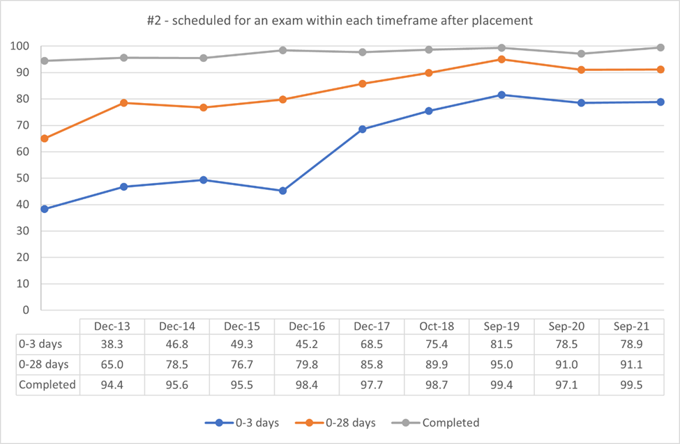

Update 2024:
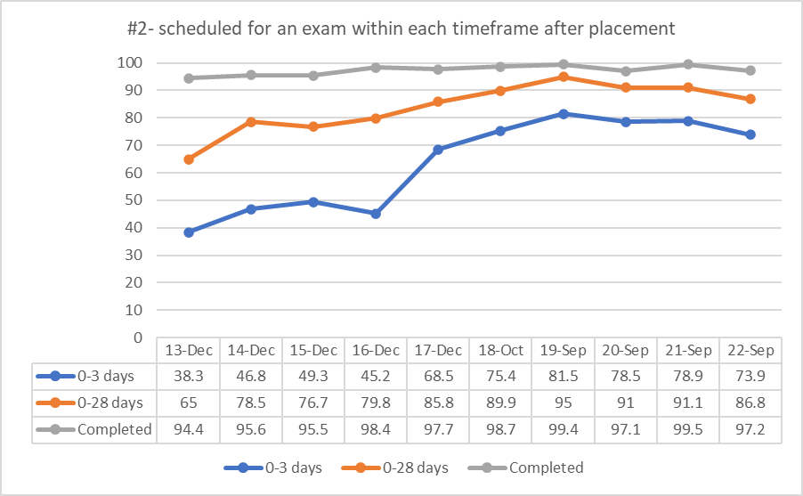

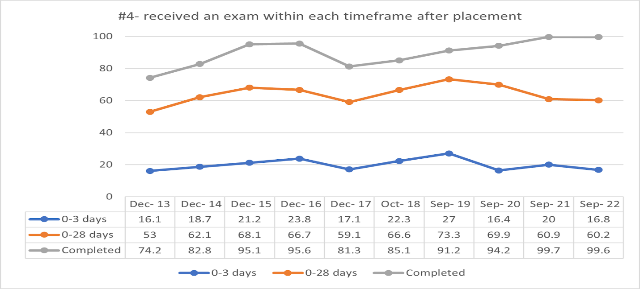

In the 2023 update Chart #4 is missing. The updated data has been added to the 2024 update.

Multidisciplinary Treatment Team
Multidisciplinary treatment team meetings (MDT) are required for all foster care cases as set forth by West Virginia State Code §49-4-403. Multidisciplinary treatment teams consist of child welfare staff, biological parents or family of origin, other necessary family members, the child or youth if deemed in the child’s best interest, service providers, and foster care providers. Many foster care providers are not permitted to participate in the multidisciplinary treatment team meeting; therefore, it is difficult for foster care providers to understand or be aware of particular cases and child goals. Often biological parent goals and foster care provider goals fail to align due to their exclusion from the process. The Department will continue to improve relationships with foster care providers and child welfare staff and will enlist the assistance of the Court Improvement Program to improve the court relationship between child welfare staff and foster parents as well. The Director of Child and Youth Services through the Supreme Court is committed to improving judicial and child welfare staff relationships for the betterment of West Virginia children and families.

Foster Care Redesign
Treatment Foster Care Program
In July 2017, West Virginia formally launched a treatment foster family service model. The model is a family-based, therapeutic, trauma-informed service delivery approach. The tiered model provides individual services for children and their families. The model is designed to ensure the child is safe while working toward permanency such as reunification, adoption, or legal guardianship. The specialized initial and ongoing training provides the foster parents the knowledge and skills needed to care for the children that meet the criteria.

The Treatment Foster Care Program is being provided statewide by five specialized foster care provider agencies. As of June 2019, there have been 256 treatments foster care homes developed across the state. The State plans to increase the provider base within the next few years so treatment/therapeutic foster homes will be available and accessible statewide for the population of youth coming into care.

Treatment Foster Care Program tiers:
- Tier II - Treatment Foster Care-serves children who exhibit mild to moderate levels of trauma/behavioral or emotional dysregulation. There may be mild or moderate difficulty in settings such as school, home and/or community. This level may be used for emergency placements, pregnant/teen moms that require special medical care or children with chronic medical conditions.
- Tier III - Intensive Treatment Foster Care or Therapeutic Foster Care serves children who currently exhibit moderate to significant indicators of trauma/behavioral or emotional dysregulation. High-risk behaviors are present. Significant support is needed. This level may be used for children stepping down from a higher level of care, are at risk of out of state placement or residential placement, infants who are drug exposed with additional medical needs beyond initial medical withdrawal or children considered medically fragile as diagnosed by a physician.

Update 2023:
West Virginia’s Stabilization and Treatment (STAT) Home program is a family-based, therapeutic, trauma-informed behavioral health intervention. The service is provided through 11 child placing agencies (CPA) statewide. In partnership with West Virginia Wraparound and funded through the CSED Waiver, STAT Homes are designed to provide intensive treatment services to children with SED who can be served in a family-like setting, ultimately diverting children from placement in RMHTFs. STAT home parents are specifically recruited and trained to provide intensive support for these children so they can remain in and actively participate in their home, school, and local community. West Virginia seeks to strengthen its STAT home program through development of model standards that clearly define services and activities that support the STAT home parents, the child, and the family of origin, and clarify the role of the child-placing agency’s case manager. The first program/service data is anticipated to be available December 2022.

STAT home providers and stakeholders provided valuable consultation and feedback through various face-to-face and virtual engagements on the proposed model and associated outcome measurements. The STAT home workgroup conducted an analysis of children receiving TFC as well as children in RMHTFs to determine the appropriateness of current placement setting and necessary level of care. Using this information, the STAT home workgroup continued to design the model to assure that children with CSED can receive services in a family-like setting, ultimately diverting children from RMHTFs.

The Treatment Foster Care model was in development during the entire year of 2021 and continues today. The initial phase-in implementation of the new model will occur in July 2022. The model will leverage current Treatment Foster Care providers to provide this service which will allow for statewide coverage.

As the model has developed, the Department has identified key performance indicators for TFC. As performance data is collected, the information can be utilized for ongoing refinement of the TFC model and will help the state understand any provider capacity needs.

As the Department continues to develop this model, the Child Placing Agencies have been consulted and are collaborating to establish services and standards. The Department and the private agencies are working together to ensure the model aligns with current licensing standards and expectations. Communication has been achieved through regular meetings with CPAs. Efforts have been made to establish a rate that will support CPAs in the recruitment and retention of families to serve as foster parents in this new model as the model serves a specific population with a higher level of need that will require additional skills for foster parents.

In late 2021 and early 2022, the Department made the decision, in consultation with the Child Placing agencies, to leave its early Tiered foster care model intact. The current Tier II and Tier III foster homes will serve children with more intensive needs that don’t rise to the eligibility of a STAT home. To be eligible for a STAT home placement, children must meet the following criteria.
- Age 4 through 20.
- In state custody.
- Approved CSED Waiver participant.
- Cannot be safely served in their current setting and are at risk of immediate.
- residential mental health treatment facility placement.
- Not an immediate danger to others or self, or a habitual flight risk which cannot be safely addressed through a safety plan/flight risk plan.
Children disrupted from a foster home, Tiers I, II, or III are also eligible for a STAT home placement if they meet the above criteria and are disrupting in their current placement and are at risk of placement in a residential treatment facility.

Update 2024:
West Virginia’s Stabilization and Treatment (STAT) Home model is currently in the active recruitment phase with the child placing agencies. Nine of West Virginia’s child placing agencies signed the addendum agreement for the STAT home model. As of April 1, 2023, one agency has one home that is ready to begin accepting placement with two other families waiting to resolve current foster care placements as the model only allows one foster child to be placed in the home at a time due to the anticipated needs and level of behavioral and or mental health issues.

The model was revised to reflect the following:
- Ages 3-20 (revised from previous qualifications).
- In state’s custody.
- Approve and actively receive CSED waiver services (revised from previous qualifications).
- Cannot be safely served in their current setting and are at risk of immediate residential mental health treatment facility placement.
- Not an immediate danger to others or self, or a habitual flight risk which cannot be safely addressed through a safety plan/flight risk plan.

West Virginia will continue to monitor the progress of the STAT Home model while working closely with the child placing agencies and families are on-boarded to begin accepting placements.

Performance based contracting

The West Virginia State Legislature passed House Bill 2010 in 2019 which requires the Department of Health and Human Resources to enter performance-based contracting with the child placing agencies who provide foster care services. As part of the procurement process under this requirement, the Department will be issuing a request for proposals by July 1, 2020.

Update 2023:
Performance based contracts have been operationalized since July 2021. Each month, agencies send their performance-based measures to the Department’s Central Office staff to be aggregated. The Department as well as providers collaboratively decided to use the first year of data collection to review and revise the scorecards as necessary. Since data collection began, many minor changes have been made to the scorecards to collect more usable information. Scorecards will be finalized in May and June 2022. By the end of June 2022, it is anticipated that baselines, items for incentives and items for penalties will be established.

Below is a sample of the aggregate data. There are 13 items total as well as a data details page that collects additional information about some of the data items. The aggregate data is color coded to highlight those areas where an agency falls below the aggregate average or is reporting data inappropriately.

 |  | 1. Percentage of total children with substantiated IIUs |  |  |  | 2. Percentage of children receiving required CPA worker visits
Agency 1 | YTD | 0.46% |  |  |  | 100.00%
 | QTR | 1.23% | 0.00% | 0.00% | NA | 100.00% | 100.00% | 100.00% | NA
Agency 2 | YTD | 0.00% |  |  |  | 100.00%
 | QTR | 0.00% | 0.00% | 0.00% | NA | 100.00% | 100.00% | 100.00% | NA
Agency 3 | YTD | 0.00% |  |  |  | 98.16%
 | QTR | 0.00% | 0.00% | 0.00% | NA | 97.05% | 99.03% | 98.53% | NA
Agency 4 | YTD | 0.00% |  |  |  | 98.26%
 | QTR | 0.00% | 0.00% | 0.00% | NA | 100.00% | 95.76% | 99.40% | NA
Agency 5 | YTD | 0.04% |  |  |  | 94.51%
 | QTR | 0.00% | 0.10% | 0.00% | NA | 89.34% | 98.12% | 96.87% | NA
State Average | YTD | 0.10% |  |  |  | 97.82%
 | QTR | 0.22% | 0.02% | 0.04% |  | 95.05% | 99.61% | 99.79%

Update 2024:
The performance-based contracts continue to be implemented and monitored by BSS. They were revised for the state fiscal reporting year, July 2022, to reword some measures and indicators. BSS continues to work closely with the CPAs to further refine the developed indicators so that baseline performance measures can be established. BSS began having monthly internal meetings to review the submitted data to begin developing base lines and determining which indicators will be used as performance measures. The example of the measures provided in last year’s update remain the same.

Kinship Navigator
The navigator program will assist with monitoring kinship/relative placements to ensure their entry into FACTS, monthly demand payments have been entered, and foster care subsidy begins upon certification approval. The Kinship Navigators will assist kinship/families by completing a brief needs assessment and linking families with necessary services and support to ensure their needs are met. The program is intended to provide added resources for kinship/relative families and assist child welfare workers when kinship/relative families have extra needs that require time and assistance.

Update 2023:
The goals of the Kinship Navigator program:

• Serve relative and kinship providers in the first 90 days after placement of children
• Ensure that they have needed resources to care for the children in their home and to pass a home study
• Reduce the task-load for CPS and Home finding workers
• Help relatives feel supported and confident in their ability to care for the children in their home
• Reduce placement disruptions

The Navigator program has filled a service gap that existed in relative/kinship cases. Now, there is a worker whose sole interest is to support the relative/kinship family. They are a non-threatening neutral party, without the ability to disrupt the placement or to “fail” the home study. Navigators are often able to resolve issues that the family was hesitant to bring up to the CPS worker or home finder. The program acknowledges and addresses the service gap that exists between child placement and resource procurement. For instance, the Navigator will help ensure that the family has food, baby supplies, beds, bedding, etc., during the time before TANF and WIC are provided. The Navigators also function beyond the basic services provided by an information and referral service. They also ensure that the families are accessing all appropriate Department services and that they apply for and are provided with them in a timely manner. When a need is identified the Navigators explore various options through Department and community resources to address the need. They may also create resources to meet ongoing needs in a specific community, such as a foster closet or food pantry. Families served by the Navigators have expressed gratitude for the service. They appear to be more confident in their ability to meet the children's needs and to maintain the placement. They also demonstrate increased understanding of how a CPS case works and the elements involved in a home study. The family is also more likely to have in place the requirements for home study, which should shorten the time frame required for certification and for receiving a boarding care check.

Case Referrals
Referrals Received | Reg I | Reg II | Reg III | Reg IV | Totals
January | 10 | 5 | 2 | 3 | 20
February | 18 | 3 | 7 | 3 | 31
March | 25 | 5 | 6 | 2 | 38
April | 22 | 2 | 9 | 3 | 36
May | 32 | 15 | 16 | 15 | 78
June | 20 | 5 | 28 | 11 | 64
July | 18 | 7 | 36 | 12 | 73
August | 18 | 10 | 29 | 21 | 78
September | 8 | 14 | 17 | 18 | 57
October-December | 29 | 60 | 57 | 31 | 177
Total | 200 | 126 | 207 | 119 | 652

- 652 Referrals were received by the program between January 1, 2021, and December 31, 2021.
- 573 Initial Assessments were completed.
- 79 cases were unable to be opened due to lack of complete contact information or lack of response by family (most often due to lack of family response).

Personnel | $128,900.00
Fringe Benefits | $50,815.00
Supplies | $1,601.00
Phones | $1,200.00
Postage | $300.00
Travel/Mileage | $8,333.00
Professional Development/Trainings | $400.00
Caregiver Needs | $0
Legal Aid/Contract Services | $3,000.00
Office Space | $1,500.00

Update 2024:
The goals of the Kinship Navigator program:
• Serve relative and kinship providers in the first 90 days after placement of children
• Ensure that they have needed resources to care for the children in their home and to pass a home study
• Reduce the task-load for CPS and Home finding workers
• Help relatives feel supported and confident in their ability to care for the children in their home
• Reduce placement disruptions

The Kinship Navigator grant is sub-granted to Mission West Virginia who implements the program. There are four to five navigators for the entire state. Kinship and relative caregiver(s) are contacted by the assigned navigator, after the navigator is notified by the Bureau that children have been entered foster care and been placed in the kinship or relative caregiver's home. The navigator is notified by the Home Finding Specialist who is assigned the kinship/relative home study via email submission of the home study request to the navigator's coordinator. The Navigator program has filled a service gap that existed in relative/kinship cases. Now, there is a worker whose sole interest is to support the relative/kinship family. They are a non-threatening neutral party, without ability to disrupt the placement or to “fail” the home study. Navigators are often able to resolve issues that the family was hesitant to bring up to the CPS worker or home finder. The program acknowledges and addresses the service gap that exists between child placement and resource procurement. For instance, the Navigator will help ensure that the family has food, baby supplies, beds, bedding, etc., during the time before TANF and WIC are provided. The Navigators also function beyond the basic services provided by an information and referral service. Rather than simply identifying a resource for the family, the Navigators contact the resource, ensure that they can serve the family/have the item needed, and complete a warm hand-off between the family and resource. They also ensure that the families are accessing all appropriate DHHR services and that they apply for and are provided with them in a timely manner. When a need is identified the Navigators explore various options through DHHR and community resources to address the need. They may also create resources to meet ongoing needs in a specific community, such as a foster closet or food pantry. Families served by the Navigators have expressed gratitude for the service. They appear to be more confident in their ability to meet the children’s needs and to maintain the placement. They also demonstrate increased understanding of how a CPS case works and the elements involved in a home study. The family is also more likely to have in place the requirements for home study, which should shorten the time frame required for certification and for receiving a boarding care check. Mission West Virginia and the Bureau will be working toward developing an evaluation process for West Virginia's Kinship Navigator Program.

Case referrals
2022 By Quarter | Referrals received | Referrals served | Unable to serve*
1 (January -March) | 166 | 151 | 15
2 (April-June) | 206 | 138 | 68
3 (July-September) | 229 | 207 | 22
4 (October-December) | 257 | 228 | 29
Total | 858 | 724 | 129

- 858 Referrals were received by the program between January 1, 2022, and December 31, 2022.
- 724 Initial Assessments were completed.
- 129 cases were unable to be opened due to lack of complete contact information or lack of response by family (most often due to lack of family response).
Residential
West Virginia intends to maximize the provisions for the qualified residential treatment programs (QRTP) and its 30-day assessment requirements to more thoroughly screen youth who are being identified to need residential mental health services. This will also help flag existing diagnoses that must be taken into consideration and help ensure unnecessary mental health diagnoses are not being made for youth to access non-family care.
West Virginia intends to slowly on-board QRTP providers through a targeted, purposeful process utilizing requests for applications (RFA) and population-specific contracting. The RFA strategy aligns with the Bureau’s need to mitigate compliance and financial risk to the State if the federal QRTP requirements are not met.
By soliciting applications from existing contracted providers, the Bureau will be able to clearly define the population for this restrictive category of congregate care. The first RFA was released on April 19, 2019, and defined the target population as youth who require an intensive, non-family residential setting and who have traditionally been served in out-of-state facilities. These youth have demonstrated an inability to function in foster homes or less restrictive forms of residential care due to significant lack of behavioral control and have been diagnosed with one or more significant behavioral, intellectual, developmental, and/or emotional disorders. Once assurances can be made that the system supporting QRTP is in place, data will be gathered to determine the extent of further QRTP on-boarding and will be focused on populations that require a higher level of care. The on boarding of QRTP will not be through the development of new beds but the reconfiguration of existing beds. There will be 42 of the existing beds converted to QRTP between January 2019 and March 2020.
The current residential structure (excluding the Medicaid categories of residential treatment psychiatric residential treatment facilities and Intermediate Care Facilities for Mental Retardation as well as one pregnant/parenting program) is being modified to fulfill the requirements of the at-risk of sex trafficking category. These programs are all in the process of training staff on new programming that will address risk factors for youth that meet this population. Until the QRTP beds are converted in January 2020, all programs will be licensed as a “vulnerable youth” program. Emergency legislative rules were filed on August 16, 2019, that will become effective on October 1, 2019. These will be included with the IV-E state plan amendment. The licensing specialists are currently in the process of making visits to each program to evaluate the curricula that the agencies will be using, how it will be trained and any new services the program requires. They will also be evaluating the new requirements for trauma-focused organizational structures.
Update 2023:
Qualified Residential Treatment Programs (QRTP)
There is no update for QRTP placements. West Virginia has no facilities that are classified as QRTPs at this time. The residential redesign will have High Intensity Treatment Facilities that utilize many elements of the QRTP model.

Youth at Risk of Sex Trafficking Programs (Vulnerable Youth)
The Residential Providers continue to train staff and educate youth on their sex trafficking curriculum. The Legislative rule requires the residential facilities to provide sex trafficking prevention programming that includes education about sex trafficking including what it is and it’s prevalence; education about understanding one’s vulnerabilities and how to protect self from traffickers; education about how to enhance the child’s existing support system of family, friends, and community; education about services for housing, homelessness prevention, and educational support; and education to prevent running away.

Re-structuring Residential Care
BSS continues to work on restructuring the residential treatment services provided for youth in West Virginia. Redesigned Transitional Living services for youth ages 15 to 21 are in the final stages and will soon be available to service and support this population. The new model of residential care that is being designed for West Virginia youth in care is progressing. Treatment plans, discharge planning and reevaluations during placement are being assessed and redefined. The model of care workgroup is utilizing data, consultants and inputs from partners and shareholders to redesign services provided to meet the needs of our youth.

Update 2024:
BSS continues to work on restructuring the residential treatment services provided for youth in West Virginia. A request for proposal (RFP) was posted for Redesigned Transitional Living setting for youth ages 17 to 21 was posted on March 31, 2023. This setting will soon be available to service and support this population. West Virginia is partnering with Casey Family Programs to gather information and data from states who have successfully made changes to their residential model. Discharge planning for all children in residential care is a priority. Rate restructuring for residential treatment is being explored.

There are no updates on the Qualified Residential Treatment Programs as West Virginia has no facilities under that classification.

Adoption/Legal Guardianship
Adoption and Legal Guardianship services provided by the Department are provided statewide. These services include recruitment of foster and adoptive families, the home-finding process, case management, the adoption resource network (ARN), and the contract with specialized private foster and adoption agencies.
Adoption/Legal Guardianship subsidy, medical assistance, and non-recurring adoption expenses are provided to all eligible children adopted or placed in Legal Guardianship through foster care through the age of twenty-one (21) if they meet eligibility criteria.
Adoption Resource Network
Children from West Virginia who are legally available for adoption and have no adoption resource identified are placed on the Adoption Resource Network at www.adoptawvchild.org
Mutual Consent Registry
The purpose of the Registry is to provide a centralized location wherein adult adoptees who were born in West Virginia and the birth parents of such adoptees may register their willingness to have their identity and whereabouts disclosed to each other and to provide for the release of this information once each party has voluntarily registered.
The Registry can also provide non-identifying background information to birth parents, adoptive parents, and adult adoptees upon request if the Department was the agency that facilitated the adoption.
The Department utilizes home-finding specialists throughout the state to certify homes for kinship relative providers. Specialized agencies are contracted by the Department to certify traditional foster and adoptive homes. The Department assigns adoption specialists to manage the cases of children who have been placed with kinship relative providers. Specialized agencies assign their agencies caseworkers to manage cases for children who have been placed in traditional foster and adoptive homes for whom no appropriate kinship/relative provider could be found. Department adoption specialists as well as specialized agency case managers have the responsibilities of completing monthly face to face contact with children, making assessments of services that children and families need, and assisting the foster/adoptive family with completing necessary documents throughout the adoption process. Once the adoption process is complete, cases are transferred to the state office for management of post adoption case records.

Service Coordination
The ultimate responsibility for service coordination is the case worker for all cases opened for services, with the help of the multidisciplinary team in cases where children have been removed from the home.
Managed Care Organization (MCO)
The West Virginia Department of Health and Human Resources is in the process of procuring a vendor to provide statewide physical and behavioral health managed care services for children and youth in the foster care system and individuals receiving adoption assistance. Additionally, the successful vendor will provide statewide administrative services for all individuals accessing socially necessary services (SNS). Per House Bill (HB) 2010, this program seeks to reduce fragmentation and offer a seamless approach to participants’ needs, deliver needed supports and services in the most integrated and cost-effective way possible, provide a continuum of acute care services, and implement a comprehensive quality approach across the continuum of care services. Services include, but are not limited to, the following:
- Coordination of physical health services, behavioral health services, and SNS
- Financial management and claims management for physical and behavioral health services
- Establishing and managing a credentialed provider network for physical and behavioral health services
- Utilization management, quality management, member and provider services, reporting, and analytics for all services under the contract
- Maintaining information systems to support delivery of services to the member population and the terms of the contract.
- Assisting in reducing the number of children entering the child welfare system

There is currently a fragmented system of care for West Virginia’s children and youth in foster care, as well as those children at risk of entering the foster care system and their families. West Virginia’s foster care population has continued to increase over the past several years due to the opioid epidemic facing our state, with 85% of cases involving substance use disorder (SUD). The Department has identified a significant need to better help those families in crisis and reduce the number of children removed from their homes. For those who have already been subjected to this event, it is imperative that the Department implement a strategy to help better coordinate the care of those members and make sure they are receiving all of the necessary services available, in hopes that reunification may occur.
A single vendor will be selected to oversee and coordinate both health and social services, with physical health and behavioral health services provided through an MCO model and SNS provided through an Administrative Services Organization (ASO) model.
The following goals and objectives support the Department’s vision for this procurement:
- Enhance coordination of care and access to services, including physical health, behavioral health, dental care, and SNS.
- Improve communication and training among stakeholders.
- Enhance quality of care.
- Reduce fragmentation and offer seamless continuity of care.
- Deliver needed support and services in the most integrated, appropriate, and cost-effective way possible.
- Improve health and social outcomes for youth and impacts on families.
- Develop and utilize meaningful and complete electronic health records (EHRs) for each member and other IT supports to improve data sharing.
- Help reduce the number of children removed from the home through increased family-centered care that provides necessary and coordinated services to all members of the family.
- Include a comprehensive quality approach across the entire continuum of care services.
The State will automatically enroll beneficiaries into an MCO in order to provide specialized and coordinated care in the most seamless and cost-effective way possible.

Members included in the MCO will receive specialized care coordination that incorporates trauma-informed practice and adverse childhood experiences (ACEs) guidelines. The MCO will be responsible for coordinating continuity of care and developing an integrated care plan with healthcare providers, child welfare providers, behavioral health providers, and the member and their family or caregiver(s). The MCO will also provide specialized support when a member leaves a residential facility or changes levels of care. The care coordinator can monitor quality and quantity of services, which will decrease duplication of services and/or prescription medications. Care coordinators will also conduct outreach to their assigned members in order to establish relationships and respond to changes in members’ needs over time.

Update 2023:
Mountain Health Promise (MHP) continues to provide statewide physical and behavioral health services for children and youth in the foster care system and individuals receiving adoption assistance. The MHP Governance Council was developed to ensure collaboration is embedded in all levels of the Foster Care System. The goal of this collaboration is to achieve system transformations and other primary goals of the State.

MHP also has a Case Management Tier of Care System. In 2021, the total number of members enrolled in this system were 24,163. Reports show that the case managers conducted the following:
- 1,200 faces to face visits since October 2021
- 1,002 Interdisciplinary Care Team Meetings from March 2021 to March 2022
- 174 Case Management Case Rounds- Year to Date
- 6,888 Community Resource Events from March 2021 to March 2022
Individualized Reviews
MHP completed 159 reviews in 2021. These reviews are to help identify the needs of the youth. The following data shows the amount of youth reviewed and the reasons for the review:
- 31 – were requested due to the length of stay at the facility.
- 30 – were requested due to the child being in a hotel, office, or ER. Most of them were exhibiting suicidal ideation or had gestured.
- 10- were turning 18 and did not have a solid plan.
- 30 – were identified due to concerns about the placement. Concerns included: needing out of BJS, age of youth in BJS, placement completion with no plan.
- 58-were losing their placements due to being inappropriately placed, behavioral issues, aggression, and suicidality.
Family Finding
Family Finding helps children find loving and nurturing adults to love and support them. During 2021 MHP reports conducting 23 Family Finding Bootcamps to educate BSS staff, management, and community stakeholders on the Family Finding practices.
HEERO (Helping Everyone and Each other Reach Out)
HEERO has held 4 Youth Workshops and 20 networking meetings have been established in 2021. A total of 76 staff across 13 agencies have been trained to complete the HEERO Youth Workshop.
CSEDW (Children with Serious Emotional Disorder Waiver)
CSED services are designed to provide services to children diagnosed with serious emotional disorder from age 3 up to the child’s 21st birthday. The CSED’s primary goal is to support children with serious emotional disorders by providing them with services in their homes and communities.
Data Report for 2021 to current:
- A total of 421 children have been approved for the program.
- To Date 246 children are active on the program.
- There are 21 CSED providers statewide.
- There have been 14 success stories to date.
- We have had 7 children successfully discharged from the program. Meaning the program assisted the child and family to the degree that the teams and legal guardian decided to drop-down to a lower level of care outside of CSED.
- Training for CSED providers is offered every month for new staff and for staff requiring refreshers and to date 13 training sessions have been offered in 2022.

Update 2024:
Mountain Health Promise (MHP) continues to provide statewide physical and behavioral health services for children and youth in the foster care system and individuals receiving adoption assistance. The MHP Governance Council was developed to ensure collaboration is embedded in all levels of the Foster Care System. The goal of this collaboration is to achieve system transformations and other primary goals of the State.

MHP also has a Case Management Tier of Care System. In 2022, the total number of members enrolled in this system were 27,981.

Individualized Reviews- “The Promise Project”
MHP completed 222 reviews in 2022. These reviews are to help identify the needs of the youth. The following data shows the amount of youth reviewed and the reasons for the review:
- 52- were requested due to the length of stay at the facility.
- 65- were requested due to the child being in a hotel, office, or ER. Most of them were exhibiting suicidal ideation or had gestured.
- 15- were turning 18 and did not have a solid plan.
- 96- were identified due to concerns about the placement. Concerns included: needing out of BJS, age of youth in BJS, placement completion with no plan.
- 140- were losing their placements due to being inappropriately placed, behavioral issues, aggression, and suicidality.
Family Finding
Family Finding helps children find loving and nurturing adults to love and support them. During 2022 MHP reports training 380 stakeholders on Family Finding. MHP held 31 orientations to educate BSS staff, management, and community stakeholders on Family Finding practices.
HEERO (Helping Everyone and Each other Reach Out)
HEERO has held 13 Youth Workshops and 24 networking meetings have been established in 2022. A total of 69 youth participated in HEERO Youth Workshop.
CSEDW (Children with Serious Emotional Disorder Waiver)
CSED services are designed to provide services to children diagnosed with serious emotional disorder from age 3 up to the child’s 21st birthday. The CSED’s primary goal is to support children with serious emotional disorders by providing them with services in their homes and communities.
Data Report for 2022 to current:
- A total of 1,946 children have been approved for the program.
- To Date 704 children are active on the program.
- There are 28 CSED providers statewide.
- There have been 608 success stories to date.
- We have had 652 children successfully discharged from the program.

Service Description
For an analysis of gaps in services please see the Service Array section of this plan.

Services to Homeless Youth
To prevent homelessness for youth in WV, BCF utilizes several approaches throughout the state. BCF policy requires workers working with children 14 years and older to develop a transition plan. This plan is informed by a multitude of information, including a life skills assessment. The life skills assessment is used to determine which areas, important to successful independent living, need improvement. The plan also includes the youth’s self-identified skills and needs and requires the youth to identify areas of improvement she/he would like to focus on every 90 days. Youth who attain the age of 16 and have demonstrated a substantial ability to support themselves are provided the opportunity to test their knowledge and skills with placement into semi-independent living programs. These programs are often housing on group residential grounds in which one or more youths live together and take responsibility for self-care under the supervision of a program worker. This allows the youth and social workers the opportunity to visualize the reality of the identified skills and needs, to further work on areas needing improvement. Once a youth has successfully demonstrated their ability to succeed in an environment of limited supervision, the youth have the option of transitioning into scattered site apartments or similar independent living units. In these units the youth will receive a subsidy for essentials, will further their education or job training, and will continue to improve on important areas of self-sufficiency such as job readiness and interviewing skills. These options remain open to foster youth and former foster youth until the age of 23, with education and training vouchers to youth up to the age of 26.
When youth who age out of foster care do become homeless, they are provided the opportunity to return to the department for voluntary removal and placement into a foster care setting to attain needed services. Youth who do not wish to return to a foster care setting may apply for independent living or homeless services, which includes the ability to obtain food, shelter, and medical care. BCF will be moving to partner with one of our state’s Continuum of Care associations to improve homeless services and access for children and families. Currently, WV homeless shelters are funded through a variety of funding sources which only fragments the system, making requirements different for each shelter. The varying requirements affect everything from the training of shelter staff, the referral process, and the point of eligibility.
The U.S. Department of Housing and Urban Development funds state homeless coalitions across the country through two primary funding streams. The Emergency Solutions Grant (ESG) program and the Continuum of Care (CoC) program fund each community’s homeless system. The ESG grant funds street outreach, homelessness prevention and diversion, emergency shelter, and rapid re-housing. The CoC program funds permanent supportive housing, rapid re-housing, transitional housing, coordinated entry, and pilots like the Youth Homelessness Demonstration Program. HUD provides funding based on a state’s population statistics and provides some regulation. These populations are counted through the mandatory use of a Homeless Management Information System (HMIS). In addition to these federal sources the WV Department of Health and Human Resources also funds shelters through two different Bureaus; the BCF and The Bureau of Behavioral Health. This allows shelters flexibility in how they deliver services and which requirements they wish to follow. The BCF intends to release a funding announcement for one of the four CoC’s to manage the BCF’s homeless program. This will enable the CoC to include the state’s data in homeless counts as it will require the use of the HMIS, it will require the use of the centralized intake line for service access, ensure system-wide training requirements and the access of services prior to ever becoming homeless through the rapid re-housing program and prevention work.
Additionally, BCF partners with several agencies to provide services and opportunities for at-risk youth. The Human Resource Development Foundation provides valuable programs and education to youth who are at high-risk of future homelessness due to being in foster care and/or having juvenile justice involvement. Job Corp is another program BCF Social workers rely on and regularly refer to for foster youth interested in pursuing on-the-job training. Particularly helpful are Job Corp sites which include supportive housing. These programs often offer youth who wish to end their involvement with the foster care system a stable and safe living environment in which they can focus on their education and job-training.
Update 2023:
West Virginia has partnered with one of our state’s Continuum of Care associations to improve homeless services and access for children and families, the West Virginia Coalition to End Homelessness (Coalition). The Coalition is the lead agency for several initiatives including the Youth Action Board (YAB), the Youth Homelessness Demonstration Program (YHDP), and the Coordinated Community Plan (CCP). The Coalition will continue to work closely with the WV BSS to assess service gaps, coordinate foster care discharge planning services, and share and analyze data to expand and target housing and support resources for youth exiting foster care. The Coalition is a key partner with the Public Housing Authorities to expand the Foster Youth to Independence Initiative (FYI) housing vouchers. The voucher resources are paired with supportive services through local service providers with the goal of developing an ideal cross-system approach for identifying youth at 17 years old who will be exiting foster care without a stable housing plan.
Youth housing navigators have been hired by the Coalition to target youth. Currently the FYI program is active in Charleston / Kanawha County, Fairmont / Morgantown, Huntington, and Point Pleasant. The next FYI will be Randolph County. The YHDP grant will enable the Coalition to continue expanding youth navigators as the FYI vouchers expand into additional counties.
The Coalition launched the YAB in 2020, and the members include youth with lived experience and state entities and local providers to figure out how to strengthen their supportive services, mental health resources, substance use disorder services, employment services, and peer support. The YAB continues to hold monthly youth led Zoom meetings to discuss service gaps and new opportunities. The group will often meet as needed when urgent topics such as the launch of FYI in a new area or a funding stream announcement occurs.
In cooperation with HUD, The Point Pleasant Housing Authority (PPHA), BSS and the Coalition, WV launched the FYI program in Mason County beginning January 2022. So far, there have been three referrals to the PPHA. The Fairmont / Morgantown Housing Authority (FMHA) has received 21 referrals with 18 confirmed eligible, and the Charleston / Kanawha Housing Authority (CHKA) has received 15 referrals with 12 confirmed eligible.
Update 2024:
The YAB continues to meet monthly with additional meetings as requested to discuss concerns. Recently, the group met to discuss the launch of the FYI program in Randolph County and are making plans to inform youth in this area about the opportunity.
In March 2023, the FYI program went live in the Randolph County Housing Authority catchment areas of Randolph, Barbour, Tucker, Lewis, Upshur, and Pendleton Counties. There have been three referrals to the Randolph County Housing Authority since its opening. The Point Pleasant Housing Authority have received six total referrals, the Fairmont/Morgantown Housing Authority has received 31 referrals, and the Charleston/Kanawha Housing Authority has received 18 referrals.
Services to LGBTQ youth
The Bureau for Children and Families has begun a collaborative relationship with the Huntington/Charleston chapter of the national organization PFLAG. PFLAG is the nation’s largest family and ally support organization. Through this collaboration BCF intends to connect with other LGBT specific groups to help us establish a system that provides support and advocacy for the LGBT community. BCF intends to enhance training efforts for foster parents specific to this issue. In 2013, BCF required all residential congregate care providers to include LGBTQ specific training to their staff. A missing element is a similar training to be required of foster parents. As our state continues in its efforts to normalize foster care for our children and youth, we must work to ensure our foster parents are equipped with the knowledge and skills to appropriately respond to children who identify as being LGBT or Q. Acceptance and support are fundamental in the healthy development of these youth and the families they live with must be able to provide this invaluable experience.
The BCF also recognizes that state agencies are not often viewed as “safe spaces” for the LGBT communities, and as a result of this perception gay and lesbian couples who are willing to provide loving and supportive homes for children and youth often seek out private adoption agencies unaffiliated with the state. BCF recognizes this as an area that needs improvement. BCF desires to develop targeted recruitment efforts for LGBT foster parents to encourage their application with the state or state affiliated agencies to foster/adopt children and youth who have been removed through social services. BCF also wishes to develop educational literature for use with our social service staff and for distribution in our local office waiting areas. The state recognizes the importance of bringing awareness to the truths about the LGBT community and works to dispel common myths. BCF will develop specific policies and procedures pertaining to the service development of youth who identify as LGBT or Q and identify agencies or organizations who can provide support and advocacy to both our children and youth and our families.
Youth identifying as LGBT are at a higher risk to experience homelessness, violence, and at a higher risk to attempt or commit suicide than their heterosexual counterparts. The CDC identifies safe and supportive learning environments and caring and accepting parents as essential to the health and well-being, both mentally and physically, of youth who identify as LGBT or Q. BCF is committed to ensuring our LGBT youth experience safety, permanency, and well-being at rates consistent with their heterosexual counterparts and believes this requires a multi-faceted approach.
Transgender youth reported the highest levels of victimization, disproportionate to their representation. These staggering statistics, coupled with a Williams Institute report citing West Virginia having the nation’s highest percentage of youth identifying as transgender, made it evident the BCF had to ensure these youth receive services in a welcoming, culturally competent environment. To accomplish this BCF undertook several key activities.
The BCF has partnered with the Aspiring Allies for Equity (AAE) to work on addressing issues of systemic oppression of marginalized communities. AAE works with the Rainbow Justice League, specifically, to help identify issues of equality and service accessibility for the LGBTQ population. The BCF has required domestic violence shelter decision makers to attend the AAE group to ensure they hear firsthand some of the accessibility and bias the LGBTQ population experience when attempting to access safety and how their services can be improved. Additionally, the BCF also required that shelters allow interested staff in joining the Rainbow Justice League protected time to participate.
The state has also piloted a new needs tool for use with our youth population. This tool will begin the full implementation process in FY 2019. The West Virginia version of the Family Advocacy and Support Tool (FAST) was developed jointly with the PRAED foundation to meet West Virginia’s needs. As part of this new tool, workers will be working to identify youth who may be victims of Intimate Partner Violence and working to address those needs specifically.
Update 2023:
While the Department does not have specific plans in place for LGBTQI+ services there are several programs that are making changes to incorporate training on this population. See Training Section under Assessment of Performance page 180. See Service Array section pages 229-231
Stakeholder focus groups have a feedback loop on LGBTQI+. For more information see Agency Responsiveness to the Community pages 317, 330, and 343.
Update 2024:
No new update.
Services to Victims of Human Trafficking
West Virginia is committed to providing necessary services for all minor trafficking victims. and has been part of the West Virginia Human Trafficking Task Force for approximately three years. The Bureau for Children and Families has representatives as part of the task force, subcommittees within the task force, as well as the leadership or steering committee that guide the task forces’ activities and responsibilities. The Bureau for Children and Families representatives have aided in education at statewide conferences and training to child welfare staff as well as other professionals who work in the child welfare system regarding the response of the Bureau for Children and Families to minor trafficking victims. The bureau will continue to work and collaborate with West Virginia’s Human Trafficking Task Force for the continued improvement of West Virginia’s response to human trafficking victims and available services. The task force will be applying for numerous available grants after their release, over the course of the next five years. The Bureau is devoted to assisting with all grant applications and providing any necessary data, information, statistics, etc., as West Virginia’s child welfare agency, that may be necessary or required for the application of any grants. The Bureau for Children and Families will aid the state task force in improving West Virginia’s response and service for minor victims of human trafficking.

The Bureau for Children and Families developed a report through the SACWIS database system to track all human trafficking referrals in 2018. However, the report is not functioning and has not been able to capture all trafficking referrals for FFY 2018. A manual report will be created, and regional social service program managers and directors will be tasked with disseminating information to all county supervisors requesting that all human trafficking referral numbers be sent to a Children and Adults Services’ program specialists who will track all human trafficking referrals and corresponding information including gender, age, maltreater type, action taken, and services offered. This report will be maintained and updated monthly until the state’s new Comprehensive Child Welfare Information System (CCWIS) is operating and can capture this information.

Update 2023:
BSS continues to provide services to victims of human trafficking. The Bureau also continues to have representation through staff who are active members of the West Virginia Human Trafficking Task Force and various subs-committees and steering committee of the task force. The task continued to meet virtually through 2021. Additionally, the steering committee agreed to dispense with the quarterly meetings, and instead provide two semi-annual meetings a year, with many of the subcommittees continuing with quarterly meetings. The semi-annual meetings occurred in September and March for the year 2021 and will follow this schedule annually.
In calendar year 2021, BSS received approximately 26 human trafficking referrals in the following categories, all were sex trafficking allegations. None were substantiated, while some are still pending. Though there was some evidence that sex trafficking had occurred but based on the lack of cooperation by some of the victims, maltreatment was unable to be substantiated. BSS continues to offer services to victims of human trafficking when they are identified. Since BSS began tracking human trafficking data in the CCWIS in September 2017, there have been 77 referrals, with approximately seven substantiations. Three were labor trafficking, while the other four were sex trafficking. Two sex trafficking cases were by a parent/caregiver.

Update 2024:
The BSS continues to provide services to minor victims of human trafficking. The Bureau remains an active member of the West Virginia Human Trafficking Task Force and the steering committee for the committee. The task force reduced their quarterly meetings to semi-annual but remains active in their subcommittees and various training and community activities throughout the year.
In the calendar year 2022, BSS received approximately 18 human trafficking referrals. Two referrals involved allegations of labor trafficking only, 14 were allegations of sex trafficking only, and two contained both labor and sex trafficking allegations. There was only one referral substantiated for sex trafficking by a parent, there is an ongoing child welfare case, and services are being provided to the child. The remaining referrals were not substantiated or closed as incomplete assessments due to being unable to locate the family.
Services to Children in Disasters
In the event of any natural disaster, the West Virginia Department of Health and Human Resources will assist in community efforts, when needed, to assure unaccompanied children remain safe. For those children who do not have family, friends, or community resources to assure their safety, the Department of Health and Human will assume custody in order to provide services and will use the following procedures.
- If emergency custody is granted then the worker will initiate placement of the child in emergency family care, foster/adopt care, or emergency shelter care.
- If placement with family members, foster care or emergency shelter is not possible during a natural disaster or emergency, the child/children will be taken to an established disaster relief site by the worker.
- Workers will provide supervision to the unaccompanied children at the disaster relief site as needed.
- The worker will see that the children’s basic needs are met during the disaster or emergency to the best of their ability.

- If the child’s parents or family members are located before the end of the two judicial days, the child may be returned to the family at that time.
- If the family cannot be located, the worker will file the petition requesting temporary custody.
- If the family is located after the Department has requested and received custody of the child/children, the worker can return the child/children to the parent or family members and then request that the petition requesting custody be dismissed at the first court hearing.

Update 2023:
There is no update to this section.

Update 2024:
There is no update to this section.

Stephanie Tubbs Jones Child Welfare Services Program (title IV-B, subpart 1)
Prevention Services, Child Protective Services, Youth Services, Foster Care Services, Adoption and Legal Guardianship Services are available to all children 0-18 in West Virginia if they meet eligibility criteria. For a complete list, please reference the Services section of this plan.

Services for Children Adopted from Other Countries
All children in West Virginia are eligible for the same array of prevention services. This includes children with no child welfare intervention as well as children adopted from other countries. Services provided under sub-part I are available to children adopted from other countries however, accessing these services may require a request to receive services.
The state's array of post-adoptive services not covered by traditional insurance or Medicaid are minimal. A Request for Proposal (RFP) was developed for these services several years ago but was never released. The Bureau for Children and Families intends to revisit this RFP for possible release in the upcoming year. This contract would make accessing these services easier for all adopted children and their families.
West Virginia has had no children adopted from other countries come into foster care in the last year.

Update 2023:
West Virginia had one child previously adopted from Russia through a private agency. This child was removed from the adoptive mother in FY 2020 and was reunified in FFY 2022. West Virginia provided medical cards, mental health services, and clothing assistance.

Update 2024:
All children in West Virginia are eligible for the same array of prevention services. This includes children with no child welfare intervention as well as children adopted from other countries. Services provided under sub-part I are available to children adopted from other countries however, accessing these services may require a request to receive services.

West Virginia has three children in custody who were previously adopted from Ukraine through a private agency. West Virginia provides the same services to these children as all other children who enter West Virginia's foster care system.

Services for Children under the Age of Five
When children are placed in foster care, the families they are placed with have already been certified and received training to be their adoptive home. This minimizes the amount of time after termination of parental rights (TPR) to adoption. This applies to kinship/relative providers as well. This practice has reduced the time it takes to move from TPR to adoption.
Focusing efforts to place children with kinship/relative providers has also helped reduce the time to adoption. West Virginia places children with relatives/kin 48% of the time. Relative/kin providers are more likely to adopt and there are fewer disruptions.
Birth to Three and Right from the Start services are available to all children in the state. Both services focus on the developmental needs of newborns to three. The Child Protective Services Policy mandates that all children with substantiated maltreatment must be referred to the Birth to Three Program. BBH offers children’s mental health services to children and youth ages newborn to twenty-one. For more detailed information about mental health services and programs for children please visit the following website. https://dhhr.wv.gov/bhhf/Sections/programs/ProgramsPartnerships/ChildandAdolescent/Pages/ChildAdolescentBehavioralHealth.aspx
Lily’s Place, a Neonatal Abstinence Syndrome Center, provides medical care to infants suffering from Neonatal Abstinence Syndrome (NAS) and offers support, education and counseling services to families and caregivers to create healthier families and help end the cycle of addiction. West Virginia has utilized services at Lily’s Place since 2014.
From Oct. 1, 2017, thru Sept. 30,2018 Lily’s place reports the following statistical information;

Admits- 48
Length of stay- 28-day average
Discharge to parents- 29
Discharge to relatives- 5
Discharge to foster care- 14

Update 2023:

From October 1, 2020, through September 30, 2021, Lily’s Place reports the following statistical information:

Admissions – 24
Length of stay – 19 days
Infants discharged to parents – 18
Infants discharged to relatives – 3
Infants discharged to foster care - 3

Update 2024:
From October 1, 2021, through September 30, 2022, Lily’s Place reports the following statistical information:

- Admissions - 20
- Length of stay - 3 weeks
- Infants discharged to parents - 16
- Infants discharged to relatives - 1
- Infants discarded to foster care - 3
A second Neonatal Abstinence Syndrome Center at Thomas Memorial Hospital in South Charleston opened Baby STEPS, an eight-bed unit for babies withdrawing from maternal drug use, in the spring of 2019.
West Virginia University Center for Excellence in Disabilities offers many services to address the developmental needs of children zero (0) to five (5). They include but are not limited to Behavior and Learning Intervention Services (BLIS), Feeding & Swallowing Clinics, and Next Steps Clinics. For a complete list of available services please visit; http://cedwvu.org/media/3286/programsservicesflyer101918.pdf
Marshall University in Huntington, West Virginia houses the Autism Training Center. They provide training, information, and support to West Virginians with autism, their families, educators, and other people. For more information please visit; https://www.marshall.edu/atc/about-autism-training-center/ .

Update 2023:
Thomas Memorial Hospital reports the following statistical information:

Admissions –16
Length of State –8.66 days
Discharge to parent –10
Discharge to relative –0
Discharge to foster care- 6

Update 2024:
Thomas Memorial no longer runs this program. There is no update.

Efforts to Track and Prevent Child Maltreatment Deaths
In the state of West Virginia there is currently a WV Child Fatality Review Panel (WVCFRP) which is operated under the Bureau for Public Health, Office of the Medical Examiner and a review team with the Bureau for Children and Families named the Critical Incident Review Team (CIRT). Both teams function differently and for different purposes but also intersect. The WVCFRP is sanctioned through the Code of Rules and the section of code is listed below.

§61-12A-1. Fatality and Mortality Review Team.
(a) The Fatality and Mortality Review Team was created under the Bureau for Public Health. The Fatality and Mortality Review Team is a multidisciplinary team created to oversee and coordinate the examination, review, and assessment of:
(1) The deaths of all persons in West Virginia who die as a result of unintentional prescription or pharmaceutical drug overdoses;
(2) The deaths of children under the age of eighteen years;
(3) The deaths resulting from suspected domestic violence; and
(4) The deaths of all infants and all women who die during pregnancy, at the time of birth or within one year of the birth of a child.
(b) The Fatality and Mortality Review Team shall consist of the following members:
(1) The Chief Medical Examiner in the Bureau for Public Health or his or her designee, who is to serve as the chairperson and who is responsible for calling and coordinating meetings of the Fatality and Mortality Review Team and meetings of any advisory panel created by the Fatality and Mortality Review Team;
(2) The Commissioner of the Bureau for Public Health or his or her designee;
(3) The Superintendent of the West Virginia State Police or his or her designee; and
(4) A prosecuting attorney, as appointed by the Governor, who shall serve for a term of three years unless otherwise reappointed to a second or subsequent term. A prosecuting attorney appointed to the team shall continue to serve until his or her term expires or until his or her successor has been appointed.
(c) Each member shall serve without additional compensation and may not be reimbursed for any expenses incurred in the discharge of his or her duties under the provisions of this article.

§61-12A-2. Responsibilities of the Fatality and Mortality Review Team and Advisory Panels.
(a) The Fatality and Mortality Review Team shall establish the following advisory panels to carry out the purposes of this article including:
(1) An unintentional pharmaceutical drug overdose fatality review panel to examine, analyze and review deaths resulting from unintentional prescription or pharmaceutical drug overdose;
(2) A child fatality review panel to examine, analyze and review deaths of children under the age of eighteen years;
(3) A domestic violence fatality review panel to examine, analyze and review deaths resulting from suspected domestic violence;
(4) An infant and maternal mortality review panel to examine, analyze and review the deaths of infants and women who die during pregnancy, at the time of birth or within one year of the birth of a child.
(b) The members of the Fatality and Mortality Review Team shall serve as members of each of the advisory panels established pursuant to this article.
(c) The Commissioner of the Bureau for Public Health, in consultation with the Fatality and Mortality Review Team, shall propose rules for legislative approval in accordance with article three, chapter twenty-nine-a of this code that the advisory panels shall follow. Those rules shall include, at a minimum:
(1) The representatives that shall be included on each advisory panel;
(2) The responsibilities of each of the advisory panels, including but not limited to, each advisory panel's responsibility to:
(A) Review and analyze all deaths as required by this article;
(B) Ascertain and document the trends, patterns, and risk factors; and
(C) Provide statistical information and analysis regarding the causes of certain fatalities;
(3) The standard procedures for the conduct of the advisory panels;
(4) The processes and protocols for the review and analysis of fatalities and mortalities of those who were not suffering from mortal diseases shortly before death;
(5) The processes and protocols to ensure confidentiality of records obtained by the advisory panel;
(6) That the advisory panels must submit a report to the Fatality and Mortality Review Team annually, the date the annual report must be submitted and the contents of the annual report;
(7) That the advisory panel may include any additional persons with expertise or knowledge in a field that it determines are needed in the review and consideration of a particular case as a result of a death in subsection (a), section one of this article;
(8) That the advisory panel may provide training for state agencies and local multidisciplinary teams on the matters examined, reviewed, and analyzed by the advisory panel.
(9) The advisory panel's responsibility is to promote public awareness on the matters examined, reviewed, and analyzed by the advisory panel.
(10) Actions the advisory panel may not take or engage in including:
(A) Call witnesses or take testimony from individuals involved in the investigation of a fatality;
(B) Contact a family member of the deceased;
(C) Enforce any public health standard or criminal law or otherwise participate in any legal proceeding; or
(D) Otherwise take any action which, in the determination of a prosecuting attorney or his or her assistants, impairs the ability of the prosecuting attorney, his or her assistants or any law-enforcement officer to perform his or her statutory duties; and
(11) Other rules may be deemed necessary to effectuate the purposes of this article.
(d) The Fatality and Mortality Review Team shall submit an annual report to the Governor and to the Legislative Oversight Commission on Health and Human Resources Accountability concerning its activities within the state and the activities of the advisory panels. The report is due annually on December 1. The report is to include statistical information concerning cases reviewed during the year, trends and patterns concerning these cases and the team's recommendations to reduce the number of fatalities and mortalities that occur in the state.

The Critical Incident Review Team which functions under the Bureau for Children and Families is an internal team which reviews cases that are known to our bureau in which the child died or was critically injured as a result of abuse and neglect. The purpose of this team is for quality assurance purposes to look at policy, practice, and training to see if improvements could be made to reduce critical incidents.

In order to ensure that the Bureau is aware of all child deaths due to abuse and neglect, the chair of the WVCFRP is notified by WV Vital Statistics of all child deaths. The chair of the WVCFRP then reports all deaths to the chair of the CIRT via a form developed by the WVCFRP (See attachment A). While not all children will be reviewed by the CIRT, at the end of the year the Chair of the CIRT which is also the Director of the Division of Planning and Quality Improvement, the Director of Social Services and the Director of CAS review the NCANDS data file to ensure all children that need to be reported are reported.

The CIRT completes an annual report to the WV Legislature which we maintain on our Bureau website at https://dhhr.wv.gov/bcf/Reports/Pages/Critical-Incident-Reports.aspx. The numbers reported on this report and the NCANDS reporting are different, the numbers reported here are only cases known to our department, not all children that have died as a result of abuse and/or neglect. The NCANDS data includes all children that died as a result of abuse/and or neglect in the state and should be reported. In 2015 the state changed policy to accept and investigate all cases of child fatality even if there are no other children in the home at the time of the death. This change allows us to capture all children who died as a result of abuse and/or neglect because they are assessed, and a determination is made in the SACWIS system.

Plans of Improvement to Prevent Child Fatalities

The WV Child Fatality Review Team Panel makes recommendations for system improvements and submits those recommendations to the legislature annually. If those recommendations include Child Protective Services, the CIRT reviews those recommendations and provides a response back to the Chair of the WVCFRP, the Chief Medical Examiner in the Office of the Chief Medical Examiner from the Commissioner of Children and Families.

The CIRT has a current Plan for Action which is maintained within the CIRT process. The plan is also included in the annual report to the legislature and can be found within that report. Since the CIRT process is a quality assurance process, information learned during the reviews is used to improve areas identified as deficiencies. An example of an action taken is safe sleep. The report shows a decline in unsafe sleep and therefore the number of fatalities as a result of unsafe sleep practices since the start of our reviews in 2014 has decreased.
Involvement of Partners to Prevent Child Fatalities

The Child Fatality Review Team Panel is required to have specific members on its panel including law enforcement, a prosecutor and several staff from the Bureau for Public Health including the Medical Examiner’s office, vital statistics, Injury Prevention and Emergency Medical personnel. The team also includes a person from BBH and Health Facilities, the Fire Marshall’s Office, state and local law enforcement and local and state child protective services. In the state of West Virginia these entities are all mandated reporters to child protective services.

The Child Welfare Oversight Team is the state level team for the CQI process in WV. Critical Incident data is a standing agenda item for this team to review and discuss the data and recommendations from the reviews. The Child Welfare Oversite Team is currently in the process of expanding the membership of the team to include the court, service providers, behavioral health We are currently expanding a state team to include our court partners, behavioral health, mental health, and service providers.

§49-2-803. Persons mandated to report suspected abuse and neglect; requirements.
(a) Any medical, dental or mental health professional, Christian Science practitioner, religious healer, school teacher or other school personnel, social service worker, child care or foster care worker, emergency medical services personnel, peace officer or law-enforcement official, humane officer, member of the clergy, circuit court judge, family court judge, employee of the Division of Juvenile Services, magistrate, youth camp administrator or counselor, employee, coach or volunteer of an entity that provides organized activities for children, or commercial film or photographic print processor who has reasonable cause to suspect that a child is neglected or abused or observes the child being subjected to conditions that are likely to result in abuse or neglect shall immediately, and not more than forty-eight hours after suspecting this abuse or neglect, report the circumstances or cause a report to be made to the Department of Health and Human Resources. In any case where the reporter believes that the child suffered serious physical abuse or sexual abuse or sexual assault, the reporter shall also immediately report, or cause a report to be made, to the State Police and any law-enforcement agency having jurisdiction to investigate the complaint. Any person required to report under this article who is a member of the staff or volunteer of a public or private institution, school, entity that provides organized activities for children, facility or agency shall also immediately notify the person in charge of the institution, school, entity that provides organized activities for children, facility or agency, or a designated agent thereof, who may supplement the report or cause an additional report to be made.
(b) Any person over the age of eighteen who receives a disclosure from a credible witness or observes any sexual abuse or sexual assault of a child, shall immediately, and not more than forty-eight hours after receiving that disclosure or observing the sexual abuse or sexual assault, report the circumstances or cause a report to be made to the Department of Health and Human Resources or the State Police or other law-enforcement agency having jurisdiction to investigate the report. In the event that the individual receiving the disclosure or observing the sexual abuse or sexual assault has a good faith belief that the reporting of the event to the police would expose either the reporter, the subject child, the reporter’s children or other children in the subject child's household to an increased threat of serious bodily injury, the individual may delay making the report while he or she undertakes measures to remove themselves or the affected children from the perceived threat of additional harm and the individual makes the report as soon as practicable after the threat of harm has been reduced. The law-enforcement agency that receives a report under this subsection shall report the allegations to the Department of Health and Human Resources and coordinate with any other law-enforcement agency, as necessary to investigate the report.
(c) Any school teacher or other school personnel who receives a disclosure from a witness, which a reasonable prudent person would deem credible, or personally observes any sexual contact, sexual intercourse or sexual intrusion, as those terms are defined in article eight-b, chapter sixty-one, of a child on school premises or on school buses or on transportation used in furtherance of a school purpose shall immediately, but not more than 24 hours, report the circumstances or cause a report to be made to the State Police or other law-enforcement agency having jurisdiction to investigate the report: Provided, That this subsection will not impose any reporting duty upon school teachers or other school personnel who observe, or receive a disclosure of any consensual sexual contact, intercourse, or intrusion occurring between students who would not otherwise be subject to section three, five, seven or nine of article eight-8, chapter sixty-one of this code: Provided, however, That any teacher or other school personnel shall not be in violation of this section if he or she makes known immediately, but not more than 24 hours. to the principal, assistant principal or similar person in charge, a disclosure from a witness, which a reasonable prudent person would deem credible, or personal observation of conduct described in this section: Provided further, that a principal, assistant principal or similar person in charge made aware of such disclosure or observation from teacher or other school personnel shall be responsible for immediately, but not more than 24 hours, reporting such conduct to law enforcement.
(d) County boards of education and private school administrators shall provide all employees with a written statement setting forth the requirement contained in this subsection and shall obtain and preserve a signed acknowledgment from school employees that they have received and understand the reporting requirement.
(e) The reporting requirements contained in this section specifically include reported, disclosed, or observed conduct involving or between students enrolled in a public or private institution of education, or involving a student and schoolteacher or personnel. When the alleged conduct is between two students or between a student and schoolteacher or personnel, the law enforcement body that received the report under this section is required to make such a report under this section shall additionally immediately, but not more than 24 hours, notify the students' parents, guardians, and custodians about the allegations.
(f) Nothing in this article is intended to prevent individuals from reporting suspected abuse or neglect on their own behalf. In addition to those persons and officials specifically required to report situations involving suspected abuse or neglect of children, any other person may make a report if that person has reasonable cause to suspect that a child has been abused or neglected in a home or institution or observes the child being subjected to conditions or circumstances that would reasonably result in abuse or neglect.

In addition to changes in reporting laws, one of the Plan for Action items included standardizing and conducting training for mandated reporters to ensure all suspected cases of child abuse are reported to child protective services in a timely fashion. The team through reviews had determined that mandated reporters sometimes know about cases prior to the deaths but did not make a child protective services report until the child was severely injured.

CAPTA Requirements
The child’s name is not included in the report we submit to the legislature, however if a request is made, information allowed by CAPTA will be provided.

Comprehensive Statewide Plan
The Child Fatality Review Team chaired by the Chief Medical Examiner for the state is required to submit a report annually on how to prevent fatalities. The report is reviewed by the Critical Incident Review Team and a response is provided to the Chief Medical Examiner on actions either taken or that will be taken based on the recommendations in the report. Since the Child Fatality Review Team reviews cases at least a year behind the reviews conducted by the Critical Incident Team, many times these issues have already been addressed. Collaboration is maintained throughout the year between the two teams.

The Critical Incident Review Team has developed a Plan for Action to address critical incidents. The Plan for Action is updated at each review meeting and recommendations on each case are discussed and a decision is made on the actions to be taken. The Plan for Action is updated annually for the legislature but as recommendations are made, it is updated and put into action as needed. The plan for action and the data from the critical incident reviews are shared and discussed at the child welfare oversight team, our state team for our CQI process. We are currently expanding a state team to include our court partners, behavioral health, mental health, and service providers.

New Plan for Action Activities 2019:
- Coordinate training for staff with local law enforcement on the drugs most prevalent in their area of the state.

To review the annual report including the detailed Plan for Action for FFY 2018 go to: https://dhhr.wv.gov/bcf/Reports/Pages/Critical-Incident-Reports.aspx

Source: Child Fatality Review Annual Reports
Update 2023:
§49-2-803. Persons mandated to report suspected abuse and neglect requirements.
(a) Any medical, dental or mental health professional, Christian Science practitioner, religious healer, school teacher or other school personnel, social service worker, child care or foster care worker, emergency medical services personnel, peace officer or law-enforcement official, humane officer, member of the clergy, circuit court judge, family court judge, employee of the Division of Juvenile Services, magistrate, youth camp administrator or counselor, employee, coach or volunteer of an entity that provides organized activities for children, or commercial film or photographic print processor who has reasonable cause to suspect that a child is neglected or abused or observes the child being subjected to conditions that are likely to result in abuse or neglect shall immediately, and not more than forty-eight hours after suspecting this abuse or neglect, report the circumstances or cause a report to be made to the Department of Health and Human Resources. In any case where the reporter believes that the child suffered serious physical abuse or sexual abuse or sexual assault, the reporter shall also immediately report, or cause a report to be made, to the State Police and any law-enforcement agency having jurisdiction to investigate the complaint. Any person required to report under this article who is a member of the staff or volunteer of a public or private institution, school, entity that provides organized activities for children, facility or agency shall also immediately notify the person in charge of the institution, school, entity that provides organized activities for children, facility or agency, or a designated agent thereof, who may supplement the report or cause an additional report to be made.
(b) Any person over the age of eighteen who receives a disclosure from a credible witness or observes any sexual abuse or sexual assault of a child, shall immediately, and not more than forty-eight hours after receiving that disclosure or observing the sexual abuse or sexual assault, report the circumstances or cause a report to be made to the Department of Health and Human Resources or the State Police or other law-enforcement agency having jurisdiction to investigate the report. In the event that the individual receiving the disclosure or observing the sexual abuse or sexual assault has a good faith belief that the reporting of the event to the police would expose either the reporter, the subject child, the reporter’s children or other children in the subject child's household to an increased threat of serious bodily injury, the individual may delay making the report while he or she undertakes measures to remove themselves or the affected children from the perceived threat of additional harm and the individual makes the report as soon as practicable after the threat of harm has been reduced. The law-enforcement agency that receives a report under this subsection shall report the allegations to the Department of Health and Human Resources and coordinate with any other law-enforcement agency, as necessary to investigate the report.
(c) Any school teacher or other school personnel who receives a disclosure from a witness, which a reasonable prudent person would deem credible, or personally observes any sexual contact, sexual intercourse or sexual intrusion, as those terms are defined in article eight-b, chapter sixty-one, of a child on school premises or on school buses or on transportation used in furtherance of a school purpose shall immediately, but not more than 24 hours, report the circumstances or cause a report to be made to the State Police or other law-enforcement agency having jurisdiction to investigate the report: Provided, That this subsection will not impose any reporting duty upon school teachers or other school personnel who observe, or receive a disclosure of any consensual sexual contact, intercourse, or intrusion occurring between students who would not otherwise be subject to section three, five, seven or nine of article eight-8, chapter sixty-one of this code: Provided, however, That any teacher or other school personnel shall not be in violation of this section if he or she makes known immediately, but not more than 24 hours. to the principal, assistant principal or similar person in charge, a disclosure from a witness, which a reasonable prudent person would deem credible, or personal observation of conduct described in this section: Provided further, that a principal, assistant principal or similar person in charge made aware of such disclosure or observation from teacher or other school personnel shall be responsible for immediately, but not more than 24 hours, reporting such conduct to law enforcement.
(d) County boards of education and private school administrators shall provide all employees with a written statement setting forth the requirement contained in this subsection and shall obtain and preserve a signed acknowledgment from school employees that they have received and understand the reporting requirement.
(e) The reporting requirements contained in this section specifically include reported, disclosed, or observed conduct involving or between students enrolled in a public or private institution of education, or involving a student and schoolteacher or personnel. When the alleged conduct is between two students or between a student and schoolteacher or personnel, the law enforcement body that received the report under this section is required to make such a report under this section shall additionally immediately, but not more than 24 hours, notify the students' parents, guardians, and custodians about the allegations.
(f) Nothing in this article is intended to prevent individuals from reporting suspected abuse or neglect on their own behalf. In addition to those persons and officials specifically required to report situations involving suspected abuse or neglect of children, any other person may make a report if that person has reasonable cause to suspect that a child has been abused or neglected in a home or institution or observes the child being subjected to conditions or circumstances that would reasonably result in abuse or neglect.
In addition to changes in reporting laws, one of the Plan for Action items included standardizing and conducting training for mandated reporters to ensure all suspected cases of child abuse are reported to child protective services in a timely fashion. The team, through reviews had determined that mandated reporters sometimes know about cases prior to the deaths but did not make a child protective services report until the child was severely injured.
CAPTA Requirements
The child’s name is not included in the report we submit to the legislature, however if a request is made, information allowed by CAPTA will be provided.
Comprehensive Statewide Plan
The Child Fatality Review Team chaired by the Chief Medical Examiner for the state is required to submit a report annually on how to prevent fatalities. The report is reviewed by the Critical Incident Review Team and a response is provided to the Chief Medical Examiner on actions either taken or that will be taken based on the recommendations in the report. Since the Child Fatality Review Team reviews cases at least a year behind the reviews conducted by the Critical Incident Team, many times these issues have already been addressed. Collaboration is maintained throughout the year between the two teams.
The Critical Incident Review Team has developed a Plan for Action to address critical incidents. The Plan for Action is updated at each review meeting and recommendations on each case are discussed and a decision is made on the actions to be taken. The Plan for Action is updated annually for the legislature but as recommendations are made, it is updated and put into action as needed. The plan for action and the data from the critical incident reviews are shared and discussed at the child welfare oversight team, our state team for our CQI process.
To review the annual report including the detailed Plan for Action for FFY 2021 go to:
https://dhhr.wv.gov/bcf/Reports/Pages/Critical-Incident-Reports.aspx

Update 2024:
To review the annual report including the detailed Plan for Action for FFY 2022 go to:
https://dhhr.wv.gov/bss/reports/Pages/Critical-Incidents.aspx

Disaster Relief Act
Disaster Act funds were used to reimburse Family Resource Networks for the cost of assisting families with the purchase of items destroyed due to severe flooding in six West Virginia counties. These items included beds and bedding, clothing, food, and appliances.

Update 2023:
Family Resource Networks did not submit a revised budget to BSS Finance to obtain these funds. Due to this reason the Disaster Act funds were used for direct staff, which would have helped families within the federal disaster counties.

Update 2024:
No new update.

COVID Aide, Relief, and Economic Security (CARES) Act
The CARES Act monies were initially used for ongoing cost for field staff providing services to families.

Update 2023:
CARES stimulus money was used to make additional payments to all foster homes in the state on two occasions to offset costs associated with childcare and additional meals while school was not in session.
The state also made payments to residential providers to help with the purchase of tablets if needed to help children complete schoolwork and conduct virtual family visits, purchase personal protective equipment (PPE) and cleaning supplies.

West Virginia also made changes to socially necessary services unique to the COVID pandemic response, including but not limited to, homemaker services aimed at teaching biological and families of origin how to effectively disinfect their homes, protect themselves and their children, and prevent contracting and/or spreading the virus.

Funding to these providers was used for the purchase of PPE to resume parent/child visitation as well as costs associated with providing platforms for virtual visits and meetings and other necessary services for reunification.

CARES funding was also used to help assist with housing for older youth who were forced to leave their dormitories.

The largest expense of CARES funding was for the reimbursement of child welfare staff for additional and overtime hours spent conducting research, preparing guidance and instruction for child welfare field staff, socially necessary service providers, child placing agencies, and residential placement facilities on appropriate strategies to prevent, prepare, and respond to the COVID pandemic and the effect on child welfare.

Update 2024:
There is no new update for this section. CARES funding was utilized in 2022 for the same purposes as described in last year’s update.

Promoting Safe and Stable Families (title IV-B, subpart 2)
Since July 2004, West Virginia has utilized a managed care system of sorts for Socially Necessary Services. These are services provided to children and families for Family Support, Family Preservation, Time-Limited Reunification and Adoption Support which are necessary to provide for the child’s safety, permanency, and wellbeing and are not covered through Medicaid. Workers are expected to use existing, community services when available.
An Internet website section was developed and linked to the Department home page to assist interested parties in communities in determining whether they wanted to enroll as a provider of Socially Necessary Services. They can also choose which services they can provide and the geographic area they can cover. The material also describes the qualifications for providers for each service.

With the development of this system and Socially Necessary Services, the Department developed uniform definitions for services, standard/consistent credentialing for staff providing services, service criteria to help provide consistent client outcomes, a standardized authorization process for the initial approval of services, reauthorization of service continuation when warranted, and a process to review the services that were provided and uniform rates of reimbursement for services. The IV-B subpart two money was equally divided among the four categories of service and administration. The state supplements all the different categories with state funds. The Internet site is http://wvaso.kepro.com/resources/manuals-reference-materials/

APS Healthcare continues to monitor the operation of the authorization process, the provision of training to service providers and Department staff, and the operation of the retrospective review process. The Bureau for Children and Families convened an oversight workgroup. The workgroup is composed of Bureau staff, staff from the ASO, and representatives of the provider agencies. The ASO continues to encourage providers to administer services in more rural areas by compensating them for traveling longer distances.

After bringing together a cross section group to look at the Family Support category of ASO in late 2010, the Department decided to close this category of services in ASO and develop a Request for Proposal (RFP) for Family Resource Centers. Family support services are now available to anyone in the state who needs the services without having to have an open Child Welfare Case. All West Virginia’s IV-B Family Support money was diverted into community-based services.
Socially Necessary Services are currently provided under Family Preservation, Time-Limited Reunification, and Adoption Preservation categories for children receiving services through both Child Protective Services and Youth Services. They are currently being provided in all geographical areas of the state and are funded equally with Subpart II money.

Update 2023:
There are no updates to report under this section. Services under Title IV-B Subpart II continue to be managed by Kepro and are available statewide. West Virginia continues to divert all its Family Support money into community-based programs for all families in the state. Families opened for child welfare and youth services have an array of services available to them through Family Preservation and Time Limited Reunification services. First Choice is still assisting with the warm peer line as mentioned in the previous year’s update.
BSS plans to review and revise some of the services that are provided by Socially Necessary Service providers in the future to better fit the needs of the families and children we serve.
Update 2024:
Services under Title IV-B Subpart II continue to be managed by Kepro and are available statewide. West Virginia continues to divert all its Family Support money into community-based programs for all families in the state.
In late 2022, BSS requested assistance from the Capacity Building Center for States on the Socially Necessary Services Redesign. The redesign should be completed by the end of 2023.

Populations at Greatest Risk
For the last five years, West Virginia has consistently identified children zero (0) to three (3) as being at greatest risk of maltreatment, specifically, children zero (0) to one (1). These numbers were derived from those children most consistently being removed from their homes to ensure safety.
West Virginia’s population at greatest risk of maltreatment continues to be infants, zero (0) to one (1) year of age. Based on referral data it’s believed this is due to the state’s substance use epidemic. In the last five years the drug of choice has been opioids, but the state is seeing a return to methamphetamines.
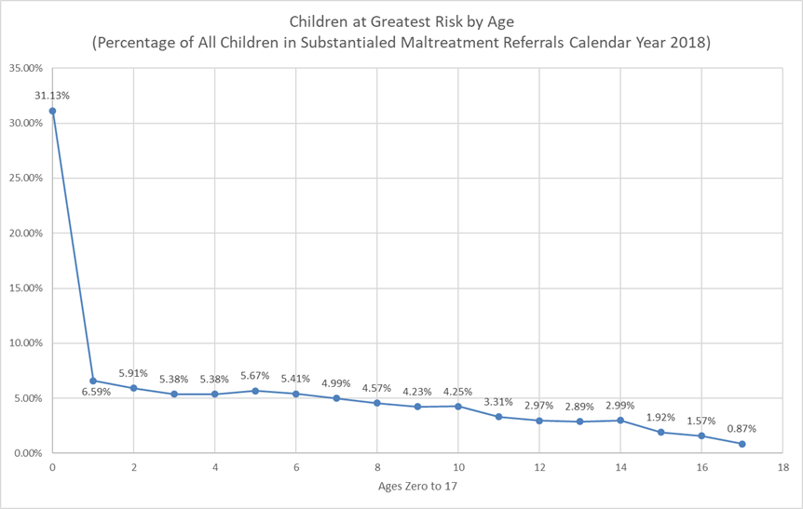
Source: Cognos CPS-5232 Maltreatment by Age Calendar Year 2018

Update 2023:
Children zero to one year of age continue to be the population at greatest risk of maltreatment in West Virginia. West Virginia continues to serve this population with Birth to Three and In-home visitation programs.
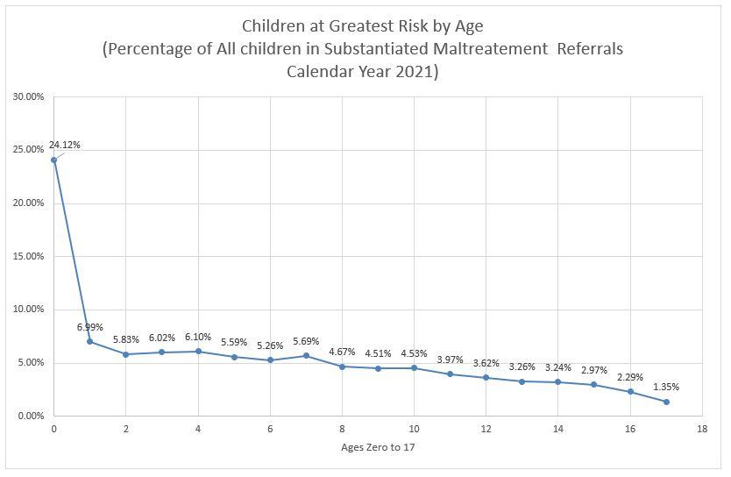
Source: Cognos CPS-5232 Maltreatment by Age Calendar Year 2021

In addition to Birth to Three and In-home visitation programs, the state has implemented Family Treatment Courts in eleven (11) courts which serve 14 counties, with plans to implement in its largest county, Kanawha County, by the summer of 2022. West Virginia has also initiated Sobriety Treatment and Recovery Teams (START) in five counties. West Virginia is implementing the START model in Fayette, Kanawha, Mercer, Putnam, and Raleigh Counties. Services to families began in 2021. West Virginia’s Family First Prevention Plan enables a different funding stream for prevention services to be obtained in safety cases when the child still remains in their home and with their biological parents. Parents as Teachers and Healthy Families America are services that target West Virginia’s population at greatest risk for removal.

Family Treatment Court Data as of 1/31/2022
• 335 Individuals assessed since September 2019
• 210 Individuals accepted into FTC statewide since September 2019
• 62 Individuals have graduated FTC
• 333 children have been involved with FTC
• 95 children have been reunified with their parents
• 80 children have achieved permanency

Update 2024:
Children zero to one year of age continue to be the population at greatest risk of maltreatment in West Virginia. West Virginia continues to serve this population with Birth to Three and In-home visitation programs.

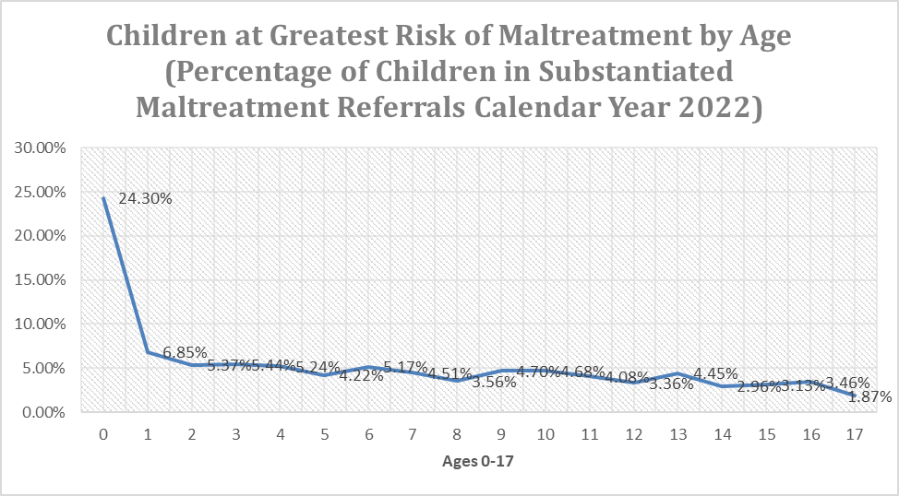
Source: Cognos CPS-5232 Maltreatment by Age Calendar Year 2022

In addition to Birth to Three and In-home visitation programs, the state has implemented Family Treatment Courts in eleven (11) courts which serve 14 counties. Two more counties will be added in Spring 2023.

Family Treatment Court Data as of 1/31/2023
• 546 Individuals assessed since September 2019
• 349 Individuals accepted into FTC statewide since September 2019
• 130 Individuals have graduated FTC
• 542 children have been involved with FTC
• 228 children have been reunified with their parents
• 197 children have achieved permanency

Emergency Funding for the MaryLee Allen Promoting Safe and Stable Families (PSSF) Funding
The Bureau for Children and Families has identified a gap in service provision for parents with Intellectual or Developmental Disorders. The state seeks to implement a Step-by-Step Parenting Program to incorporate into its Socially Necessary Services milieu. The main goals of the Step-by-Step Parenting Program are to reduce the risk for child neglect due to parenting skills deficits and to promote family preservation. It is one of the few evidence-based programs in the world that focuses on teaching skills to parents with learning differences, including parents who have intellectual disabilities, fetal alcohol spectrum disorder, autism spectrum disorder, acquired brain injury, slow learners, learning disabilities, and low reading skills.

BCF seeks to implement the new service in four selected pilot counties. These counties include Wood, Cabell, Harrison, and Mercer. Agencies already approved to provide Socially Necessary Services in those counties can apply to be selected as a pilot agency. Selection of agencies will be completed by a Request for Funding Announcement Application process. Applicants will need to be able to execute a plan to ensure staff are trained on the program. The agency will need to detail their plan of fidelity and outcome measurements as part of the application. Agencies that are selected will in return accept referrals from Department staff located in those specific pilot counties.

The state anticipates utilizing PSSF supplemental funding to support start-up costs and reimbursement of services costs for this new program model.

Update 2023:
In 2021, BSS met with the proprietor of the Step-By-Step Parenting Program to gather more information about the process for service providers to become trained in model. After discussing the costs of the training and associated expenses BSS decided to open the pilot program up to all Socially Necessary Service Providers.

In 2022, BSS will work with Aetna and KEPRO to create and execute a plan of action for the application process, funds distribution and monitoring of this initiative.

Update 2024:
In 2022, BSS had 20 Socially Necessary Service providers agree to become trained under the Step-By-Step Parenting Program model. All of those training sessions have been completed. Information about the new service was provided to field staff and management. At the end of 2022, no service authorizations were requested for this service.

In 2023, BSS will communicate with field management and stakeholders to inform them of the new service.

Monthly Caseworker Visit Formula Grants and Standards for Caseworker Visits
All staff have access to a face-to-face dashboard to track their monthly visits with each child in care on their workload. Similarly, supervisors and managers have access to the dashboard to track progress for all staff for whom they have responsibility. This tool is of great assistance in measuring compliance but does not ensure quality. Case review is the only true measure of quality and is being implemented as an action for the state’s Program Improvement Plan to improve meaningful contact.
Face-to-face visits with children and their families is also an objective in the state's Program Improvement Plan as well as outlined goals for the next five years. This data measurement will be tracked on a monthly basis by county and will be addressed in training and technical assistance to be provided to countries who have been identified as needing improvement in this area.
Monthly Caseworker grant money will be used to support Training and Technical Assistance Teams in providing specific, targeted training to individual districts on safety planning, treatment planning and meaningful contacts with children and families receiving child welfare services. This in-depth assistance is aimed at improving West Virginia’s outcomes in Safety, Permanency and Well-being.
Update 2023:
The funding was used for costs associated with caseworker travel to complete face-to-face contacts with children and families. With COVID-19 restrictions ended, BSS will be executing the Training and Technical Assistance Teams, with the first round of training and technical assistance to begin late May 2022, regarding proper completion of on-going assessments and case planning with families.

Update 2024:
The funding was again used for costs associated with caseworker travel to complete face to face contacts with children, youth, and families. The Training and Technical Assistance Teams did deploy officially in late 2022 and will continue to be ongoing as districts are reviewed by our DPQI Division and findings and corrective actions plans (CAPS) are put in place.

Additional Service Information

Child Welfare Waiver Demonstration Activities
West Virginia Department of Health and Human Resources implemented its Title IV-E Waiver program, Safe at Home, to address the growing number of children entering its foster care system, with a substantial portion of those children and youth being placed in congregate care. Safe at Home employs a wraparound service model for youth ages 12 to 17 with a mental health diagnosis or at risk of entering congregate care with a possible mental health diagnosis.

While some challenges were encountered during the first phase of implementation, changes were quickly implemented to remedy those issues. Those changes allowed for easier implementation of Safe at Home during the final two phases. In April 2017, Safe at Home began operating on a statewide basis.

The focus of the program has shifted over time, focusing less on youth who are placed in congregate care (including those placed into out-of-state facilities) and more on those who remain in their homes. This shift is largely the result of reduced numbers of youth being placed into congregate care, both in and out of state.

When safety, permanency and well-being outcomes for treatment youth are compared to a matched comparison group, Safe at Home youth tend to have a higher degree of success within six months of the start of service delivery or referral to the program, but the success appears to dissipate by 12 months.

The stepwise regression analyses highlighted which populations of youth the program did and did not work well. Youth with an Axis 1 diagnosis are at higher risk of not achieving favorable outcomes than youth without a diagnosis. Conversely, Safe at Home appears to be working well for youth with juvenile justice involvement and those who receive formal services. Additionally, treatment youth referred while placed in congregate care show more favorable outcomes than comparison group youth referred while in such a setting.

The overall costs for Safe at Home youth are greater than youth in the comparison group. However, Safe at Home youth are receiving services that are beyond those which can normally be provided. The provision of additional services yielded positive results, especially in relation to the youths’ well-being and overall functioning.

Programmatic/Implementation Lessons Learned and Recommendations

As noted in the discussion above, West Virginia encountered a few challenges at the start of implementation. One of those challenges involved the training which Department and Licensed Coordinating Agency (LCA) staff were provided. Once identified, the State responded quickly, putting together a work group and a 90-day work plan, expanding policy, updating the program manual, and retraining staff. In fact, West Virginia incorporated Safe at Home’s Wraparound 101 and CANS training into its new worker training, ensuring that all Department staff are trained on the program. In addition, LCAs have expanded their own training materials to address the needs of wraparound facilitators.

While communication with key stakeholders was an important element of implementing Safe at Home, central office staff recognized, after the implementation of Phase I, that their initial outreach efforts, especially to judges, were inefficient. A combined communication plan was created for Community Services Managers (CSM) and LCA program directors to use with the judges in their areas. Materials were sent out by CSMs two and a half months prior to roll out in later implementation phases which were helpful. Meeting with judges became a regular part of CSMs’ work and the addition of LCA program directors to attend some of these meetings offered the opportunity to provide judges with more detail about Safe at Home.

Access to services, especially in the early phases of implementation, was a challenge. One barrier, as reported by caseworkers and facilitators, was the lack of consistency by the youth/families and follow through to participate in services. While several services were not readily available, especially in more rural areas of the state, LCAs took creative steps to address the lack of services. For example, transportation to services is limited in several areas of the state. LCAs hired individuals to transport youth and their families, thus addressing that shortage.

Evaluation Lessons Learned and Recommendations

Two primary issues have been encountered over the term of the evaluation, with steps taken to remedy them as they were identified. The first involves obtaining a sufficient level of response to the online surveys administered to Department staff. An email message was sent to CSMs, asking each to complete the annual survey and send the link to the Safe at Home-involved staff to also complete the survey. This process was used in lieu of asking CSMs to provide a list of email addresses for all Safe at Home caseworkers to the evaluator. Because the request to complete the survey was sent to the group of CSMs via a listserv, the Department’s mail system identified the message as spam. Many CSMs did not receive the request. The process was changed to send individual email messages to CSMs which yielded a higher rate of response.

The second issue involves understanding the full range of data contained within the Department’s case management system, FACTS, and how the data tables are applied. Over time, additional data has been requested to be included within the data extracts received. This has provided a more robust ability to identify the populations or characteristics of youth for whom Safe at Home has been successful.

The work and efforts of the Demonstration project align with the larger initiative of the Department of the WV Child Welfare Reform. As we move toward the completion of the demonstration project, WV continues to work on sustaining Safe at Home WV by incorporating the successful efforts of the project into current initiatives and work throughout our child welfare system.

While initially focused on reducing and preventing congregate care placement of youth with a behavioral health issue, the program was quickly expanded to focus on preventing any foster care placement for youth with known or possible behavioral health issues. The waiver project was successful at preventing the re-entry of youth into congregate care, reducing the length of stay when placed in congregate care, returning youth to their communities, placing youth with relatives, increasing their rate of reunification, reducing repeat maltreatment, and improving youth’s educational and family functioning. The demonstration project, however, was not as successful, when results are compared to an historical group of comparison youth, in preventing removal.

From a fiscal perspective, the wraparound model was successful in reducing the costs of out-of-home placement expenditures and payments for fee-for-service items. However, when the monies paid to local coordinating agencies to provide assessments, case management, supervision and services are factored in, the costs for treatment youth are more than those for comparison youth; the difference does not take into account the reduction in time caseworkers spend on waiver youth with wraparound facilitators providing intensive services to youth and their families. Based on the overall success of the program, West Virginia intends to expand its wraparound program to serve children and families under the age of twelve (12).

Family First Prevention Services Act FFPSA

As part of our ongoing sustainability efforts WV continues to work with the upcoming changes through FFPSA to incorporate appropriate utilization of wraparound moving forward.
WV will also continue efforts Foster Care Candidacy Claiming to assist potentially in financial support for sustainability of wraparound.

Seriously Emotionally Disorder Waiver Application

The Bureau of Medical Services, one of our sister bureaus within the Department, has been working on a SED 1915C Waiver for wraparound of children with severe emotional disorders. The application is currently under public comment period. WV believes that approval of this waiver will provide continued coverage of services to the portion SAH WV wraparound children that meet the criteria.

Behavioral Health Wrap Around Pilot Expansion

The Bureau of Behavioral Health previously ran a pilot for children in parental custody that met the criteria for wraparound. After the successful pilot they have been granted additional funding to expand the service statewide. WV believes this too, will serve a portion of children in parental custody that need wraparound.

Wraparound Continuum of Care Post Waiver

The entire Department and the involved agencies have begun working together to align all WV Wraparound into a single continuum of wraparound service for the children and families of WV. As the work continues, more updates will be provided.

Licensed Coordinating Agencies

LCA meetings have been increased during the reporting period to provide the opportunity for better communication in monthly conference calls and face-to-face LCA meetings. In the next review period LCA face to face meetings and sub workgroup meetings continue to work collaboratively on enhancements to improve practice during the move to post waiver SAH work.

Marshall University

Collaborative work began with Marshall University to continue the expansion of the Child and Adolescent Needs and Strengths (CANS) Automated System to gather data and continue work post waiver. Marshall will begin oversight of the CANS Training and hopes to become a center of excellence to carry on the valuable work and utilization during our Demonstration Project.

Update 2023:
See section Safe at Home for more information.

Update 2024:
See section Safe at Home for more information.

Adoption and Legal Guardianship Incentive Payments
The Bureau of Children and Families will use adoption and legal guardianship incentive payments during the next five years to improve post adoption and legal guardianship services offered to West Virginia’s children and families. Incentive funds will be used to decrease the amount of time it takes for foster children to achieve permanency through adoption or legal guardianship and for post adoption services and post legal guardianship services.
Thirty percent of incentive funds will be used by the Bureau of Children and Families toward post adoption and post legal guardianship services. The Bureau of Children and Families will release a Request for Application (RFA) for applicants to implement plans to provide prevention, post adoption, and post legal guardianship services to West Virginia’s children and families. These funds will be used to strengthen Socially Necessary Services offered through Title IV-B funding and prevention services offered through Title IV-E funding. The Bureau of Children and Families will use incentive payments to provide the necessary services to keep adoptive and legal guardianship families together that are at risk of disruption.
Incentive payments will be used by the Bureau of Children and Families to provide services to help decrease disruption before permanency and to decrease the amount of time before permanency is achieved through adoption or legal guardianship. Kinship providers as well as foster care providers will receive services that will help them manage tasks of transporting children to medical and mental health appointments, school activities, and extracurricular activities. Incentive payments will be used to strengthen services in order to meet the needs of West Virginia’s children and families, so that disruptions will decrease and time to permanency will increase.

Update 2023:
BSS has implemented payment to Child Placing Agencies (CPA) of $1,000 incentives for each completed adoption. Based upon the payment history from December 1, 2020, through March 31, 2022, 730 incentives have been issued to the CPAs. An analysis of the number of Private Agency Foster Care Homes opened during the period will provide the data on the success of these incentives. Analysis would need to carefully exclude foster families who transfer from one CPA to another.

Update 2024:
BSS continues to make a payment to Child Placing Agencies (CPA) of $1,000 incentives for each completed adoption. Based upon the payment history from April 1, 2022, through December 31, 2022, 512 incentives have been issued to the CPAs. An analysis of the number of Private Agency Foster Care Homes opened during the period will provide the data on the success of these incentives. Analysis would need to carefully exclude foster families who transfer from one CPA to another. Due to issues in PATH no incentive payments have been made in 2023. The issue was reported to OPTUM in February but to date there has been no resolution.

Adoption Savings
The calculated savings must be spent on title IV-B and IV-E programs; 30 percent of which must be spent on post-adoption services, post-guardianship services and services to support positive permanent outcomes for children at risk of entering foster care. Two-thirds of the 30 percent must be spent on post-adoption and post-guardianship services. (In other words, title IV-E agencies must spend at least 20 percent of calculated savings on post-adoption and post-guardianship services. If at least 20 percent, but less than 30

Please see attached FORM CB-496: TITLE IV-E PROGRAMS QUARTERLY FINANCIAL REPORT
PART 4: ANNUAL ADOPTION SAVINGS CALCULATION AND ACCOUNTING
REPORT

Update 2023:

While the Mobile Crisis line is not funded by adoption savings, when the Assessment Pathway is utilized by post-adoptive families, the resulting Safe at Home referral and services are funded through adoption savings. Through analysis of state fiscal year 2022 (July 2021 through June 2022) of all Safe at Home referrals, the data was pulled manually to indicate the following post-adoptive services. During SFY 2022, 1,191 children that were receiving Safe at Home services, 122 or 10% were adoptive clients. It is estimated that the cost of serving these clients is $1.6 million during this time.

A challenge for pulling data is the current FACTS system requires a new case be opened to document an adopted child receiving Safe at Home. Each case must be reviewed individually to determine if the child receiving services, was a previously adopted child. WV is working with PCG and the CANS system to require entry of type of case (adoption, foster care, family preservation, etc.) to be able to report the data. WV will track funds spent for post-adoptive families and report this spending as re-investing those adoptions savings. ASO, Assessment Pathway, and Safe at Home wrap-around are the primary services to adoptive families.

Often children have been parentally placed prior to receiving post-adoption services. WV began providing adoptive families with information about the services available from the department post-adoption to address issues before placement in treatment facilities becomes necessary. WV will explore utilizing a community-based agency to promote post-adoption services and direct families to the department for SNS services, Assessment Pathway, and Safe at Home wrap-around services.

Update:
During SFY 2023, 921 children that were receiving Safe at Home services, 82 or 9% were adoptive clients. It is estimated that the cost of serving these clients cost nearly $1 million during this time period.

WV continues to provide post-adoptive services as stated in last year’s update.

Adoption Savings Methodology
No Update

Adoption Savings Expenditures
The Bureau for Children and Families will pursue the release of a Request for Applications designed at providing post-adoptive services statewide to adoptive families. The services will include;

- training and education for adoptive parents regarding the special needs of adopted children, including adjustment and attachment issues.
- Providing or referring families to counseling services for both families and individuals.
- Providing educational advocacy and support.
- Respite care.
- Facilitating support groups or referrals to support groups for parents and children.
- Family crisis response team – including crisis respite.
- Case management services, including introduction to the family prior to finalization.
- Financial services, including transportation, lodging, and meals.
- Completing assessments to determine which services would benefit the family.

Update 2023:
West Virginia has promoted the use of three components of the Children’s Mental Health Wraparound for post-adoptive families that can meet all levels of need. First is the Children with Serious Emotional Disorder Waiver (CSED), which provides an array of home and community-based services for eligible children with serious emotional disorders. Second is the statewide Children’s Crisis and Referral line, which provides a centralized resource for children and families in crisis to receive immediate support while also providing a connection to statewide Children’s Mobile Crisis Response and other services to meet their needs. Third is the Pathway to Children’s Mental Health Services (Assessment Pathway) to streamline access to mental and behavioral health services for children and families while quickly connecting post-adoptive parents with a Wraparound Facilitator to help children and families navigate the process. Additionally, Aetna case managers who contact post-adoptive families currently upgrade or intensify case management contacts when families need more intensive services. These Aetna case managers also assist families with obtaining covered services in their communities.

Update 2024:
The RFP for post-adoptive services mentioned in previous updates was not released and other opportunities for utilizing the adoption savings money was explored.

West Virginia is still utilizing Children’s Mental Health Wraparound as a post-adoption service for families. The Post Permanency Support Unit recently started tracking data on inquiries they receive from post-adoptive families. Data will be provided on this in future reports.

West Virginia has spent the allotted 30% of the adoption savings on post adoption services through Safe at Home over the last several years. The Safe at Home program also keeps at risk children from entering foster care. West Virginia estimates that nearly $1 million state dollars is spent on Safe at Home services monthly. BSS Programs and BSS Finance are currently working together to get an accurate number of how much unused adoption savings money is left over after the end of calendar year 2023.

Family First Act Transition Grants

Update 2022:
The state has yet to submit its cost allocation plan to begin implementing Family First Prevention Services Act Plan services. West Virginia received feedback on its initial submission in February 2021 but has yet to submit the revised plan. As the state awaits the cost allocation plan to be revised, submitted, and approved, it will move forward with supporting the implementation of services through the use of transition grants. Funding will be used to expand the availability of Parents as Teachers across the state and provide ongoing cost support to expanding the use of Functional Family Therapy (FFT).

Update 2023:
The Department received approval of its Family First Five-Year Prevention Plan on September 14, 2020, from the U.S. Department of Health and Human Services, Administration for Children and Families, ACF Children’s Bureau. The approval was for three evidence-based prevention services that are ready for implementation: Functional Family Therapy, Healthy Families America, and Parents as Teachers. BSS continues preparations for implementation of its title IV-E prevention services. The Department is planning to submit a CAP Amendment to account for administrative claims for staff connecting families with Prevention services. The federal government must approve the cost allocation plans for the Department of Finance to receive federal funding. The Department can bill retroactively once the cost allocation plans are approved.

Continued response to the COVID pandemic has caused delays for the federal government. Department Finance has established the necessary budget codes for the services listed in the Family First Prevention Plan for auditing and federal claiming.

In anticipation of the cost allocation being finalized, BSS worked with providers of Functional Family Therapy, Parents as Teachers, and Healthy Families America on billing related items for these services. Providers of these services are required to enroll as a Socially Necessary Service Provider as mentioned in the Family First Prevention Plan. Currently there are two providers for Parents as Teachers enrolled to provide these services to 16 counties in West Virginia. Healthy Families America will be provided to 5 counties in West Virginia by one service provider. Functional Family Therapy is currently provided by one provider that covers 15 counties.
In preparation of the Family First services rolling out under SNS, BSS currently utilizes Transformational Collaborative Outcomes Management (TCOM) in child welfare. TCOM is a framework that includes the philosophy, strategies, and tools to address the needs of children and families, including those served by youth placed in out-of-state facilities or returning from existing out-of-state placements. TCOM includes a structured assessment that directly informs service/intervention planning which includes the Family Advocacy and Support Tool (FAST), the Child and Adolescent Needs and Strengths (CANS) and the Adult Needs and Strengths Assessment (ANSA). The TCOM tools provide effective decision-making at every level of the system because it involves a shared understanding of the current needs and strengths of children, youth, and caregivers. This will assist BSS staff in developing accurate case plans which are a requirement under the Family First Prevention Services.
Under this grant, BSS continues to contract with Marshall University’s Center of Excellence for Recovery to continue development of the TCOM model, which includes use of the TCOM tools. Marshall University’s Center of Excellence for Recovery is responsible for the management of the TCOM model and tools in West Virginia.

For 2022, BSS plans to add PAT, FFT, and HFA to the Utilization Management Guideline for Socially Necessary Services. Provider expansion in FFT will be researched and developed in the future. Education on service delivery to field staff, judicial partners and community stakeholders will continue through 2022. The partnership between BSS and Marshall University will continue with the goal of supporting the TCOM model and fidelity monitoring.
Update 2024:
During SFY 2022 it was determined that the above-mentioned CAP amendment was not needed as the Department was capturing the administrative costs appropriately. DHHR and BSS finance are currently working with the federal cost allocation authority to make sure nothing additional is needed at this time.

Functional Family Therapy, Parents as Teachers, and Healthy Families America have been added to the Utilization Management Guidelines for Socially Necessary Services.

Providers of each service and West Virginia counties where these services are offered are:

Functional Family Therapy (FFT)
The National Youth Advocate Program is the agency providing FFT in West Virginia. They offer FFT in the following counties: Berkeley, Jefferson, Morgan, Marion, Monongalia, Harrison, Taylor, Preston, Ohio, Brooke, Hancock, Marshall, Putnam, Wood, and Cabell Counties. They can deliver FFT on a case-by-case basis to other districts as well. In 2022 FFT was provided to 69 families.

Healthy Families Mountain State (HFA)
This service is offered by Team for West Virginia Children, Inc. in Cabell, Lincoln (shared with Cornerstone), Logan, Mason, Putnam, Wayne Counties.

Parents as Teachers (PAT)
- Brooke Hancock Family Resource Network, Inc offers PAT in Brooke, Hancock, Marshall Counties.

- Burlington United Methodist Family Services covers Berkeley, Grant, Hampshire, Hardy, Jefferson, Mineral, Morgan, and Pendleton Counties.

- Children's Home Society provides PAT in Calhoun, Gilmer, Ritchie, Roane, Wirt, and Wood Counties.

- Cornerstone Family Interventions covers Boone and Lincoln (shared with Team for WV Children).

- Lewis County Family Resource Network covers Harrison, Lewis, Marion, and Upshur Counties.

- Northern Panhandle Head Start, Inc. provides PAT in Ohio County.

- Tucker County Family Resource Network, Inc. Allegheny Highlands PAT covers Tucker, Randolph, and Barbour Counties.
Consultation and Coordination Between State and Tribes
There are currently no federally recognized tribes in the state of West Virginia. Current Foster Care Policy states that if a child is recognized as a member of a tribe, the child’s social worker is to contact the U. S. Department of Interiors Bureau for Indian Affairs to determine if the tribe has child welfare jurisdiction.

West Virginia is currently working to strengthen its child welfare policies regarding ICWA. Child welfare staff will be expected to determine tribal affiliation much earlier in the case to provide a more seamless process for the family. If the tribe does not have jurisdiction over the child or family, our staff will ensure that they are contacting the tribe continuously throughout the life of the case to ensure that all the child and family’s rights are being respected regarding their tribal affiliation.

Foster Care Policy states that children of families that have American Indian ancestry are to be referred to the tribe in which ancestry is claimed for child welfare services.

The state continues to work with the ACF Children’s Bureau to find a resource for this review.

Update 2023:
A bill titled “West Virginia Native American Tribes Unique Recognition, Authentication and Listing Act” was introduced again during the West Virginia 2022 Legislative session but was not enacted.

Presentations to supervisors regarding the Indian Child Welfare Act (ICWA) were completed in July and September 2021. The presentations generated questions from child welfare staff on specific cases and technical assistance was provided by policy specialists. Draft policy specific to the ICWA is currently under review and is being prepared for release.

Update 2024:
The Indian Child Welfare Act Policy was released to the field on January 3, 2023. The policy outlines when child welfare staff can engage families earlier in the child welfare process to find out if the family has tribal affiliation. It further guides child welfare staff in the processes needed to ensure tribes are involved in the process with the family and that active efforts are made to prevent removal and to help reunify families.

Update on John H. Chafee Foster Care Program for Successful Transition to Adulthood

Agency Administering Chafee
The West Virginia Department of Health and Human Resources is responsible for assisting youth transitioning to adulthood into safe, healthy, self-sufficient adults. In meeting this responsibility West Virginia contracts with other agencies to provide transitioning services.
Currently, West Virginia provides some direct services to youth fourteen and up through our casework process and relies heavily on contracts with a few community agencies to provide monitoring, oversight, and some direct services for youth transitioning.
The Department has established and sustained a relationship over the past 30 years with West Virginia University (WVU) and the Center for Excellence in Disabilities (WVU CED). The Mentoring and Oversight for Developing Independence for Foster Youth (MODIFY) Program within the WVU CED has collaborated closely with the Department to provide: 1) services to youth who are 17.5 years and aging out of the foster care system and those who are adopted or placed in legal guardianship after the age of 16 years; 2) technical assistance to the Department on subject matter pertaining to youth transition; and 3) support and oversight for youth councils throughout West Virginia (WV).
This relationship will continue over the next five years with the MODIFY program taking on more of a consultant role with youth transitioning and transitional living agencies. Due to their lengthy involvement with older youth in foster care, their expertise will be invaluable in developing our continuum of care for youth transitioning.

Description of Program Design and Delivery
The purpose of the Chafee Foster Care Independence Act was to provide states with flexible funding to develop and design services and activities to meet the needs of youth transitioning from foster care. The Act provides guidance for seven specific purposes listed below:

- Help youth transition to self-sufficiency.
- Help youth receive the education, training, and services necessary to obtain employment.
- Help youth prepare for and enter post-secondary training and educational institutions.
- Provide personal and emotional support to youth aging out of foster care through mentors and the promotion of interactions with dedicated adults.
- Provide financial, housing, counseling, employment, education, and other appropriate support and services to former foster care recipients between 18 and 23 years of age to complement their own efforts to achieve self-sufficiency and to assure that program participants recognize and accept their personal responsibility for preparing for and then making the transition to adulthood.
- Make available vouchers for education and training, including post-secondary education, to youth who have aged out of foster care.
- Provide services to youth who, after attaining 16 years of age, have left foster care for kinship guardianship or adoption.

The Bureau for Children and Families (BCF) has incorporated Positive Youth Development (PYD) practices into its policy and procedures, and through the MODIFY program that serves Chafee eligible transitioning youth. The Prudent Parent Standard has been defined and informs workers and children and youth in foster care on parental decisions that should encourage emotional and developmental growth. In Foster Care Policy, the completion of a Life Skills Assessment has been mandated which begins for youth aged 14 and assesses and educates youth on a variety of necessary life skills. Youth Services (YS) requires youth participation within the Multidisciplinary Treatment Team (MDT) process both as an invitee and a participant. Through this, the youth involved with YS and the MDT have an opportunity to lead and discuss what they would like to see happen with their case plan.

Additionally, the WV MODIFY program has incorporated PYD into their process. MODIFY promotes youth skills in self-directed decisions regarding educational goals, living arrangements and establishing independent decision making in activities of daily living. Youth are presented with options for education and are encouraged to determine what kind of degree or certification they are interested in obtaining based on their interest, beliefs and what they want to pursue for employment. Living arrangements are individualized and based on the youth’s preference, strengths, and limitations. Budget and money management, establishing dorm or apartment living management, productivity management, social interaction and self-care skills are an intricate part of the MODIFY program in reinforcing the youth establishing independence. As needed and requested for the youth, MODIFY serves as a coordinator of services and support to strengthen a successful outcome. MODIFY age eligibility has been expanded to better meet the needs of the youth while increasing the opportunity to succeed. MODIFY focuses on the ideology that the youth are now adults and can make their own decisions. Additionally, MODIFY has begun establishing two youth-led councils, one for the northern portion of the state, and one for the southern. These councils will be composed of, and lead by current and former foster youth and will provide recommendations for service improvement to the MODIFY program and the Department.

NYTD data collected through the CCWIS system, as well as NYTD data collected through age 17, 19, and 21-year-old surveys are and will continue to be distributed to various entities, agencies, and workgroups. The Court Improvement Program (CIP) conducts permanency reviews and NYTD data is provided to them on a regular or as needed basis and is the avenue in which NYTD data is provided to West Virginia’s court systems. NYTD data is also provided to workgroups such as the Service Development and Delivery Workgroup (SDDW), and the Transitional Living Workgroup (TLW), and to other state oversight entities such as the Bureau for Health Facilities (BHF). The SDDW, TLW, and other workgroups contain members of the Department, service providers, IL coordinators, and members of the public and use NYTD data to identify gaps in services, needs, and trends.

● Life Skills Assessment Process:
At age 14 or older (if a youth enters care at an older age), each child in foster care completes their Casey life skills assessment. The assessment is completed within 30 days following the youth’s 14th birthday or entrance into care if the youth is already age 14. The assessment helps determine the child’s level of functioning in several areas including but not limited to personal hygiene, food management, housekeeping, employability, education planning, and so forth. The results of the assessment provide critical information regarding strengths and weaknesses in various life skills areas. In order to ensure that foster care youth are gaining necessary skills to prepare them for independence, the life skills curriculum provides foster care youth in all out-of-home placements in West Virginia the opportunity to learn these valuable skills. The learning objectives of the life skills curriculum are taught to the foster child by the foster parents, by staff in group residential settings/specialized foster care, or by the child’s Department caseworker. The life skills assessment is completed on youth in care annually.

The Department has continued to implement the new life skills assessment and curriculum process. West Virginia continues utilizing the Casey Life Skills Assessment and Curriculum. When the Casey Assessment process and website changed, provider agencies and staff were provided with information on the new process and how to access the site and assessment. The utilization of the Casey Assessment and Curriculum process is being used statewide.

● Transition Plan and Services:
At the age of 14 or older (if a youth enters care at an older age), each child in foster care develops their individualized transition plan, which will help the youth move towards independence and self-sufficiency. The transition plan is to be developed within 60 days following the youth’s 14th birthday or entrance into care if the youth is already age 14. The transition plan is reviewed every 90 days and revised as necessary. Some areas that are addressed in the transition plan are housing options, insurance options, community supports, educational plans and supports, employment plans and supports, workforce supports, mentoring services, healthy relationships, family planning, supportive counseling, life skill curriculum, and benefits available (SSI, SS, ETV, Food Stamps, etc.). The Department recently updated the transition plan with the input of the older youth transitioning task team. The new format has been shared with partners at the Court Improvement Program and at various supervisor meetings across the state.
● Transitional Living Placement with Subsidy:
Currently, when a youth reaches the age of 17 or older, he or she has an option to move into a community setting in his or her own apartment if they meet the eligibility criteria. The purpose of this placement type is to allow the youth an opportunity to use the life skills acquired while in foster care and continue to receive support from the state. In this setting, the youth is pursuing an educational/vocational goal, learning job skills, or is employed or seeking employment. West Virginia plans to expand this opportunity to all youth transitioning to adulthood to include different living situations and support from a transitional living provider regardless of placement setting.
● Employment Programs:
The employability project will continue to help youth obtain employment. The employability services are available to youth currently in foster care and to the 18-20-year-old population who have aged out of foster care and are provided statewide. The services and activities provided are designed to not just place youth into employment but also provide them with the skills, guidance, and ongoing support necessary to sustain employment and succeed in the workplace. Services are provided at the youth’s place of residence, agency site, within the community, or at Sponsored Employment sites.

Youth participating in this project are provided the opportunity to:
- Develop Job Seeking Skills;
- Develop an employment history;
- Receive cash for attendance;
- Receive assistance with job placement, on the job training, and job shadowing; and
- Gain/Maintain employment.

In the next five years, the state expects to expand these services by increasing the number of Transitional Living providers as well as the services and supports they provide to youth transitioning.
Some unique and promising programs offered to youth transitioning in West Virginia by various agencies, coordinated with MODIFY, include the following:

● Helping our Undergraduates Succeed in Education (H.O.U.S.E.) Project:
Some transitioning youth who are first-time freshmen at West Virginia State University (WVSU) live in the H.O.U.S.E. project. This initiative provides a small, staff supervised house on the WVSU campus for students who may need a gradual introduction to college life and support services.
● Foster Care Tuition Waiver:
House Bill 4787 was passed in 2000 and provides for youth in foster care and former foster care youth to receive tuition waivers for the purpose of attending one of the public colleges/universities in West Virginia.
● Computers for Graduates Program:
Access to technology is a necessity and no longer a luxury in today’s post-secondary education environment. Each year, the Department makes funds available for the purchase of a computer to youth who graduate from high school or complete the High School Equivalency exam while in foster care.
● Mentoring:
The Department has developed close working relationships with transitional living providers to address the issues that youth face when transitioning out of foster care. The Department has also encouraged the use of the FosterClub Permanency Pact in several regions in the state.
Youth councils will also continue to be a priority in the next five years as leadership skills continue to be important to this increasing cohort of youth who are transitioning to vocational and/or educational phases in their lives. West Virginia helped to establish a youth group, West Virginia Foster Youth Advocacy Movement (WV FAM). There are currently several members of this group in the state, but they’ve lost their infrastructure and organization. Several planning sessions with youth have occurred to get youth councils up and running again in the state. The state plans to continue to support the reorganization and functioning of WV FAM.
● Conferences:
In the past, several conferences were held which provided opportunities for youth in foster care to interact with positive adult role models. Youth were given the opportunity to interact with adult role models during statewide conferences. The state has hosted transitioning youth conferences. The conference provided opportunities to interact socially with foster parents (their own and others), staff (their own and others), and adult volunteers.

During development of the Transitional Living continuum, the state will add regional conferences for transitioning youth to be part of the program. These conferences will provide life skills training, networking for WV FAM, the opportunity to interact with positive role models, development of positive peer to peer relationships and the opportunity for youth to offer input on the state's program and design.

Update 2023:
Better utilization of Chafee socially necessary services has been seen in the past several years and continues through the current year. This trend provides support from ASO Agencies directly to youth. Overall, delivery of Chafee-funded services through the ASO Agencies remains a strong avenue to fund Transitional Living Agencies to support youth in the community to achieve independence. This funding stream will be an important driver to the sustainability of the pilot community-based independent living programs.

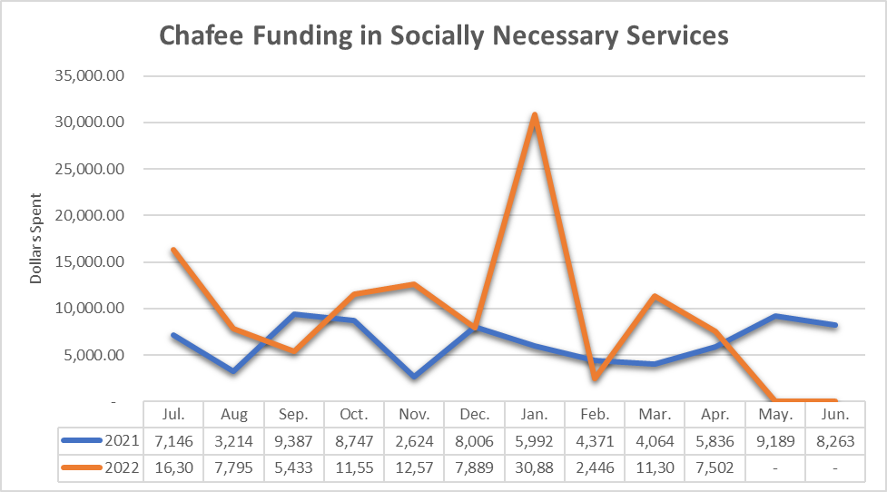
The iFoster-Aetna Connections for Life program provides West Virginia youth in foster care with technology. In addition, it provides these transition-age youth (TAY), their caregivers and agencies with access to needed resources and information through the on-line iFoster resource portal. TAY ages 13-17 received tablets and those ages 18-20 received laptops. All TAY ages 16-20 were eligible to enroll in the iFoster resource portal, as were their caregivers and affiliated child welfare agencies.

The program launched in April of 2020 and from then until March 2022, 445 TAY have received devices through the Connections of Life Program. In the period April 2021 to March 2022, 94 youth received tablets and 64 youth received laptops for a total of 158 youth receiving a device through the Connections for Life program.

Update 2024:

Source: COGNOS ASO Payments
Please note the chart above is reflective of the State Fiscal Year which runs from July 1st to June 30th of the next year.

The iFoster-Aetna Connections for Life Program continues to provide West Virginia youth in foster care with technology. In addition, it provides these transition-age youth (TAY), their caregivers and agencies access to needed resources and information through the online iFoster resource portal. In the period April 2022 to March 2023, 192 youth received tablets and 72 youth received laptops through the Connections for Life program.

Serving Youth Across the State
West Virginia provides Chafee funded services through its general casework practice as well as targeted transitioning services to its older youth in all areas of the state. Although the state does provide services through its general casework practice and its MODIFY program, there is a very limited number of transitional providers that provide the more intensive transitional services.

West Virginia has developed a plan to increase the number of transitional providers across the state to promote a more flexible diverse continuum of care to youth in all communities. We would like every youth transitioning from foster care to have the opportunity to receive quality services to help them become safe, healthy, self-sufficient adults.

Mentoring and Oversight for Developing Independence for Foster Youth (MODIFY) with CED Program:
A referral to the MODIFY Program becomes appropriate when a youth is 17.5 years or six months prior to graduating or obtaining a high school equivalency. Once eligibility is confirmed and the youth is enrolled for services, the MODIFY Project specialists assist youth within two large domains: independent living services and/or postsecondary education attainment. As noted earlier, the MODIFY Program is maintained through a cooperative agreement with the Department. The relationship between the MODIFY Program and the Department has been sustained and strengthened over the past thirty years. The program is one of eight programs and 11 initiatives within the WVU CED (www.wvuced.org) designed to provide at least one of the following services to youth, families, and/or providers where applicable: training, direct services and technical assistance, information dissemination, and research/evaluation. The WVU CED is one of 62 centers within a national network of university-based centers of excellence coordinated by the Association of University Centers for Excellence in Developmental Disabilities (AUCD; www.aucd.org).

Within the areas of independent living and postsecondary education services, the MODIFY Program team works closely with the youth and other providers to:
- Ensure that youth who are likely to remain in foster care until 18 years of age are provided education, training, financial support, and other needed transitioning services (e.g., start-up funds, independent living subsidies);
- Support and serve recipients between 18-20 years of age in a way that compliments their own efforts toward self-sufficiency; and
- Provide youth who exit foster care at 18 years or older with education and training vouchers with the purpose of attending a post-secondary educational program. These funds may be used for the costs of attending college or vocational training.
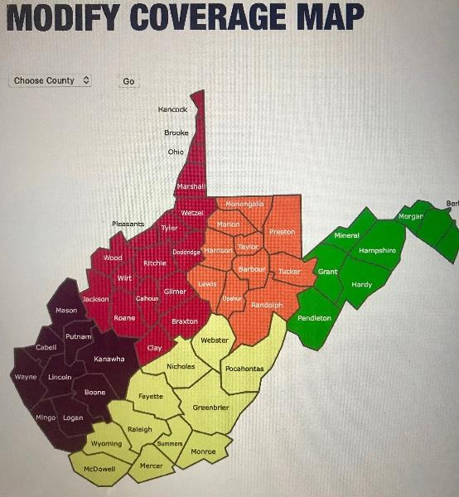
Initiated in the past plan and continued in this plan, the MODIFY Program team also supports opportunities and training for youth to develop their leadership skills within their local communities and national events, where applicable. The MODIFY Program is fully staffed with five Youth Specialists who serve youth across five regions within WV (see map). Two additional specialists additionally refer eligible youth to the program while also collecting important information from youth about the transition, their ongoing needs, and the services they need to address those needs. Led by a Program Manager and Program Assistant, the MODIFY Program is fully able to reach youth throughout the state within these service domains. The Department and the MODIFY Program team will continue to focus on increased utilization of services, training, and professional education opportunities in the next period. The Department will continue to monitor the utilization of services and work within the MODIFY Program to promote and recruit eligible youth over the next five years.

The continued increase in the number of youths within the foster care system is a significant factor in service efficiency and effectiveness over the next five years. Discussions about this increased number have been conducted in the past year to identify support for the youth, providers, and the MODIFY Program directly, as the number of eligible youths for MODIFY services continues to increase perhaps beyond the current size of the MODIFY team. MODIFY will continue to examine the characteristics of youth cohorts each year and the needs of cohorts to better address needed services and training over time. Additional partners may be identified to provide additional services to these larger cohorts. MODIFY Program team members will expand efforts to reach out and work closely with these providers for training and educational opportunities as well as continuation of services and communication of care.

Serving Youth of Various Ages and Stages of Achieving Independence
Beginning at age fourteen, all youth in foster care are eligible for transitioning services up to the age of twenty-three. These services are provided, contracted and/or monitored by agency workers and foster care providers. One area to be targeted for improvement is services to youth placed in kinship or relative homes. Currently, these youth are not as well served, and case management and oversight are sporadic. The services that are being provided to youth in kinship homes successfully are educational support as well as employment services to youth seventeen and older and are provided by the MODIFY program.

West Virginia is currently working on a transitional living program model that will provide a continuum of services for youth transitioning out of foster care. These services will be provided in a tiered manner so youth can receive the level of services that best meets their needs. The program will operate under a trauma informed structure and will be flexible, so youth can move from one tier to another without a disruption in services. The WV CANS and Casey Life Skills Assessment will help workers determine which level of services will best meet their needs. West Virginia will be working towards increasing the number of transitional living providers across that state in order to provide this continuum of services up to age twenty-three (23) for transitional living and twenty-six (26) for Educational Training Vouchers for transition living.
Some of the services/training that will be provided to youth in a transitional living program:
- Supervision/Monitoring and Support
- Transition Planning & Life Coaching
- Life Skills
- Educational Support and Planning
- Job Prep & Support
- Career & Interest Inventories
- Financial Literacy
- Community Linkage & Support
- Support & Crisis Response
- Peer to Peer Relationships
- Adolescent Brain Development
- Normalcy/Prudent Parent Standard

Update 2023:
A proposal was submitted regarding a redesign of our transitional living programs in August of 2019 and is revision currently for possible launch in FFY 2023. Using the experiences of the Pilot community-based independent living programs to inform the design and policies, the programs intend to allow more flexibility in where and how youth could be served. The model intends to allow a youth to live in a setting they choose, as opposed to a foster care or residential setting, to obtain the necessary services. Services would be tiered into four separate levels, distinguished by the level of supervision and support required, as well as by age. The program will be suitable to serve youth from age 17 through age 26.

The model would take advantage of the Legislative Rules for non-treatment settings where several youth share housing with supervision. The innovative Tiny Village on Stepping Stones Wayne campus would be one of the types of experiential support setting for youth to choose. The Transitional Living Agencies, through the pilot and their own work in the community, have established strong relationships with the public housing authorities, private landlords and family resource networks for housing and community services.

The current Mentoring and Oversight for Developing Independence for Foster Youth (MODIFY) program serves youth enrolled / attending college or university. During FFY 2022 the program staff have been receiving training and oversight by the Transitional Living and Permanency Support Program Manager. Through weekly virtual meetings, staff have been directed to complete documentation in the current child welfare information system (FACTS). Specifically, the data for educational attainment has been lacking for several years. For the academic semester Fall 2021 MODIFY had nine (9) graduates and for Spring 2022 twenty-two youth are ready to graduate.

Update 2024:
West Virginia continues to utilize the pilot programs for youth who have chosen not to pursue post-secondary education, and the MODIFY program for youth who do. Youth who are in pilot programs and wish to go to school, can transfer their service oversite from that agency to MODIFY, and youth who have issues with post-secondary education or choose to leave their education setting, can transfer service oversite from MODIFY to a pilot agency, or the county of residence if a pilot is not available in that area. For the academic semester Fall 2022 MODIFY had seven (7) graduates and for Spring 2023 nine (9) youth are ready to graduate.

West Virginia lacks culturally specific providers but continues to work with the West Virginia Managed Care Organization and the Administrative Services Organization to ensure providers are receiving appropriate culturally specific training. This issue is being addressed in the Socially Necessary Services Redesign. There is a workgroup that has been developed to focus on the training of service providers. This training will be provided to service providers outside of Socially Necessary Services such as the Transitional Living providers mentioned in the above paragraph.

Collaboration with Other Private and Public Agencies
The Department and MODIFY program have established and sustained strong partnerships with public and private partners throughout the state and in surrounding areas that serve youth in West Virginia (WV). For example, MODIFY, Youth Services System, and Human Resource Development Foundation partners, Bureau of Juvenile Services, Bureau for Mental Health, Community and Technical Colleges, Mission WV, Administrative Services Organization, Court Improvement Board, and multiple Community Collaborative groups have worked closely for more than two decades to coordinate youth services around such needs as independent living, substance use prevention, and job skills training. Additionally, partners who provide new services are routinely identified throughout the year and meet with Departmental team members to learn more about youth services and to identify potential roles and collaborations. Once a partnership is established, team members touch base with one another regularly (e.g., team meetings, workshop sponsorships) to sustain global awareness of the various programs that are available to youth, eligibility criteria if applicable, and referral procedures. Working closely together ensures continuation of services, unique contributions to youth service provisions (rather than duplication of services), and smoother transitions. New youth initiatives are often coordinated by the Department and sent to all youth service providers. Project materials are also shared across partners on a regular basis to increase dissemination among eligible youth. Results of our NYTD profile are shared with partners, including the Court Improvement Program, to help determine services to be developed and processes and training to be refined. Finally, social media postings and shared information have become more common among the partners as a means of disseminating information among team members but also directly to youth.
Update 2023:
Pilot community-based independent living programs began serving youth in October 2021. Children’s Home Society, Youth Services System, and NECCO hired specific staff to work with youth who were exiting from or returning to the Department. Transitional Living Agencies are serving youth with employment services, safe and stable housing, food security, reliable transportation, and financial education. The pilots have served youth 17 to 23 years of age in the counties of Cabell, Wayne, Mason, Putnam, Lincoln, Boone, Raleigh, Fayette, Greenbrier, Monroe, Summers, Pocahontas, Wood, Ritchie, Ohio, and Brooke.

Update 2024
Pilot community-based independent living programs continue to serve the initial counties listed. However, NECCO has now expanded into Putnam and Kanawha County. In 2023, the statement of work for these pilot programs will be changed to capture more data than what was previously in place. The pilot program will be called “Transition to Adulthood”. BSS continues to collaborate with providers on developing this program model to fit the needs of young adults that have aged out of foster care in West Virginia. West Virginia will work with providers and stakeholders to determine the best way to complete outreach and education of the program so youth in foster care or formerly in foster care will know what services are available to them.

Determining Eligibility for Benefits and Services
All youth in foster care will be eligible for age-appropriate services as described within the John H. Chafee Foster Care Program for Successful Transition to Adulthood section. Services will be determined by age and developmental level and may be provided by newly developed Transitional Living agencies. The services will be available to all current and former foster youth as described in Foster Care Policy, but the frequency and intensity will be delivered according to the level of the youth.

Update 2023:
West Virginia began participating in the recent collaborative webinars and discussions to look more closely at policy and practice around Chafee services. These sessions have been led by John Burton Advocates for Youth (JBAY), Foster Academic Achievement Nationwide (FAAN), and state programs such as Education Reach for Texans and Embark Georgia. West Virginia is interested in the research and recommendations regarding Tuition Waivers and ETV.

Youth who return for services and support after exiting foster care may access community-based independent living services with private Transitional Living Agencies. Specifically, the pilot programs noted under Collaboration with Other Private and Public Agencies are serving youth with employment services, safe and stable housing, food security, reliable transportation, and financial education.

Update 2024:
West Virginia continues to educate social services staff and community partners and providers on the process for signing back into care and applying for TL services through pilots, county offices, and MODIFY.

Cooperation in National Evaluation
In May 2016, the Department’s BCF participated in a 3-day voluntary onsite NYTD Pilot Assessment Review. While there were findings, and areas needing to be improved upon, since this assessment was voluntary, no financial penalties were imposed. During the 3-day review, a system demonstration was provided, the NYTD Survey was reviewed, a case review completed, and stakeholder interviews held.
At the conclusion of the review, several findings were noted and a NYTD- Quality Improvement Plan (N-QIP) created. Findings included; but are not limited to, the general requirements and the reporting of various elements within the client demographics, services, and the NYTD Outcome Survey. In addition, it was found that for a few of the youth reviewed, what was reported in the 2015B submission was not actually what the youth had reported.

At this time, West Virginia is in the process of replacing the current legacy system (FACTS) with functional modules which will comprise the new Comprehensive Child Welfare Information System. Due to this endeavor, it was determined making changes in the current legacy system was not feasible due to scope and complexity of work to be done. To date, most findings have been completed, however, some findings which remain pending, in the N-QIP, and are to be completed in the new WV PATH System. The 2015B file has been corrected and a subsequent file was submitted in January 2017 to correct the 2015B submission. A Quality Assurance tool has been created and shared in our latest NYTD-QIP quarterly submission. In addition, an updated Foster Care policy has been developed and implemented. The state continues to address outstanding items on the NYTD-QIP.

Update 2023:
Development of the new Comprehensive Child Welfare Information System (CCWIS) has been a huge task for the State in 2021. The rollout of this system is expected to go live in October 2022.

Update 2024:
No new update. The CCWIS rollout was delayed to January 2023. Please see additional information regarding gathering data for the national evaluation as mentioned on pages 157, 165, 254-255, 278, and 297-305.

Chafee Training
West Virginia is planning to develop regional teams to target specific training and technical assistance to individual counties or districts in areas needing improvement. Chafee services to youth fourteen to seventeen will be one area addressed in all fifty-five counties. The state will explore expanding a service currently offered in only one county that provides mentoring and advocacy services to foster youth to help improve educational outcomes. The program currently offers the following services.

Academic Success Coaching - The program is guided by the concept of ABC model (Attendance, Behavior, and Course Completion). The program ensures that the student has the highest level of support possible. Our Mentor will track attendance, behavior and course completion and respond to any areas of concern.
Educational Advocacy –Ensuring that the students' rights are upheld in the school setting; helping students access education-related support services; minimizing the effects of disciplinary actions that keep students out of school; assisting high school youth in making up credits when necessary and possible; and facilitating participation in extracurricular activities.
Student Enrichment Opportunities - Students need opportunities to flourish outside of the classroom. These experiences bring classroom concepts to life and establish a new future horizon on which students in foster care may focus. The program and county school provide student enrichment workshops, college visit field trips, and educational experiences.
Post-Secondary Education Planning - The goal is to build the confidence, skills and support youth impacted by foster care need to take charge of their lives and future. The program and county schoolwork with youth to create a personal plan to graduate high school and pursue their dreams. The program uses Check & Connect along with other research-based methods to give students the necessary tools to first understand and use their individual strengths and interests.
Group Counseling – In the grade school setting, the Mentor works with the elementary school counselor to co-facilitate Journey of Hope, a trauma informed program through Save the Children that teaches students how to deal and cope with circumstances they may face.
The most recent data available for the school months of August 2018– April 2019 yielded the following results:
- 33 Students were enrolled in the program.
- Since the 2018-19 school year started in mid-August the Mentor has made 750 “Connects” or encounters with 33 students.
- 0 of the 33 students have had behavior incidents this 18-19 school year.
- Graduating Seniors – There are seven seniors enrolled in the program currently and all are on target for graduation in May. Five of the seniors will be attending college in the fall, one has plans to join the military and get a college degree as well.
- 100% of seniors in the program have a post-secondary education plan.
- 53 Youth have been involved in post-secondary education field trips.
- 100% of youth participating in field trips reported on a survey college trips as beneficial to their post-secondary plans.
- 28 of 29 middle and high school youth receiving one-on-one mentoring show improvement in core subject areas than prior year (before being served.)
- 28 of 29 middle and high school-youth receiving one-on-one mentoring have maintained or shown improvement on their report card with services than without.
- All students in the program follow the attendance policy.
- All students in the program are on target for graduation with their class and no discipline issues causing expulsion or ALC.

Update 2023:
No 2023 Update

Update 2024:
While there are no new updates under this section for the year 2022, West Virginia continues to provide information on the Chafee program through new worker training.

Additional Chafee Funding Division X
Planned enhancement of the current HRDF and YSS/CHS grants with Chafee IL Pandemic Funds during July 1, 2021, to Sept 30, 2022, to achieve housing, employment or stable income, food security, transportation and monthly utilization of Medical/ Mental health and Driver’s License attainment. The HRDF enhancement would serve Mason, Putnam, Kanawha, Raleigh, and Fayette. The YSS/ CHS enhancement would serve Jackson, Wood, Wetzel, Marshall, Ohio, and Brooke.

Youth served by these programs, and by Department field staff will receive IL Subsidies, start-up funding, driver’s program funding, and other financial support as necessary. Youth will also be connected to Medicaid to meet their medical and mental health needs.

Update 2023:
Division X Independent Living funds were utilized to provide community-based independent living services and support through the coordinated efforts of four Transitional Living (TL) Agencies and the West Virginia Coalition to End Homelessness (WVCEH). The TL Agencies worked with youth who would otherwise age out of foster care during the public health emergency, assisting with housing, transportation, employment, and life skills. Outreach efforts, especially by the Youth Navigators at WVCEH, permitted youth to voluntarily seek assistance from the Department through these TL Agencies, alleviating the risk of homelessness.

These funds also permitted youth to repair vehicles, obtain driver’s licenses, and purchase vehicles. Auto insurance and inspection payments provided stability and safe operation of youth’s vehicles. Youth who decided not to return to an academic program were assisted by the TL Agencies to obtain employment and maintain housing.

Update 2024:
Division X funding continued to be used for the four TL Agencies to provide case management on youth that aged out of foster care and are between the ages of 18-23. The agencies were able to serve 68 youth under this program. The Department would like to move forward with sustaining this program under Chafee funding. The program is now called the Transition to Adulthood Program. An announcement of funding availability was released in June 2023 and contracts are currently being worked on.

BSS learned from working with providers and obtaining feedback from youth on the program how beneficial the program is to the state as it lacks proper resources for this targeted population. This has sparked the efforts in a redesign of Transitional Programs under BSS. BSS is currently working with stakeholders and Casey Family Programs on the redesign.

Access to Medicaid for Former Foster Youth
West Virginia’s youth remain unaware of the breadth of services available with their “medical card,” and they are not utilizing the wellness benefits through Aetna’s Mountain Health Promise. To increase awareness and access, Aetna has launched a public awareness campaign to ensure Medicaid recipients utilize their value added and wellness benefits. This effort coincides with the anticipated end of the public health emergency with a focus to ensure former foster youth. Youth will receive requests to update contact information in several formats (mail, phone, and email). BMS will then notify youth when it's time to renew Medicaid coverage through the extended foster care benefit through age 25.

West Virginia assists youth on a case-by-case basis when they are moving out of state. If youth are adopted or are in legal guardianship, the ICAMA process is utilized, and this is done routinely for youth attending college out of state. If youth are former foster youth attending out of state college, the MODIFY staff assist with the linkage to continued Medicaid. Continued work on the public facing web sites of the Bureaus will seek to mirror the easy-to-understand explanation and application processes of states like Texas, Pennsylvania, and Washington.

Update 2024:
No new update. The section above was the first update provided on access to Medicaid for former foster youth.

Education and Training Vouchers (ETV)
The education and training vouchers are supported using money provided to the state as a part of the reauthorization of the independent living program. Education Training Voucher (ETV) funds are State administered funds provided to foster care and former foster care youth by the MODIFY Community Support Specialists as well as Department caseworkers, through the Department’s State Office of Finance and Administration. Youth eligible for Chafee ETV funds include the following: a) youth adopted or placed in legal guardianship from foster care after the age of 16 years old; and b) foster/ former foster care youth through 26 years old, who aged out of care at 18 or older. If an eligible youth is enrolled, attending, and making satisfactory progress in a post-secondary educational program on their 25th Birthday, then they may be eligible to continue to receive ETV funds until their 26th birthday.

ETV funds may not exceed $5000 per FFY (10/01 – 09/30). ETV funds may be used to cover educational expenses as outlined by the Higher Education Act which may include tuition/fees, books/supplies, room/board, transportation, tutoring, etc. A student must reapply each year to receive ETV funds and must maintain satisfactory standing within the guidelines of the ETV program.

To meet the guidelines of satisfactory standing and receive ETV funds, youth must meet the following: 1) a 2.0 GPA; an 80% course completion rate; and maintain regular attendance and provide monthly progress reports to the MODIFY Community Support Specialist.

MODIFY specialists monitor each case individually through both FACTS and WVU CED CODA systems. The student and payment allotment are kept on an excel spreadsheet which is checked each time a payment is rendered. Youth enrolled in education is counted only once as a new enrollee no matter the number semesters attended per year. All new youth who officially receive an intake and are opened as a MODIFY client are an unduplicated client. Through case management and data collection system MODIFY specialists verify individual counts and numbers. Specialists send their requested payments to the MODIFY director each month who enters it for payment. Those payments are then approved by a Department specialist who checks the payments against an Excel spreadsheet.

The Department, through the MODIFY program, produces materials and training sessions designed to sustain awareness about the ETV funds and other support services among higher educational staff, advisors, and families throughout the network. This collaboration is bidirectional in that higher education institutions, state scholarship programs, and noted tuition waiver programs also provide information to the Department teams to inform youth and families of changes in fiscal support and procedures. Youth assessments, case modifications, and other updates are shared through similar tracking methods to identify strengths and areas of improvement for youth enrolled in the program. Students placed on probation are provided resources across Department partners and higher education institutions. Attempts to resolve challenges prior to issues with fiscal support, scholarships, and other concerns are made collectively by teams and institutions when possible.

The state provides Chafee Services to youth who have been adopted or who were placed in legal guardianship. Some of the services that youth are provided include Educational and Training Voucher (ETV) funds, case management oversight, community referral services, mentoring services, and other transitioning services as needed as indicated above.

West Virginia provides the same MODIFY services to youth adopted or placed in Subsidized Legal Guardianship.

Update 2023:
For the 2020-2021 school year, we served more youth than usual due to the pandemic with little to no closures occurring at this time. We started the first quarter with 274 total ETV awarded. Thirty-six were new; 20 were closed out. By the end of the year, our ETV awards had increased to 321. Twenty-one new ETV cases; 8 were closed out. Overall, for that year we had 134 new ETV awarded for the 2020-21 performance period.

For the 2021-2022 school year, the numbers may appear to drop since regular guidelines for compliance for continued funding were in effect and some youth did not return to school for this school year after the pandemic. This school year may also reflect a lower amount of new ETV youth being served prior to implementing new procedures, such as screening for readiness for a college/university setting and referrals not being opened until required documentation is obtained to start services.

Update 2024:
For the 2022-2023 school year, the program started off with serving 169 youth. The program started off with twenty-five new youth being served at the beginning of the school year while another twenty-five were closed out for various reasons. Since the beginning of the school year, the program has received 261 referrals. Of the 261 referrals received 130 were screened out for various reasons. The program continues to see an increase in information referrals and referring to more appropriate resources, such as DHHR TL program, WorkForce WV, etc. for those youth interested in career training programs or wanting to go straight into the workforce.

Final Number: 2021-2022 (July 1, 2021 to June 30, 2022)
Total: 300
New Awards 42

2022-2023 (July 1, 2022 to June 30, 2023) (Estimated)
Total: 245
New Awards: 38

Additional Funding ETV Division X
MODIFY program specialists are directed to provide up to an additional $7000 to each current youth on caseloads (current caseload is 250), for payment of educational expenses, housing, meal plans, or other expenses, exercising leniency towards educational progress. The additional funding will supplement the $5000 allocation to each of the students on the current caseloads.

New enrollees (up to 30 youth) for the academic year Fall 2021 through Summer 2022 shall receive $12000 in educational expenses, housing, meal plans, or other expenses exercising leniency towards educational progress. These youth will likely be housed off-campus to ensure stable housing and food security should another campus shut-down occur.

Update 2023:
During the initial outbreak of the COVID 19 public health emergency, youth residing on-campus at West Virginia colleges and universities had to obtain safe and stable off-campus housing. Coordination with public housing authorities, the West Virginia Coalition to End Homelessness (WVCEH) and MODIFY staff enabled each youth to settle into off-campus housing, obtain wireless connectivity for remote learning, and have basic needs met. The Division X ETV funds were utilized to provide necessary technology upgrades, pay additional tuition and fees, settle remaining balances with institutions, and direct payments to youth.

Utilizing the flexibilities of the Division X ETV, many students who did not meet student success minimum standards received services, support, and direct payments. The Youth Action Board of the WVCEH made outreach efforts to enable youth to connect with MODIFY and BSS staff to obtain assistance with past-due expenses including transportation, housing, and utilities.

Update 2024:
Prior to the ending of Division X funding, WV utilized this funding source to help with housing through the WVCEH, and to assist MODIFY youth with housing, outstanding education payment balances, and transportation needs.

During SFY 2022 and 2023, 302 youth received funding under Division X to purchase items related to schooling. Requests for funding approval was submitted to the BSS Transitional Living Unit by case workers and providers on behalf of the youth. Most of the requests were related to transportation needs such as car repairs, insurance, obtaining driver’s licenses, and car registrations. Ensuring that youth have reliable transportation provided the ability for some youth to go to school due to the distance between their home and school.

WV changed from a SACWIS to a CCWIS on January 1, 2023. System enhancements to capture appropriate data on demographics of youth that received this funding was not developed. BSS is working with our CCWIS technical team to address this issue to better capture how funds under Chafee ETV are utilized.

Update on CAPTA

Update 2023:
No 2023 Update

Update 2024:
No 2024 Update

Program Areas
Intake, assessment, screening, and investigation of reports of child abuse or neglect

Update 2023:
The Citizen Review Panel (CRP) continued to meet virtually in 2021 due to the pandemic. The CRP had a panel member step into the role of the Chair during the year. A CRP coordinator was not hired during 2021 and efforts continue to locate applicants for the position. The CRP continued to focus on recruitment efforts and updating the structures and processes of the panel in order to strengthen the panel and begin focusing on issues within child welfare. The meetings were held quarterly but one could not be scheduled, resulting in three meetings during the reporting period. At the December 2021 meeting, panel members agreed to begin shorter, monthly meetings, to get the panel and the structures and processes back on track in 2022.

Update 2024:
During 2022, the Citizen Review Panel (CRP) met virtually every month, except in April 2022 and June 2022. The CRP chair stepped down and no other members stepped forward to fill the position. The structures and processes were updated for the panel. A CRP Coordinator was hired in late 2022 and attended the December 2022 meeting. The CRP focused on discussion regarding evidence-based case planning models that could be used within child welfare and what recommendations to make to the department.

Creating and improving the use of multidisciplinary teams and interagency, intra-agency, interstate, and intrastate protocols to enhance investigations; improving legal preparation and representation, including procedures for appealing and responding to appeals of substantiated reports of child abuse or neglect; and provisions for the appointment of an individual appointed to represent a child in judicial proceedings.
Update 2023: No 2023 Update
Update 2024: No 2023 Update

Case management, including ongoing case monitoring, and delivery of services and treatment provided to children and their families.
Update 2023:
See updates in the Child Protective Services section.
Update 2024:
See updates in the Child Protective Services section.

Enhancing the general child protective system by developing, improving, and implementing risk and safety assessment tools and protocols, including the use of differential response
Update 2023:
West Virginia is exploring different models of alternative responses in child welfare cases.

In addition to diverting Plans of Safe Care referrals, West Virginia has completed considerable research of available guidance and examples of differential or alternative responses in child welfare cases to address the diverse needs of families. Sources such as the ACF Children’s Bureau and several state demonstrations projects, have guided West Virginia’s vision of a possible “multi-track” system of responding to child abuse and neglect referrals. Demonstration projects in states such as Nebraska, Washington, Ohio, and Wisconsin, have provided insight into how a differential or alternative response could be framed to meet the needs of West Virginia’s families being referred to the child welfare system.

In its infancy of developing a “best practice” approach, West Virginia has outlined what should to be addressed for successful implementation:
- Number of “tracks”:
  - Responding to families with varying levels of need
- Privatization of differential response functions:
  - Could any track assignment or function be completed by a private agency?
- Track assignment process
- Track assessment tools
- Policy and system changes
- Practitioner selection
- Training and coaching
- Performance assessment:
  - Fidelity
- Systems interventions:
  - Educate, inform, and get buy-in from internal and external stakeholders.
- Facilitative administration
- Documentation
- Pilot or Statewide rollout
- Time frames and schedules
- Implementation plan

Goals would include but are not limited to moving from a primarily incident-based, investigative response to a family “needs” focused assessment; increasing prevention services to reduce the incidence of child maltreatment; improving family engagement and collaboration; increasing access to community resources and services to families; and reducing recidivism.

A reduction in the number of referrals where no abuse or neglect is identified allows child welfare staff to focus and prioritize the safety of children and services to families most in need. Creating a multi-track system would allow for more flexible and appropriate responses to the varying needs of families.

Update 2024:
West Virginia has completed considerable research of available guidance and examples of differential or alternative responses in child welfare cases to address the diverse needs of families. Sources include:
- ACF Children’s Bureau.
- several state demonstrations projects, and
- examples from states using a Structured Decision-Making model.

West Virginia has assembled a team that is reviewing practice models with the goal of implementing a differential or alternative response system for families who receive child welfare services. The team consists of representatives from the following divisions of the Bureau of Social Services:
- Planning and Quality Assurance;
- Policy and Programs;
- Field Support; and
- Training.

West Virginia has outlined and began work on the decision points for successful implementation:
- Number of “tracks”:
  - Responding to families with varying levels of need
- Intake assessment and referral acceptance;
- Track assessment tools and processes;
- Policy and system changes;
- Practitioner selection;
- Training and coaching;
- Performance assessment:
  - Fidelity.
- Systemic and stakeholder interventions:
  - Educate, inform, and get buy-in from internal and external stakeholders.
- Facilitative administration;
- Documentation;
- Pilot or statewide rollout;
- Implementation schedules; and
- Implementation date.

Goals include but are not limited to:
- Moving from a primarily incident-based, investigative response to a family “needs and strengths” focused assessment;
- Increasing prevention services to reduce the incidence of child maltreatment;
- Improving family engagement and collaboration;
- Increasing access to community resources and services to families;
- Reducing the number of children in out-of-home placements; and
- Reducing recidivism.

A reduction in the number of referrals where no abuse or neglect is identified will allow child welfare staff to focus and prioritize the safety of children and services to families most in need. Creating a multi-track system will allow for more flexible and appropriate responses to the varying needs of families.

Developing and updating systems of technology that support the program and track reports of child abuse and neglect from intake through final disposition and allow interstate and intrastate information exchange.

Update 2023:
The implementation of WV PATH is still ongoing. WV PATH is slated to go live in October 2022. WV PATH will interface with NEICE, which will allow electronic submission of cases involved with the Interstate Compact on the Placement of Children to other states.
Update 2024:
WV PATH and NEICE did not go live until January 2023. No other updates are available currently.

Developing, strengthening, and facilitating training including training regarding research-based strategies, including the use of differential response, to promote collaboration with the families; training regarding the legal duties of such individuals; personal safety training for case workers; and training in early childhood, child, and adolescent development.

Update 2023:
See Training section for any updates.

Update 2024:
See Training section for any updates.

Improving the skills, qualifications, and availability of individuals providing services to children and families, and the supervisors of such individuals, through the child protection system, including improvements in the recruitment and retention of caseworkers

Update 2023:
See update in Staff Training, Technical Assistance, and Evaluation section.

Update 2024:
See update in Staff Training, Technical Assistance, and Evaluation section.

Developing, facilitating the use of, and implementing research-based strategies and training protocols for individuals mandated to report child abuse and neglect.

Update 2023:
Through use of the Children’s Justice Act grant funding and as part of the activities tied to that grant, West Virginia’s Center for Children’s Justice has developed an online mandated reporter training. The training includes a certificate of completion and PowerPoint for agencies to use with staff.

This training went live on the Handle with Care website on December 8, 2021. As of February 24, 2022, there have been 6,594 views on this page and 2,439 have created an account.

Update 2024:
The West Virginia’s Center for Children’s Justice, through the Children’s Justice Act grant funding, continues to maintain an online mandated reporter training and a PowerPoint for agencies to use with staff. As of April 2023, there have been 4,657 enrollments and 4,463 certificates issued for the completion of the online training.

Developing, implementing, or operating programs to assist in obtaining or coordinating necessary services for families of disabled infants with life-threatening conditions, including existing social and health services; financial assistance; services necessary to facilitate adoptive placement of any such infants who have been relinquished for adoption; and the use of differential response in preventing child abuse and neglect.

Update 2023:
Through an established memorandum of understanding with the Bureau for Children and Families and Bureau for Public Health/Office of Maternal, Child and Family Health (OMCFH) roles and responsibilities between the parties were established for the purposes of addressing the delivery of health care services and coordination to children and youth in foster care, and providing coordination to promote prompt access to comprehensive, coordinated services and supports in a patient-centered medical home.

The West Virginia Children with Special Health Care Needs (CSHCN) Program located within the OMCFH works to facilitate a team approach to health care, with coordination across multiple services and settings, in accordance with the National Standards for Systems of Care for Children and Youth with Special Health Care Needs (CYSHCN). Per the West Virginia CSHCN Program Policy, at minimum, children will be automatically deemed eligible for care coordination when the child:
· Receives 100% nutritional intake through the gastrointestinal tract via a tube, catheter, or stoma that delivers sustenance distal to the oral cavity, as confirmed by the CSHCN Program’s Eligibility Unit.
· Is a member of the Children with Disabilities Community Services Program (CDCSP).
· Is in foster care, as defined by 45 CFR 1355.20.
· Was in foster care, as defined by 45 CFR 1355.20 and now qualifies for federal Title IV-E adoption assistance.
· Diagnosed with Neonatal Abstinence Syndrome (NAS; ICD-10 code: P96.1).

Per the memorandum of understanding, the West Virginia CSHCN Screener is utilized in a standardized process and each foster child is assigned a care coordination tier level. Care coordination tier levels vary:
- Tier 1 – CSHCN who are identified as having a special health care need according to the MCHB definition^{[1]} with low service utilization and mild or few functional limitations,
- Tier 2 – CSHCN with a special physical health care need (defined as an organ dysfunction and/or a neuromotor or musculoskeletal chronic condition that must have lasted, or is certain to last, for at least one year and is not behavioral or emotional in origin) in addition to high service utilization and moderate to severe functional limitations; or
- Tier 3 – CSHCN with a special physical health care need in addition to high service utilization and moderate to severe functional limitations and are financially eligible for Title V coverage of medically-necessary medical nutrition foods prescribed by a physician.

For children and youth in foster care with a Tier 1 designation, targeted case management is provided through review of the EPSDT Well Child Exam as typically these children are involved in multiple child-serving systems. Those with Tier 2 and Tier 3 care coordination levels, are afforded the following care coordination functions:
- Advocate patient-centered, coordinated, ongoing comprehensive care within a medical home.
- Ensure an appropriate written (shared) care plan;
- Promote communications within the medical home and ensure defined minimal intervals between communication.
- Support and/or facilitate (as appropriate) care transitions from practice to practice from the pediatric to adult systems of care.
- Support medical homes’ capacity for electronic health information and exchange; and
- Facilitate access to comprehensive home and community-based supports.

Effective and lasting support for CYSHCN and their families requires a whole system response that extends beyond care coordination. Organizing care involves the exchange of information among participants responsible for different aspects of care and the resources needed to carry out all required patient care activities. The CSHCN Care Coordinators (registered nurses and licensed social workers) provide services to children and youth in foster care based on their county of placement rather than origin to ensure continuity of care. CSHCN Program care coordinators completed care plans for 140 children with a diagnosis of NAS. In the calendar year 2021, 1,496 foster children were screened to identify the appropriate care coordination tier level. Of the 1,496 foster children screened, 414 foster children were enrolled for services and 1,082 were found ineligible due to leaving foster care. CSHCN Care Coordinators provided Tier 1 services to 852 foster children, Tier 2 services to 377 foster children and 71 foster children received Tier 3 services. Of the eligible children, 68% received a care plan and services received were documented in FACTS. A shared plan of care contains input from multidisciplinary providers and services, including primary, subspecialty and behavioral health professionals. Based on the eligibility criteria, these children may be found eligible for Title V funded medical nutrition.
The CSHCN Program facilitated the authorization for medical foods through the child’s EPSDT Medicaid benefit for 88 children, 12 of these children were in foster care or received adoption services. The CSHCN Program will ensure that 100% of all children and adolescents in foster care receive health care through a medical home and ensure that the medical home remains the same despite changes in foster placement to maximize access and continuity of care.

Nationally, more than 250,000 children enter foster care each year and over 22% of those children are identified with at least one special health care need.^{[2]} Therefore, there are an estimated 1,600 CYSHCN in WV in foster care placement based on the estimate found in Data Brief series: Exploring child welfare
outcomes of children with special health care needs (CSHCN)— a national overview from a first-time entry cohort perspective, AFCARS 2017 data, Data Brief 1: Analysis according to special health care needs status. It should be noted that the percentage of CSHCN in WV exceeds the US percentage (23.2% vs. 19.4%), so the number reported here may be underreported.

The CSHCN Program’s Plan of Care reflects the goals and outcomes developed by the multidisciplinary team from information obtained during the CSHCN assessment and continuous monitoring of medical/clinical records and collaboration with the client’s medical home. The Plan of Care is distinctive in that the compilation of information is obtained from hard copy medical/clinicals reports such as the annual EPSDT well child exam, electronic medical records (EMRs), specialist reports, specialized children hospitals discharge orders, educational records and/or other state program records. The CSHCN Program staff has access to various highly protected state electronic data systems that allows the Care Coordination Team Registered Nurse or Social Worker to view records/history specific to the enrolled CSHCN Program Foster Child. The information obtained from the data systems and medical records provides the foundation for building the Plan of Care that is specific to that child who is enrolled in the CSHCN Program.

^{[1]} Children and youth with special health care needs (CSHCN) “have or are at increased risk for chronic physical, developmental, behavioral or emotional conditions and who also require health and related services of a type or amount beyond that required by children generally.” (https://mchb.hrsa.gov/maternal-child-health-topics/children-and-youth-special-health-needs)
^{[2]} https://www.acf.hhs.gov/sites/default/files/documents/cb/Brief%201-Analysis%20by%20special%20health%20care%20needs%20status.pdf

Update 2024:
Nationally, more than 250,000 children enter foster care each year and over 22% of those children are identified with at least one special health care need.[i] Therefore, there are potentially an estimated 1,600 Children and Youth with Special Health Care Needs (CYSHCN) in West Virginia (WV) in foster care placement[ii]; however, as the percentage of children with special health care needs (CSHCN) in WV exceeds the US percentage (23.2% vs. 19.4%), this estimate may be indeterminate.
Through an established memorandum of understanding (MOU) between the Bureau for Social Services and Bureau for Public Health/Office of Maternal, Child and Family Health (OMCFH/WV Title V Agency), roles and responsibilities were established to address the delivery of health care services and care coordination to children and youth in foster care. These services and coordination promote prompt access to comprehensive, coordinated planning and support in a patient-centered medical home.
The WV CSHCN Program located within the OMCFH works to facilitate a team approach to health care, with coordination across multiple services and settings, in accordance with the National Standards for Systems of Care for Children and Youth with Special Health Care Needs. The CSHCN Program’s goal is to ensure that all children and adolescents in foster care receive health care through a medical home to maximize access and continuity of care. Per the WV CSHCN Program Policy, at minimum, children will be automatically deemed eligible for care coordination when the child:
- Receives 100% nutritional intake through the gastrointestinal tract via a tube, catheter, or stoma that delivers sustenance distal to the oral cavity, as confirmed by the CSHCN Program’s Eligibility Unit.
- Is a member of the Children with Disabilities Community Services Program (CDCSP).
- Is in foster care, as defined by 45 CFR 1355.20.
- Was in foster care, as defined by 45 CFR 1355.20 and now qualifies for federal Title IV-E adoption assistance.
- Diagnosed with Neonatal Abstinence Syndrome (NAS; ICD-10 code: P96.1).
Effective and lasting support for CYSHCN and their families requires a whole system response that extends beyond care coordination. Organizing care involves the exchange of information among participants responsible for different aspects of care and the resources needed to carry out all required patient care activities. The CSHCN Care Coordinators (registered professional nurses and licensed social workers) provide services to children and youth in foster care based on their county of placement rather than origin to ensure continuity of care.
The CSHCN Program’s Plan of Care reflects the goals and outcomes developed by the multidisciplinary team from information obtained during the CSHCN assessment and continuous monitoring of medical/clinical records and collaboration with the client’s medical home. The Plan of Care is distinctive in that the compilation of information is obtained from hard copy medical/clinicals reports such as the annual EPSDT well child exam, electronic medical records (EMRs), specialist reports, specialized children hospitals’ discharge orders, educational records and/or other state program records. The CSHCN Program staff has access to various highly protected state electronic data systems that allows the Care Coordination Team Registered Professional Nurse or Licensed Social Worker to view records/history specific to the enrolled CSHCN Program Foster Child. The information obtained from the data systems and medical records provides the foundation for building the Plan of Care that is specific to that child who is enrolled in the CSHCN Program. Based on the eligibility criteria, these children may also be eligible for Title V funded medical nutrition.
Per the MOU, the WV CSHCN Screener is initiated, and each foster child is assigned a care coordination tier level. The CSHCN Screener is a five item, parent-reported tool designed to reflect the federal Maternal and Child Health Bureau’s (MCHB) consequences-based definition of children with special health care needs. Care coordination tier levels vary:
· Tier 1 – CSHCN who are identified as having a special health care need according to the MCHB definition[i] with low service utilization and mild or few functional limitations,
· Tier 2 – CSHCN with a special physical health care need (defined as an organ dysfunction and/or a neuromotor or musculoskeletal chronic condition that must have lasted, or is certain to last, for at least one year and is not behavioral or emotional in origin) in addition to high service utilization and moderate to severe functional limitations; or
· Tier 3 – CSHCN with a special physical health care need in addition to high service utilization and moderate to severe functional limitations and are financially eligible for Title V coverage of medically-necessary medical nutrition foods prescribed by a physician.
For children and youth in foster care with a Tier 1 designation, case management is provided through review of the EPSDT Well Child Exam. Those with Tier 2 and Tier 3 care coordination levels are afforded the following additional care coordination functions:
- Advocate patient-centered, coordinated, ongoing comprehensive care within a medical home.
- Ensure an appropriate written (shared) care plan.
- Promote communications within the medical home and ensure defined minimal intervals between communication.
- Support and/or facilitate care transitions from practice to practice from the pediatric to adult systems of care.
- Support medical homes’ capacity for electronic health information and exchange; and
- Facilitate access to comprehensive home and community-based support.
In the calendar year 2022, 6,002 eligibility determinations were completed for foster children to identify the appropriate car coordination tier level. Of those foster children screened, 721 foster children were enrolled for services and 5,281 were determined to be ineligible due to leaving foster care. CSHCN Care Coordinators provided Tier 1 services to 1,216 foster children, Tier 2 services to 522 foster children, and 73 foster children received Tier 3 services. Of all enrolled foster children, 48% received a care plan and services received were documented in FACTS. Additionally, the CSHCN Program facilitated the authorization for medical food through the child’s EPSDT Medicaid benefit for 88 children, 10 of these children were in foster care or received adoption services.
_________________________
[i]https://www.acf.hhs.gov/sites/default/files/documents/cb/Brief%201-Analysis%20by%20special%20health%20care%20needs%20status.pdf
[ii] Exploring child welfare outcomes of children with special health care needs (CSHCN)— a national overview from a first-time entry cohort perspective, AFCARS 2017 data, Data Brief 1: Analysis according to special health care needs status.
[iii] Children and youth with special health care needs (CSHCN) “have or are at increased risk for chronic physical, developmental, behavioral or emotional conditions and who also require health and related services of a type or amount beyond that required by children generally.” (https://mchb.hrsa.gov/maternal-child-health-topics/children-and-youth-special-health-needs)

Developing and delivering information to improve public education relating to the role and responsibilities of the child protection system and the nature and basis for reporting suspected incidents of child abuse and neglect, including the use of differential response.

Update 2023:
No Update

Update 2024:
No Update

Developing and enhancing the capacity of community-based programs to integrate shared leadership strategies between parents and professionals to prevent and treat child abuse and neglect at the neighborhood level.

Update 2023:
No Update

Update 2024:
No Update

Supporting and enhancing interagency collaboration between the child protection system and the juvenile justice system for improved delivery of services and treatment, including methods for continuity of treatment plan and services as children transition between systems

Update 2023:
BSS continues to have weekly meetings with the Bureau for Juvenile Services (BJS) to help facilitate the transfer of youth inappropriately placed in BJS facilities back into a child welfare setting. This initiative has been on-going since June 2017. There is a new law in West Virginia addressing competency of youth under the age of 14 but we as a State are continuing to learn how to apply the new law and those youth are still coming to BJS in detention while placement is being sought and competency is being determined. Many barriers are identified and are addressed the best that we can, but the need continues for these aggressive and hard-to-place youth involved in the mental health area.

Additionally, BSS and BJS continue as participating members of the Commission to Study the Residential Treatment of Children and the West Virginia System of Care Implementation Team, focused on the seamless delivery of services to these populations between systems. Further, BSS has begun a collaboration with BJS concerning former foster youth transitioning out of detention to adulthood. This collaboration is connecting youth to the local Public Housing Authority to issue a Family Youth Initiative Voucher for housing when needed and provide 18 months of supportive aftercare services.

Update 2024
There is no new update on this section. The calls continue to take place in collaboration with BJS.

Supporting and enhancing interagency collaboration among public health agencies, agencies in the child protective service system, and agencies carrying out private community-based programs to provide child abuse and neglect prevention and treatment services (including linkages with education systems), and the use of differential response; and, to address the health needs, including mental health needs, of children identified as victims of child abuse or neglect; including supporting prompt, comprehensive health and developmental evaluations for children who are the subject of substantiated child maltreatment reports

Update 2023:
Due to the state’s commitment to ensuring that children can receive mental health services in their homes and communities, the Pathway to Children’s Mental Health Services was implemented. Screening for the mental health needs of children who are involved with child welfare is the first step in supporting this commitment. The Pathway to Children’s Mental Health Services aims to improve the access to, and quality of, in-home services for children with serious emotional disorders and serious emotional illness. To assist child welfare staff, two job aides were developed that are specific to screening for the mental health needs of children between ages 0-4 and 5-18. The mental health needs of children are evaluated during family assessments but can be identified at any point during a child welfare case.

The state has continued to work on a plan of safe care policy and initiative. The initiative aims to change how child welfare addresses reports from hospitals and birthing centers to Child Protective Services of a drug affected infant and there is no indication that the parent or caregiver’s substance use impacts their ability to parent safely. In these cases, Centralized Intake would be able to route those accepted referrals for a plan of safe care to a specified case manager to oversee the development, implementation, and monitoring of the plan of safe care. All other reports of drug affected infants will be assessed by child welfare staff and the development and implementation of the plan of safe care will be completed through the normal casework process.

BSS maintained its funding of the Drug Endangered Children’s Grant with CAPTA funds. The West Virginia Children’s Justice Task Force (WVCJTF) held the 2021 WV Center for Children’s Justice Handle with Care Conference on October 13-15, 2021. There were 514 registered to attend and 16 exhibitors. This three-day event provided training for a trauma informed response to child maltreatment and children’s exposure to violence. The goal of the conference is to provide current information to better help serve those in our communities who experience abuse and violence. Sessions included topics on the investigation, prosecution, and treatment of child maltreatment and family violence. The WVCJFT also continued to provide training and support to local multidisciplinary teams that coordinate services and support for drug endangered children over this past year. They provided education and awareness to law enforcement, child welfare agencies, other professionals, and the public, regarding their activities. The following activities were provided or completed to support this service.
Activity: Provide training to first responders where needed or upon request on emerging drug issues as most WV child maltreatment cases involve caregivers with substance use disorder.
2021
Aug 24 – 25 Attended National DEC Conference
Oct 15 - Emerging Drug Trends with Chad Napier

Update 2024:
BSS continued to maintain its funding of the Drug Endangered Children’s Grant with CAPTA funds. The 2022 West Virginia (WV) Center for Children's Justice Handle with Care Conference was held in-person and virtually on October 12-14, 2022. The WV Center for Children’s Justice (CCJ); the WV Department of Health and Human Resources (WVDHHR), Bureau for Social Services; AETNA Better Health of West Virginia, and the WV ACE’s Coalition. This project was supported by Grant No. 19-AIEEP-16, a grant awarded from the West Virginia Division of Administrative Services, Justice, and Community Services Section by the Bureau of Justice Assistance.

Approximately 488 in-person and 300 virtual participants, 23 exhibitors and 32 speakers attended this nationwide, three-day conference and provided a wonderful opportunity for the criminal justice and child maltreatment professionals—federal, state, and local—to collaborate and network.

This three-day event provided training for a trauma informed response to child maltreatment and children’s exposure to violence. The goal was to provide current information to better help serve those in our communities who experience abuse and violence. Sessions included topics on the investigation, prosecution, and treatment of child maltreatment and family violence.

Developing and implementing procedures for collaboration among child protective services, domestic violence services, and other agencies in investigations, interventions, and the delivery of services and treatment provided to children and families, including the use of differential response, where appropriate; and the provision of services that assist children exposed to domestic violence, and that also support the caregiving role of their non-abusing parents
Update 2023:
West Virginia is developing a form of differential response for families that require a Plan of Safe Care. A Plan of Safe Care RFP to divert families required to be reported due to drug affected infants and a differential response for Child Welfare cases.

West Virginia is exploring diversion of potential cases that only require a Plan of Safe Care (POSC). The Plan of Safe Care Policy and initiative has been an evolving project for approximately 3+ years. Between 2019 and 2020 the POSC Policy intended to support an initiative that was to be piloted in two counties, Greenbrier and Ohio. The pilot counties have Drug Free Moms and Babies Clinics located at Greenbrier Valley Medical Center and Wheeling Hospital. Prior to fully piloting this policy and initiative, the COVID-19 pandemic occurred, preventing face to face meetings, changing priorities of the respective hospitals, and halting continued collaboration between the Department and stakeholders (Drug Free Moms and Babies and Perinatal Partnership). Since that time, the Department has made changes to child welfare policy that included terminology and assessment changes. The working POSC Policy had to evolve with these changes to maintain relevance and consistency. As COVID restrictions eased and communication with stakeholders could resume, there were changes to the needs and climate of the pilot Drug Free Moms and Babies Clinics that were initially chosen. A new idea for how to approach this initiative was then formed which relied less on one program (Drug Free Moms and Babies Clinic) and looked to incorporate as potential partners for developing and monitoring POSC, many of the community resources that work with moms and infants who are born drug affected.

The current POSC Policy and initiative focuses on two primary populations of mothers/caregivers and infants that could potentially best be served in the community. They are:
- Mothers who are using legal or illegal substances, prescription medication or alcohol, that can result in withdrawal symptoms but do not have a substance use disorder; and
- Mothers receiving medication assisted treatment (MAT) for an opioid use disorder (Buprenorphine or Methadone) or mothers who are actively engaged in treatment for a substance use disorder, or treatment for an alcohol misuse disorder.

Through collaboration with stakeholders (Perinatal Partnership) the current policy and initiative is designed to support reporting, developing, and monitoring of plans of safe care for referrals of drug affected infants that do not indicate that a parent or caregiver’s substance use impacts their ability to parent safely.

For better understanding of the proposed changes to supporting families of drug affected infants through a POSC when there are NO allegations of abuse or neglect, a flow chart is provided:

Request for Funding Announcement
The Request for Funding Announcement (RFA) that has been submitted for this initiative seeks to locate an agency/provider that can provide two staff that can receive referrals of drug affected infants (DAI) that require a POSC, but there are no allegations of abuse or neglect of the infant or any other child in the home. Centralized Intake would screen and route those referrals to these staff for completion of a POSC only. These staff, or the POSC Case Managers, would be responsible for determining if the hospital or birthing center has already developed a “plan of care” with the family which could be utilized as the POSC or if they need to refer the family to another community provider such as the West Virginia Home Visitation Program or a child welfare Socially Necessary Services (SNS) provider agency. Once the POSC has been developed, the POSC Case Managers would be responsible for documenting the POSC in the state child welfare database.

The POSC Case Manager is then responsible for ensuring that once the POSC is developed that the family has continued support through time-limited monitoring of the POSC. They would ensure that if the POSC was developed by the hospital or birthing center that a referral to a community provider, of the family’s choice, for monitoring, is made immediately. This could be a provider already included in the POSC or another provider that the family may choose. If the POSC is developed by another party, then that community provider would be responsible for the continued monitoring of the POSC. Monitoring of the POSC is not a determined time frame for every family, but the POSC Case Manager is to have follow-up telephone contact with the family every 30, 60 and 90 days from the completion of the POSC to ensure that their needs are being met and if additional services or resources are required.

New Plan of Safe Care Form
A new form has been created to assist providers in the development of a POSC. The form focuses on identifying the needs of the family to support the continued safety and well-being of the infant. It relies on community and informal resources to address those needs and serves as the support network for families of drug affected infants. It aims to prevent the unnecessary involvement of child welfare in families that can best be served in the community.

Update 2024:
West Virginia is continuing to develop a differential response for mother/caregivers and infants that require a plan of safe care (POSC). A Plan of Safe Care RFP was initiated to divert some families required to be reported due to allegations of a drug affected infant, or allegations and/or evidence of substance exposure in utero, to a less invasive process that would identify the needs of the family and infant without traditional child welfare involvement.

West Virginia is exploring diversion of potential cases that require a POSC, but do not need the intensive oversight of traditional child welfare services. The Plan of Safe Care Policy and initiative has been an evolving project for approximately 4+ years.

The POSC policy and initiative will focus on two primary populations of mothers/caregivers and infants that could potentially best be served in the community. They are:
- Mothers who are using legal or illegal substances, prescription medication or alcohol, that can result in withdrawal symptoms but do not have a substance use disorder; and
- Mothers receiving medication assisted treatment (MAT) for an opioid use disorder (buprenorphine, methadone, or naltrexone) or mothers who are actively engaged in treatment for a substance use disorder, or treatment for an alcohol misuse disorder.

Through collaboration with stakeholders (Perinatal Partnership) the policy and initiative are designed to support reporting, developing, and monitoring of plans of safe care for referrals of drug affected infants that do not indicate that a parent or caregiver’s substance use impacts their ability to parent safely.

Announcement for Funding Availability
The Announcement for Funding Availability (AFA) that has been submitted for this initiative, seeks to locate an agency/provider that can provide staff that can receive referrals of drug affected infants (DAI) that require a POSC, but there are no allegations of abuse or neglect of the infant or any other child in the home. Centralized Intake would screen and route those referrals to these staff for completion of a POSC only. These staff, or the POSC Case Managers, would be responsible for determining if the hospital or birthing center has already developed a “plan of care” with the family which could be utilized as the POSC, or if they need to refer the family to another community provider such as the West Virginia Home Visitation Program or a child welfare Socially Necessary Services (SNS) provider agency. Once the POSC has been developed, the POSC Case Managers would be responsible for documenting the POSC in the state child welfare database.

Plan of Safe Care Form
A form was created to assist those developing a POSC with families when the child is determined to be safe. The form focuses on identifying the needs of the family to support the continued safety and well-being of the infant. It relies on community and informal resources to address those needs and serves as the support network for families of drug affected infants. It aims to prevent unnecessary involvement of child welfare in families that can best be served in the community.

Plans of Safe Where Abuse and Neglect are Suspected.
Child welfare workers may use the family safety plan or case plan as the Plan of Safe Care for infants and families, where substance misuse/abuse are identified and considered to be a safety threat to the infant. These cases involved a drug affected infant, or infant who was affected by substance exposure in utero

Supplemental CAPTA Funding American Rescue Plan
The state intends to utilize supplemental CAPTA funds to support enhancement grants to the state Family Resource Networks (FRN). FRNs are a linkage between services and resources for families and individuals in need. They often refer families to other agencies such as Health Care, Community-Based Supports Agencies, and Governmental Services. This requires having an expanded knowledge of their community. To assist additional agencies in the community, the FRNs develop resource guides specific to their service area. These resource guides are updated annually and monitored by the Department.

Grant funds from CAPTA will allow the FRNs to enhance their ability to coordinate events and activities that promote prevention awareness. While being able to network more, the FRNs will make connections throughout their community to broaden their knowledge of service and resources. Connection of services for basic needs of the community can lessen burdens on families that can lead to child abuse and neglect.
The state has also engaged the Capacity Building Center for States to determine what supports may be available to support enhanced case planning and technical assistance regarding assessment and case planning in child welfare cases.

Update 2023:
Supplemental CAPTA Funding under the American Rescue Plan was used for administrative costs in 2021.
During 2021 program monitoring of the Family Resource Networks will be transitioning to the Bureau of Family Assistance. Support, technical assistance, and programmatic goals may change in the year 2022.

Update 2024:
There are no new updates to provide in this section. The Family Resource Networks still reside under the Bureau for Social Services, so funding has not changed.

Update on Targeted Plans within the 2020-2024 CFSP

Foster and Adoptive Parent Diligent Recruitment Plan
The Foster and Adoptive Parent Diligent Recruitment Plan was developed with the states Regional Recruitment and Retention teams, Mission WV, the Foster and Adoptive Diligent Recruitment Program Improvement Plan team, and West Virginia’s Specialized foster care agencies. Please see attached.

Update 2023:
Between January 1, 2021, and December 31, 2021, Mission WV responded to 1326 inquiries, with over 99% of families receiving responses within 2 business days. Main sources of inquiries included: Internet, the Department and word of mouth. Other inquiry sources included media, special events, publications, billboards, AdoptUSKids, etc. Approximately 1,500 to 1,800 families who are actively considering or pursuing certification are served by Mission West Virginia at any given point in time. During this period 12,845 follow-up contacts were made to these families. Contacts are made to provide information and assistance, to resolve issues between the families and providers, to track families’ progress toward certification, etc. During this period the following progress was tracked:
325 families connected with an agency,155 families received training and 161 families were certified. (*Data only applies to families that stayed engaged in the process with Mission West Virginia. It is known that a percentage of families do complete steps toward certification without reporting back to the agency).
Mission West Virginia has developed tracking to measure how many families “engage” in the follow up protocol. Families are counted as engaged when they respond to or initiate contact past the initial inquiry. During this period over 70% of families “engaged” in the process. We believe that tracking this figure will allow us to better measure the success rate of our protocol by separating out the families who only wanted to receive information but did not actively begin any steps in the process and/or engage in our follow-up protocol.
Mission West Virginia specifically engages in “inquiry retention” meaning that they work with families from their first expression of interest and continue to engage with them even if the family is not ready to take the first steps of application or training. During the period in which the family is considering a first step, Mission West Virginia offers services and support. Many families may spend several months or even a year or more in the process of “considering” and Mission West Virginia ensures that the inquiry is not “lost” during this time. This protocol is based on that developed and used by AdoptUSKids over the past few decades.
- Mission West Virginia engages in General, Targeted, Child-specific, and Child-focused recruitment. Current recruitment methods include:
- General: website optimization, google AdWords, social media, awareness events, print media, PSAs, business partnerships, etc.
- Targeted: presentations, work with faith communities, newsletters, direct mail, targeted social media, video success stories, webinars, use of experienced foster/adoptive parents for messaging and recruitment targeted at specific areas of the state
- Child-specific recruitment- Heart Gallery, Sunday’s Child, website, and newsletter features
- Child-focused recruitment- individual meetings with children, case file review
- In partnership with the Department, we are targeting certified relative/kinship parents who may be appropriate to convert to resource foster homes. The Department generally initiates the initial outreach and then directs families to Mission West Virginia for information and response. They are then referred to private foster care and adoption agencies for certification. In 2021 52 families inquired about converting from relative/kinship providers to providing general foster care.
- Recruitment messaging is intended to recruit families interested in fostering or adopting from the foster care system. Messaging and images focus on older youth, sibling groups and racially diverse families.
- Mission West Virginia writes a monthly column for the Charleston Gazette on a variety of topics related to foster care and adoption. Mission West Virginia also has a monthly public access television show that focuses on topics related to child welfare.
- Additionally, Mission West Virginia provides technical assistance and leadership for regional and community-based recruitment efforts. Activities are based on county or regional data identifying needs and county-specific messaging is used in recruitment efforts. Efforts are also based on input from regional Department staff.

During 2021 Mission West Virginia engaged in the following additions to the standard recruitment plan:
Webinars focused on specialized recruitment topics:
- April Dinwoodie - 2 webinars
  - Transracial Adoption Today: Seeing Color and Creating Culture
  - Engaging the Extended Family of Adoption
- Adam Starks - Raising Troubled Youth Soothing Doubts & Overcoming Obstacles to Fostering Children
- Sarah Anders (foster parent) 20 Years 20 Lessons

Foster Care Month: Mission West Virginia hosted an outdoor exhibit of self-portrait art by foster youth. The exhibit “More than a Foster Youth” was designed to portray waiting youth as individuals as opposed to a number. Youth in residential foster care were given the opportunity to paint self-portraits and describe themselves with one adjective. The youth described themselves as funny, sassy, gnarly, and brave, just as examples. The self-portrait art was displayed in outdoor exhibits across the state throughout May, June, and July, with the exhibit displaying in each region. Several media outlets covered the exhibit. Other activities for Foster Care month included a Foster Parent Appreciation Dinner and the distribution of stickers and decals with foster care messaging.
Adoption Month: Mission West Virginia engaged in a multi-faceted campaign throughout November to observe and celebrate adoption. A poster campaign was designed and shared with agencies and supporters across the state. Packages included 3 different poster designs (promoting adoption, foster care, and kinship/relative care) as well as decals and other materials were mailed to Department offices, FRNs and churches and other businesses as well as to individuals who requested materials. In addition to the poster campaign, Mission WV designed custom t-shirts to match the adoption month theme. T shirts were sold online, both to raise funds for youth served through MWV’s programming but more importantly to raise community awareness and generate conversation about the need. A press conference was also held in partnership with the US Attorney’s Office.
For the time period January 1, 2020- December 31, 2020.

Chart provided by Mission West Virginia

Chart provided by Mission West Virginia
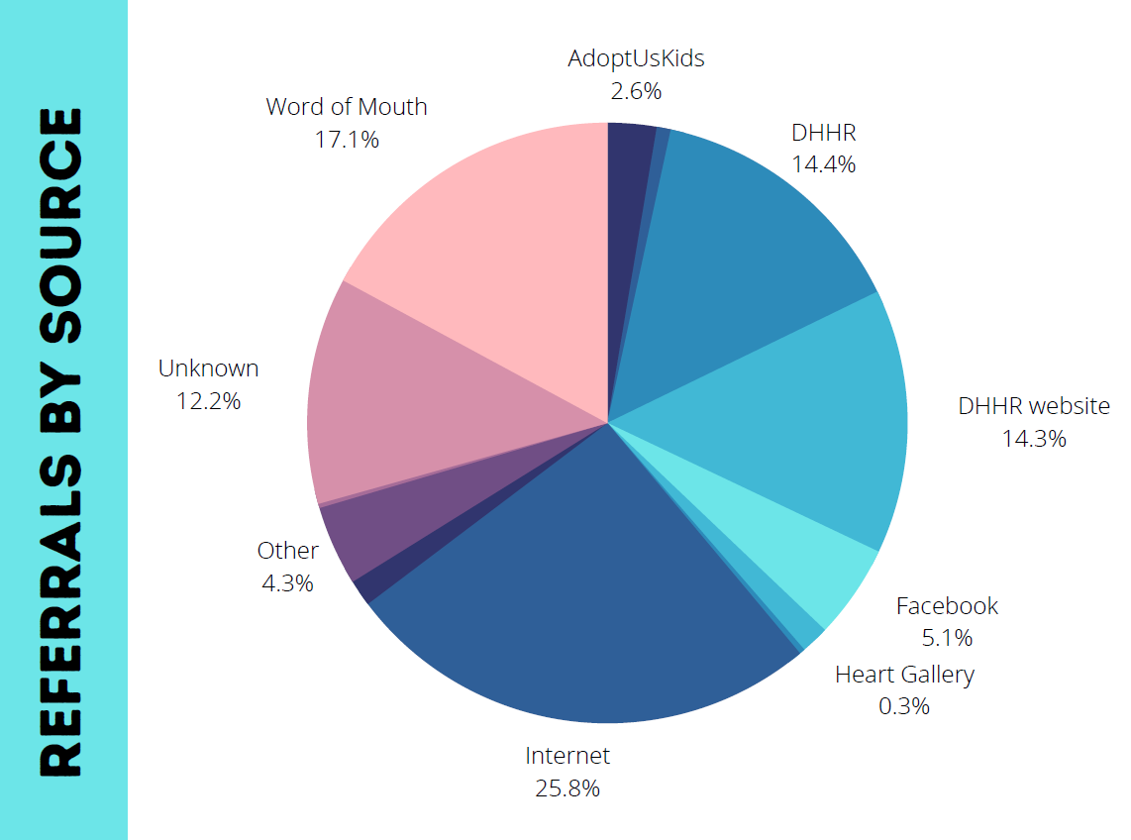
Chart provided by Mission West Virginia
AdoptUsKids | 35
Community Event | 10
DHHR | 191
DHHR website | 189
Facebook | 67
Flyer/Publication | 20
Heart Gallery | 4
Internet | 342
Media | 19
Other | 57
Sunday's Child | 3
Unknown | 162
Word of Mouth | 227

Upcoming
Foster Care Month 2022: With COVID restrictions lifted an in-person event is scheduled for May 21: Walk with Me for Youth in Foster Care. The event, which takes place in Charleston, will be held for a 10th year in partnership with Child Placing Agencies and other partners. The event will serve as a celebration and retention event for foster families and their children as well as a general awareness piece.

Mission West Virginia will lead a “Recruitment Summit” meeting, in April 2022. The event will take place over a full day and will include agency updates and planning sessions involving foster parent recruitment activities throughout the state. The agencies will also take part in the filming of a collaborative recruitment video designed to showcase the cooperative nature of foster care work in West Virginia. The video will be used to encourage families to consider fostering and to showcase the support and positive nature of the foster care community.
As part of West Virginia’s Program Improvement Plan, several initiatives are currently in process to improve foster parent recruitment and retention. These initiatives include sending letters to kinship/relative providers six months into their certification process to inform them of their qualification to transition to traditional foster care if they are interested. This letter provides information on contacting Mission West Virginia to discuss their process. Mission West Virginia tracks these providers for reporting purposes to demonstrate the interest and increase in traditional foster care providers. Additional strategies include training and assistance from the child placing agencies for child welfare staff regarding working collaboratively with foster care providers and building strong supportive relationships. Providing open house type meetings to initiate a “warm handoff” of kinship/relative providers to child placing agencies for the purpose of converting to traditional foster care providers. West Virginia continues to work on the approved strategies and goals to improve foster parent recruitment and retention.
Update 2024:
Between January 1, 2022, and December 31, 2022, Mission WV responded to 1174 inquiries, with over 99% of families receiving responses within two (2) business days. Main sources of inquiries included: Internet, DHHR and word of mouth. Other inquiry sources included media, special events, publications, billboards, AdoptUSKids, etc. Approximately 1,000 to 1,500 families who are actively considering or pursuing certification are served by Mission West Virginia at any given point in time. During this period 19,518 follow-up contacts were made to these families. Contacts are made to provide information and assistance, to resolve issues between the families and providers, to track families’ progress toward certification, etc. During this period the following progress was tracked:
Over 200 families connected with an agency, 112 families received training and 185 families were certified. (*Data only applies to families that stayed engaged in the process with Mission West Virginia. It is known that a percentage of families do complete steps toward certification without reporting back to the agency).
Mission West Virginia has developed tracking to measure how many families “engage” in the follow up protocol. Families are counted as engaged when they respond to or initiate contact past the initial inquiry. During this period over 63% of families “engaged” in the process. We believe that tracking this figure will allow us to better measure the success rate of our protocol by separating out the families who only wanted to receive information but did not actively begin any steps in the process and/or engage in our follow-up protocol.
Mission West Virginia specifically engages in “inquiry retention” meaning that they work with families from their first expression of interest and continue to engage with them even if the family is not ready to take the first steps of application or training. During the period in which the family is considering a first step, Mission West Virginia offers services and support. Many families may spend several months, even a year or more in the process of “considering” and Mission West Virginia ensures that the inquiry is not “lost” during this time. This protocol is based on that developed and used by AdoptUSKids over the past few decades.
As MWV reaches out to families who are engaged in the process, they often address barriers and problem-solve issues that are causing delays or even causing families not to be certified, including facilitating communication and addressing barriers and customer service issues with the certifying agencies.
- Mission West Virginia engages in General, Targeted, Child-specific, and Child-focused recruitment. Current recruitment methods include:
- General: website optimization, google adwords, social media, awareness events, print media, PSAs, business partnerships, etc. Mission West Virginia has obtained and been extensively training in google ads grants, which provides up to $10,000 in free advertising for recipient non-profits.
- Targeted: presentations, work with faith communities, newsletters, direct mail, targeted social media, video success stories, webinars, use of experienced foster/adoptive parents for messaging and recruitment targeted at specific areas of the state
- Child-specific recruitment- website and newsletter features
- Child-focused recruitment- individual meetings with children, case file review
- In partnership with the DHHR, MWV is targeting certified relative/kinship parents who may be appropriate to convert to resource foster homes. DHHR generally initiates the initial outreach and then directs families to Mission West Virginia for information and response. They are then referred to private foster care and adoption agencies for certification. In 2022 40 families inquired about converting from relative/kinship providers to providing general foster care.
- Recruitment messaging is intended to recruit families interested in fostering or adopting from the foster care system. Messaging and images focus on older youth, sibling groups and racially diverse families.
- Mission West Virginia writes a monthly column for the Charleston Gazette on a variety of topics related to foster care and adoption. Mission West Virginia also has a monthly public access television show that focuses on topics related to child welfare.
- Additionally, Mission West Virginia provides technical assistance and leadership for regional and community-based recruitment efforts. Activities are based on county or regional data identifying needs and county-specific messaging is used in recruitment efforts. Efforts are also based on input from regional DHHR staff.
During 2022 Mission West Virginia engaged in the following additions to the standard recruitment plan:
Foster Care Month
For National Foster Care Month, the Mission West Virginia brought back Walk with Me…For Youth in Foster Care on Saturday May 21, 2022, after a five-year hiatus. This was the 10th Walk Mission West Virginia hosted. Walk With Me is an event to create awareness about foster care in WV and a celebration of foster families and the children they care for. This year over $9,000 in sponsorships was secured to cover costs and 330 people registered for the event. Foster, adoptive, relative/kinship families could register to attend the event for free with their families and receive a t-shirt.
At the event, nine out of the eleven foster care agencies in the state attended and provided their own entertainment. In addition, paid entertainment such as a DJ, face painter, Disney Character entertainment and more was provided. The two top sponsors were child welfare attorneys who made themselves available for answering foster/adopt questions. An interactive play therapy bus was also present.
Mission West Virginia engaged in a multi-faceted campaign throughout November to observe and celebrate adoption. Although we traditionally observe through in-person celebration, we modified our plans this year to ensure safety during the pandemic. To celebrate Adoption Month for 2021, we created a poster campaign that was shared with agencies and supporters across the state. Packages included 3 different poster designs (promoting adoption, foster care, and kinship/relative care) as well as decals and other materials were mailed to DHHR offices, FRNs and churches and other businesses as well as to individuals who requested materials. In addition to the poster campaign, Mission WV designed custom t-shirts to match the adoption month theme. T shirts were sold online, both to raise funds for youth served through MWV’s programming but more importantly to raise community awareness and generate conversation about the need.
Additional Adoption Month Activities
- Social Media: All MWV social media during the month of November focused on adoption-themed posts that were available for sharing by other organizations.
- Kids In Care: Our monthly column in the Charleston Gazette focused on the topic of Adoption Month
- The Mission West Virginia monthly public access show addressed Adoption Month through an interview with a guest from a Child Placing Agency
- A radio campaign focused on the need for foster/adoptive parents.
- Digital marketing campaign, which began in September, ran through the end of November.
Foster West Virginia: Mission West Virginia is working with Chestnut Mountain Village to launch their Foster WV campaign, which is working with churches across the state to educate and equip church members to support the foster, adoptive and kinship families in their communities. Because foster parent recruitment is a naturally occurring extension of this program, MWV serves as the response team for families interested in pursuing certification.

For the time period January 1, 2022- December 31, 2022.
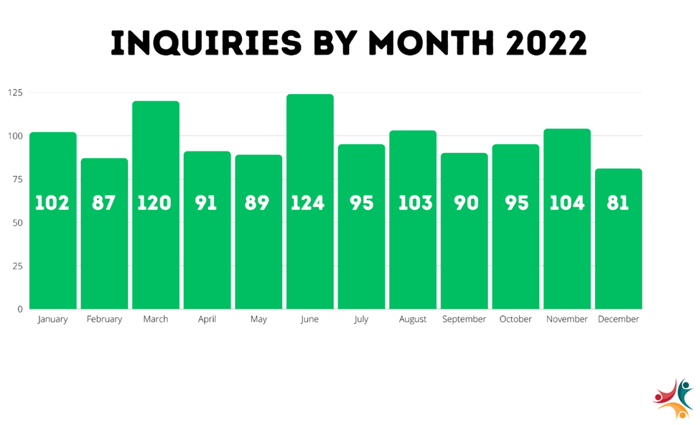Chart provided by Mission West Virginia
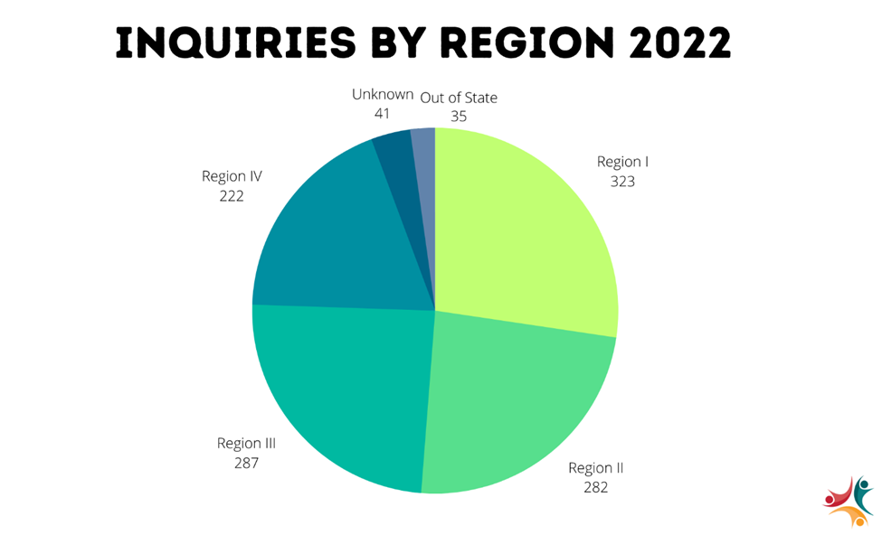
Chart provided by Mission West Virginia
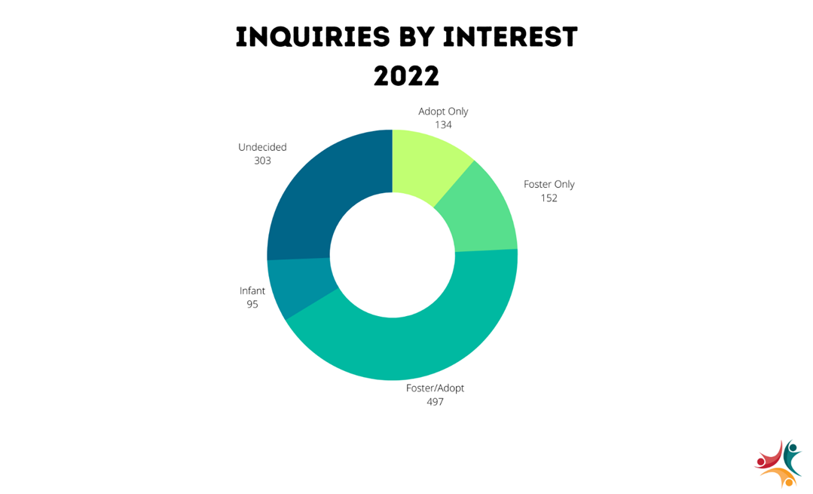
Chart provided by Mission West Virginia
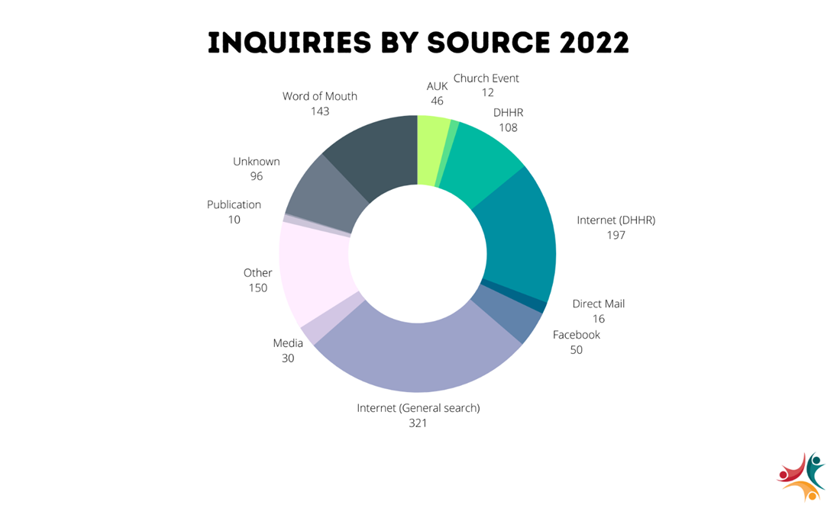Chart provided by Mission West Virginia
Upcoming 2023 goals include a Recruitment Summit.
Mission West Virginia will host 2 additional recruitment summits for all private agencies providing service statewide. The spring summit will be April 18th in Charleston and the fall summit will be in October in the northern part of the state.
Mission West Virginia is working with a committee of private agencies as well as Aetna (the state’s MCO) for a statewide recruitment campaign that should launch mid-2023.
Mission West Virginia will participate in the All in Foster Care Summit in May, a statewide summit for church and social service leaders to create supportive services for foster/adopt/kinship families. The event will be attended by national and state child welfare experts as well as leaders in the faith community.

Health Care Oversight and Coordination Plan
The Health Care Oversight and Coordination Plan was developed with the Office of Maternal Child and Family Health, BMS and the Bureau for Children and Adult Services. Please see attached.

Update 2023:
See MCO update in Service Coordination section.

Update 2024:
See MCO update in Service Coordination section.

Disaster Plan

Update 2023:
There were no revisions to the Disaster Plan. On May 20, 2021, there was a Presidential declaration of a major disaster for the State of West Virginia. Certain areas in West Virginia were damaged by severe storms and flooding during the period of February 27 to March 4, 2021. The following counties in West Virginia were affected: Boone, Cabell, Kanawha, Logan, Mingo, and Wayne.

Update 2024:
There were no revisions to the Disaster Plan.

Training Plan
See attached.

Update on Statistical Information
Child Protective Services Workforce FFY 2019 | Region I | Region II | Region III | Region IV | Statewide
Total CPS Cases¹ | 21,297 | 29,147 | 16,701 | 21,095 | 88,240
Monthly Average CPS Cases² | 1,775 | 2,429 | 1,392 | 1,758 | 7,353
Staff Needed @ Action Standard³ | 178 | 243 | 139 | 176 | 735
Total CPS Staff Allocated Positions⁴ | 122 | 151 | 100 | 117 | 490
% Of Allocated Positions Meeting Action Standard⁵ | 69% | 62% | 72% | 66% | 67%
Average CPS Caseload for Allocated Positions⁶ | 15 | 16 | 14 | 15 | 15
Caseload Difference (allocated to action standard)⁷ | -56 | -92 | -39 | -59 | -245
^{1 Obtained} by adding the monthly case totals of On-going Child Protective Services staff (FREDI CPS-8802) to the number of referrals accepted for the
month (Cognos-Referrals Accepted) for FFY 2019 (October 2018-September 2019)
^{2 Total} CPS cases divided by 12 (months) rounded to nearest integer
^{3 Monthly} average of CPS cases divided by 10(action standard for CPS cases) rounded to nearest integer
^{4 Obtained} from monthly "Position Vacancy Report" submitted by each region rounded to nearest integer
⁵Total CPS allocated positions divided by staff needed at action standard (10) multiplied by 100 rounded to nearest integer
^{6 Monthly} average CPS cases divided by total CPS staff allocated positions rounded to nearest integer
⁷Staff needed at action standard (10) subtract CPS allocated positions rounded to nearest integer (positive numbers mean above action standard,
negative numbers mean below action standard)

CAPTA Annual State Data Report:

Update 2023:
Child Protective Services Workforce FFY 2021 | Region I | Region II | Region III | Region IV | Statewide Total
Total CPS Cases¹ | 18,335 | 26,042 | 17,691 | 16,720 | 78,788
Monthly Average CPS Cases² | 1,528 | 2,170 | 1,474 | 1,393 | 6,566
Staff Needed @ Action Standard³ | 153 | 217 | 147 | 139 | 657
Total CPS Staff Allocated Positions⁴ | 129 | 163 | 111 | 129 | 532
% Of Allocated Positions Meeting Action Standard⁵ | 84% | 75% | 76% | 93% | 81%
Average CPS Caseload for Allocated Positions⁶ | 12 | 13 | 13 | 11 | 12
Caseload Difference (allocated to action standard)⁷ | -24 | -54 | -36 | -10 | -125
^{1 Obtained} by adding the monthly case totals of On-going Child Protective Services staff (FREDI CPS-8802) to the number of referrals accepted for the
month (Cognos-Referrals Accepted) for FFY 2021 (October 2020-September 2021)
^{2 Total} CPS cases divided by 12 (months) rounded to nearest integer
^{3 Monthly} average of CPS cases divided by 10(action standard for CPS cases) rounded to nearest integer
^{4 Obtained} from monthly "Position Vacancy Report" as of 9/30/21 submitted by each region rounded to nearest integer. Positions included
in count are CPSW/T, CPSW FTDC and CPSW Senior.
⁵Total CPS allocated positions divided by staff needed at action standard (10) multiplied by 100 rounded to nearest integer
^{6 Monthly} average CPS cases divided by total CPS staff allocated positions rounded to nearest integer
⁷Staff needed at action standard (10) subtract CPS allocated positions rounded to nearest integer (positive numbers mean above action standard,
negative numbers mean below action standard)

Youth Services Workforce FFY 2021 | Region I | Region II | Region III | Region IV | Statewide Total
Total YS Cases¹ | 6,780 | 9,299 | 5,870 | 3,941 | 25,890
Monthly Average YS Cases² | 565 | 775 | 489 | 328 | 2,158
Staff Needed @ Action Standard³ | 47 | 65 | 41 | 27 | 180
Total YS Staff Allocated Positions⁴ | 31 | 49 | 32 | 24 | 136
% Of Allocated Positions Meeting Caseload Standard⁵ | 66% | 75% | 78% | 89% | 76%
Average YS Caseload for Allocated Positions⁶ | 18 | 16 | 15 | 14 | 16
Caseload Difference (Allocated Action Standard)⁷ | -16 | -16 | -9 | -3 | -44
^{1 Obtained} by adding the monthly case total of Youth Services staff (FREDI-0010) each month during FY 2021 (October 2020-September 2021)
^{total} Youth Services Cases divided by 12 (number of months) rounded to nearest integer
³Monthly average of Youth Services Cases divided by 12 (action standard for Youth Services cases) rounded to nearest integer
^{4 Obtained} from the "Position Vacancy Report" as reported by each region as of September 30, 2021
⁵Total Youth Services staff allocated positions divided by the staff needed at action standard multiplied by 100 rounded to nearest integer
^{6 Monthly} average of Youth Services cases divided by total allocated Youth Services positions rounded to nearest integer
^{7 Youth} Services allocated positions subtract Youth Services staff needed at action standard rounded to nearest integer
(Positive numbers mean above action standard, negative numbers mean below action standard)

A survey was conducted in December 2021 to obtain the demographics, education, and qualifications of child welfare personnel. As previously mentioned, however, the state envisions full reporting capabilities with its new SACWIS system implementation.

This chart provides the survey participation of personnel by position type. 78% of the respondent workforce were females and 20% were male, while a combined 1% identified as either transgender male, preferred not to answer, or identified with a non-represented gender. Child Welfare personnel primarily identified as white, making up 90% of respondents; while 8% identified as African American or Black, and Hispanic or Latino represented 1% of participants. Nearly 38% of participants had been with the agency less than three years, 22% had more than 10 years of tenure, and 40% had between three and 10 years of experience.

Participants by Field of Study
Behavioral Science | 1%
Board of Regents | 7%
Business Management | 4%
Counseling | 2%
Criminal Justice | 18%
Criminology | 1%
Education | 7%
Health Service and Social Welfare | 1%
Human Resource Management | 0%
Political Science | 0%
Psychology | 13%
Social Work | 25%
Sociology | 5%
Special Education | 1%
Not Listed/Other | 12%

License Type
Social Service Registry | Licensed Social Worker | Licensed Certified Social Worker | Licensed Graduate Social Worker | Licensed Independent Clinical Social Worker
52% | 42% | 2% | 4% | 0%

Information related to Child Protective Services education, qualifications, and training requirements, as well as advancement criteria can be found at the following links:
Child Protective Services Case Coordinator
Child Protective Services Worker Trainee
Child Protective Services Worker
Child Protective Worker Senior
Child Protective Services Supervisor
Social Service Coordinator

Update 2024:
Due to the reorganization of the districts and regions the reporting chart will reflect data reported by North and South regions.

Youth Services Workforce FFY2022 | North | South | Statewide Total
Total YS Cases1 | 13,019 | 16,209 | 29,228
Monthly Average YS Cases2 | 1,085 | 1,351 | 2,436
Staff Needed @ Action Standard3 | 90 | 113 | 203
Total YS Staff Allocated Positions4 | 55 | 76 | 131
% of Allocated Positions Meeting Caseload Standard5 | 61% | 67% | 65%
Average YS Caseload for Allocated Positions6 | 20 | 18 | 19
Caseload Difference (Allocated Action Standard)7 | -35 | -37 | -72
1Obtained by adding the monthly case total of Youth Services staff (FREDI-0010) each month during FFY2022 (October 2021-September 2022)
2Total Youth Services Cases divided by 12 (number of months)rounded to nearest integer
3Monthly average of Youth Services Cases divided by 12 (action standard for Youth Services cases) rounded to nearest integer
4Obtained from the "CPS-YS Vacancy Report" as reported by each region as of September 30, 2022.
5Total Youth Services staff allocated positions divided by the staff needed at action standard multiplied by 100 rounded to nearest integer
6Monthly average of Youth Services cases divided by total allocated Youth Services positions rounded to nearest integer
7Youth Services allocated positions subtract Youth Services staff needed at action standard rounded to nearest integer
(positive numbers mean above action standard, negative numbers mean below action standard)

Child Protective Services Workforce FFY2022 | North | South | Statewide Total
Total CPS Cases1 | 35,077 | 41,217 | 76,294
Monthly Average CPS Cases2 | 2,923 | 3,435 | 6,358
Staff Needed @ Action Standard3 | 292 | 344 | 636
Total CPS Staff Allocated Positions4 | 229 | 289 | 518
% of Allocated Positions Meeting Action Standard5 | 78% | 84% | 81%
Average CPS Caseload for Allocated Positions6 | 13 | 12 | 12
Caseload Difference(allocated to action standard)7 | -63 | -55 | -118
1Obtained by adding the monthly case totals of On-going Child Protective Services staff (FREDI CPS-8802) to the number
of referrals accepted for the month (Cognos-Referrals Accepted) for FFY2022 (October 2021-September 2022)
2Total CPS cases divided by 12 (months) rounded to nearest integer
3Monthly average of CPS cases divided by 10(action standard for CPS cases)rounded to nearest integer
4Obtained from monthly "CPS-YS Vacancy Report" as of 9/30/22 submitted by each region rounded to nearest integer.
Positions included in count are CPSW/T, CPSW FTDC and CPSW Senior.
5Total CPS allocated positions divided by staff needed at action standard (10) multiplied by 100 rounded to nearest integer.
6Monthly average CPS cases divided by total CPS staff allocated positions rounded to nearest integer.
7Staff needed at action standard (10) subtract CPS allocated positions rounded to nearest integer (positive numbers mean
above action standard, negative numbers mean below action standard)

The survey mentioned in last year’s update did not take place in 2022 therefore, the data in the charts in last year's update is no longer available.

Juvenile Justice Transfers:

Update 2023:
The methodology for obtaining juveniles transfer numbers has not changed. During the previous reporting period for FFY 2020 the count of transfers must be revised to 63 which is consistent with FFY 2021. For the current reporting period of FFY 2021 there were 61 transfers. A table of the data is shown below.

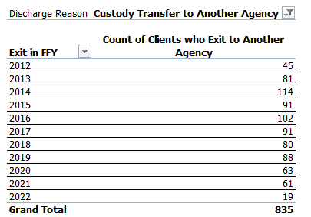

Update 2024:
The methodology of obtaining juvenile transfer numbers has changed since the previous reporting year. The data is pulled from the “Children in Care Report”, and the count of children exiting care with a “custody transfer to another agency” was totaled for the FFY. For the period of FFY 2022, thirty-three juveniles transferred. FFY 2023 has not concluded, but thus far (October 1, 2022 - April 1, 2023) five juveniles have been transferred.

Education and Training Vouchers:
See Attachment D

Inter-Country Adoptions:

Update 2023:
West Virginia had one child adopted from Russia that entered state custody due to abuse/neglect. The child was reunified with her adoptive mother in FFY 2021.

Update 2024:
West Virginia had no children adopted from other countries that entered state custody in FY 2023.

Monthly Caseworker Visit Data:

Update 2023:
In FFY 2021, 94.87% of the children in foster care in West Virginia were visited during each and every month, with 69.91% of those visits occurring in the child’s place of residence. West Virginia did not meet the required 95 percentile range for visitation with each child in foster care during FFY 2021. West Virginia recently completed their two-year implementation period of the PIP agreement that included goals around meaningful contact with children in foster care. However, West Virginia did exceed the required 50 percentile range for visits occurring within the placement residence. The demonstration of increased visits within the child’s placement residence was likely due to the COVID-19 pandemic and the ability to complete some monthly face-to-face visits virtually.

Update 2024:

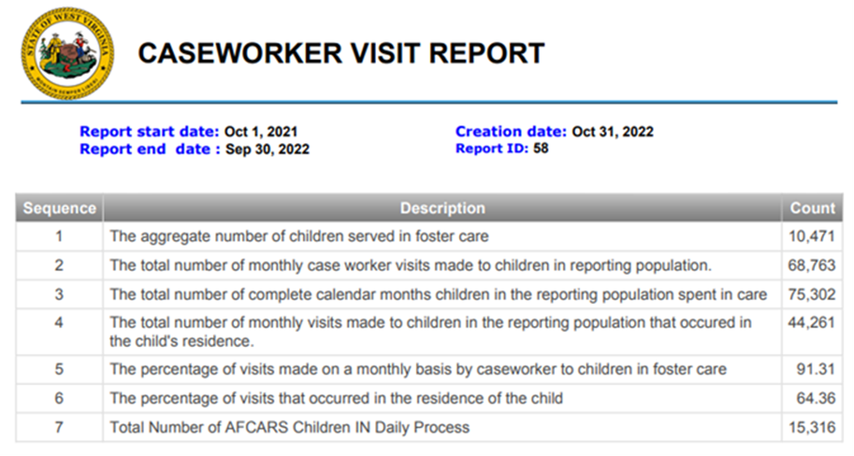

In FFY 2022, 91.31% of the children in foster care in West Virginia were visited during each month, with 64.36% of those visits occurring in the child’s place of residence. West Virginia did not meet the required 95 percentile range for visitation with each child in foster care during FFY 2022. West Virginia recently completed their two-year implementation period of the PIP agreement that included goals around meaningful contact with children in foster care. However, West Virginia did exceed the required 50 percentile range for visits occurring within the placement residence.

Financial Information

Update 2023:
Please see attached CFS-101 parts I, II and III.

Update 2024:
Please see attached CFS-101 parts I, II and III.

