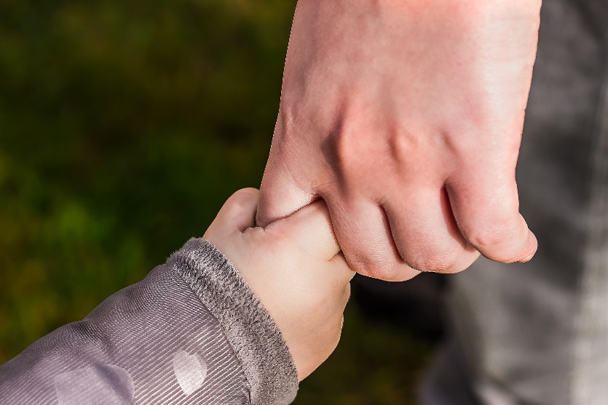
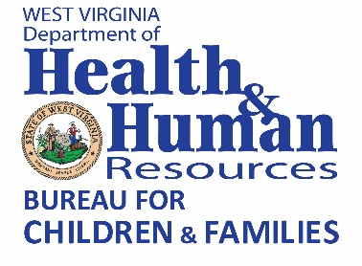
West Virginia Family Resource Networks
Region 4 Report
CONTINUOUS QUALITY
IMPROVEMENT SURVEY

Community Partnerships
Jessica L. Ball, HHR Specialist, Sr.
January 25, 2021
To foster a culture of continuous quality improvement, the West Virginia Department of Health and Human Resources (DHHR), Bureau for Children and Families, Division of Children and Adult Services adopted the Continuous Quality Improvement (CQI) Survey to assist the West Virginia Family Resource Networks (FRNs) in determining the areas for improvement.
FRNs receive planning and coordination grants from DHHR, and the two entities work together to strengthen communities statewide. During State Fiscal Year (SFY) 2012, DHHR program staff met with staff of the FRNs to review a quality improvement survey, take comments, and revise the survey for distribution. FRNs distribute this survey electronically or by paper to community stakeholders. Using SelectSurvey.Net software, responses are recorded electronically or manually entered when completed paper surveys are received. The following charts provide data from statewide community stakeholders on the performance of the Region 4 FRNs during SFY 2020.

1. Which answer best describes your role in your FRN?

- The FRNs involve families to identify needs.

- The FRNs help organize and mobilize groups that advocate for local, state, and federal policy
changes that will promote better services for families.

- The FRNs coordinate with local, public and private service providers to assess gaps in services
and design plans to address those gaps.

- The FRNs adapt to the changing needs of the community.

- The FRNs provide information or presentations on activities, events, and services within the
community.

- The FRNs consistently update resources and referral information on education, healthcare, domestic violence, substance abuse, child welfare, mental health, immigration, childcare, housing, legal/financial, food/clothing and child safety and well-being.

8. The FRNs encourage and develop effective strategies to partner with families.

9. Communities demonstrate their support of the FRNs by providing resources such as financial support and in-kind donations.

10. The FRNs work to ensure that community partnerships are culturally representative of the community and inclusive of the range of resources.

11. The FRNs participate in community-building activities such as health and resource fairs, cultural celebrations, school events, town hall meetings and community advocacy/self-advocacy activities.

12. The FRNs encourage community partnerships with public and private agencies and participate in collaborative planning bodies.

13. The FRNs adapt to economic and social trends.

14. How would you rate the FRNs overall?

16. How long have you been involved with your FRN?

236 people from Region 4 completed the FRN survey. The following information shows the percentage of respondents and their answers:

- 93% of the people surveyed agreed that the FRNs involve families to identify needs.

- 90% of the people surveyed agreed that the FRNs advocate for local, state and federal policy changes that will promote better services for families.

- 95% of the people surveyed agreed that the FRNs coordinate with local, public and private service providers to assess gaps in services and design plans to address those gaps.

- 95% of the people surveyed agreed the FRNs adapt to the changing needs of families and the community.

- 95% of the people surveyed agreed the FRNs provide information or presentations on activities, events, and services within the community.

- 90% of the people surveyed agree the FRNs encourage and develop effective strategies to partner with family representatives.

- 78% of the people surveyed agree the FRNs demonstrate their support by providing resources such as financial support and in-kind donations.

- 87% of the people surveyed agree the FRNs work to ensure that community partnerships are culturally representative of the community and inclusive of the range of resources.

- 92% of the people surveyed agree the FRNs participate in community building activities such as health and resource fairs, cultural celebrations, school events, town hall meetings and community advocacy/self-advocacy activities.

- 95% of the people surveyed agree the FRNs encourage community partnerships with public and private agencies and participate in collaborative planning bodies.

- 90% of the people surveyed agree the FRNs adapt to economic and social trends.

- 92% of the people surveyed agree the FRNs are effective overall.

- 68 people taking the survey have been involved with the FRN between 1 and 3 years, with 48 involved between 3 and 5 years, and 92 who have been involved 5 years or more.

