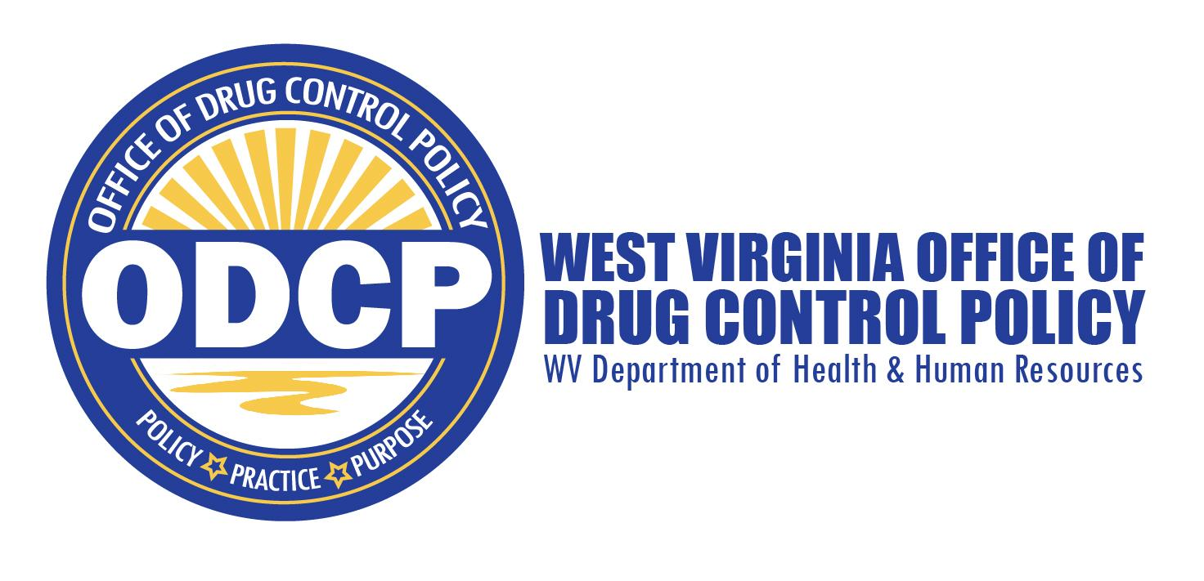
Agenda
Governor’s Council on Substance Abuse Law Enforcement Subcommittee
Tuesday, July 11, 2023

Start Time: 9:00 a.m. Location: Zoom

I. Intro and welcome

II. Approval of Minutes

III. 2023 Implementation Planning and Review of KPI Q2 Progress

IV. Other Business
V. Adjourn

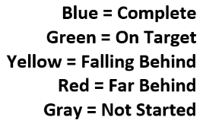
Law Enforcement
Goal 1: Equip and train law enforcement agencies to respond to overdoses.
 |  | Q1 Progress | Q2 Progress | Q3 Progress | Q4 Progress
Strategy 1 | Provide education and training on naloxone, self-care, harm reduction principles, stigma, and models for responding to overdoses to all law enforcement officers.
KPI 1 | By December 31, 2023, provide at least two training events per year (virtual on in person) for law enforcement that includes naloxone administration, self-care, harm reduction, stigma reduction, and models for responding to overdoses. | 25%
KPI 2 | Through December 31, 2023, convene a workgroup that will be focused on coordinating/planning trainings and tracking of number trained. | 0%

Goal 3: Provide law enforcement with analytical tools, techniques, resources, and policies to improve
the enforcement of drug laws.
 |  | Q1 Progress | Q2 Progress | Q3 Progress | Q4 Progress
Strategy 1 | Utilize the Overdose Detection Mapping Application Program to identify drug  trafficking routes across state lines and encourage local law enforcement to enter  overdose data, as required by law
KPI 1 | Through December 31, 2023, continue to inform all local law enforcement agencies and first responders that entering overdose data into the Overdose Detection Mapping Application Program within 72 hours of overdose is state required and report number of trainings provided. | 25%
KPI 2 | Through December 31, 2023, continue notifying state and local law enforcement of overdose events and apparent drug routes identifiable via the Overdose Detection Mapping Application Program. | 25%

Goal 4: Strengthen the use and implementation of strategies among law enforcement and first responders to address the incidence and prevalence of children’s exposure to violence and trauma.
 |  | Q1 Progress | Q2 Progress | Q3 Progress | Q4 Progress
Strategy 1 | Support and expand the Handle with Care program to all first responders in all 55 counties of West Virginia.
KPI 1 | By December 31, 2023, offer training on Handle With Care and Handle With Care protocols to at least 400 law enforcement officers. | 70%
KPI 2 | By December 31, 2023, offer training on Handle With Care and Handle With Care protocols to at least 200 personnel who interact with law enforcement to include emergency medical services, 911, social workers, mental health providers, victim advocates, teachers and school staff | 0%
KPI 3 | Through December 31, 2023, maintain law enforcement referrals and use of Handle with Care quarterly to identify opportunities for continued improvements, additional supports needed, etc. | 25%

LAW ENFORCEMENT
Goal 1: Equip and train law enforcement agencies to respond to overdoses.
Strategy 1: Provide education and training on naloxone, self-care, harm reduction principles, stigma, and models for responding to overdoses to all law enforcement officers.
KPI 1: By December 31, 2023, provide at least two training events per year (virtual on in person) for law enforcement that includes naloxone administration, self-care, harm reduction, stigma reduction, and models for responding to overdoses.
KPI 2: Through December 31, 2023, convene a workgroup that will be focused on coordinating/planning trainings and tracking of number trained.

Goal 3: Provide law enforcement with analytical tools, techniques, resources, and policies to improve the enforcement of drug laws.
Strategy 3: Utilize the Overdose Detection Mapping Application Program to identify drug trafficking routes across state lines and encourage local law enforcement to enter overdose data, as required by law.
KPI 1: Through December 31, 2023, continue to inform all local law enforcement agencies and first responders that entering overdose data into the Overdose Detection Mapping Application Program within 72 hours of overdose is state required and report number of trainings provided.
KPI 2: Through December 31, 2023, continue notifying state and local law
enforcement of overdose events and apparent drug routes identifiable via the Overdose Detection Mapping Application Program.

Goal 4: Strengthen the use and implementation of strategies among law enforcement and first responders to address the incidence and prevalence of children’s exposure to violence and trauma.
Strategy 1: Support and expand the Handle with Care program to all first responders in all 55 counties of West Virginia.
KPI 1: By December 31, 2023, offer training on Handle With Care and Handle With Care protocols to at least 400 law enforcement officers.
KPI 2: By December 31, 2023, offer training on Handle With Care and Handle With Care protocols to at least 200 personnel who interact with law enforcement to include emergency medical services, 911, social workers, mental health providers, victim advocates, teachers and school staff.
KPI 3: Through December 31, 2023, maintain law enforcement referrals and use of Handle with Care quarterly to identify opportunities for continued improvements, additional supports needed, etc.

