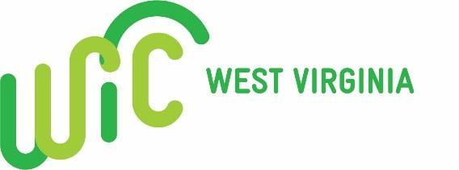

West Virginia WIC Vendor Advisory Board
Meeting Notes

January 25, 2023

Participants: Phone Conference through Google Meet

Addition to Food List

Ultra and Super Skim Milks will be added as UPC’s come in; please email at dhhrwicvu@wv.gov or call the Vendor Unit at 304-558-1115 to request your stores’ brand to be added. United Dairy UPCs for gallon, ½ gallon, and quart will be active February 1, 2023.

New Cereal sizes to be approved by WV WIC due to manufacturer downsizing on ounces of already approved cereals. Currently, approved sizes are 12-36oz for cold cereals and 11-36oz for hot. On February 1,2023 participants will be allowed to purchase 9-ounce boxes of General Mills Original and Multigrain Cheerios, and Kellogg’s Crispix, Rice Krispies, Cornflakes, and Original Special K cold cereals. Also, added for hot cereal is Quaker Original Oatmeal.

New Cereal to be added beginning February 1,2023 is Cheerios Oat Crunch Berry in 24 and 18 ounce boxes.

WIC’r Basket

WIC’r Basket newsletter is being sent by MailChimp services. Please check your emails and spam folders for this information. According to reports, many of the subscribed users are not opening their emails. Please see that someone is reading and posting these for employees quarterly as this is how we communicate changes and updates to you. If you are not subscribed go to the website at to sign up at https://dhhr.wv.gov/WIC/formsmaterials/Pages/Vendors.aspx .
Mid-Ohio Valley Region Reauthorization

Notice of reauthorization with dates of training will be coming soon to vendors in the following counties- Calhoun, Gilmer, Jackson, Mason, Pleasant, Ritchie, Roane, Wirt, and Wood. The vendor application with any changes can be submitted via the Vendor Portal at https://wvwicvendor.wvdhhr.org/. The Vendor Agreement will now be signed electronically through Docusign which will be emailed to you after the mandatory training.

Formula Issues
WV WIC has been made aware that some vendors are separating their 6 packs of formula for individual sale. Due to the UPCs being specific to a 6 pack the individual sales are subtracting more than what was actually purchased from participant’s benefit package. Please discontinue the individual sales of these products.

USDA Proposed Changes
The USDA is currently working on possible changes to the WIC Food Benefit Package. This includes adding additional fish, different types of whole grains, and lowering the amount of juice and milk to be purchased monthly. The only noted change to possibly negatively affect vendors is they maybe be required to stock 3 different varieties of vegetables at all times. WV WIC does not foresee this as an issue as most vendors already carry many varieties of vegetables as we allow fresh, frozen, and/or canned to be purchased. If a vendor would like to comment on the upcoming changes you can go to www.regulation.gov and click on the WIC tab.

Date of next quarterly voluntary call: July 26,2023 9:00 am

